Usiel Figueroa

Module 7.2 Assignment: Test Cases

CSD325-A311 Advanced Python

November 26, 2024

**City Functions**

This screenshot shows the output of the city_functions.py program when the function city_country is called with different sets of arguments.

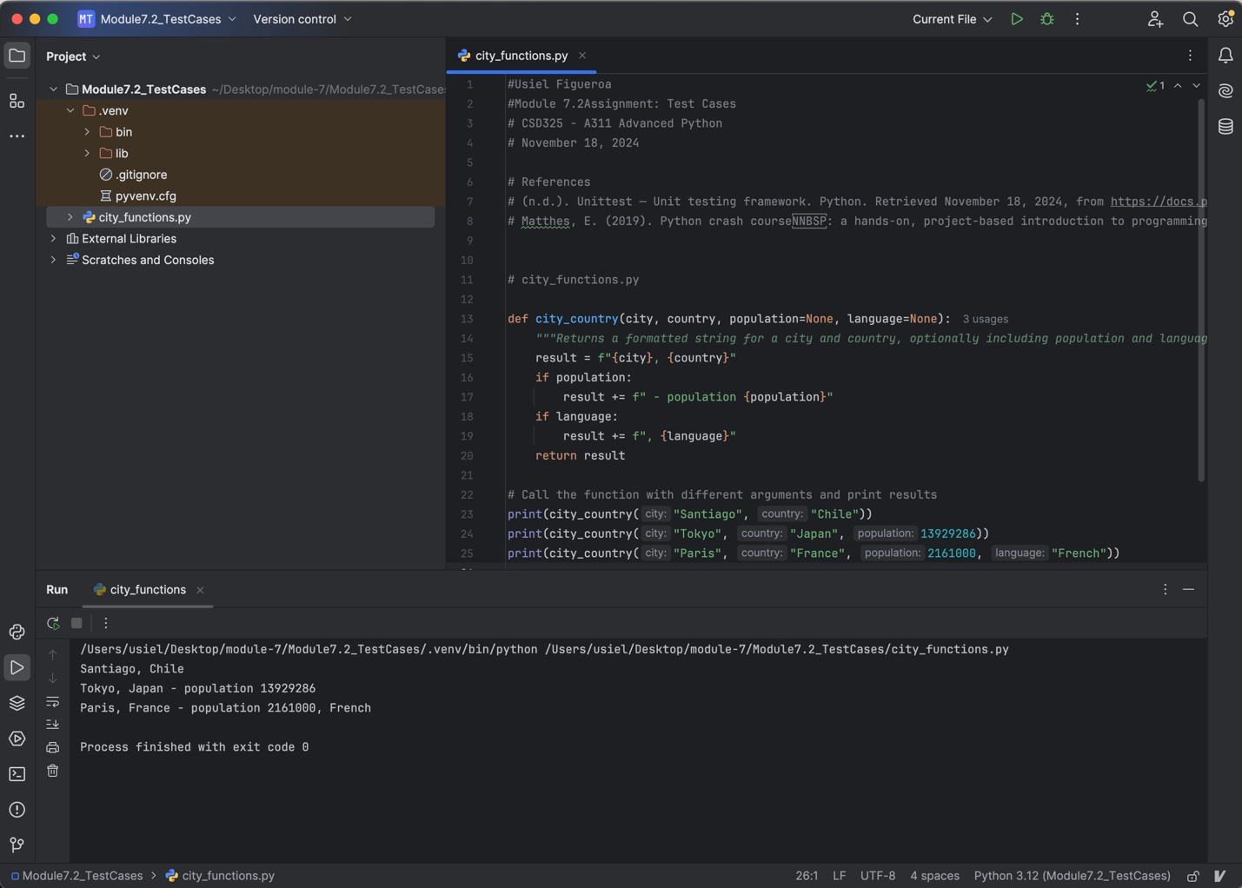

**Run Test**

This screenshot shows the initial successful execution of test_cities.py. All tests pass, verifying the city_country function works correctly

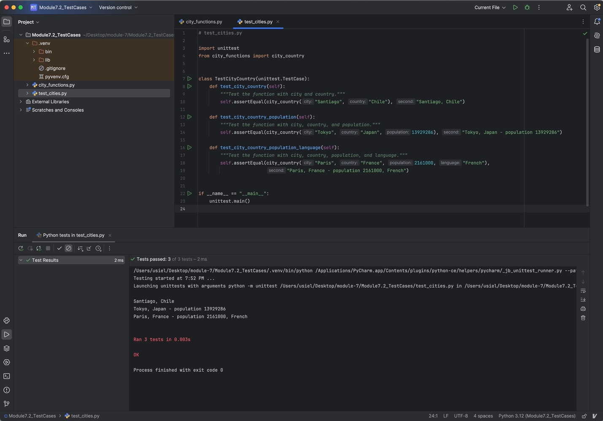

**Test Fail**

This screenshot shows the failed test results after modifying the city_country function to require the population parameter.

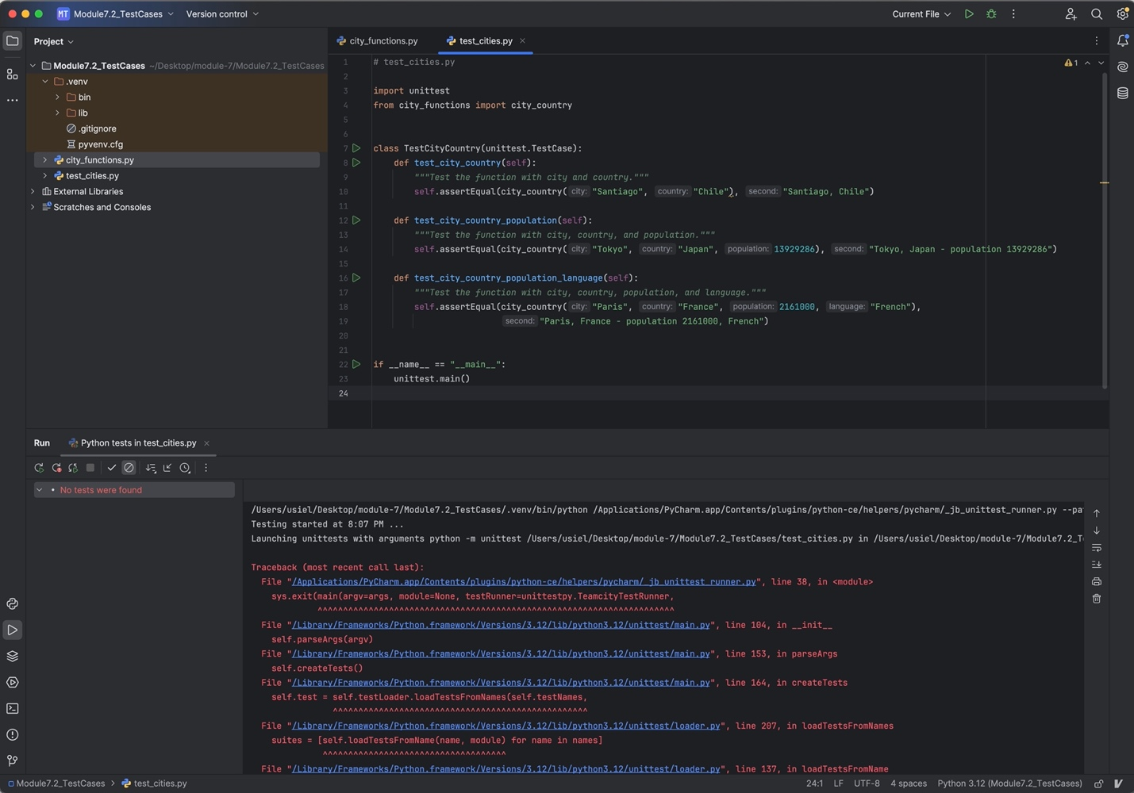

**Population Optional**

This screenshot shows the successful execution of test_cities.py after modifying the city_country function to make the population parameter optional again.

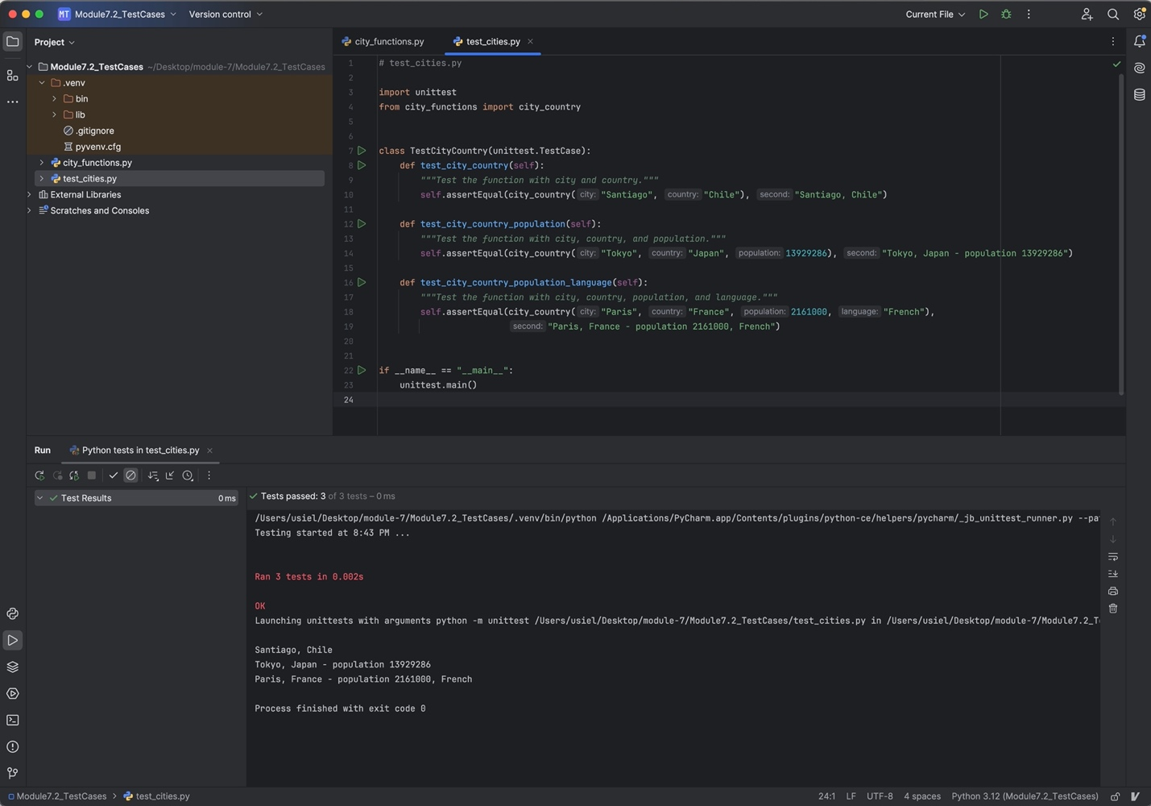

**Language Failed Test**

This screenshot shows the failed test results after modifying the city_country function to require the language parameter. Tests that don’t provide a language argument fail, confirming that the function expects this argument.

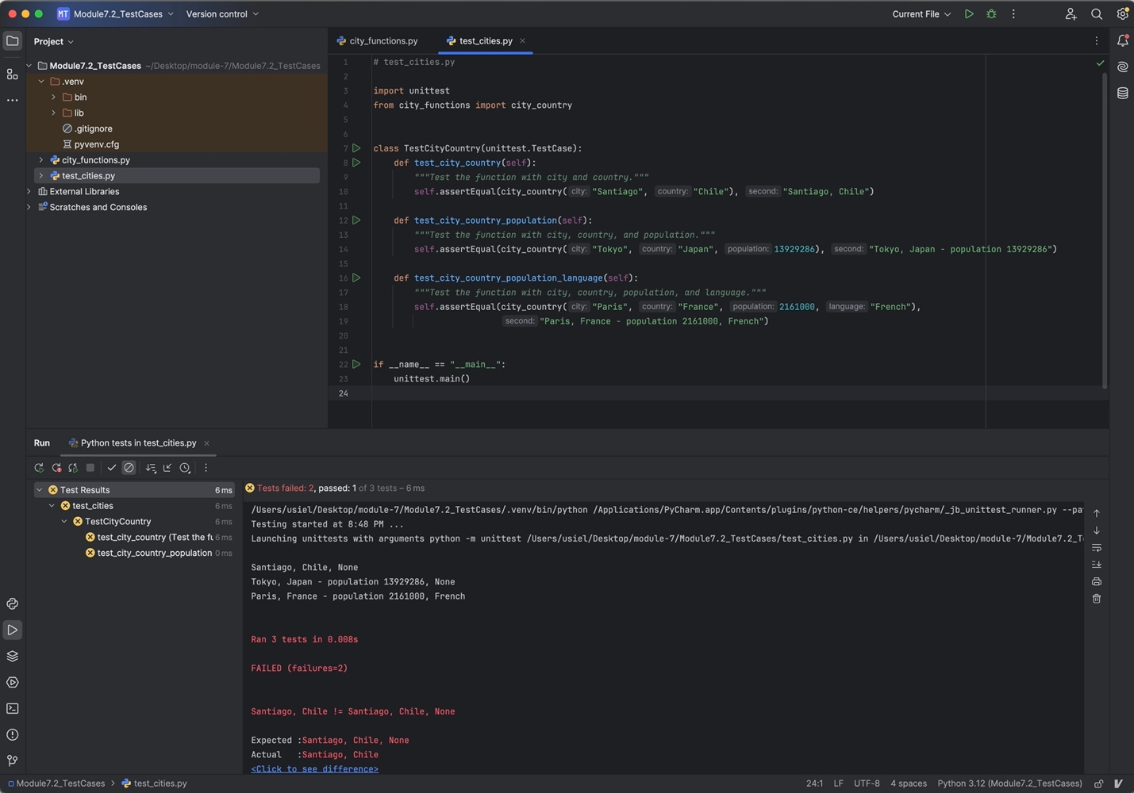

**Successful Test**

This screenshot shows the successful execution of test_cities.py after modifying the city_country function to make the language parameter optional. The function now handles cases with or without the language argument, and all tests pass.

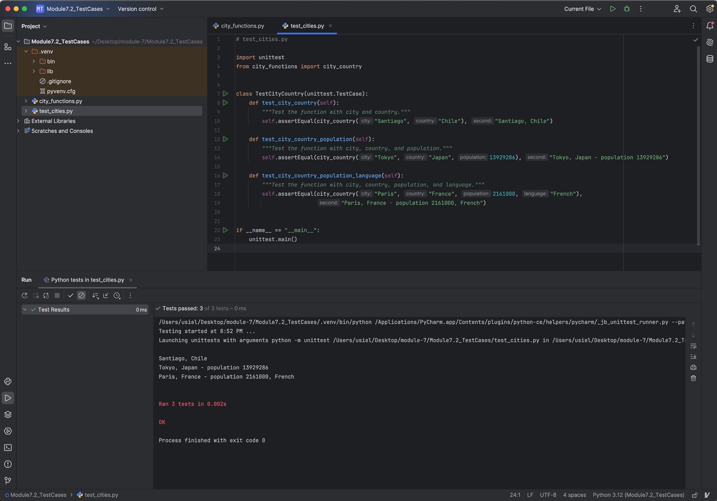

**Add to city_country**

This screenshot shows the output of city_functions.py It demonstrates the flexibility of the final implementation to handle all combinations of arguments.

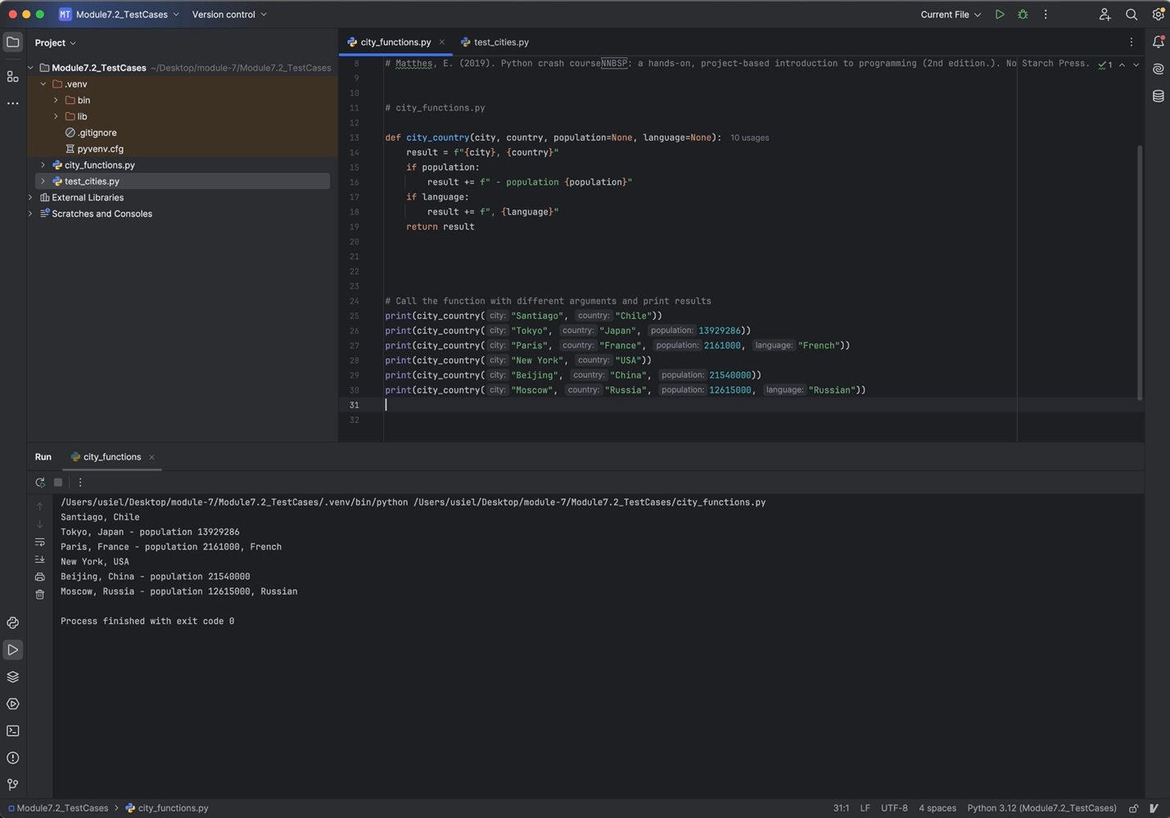

**References**

(n.d.). *Unittest — Unit testing framework*. Python. Retrieved November 18, 2024, from <https://docs.python.org/3/library/unittest.html>

Matthes, E. (2019). *Python crash course : a hands-on, project-based introduction to programming* (2nd edition.). No Starch Press.