Usiel Figueroa

November 26, 2024

Module 8.2 Assignment: JSON + Flowchart

CSD325 Advanced Python

**Output notification to the user that the .json file was updated.**

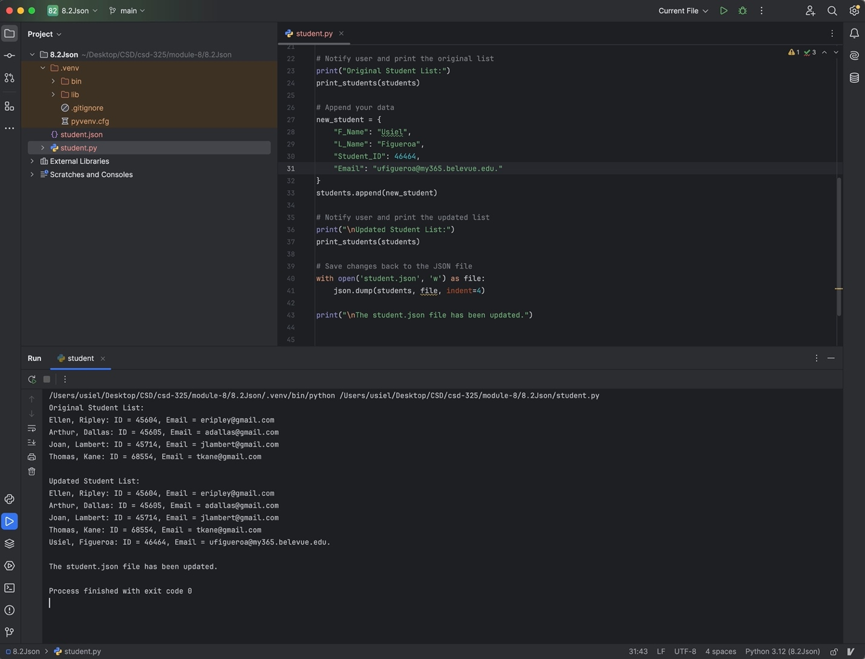

**Notification**

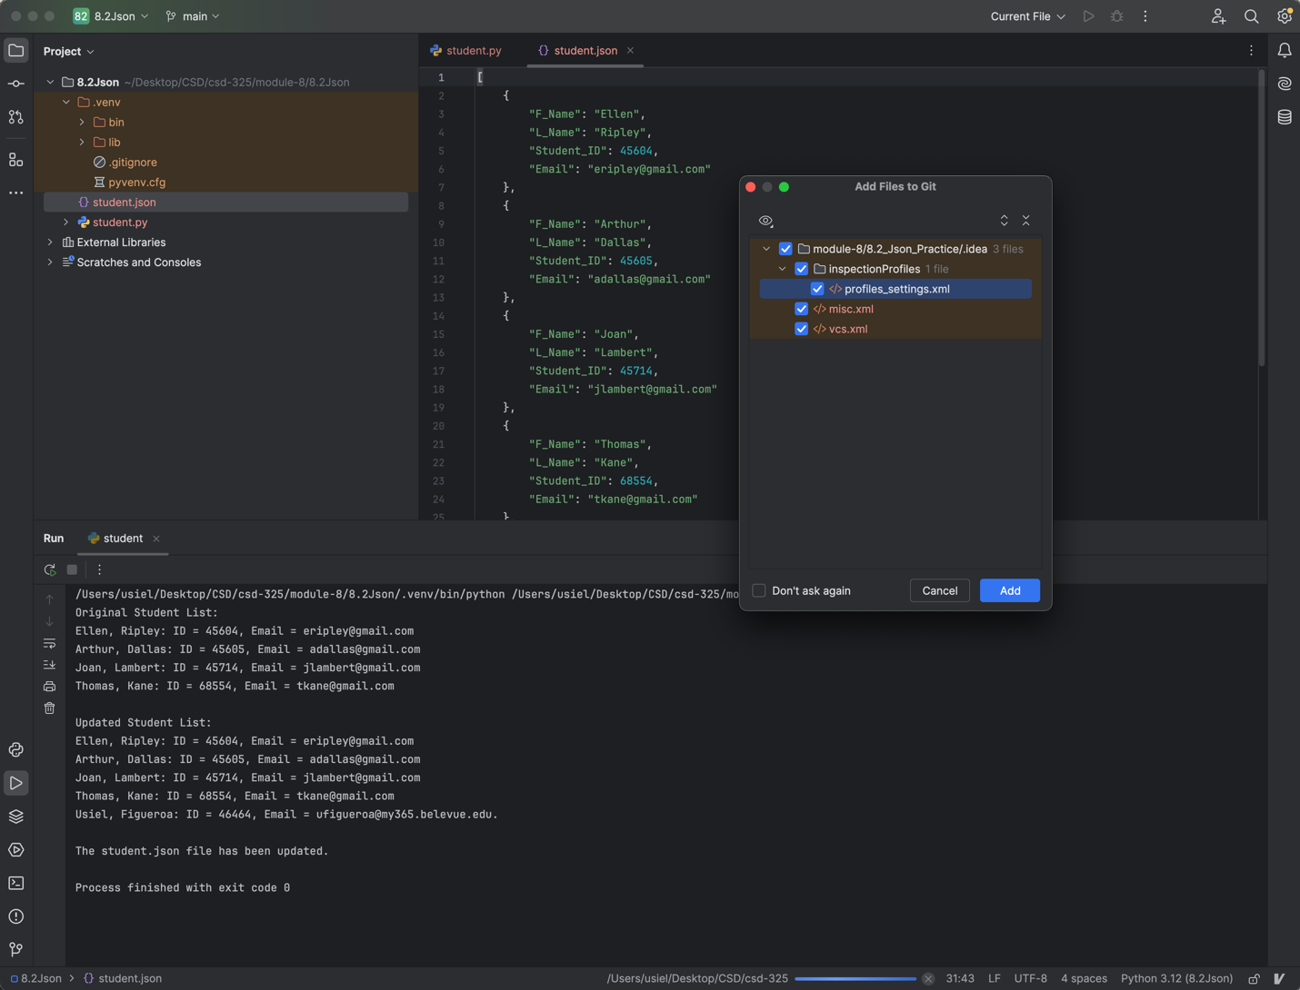

**JSON Content**

[

{  
 "F_Name": "Ellen",  
 "L_Name": "Ripley",  
 "Student_ID": 45604,  
 "Email": "[eripley@gmail.com](mailto:eripley@gmail.com)"  
 },  
 {  
 "F_Name": "Arthur",  
 "L_Name": "Dallas",  
 "Student_ID": 45605,  
 "Email": "[adallas@gmail.com](mailto:adallas@gmail.com)"  
 },  
 {  
 "F_Name": "Joan",  
 "L_Name": "Lambert",  
 "Student_ID": 45714,  
 "Email": "[jlambert@gmail.com](mailto:jlambert@gmail.com)"  
 },  
 {  
 "F_Name": "Thomas",  
 "L_Name": "Kane",  
 "Student_ID": 68554,  
 "Email": "[tkane@gmail.com](mailto:tkane@gmail.com)"  
 },  
 {  
 "F_Name": "Usiel",  
 "L_Name": "Figueroa",  
 "Student_ID": 46464,  
 "Email": "[ufigueroa@my365.belevue.edu](mailto:ufigueroa@my365.belevue.edu)."  
 }  
]

**Flowchart**

