Usiel Figueroa

Module 9.2 Assignment: API’s

CSD325-A311 Advanced Python

December 01, 2024

**Assignment: APIs**

**Screenshot of 200 Code, API response Format**

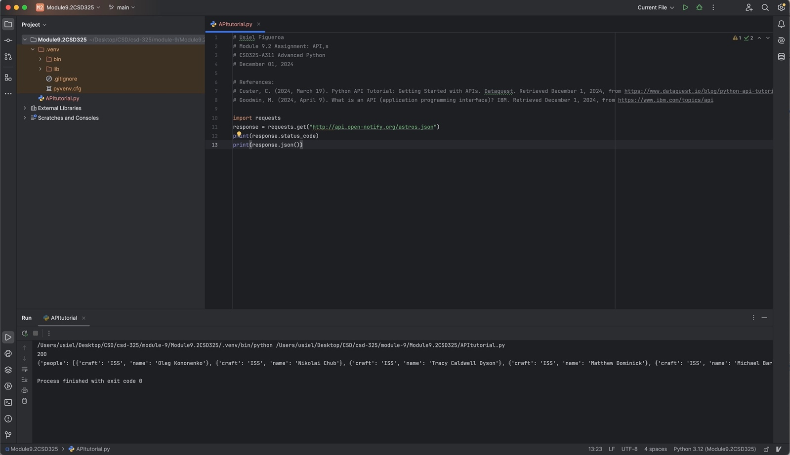

**Current Astronauts and JSON Formatting Output**

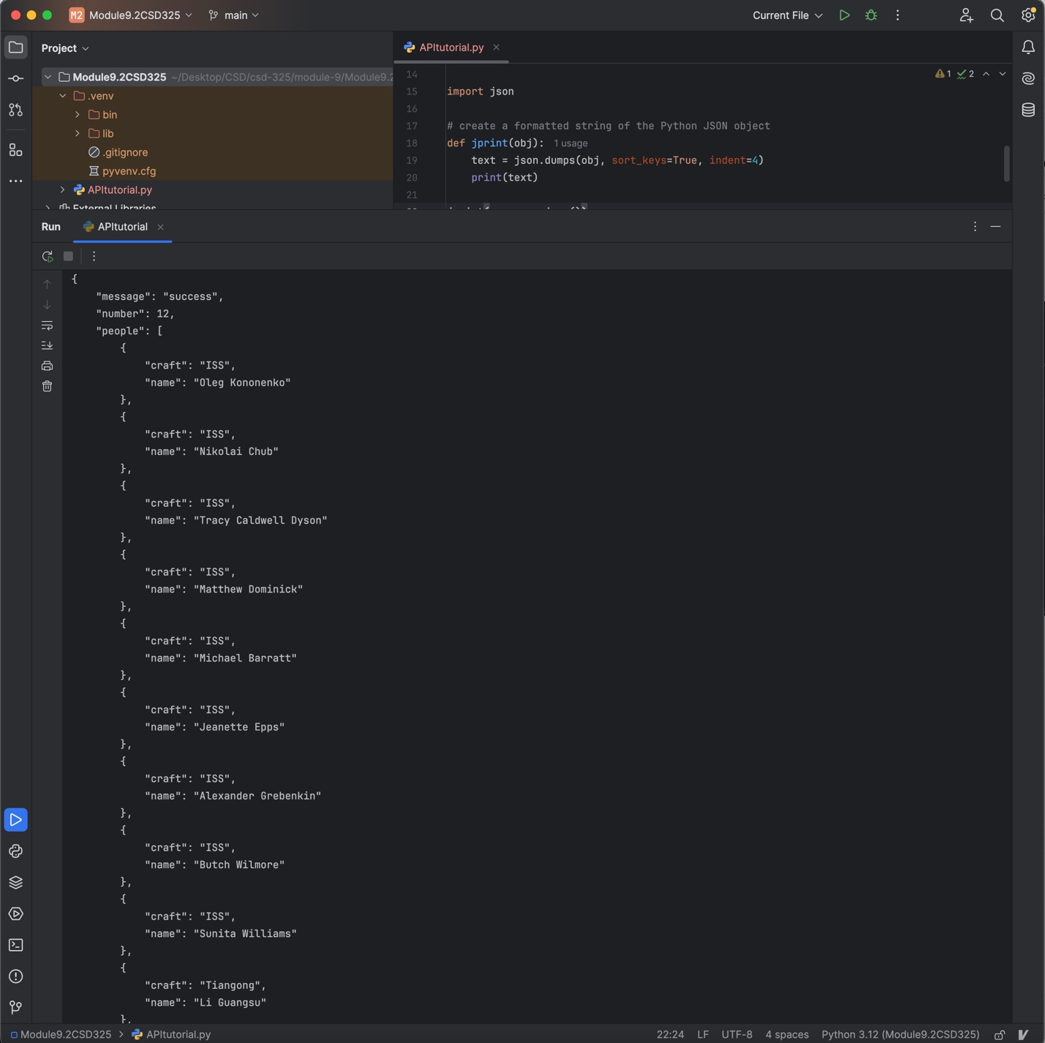

**Testing my own API**

*APIs in the Stars Above*

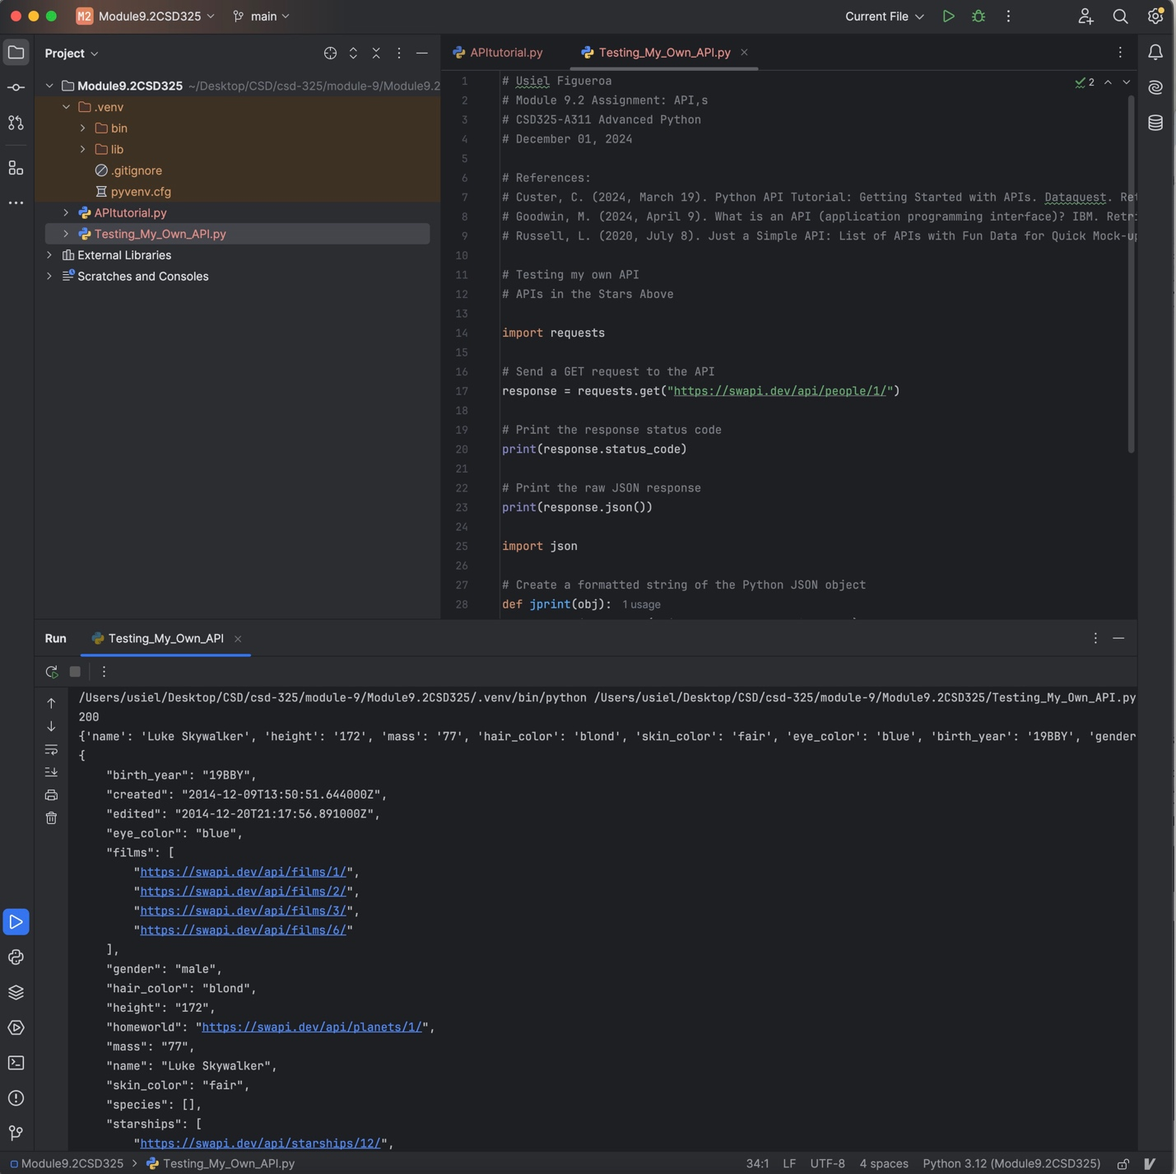

**References**

Custer, C. (2024, March 19). Python API Tutorial: Getting Started with APIs. Dataquest. Retrieved December 1, 2024, from <https://www.dataquest.io/blog/python-api-tutorial/>

Goodwin, M. (2024, April 9). What is an API (application programming interface)? IBM. Retrieved December 1, 2024, from <https://www.ibm.com/topics/api>

Russell, L. (2020, July 8). *Just a Simple API: List of APIs with Fun Data for Quick Mock-ups*. Stoplight. Retrieved December 1, 2024, from <https://blog.stoplight.io/just-a-simple-api>