Usiel Figueroa

Assignment 1.2: GitHub Repository Setup

CSD340-A311 Web Development with HTML and CSS

January 06, 2025

Link to my GitHub repository

<https://github.com/Usiel-Figueroa/csd-340.git>

Screenshot of Local Directory (formatted)

GitHub (README.md Modified)

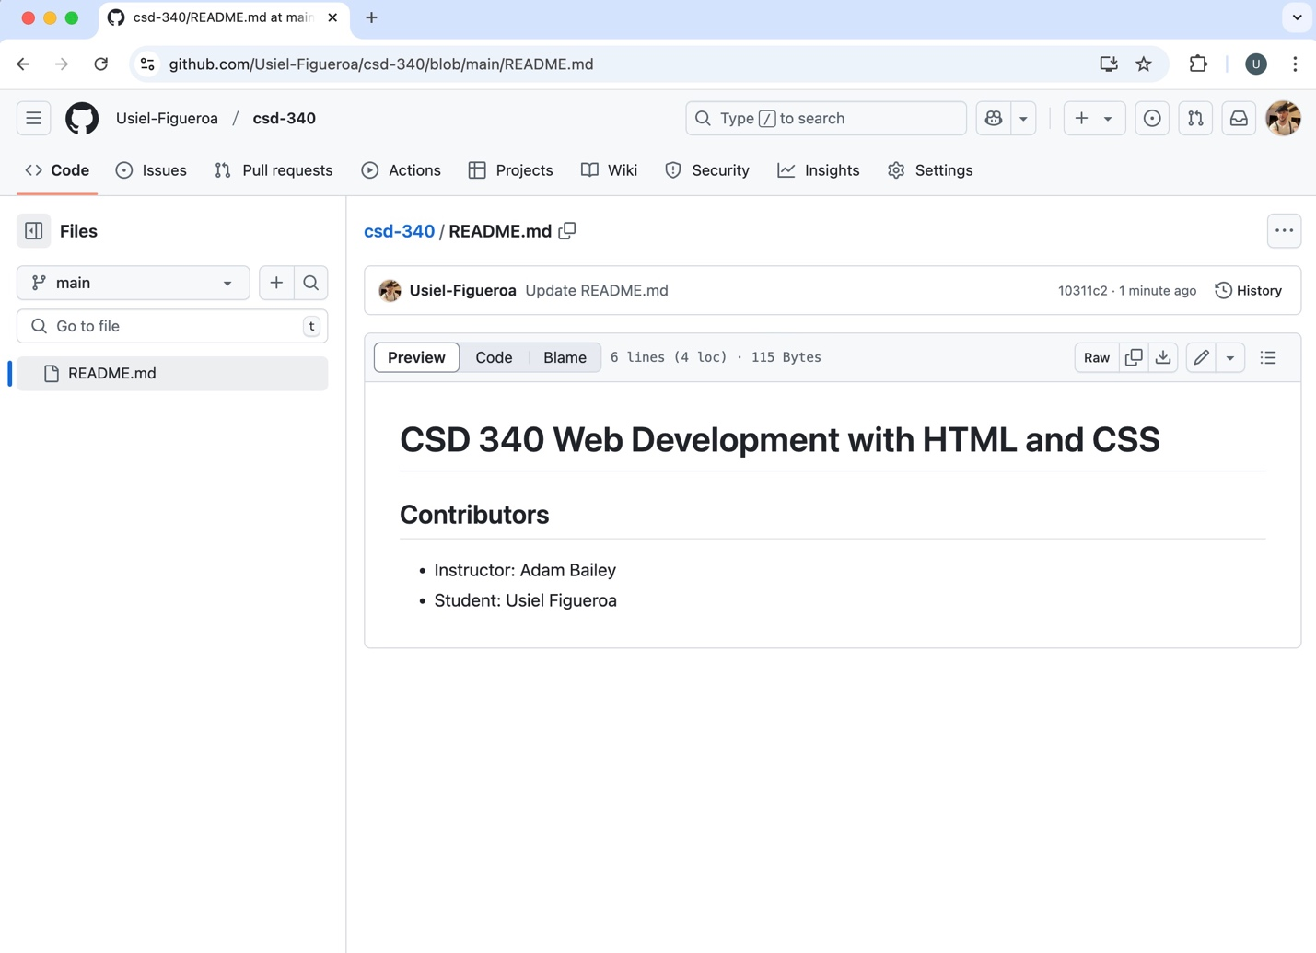

**Reference**

(2022, March 27). *Markdown Cheatsheet*. GitHub. Retrieved January 6, 2025, from https://github.com/adam-p/markdown-here/wiki/Markdown-Cheatsheet#h1