Usiel Figueroa

Assignment 1.3: Building a Web Page Exercise, Part 1

CSD340-A311 Web Development with HTML and CSS

January 06, 2025

Link: <https://github.com/Usiel-Figueroa/csd-340.git>

**Screenshot of the validators results (3 errors)**

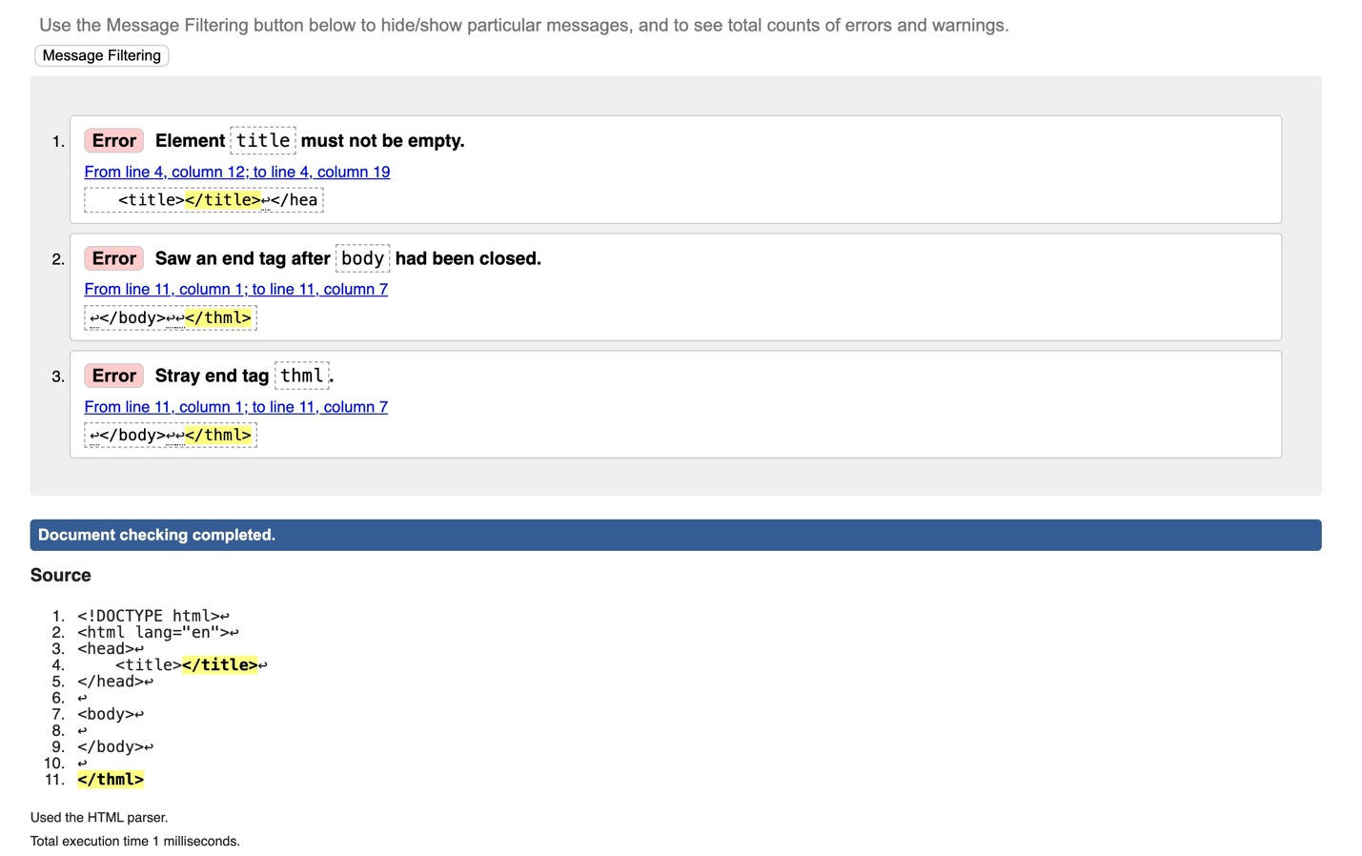

**Re-validate the HTML code (No Errors)**

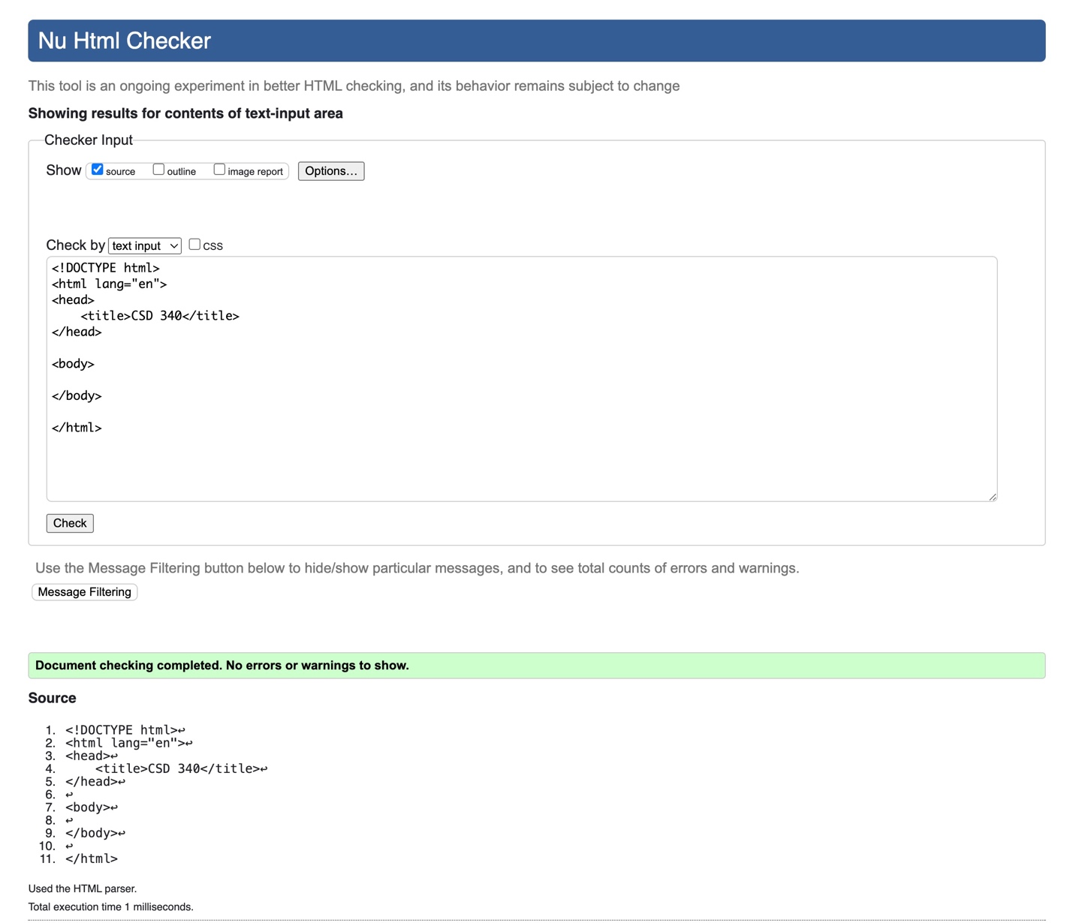

**Re-validate the HTML code (update the text)**

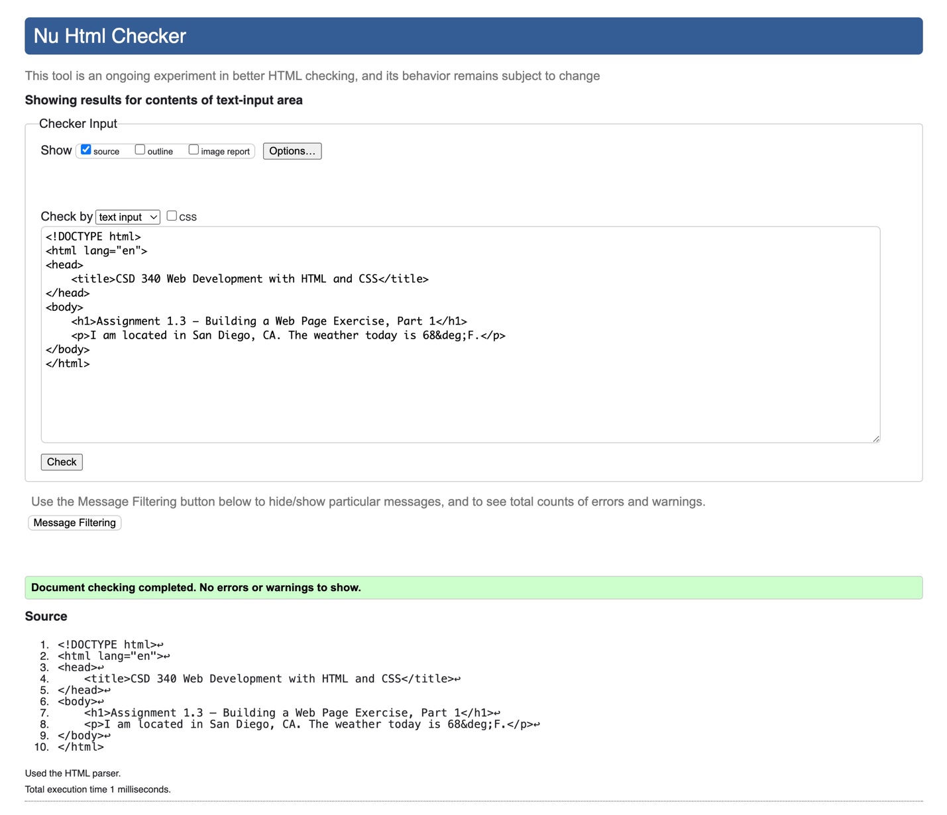

**Screenshot of the web page in your computer's default browser (Chrome)**

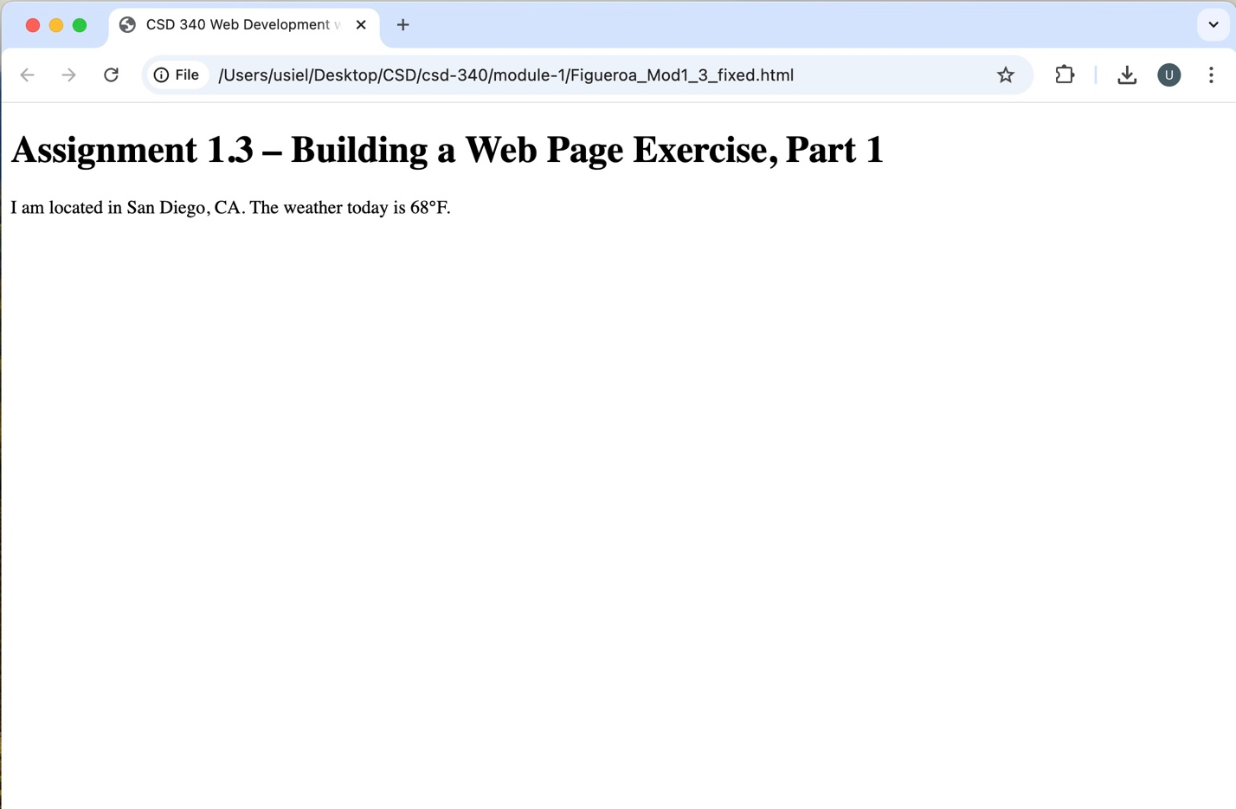

**Reference**

(n.d.). Markup Validation Service. W3C. Retrieved January 6, 2025, from <https://validator.w3.org/#validate_by_input>