Usiel Figueroa

Module 3.2 Assignment: GitHub Pages

CSD340-A311 Web Development with HTML and CSS

January 08, 2025

**Screenshot of the HTML by using the W3C HTML validator and correct no errors**

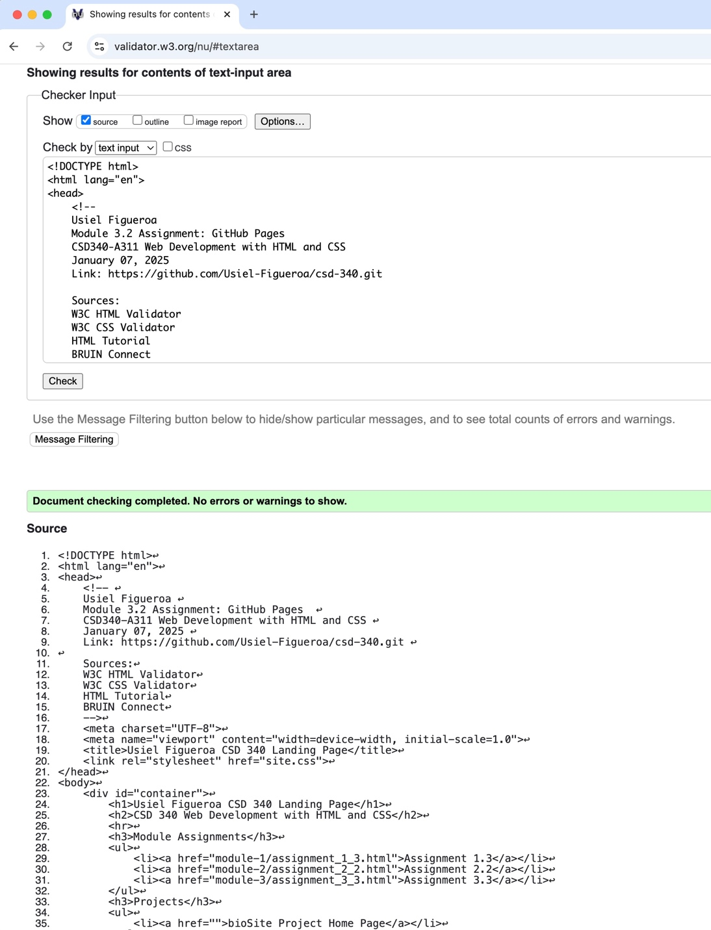

**Screenshot of the CSS by using the W3C CSS validator and correct no errors**

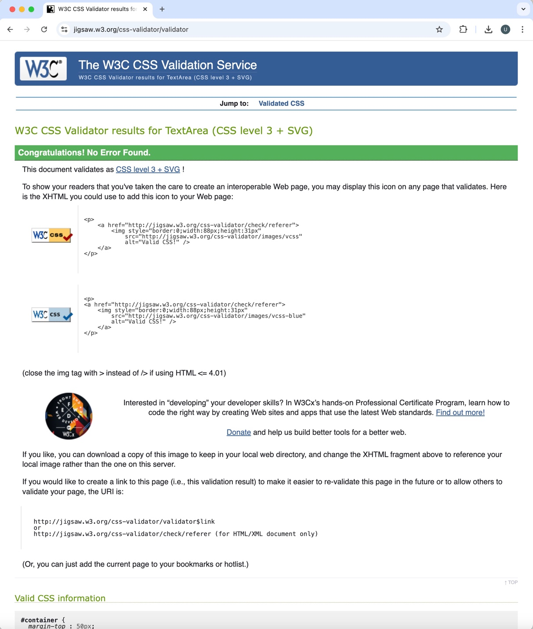

**Screenshot of index page in a browser**

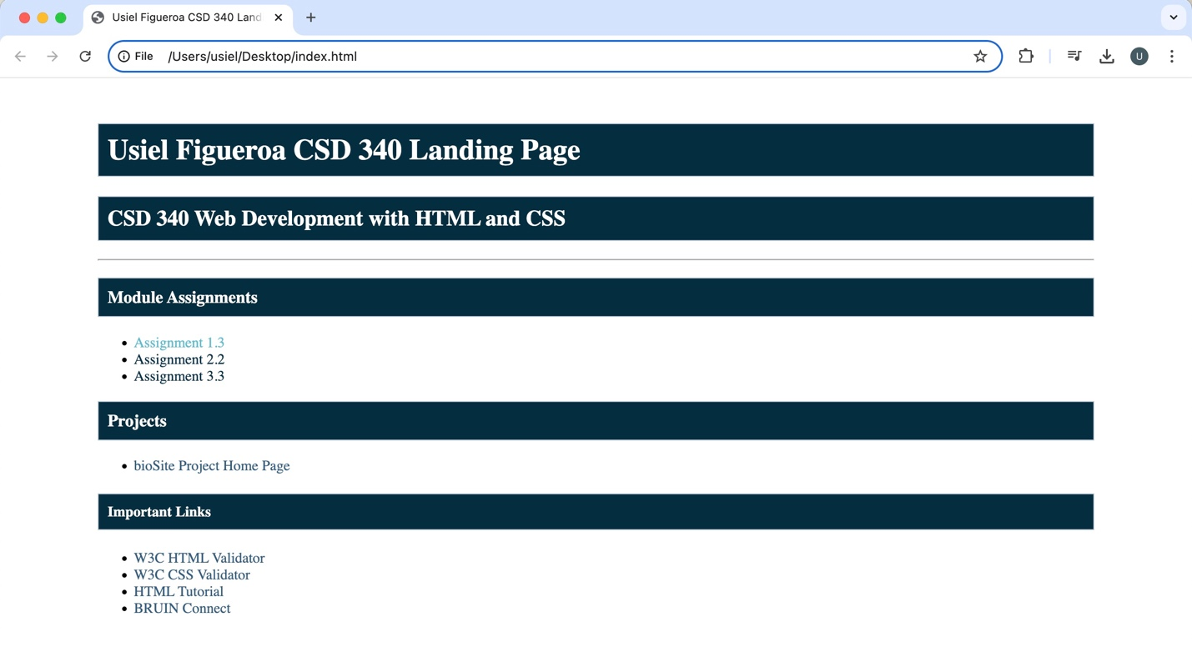

**Second Option Format**

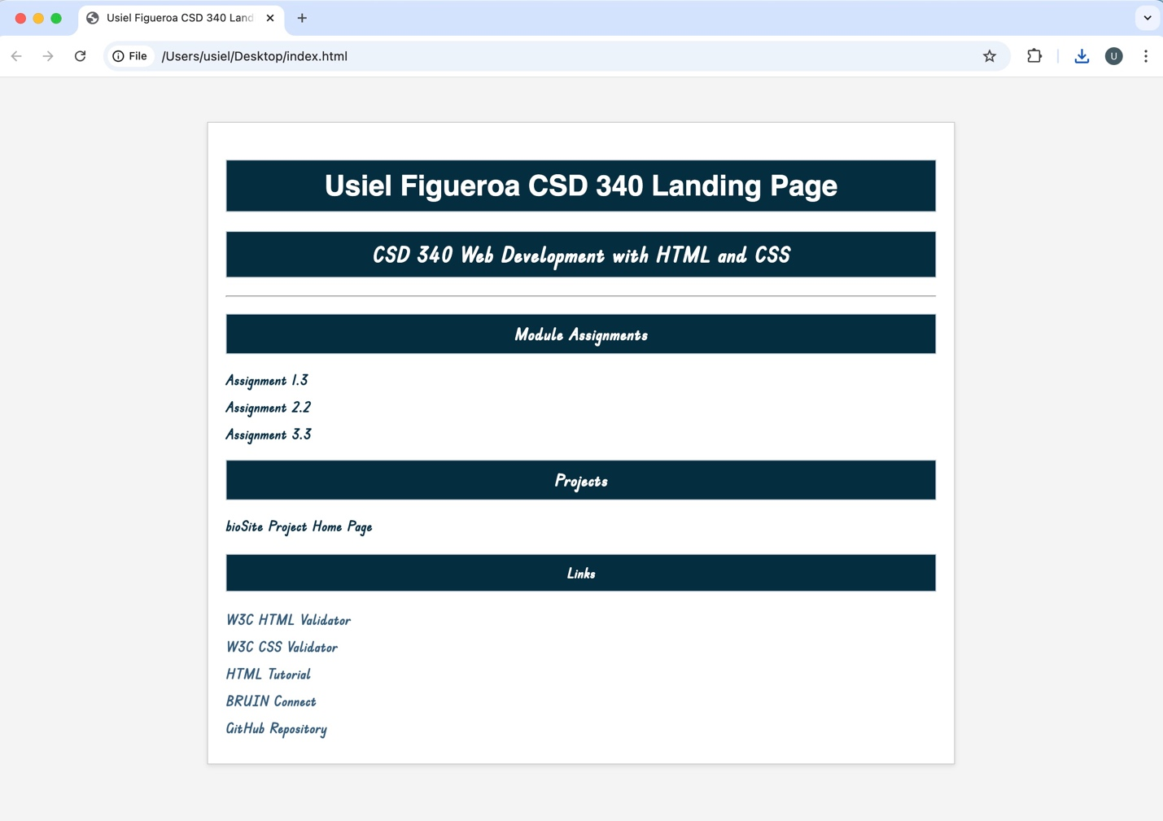

Sources:

* W3C HTML Validator: <https://validator.w3.org/>
* W3C CSS Validator: <http://jigsaw.w3.org/css-validator/>
* HTML Tutorial: <https://www.w3schools.com/html/>
* BRUIN Connect: <https://bruinconnect.bellevue.edu/>