Usiel Figueroa

March 17, 2025

CSD420-A311 Advanced Java Programming

M1 Assignment: Git Hub Setup

Link: <https://github.com/Usiel-Figueroa/csd-420.git>

Screenshot of GitHub repository.

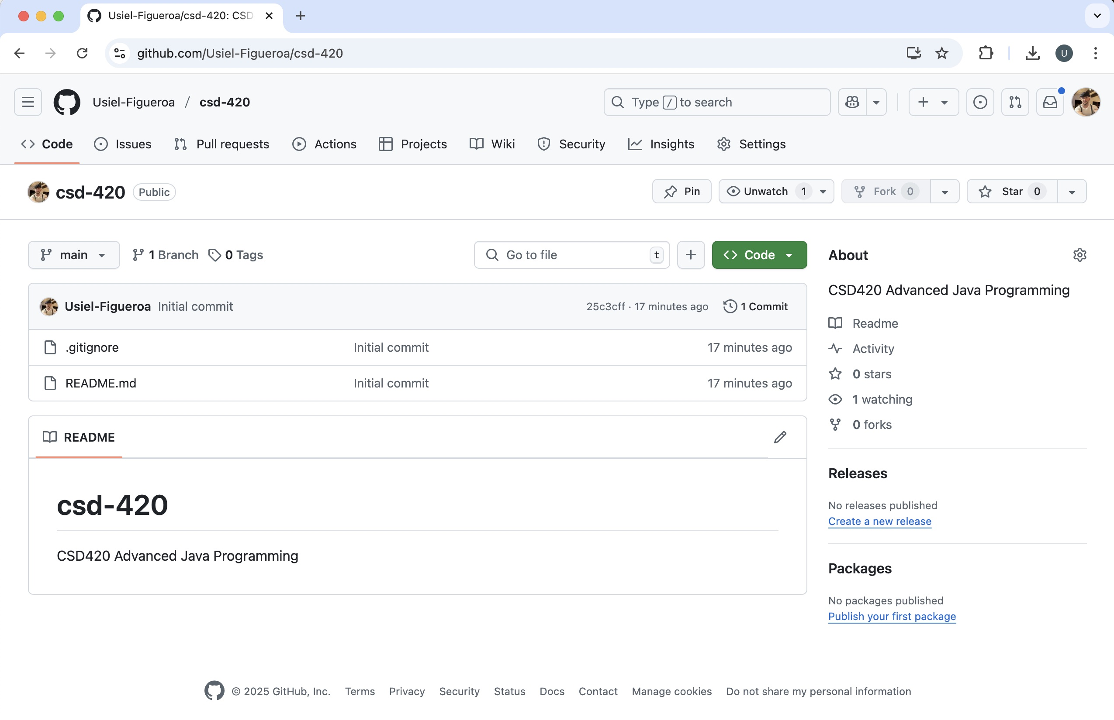

Screenshot of local directory (properly formatted)

