Usiel Figueroa

April 25, 2025

CSD420-A311 Advanced Java Programming

M9: Programming Assignment

**Create Table Test Screenshot**

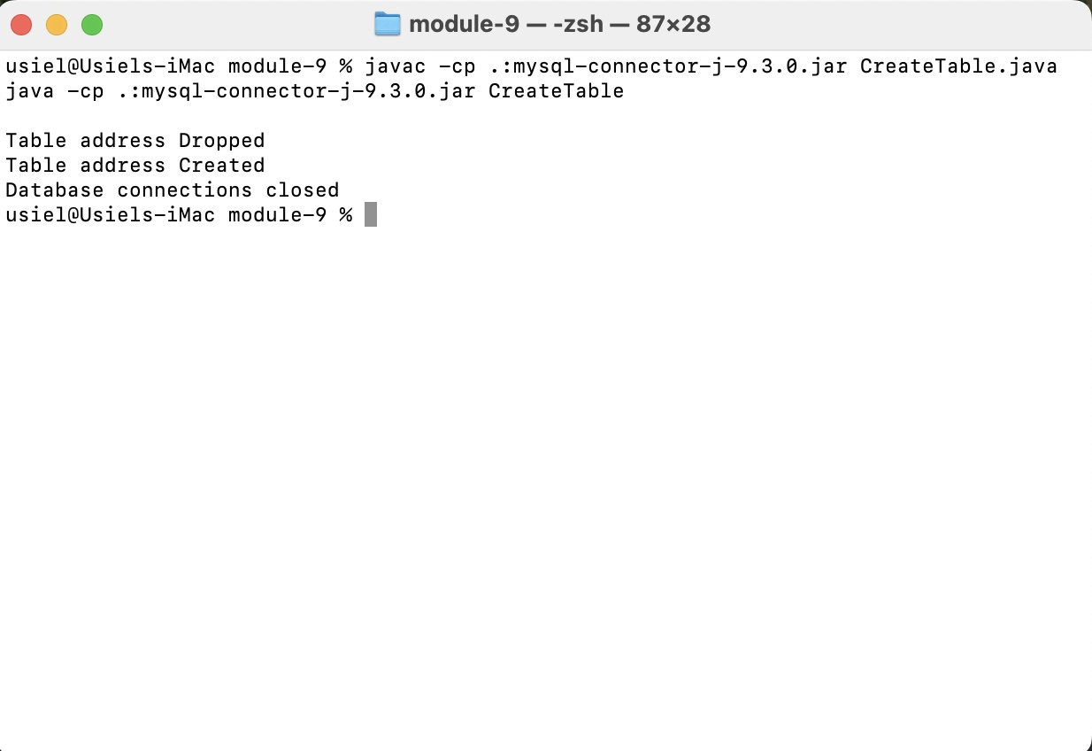

**Insert Data Test Screenshot**

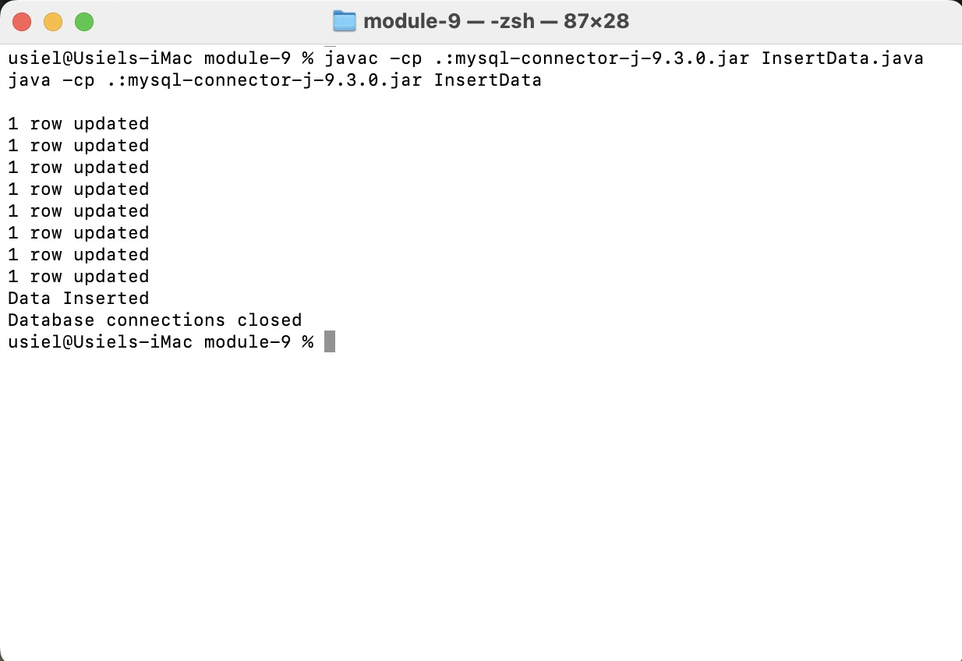

**Select 5 Test Screenshot**

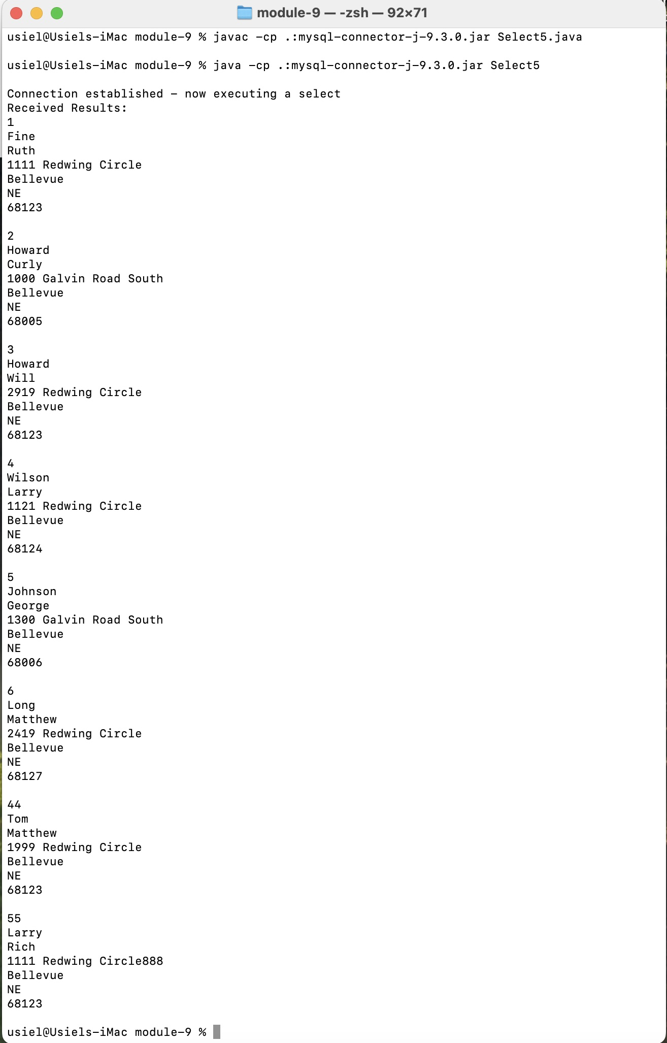

Source: Code Examples/ Professor Darrell Payne/ Bellevue University

**References**

(n.d.). JDBC - Sample, Example Code. Tutorialspoint. Retrieved April 21, 2025, from <https://www.tutorialspoint.com/jdbc/jdbc-sample-code.htm>

(2025, March 24). 5 Steps to Connect Database in Java. Tpointtech. Retrieved April 21, 2025, from <https://www.tpointtech.com/steps-to-connect-to-the-database-in-java>

(2025, April 17). Establishing JDBC Connection in Java. Geeksforgeeks. Retrieved April 21, 2025, from <https://www.geeksforgeeks.org/establishing-jdbc-connection-in-java/>

(n.d.). Class DriverManager. ORACLE. Retrieved April 21, 2025, from <https://docs.oracle.com/en/java/javase/11/docs/api/java.sql/java/sql/DriverManager.html>

(n.d.). DriverManager Class. Microsoft. Retrieved April 21, 2025, from <https://learn.microsoft.com/en-us/dotnet/api/java.sql.drivermanager?view=net-android-35.0>