Usiel Figueroa

May 26, 2025

CSD 430-A311 Server-Side Development

Module 1 Assignment: Project Setup and Repository

GitHub link: https://github.com/Usiel-Figueroa/csd-430.git

Successful installation and configuration of Java, Jakarta-Tomcat, and my selected IDE Eclipse

**Java**

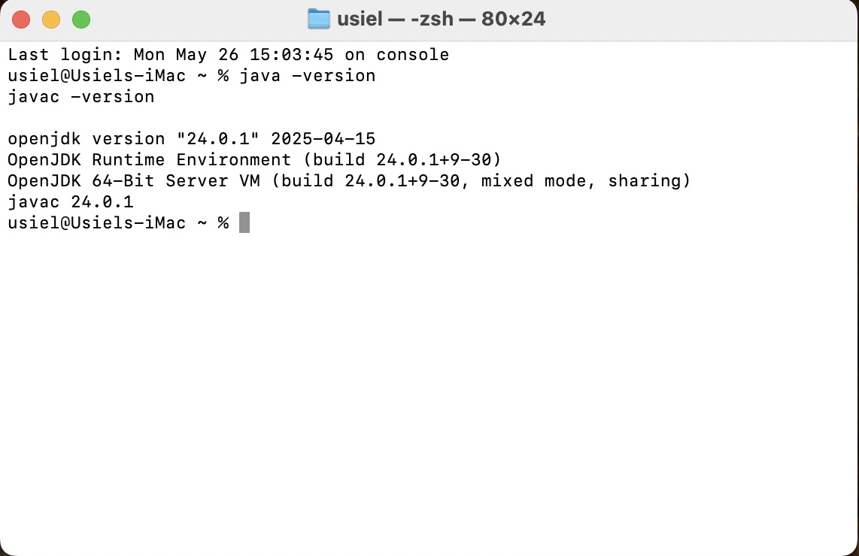

**Jakarta-Tomcat**

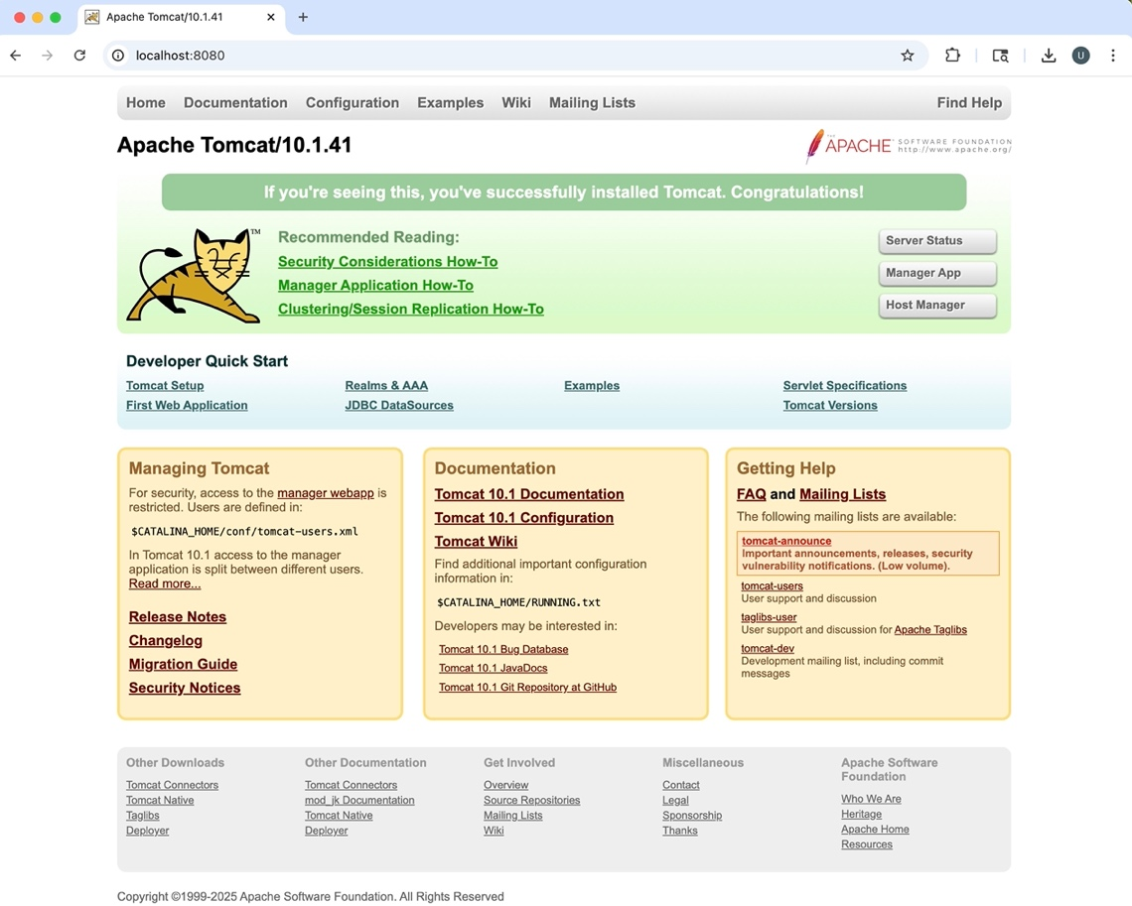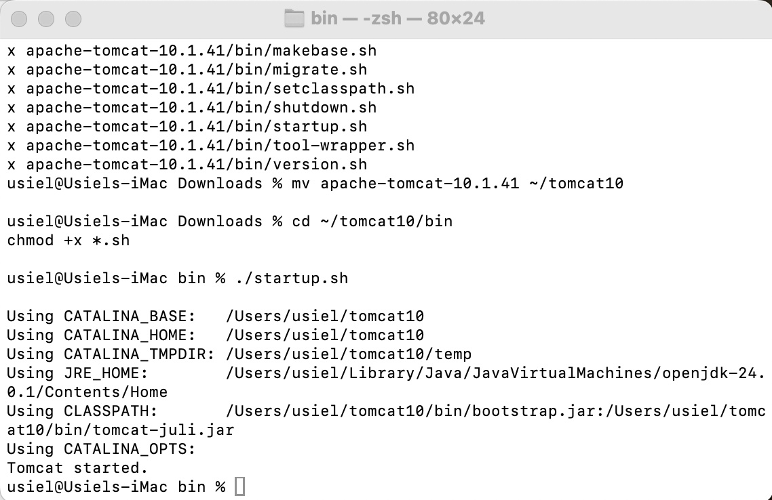

**IDE Eclipse**

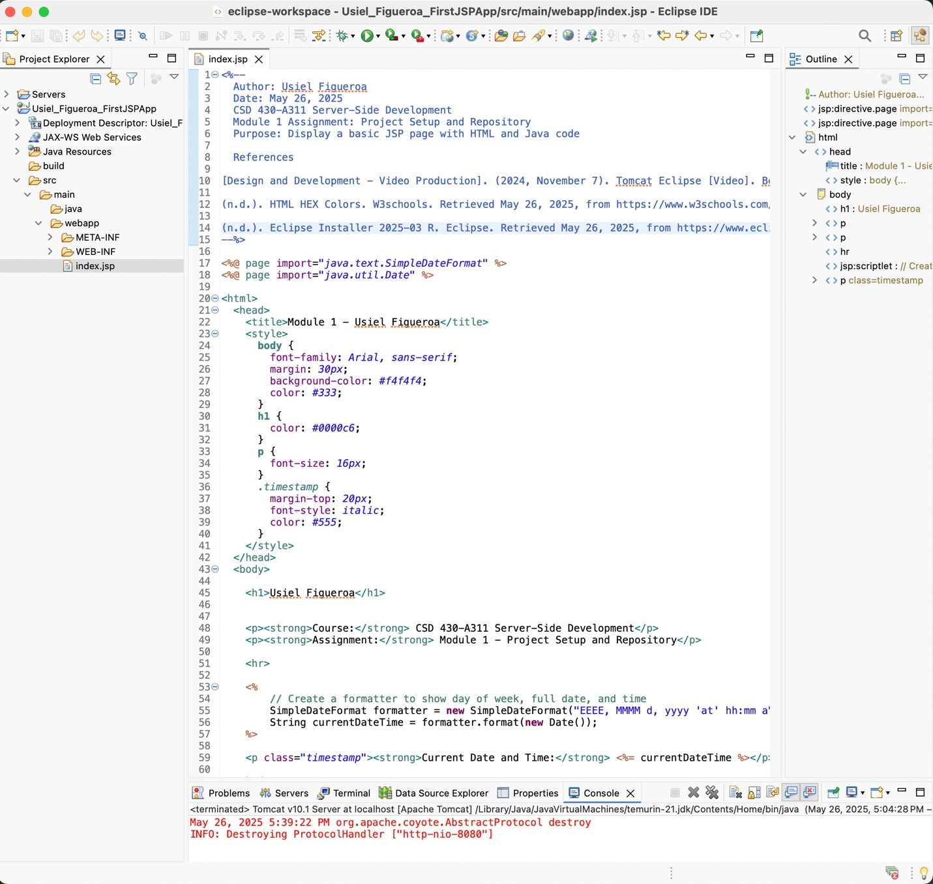

**A Simple JSP File (Screenshot)**

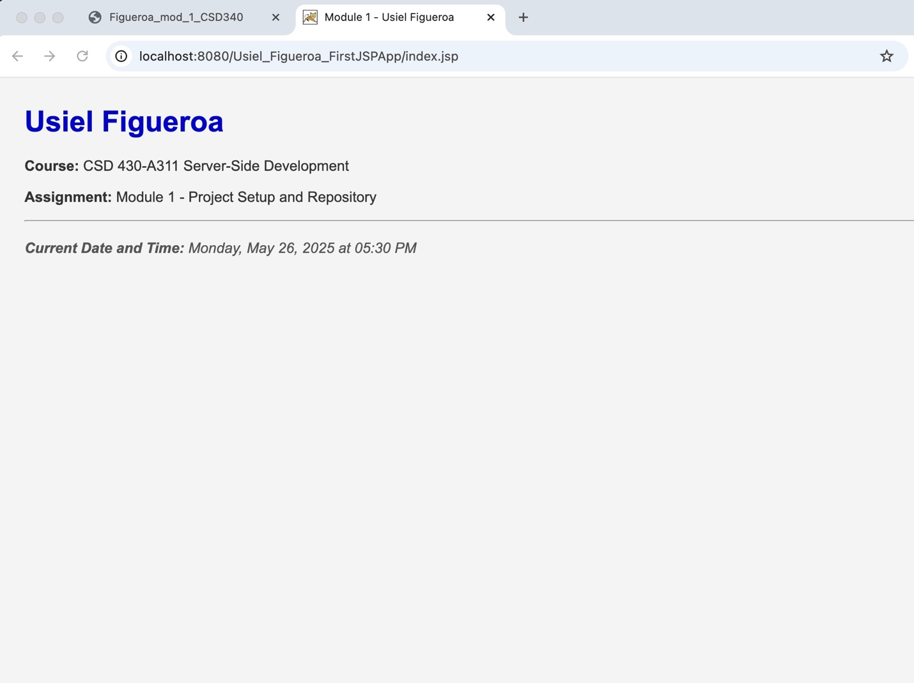

**References**

[Design and Development - Video Production]. (2024, November 7). Tomcat Eclipse [Video]. Bellevue University. <https://bellevue.mediaspace.kaltura.com/media/Tomcat+Eclipse/1_rj04forw>

(n.d.). HTML HEX Colors. W3schools. Retrieved May 26, 2025, from <https://www.w3schools.com/html/html_colors_hex.asp>

(n.d.). Eclipse Installer 2025-03 R. Eclipse. Retrieved May 26, 2025, from <https://www.eclipse.org/downloads/packages/installer>