Usiel Figueroa

May 27, 2025

CSD 430-A311 Server-Side Development

Module 2 Assignment: Java Scriplet – Data Display

The purpose of the code is to dynamically display information about the selected topic of Washington State using JSP scriptlets and an HTML table styled with external CSS.

* Use Scriptlets for holding Java code.
* All HTML tags will be outside of Java Scriptlets.
* Display data in an HTML table format.
* The data will be grouped into topical categories.
* Include other display items such as field and recode descriptions, title, and overall data description.
* Data will have a minimum of 5 records with three fields.

**JSP Screenshot**

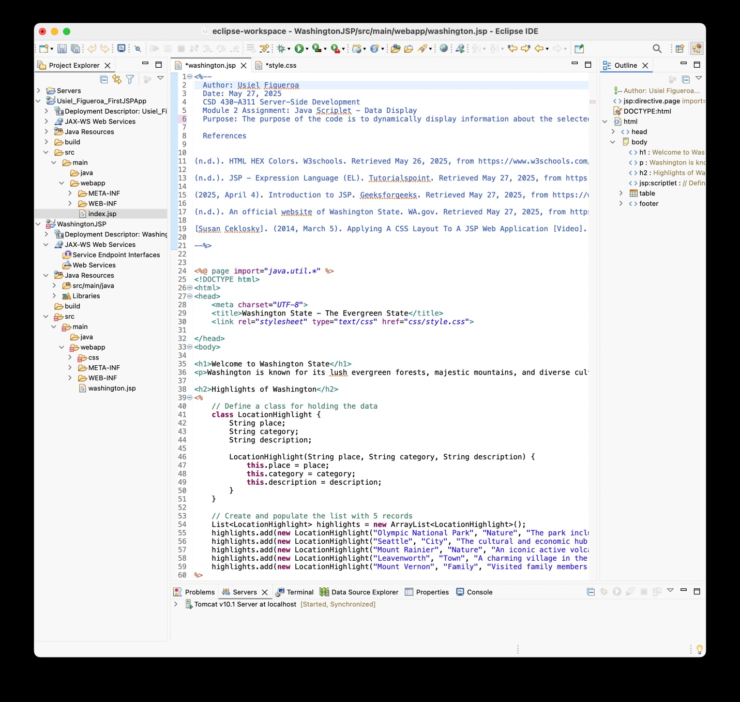

**CSS file**

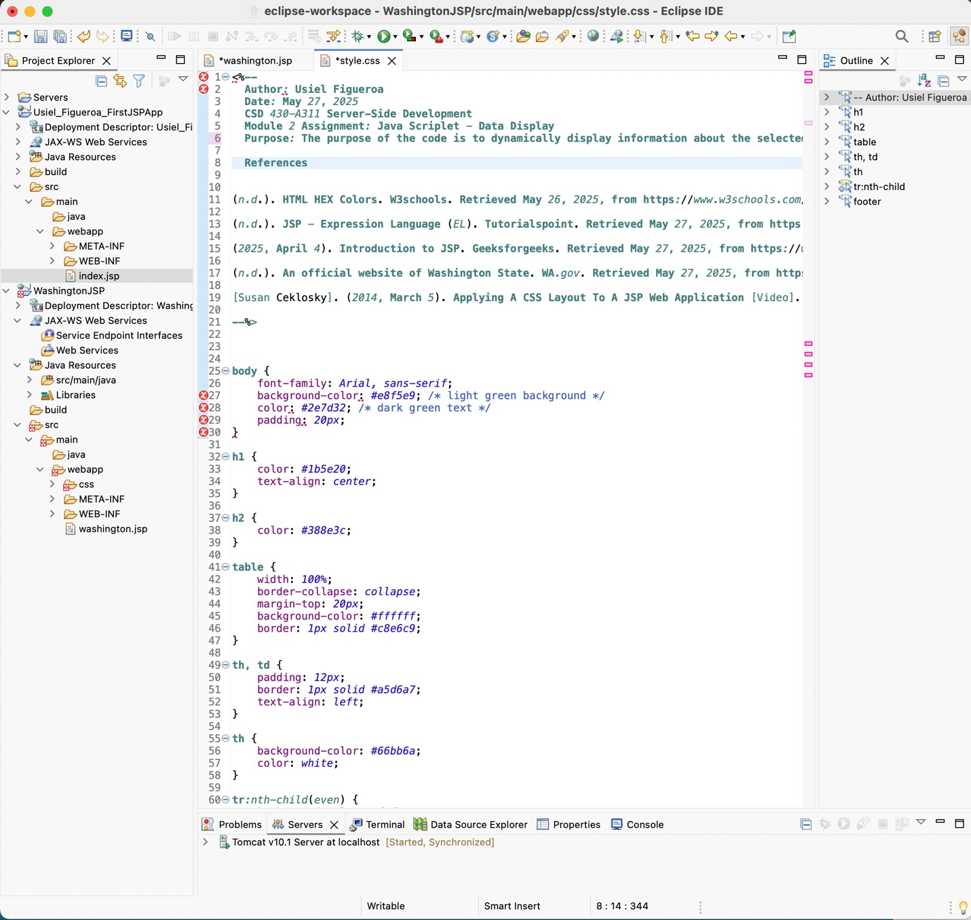

**Website Output's**

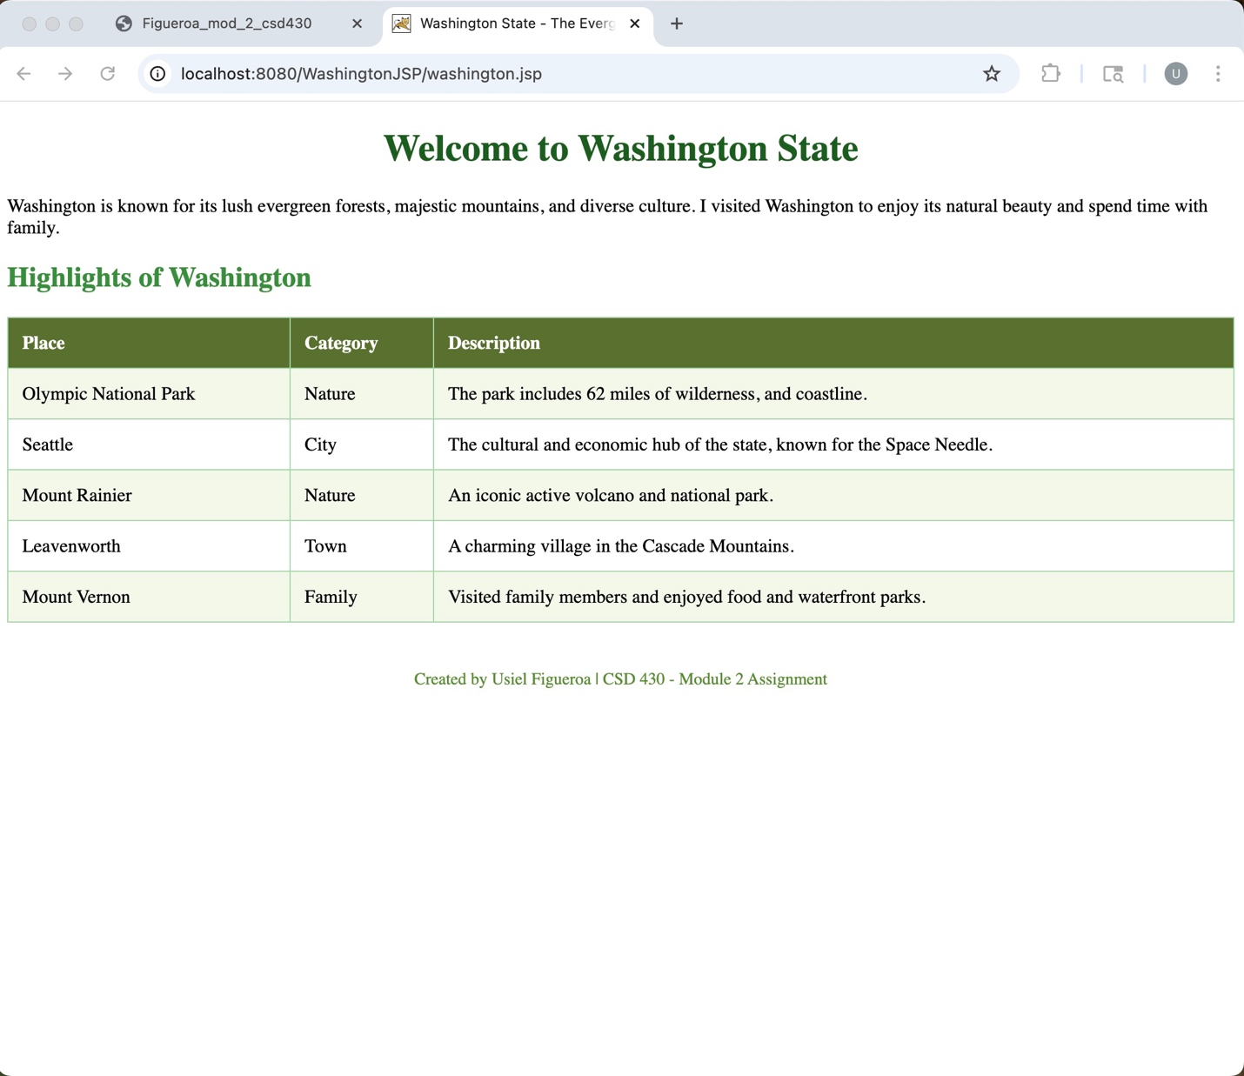

**Alternative colors**

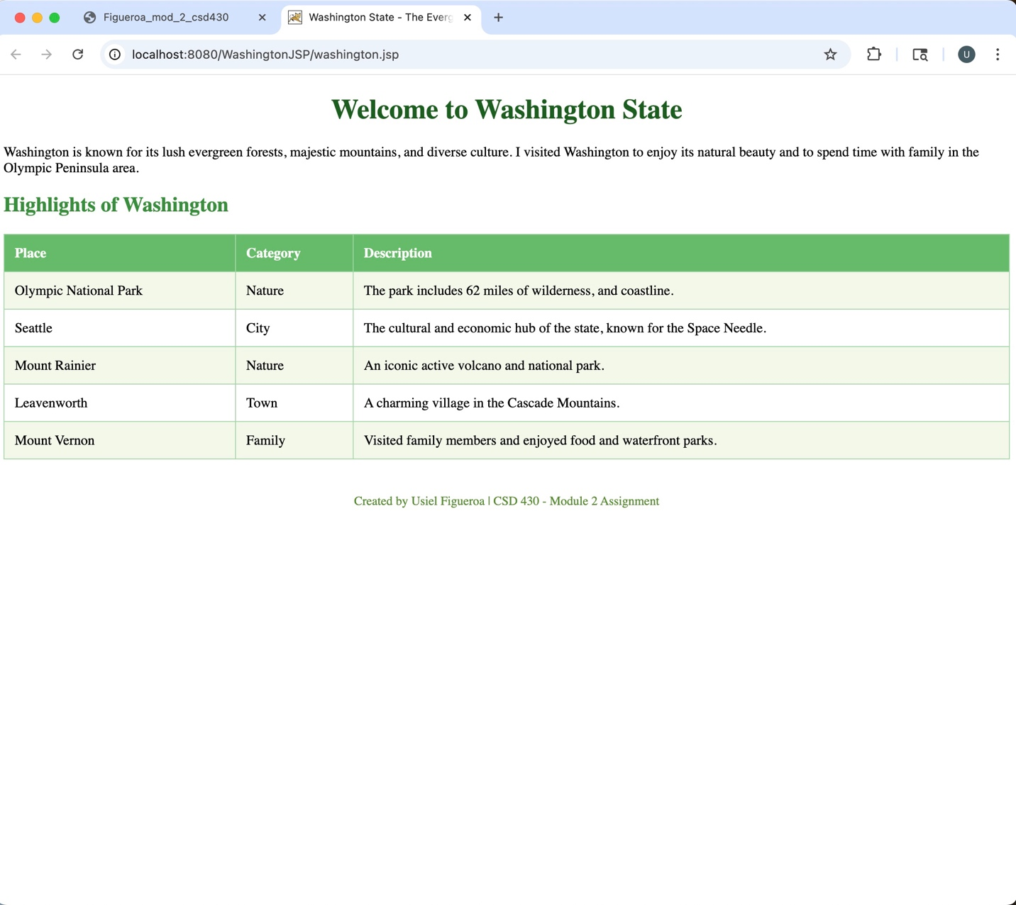

**References**

(n.d.). HTML HEX Colors. W3schools. Retrieved May 26, 2025, from <https://www.w3schools.com/html/html_colors_hex.asp>

(n.d.). JSP - Expression Language (EL). Tutorialspoint. Retrieved May 27, 2025, from <https://www.tutorialspoint.com/jsp/jsp_expression_language.htm>

(2025, April 4). Introduction to JSP. Geeksforgeeks. Retrieved May 27, 2025, from <https://www.geeksforgeeks.org/introduction-to-jsp/>

(n.d.). An official website of Washington State. WA.gov. Retrieved May 27, 2025, from https://wa.gov/recreation

[Susan Ceklosky]. (2014, March 5). Applying A CSS Layout To A JSP Web Application [Video]. YouTube. <https://www.youtube.com/watch?v=YB9PjgLZhUk>

[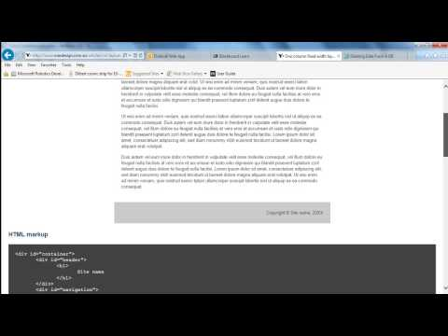](https://www.youtube.com/watch?v=YB9PjgLZhUk)