Usiel Figueroa

June 02, 2025

CSD 430-A311 Server-Side Development

Module 3 Assignment: Working with JSP Forms

Purpose: Create a JSP form for a job application and gather user data

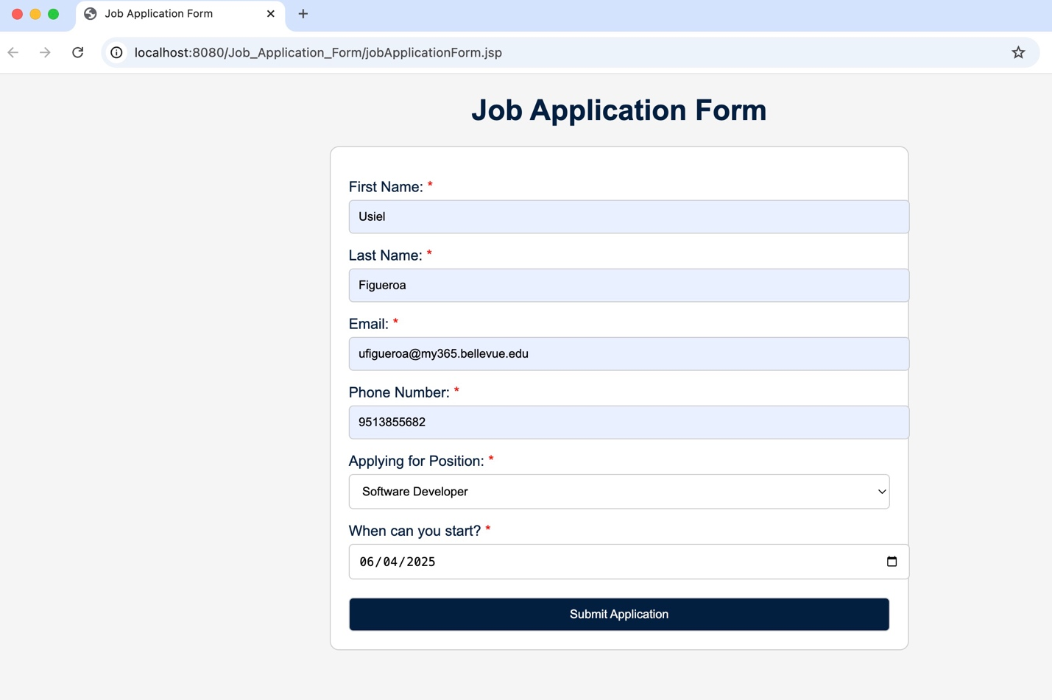

Display job application data submitted from the form in an HTML table

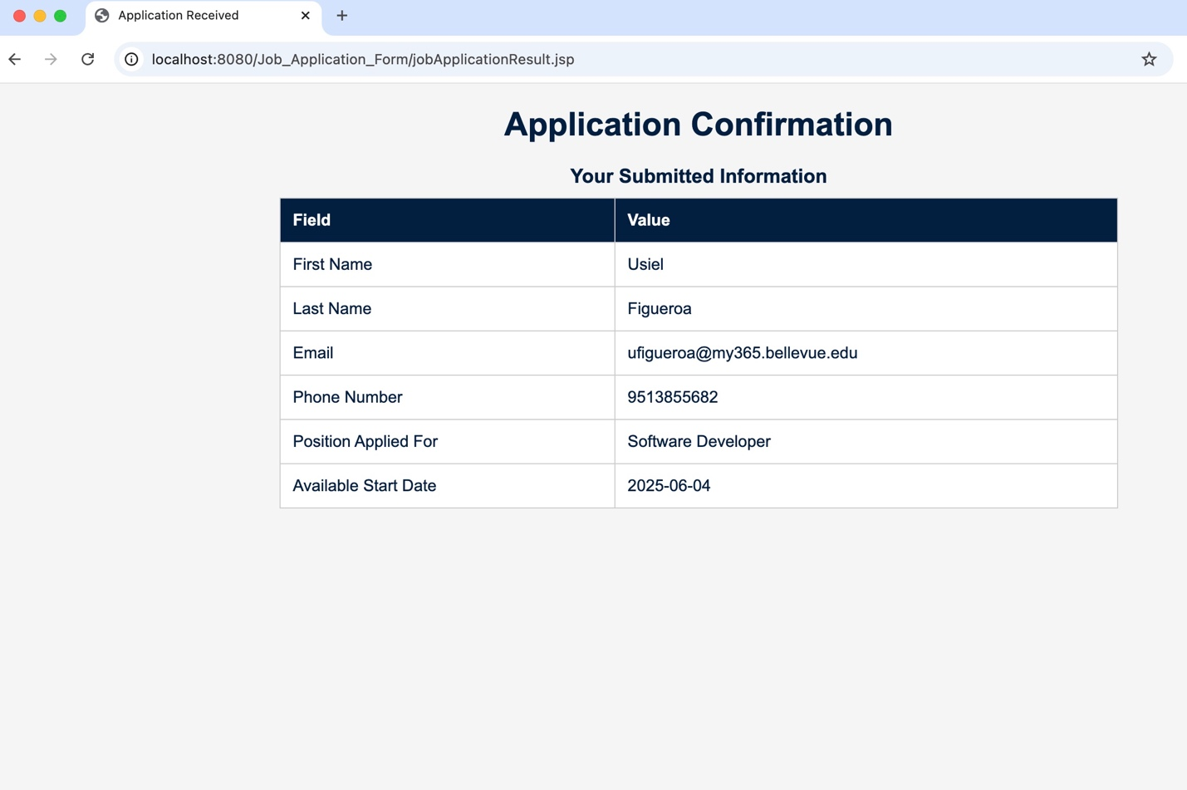

References

[Design and Development - Video Production]. (2024, November 4). Forms [Video]. Bellevue University. <https://bellevue.mediaspace.kaltura.com/media/Forms/1_f9er6v1b>

(2023, September 12). Creating HIPAA Compliant Secure Web Forms: What You Need to Know. Luxsci. Retrieved June 2, 2025, from https://luxsci.com/blog/creating-secure-web-forms.html

(n.d.). HTML HEX Colors. W3schools. Retrieved May 26, 2025, from <https://www.w3schools.com/html/html_colors_hex.asp>

(n.d.). JSP - Expression Language (EL). Tutorialspoint. Retrieved May 27, 2025, from <https://www.tutorialspoint.com/jsp/jsp_expression_language.htm>

(2025, April 4). Introduction to JSP. Geeksforgeeks. Retrieved May 27, 2025, from <https://www.geeksforgeeks.org/introduction-to-jsp/>

[Susan Ceklosky]. (2014, March 5). Applying A CSS Layout To A JSP Web Application [Video]. YouTube. <https://www.youtube.com/watch?v=YB9PjgLZhUk>