Usiel Figueroa

September 22, 2025

CSD 440-A311 Server-Side Scripting

Professor: Elijah Finch

Module 9 Programming Assignment

**Assignment:**

This site demonstrates managing software development technologies, skill levels, and projects using PHP and MySQLi.

*Screenshots*



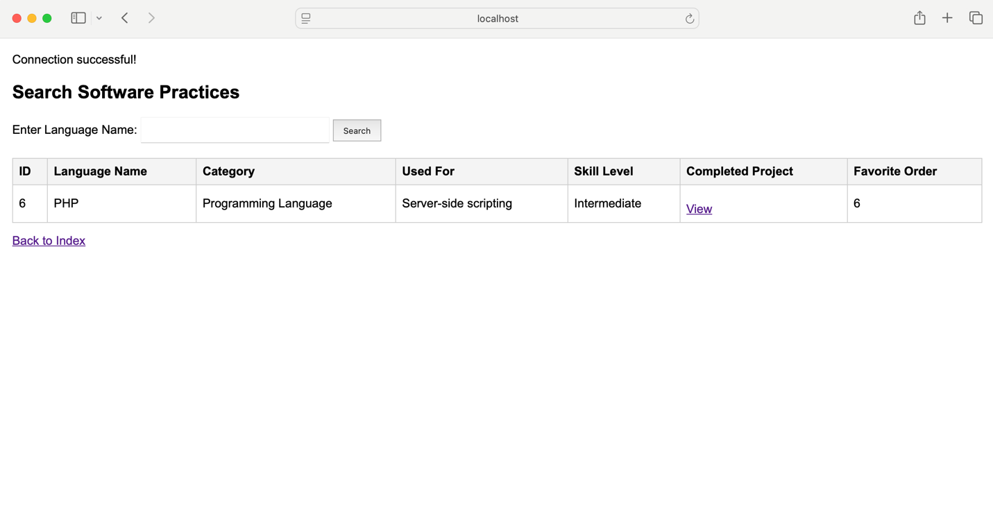

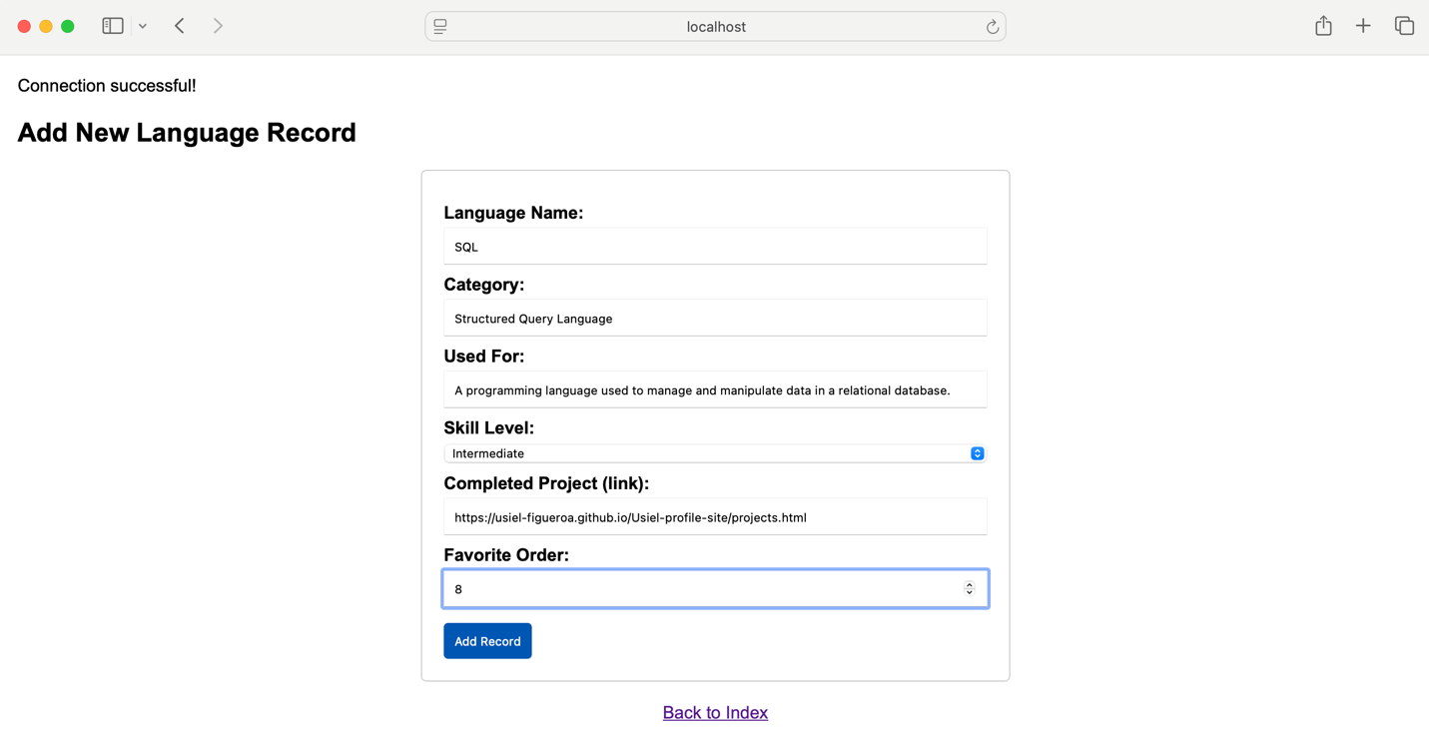

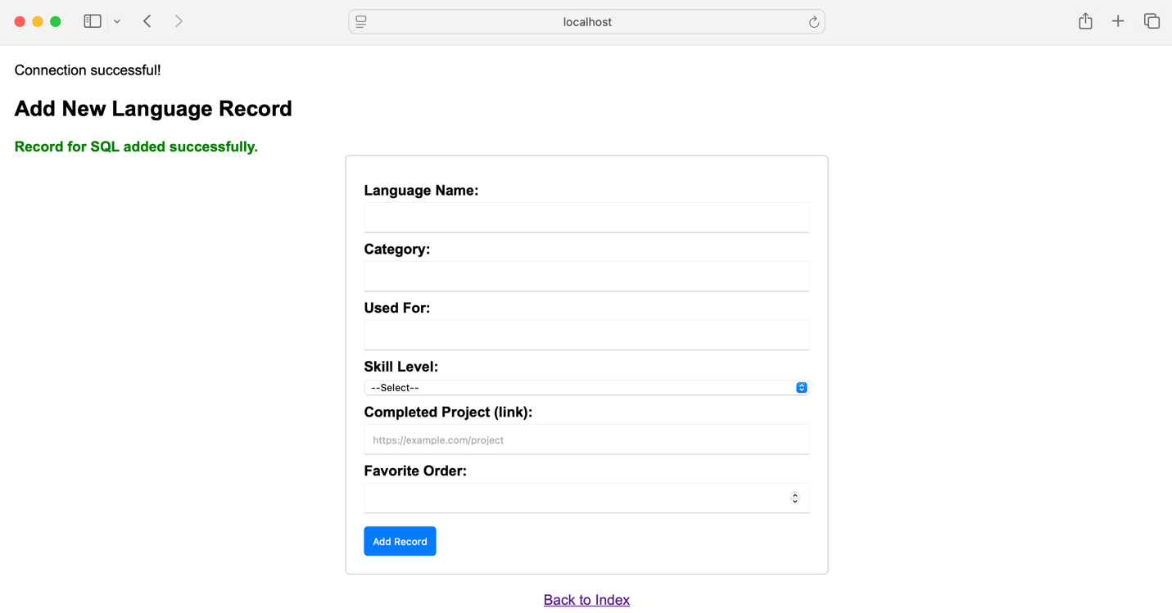

References

Tatroe, K., & MacIntyre, P. (2020). Programming PHP: Creating dynamic web pages (4th ed.). O’Reilly Media.

[Design and Development - Video Production]. (2021, June 16). Database Form [Video]. Bellevue University. https://bellevue.mediaspace.kaltura.com/media/Database+Form/1_ob4xa795/6624231