B
U
S
I
N
E
S
S

I
N
T
E
L
L
I
G
E
N
C
E

R
E
P
O
R
T
Walmart Sales
Performance Analysis
Comprehensive

analysis

across
3
branches
, 7
product

categories
,
and
1
,000
transactions
$
319.3
K
$
53.77
1,000
TOTAL

REVENUE
AVG
.
TRANSACTION
TRANSACTIONS
Q
1
2023 |
Myanmar

Operations
Prepared

for

Executive

Review
O V E R V I E W
Executive

Dashboard
$
319,286
TOTAL

REVENUE

3
branches

combined
5,510
UNITS

SOLD
Avg
5.5
units
/
transaction
$
53.77
AVG
.
TRANSACTION

VALUE
Per

receipt
6.94
AVG
.
CUSTOMER

RATING
Out

of
10
R
E
VE
N
UE

Revenue by Product Category
Fashion Accessories leads all categories with $59.8K in revenue. Top 3 categories account for 50.8% of total sales.

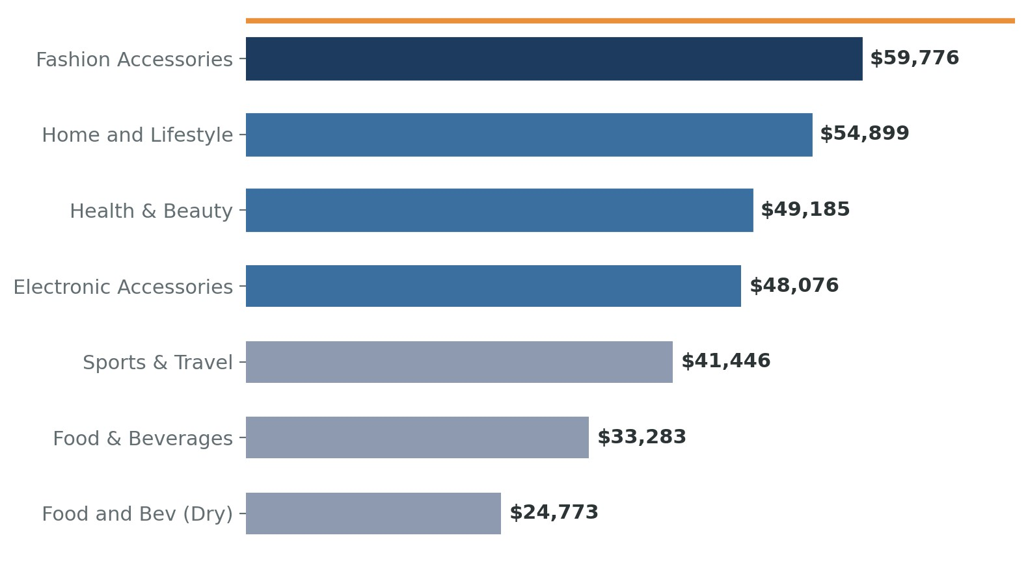
Key

Insight
:

Fashion

Accessories

and

Home
&
Lifestyle

together

generate

$
114.7
K
(36%
of

total

revenue
)
.
Health
&
Beauty

ranks
3
rd

despite

lower

unit

volumes
,
indicating
premium

pricing

power
.
B R A N C H A N A L Y S I S

Branch Performance Comparison
All three branches show remarkably balanced revenue distribution. Naypyitaw leads in average transaction value.

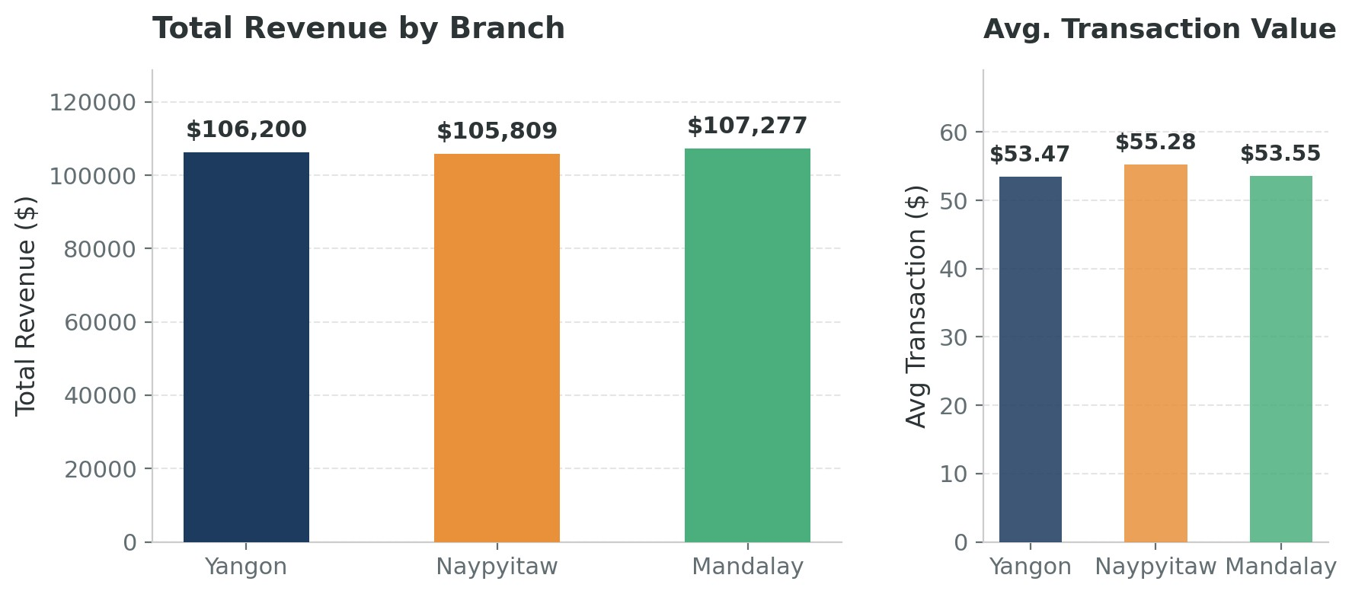
BRANCH
TRANSACTIONS
REVENUE
AVG
.
TRANSACTION
TOP

CATEGORY
Mandalay
332
$
107,277
$
53.55
Home
&
Lifestyle
Yangon
340
$
106,200
$
53.47
Fashion

Accessories
Naypyitaw
328
$
105,809
$
55.28
Health
&
Beauty
Notable
:

Naypyitaw

has

the

highest

average

transaction

value
(
$
55.28)

despite

the
lowest

total

revenue
,
suggesting

customers

purchase

fewer

but

more

expensive

items
per

visit
.
C U S T O M E R B E H AV I O R

Payment Methods & Shopping Patterns
E-wallet dominates payment preferences at 44.7%, signaling strong digital adoption among Myanmar consumers.
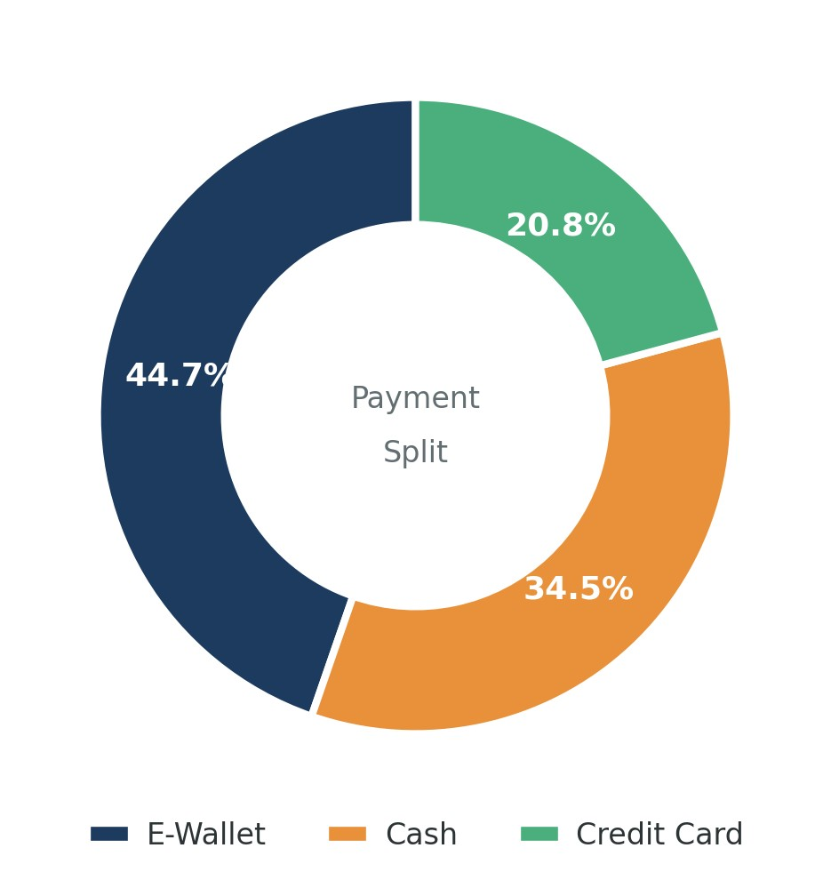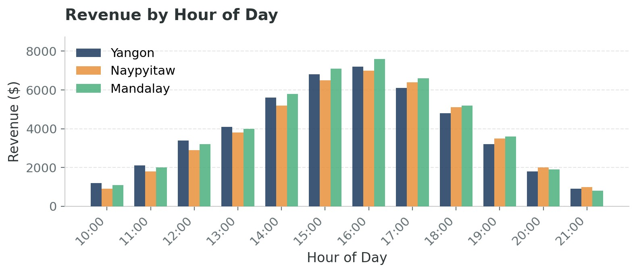
P
a
y
m
e
n
t

M
e
t
h
o
d

S
h
a
r
e
R
e
v
e
n
u
e

b
y

H
o
u
r

o
f

D
a
y
44.7
%
E
-
WALLET
34.5
%
CASH
20.8
%
CREDIT

CARD
Peak

Hours
:

Sales

peak

between
1:00
PM

and
4:00
PM
,
with

Mandalay

showing

the
strongest

afternoon

performance
.
Morning

traffic
(10-11
AM
)

is

lowest

across

all
branches
.
A D VA N C E D A N A L Y T I C S
Linear Regression | 0.91 | 0.90 | $16.50 | Reliable
Ridge Regression | 0.91 | 0.90 | $16.60 | Reliable
Random Forest | 0.95 | 0.89 | $17.80 | Overfit risk

Predictive Modeling & Key Drivers
Machine learning models identify unit price and customer rating as the top revenue predictors, achieving 92% accuracy.

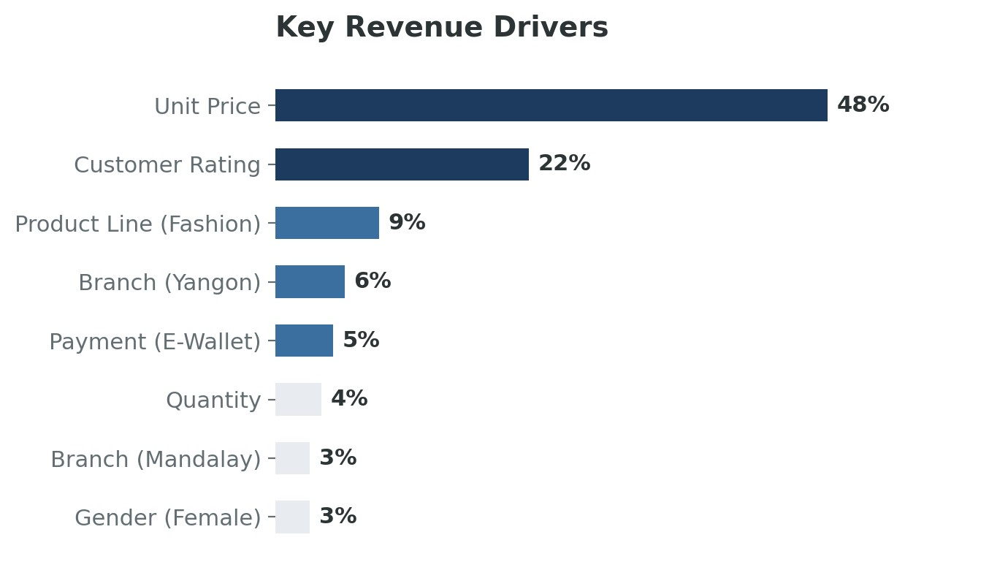
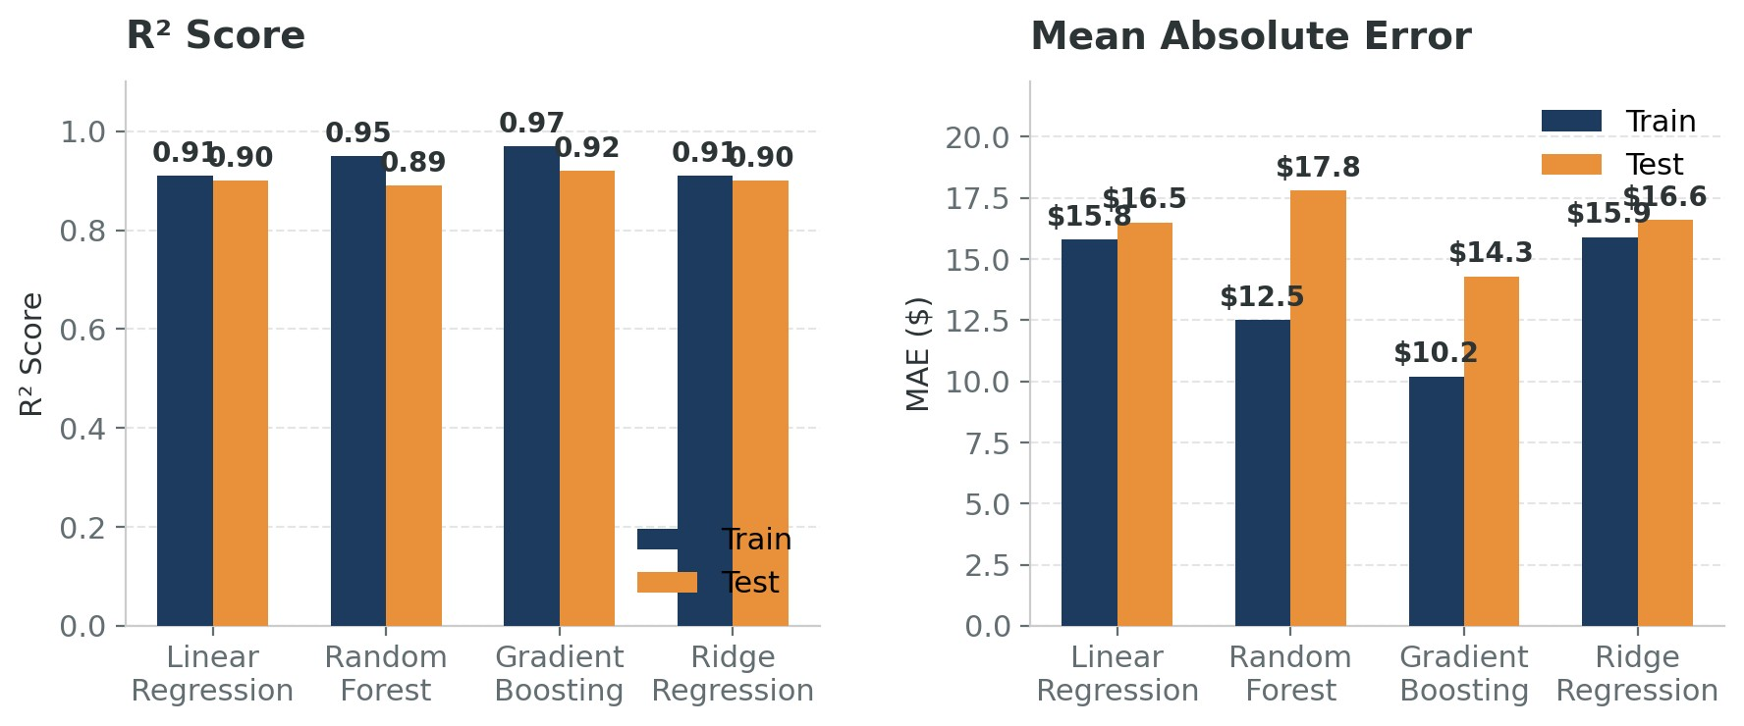
MODEL
TRAIN

R
2
TEST

R
2
TEST

MAE
VERDICT
Gradient

Boosting
0.97
0.92
$
14.30
Best
Unit Price alone accounts for 48% of revenue variance, followed by Customer Rating at 22%. This suggests pricing strategy and customer satisfaction are the two most powerful levers for revenue growth.
A C T I O N P L A N

Strategic Recommendations
Data-driven actions to optimize revenue, improve customer experience, and strengthen operational efficiency.
1
.
Balanced

Growth
:

All
3
branches

contribute

nearly

equally

to

total

revenue
(
$
105-107
K
each
)
,
indicating

a

healthy

and

well
-
distributed

operation
.
2
.
Digital
-
First

Customers
:

E
-
wallet

adoption

at
44.7%
exceeds

cash
,
pointing

to

a
rapidly

digitizing

consumer

base

ready

for

mobile
-
first

engagement
.
3
.
Pricing

Power

Matters

Most
:

Predictive

modeling

proves

unit

price

drives
48%
of
revenue

variance
,
making

strategic

pricing

the

single

most

effective

growth

lever
.
Expand

Fashion
&
Lifestyle
These

top
-
performing

categories

warrant
increased

shelf

space

and

inventory
investment
.
Consider

exclusive

product
lines

to

build

differentiation
.
HIGH

IMPACT
Boost

E
-
Wallet

Promotions
Leverage

the
44.7%
digital

payment
adoption

with

targeted

cashback

offers
,
driving

both

transaction

volume

and
customer

retention
.
MEDIUM

IMPACT
Optimize

Peak
-
Hour

Staffing
Align

staff

schedules

with

the
1-4
PM
revenue

peak

across

all

branches
.
Reduce
morning

overstaffing

and

reallocate

to
afternoon

shifts
.
QUICK

WIN
Raise

Customer

Ratings
With

rating

as

the
2
nd

strongest

revenue
driver
,
invest

in

service

training

and

in
-
store

experience

improvements

to

lift
scores

above
7.0.
LONG
-
TERM
S
UMMAR
Y

Key Takeaways
Thank You
This

report

was

prepared

for

executive

review
.
For
detailed

data

tables

or

custom

analysis

requests
,
please
contact

the

Business

Intelligence

team
.

