AREA AND PERIMETER OF CIRCLE AND RECTANGLE

Pseudo Code

\\ Main module

START

WRITE "Enter radius of circle : "

READ rad

WRITE "Enter length of Rectangle : "

READ len

WRITE "Enter width of Rectangle : "

READ wid

AC = 3.14 * rad * rad

PC = 2 * 3.14 * rad

AR = len * wid

PR = (len + wid) * 2

WRITE "Area of Rectangle is : " , AR

WRITE "Perimeter of Rectangle is : " , PR

WRITE "Area of Circle is : " , AC

WRITE "Perimeter of Circle is : " , PC

END

FLOW CHART

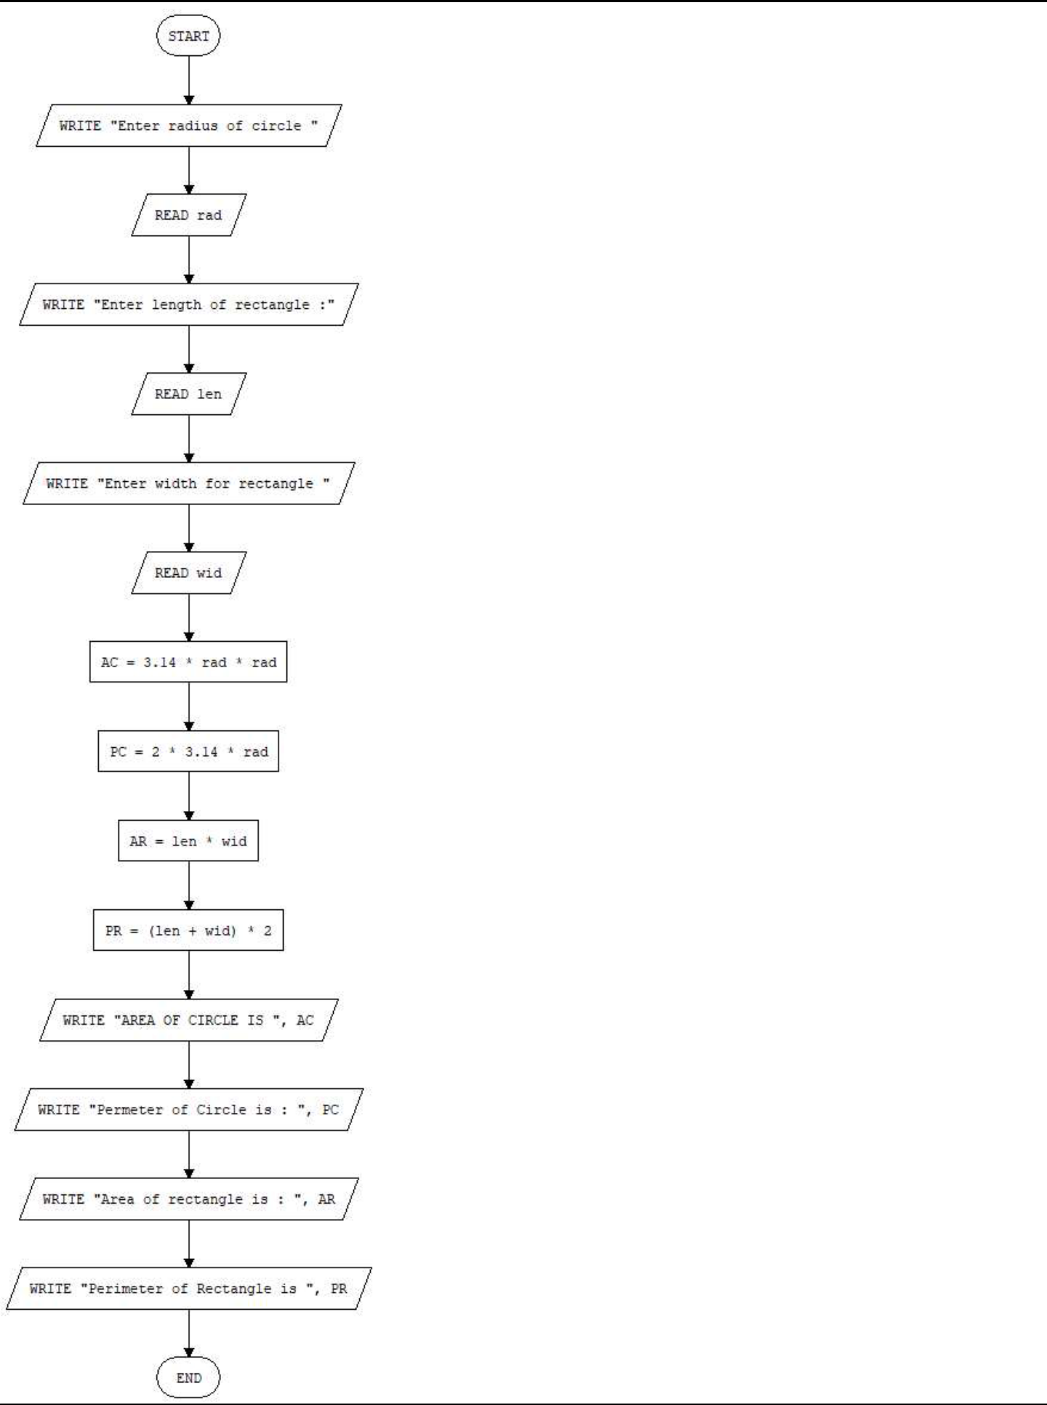

Average of Numbers

Pseudo Code

\\ Main module

START

WRITE "ENTER TOTAL NUMBERS: "

READ n

sum = 0

FOR i = 0 TO n-1 DO

WRITE "Enter number "

READ number

sum = sum + number

ENDFOR

avr = sum / n

WRITE "AVERAGE OF " , n , " Number is : ", avr

END

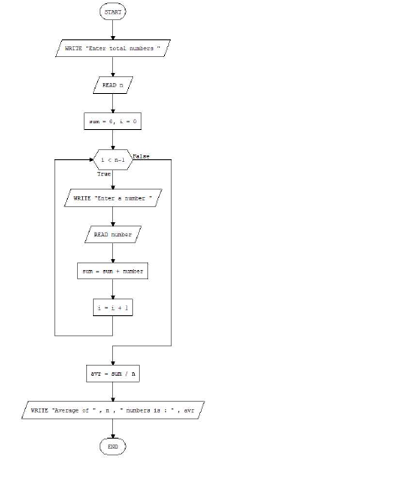

**EVEN NUMBERS:**

**Pseudo Code:**

**\\ Main module**

**START**

**WRITE "Enter a number to get Even Number : "**

**READ n**

**FOR i = 0 TO n-1 DO**

**IF i % 2 = 0 THEN**

**WRITE i**

**ENDIF**

**ENDFOR**

**END**

**Flow Chart**

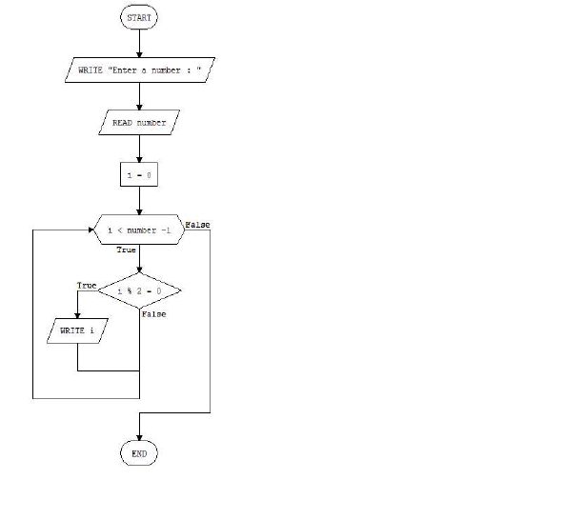

Fibonacci Numbers

Pseudo Code

\\ Main module

START

WRITE "ENTER NUMBER : "

READ n

n1 = 0

n2 = 1

WRITE n1

WRITE n2

FOR i = 2 TO n-1 DO

n3 = n1 + n2

WRITE n3

n1 = n2

n2 = n3

ENDFOR

END

FLOW CHART

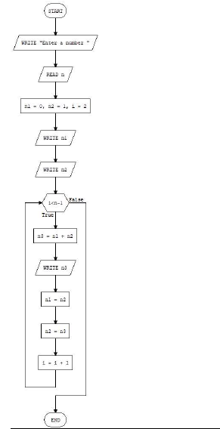

**LARP Version 3.00** **Page 4**

**LEAST COMMON FACTOR**

**\\ Main module**

**START**

**WRITE "Enter first number : "**

**READ number1**

**WRITE "Enter Second Number : "**

**READ number2**

**mini = 0**

**maxi = 0**

**lfc = 0**

**IF number1 = 0 or number2 = 0 THEN**

**WRITE "Least Common Factor is : " , 0**

**ELSE**

**IF number1 < number2 THEN**

**mini = number1**

**maxi = number2**

**ELSE**

**mini = number2**

**maxi = number1**

**ENDIF**

**lcf = maxi**

**WHILE lcf % mini = 0 DO**

**lcf = lcf + maxi**

**ENDWHILE**

**ENDIF**

**WRITE "LEAST COMMON FACTOR IS : ", lcf**

**END**

**Flow Chart**

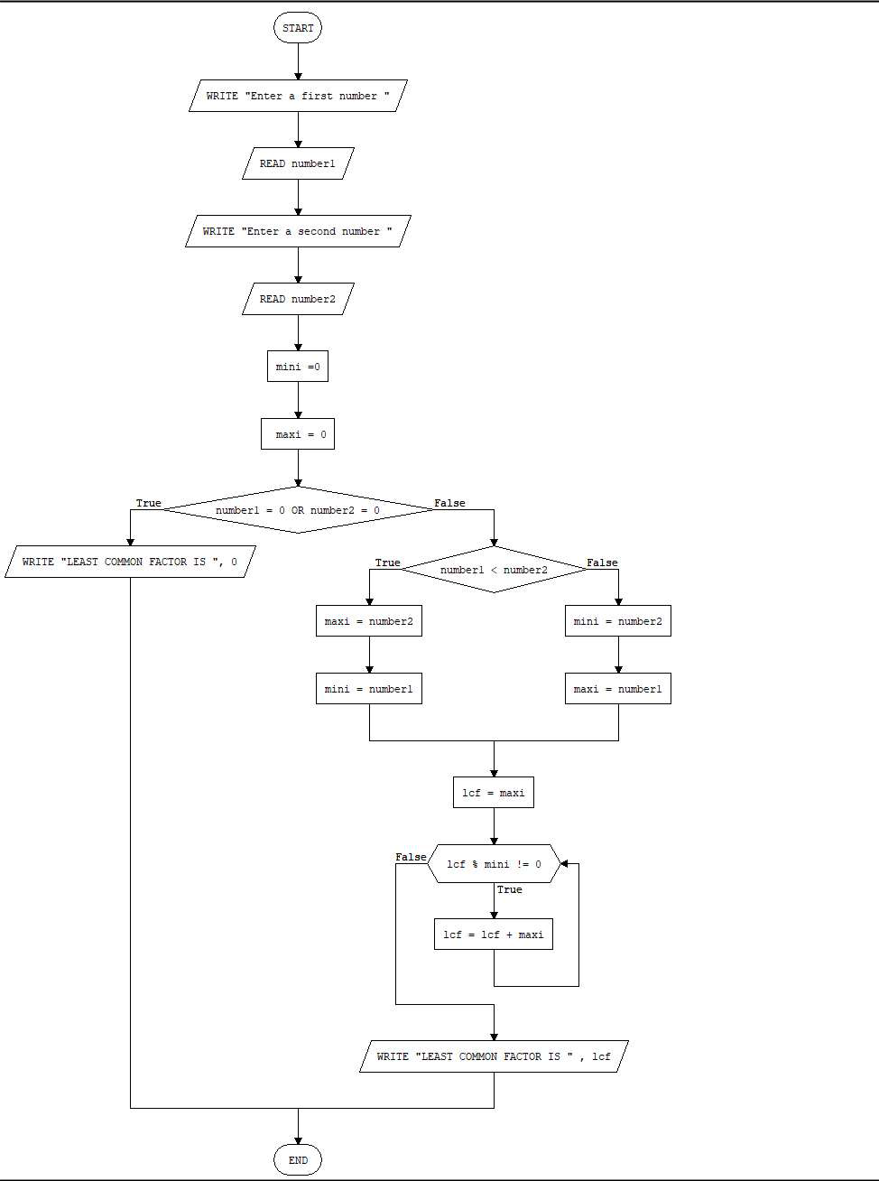

**PRIME NUMBER**

**Pseudo Code**

**START**

**WRITE "Enter a number: "**

**READ number**

**i=1**

**counter = 0**

**WHILE (i < number) DO**

**IF (number % i = 0) THEN**

**counter = counter + 1**

**ENDIF**

**i = i + 1**

**ENDWHILE**

**IF counter > 1 THEN**

**WRITE "NUMBER IS NOT PRIME"**

**ELSE**

**WRITE "NUMBER IS PRIME"**

**ENDIF**

**END**

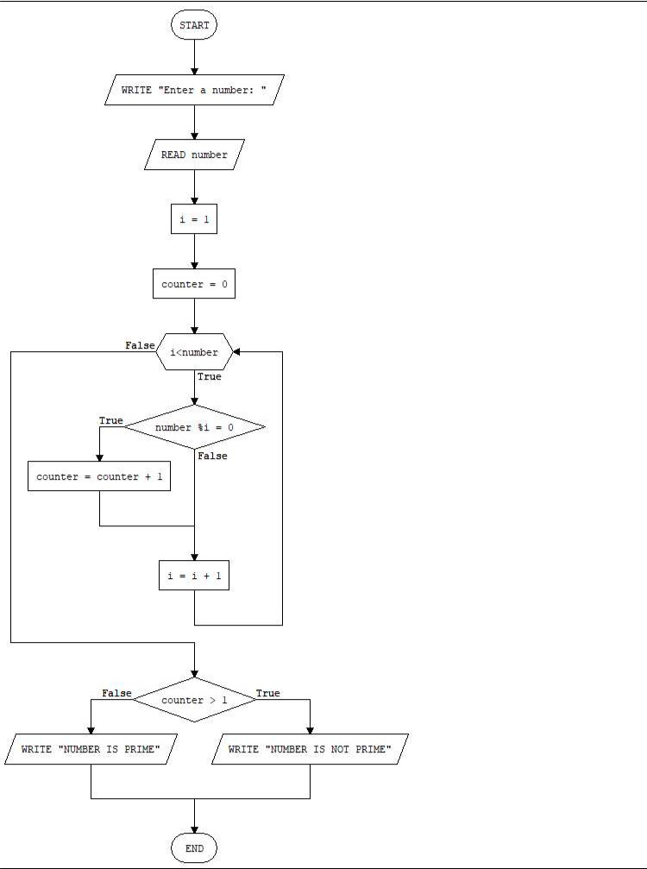

**MODULE: MAIN**