Complete micro operations
PART 5: Microoperation Reference for the Report
This is the most technical part of the report. Your instructor writes microoperations for every instruction. Below are the DUAD-16 microoperations in your instructor's notation. Usman must include all of these in Section 10 of the report.
5.1 Fetch and Decode (same for all instructions)
T0: AR <- PC
T1: IR <- M[AR], PC <- PC + 1
T2: OPCODE <- IR[15:11], MODE <- IR[10:9], DST <- IR[8:6], SRC <- IR[5:0]
Decode OPCODE using 5-to-32 decoder

5.2 Register-to-Register Instructions (MODE = 00)
For ADD, SUB, MUL, AND, OR, XOR, MOV the execution is:
T3: A <- RF[DST], B <- RF[SRC] (read both registers from register file)
T4: RF[DST] <- ALU_result, set Z/C/N flags, SC <- 0
The specific ALU operation at T4 depends on the opcode. For ADD: result = A + B. For AND: result = A AND B. And so on.

5.3 Load Immediate (LDI Rd, #imm)
T3: RF[DST] <- IR[5:0] (the 6-bit immediate field), SC <- 0
5.4 Load from Memory (LDM Rd, [Rs])
T3: AR <- RF[SRC] (address is in register Rs)
T4: DR <- M[AR] (read from memory)
T5: RF[DST] <- DR, SC <- 0

5.5 Store to Memory (STM [Rd], Rs)
T3: AR <- RF[DST] (address is in register Rd)
T4: M[AR] <- RF[SRC], SC <- 0

5.6 Jump Unconditional (JMP addr)
T3: PC <- IR[8:0], SC <- 0 (9-bit address from instruction)

5.7 Jump if Zero (JZ Rd, addr)
T3: if (RF[DST] = 0) then PC <- IR[5:0]
SC <- 0

5.8 Jump if Not Zero (JNZ Rd, addr)
T3: if (RF[DST] != 0) then PC <- IR[5:0]
SC <- 0

5.9 Single-Register Instructions (NOT, INC, DEC)
T3: A <- RF[DST]
T4: RF[DST] <- ALU_result (NOT A / A+1 / A-1), SC <- 0

5.10 Shift Instructions (SHL Rd, #n and SHR Rd, #n)
T3: A <- RF[DST], n <- IR[3:0] (shift amount from lower 4 bits of SRC field)
T4: RF[DST] <- A shifted by n, set C flag if bits shifted out, SC <- 0

5.11 Compare (CMP Rd, Rs)
T3: A <- RF[DST], B <- RF[SRC]
T4: temp <- A - B, set Z/C/N flags only (do NOT write result back), SC <- 0

5.12 Halt (HLT)
T3: S <- 0, SC <- 0 (S is the start-stop flip-flop, same as Mano Machine)

5.13 Interrupt Cycle (adapted from Mano Machine Lecture 22)
Condition to trigger interrupt: T0.T1.T2 . IEN . (FGI + FGO): R <- 1
RT0: AR <- 0, TR <- PC
RT1: M[AR] <- TR, PC <- 0
RT2: PC <- PC + 1, IEN <- 0, R <- 0, SC <- 0

5.14 INP (Input)
T3: If FGI = 1: R0 ← INPR, FGI ← 0, SC ← 0
If FGI = 0: SC ← 0 (no-op — use SKI to poll before INP)

5.15 OUT (Output)
T3: If FGO = 1: OUTR ← R0[7:0], FGO ← 0, SC ← 0
If FGO = 0: SC ← 0 (no-op — use SKO to poll before OUT)

5.16 SKI (Skip if Input Ready)
T3: If FGI = 1: PC ← PC + 1
SC ← 0

5.17 SKO (Skip if Output Ready)
T3: If FGO = 1: PC ← PC + 1
SC ← 0

5.18 ION (Interrupt Enable)
T3: IEN ← 1, SC ← 0
5.19 IOF (Interrupt Disable)
T3: IEN ← 0, SC ← 0

5.20 Register-Reference Group (opcode = 11110, decoded by one-hot bits [8:2])
The control unit checks IR[15:11] = 11110, then decodes the one-hot function bits:
CLA (IR[8] = 1): T3: R0 ← 0, SC ← 0

CMR (IR[7] = 1): T3: A ← RF[DST]
T4: RF[DST] ← NOT A, set Z/N flags, SC ← 0

CLC (IR[6] = 1): T3: C ← 0, SC ← 0

STC (IR[5] = 1): T3: C ← 1, SC ← 0

CLZ (IR[4] = 1): T3: Z ← 0, SC ← 0

NOP (IR[3] = 1): T3: SC ← 0 (no operation — immediately resets)

SWAP (IR[2] = 1): T3: TR ← RF[DST]
T4: RF[DST] ← RF[SRC]
T5: RF[SRC] ← TR, SC ← 0

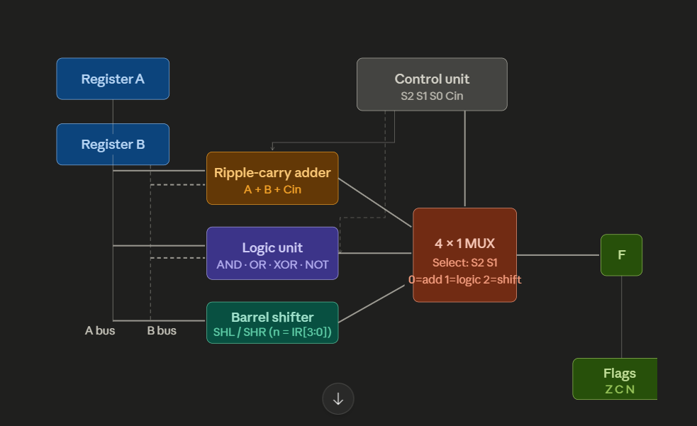

Here's the DUAD-16 ALU data path:
Register A, Register B → Ripple-carry adder (A + B + Cin)
Register A, Register B → Logic unit (AND / OR / XOR / NOT)
Register A → Barrel shifter (SHL / SHR, n from IR[3:0])
Control unit (S2 S1 S0 Cin) → 4×1 MUX (selects adder / logic / shifter output)
4×1 MUX → F[15:0] result → RF[DST] write-back + Flags (Z C N)

Final count of circuits you need to produce
- Full adder (1-bit)
- Arithmetic circuit (4-bit slice)
- Logic microoperation circuit (1-bit slice with 4×1 MUX)
- Shift microoperation circuit (4-bit)
- ALU block diagram (arithmetic + logic + shift feeding final 4×1 MUX)
- Bus using MUX (4-bit example)
- Common bus system (full block diagram)
- 5-to-32 decoder block
- Sequence counter block
- Control unit full block diagram

About the project (written sections)
Abstract — one paragraph, what DUAD-16 is, what problem it solves, what makes it different from Mano Machine.
Introduction — background on Mano Machine, why 1-address accumulator is a bottleneck, what DUAD-16 improves and how.
Design philosophy and innovation — 2-address architecture explained, 8 general purpose registers vs single accumulator, why this is better.
Word size memory and registers — justify every choice, 16-bit word, 4096×16 memory, R0–R7, PC IR TR flags flip-flops.
Instruction format — explain the 4-field format, each field's purpose, why 5-bit opcode was chosen, how MODE field works.
Addressing modes — explain all 4 modes with an example instruction for each.
Instruction set — describe all 5 categories and why each one is needed for completeness.
CPU internal components — written description of ALU, CU, register file, PC, IR. Already drafted in your project notes.
Microoperations — fetch decode execute for every instruction in T-notation. This is Section 10, the longest section.
Comparison with Mano Machine — side by side comparison showing what DUAD-16 changed and why each change matters.
Conclusion — summary of what was achieved, limitations, possible future extensions.
References and bibliography — textbook, lecture slides, any other sources.

Diagrams (must include)
- DUAD-16 register layout diagram — like Mano's register slide but with R0–R7 replacing AC and DR
- Instruction format diagram — 16-bit word split into OPCODE MODE DST SRC fields with bit numbers labeled
- Full adder circuit
- Arithmetic circuit (4-bit slice)
- Logic microoperation circuit
- Shift microoperation circuit
- ALU block diagram (all three units feeding final 4×1 MUX)
- Bus using MUX (4-bit example)
- Common bus system block diagram
- Control unit block diagram (5-to-32 decoder, sequence counter, register file selector, PLA)

Flowcharts (must include)
- Master fetch-decode-execute flowchart — Start → Fetch T0 T1 T2 → Decode opcode → branch to instruction type → Execute → Interrupt check → loop back. This is the most important one.
- Interrupt cycle flowchart — condition check IEN FGI FGO → R=1 → RT0 RT1 RT2 → return.
- I/O polling flowchart — SKI/SKO loop showing how program waits for FGI or FGO before INP or OUT.
Those three are necessary. You can optionally add a flowchart for the MUL shift-and-add loop but it is not mandatory.

Tables (must include)
- Register summary table — name, size in bits, purpose. Same format as Mano's slide.
- Instruction format fields table — field name, bit positions, size, purpose.
- Addressing modes table — mode name, binary code, meaning, example. Already drafted.
- Complete instruction set table — number, opcode binary, mnemonic, operation, category. Already done.
- ALU control signal table — S3 S2 S1 S0 Cin, operation, function. Already done.
- Register-reference one-hot encoding table — which IR bit maps to which instruction.
- Microoperation summary table — every instruction with all its T-steps in one master table. This goes in Section 10.
- Comparison table — DUAD-16 vs Mano Machine side by side on key features like address type, register count, opcode width, memory size, ALU operations.

What the comparison table should cover specifically
Feature / Mano Machine / DUAD-16 — rows should be: architecture type, number of registers, opcode bits, memory, addressing modes, instruction count, ALU operations, I/O method.

Quick summary of counts
Written sections — 12 Diagrams — 10 Flowcharts — 3 mandatory, 1 optional Tables — 8
That covers everything needed for a complete and high-scoring report.
Overall strategy before starting
All three members must read the full instruction set table and the microoperations section before day 1 starts. Everyone needs the same base knowledge or the work will not connect. Spend 30 minutes together on day 0 just reading and asking each other questions.

Day 1 — Foundations and circuits
The goal of day 1 is to get all 10 circuits and diagrams done on paper or PowerPoint. Divide as follows.
Usman — circuits 1 2 3 Draw the full adder circuit with inputs A B Cin and outputs Sum Cout using gates. Then draw the 4-bit arithmetic circuit slice showing the B-input 4×1 MUX feeding into the full adder chain with S1 S0 Cin labeled. Then draw the logic microoperation circuit showing A and B going into AND OR XOR NOT gates then into a 4×1 MUX with S1 S0 select and output E.
Reyan — circuits 4 5 6 Draw the shift microoperation circuit showing 4 MUXes with A0 A1 A2 A3 wired so select 0 shifts right and select 1 shifts left with serial inputs IL and IR. Then draw the ALU block diagram showing arithmetic circuit logic circuit and shifter all feeding into the final 4×1 MUX with S3 S2 selecting the output F. Then draw the bus using MUX diagram showing a 4-bit example of registers feeding into MUX slices with select lines producing the bus output.
Saim — circuits 7 8 9 10 Draw the common bus system block diagram showing register file DR PC feeding the bus with select lines. Then draw the 5-to-32 decoder block with IR[15:11] as input and D0–D31 as output. Then draw the sequence counter block with CLK CLR INR inputs and T0–T5 outputs. Then draw the full control unit block diagram combining the decoder sequence counter register file selector and PLA block with arrows showing how they connect and what signals go out.
At the end of day 1 all three members photograph or scan their drawings and share with the group. Everyone reviews all 10 circuits together for 30 minutes before sleeping.

Day 2 — Written content and tables
The goal of day 2 is to write the report body and fill all tables. Divide as follows.
Usman — main body writing Write sections: introduction, design philosophy, word size memory registers, instruction format, addressing modes, CPU internal components. Use the drafted content from your project notes already done in previous sessions. Aim for 1500 words covering these sections. Also write the comparison section with Mano Machine using the comparison table.
Reyan — microoperations and tables Write Section 10 which is the full microoperation reference. Take every instruction and write all T-steps in T-notation in a clean formatted table. This is the master microop table. Also fill the register summary table, instruction format fields table, ALU control signal table, and register-reference one-hot table. This is heavy technical work but purely copy and format from what is already drafted — do not invent anything new.
Saim — abstract conclusion bibliography and flowcharts Write the abstract in one paragraph. Write the conclusion. Collect all references. Also draw all 3 flowcharts: master fetch-decode-execute flowchart, interrupt cycle flowchart, and I/O polling flowchart. For flowcharts use PowerPoint shapes, simple rectangles for process steps and diamonds for decisions.
At the end of day 2 Usman assembles everything into one document. All three review it together and fix inconsistencies. Check that every diagram is referenced in the text and every table is introduced before it appears.

Day 3 — Simulator and final review
Split the day into two halves.
First half — simulator (all three work together) Second half — report polish and submission prep

Simulator — how to make it without AI
The simulator is an HTML and JavaScript file. Here is exactly how to build it manually.
The concept is simple. You are building a web page that pretends to be the DUAD-16 CPU. It has memory stored as a JavaScript array of 4096 numbers. It has 8 registers stored as a JavaScript array of 8 numbers. It has PC IR TR flags stored as individual variables. The user types assembly instructions, clicks assemble, and the page converts them to binary. Then the user clicks step or run and the page executes one instruction at a time showing register values updating on screen.
Divide the simulator work as follows.
Usman — assembler function Write a JavaScript function that takes a line of text like ADD R2 R3 and converts it to a 16-bit binary number. You do this with a series of if-else statements or a lookup object. The opcode lookup table maps ADD to 00000, SUB to 00001 and so on. The register lookup maps R0 to 000, R1 to 001 and so on. You concatenate the strings to form the 16-bit binary instruction and store it in the memory array. No libraries needed, just string operations and a lookup table.
Reyan — execute function Write a JavaScript function that reads the instruction at memory[PC], extracts the fields using substring or bitwise operations, then uses a switch statement on the opcode to perform the correct operation. For ADD it does registers[dst] = registers[dst] + registers[src]. For JMP it sets PC to the address field. For HLT it sets a running flag to false. After each instruction update the Z C N flags. This is the most important function.
Saim — HTML display and controls Build the HTML page layout. A text area on the left where the user types assembly code. An assemble button and a step button and a run button and a reset button. On the right show a table of R0–R7 values, PC value, IR value, flags Z C N. Below that show the memory contents from address 0 to 20 or so. All values display in both binary and decimal. Update the display after every step by reading the JavaScript variables and writing them into the HTML elements using getElementById.
How they connect — Usman's assembler fills the memory array. Reyan's execute function reads from it and updates the register variables. Saim's display reads those same variables and shows them. They share one JavaScript file. Test together using a simple program like LDI R0 5 then LDI R1 3 then ADD R0 R1 then HLT and verify R0 shows 8 after running.
Strictly no AI means write every line by hand. You are allowed to look at JavaScript documentation for syntax. The logic must come from your own understanding of the microoperations you already wrote.

Second half of day 3 — final report
Usman inserts all diagrams into the report document in the correct sections and writes a caption for each one.
Reyan proofreads the entire report for technical accuracy. Check that every microoperation in the text matches the master table. Check that every instruction in the text matches the instruction set table.
Saim checks word count, section count, formatting, page numbers, turnitin preparation. Confirm the report has 12 sections, 3000+ words, all tables labeled, all figures labeled.
All three do a final read-together of the abstract and conclusion to make sure they match what is actually in the report.

Quick reference — who owns what
Usman — written body sections, assembler function, circuit drawings 1 2 3, document assembly
Reyan — microoperations and tables, execute function, circuit drawings 4 5 6, technical proofreading
Saim — abstract conclusion bibliography, flowcharts, HTML display, circuit drawings 7 8 9 10, formatting

Critical rule for all three days
Never work in isolation for more than 2 hours without syncing. If one person is stuck the others stop and help. The report is one document and the simulator is one file. Integration problems at the end will cost more time than helping each other mid-day

