* 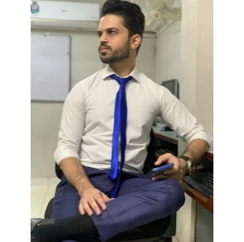dsdsdsdsdsds HTML5, CSS, Bootstrap

E-Mail [usmanhameed1790@gmail.com](mailto:usmanhameed1790@gmail.com)

Contact No. +923355307493

LinkedIn [linkedin.com/in/usman-hameed-05b513240](https://www.linkedin.com/in/usman-hameed-05b513240)

WORK EXPERIENCE

PROFILE

**USMAN HAMEED**

**Objective**

Secure a position in a creative and dynamic work environment where I can apply my skills in development.

* Php
* MySQL
* Ajax

JavaScript/jQuery

* JSON

1) Online Laundry Management Website.

2) Shaharda Bookstore E-Commerce Website.

3) Fee Management System Web Portal for Aptech University Road Center.

4) Mad-alpha designer eCommerce website.

SKILLS

* HTML5, CSS, Bootstrap
* Php
* MySQL
* Ajax
* JavaScript/jQuery
* JSON

HOBBIES

* Coding
* Gaming
* Movies

CONTACT

EDUCATION

* Currently enrolled in Aptech Learning Pakistan (5th semester)
* Intermediate
* Matriculation