Data Query Language:
Sub-Queries:
1- Display Products_Name with Above-Average Prices
Code:
SELECT P.Product_name
FROM Products AS P
INNER JOIN(
SELECT *
FROM Product_variants
WHERE Original_Price > (
SELECT AVG(Original_Price)
FROM Product_variants
)
) AS S
ON P.ID = S.Product_ID;
Output:
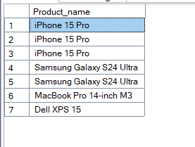

2-Finding Users Who Have Ordered a Specific Product(iPhone 15 Pro)
SELECT *
FROM Users
WHERE ID IN
(
SELECT User_Id
FROM Orders
WHERE ID IN(
Select Order_Id
from Order_Items
WHERE Product_variant_Id IN (
Select ID
from Product_variants
WHERE Product_ID = (
Select ID
from Products
WHERE Product_name = 'iPhone 15 Pro'
)
)
)
)
Output:
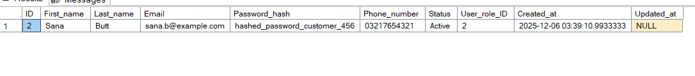

3-Finding Categories That Have No Products
Code:
SELECT
C.ID,
C.Category_name,
C.Status
FROM
Categories AS C
WHERE
NOT EXISTS (
SELECT 1
FROM Products AS P
WHERE P.Cat_ID = C.ID -- The Correlation
);

Output:
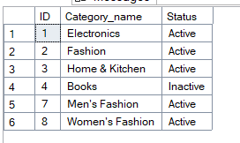

4- Finding an Order's Most Expensive Item
CODE:
SELECT
O.Order_Number,
(
SELECT TOP 1 P.Product_name
FROM Order_Items O_I
INNER JOIN Product_variants P_V ON P_V.ID = O_I.Product_variant_Id
INNER JOIN Products P ON P.ID = P_V.Product_ID
WHERE O.ID = O_I.Order_Id
ORDER BY O_I.Original_Price_Per_Unit DESC
) AS [Expensive Item]
FROM Orders O;

Output:
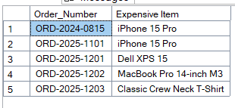

5- Finding Users Who Have Spent More Than a Certain Amount in a Single Order(i.e Rs. 50,000)
SELECT *
FROM Users AS U
WHERE ID IN
(
SELECT User_Id
FROM Orders AS O
WHERE 50000 < (
SELECT SUM(Original_Price_Per_Unit - Discount_Per_Unit)
FROM Order_Items AS O_I
WHERE O.ID = O_I.Order_Id
)
)

Output:
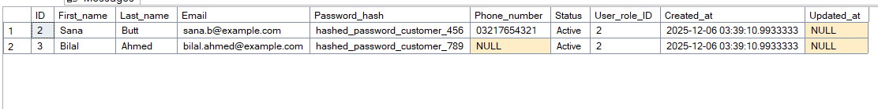

6- Finding Products That Have Never Been Sold
SELECT *
FROM Products
WHERE ID NOT IN
(
SELECT Product_ID
FROM Product_variants AS P_V
WHERE ID IN
(
SELECT Product_variant_Id
FROM Order_Items
)
)
Output:

7- Finding Customers with the Same City as a Specific User (Sana Butt)
Code:
SELECT U.*
FROM Users AS U
INNER JOIN Addresses AS A
ON U.ID = A.User_Id
WHERE First_name != 'Sana' AND Last_name != 'Butt'
AND A.City IN
(
SELECT A.City
FROM Users AS U
INNER JOIN Addresses AS A
ON U.ID = A.User_Id
WHERE First_name = 'Sana' AND Last_name = 'Butt'
)

8- Finding the Most Recently Placed Order for Each User
Code:
SELECT
ID,
First_name,
Last_name,
(
SELECT TOP 1 Order_Number
FROM Orders AS O
WHERE O.User_Id = U.ID
ORDER BY Created_at DESC
) AS Recent_Order_Number
FROM Users AS U

Output:
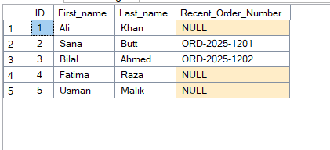
9- Finding Categories Whose Average Product Price is Higher Than the Overall Average
Code:
SELECT *
FROM
(
SELECT C.ID, C.Category_name, AVG(P_V.Original_Price) AS AVG_PRICE
FROM Categories AS C
INNER JOIN Products AS P ON P.Cat_ID = C.ID
INNER JOIN Product_variants AS P_V ON P_V.Product_ID = P.ID
GROUP BY C.ID, C.Category_name
) AS Parent_Cat
WHERE AVG_PRICE >
(
SELECT AVG(Original_Price)
FROM Product_variants
)

Output:
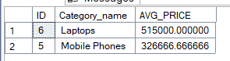

JOINS:

1-Generate a Basic Product Catalog for the Website
- Question: Write a query to create a product list for a webpage. The list must show each product's name, its category name, its color and size, and its price.
- Business Use: This is the most fundamental query for displaying products on a category page.
Code:
SELECT C.Category_name, P.Product_name, P_V.Color, P_V.Size, P_V.Original_Price, P_V.Sale_Price
FROM Categories AS C
INNER JOIN Products AS P ON C.ID = P.Cat_ID
INNER JOIN Product_variants AS P_V ON P.ID = P_V.Product_ID

Output:
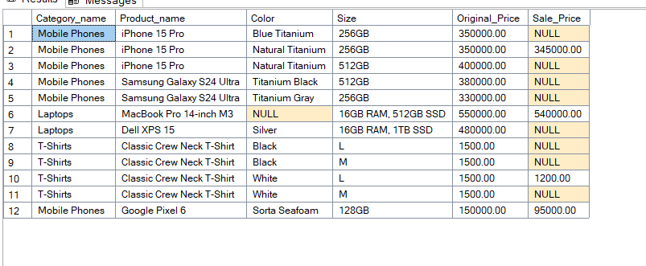
2-Find Inactive Customers for a Marketing Campaign
- Question: Generate a list of all registered users who have never placed an order. This list will be used for a "come back and shop!" email campaign.
- Business Use: Identifying non-purchasing customers is crucial for targeted marketing.
Code:
SELECT U.First_name, U.Last_name, U.Email
FROM User_roles AS U_R
INNER JOIN Users AS U
ON U_R.ID = U.User_role_ID
LEFT JOIN Orders AS O
ON U.ID = O.User_Id
WHERE U_R.ID = 2 AND O.Order_Number is NULL
Output:
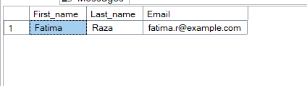

3-Generate a Detailed Invoice for a Single Order
- Question: For a specific Order_Number (e.g., 'ORD-2025-1201'), create a detailed invoice. The invoice should list every item in that order, its quantity, the price per unit at the time of purchase, and the total for that line item.
- Business Use: This is essential for generating customer receipts, for customer support inquiries, and for accounting.

Code:
SELECT
P.Product_name,
O_I.Quantity,
(O_I.Original_Price_Per_Unit - O_I.Discount_Per_Unit) AS [Price Per Unit],
((O_I.Original_Price_Per_Unit - O_I.Discount_Per_Unit)*O_I.Quantity) AS [Line Total]
FROM Orders AS O
INNER JOIN Order_Items AS O_I ON O.ID = O_I.Order_Id
INNER JOIN Product_variants AS P_V ON O_I.Product_variant_Id = P_V.ID
INNER JOIN Products AS P ON P_V.Product_ID = P.ID
WHERE O.Order_Number = 'ORD-2025-1201';
Output:
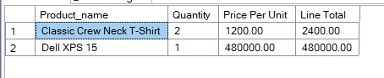

4-Identify Unsold Inventory (Dead Stock)
- Question: Create a report of all product variants that have a stock quantity greater than zero but have never been sold (i.e., they do not appear in the Order_items table).
- Business Use: This helps inventory managers identify "dead stock" that isn't selling and needs to be put on clearance or discontinued.
Code:
SELECT P_V.*
FROM Order_Items AS O
RIGHT JOIN Product_variants AS P_V
ON O.Product_variant_Id = P_V.ID
WHERE O.Order_Id IS NULL AND Stock_quantity > 0
Output:
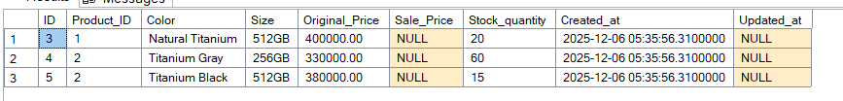

5- Build a Category Navigation Menu (Breadcrumbs)
- Question: For every sub-category in your store, display its name and the name of its direct parent category. The result should look like "Sub-Category Name | Parent Category Name".
- Business Use: This is exactly how multi-level navigation menus and "breadcrumb" trails (e.g., Home > Fashion > Men's Fashion) are built on a website.
Code:
SELECT C.Category_name, C1.Category_name AS Parent_Category_Name
FROM Categories AS C
INNER JOIN Categories AS C1
ON C.Parent_cat_id = C1.ID

Output:
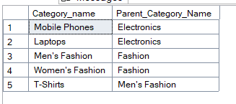

6- Find Your Top 5 Best-Selling Products
- Question: Identify the top 5 best-selling product variants of all time, based on the total quantity sold. The report should show the product's name, color, size, and the total quantity sold.
- Business Use: This is one of the most important reports for any retail business to understand what products are popular.

Code:
SELECT TOP 5 P.Product_name, P_V.Color, P_V.Size, SUM(O_I.Quantity) AS Quantity
FROM Order_Items AS O_I
INNER JOIN Product_variants AS P_V ON O_I.Product_variant_Id = P_V.ID
INNER JOIN Products AS P ON P.ID = P_V.Product_ID
GROUP BY P.Product_name, P_V.Color, P_V.Size
ORDER BY Quantity DESC
Output:
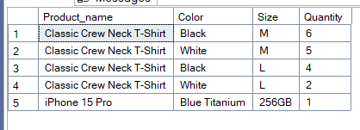

7-Calculate Customer Lifetime Value (LTV)
- Question: Create a customer value report that shows each customer's full name and the total amount of money they have spent across all of their orders. Sort the list to show the highest-spending customers at the top.
- Business Use: Identifying high-value customers is key to loyalty programs and VIP marketing.
Code:
SELECT U.First_name, U.Last_name, SUM(Original_Price_Per_Unit - Discount_Per_Unit) AS TotalOrdersPrice
FROM Order_Items AS O_I
INNER JOIN Orders AS O ON O_I.Order_Id = O.ID
INNER JOIN Users AS U ON O.User_Id = U.ID
GROUP BY O.User_Id, U.First_name, U.Last_name
Order by SUM(Original_Price_Per_Unit - Discount_Per_Unit) DESC

Output:
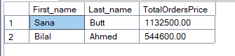
8-Analyze Sales Revenue by City (Geographic Analysis)
- Question: Generate a report to find out which city is generating the most sales revenue. The report should list each city and the total sales amount from that city, sorted from highest to lowest.
- Business Use: This is a crucial business intelligence report. It helps the marketing team decide where to focus their advertising budget and helps the logistics team plan for high-volume delivery areas.
Code:
SELECT A.City, SUM(O_I.Original_Price_Per_Unit - O_I.Discount_Per_Unit) AS [TotalSalesAmount]
FROM Order_Items AS O_I
INNER JOIN Orders AS O ON O_I.Order_Id = O.ID
INNER JOIN Addresses AS A ON O.Shipping_Address_Id = A.ID
GROUP BY A.City
ORDER BY SUM(O_I.Original_Price_Per_Unit - O_I.Discount_Per_Unit) DESC
Output:
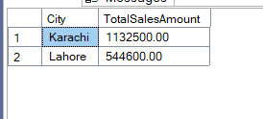
9- Display a Customer's Complete Order History
- Question: For a single, specific user (e.g., 'Sana Butt'), create a summary of all orders they have ever placed. The list should show each Order_Number, the Order_Date (Created_at), the order's Status, and the calculated total amount for each individual order.
- Business Use: This is the exact query needed to build the "My Account -> Order History" page on the website, which is a fundamental feature for any logged-in customer.
Code:
SELECT
O.Order_Number,
O.Created_at,
O.Status,
SUM((O_I.Original_Price_Per_Unit - O_I.Discount_Per_Unit) * O_I.Quantity) AS CalculatedTotal
FROM Orders AS O
INNER JOIN Order_Items AS O_I ON O.ID = O_I.Order_Id
INNER JOIN Users AS U ON O.User_Id = U.ID
WHERE U.First_name = 'Sana' AND U.Last_Name = 'Butt'
GROUP BY O.Order_Number, O.Created_at, O.Status;
Output:
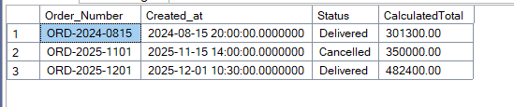

Views:
1- Simplify Access to a User's Full Name and Role (Security & Simplicity)
- Scenario: Many departments (like Marketing or Customer Support) frequently need a simple list of users with their full name and role, but they should not see sensitive information like Password_hash.
- Business Use: This provides a secure and simplified "window" into user data for non-technical users or other applications. You grant them access to the VIEW, not the underlying tables.
Code:
CREATE VIEW V_User_Details AS
(
SELECT U.First_name, U.Last_name, U_R.Role_name
FROM Users AS U
INNER JOIN User_roles AS U_R
ON U.User_role_ID = U_R.ID
)

SELECT *
FROM V_User_Details;
Output:
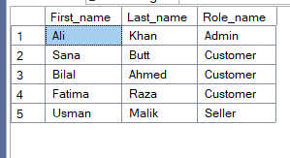

2-Create a Live Product Catalog View
  - Scenario: The frontend of your website always needs to display a full list of products with their category, all variants, and current pricing. Running a complex 4-table join every time a user visits the page can be cumbersome.
  - View to Create (V_Product_Catalog): Create a view that joins Categories, Products, and Product_variants. It should display all the necessary information for a product listing page: ProductName, CategoryName, Color, Size, Original_Price, Sale_Price, Stock_quantity, and Status.
  - Business Use: Developers can now write a simple SELECT * FROM V_Product_Catalog WHERE Status = 'Active' instead of a complex join every time, making their code cleaner and less prone to errors.
Code:
CREATE VIEW V_Product_Catalog AS
(
SELECT C.Category_name, P.Product_name, P_V.Color, P_V.Size, P_V.Original_Price, P_V.Sale_Price, P_V.Stock_quantity, P.Status
FROM Categories AS C
INNER JOIN Products AS P ON C.ID = P.Cat_ID
INNER JOIN Product_variants AS P_V ON P.ID = P_V.Product_ID
WHERE P.Status = 'Active'
)

SELECT *
FROM V_Product_Catalog;
Output:
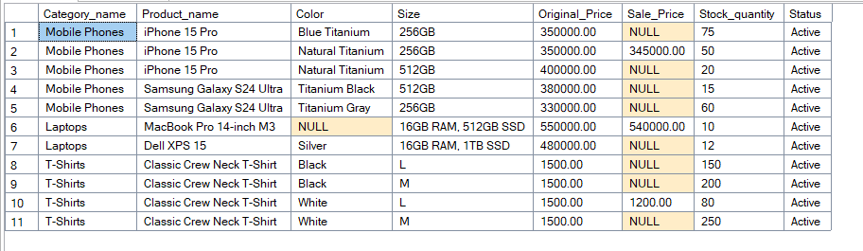

3-Provide a Summary of Order Information (Data Aggregation)
  - Scenario: Your finance team constantly asks for a report of all orders with their calculated total amounts. Calculating this total requires a complex SUM and GROUP BY on the Order_items table every single time.
  - View to Create (V_Order_Totals): Create a view that shows key information from the Orders table (Order_Number, User_Id, Status, Created_at) and joins it with an aggregated query on Order_items to include a calculated Total_Order_Amount for each order.
  - Business Use: This pre-calculates the total for every order. The finance team can now query this view directly for their reports, making their work faster and ensuring the calculation is always done consistently.

Code:
CREATE VIEW Order_Info AS
(
SELECT
O.Order_Number,
O.User_Id,
O.Status,
O.Created_at,
SUM(((O_I.Original_Price_Per_Unit - O_I.Discount_Per_Unit) * O_I.Quantity)) AS Total_Order_Amount
FROM Orders AS O
INNER JOIN Order_Items AS O_I
ON O.ID = O_I.Order_Id
GROUP BY O.Order_Number, O.User_Id, O.Status, O.Created_at
)

SELECT * FROM Order_Info;
Output:
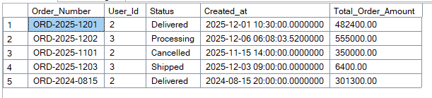

4- Isolate Business Logic for "Active Sale" Items
  - Scenario: The logic for determining if a product is on sale is "an item is on sale if its Sale_Price is not NULL and is less than its Original_Price". You don't want every developer to have to write this WHERE clause logic themselves.
  - View to Create (V_Active_Sale_Items): Create a view based on the Product_variants table (joined with Products for the name) that has this logic built into its WHERE clause. It will only ever show items that are currently on sale.
  - Business Use: This encapsulates business logic. Marketing can simply query this view to see all sale items. If the definition of a "sale" changes, you only need to update the view, not every query in every application.

Code:
CREATE VIEW Item_On_Sale AS
(
SELECT P.ID, P.Product_name,P_V.Color, P_V.Size
FROM Products AS P
INNER JOIN Product_variants AS P_V
ON P.ID = P_V.Product_ID
WHERE P_V.Sale_Price is NOT NULL AND P_V.Sale_Price < P_V.Original_Price AND P_V.Stock_quantity !=0 AND P.Status = 'Active'
)

SELECT *
FROM Item_On_Sale;
Output:
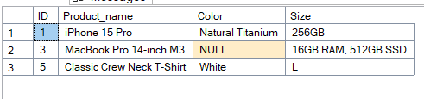

Stored Procedures:
1-Get a Specific User's Profile (Simple SELECT with a Parameter)
- Scenario: An application frequently needs to retrieve the profile details (e.g., name, email, status) for a single user based on their ID or email.
- Business Use: To fetch data for the "My Profile" page of the application.
Code:
CREATE PROCEDURE sp_GetUserProfile
@UserId INT
AS
BEGIN
SELECT First_name, Last_name, Email, Status
FROM Users
WHERE ID = @UserId
END

EXEC sp_GetUserProfile @UserId = 2
Output:
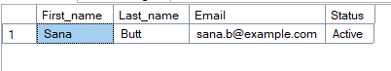

2- Register a New User (Simple INSERT with Parameters)
- Scenario: A new entry must be added to the Users table whenever a new user signs up.
- Procedure to Create (sp_RegisterUser): Create a procedure that accepts a user's FirstName, LastName, Email, PasswordHash, and UserRoleID as parameters and inserts a new record into the Users table.
- Business Use: To handle the backend logic for a new user registration form.

Code:
CREATE PROCEDURE sp_RegisterUser
@FirstName VARCHAR(50),
@LastName VARCHAR(50),
@Email VARCHAR(255),
@PasswordHash VARCHAR(255),
@PhoneNumber VARCHAR(20),
@UserRoleID INT
AS
BEGIN
INSERT INTO Users(First_name, Last_name, Email, Password_hash, Phone_number, User_role_ID)
VALUES
(@FirstName, @LastName, @Email, @PasswordHash, @PhoneNumber, @UserRoleID)
END
EXEC sp_RegisterUser @FirstName = 'Ayesha', @LastName = 'Malik', @Email='ayesha_malik_28@gmail.com', @PasswordHash='hashed_password_seller_1190', @PhoneNumber='123456789',@UserRoleID = 2

Output:
Before Execution:
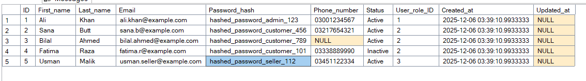
After Execution:
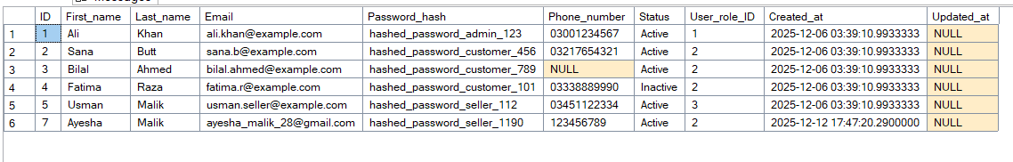
3-Update a User's Shipping Address (Simple UPDATE with Parameters)
- Scenario: A user wants to update their shipping address from their account page.
- Procedure to Create (sp_UpdateUserAddress): Create a procedure that accepts @AddressID, @AddressLine1, @City, @PostalCode, etc., as parameters and updates the corresponding record in the Addresses table.
- Business Use: To power the "Edit Address" functionality in the user's account section.
Code:
CREATE PROCEDURE sp_UpdateUserAddress
@Address_Line_1 VARCHAR(255),
@City VARCHAR(100),
@Postal_Code VARCHAR(20),
@UserId INT
AS
BEGIN
UPDATE Addresses
SET
Address_Line_1 = @Address_Line_1,
City = @City,
Postal_Code = @Postal_Code
WHERE
ID = @UserId
END

EXEC sp_UpdateUserAddress @Address_Line_1 = 'House no 7 Street no 9/b', @City= 'Karachi', @Postal_Code='1234', @UserId = 2;
SELECT *
FROM Addresses;
Output:
Before Execution:
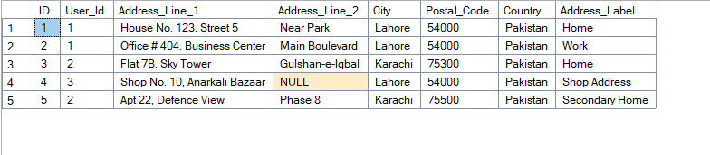

After Execution:
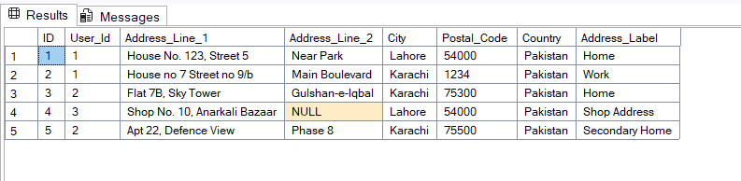
4- Get All Products in a Specific Category (Dynamic Filtering)
- Scenario: When a user navigates to a specific category page on the website (e.g., 'Mobile Phones'), the application must display only the products belonging to that category.
- Procedure to Create (sp_GetProductsByCategory): Create a procedure that accepts a @CategoryID as a parameter and returns a complete list of all products and their variants within that category.
- Business Use: To dynamically populate product listing pages on the e-commerce website.
Code:
CREATE PROCEDURE sp_GetProductsByCategory
@CategoryId INT
AS
BEGIN
SELECT
P.Product_name,
P_V.Color,
P_V.Size,
P_V.Original_Price,
P_V.Sale_Price
FROM Categories AS C
INNER JOIN Products AS P
ON C.ID = P.Cat_ID
INNER JOIN Product_variants AS P_V
ON P.ID = P_V.Product_ID
WHERE C.ID = @CategoryId
END

EXEC sp_GetProductsByCategory @CategoryId = 5;
Output:
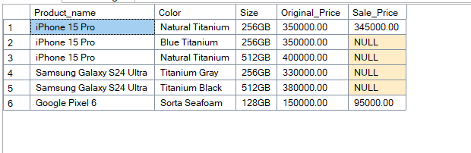

5- Get a Detailed Order Invoice (Complex SELECT with a Parameter)
- Scenario: A customer support agent needs a complete view of a specific order (@OrderID), including customer information, shipping address, all items ordered, prices paid, and payment/order statuses.
- Procedure to Create (sp_GetOrderInvoice): Create a procedure that accepts an @OrderID as a parameter and runs a complex query joining multiple tables to return a comprehensive invoice-like report for that single order.
- Business Use: For customer support dashboards and "Print Invoice" features.
Code:
CREATE PROCEDURE sp_GetOrderInvoice
@OrderID INT
AS
BEGIN
SELECT
O.Order_Number,
U.First_name,
U.Last_name,
A.Address_Line_1,
A.Address_Line_2,
P.Product_name,
P_V.Color,
P_V.Size,
((O_I.Original_Price_Per_Unit - O_I.Discount_Per_Unit) * O_I.Quantity) AS Price_Paid,
O.Payment_Status,
O.Status
FROM Orders AS O
INNER JOIN Users AS U ON O.User_Id = U.ID
INNER JOIN Addresses AS A ON O.Shipping_Address_Id = A.ID
INNER JOIN Order_Items AS O_I ON O.ID = O_I.Order_Id
INNER JOIN Product_variants AS P_V ON O_I.Product_variant_Id = P_V.ID
INNER JOIN Products AS P ON P_V.Product_ID = P.ID
WHERE O.ID = @OrderID
END

EXEC sp_GetOrderInvoice @OrderID = 2;

Output:
6-Change an Order's Status (Encapsulating Business Logic)
- Scenario: The warehouse staff needs to update an order's status e.g (from 'Processing' to 'Shipped'). When this happens, the Shipped_at column must also be updated with the current timestamp.
- Procedure to Create (sp_UpdateOrderStatus): Create a procedure that accepts an @OrderID and @NewStatus as parameters. Inside the procedure, update the Orders table. Use conditional logic (an IF statement) to set the Shipped_at column to GETDATE() only if the @NewStatus is 'Shipped'.
- Business Use: To control the workflow of the order management system used by internal staff.

Code:
ALTER PROCEDURE sp_UpdateOrderStatus
@OrderID INT, @NewStatus VARCHAR(50)
AS
BEGIN

UPDATE Orders
SET Status = @NewStatus
WHERE ID = @OrderID

IF @NewStatus = 'Shipped'
BEGIN
UPDATE Orders
SET Shipped_at = GETDATE()
WHERE ID = @OrderID AND Shipped_at IS NULL
END
IF @NewStatus = 'Delivered'
BEGIN
UPDATE Orders
SET Delivered_at = GETDATE()
WHERE ID = @OrderID AND Delivered_at IS NULL
END
END

EXEC sp_UpdateOrderStatus @OrderID = 2, @NewStatus = 'Shipped'
Output:
Before Execution:
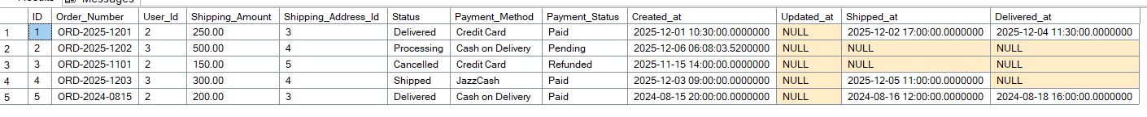
After Execution:
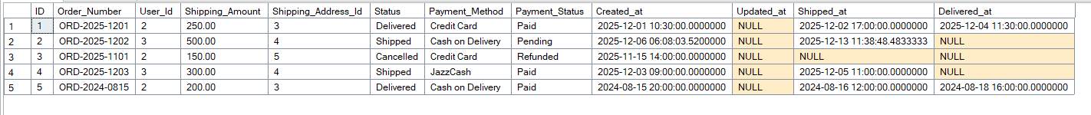

7-Update Inventory Stock Levels (Handling Positive/Negative Values)
Scenario: When an order is fulfilled, the stock for the ordered items must be decreased. If an order is cancelled, the stock must be returned to inventory.
Procedure to Create (sp_UpdateStockQuantity): Create a procedure that accepts a @ProductVariantID and a @QuantityChange (which can be a positive or negative integer). The procedure will update the Stock_quantity column in the Product_variants table accordingly (Stock_quantity = Stock_quantity + @QuantityChange).
Business Use: To automate inventory management during order fulfillment and cancellation.
Code:
SELECT *
FROM Product_variants;

CREATE PROCEDURE sp_UpdateStockQuantity
@ProductVariantID INT, @QuantityChange INT
AS
BEGIN
UPDATE Product_variants
SET Stock_quantity = Stock_quantity + @QuantityChange
WHERE ID = @ProductVariantID
END

EXEC sp_UpdateStockQuantity @ProductVariantID = 1 , @QuantityChange = -1;
Output:
Before Execution:
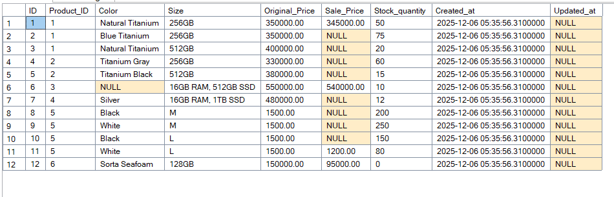
After Execution:
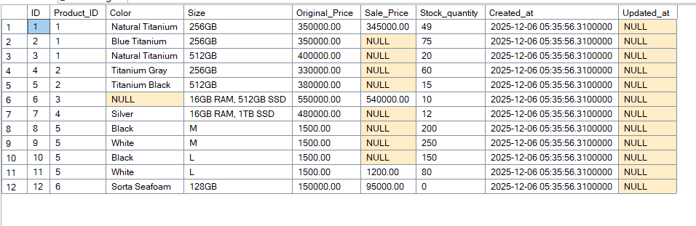

8- Add an Item to a User's Shopping Cart (Logic with IF/ELSE)
- Scenario: When a user clicks the "Add to Cart" button, the system must check if the item is already in their cart. If it is, the quantity should be increased (UPDATE). If it isn't, a new item should be added (INSERT).
- Procedure to Create (sp_AddItemToCart): Create a procedure that accepts @UserID, @ProductVariantID, and @Quantity. It will first check if the item EXISTS in the user's cart and then perform either an UPDATE or an INSERT operation.
- Business Use: To power the core functionality of the "Add to Cart" button.
Code:
CREATE PROCEDURE sp_AddItemToCart
@UserId INT, @ProductVariantID INT, @Quantity INT
AS
BEGIN

IF EXISTS(SELECT 1 FROM Cart_items WHERE User_Id = @UserId AND Product_variant_Id = @ProductVariantID)
BEGIN
UPDATE Cart_items
SET Quantity = Quantity + @Quantity
WHERE User_Id = @UserId AND Product_variant_Id = @ProductVariantID
END

ELSE
BEGIN
INSERT INTO Cart_items(User_Id, Product_variant_Id, Quantity)
VALUES
(@UserId, @ProductVariantID, @Quantity)
END

END

EXEC sp_AddItemToCart @UserId = 2, @ProductVariantID = 7, @Quantity = 3;
EXEC sp_AddItemToCart @UserId = 3, @ProductVariantID = 7, @Quantity = 3;
Output:
Before Execution:
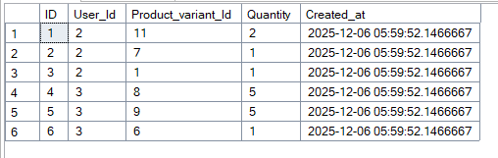
After Execution:
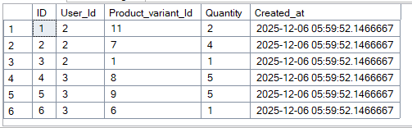
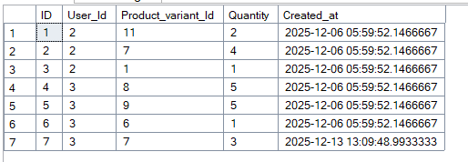
9-Transfer Stock Between Product Variants
- Scenario: Business Use: Imagine that due to a warehouse error, inventory for one product variant (e.g., "Red T-Shirts") was mistakenly added to another variant's stock (e.g., "Blue T-Shirts"). A manager needs a safe way to correct this by moving a specific quantity of stock from one variant to another.
- Procedure to Create (sp_TransferStock): Create a stored procedure that accepts three parameters:
@SourceVariantID (The ID of the variant to decrease stock from).
@DestinationVariantID (The ID of the variant to increase stock for).
@QuantityToTransfer (The amount of stock to move).
Code:
CREATE PROCEDURE sp_TransferStock
@SourceVariantID INT,
@DestinationVariantID INT,
@QuantityToTransfer INT
AS
BEGIN
BEGIN TRY
BEGIN TRANSACTION

UPDATE Product_variants
SET Stock_quantity = Stock_quantity - @QuantityToTransfer
WHERE ID = @SourceVariantID

UPDATE Product_variants
SET Stock_quantity = Stock_quantity + @QuantityToTransfer
WHERE ID = @DestinationVariantID

COMMIT TRANSACTION

END TRY

BEGIN CATCH
ROLLBACK TRANSACTION
END CATCH
END

EXEC sp_TransferStock @SourceVariantID = 2, @DestinationVariantID = 1, @QuantityToTransfer = 10
Output:
Before Execution:
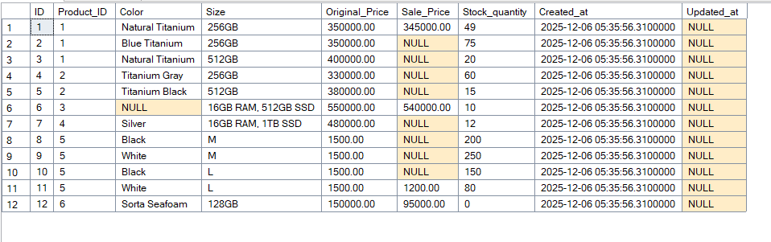

After Execution:
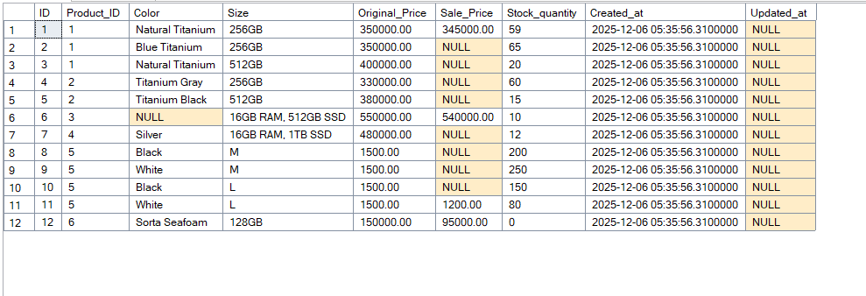

Functions:
1-Calculate the Final Price of a Variant
- Scenario: You need to consistently determine an item's actual current price. The business rule is: "If a Sale_Price exists and is valid, use it; otherwise, use the Original_Price." You don't want to write this CASE statement in every single query.
- Function to Create (fn_GetFinalPrice): Create a function that accepts a @ProductVariantID and returns a single DECIMAL value representing the final price after checking for a valid sale price.
- Business Use: This ensures that price calculations are always consistent, whether on a product page, in the cart, or in reports.
Code:
CREATE FUNCTION fn_GetFinalPrice (
@ProductVariantID INT
)
RETURNS DECIMAL(10, 2)
AS
BEGIN

DECLARE @OriginalPrice DECIMAL(10, 2);
DECLARE @SalePrice DECIMAL(10, 2);
DECLARE @FinalPrice DECIMAL(10, 2);

SELECT
@OriginalPrice = Original_Price,
@SalePrice = Sale_Price
FROM
Product_variants
WHERE
ID = @ProductVariantID;

IF @SalePrice IS NOT NULL AND @OriginalPrice > @SalePrice
BEGIN
SET @FinalPrice = @SalePrice;
END
ELSE
BEGIN
SET @FinalPrice = @OriginalPrice;
END

RETURN @FinalPrice;
END;

SELECT
ID,
Product_ID,
Color,Size,
dbo.fn_GetFinalPrice(ID) AS Final_Price
FROM Product_variants;

2-Get a User's Full Name
- Scenario: Many parts of your application and reports need to display a user's full name (e.g., "Ali Khan"), but your database stores First_name and Last_name in separate columns.
- Function to Create (fn_GetFullName): Create a function that accepts a @UserID. It will query the Users table and return a single VARCHAR string by concatenating the first and last names with a space in between.
- Business Use: Simplifies queries for generating reports, invoices, or displaying "Welcome, [User's Name]!" on the website.

Code:
CREATE FUNCTION fn_GetFullName(@UserID INT)
RETURNS VARCHAR(100)
AS
BEGIN
DECLARE @FullName VARCHAR(100);

SELECT @FullName = First_name + ' ' + Last_name
FROM Users
WHERE ID = @UserID

RETURN @FullName

END

SELECT First_name, Last_name, dbo.fn_GetFullName(ID) AS FULL_NAME
FROM Users

Output:
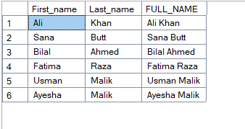
3- Calculate the Total Items in a Specific Order
- Scenario: On an order summary page or in a report, you want to quickly show the total number of items (sum of all quantities) that were in a specific order.
- Function to Create (fn_GetTotalItemCountForOrder): Create a function that accepts an @OrderID. It will query the Order_items table, SUM() the Quantity column for that order, and return a single integer (INT).
- Business Use: Useful for logistics (to know how big an order is) and for displaying order summaries to customers.
Code:
CREATE FUNCTION fn_GetTotalItemCountForOrder(@OrderID INT)
RETURNS INT
AS
BEGIN
DECLARE @Sum_Quantity INT;

SELECT @Sum_Quantity = SUM(Quantity)
FROM Order_Items
WHERE Order_Id = @OrderID

RETURN @Sum_Quantity
END

SELECT
O.Order_Number,
O.Created_at,
O.Status,
dbo.fn_GetTotalItemCountForOrder(O.ID) AS Total_Items_in_Order
FROM Orders AS O
WHERE O.ID = 1;
Output:
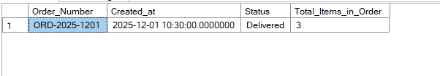
4-Get All Addresses for a Specific User
- Scenario: When a user is at the checkout page, they need to see a list of all their saved shipping addresses to choose from.
- Function to Create (fn_GetUserAddresses): Create an inline table-valued function (iTVF) that accepts a @UserID. It will return a table containing all columns from the Addresses table for that specific user.
- Business Use: Directly powers the "Select a Shipping Address" dropdown menu during the checkout process.
Code:
CREATE FUNCTION fn_GetUserAddresses(@UserID INT)
RETURNS TABLE
AS
RETURN(
SELECT *
FROM Addresses
WHERE User_Id = @UserID
)

SELECT *
FROM fn_GetUserAddresses(1)
Output:
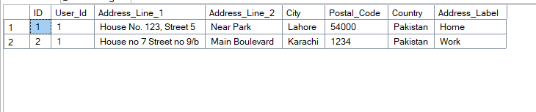
5- Get All Order Items for a Specific Order
- Scenario: You need to get all the line items for a specific order to generate an invoice or a packing slip for the warehouse.
- Function to Create (fn_GetOrderLineItems): Create an iTVF that accepts an @OrderID. The function will JOIN Order_items with Products and Product_variants to return a detailed table of every item in that order (name, color, size, quantity, price paid, etc.).
- Business Use: This is a reusable component for any feature that needs to display the contents of a specific order. It's more flexible than a stored procedure because its result can be joined with other tables.
Code:
CREATE FUNCTION fn_GetOrderLineItems (
@OrderID INT
)
RETURNS TABLE
AS
RETURN (
SELECT
o.Order_Number,
p.Product_name,
pv.Color,
pv.Size,
oi.Quantity,
oi.Original_Price_Per_Unit,
oi.Discount_Per_Unit,
(oi.Original_Price_Per_Unit - oi.Discount_Per_Unit) * oi.Quantity AS Line_Total
FROM
Order_items AS oi
JOIN
Product_variants AS pv ON oi.Product_variant_Id = pv.ID
JOIN
Products AS p ON pv.Product_ID = p.ID
JOIN
Orders AS o ON oi.Order_Id = o.ID
WHERE
oi.Order_Id = @OrderID
);

SELECT * FROM dbo.fn_GetOrderLineItems(2);
Output:
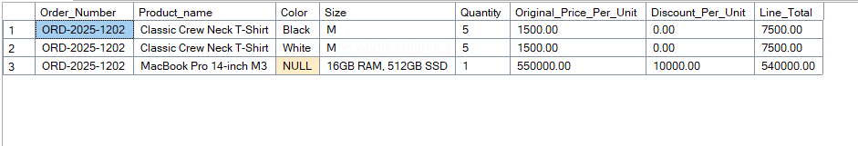

6- Search Products by Keyword
- Scenario: Your website's search bar must return a list of all products that match a user's keyword search.
- Function to Create (fn_SearchProducts): Create a Function that accepts a @SearchTerm as a parameter. The function will return a table of all products where the Product_name or Description contains the search term (using the LIKE operator).
- Business Use: This function is called by your application's backend every time a user performs a search.

Code:
ALTER FUNCTION fn_SearchProducts (@SearchTerm VARCHAR(255))
RETURNS TABLE
AS
RETURN
(
SELECT *
FROM Products
WHERE (Product_name LIKE '%'+@SearchTerm+'%' OR Description LIKE '%'+@SearchTerm+'%') AND Status != 'Inactive'
)

SELECT *
FROM fn_SearchProducts('IPHONE')

Output:
Triggers:
1-Automatically Set Updated_at Timestamp (AFTER UPDATE)
- Scenario: Whenever a record in the Products table is modified (e.g., its Description is updated), the Updated_at column for that record must be automatically updated to the current timestamp.
- Business Use: This is essential for data tracking and auditing, as it provides a reliable timestamp for the last modification of any record.
- Trigger to Create (trg_SetProductUpdatedAt on Products table): Create an AFTER UPDATE trigger on the Products table. When fired, it will use the inserted magic table to identify the updated row(s) and execute an UPDATE statement to set their Updated_at column to GETDATE().

Code:
CREATE TRIGGER trg_SetProductUpdatedAt
ON Products
AFTER UPDATE
AS
BEGIN
UPDATE Products
SET Updated_at = GETDATE()
WHERE ID IN(
SELECT ID
FROM INSERTED AS I
)
END
Output:
SELECT *
FROM Products;
Product table before Update
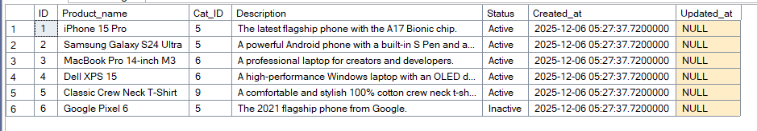

UPDATE PRODUCTS
SET Description = 'Good Mobile'
WHERE ID = 2
Product Table after Update:
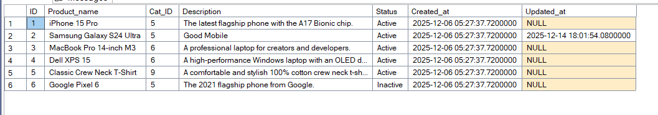

2-Scenario: Automatically Set Updated_at Timestamp for Categories (AFTER UPDATE)
- Scenario: Whenever a record in the Categories table is modified (for example, its name or status is changed), the Updated_at column for that specific record must be automatically updated to the current timestamp.
- Business Use: The Categories table is also a critical part of the data structure. Having an Updated_at timestamp on this table is essential for tracking when category information was last modified, which is helpful for content managers and for auditing changes to the store's structure.
- Trigger to Create (trg_SetCategoryUpdatedAt on Categories table): Create an AFTER UPDATE trigger on the Categories table. When this trigger fires, it should execute an UPDATE statement that uses the ID from the inserted magic table to set the Updated_at column to GETDATE() for all the modified rows.

Code:
CREATE TRIGGER trg_SetCategoryUpdatedAt
ON Categories
AFTER UPDATE
AS
BEGIN
UPDATE Categories
SET Updated_at = GETDATE()
WHERE ID IN(
SELECT ID
FROM INSERTED
)
END;
Output:
SELECT *
FROM Categories;
Before Update:
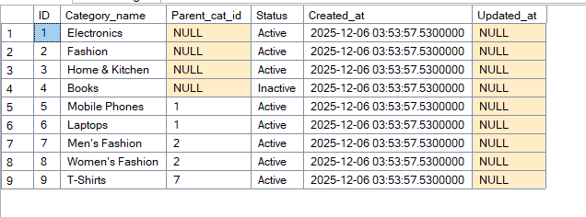
UPDATE Categories
SET Category_name = 'Books & Magazines'
WHERE ID = 4;

SELECT *
FROM Categories;

After Update:
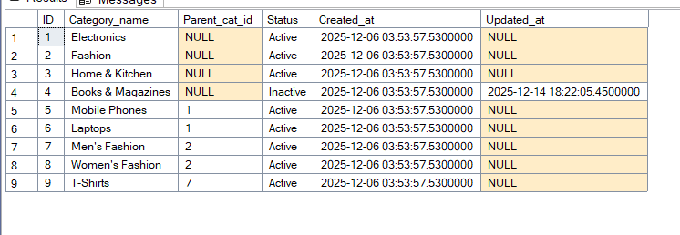
3-Scenario: Automatically Set Updated_at Timestamp for Product_variants (AFTER UPDATE)
- Scenario: Whenever a record in the Product_variants table is modified the Updated_at column for that record must be automatically updated to the current timestamp.
- Business Use: This is extremely important for inventory management and price analysis. It allows you to track key events, such as "When was the price of this T-shirt last changed?" or "When was the stock for this mobile phone last updated?". This provides a clear audit trail for the most frequently changing data in the catalog.
- Trigger to Create (trg_SetVariantUpdatedAt on Product_variants table): Create an AFTER UPDATE trigger on the Product_variants table. When this trigger fires, it should execute an UPDATE statement that uses the ID from the inserted magic table to set the Updated_at column to GETDATE() for all the modified rows.

Code:
CREATE TRIGGER trg_SetVariantUpdatedAt
ON Product_variants
AFTER UPDATE
AS
BEGIN
UPDATE Product_variants
SET Updated_at = GETDATE()
WHERE ID IN(
SELECT ID
FROM INSERTED
)
END

Output:
Before Update Product_variants
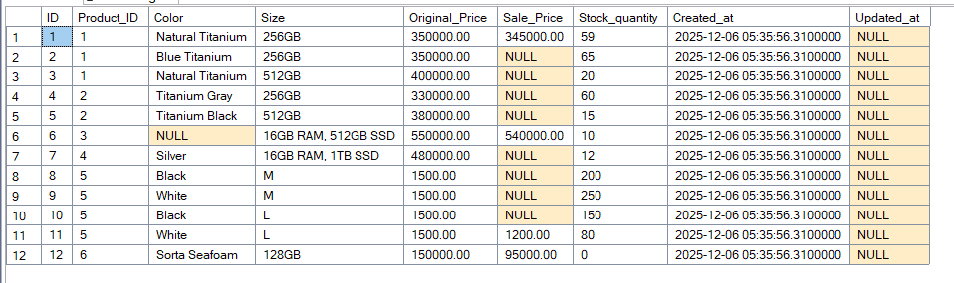

UPDATE Product_variants
SET Color = 'Black'
WHERE ID = 6

SELECT *
FROM Product_variants;
After Update:
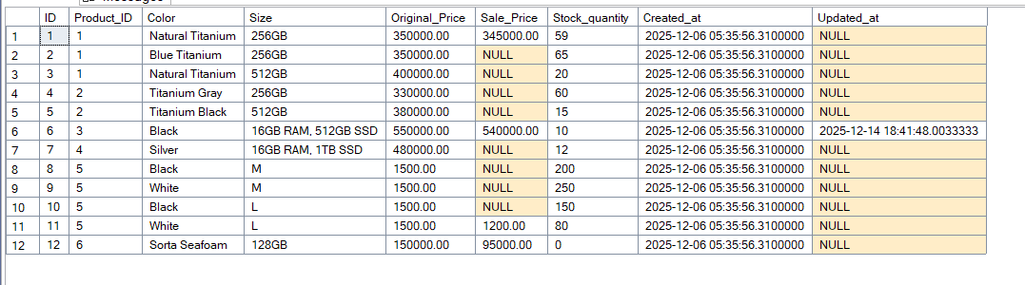

4- Scenario: Automatically Set Updated_at Timestamp for Users (AFTER UPDATE)
- Scenario: Whenever a user's record in the Users table is modified (e.g., their Phone_number, Status, or Password_hash is changed), the Updated_at column for that user's record must be automatically updated to the current timestamp.
- Business Use: This is a critical security and administrative feature. It provides a clear audit trail for when any user's profile was last altered, which is essential for tracking status changes, password resets, or updates to personal information.
- Trigger to Create (trg_SetUserUpdatedAt on Users table): Create an AFTER UPDATE trigger on the Users table. When this trigger fires, it will execute an UPDATE statement that uses the ID from the inserted magic table to set the Updated_at column to GETDATE() for all the modified rows.
Code:
CREATE TRIGGER trg_SetUserUpdatedAt
ON Users
AFTER UPDATE
AS
BEGIN
UPDATE Users
SET Updated_at = GETDATE()
WHERE ID IN(
SELECT ID
FROM INSERTED
)
END

Output:
Before Update User Table
SELECT *
FROM Users;
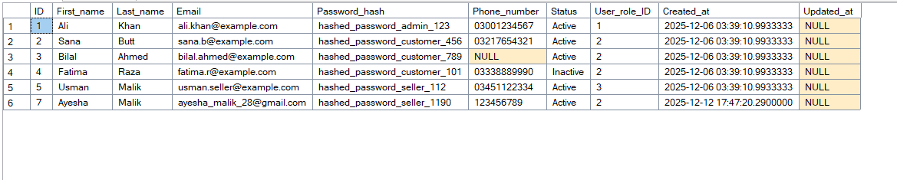
UPDATE Users
SET Password_hash = 'hashed_password_c_123'
WHERE ID = 3

SELECT *
FROM Users

After Update User Table
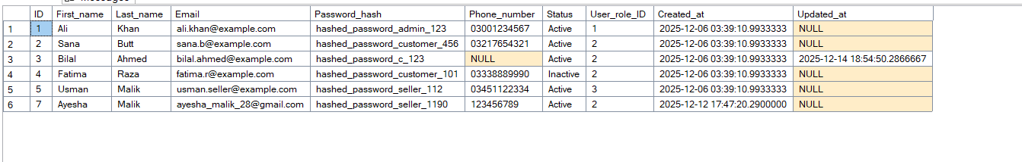
5- Scenario for User_roles Table
Scenario: Automatically Set Updated_at Timestamp for User_roles (AFTER UPDATE)
- Scenario: The User_roles table changes infrequently, but when it does (e.g., a Role_name is corrected from 'Admin' to 'Administrator'), it's important to know when that change occurred. The Updated_at column for that role must be automatically updated.
- Business Use: This provides an administrative log for changes to fundamental system roles. It helps track when permissions or role definitions were last modified, which is important for system governance.
- Trigger to Create (trg_SetRoleUpdatedAt on User_roles table): Create an AFTER UPDATE trigger on the User_roles table. When this trigger fires, it will execute an UPDATE statement that uses the ID from the inserted magic table to set the Updated_at column to GETDATE() for the modified row(s).
Code:
CREATE TRIGGER trg_SetRoleUpdatedAt
ON User_roles
AFTER UPDATE
AS
BEGIN
UPDATE User_roles
SET Updated_at = GETDATE()
WHERE ID IN(
SELECT ID
FROM INSERTED
)
END
Output:
Before Update
SELECT *
FROM User_roles
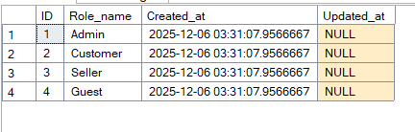

After Update
UPDATE User_roles
SET Role_name = 'New Guest'
WHERE ID = 4;

SELECT *
FROM User_roles;
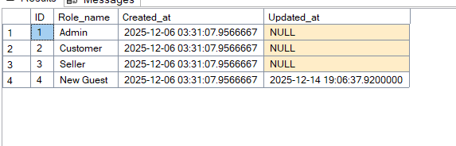
6- Scenario: Automatically Set Updated_at Timestamp for Orders (AFTER UPDATE)
- Scenario: Whenever a record in the Orders table is modified (especially important columns like Status or Payment_Status), the Updated_at column for that record must be automatically updated to the current timestamp.
- Business Use: This is critical for tracking the order lifecycle. It provides an immediate and reliable record of when the last action was taken on an order, which is invaluable for customer support, debugging fulfillment issues, and analyzing operational bottlenecks.
- Trigger to Create (trg_SetOrderUpdatedAt on Orders table): Create an AFTER UPDATE trigger on the Orders table. When this trigger fires, it will get the list of IDs from the inserted magic table and execute an UPDATE statement to set the Updated_at column to GETDATE() for all the affected rows.
Code:
CREATE TRIGGER trg_SetOrderUpdatedAt
ON Orders
AFTER UPDATE
AS
BEGIN
UPDATE Orders
SET Updated_at = GETDATE()
WHERE ID IN(
SELECT ID
FROM INSERTED
)
END
Output:
Before Update:
SELECT *
FROM Orders
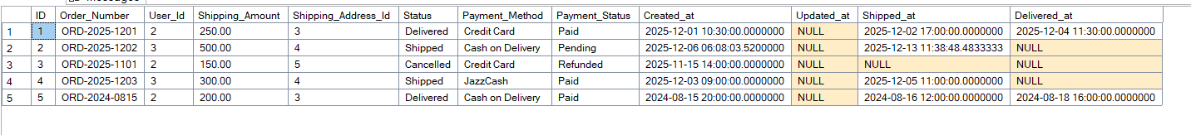
After Update:
UPDATE Orders
SET Delivered_at = GETDATE()
WHERE ID = 2

SELECT *
FROM Orders
