Table of Contents
1 Group Members: 3
2 Project Overview: 3
3 Detected Sequences: 3
4 Basic features of the project: 3
5 Optional features: 3
6 State transition diagram: 4
7 Tables: 4
7.1 Assignment of States: 4
7.2 Excitation Table D-flipflop: 4
7.3 Final State Table: 5
8 Equations for FSM: 5
8.1 Equation for D1: 5
8.2 Equation for D0: 5
8.3 Equation for Y: 6
9 Implementation: 6
9.1 D₁ logic: 6
9.2 D0 logic: 6
9.3 Y logic: 7
9.4 Main FSM: 7
9.5 Counter implementation: 7
9.6 Seven Segment Display (Using 7447 IC): 8
9.6.1 Display for FSM State Indication: 8
9.6.2 Display for Counter Output: 9
9.7 Main Circuit: 10
10 Circuit Diagrams: 11
10.1 D1 Subcircuit: 11
10.2 D0 Subcircuit: 11
10.3 Y Subcircuit: 11
10.4 Main FSM Subcircuit: 12
10.5 Seven Segment Display Implementation (State) Subcircuit: 12
10.6 Seven Segment Display Implementation (Counter) Subcircuit: 13
10.7 Main Circuit: 13
11 Individual Contributions: 14
12 GitHub Repository and Project Resources: 14

Group Members:
- Usman Rasheed Siddiqui (CS-24038) (Group Leader)
- Khwaja Syed Hurraim Bin Ather (CS-24040)
- Ebrahim Rizvi (CS-24041)

Project Overview:
This project involves the design and implementation of a Finite State Machine (FSM)–based Sequence Detector that identifies the binary sequences ‘001’ and ‘010’ in a serial input stream. The FSM produces an output ‘1’ whenever either of the specified sequences is detected, and ‘0’ otherwise.
A seven-segment display shows the current state, while another, connected to a counter, displays the number of detections.

Detected Sequences:
This project implements an overlapping Mealy-type FSM that detects the following binary sequences from the input bit stream:
✅ 001
✅ 010
The FSM produces an output “1” as soon as the last bit of either of the sequences is received.
As it is an overlapping sequence, bits from one sequence can act as the starting bit of another sequence, which ensures continuous sequence detection during input stream.

Basic features of the project:
- Detects binary sequence ‘001’ and ‘010’ using an overlapping Mealy FSM.
- Produces an output ‘1’ when a sequence is detected, displayed via an LED indicator.
- Operates with a clock signal to synchronize detections.
- Includes a reset button to reset the FSM to its initial state.
- Accepts a serial input stream for sequence detection.

Optional features:
- Circuit increments a counter each time a valid sequence is detected.
- The counter is limited to a maximum count of 9 detections.
- Shows the total number of detections on one seven-segment display connected to the counter.
- A reset pin to reset the counter to initial state.
- The circuit displays the current FSM state on another seven-segment display.

State transition diagram:
A total of 4 states were used to design the FSM. These are as follows:

- S₀ indicates Initial State
- S₁ indicates a “0” is detected
- S₂ indicates “00” is detected
- S₃ indicates a “01” is detected
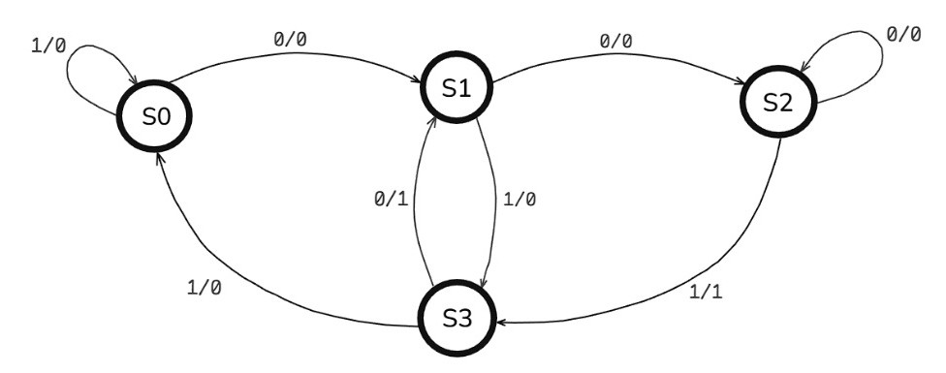
The diagram below shows the transition between the states:
Figure 1: State Transition Diagram

Tables:

Assignment of States:
States | $$Q_{1}$$ | $$Q_{0}$$
$$S_{0} ≜$$ | 0 | 0
$$S_{1} ≜$$ | 0 | 1
$$S_{2} ≜$$ | 1 | 0
$$S_{3} ≜$$ | 1 | 1

Excitation Table D-flipflop:
According to the excitation table of D-flip flop, the next state (Q_{t+1}) is simply whatever is put on D at the clock edge:
$$Q_{t+1} = D$$
$$Q_{t}$$ | $$Q_{t+1}$$ | $$D$$
0 | 0 | 0
0 | 1 | 1
1 | 0 | 0
1 | 1 | 1

Final State Table:

$$X$$ | $$Q_{1}$$ | $$Q_{0}$$ | $$Q_{1}’$$ | $$Q_{0}’$$ | $$Y$$ | $$D_{1}$$ | $$D_{0}$$
$$0$$ | $$0$$ | $$0$$ | $$0$$ | $$1$$ | $$0$$ | $$0$$ | $$1$$
$$0$$ | $$0$$ | $$1$$ | $$1$$ | $$0$$ | $$0$$ | $$1$$ | $$0$$
$$0$$ | $$1$$ | $$0$$ | $$1$$ | $$0$$ | $$0$$ | $$1$$ | $$0$$
$$0$$ | $$1$$ | $$1$$ | $$0$$ | $$1$$ | $$1$$ | $$0$$ | $$1$$
$$1$$ | $$0$$ | $$0$$ | $$0$$ | $$0$$ | $$0$$ | $$0$$ | $$0$$
$$1$$ | $$0$$ | $$1$$ | $$1$$ | $$1$$ | $$0$$ | $$1$$ | $$1$$
$$1$$ | $$1$$ | $$0$$ | $$1$$ | $$1$$ | $$1$$ | $$1$$ | $$1$$
$$1$$ | $$1$$ | $$1$$ | $$0$$ | $$0$$ | $$0$$ | $$0$$ | $$0$$

Equations for FSM:
Following are the equations derivation for D₁, D₀ and Y.

Equation for D1:
$$Q_{1}Q_{0}$$
00 01 11 10
$$X$$
0
1
 | 1 |  | 1
 | 1 |  | 1

$$D_{1}=\overline{Q_{1}}Q_{0}+Q_{1}\overline{Q_{0}}$$
$$∴\overline{A} B+A \overline{B}=A ⨁ B$$
$$D_{1}=Q_{1}⊕Q_{0}$$

Equation for D0:
00 01 11 10
0
1
$$X$$
$$Q_{1}Q_{0}$$

1 |  | 1
 | 1 |  | 1

$$D_{0}= \overline{X} {\overline{Q}}_{1}\overline{ Q_{0}}+X\overline{Q_{1}}Q_{0}+\overline{X}Q_{1}Q_{0}+XQ_{1}{\overline{Q}}_{0}$$
$$∵ A(B + C) = AB + AC$$
$$D_{0}= \overline{X} {(\overline{Q}}_{1}\overline{ Q_{0}}+Q_{1}Q_{0})+X(\overline{Q_{1}}Q_{0}+Q_{1}{\overline{Q}}_{0})$$
$$D_{0}= \overline{X}(Q_{1} ⨀ Q_{0})+X(Q_{1} ⨁ Q_{0})$$
$∴A ⨀{B}=\overline{A ⨁{B}}$
$$D_{0}= \overline{X}(\overline{Q_{1} ⨁ Q_{0}})+X(Q_{1} ⨁ Q_{0})$$
$$∴A ⨀ B= \overline{A} \overline{B} +AB$$
$$D_{0}= X ⨀ (Q_{1} ⨁ Q_{0})$$

Equation for Y:
00 01 11 10
0
1
$$X$$
$$Q_{1}Q_{0}$$
1
1

$$Y= \overline{X}Q_{1}Q_{0}+XQ_{1}{\overline{Q}}_{0}$$
$$∵ A(B + C) = AB + AC$$
$$Y=Q_{1}(\overline{X}Q_{0}+ X{\overline{Q}}_{0})$$
$$∴\overline{A} B+A \overline{B}=A ⨁ B$$
$$Y= Q_{1}(X ⨁ Q_{0})$$

Implementation:
The circuit implements one 7474 IC that contains two D flip flops. Let D₁ be the input of first flip flop and D₀ be the input of second flip flop. Let Q₁ be the output of first flip flop and Q₀ be the output of second flip flop. Let Y be the final output received. The combinational logics of D₁, D₀ and Y are given by:

D₁ logic:
$D_{1}$(output pin 11) is obtained by applying $XOR$ to $Q_{1}$(output pin 12) and $Q_{0}$ (output pin 13) using 7486 IC (Derived in 7.1).

D0 logic:
$D_{0}$ (from output pin 11 of 747266 IC) is the $XNOR$ of (Derived in 7.2):
- $X$ (input pin 12).
- $XOR$ of $Q_{1}$ (pin 12) and $Q_{0}$ (pin 13), output taken from pin 11 of 7486 IC and given at input (pin 13) of 747266 IC.

Y logic:
$Y$ (from output pin 11 of 7408 IC) is the $AND$ of (Derived in 7.3):
- $Q1$ (input pin 12).
- $XOR$ of $X$ (pin 12) and $Q_{0}$ (pin 13), output taken from pin 11 of 7486 IC and given at input (pin 13) of 7408 IC.

Main FSM:
A 7474 IC is used to make the main FSM which contains two D flip-flops. Following are the connections:
- Power Connections
- VCC (pin 14) is connected to power.
- GND (pin 7) is connected to ground.
- Input and Reset
- The X input pin is connected to inputs of D₀ and Y respectively.
- A RESET pin is connected to a NOT gate and is given to the IC’s CLR (active low) at pin 1 and 13.
- Clock and Flip-Flop Connections
- A CLK (clock) pin is connected to the CLK inputs of IC at pin 3 and 11.
- The D₁ logic output is given as input to pin 2 (input of first D flip flop).
- The D₀ logic output is given as input to pin 12 (input of second D flip flop).
- State and Output Logic Connections
- The Q₁ and Q₀ outputs from pins 5 and 9 respectively are connected to the D₁, D₀ and Y combinational logic’s Q₁ and Q₀ inputs respectively.
- An output Y is obtained from Y’s combinational logic which is indicated by an LED to light up at 1.

Counter Implementation:
A 74163 IC is used to implement a four-bit synchronous counter. Following connections are implemented:

- Power Connections
- VCC (pin 16) is connected to power.
- GND (pin 8) is connected to ground.
- Clock and Enable Inputs
- A CLK (clock) pin is connected to the CLK input of IC at pin 2.
- The ENT (Terminal Count Enable pin 10) is connected to an output pin Y; it allows the counter to increase if ENP is also HIGH.
- The ENP (Parallel Enable pin 7) is connected to power; It directly enables the counter to count.
- Counter Outputs
- The outputs of the counter are obtained from QA (pin 14), QB (pin 13), QC (pin 12) and QD (pin 14) (QA – QD: LSB – MSB).
- Load and Reset Mechanism
- The outputs QA and QD are also given to a 7400 NAND gate IC at pins 1 and 2 respectively, and the output (pin 3) is given to the Load input (active low) (pin 9).
- The Load input is used to disable and enable parallel loading.
- When QA and QD are both 1, an active low input is sent to the Load input which sets the IC in parallel loading mode.
- The inputs A (pin 3), B (pin 4), C (pin 5) and D (pin 6) are connected to ground to set the IC to all 0’s as soon as the Load input receives a zero.
- This ensures that when 9 (1001) is obtained at the counter, the Load sets the counter to parallel mode and grounded A, B, C and D set the IC to all 0000 at the next clock so a new count can start.

Seven Segment Display (Using 7447 IC):
The 7447 BCD to Seven Segment Decoder/Driver IC was used to drive a seven-segment display.

Display for FSM State Indication:
The following connections were implemented:
- Power Connections:
- VCC (pin 16) is connected to power (+5 V).
- GND (pin 8) is connected to ground.

- BCD Input Pins:
- The Q0 output pin of second flip flop is given to the A input (pin 7).
- The Q1 output pin of first flip flop is given to the B input (pin 1).
- The C (pin 2) and D (pin 6) are connected to ground.

- Control Pins:
- LT (Lamp Test, pin 3) connected to VCC to disable test mode.
- BI (Blanking Input, pin 5) connected to VCC to prevent blanking of display.
- RBI (Ripple Blanking Input, pin 7) connected to VCC to disable ripple blanking.

- Segment Output Pins:
The a (pin 13), b (pin 12), c (pin 11), d (pin 10), e (pin 9), f (pin 15), g (pin 14) are NOT first through a 7404 IC and given as output pins to be connected to the corresponding seven segment display in the main circuit.

Display for Counter Output:
The following connections were implemented:
  - Power Connections:
- VCC (pin 16) is connected to power (+5 V).
- GND (pin 8) is connected to ground.

  - BCD Input Pins:
The BCD input pins A (pin 7), B (pin 1), C (pin 2), and D (pin 6) are connected to the counter outputs Qa, Qb, Qc, and Qd respectively.

  - Control Pins:
- LT (Lamp Test, pin 3) connected to VCC to disable test mode.
- BI (Blanking Input, pin 5) connected to VCC to prevent blanking of display.
- RBI (Ripple Blanking Input, pin 7) connected to VCC to disable ripple blanking.

  - Segment Output Pins:
The a (pin 13), b (pin 12), c (pin 11), d (pin 10), e (pin 9), f (pin 15), g (pin 14) are NOT first through a 7404 IC and given as output pins to be connected to the corresponding seven segment display in the main circuit.

Main Circuit:
The main circuit includes all subcircuits of the project into a single functional design.
It receives an input bit stream (X), a clock (CLK) signal, and reset controls for both the FSM and the counter.
The main FSM processes the input stream, while the display circuits show the FSM’s current state and the number of detections on seven-segment displays.
An LED is also used to visually indicate when the FSM’s output Y = 1.
- Inputs:
- X: Input pin for the binary input stream.
- CLK: Common clock signal provided to the FSM and the counter.
- RESET: Resets the FSM and all internal states.
- RESET_COUNTER: Resets the counter circuit (requires a clock pulse due to synchronous reset).
- Outputs:
- Y: Output of the FSM that indicates detection of the required sequence; also connected to an LED for indication.
- Q₁, Q₀: Outputs representing the FSM’s current state, displayed on the seven-segment display through the 7447 IC.
- a–g: Segment outputs from the two 7447 ICs connected to the respective seven-segment displays.
- Implemented Subcircuits:
- Main FSM Circuit:
– Takes inputs X, CLK, and RESET.
– Produces outputs Y, Q₁, and Q₀.
- State Display Circuit (7447 IC):
– Takes FSM outputs Q₁ and Q₀ as inputs.
– Displays the current state on a seven-segment display.
- Counter and Display Circuit (74163 + 7447):
– Takes inputs Y, RESET_COUNT, and CLK.
– Counts the total number of detections (up to 9).
– Displays the count on another seven-segment display.
- Display and Output Indication:
  - The two seven-segment displays are used to show the FSM current state and the number of detections respectively.
  - An LED connected to output Y turns ON when the required sequence (001 or 010) is detected.

Circuit Diagrams:

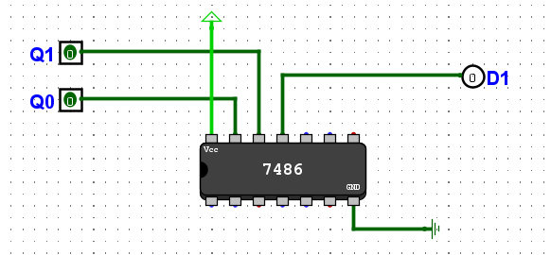
D1 Subcircuit:
Figure 2: D1 Combinational Subcircuit

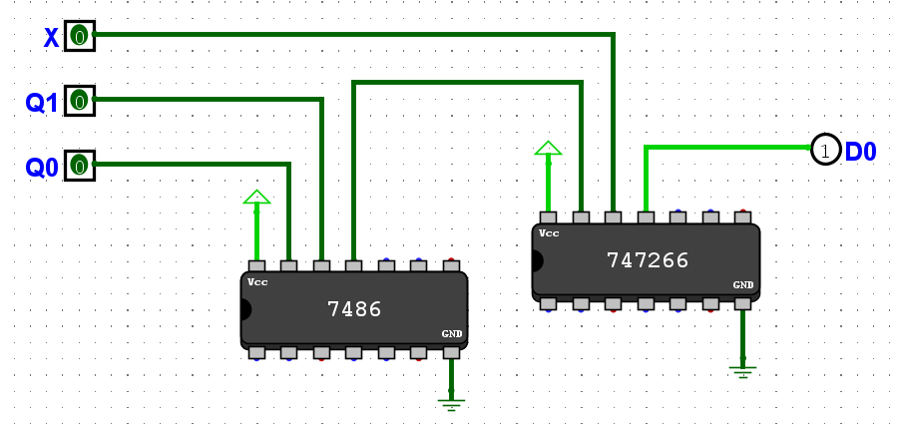
D0 Subcircuit:
Figure 3: D0 Combinational Subcircuit

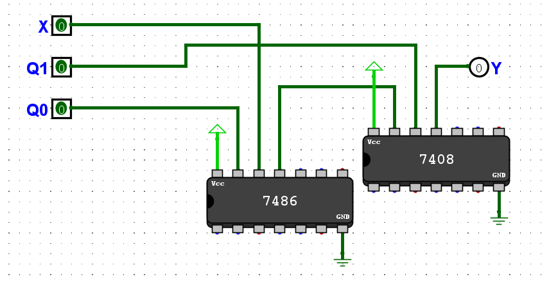
Y Subcircuit:

Figure 4: Y Combinational Subcircuit

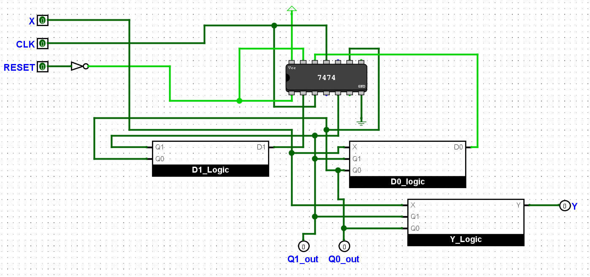
Main FSM Subcircuit:
Figure 5: Main FSM Subcircuit

Seven Segment Display Implementation (State) Subcircuit:
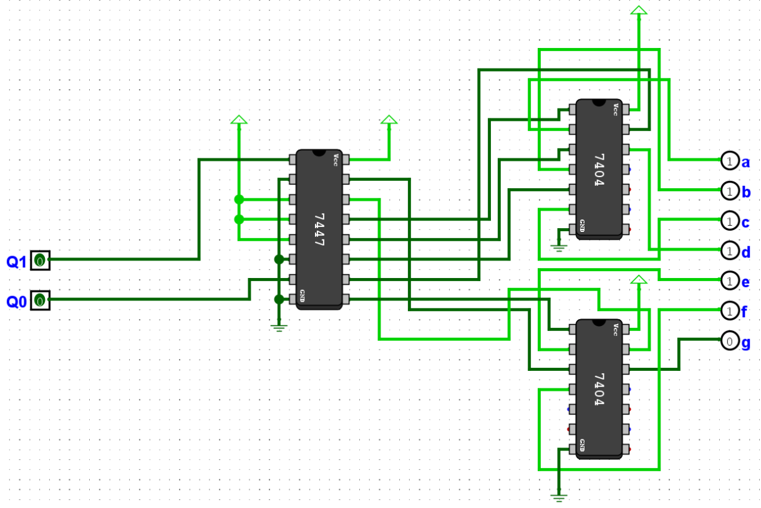

Figure 6: 7447 IC for Seven Segment Display (Current States)

Seven Segment Display Implementation (Counter) Subcircuit:
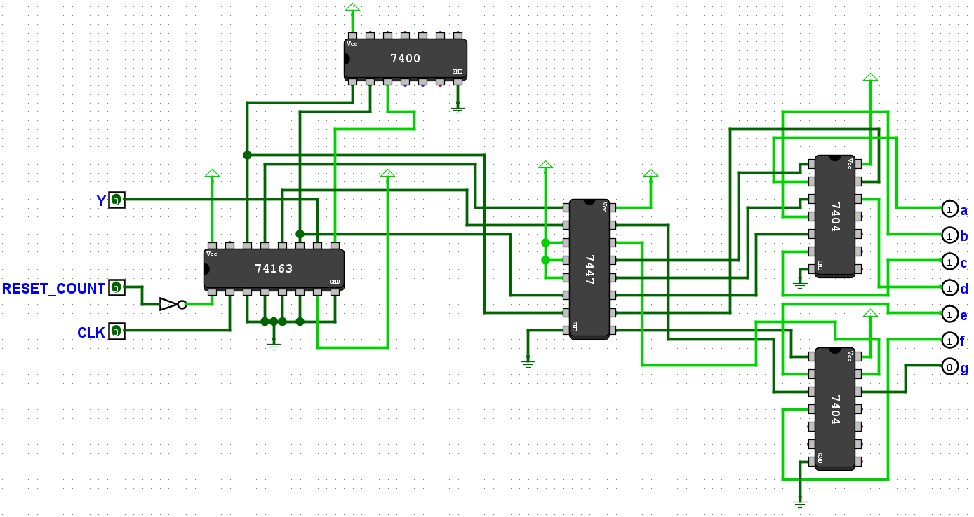
Figure 7: 7447 IC and 74163 IC for Implementing and Displaying Count

Main Circuit:
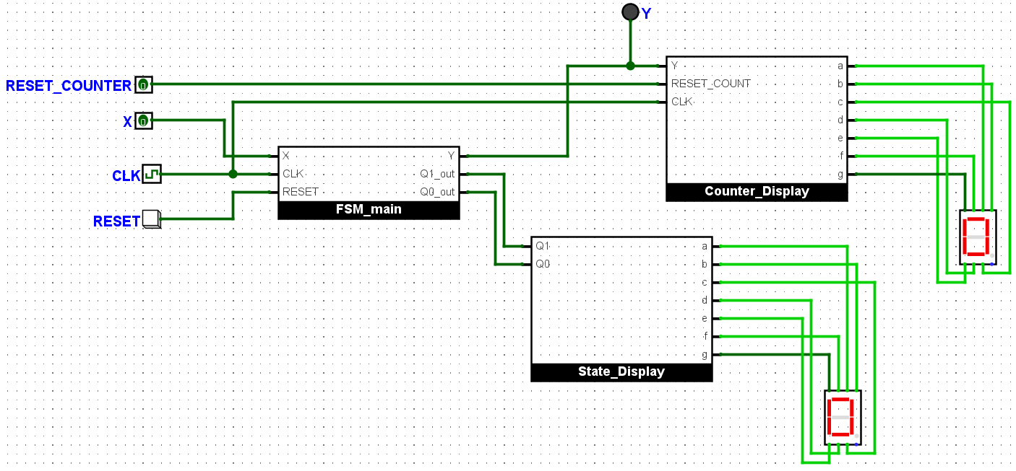
Figure 8: Main Circuit Implementation

Individual Contributions:
  - Usman Rasheed Siddiqui (CS-24038):
Designed the complete FSM, prepared the state table, state diagram, excitation tables, derived the logic equations, made the counter and executed the seven segment displays. Implemented the full Logisim circuit simulation and handled most of the hardware arrangement. Also prepared the main structure and technical content of the report.

  - Khwaja Syed Hurraim Bin Ather (CS-24040):
Helped in digitizing the state diagram and assisted with parts of the hardware setup during implementation. Also, contributed to sections of the written report.
  - Ebrahim Rizvi (CS-24041):
Assisted with reviewing the report and simulation and supported the hardware phase by contributing to component procurement. Also, contributed to sections of the written report.

GitHub Repository and Project Resources:
All project files and supporting documents are available in the GitHub repository linked below. This includes:
  - Complete Logisim circuit file
  - PDF version of the report
  - Word document of the report
  - Simulation demonstration video
GitHub Repository Link:
https://github.com/Usman-Rasheed-Siddiqui/DLD-CEP

