Contents

2. Introduction: 2
2.1 Problem Description: 2
2.2 Project Scope: 2
3. Features of the Circuit: 2
3.1 Electrical Characteristics: 2
3.2 Components Used: 3
3.3 Distinguishing Features of Experiment: 3
4. Flow of Experiment: 3
4.1 Circuit Configuration: 3
4.2 Circuit Diagram: 4
4.3 Physical Circuit: 4
5. Technical Concepts: 5
5.1 RLC Series Theory: 5
5.2 Energy Storage Equations: 5
6. Challenges Faced During Experiment: 5
7. Calculations: 6
7.1 Resonant (natural) angular frequency $ω0$: 6
7.2 Damping factor $α$: 6
7.3 Characteristic roots s: 6
7.4 Time constants (magnitudes): 6
7.5 50% (t₅₀) or “time-delay” estimate: 7
8. Observations: 7
9. Conclusion: 7

Introduction:

Problem Description:
The objective of this experiment is to analyze an Acceptor (RLC Series) resonant circuit and study its transient energy storage characteristics. A 9V supply energizes the circuit, and the LED glow duration after removing the supply reflects the energy stored in the inductor and capacitor.
The system demonstrates:
- Energy stored in capacitor & inductor
- Slow discharge through resistance
- Overdamped transient behavior

Project Scope:
This experiment focuses on:
- Understanding RLC behavior without AC resonance testing
- Measuring stored energy visibility through LED light
- Observing the extended discharge response

Features of the Circuit:

Electrical Characteristics:
- Series-connected components
- High resistance that causes slow decay
- LED to demonstrate energy storage
- Capacitor stores electric energy, and inductor stores magnetic energy

Components Used:
Component | Value
Resistor 1 | 15 kΩ
Resistor 2 | 4.7 kΩ
Inductor (L) | 20 mH
Capacitor (C) | 2200 µF
LED | Standard Blue LED
Power Source | 9V DC

Distinguishing Features of Experiment:
- Long LED after-glow (approximately 4.5 minutes)
- High-resistance overdamped response
- Slow exponential energy decay visually measurable
- Non-AC RLC demonstration (DC charging)

Flow of Experiment:

Circuit Configuration:
- 9V Supply
- 15 kΩ Resistor
- 20 mH Inductor
- 2200 µF Capacitor
- 4.7 kΩ Resistor
- LED

Circuit Diagram:
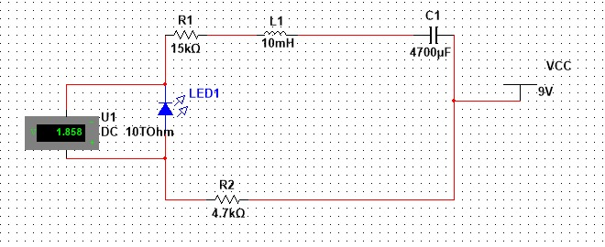
  - Multisim:

  - Graph:

Physical Circuit:
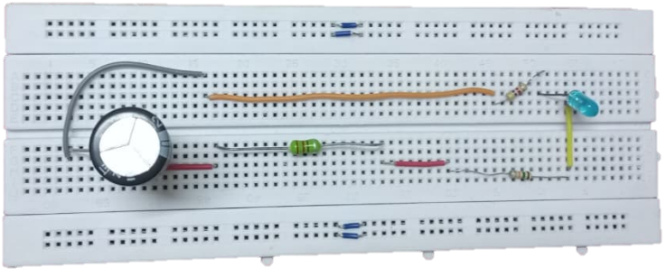

Technical Concepts:

RLC Series Theory:

Current remains same in the loop but:
- Inductor opposes sudden change in current
- Capacitor opposes sudden change in voltage

Energy Storage Equations:

  - Capacitor:
$$E_{C}=\frac{1}{2}CV^{2}$$
  - Inductor:
$$E_{L}=\frac{1}{2}LI^{2}$$

Challenges Faced During Experiment:

Area | Challenge
Component Selection | Ensuring safety for LED
Measurement | LED’s faint glow hard to detect in room light
Time Recording | Manual stopwatch introduces error

Calculations:
$R=19.7 KΩ=19.7 ×{10}^{3} Ω$ $= 19, 700 Ω$
$$C=2200 μF=2200×{10}^{-6}F=0.0022 F$$
$$L=10mH=10×{10}^{-3}H=0.01 H$$

Resonant (natural) angular frequency $ω_{0}$:
ω₀₌ $\frac{1}{\sqrt{LC}}$
ω₀₌ $\frac{1}{\sqrt{\left(0.01\right)*(0.0022)}}$
$$ω0 = 213.2 rad/sec$$

Damping factor $α$:
$$α= \frac{R}{2L}$$

$α=$ $\frac{19,700}{2(0.01)}$

$$α= 985,000 Np/sec$$
Since $α$ is greater than $ω_{o},$ The damping will be overdamped.

Characteristic roots s:
$s =$ $- α ± \sqrt{α^{2}-{ω_{o}}^{2}}$
$$s= -985,000 ± \sqrt{{(985,000)}^{2}-{(213.2)}^{2}}$$
$$s= -985,000 ± 984,999.9769$$
$$s1= -985,000+ 984,999.9769 s2= -985,000- 984,999.9769$$
$$s1= -0.0231 s^{-1} s2 = -1,969,999.977 s^{-1}$$

Time constants (magnitudes):
$$T1= -\frac{1}{s1}= -\frac{1}{-0.0231}=43.34 sec$$
$$T2= -\frac{1}{s2}= -\frac{1}{-1,969,999.977}=5.08 ×{10}^{-7} sec$$
The dominant time constant is $τ_{1}≈43.34\text{ s}$

50% (t₅₀) or “time-delay” estimate:
For an exponential decay, the time to reach 50% is about
$$t_{50}​≈0.693τ_{1}​≈0.693×43.34≈30.0 seconds.$$

Observations:
- Brightness ≈ 20–25 sec
- Faint visibility ≈ 4.5 minutes
- Smooth decay – no flicker

Conclusion:
The experiment confirms that an RLC series circuit can store and gradually release energy, demonstrating an overdamped transient response. The LED glow proves prolonged discharge behavior when resistance is high.

