Start of classic game:
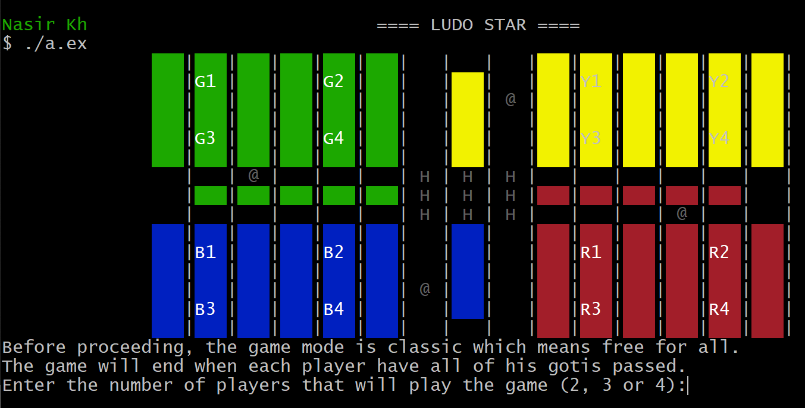
Choosed to play match of 4 and green got 6:
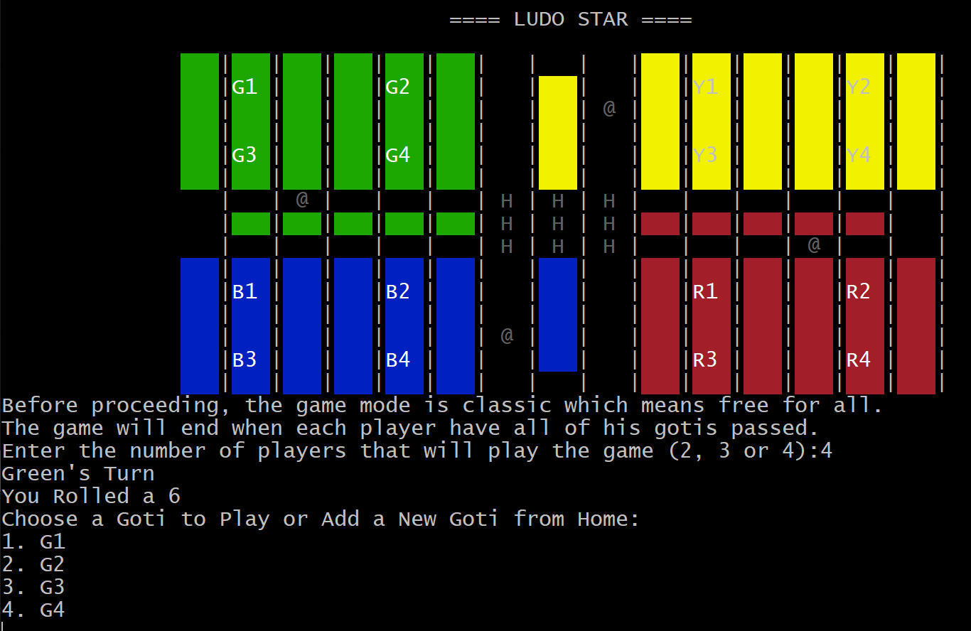
Unlocked G2 and got an extra move because of getting 6 previously:
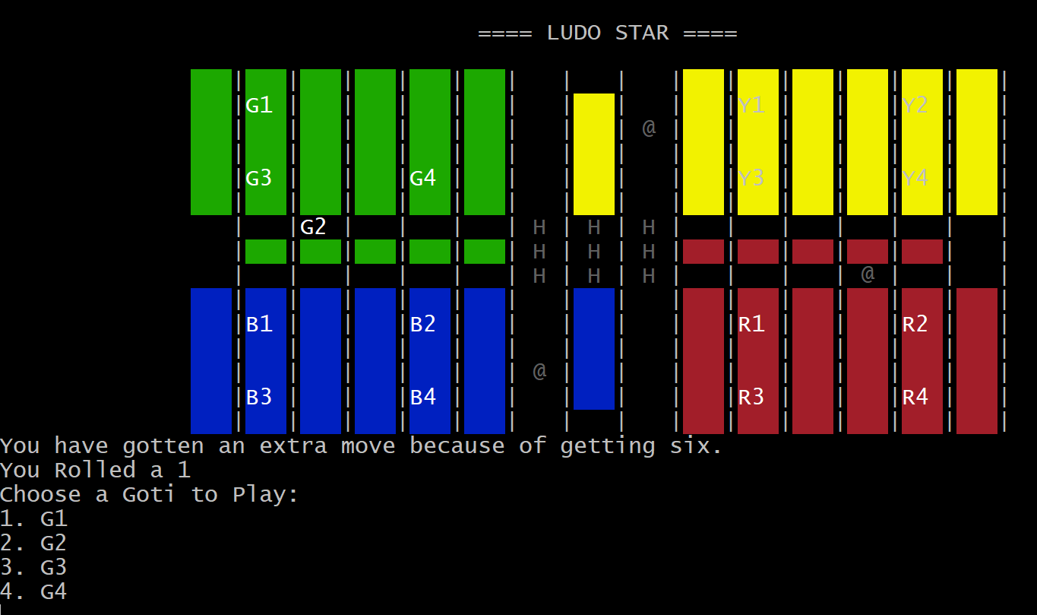
Blue still hasn’t gotten 6, and can’t move his pieces:
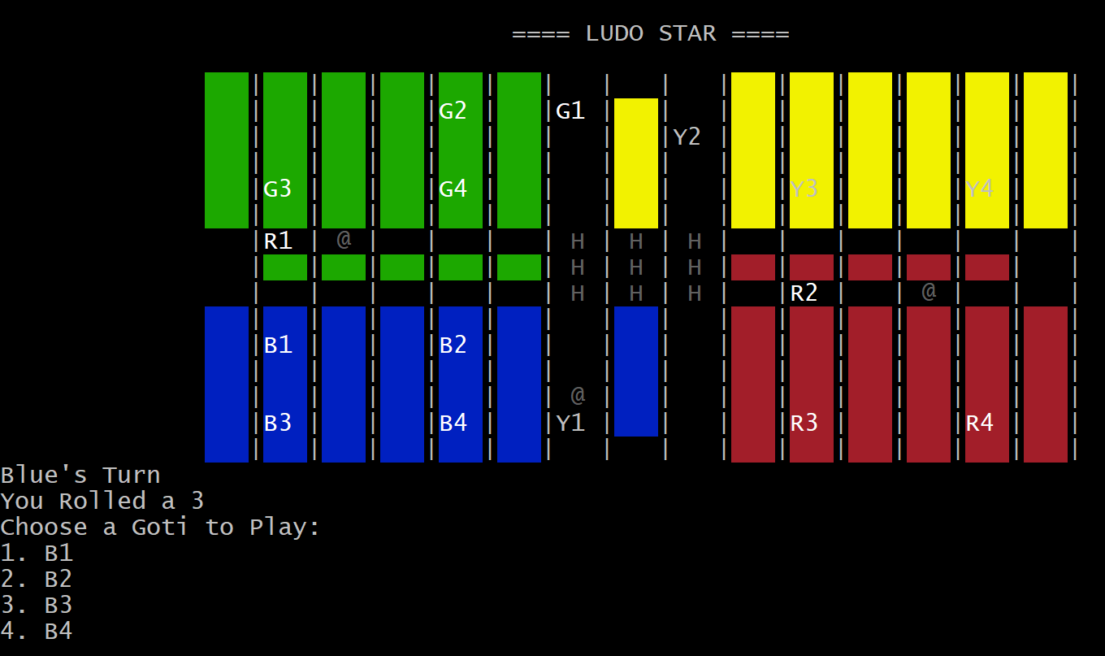
Green had 3 consecutive 6s:
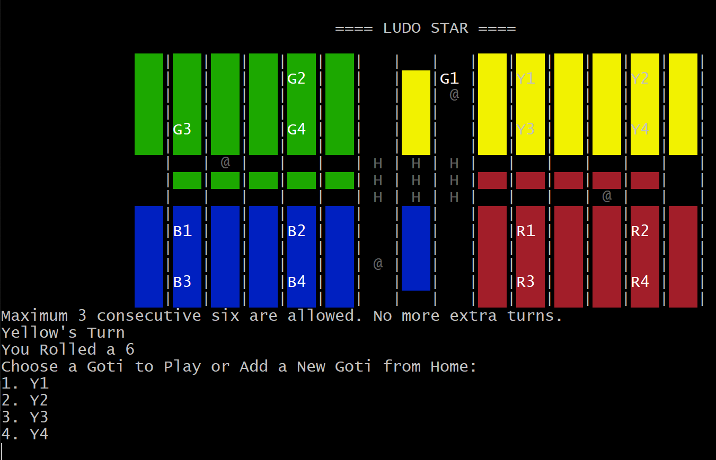
Green G1 got a 1, and he will send B1 to home:
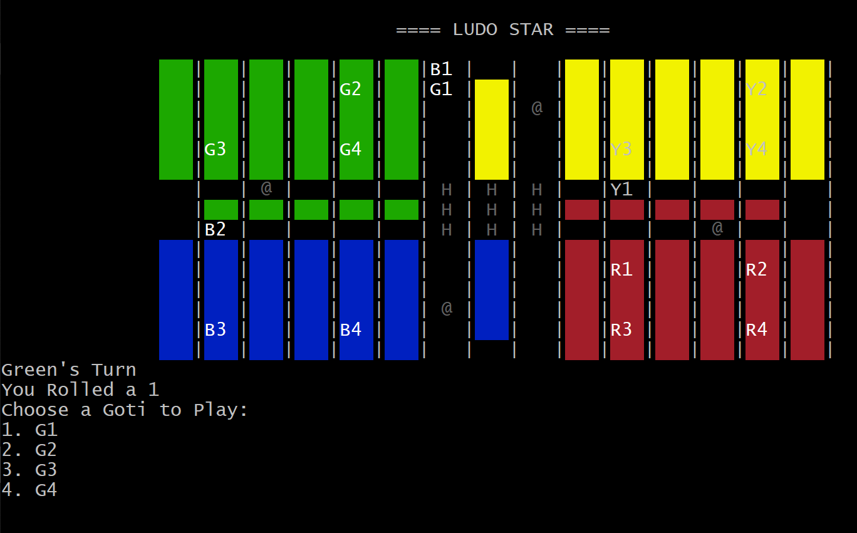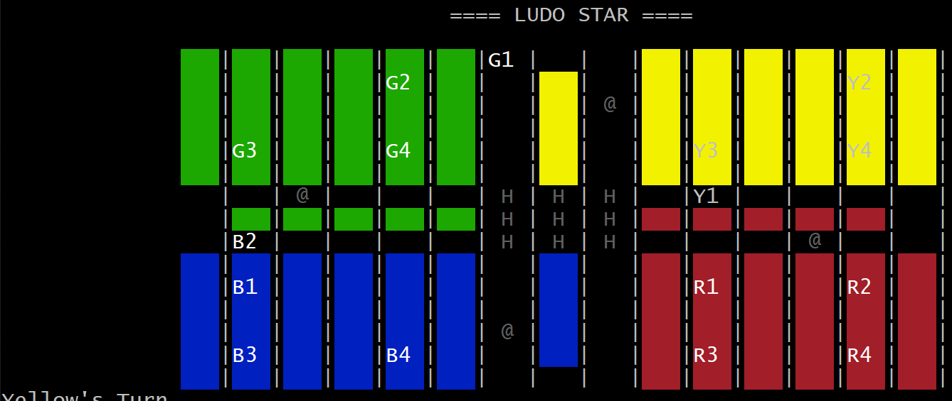
B2 has gotten 3 and can send Y2 back home, but Y2 is in safecell (@); Y2 doesn’t go home, it’s hidden by B2 only:
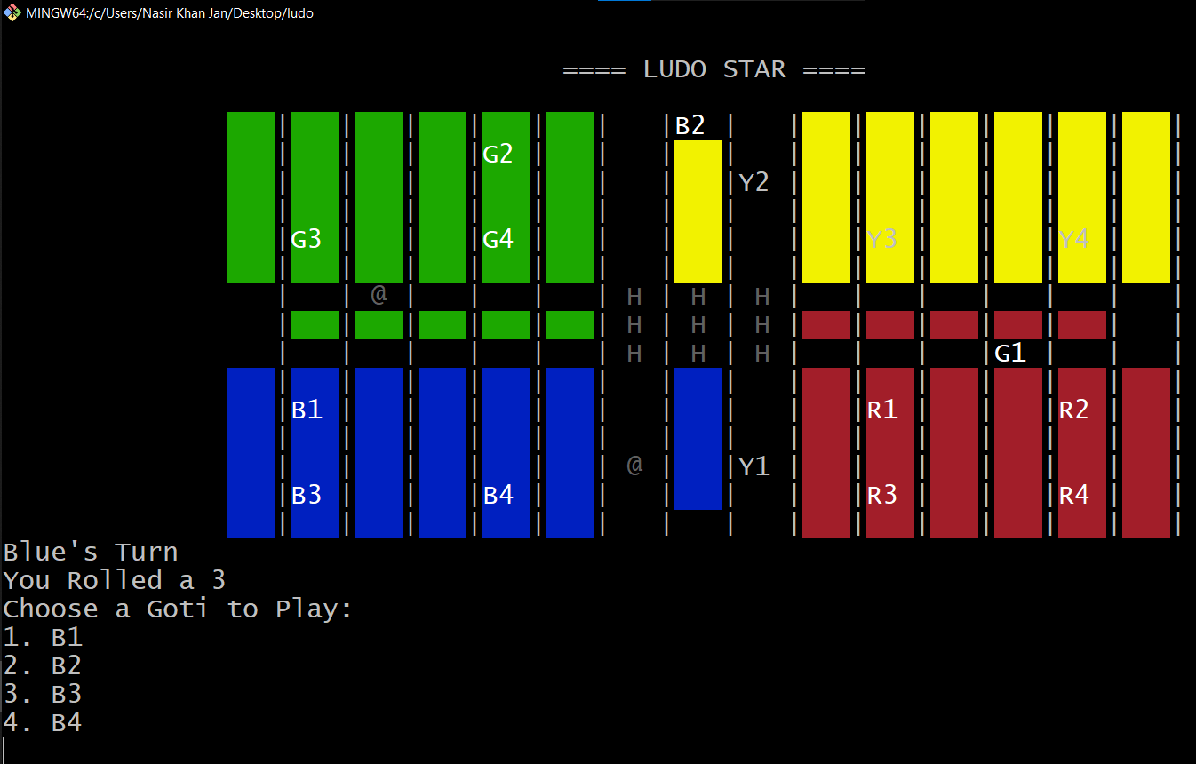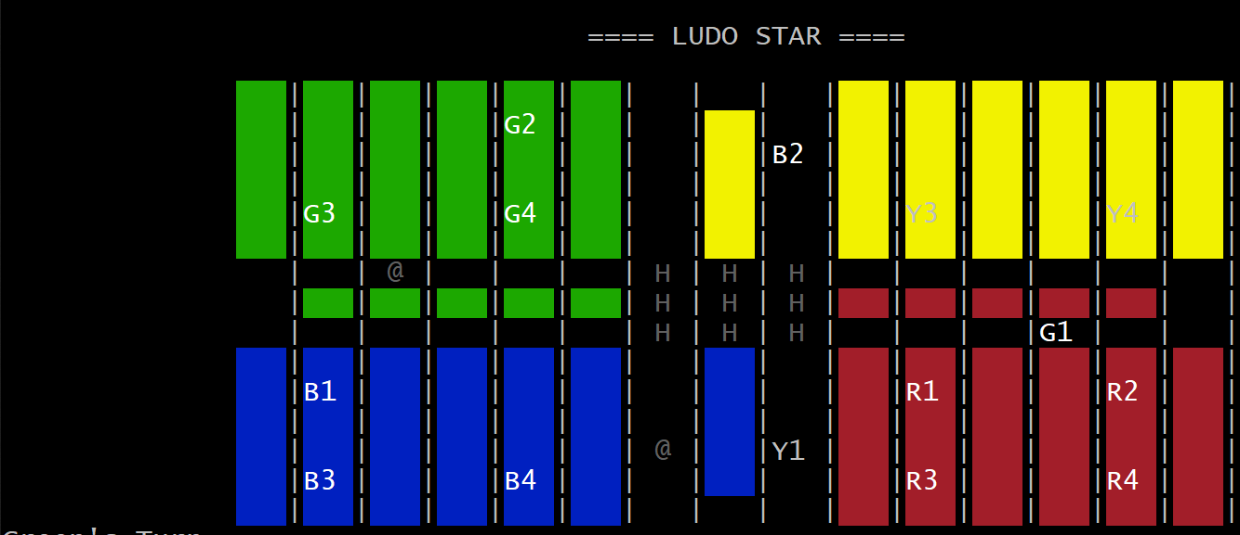
A classic game of 2 players was played to show the goti’s going in their home behaviour:
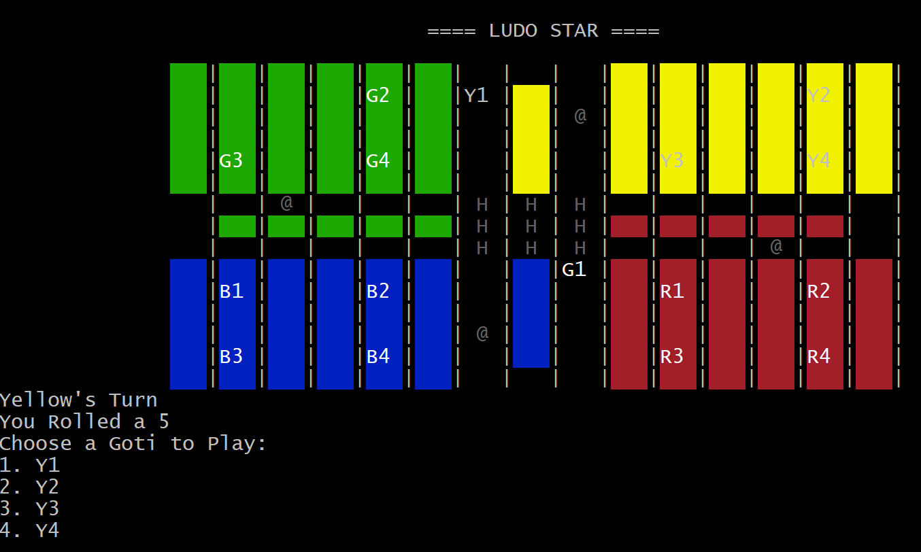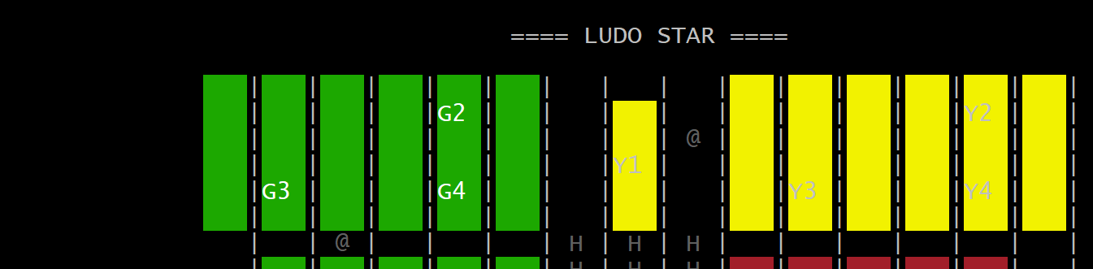
The goti G1 will pass, and can’t be played again (had gotten 6 in the 2nd image):
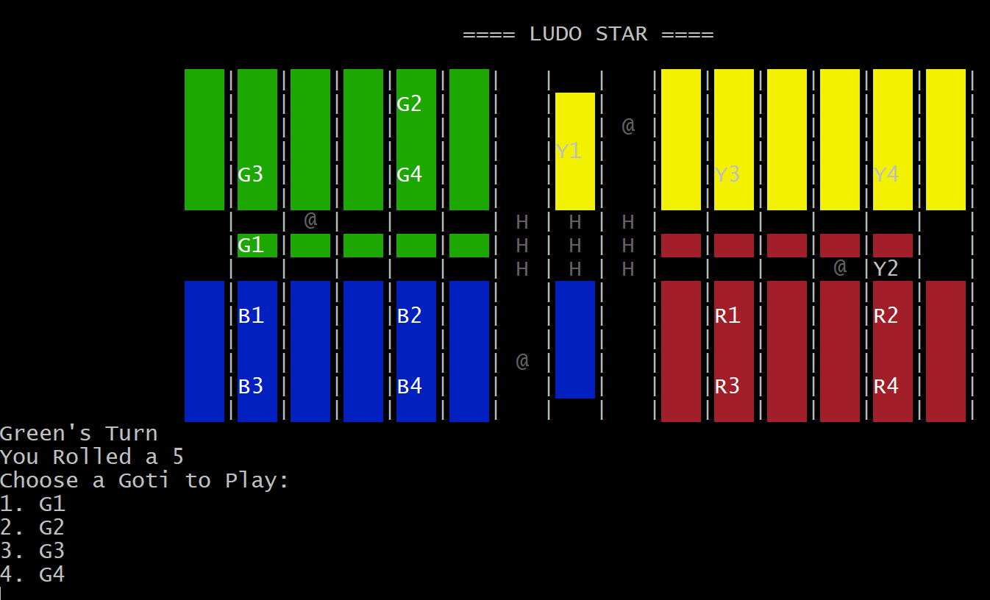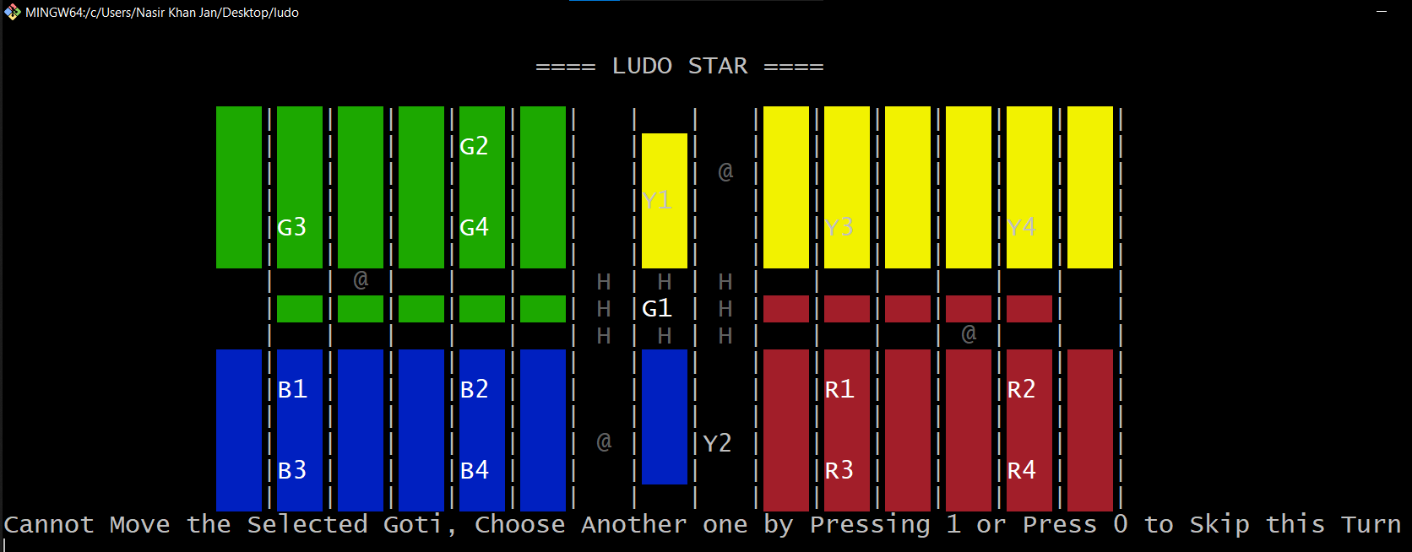
The classic mode game is finished:
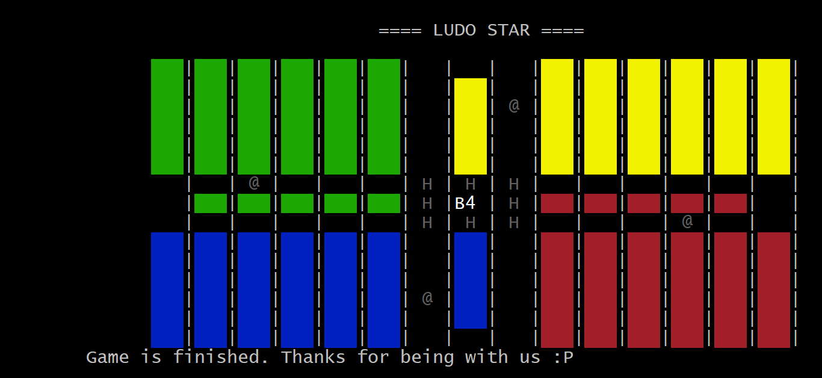
Start of the team mode:
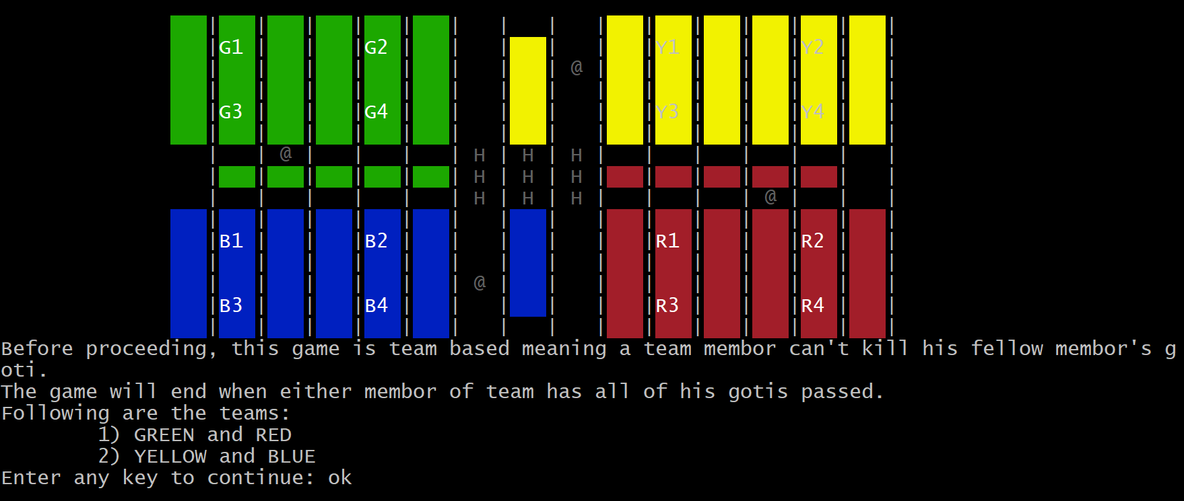
Y1 and Y2 are at safecells (@) and since they are teamed up with blue, they can’t send him back home. Y1 will be hidden beneath B1
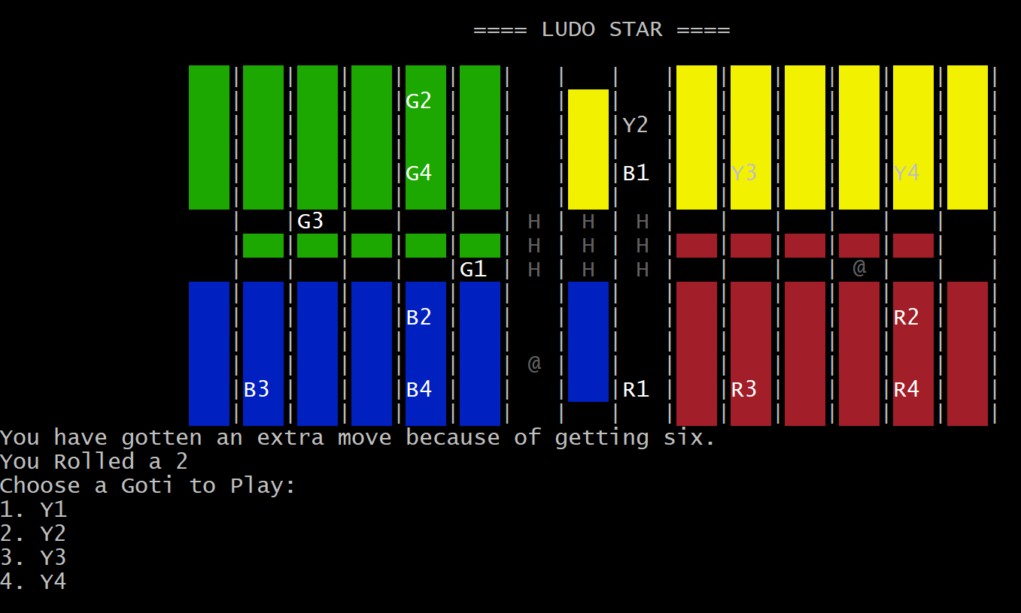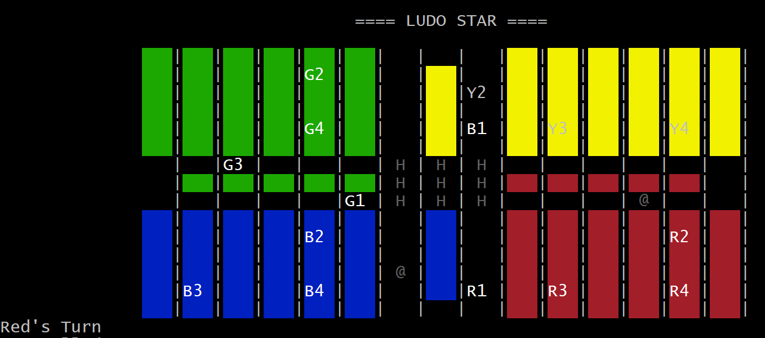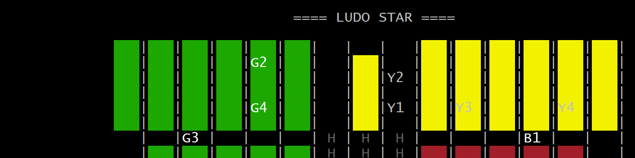
Team mode winning screen, green had all of its gotis passed:
