for="object in objects"

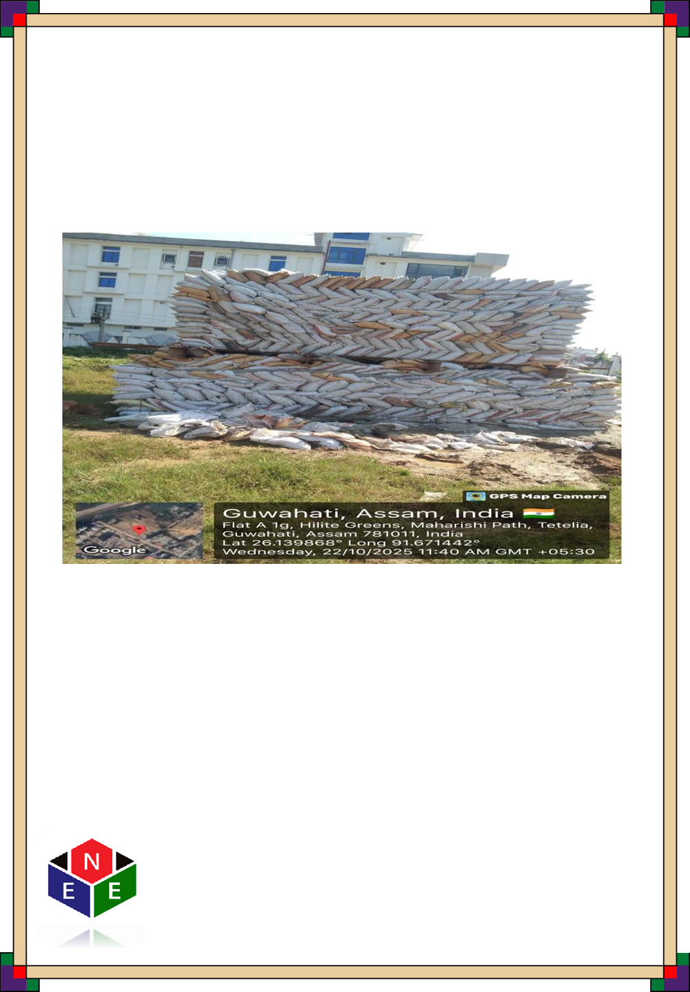
Name: name

  - INTRODUCTION:
introduction

  - OBJECTIVE:

objective

  - TESTING EQUIPMENTS:
Pressure gauge, Dial gauge with magnetic stand, Hydraulic Jack, Oil Pump fitted with Hose Pipe, Adopter for fixing pressure gauge, Kentledge-sand bags on ISMB Girder welded with plates on top.

  - TEST PROCEDURE:
test_procedure

  - : TABLE 1 : BASIC DATA:

Sl No | PARTICULARS | VALUES / DETAILS
for="obj in object.basic_data_ids"
sr_no | parameter | value
/for
  - INTERPRETATION :
interpretation

Date | Time | Load Applied | Dial Gauge Reading |  | Mean
Date | Time | Load Applied | (mm) |  | Mean
Date | (Hours) | (Tons) | A | B | (mm)
for="load in object.loading_reading_ids"
date | time_hours | load_tonne | dial_a | dial_b | mean_mm
/for
UNLOADING
for="load in object.unloading_reading_ids"
date | time_hours | load_tonne | dial_a | dial_b | mean_mm
/for

FIG 1 LOAD SETTLEMENT GRAPH FROM FIELD DATA
LOAD SETTLEMENT GRAPH

/for

