Probability and Statistics (MT-2005)

Project Report



**Submitted to:**

Ms Rijah Khan

**Submitted by:**

Usman Ali (22I-2725)

Momin Nazar (22I-2491)

BS-SE(E)

Table of Contents

1. Introduction: 3

2. Literature Review: 4

1. Report: Finance Division, Government of Pakistan: 4

2. Article: An Empirical analysis of Export, Import, and Inflation: 4

3. Research Paper: Reason of Inflation in Pakistan by SSRN Papers: 5

4. Report: Pakistan Economic Survey 2022-23 by Finance Division, Government of Pakistan: 5

5. Journal: Lahore Journal of Economics: 5

3. Regression Model and Variables: 6

4. Results: 8

1. Data Set: 8

2. Summary of Dependent and Independent Variables: 8

3. Box Plot 9

4. Scatter Plot 10

5. Regression Model: 11

5. References: 11

# Introduction:

Inflation is defined as an increase in the overall price level of goods and services in an economy over time. Inflation is caused by an imbalance between the economy's demand and supply. Since the rise of globalization and market industrialization, both domestic and foreign causes have contributed to inflationary pressure. The Russia-Ukraine war, disruptions in the global supply chain, overloaded ports, logistical challenges, and strong merchandise demand have all contributed to rising inflationary pressures in recent years. The Consumer Price Index (CPI) is the most extensively quoted and used.   
Pakistan is a net importer of foods and petroleum products. Since November 2021, the country has seen double-digit inflation due to a rise in crude oil prices caused by the worldwide crisis. The weakening of the Pakistani rupee pushed up the price of imported goods. The dollar's rise is primarily driven by fundamental issues such as US monetary policy tightening and the energy crisis.   
Thus, it is critical to identify the causes influencing inflation. The report includes a summary of the extensive statistical research to investigate the independent variables influencing inflation.

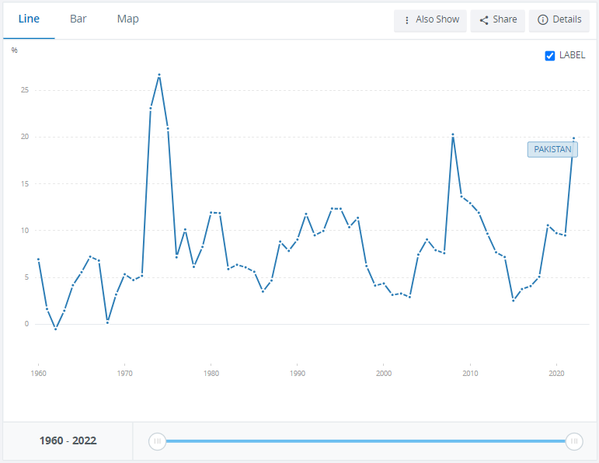

***Inflation (CPI Index) From 1960 - 2022***

# Literature Review:

## Report: Finance Division, Government of Pakistan:

According to the report provided by the Federal Division Pakistan said that, with few exceptions, global inflation has decreased during the past decade. Inflation has lately begun to climb again, owing to improved economic development. Pakistan's economy has followed a similar trajectory, with low inflation for numerous years and a dramatic increase in the last three years. Several internal and external causes have led to the recent increase in inflation in Pakistan. These variables include: a fast economic rebound resulting in a rise in income levels and the subsequent spike in domestic demand; the sustained pass-through effect of the previous rise in international oil prices; and a sharp pick up in the international prices of essential commodities.

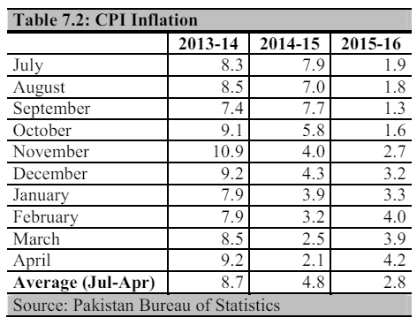

***Yearly CPI Analysis***

## Article: An Empirical analysis of Export, Import, and Inflation:

This article investigates the relationship between inflation, exports, and imports within the context of the Pakistani economy. The researchers collected monthly data on CPI (the inflation index), imports, and exports from July 2001 to June 2017.   
The researchers used the error correction model to explore the short-run correlation among the variables, whereas Johansen cointegration was used to investigate the long-run association among the variables. The Granger causality technique was used to determine the causal directionality of the pair of variables.

The analysis revealed that in the long run, a 1% rise in exports and imports causes 0.63% and 0.57% increases in the CPI (inflation), respectively. However, the coefficient of predictable error correlation indicates that the inflation rate's divergence from the long-run level of equilibrium is adjusted every year by around 1.18%. In contrast, the results of variance decomposition analysis (VDA) revealed that exports had the greatest innovation influence on the CPI (inflation) of all three indicators in the overall arrangement of inflation. Finally, the results of Granger causality and Toda Yamamoto causality do not support the hypothesis that monthly fluctuations in export and import do not cause a monthly change in inflation in the Pakistani economy.

## Research Paper: Reason of Inflation in Pakistan by SSRN Papers:

A devaluation in the Pakistani rupee can raise import prices, contributing to inflation.   
Global Commodity Prices: Like many other countries, Pakistan imports a variety of important commodities, including oil and food.

## Report: Pakistan Economic Survey 2022-23 by Finance Division, Government of Pakistan:

Pakistan's economy is no exception, as the country has experienced food and energy-driven inflation over the same time. Other variables are also contributing to the continual rise in overall prices. Key factors include depleting foreign exchange reserves and the accompanying currency depreciation, a shortage of important crops caused by flash floods, and political and economic insecurity.

## Journal: Lahore Journal of Economics:

High inflation in the 1990s was linked to the depreciation of the native currency and political instability. After remaining relatively low in the early 2000s, it increased in 2005, owing to low export growth compared to imports, high oil prices, an insufficient supply of food and nonfood commodities, and a reduction in foreign capital inflows. Food and nonfood inflation account for the majority of double-digit inflation from 2005 to 2012. International inflation, monetary expansion, BOP deterioration, domestic currency depreciation, political instability, fiscal imbalance, and high oil costs are the primary causes of high inflation in Pakistan.

# Regression Model and Variables:

There were 11 independent variables that were shortlisted after research from different.

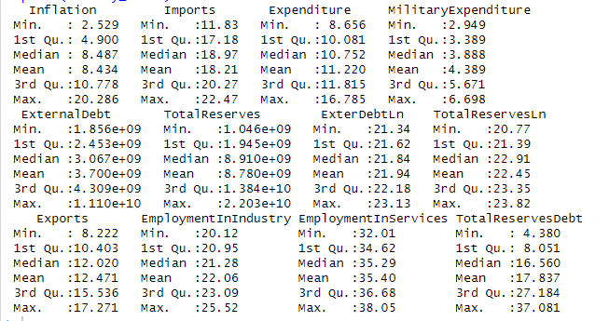

***Result: Variables Summary***

Although, after running the regression model on these variables, it was found out that most of these are insignificant, and only three of them were significant. There insignificant variables were eliminated:

1. Imports
2. Exports
3. Total Reserves Debt

Following is the result of regression model on the above variables

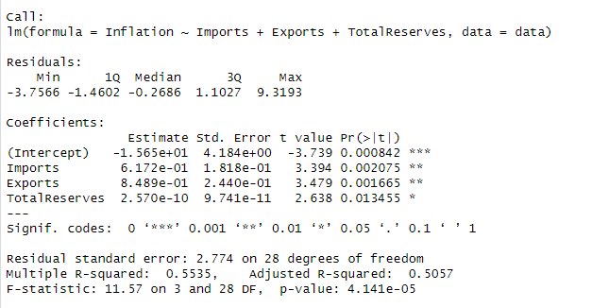

***Regression Model Execution***

# 4. Results:

## Data Set:

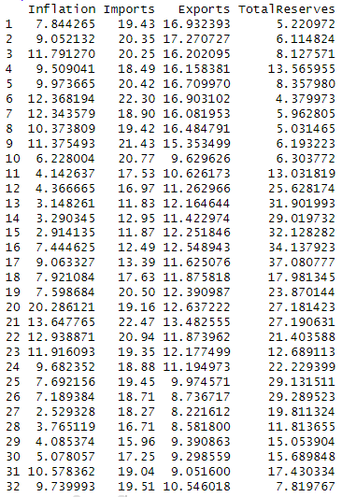

***Data Set: Dependent & Independent Variables***

## Summary of Dependent and Independent Variables:

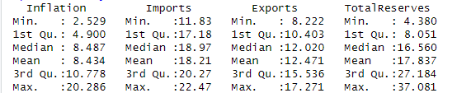

***Summary of Dependent and Independent Variables***

## Box Plot

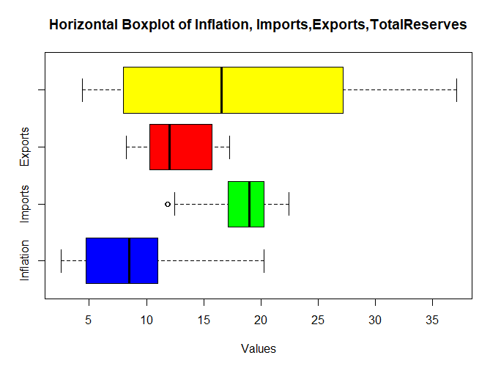

***Box Plot Execution***

## Scatter Plot

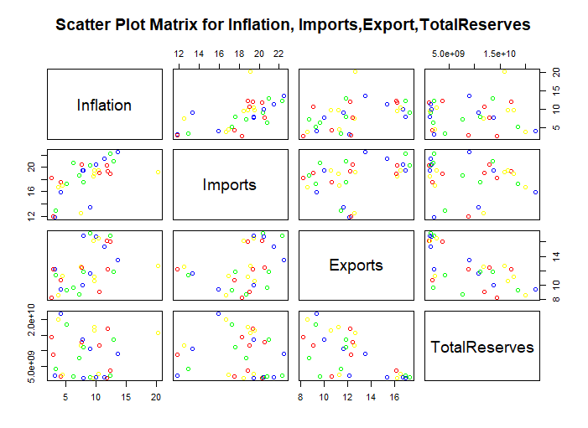

***Scatter Plot Execution***

## Regression Model:



***Regression Model Execution***

# References:

<https://www.finance.gov.pk/survey/chapters_23/07_Inflation.pdf>

<https://papers.ssrn.com/sol3/papers.cfm?abstract_id=4561664#:~:text=A%20depreciation%20of%20the%20Pakistani,commodities%2C%20including%20oil%20and%20food>.

<https://www.jstor.org/stable/25825133>

<https://www.researchgate.net/publication/328268683_An_Empirical_analysis_of_Export_Import_and_Inflation_A_Case_of_Pakistan>

<https://lahoreschoolofeconomics.edu.pk/assets/uploads/lje/Volume19/Ijaz,_Zakaria_and_Fida2.pdf>

<https://data.worldbank.org/indicator/FP.CPI.TOTL.ZG?end=2022&locations=PK&start=1960&view=chart>

<https://www.finance.gov.pk/survey/chapters_16/07_Inflation.pdf>

<https://www.finance.gov.pk/survey/chapters/08-Inflation.PDF>

<https://www.pbs.gov.pk/sites/default/files/press_releases/2023/CPI_Press_Release_January_2023.pdf>