

**JACK KEROUAC**

**St Mary’s School** | *Project Manager*

* Établissement des inventaires
* Respect
* Respect
* Respect

**Kids in Need** | *Project Coordinator*

**2022**

**20XX**

**20XX**

**EDUCATION**

**Apple a Day** | *Project Manager*

**PROFESSIONAL EXPERIENCE**



©AZURIUS - My-resume-templates.com

NY, US

+1 212 999 9999

name@email.com

email

*Sep 20XX – June 20XX*

**Bachelor’s in Public Relations** *| NYU*

Project Director | St Mary’s

John Perkins

name@email.com

+1 212 4444 444

* Performed various administrative tasks to help the project manager stay on schedule and within budget.
* Gathered equipment to make sure the project runs smoothly and timely.
* Labor realizada xxxxxxx xxxxxxxxxx xxxxxx xxx.
* Evaluated the effectiveness of partnerships and programs monthly.
* Increased productivity by 30% through implementing changes based on stakeholder feedback.
* Applied for grants and created proposals for funding.
* Maintain positive relations between partners and community members.
* Develop and prepare draft reports, presentations, and related correspondence documents.
* Performs other duties assigned by administrator. their representative.Labor realizada xxxxxxx xxxxxxxxxx xxxxx.

New York

*Sep 20XX – June 20XX*

New York

**Master’s in International Relations** *| NYU*

Enthusiastic and organized project manager with 7 years of experience working in educational non-profit organizations. My responsibilities included managing 3 school programs and their funding while maintaining 98% productivity levels.

**PROFILE**

*Jan 20XX – Nov 20XX*

*March 20XX – October 20XX*

*November 20XX – Present*

PROJECT MANAGER

**20XX**

**20XX – 20XX**

**REFERENCES**

* Writing
* Communication
* Interpersonal
* Excel
* Asana
* Trello

Mai Tai

Kickboxing

Ping Pong

**INTERESTS**

**SKILLS**

**CONTACT**

**20XX**

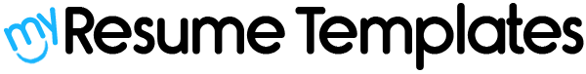

**Dear Job Seeker,**

If you're having difficulty composing your resume, here are some free resources available that can assist you in creating a strong resume that highlights your suitability for the position to potential employers:

* [How to Make a Good Resume](https://www.my-resume-templates.com/how-to-make-a-resume/?utm_source=Word_Doc&utm_medium=Model_CV_Link&utm_campaign=MDC_Downloads)
* [Skills to Put on a Resume](https://www.my-resume-templates.com/skills-to-put-on-a-resume/?utm_source=Word_Doc&utm_medium=Model_CV_Link&utm_campaign=MDC_Downloads)
* [Resume Objective Examples](https://www.my-resume-templates.com/resume-objective-examples/?utm_source=Word_Doc&utm_medium=Model_CV_Link&utm_campaign=MDC_Downloads)

Also discover other free downloadable and ready-to-fill CV templates in Word format:

* [Basic Resume Templates](https://www.my-resume-templates.com/basic-resume-templates/?utm_source=Word_Doc&utm_medium=Model_CV_Link&utm_campaign=MDC_Downloads)
* [Modern Resume Templates](https://www.my-resume-templates.com/modern-resume-samples/?utm_source=Word_Doc&utm_medium=Model_CV_Link&utm_campaign=MDC_Downloads)
* [Creative Resume Templates](https://www.my-resume-templates.com/creative-cv-templates/?utm_source=Word_Doc&utm_medium=Model_CV_Link&utm_campaign=MDC_Downloads)
* [Professional Resume Templates](https://www.my-resume-templates.com/career-resume-templates/?utm_source=Word_Doc&utm_medium=Model_CV_Link&utm_campaign=MDC_Downloads)
* [Europass CV](https://www.my-resume-templates.com/europass-cv/?utm_source=Word_Doc&utm_medium=Model_CV_Link&utm_campaign=MDC_Downloads)

Best regards,

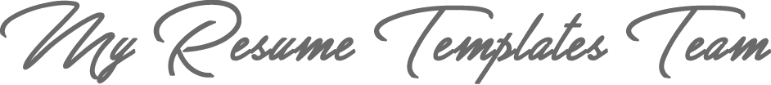

[www.my-resume-templates.com](https://www.modelos-de-curriculum.com/?utm_source=Word_Doc&utm_medium=Model_CV_Link&utm_campaign=MDC_Downloads)

**COPYRIGHT - PLEASE READ THIS MESSAGE**

©These examples of free resume templates are the property of Azurius S.L. You may   
download and modify them without any problem if they are for personal use.

Do not forget to remove this copyright notice before modifying and printing your CV.

You cannot resell these examples or their derivatives. You cannot make them available on other websites without our consent. For any related questions, please write to us at contact@my-resume-templates.com

Discover more resume templates at [www.my-resume-templates.com](https://www.my-resume-templates.com/)