CHAPTER 69A-60

THE FLORIDA FIRE PREVENTION CODE

69A-60.001 Title

69A-60.002 Scope; Description of Florida Fire Prevention Code

69A-60.003 Standards of the National Fire Protection Association, NFPA 1, the Uniform Fire Code, Florida 2018 Edition, Adopted

69A-60.004 Standards of the National Fire Protection Association, NFPA 101, the Life Safety Code®, Florida 2018 Edition, Adopted

69A-60.005 Publications Referenced in NFPA 1, the Florida 2018 Edition, and NFPA 101, the Florida 2018 Edition, Added to the Florida Fire Prevention Code

69A-60.006 Manufactured and Prototype Buildings

69A-60.007 Enforcement of the Florida Fire Prevention Code

69A-60.0081 Notice Required for Structures With Light-frame Truss-type Construction

69A-60.011 Non-Binding Interpretations of the Florida Fire Prevention Code

69A-60.012 Purpose, Criteria and Procedures for Designation as an Approved Nationally Recognized Testing Laboratory in Florida for Firesafety Purposes

69A-60.001 Title.
This rule chapter shall be known, and may be cited, as the Florida Fire Prevention Code.
Rulemaking Authority 633.104, 633.202, 633.208 FS. Law Implemented 633.104, 633.202, 633.208 FS. History–New 11-15-01, Formerly 4A-60.001.

69A-60.002 Scope; Description of Florida Fire Prevention Code.
(1) The Florida Fire Prevention Code is the minimum fire prevention code deemed adopted by each municipality, county, and special district with firesafety responsibilities, and applies to every building and structure throughout the state, except:
(a) Buildings and structures subject to the uniform firesafety standards adopted under Section 633.206, F.S.; and,
(b) Buildings and structures subject to the minimum firesafety standards adopted pursuant to Section 394.879, F.S.
(2) Municipalities, counties, and special districts with firesafety responsibilities may supplement the Florida Fire Prevention Code adopted by this rule, with more stringent standards adopted in accordance with Section 633.208, F.S. Such standards shall be effective until repealed by the adopting municipality, county or special district if the requirements of Section 633.202(10), F.S., were met; in all other cases, the standards shall expire following the adoption of the triennial amendment to this rule, unless adopted by the amendment into the Code.
(3)(a) The Florida Fire Prevention Code consists of:
1. National Fire Protection Association (NFPA) 1, the Fire Code, Florida 2018 edition, as adopted in Rule 69A-60.003, F.A.C.;
2. NFPA 101, the Life Safety Code®, Florida 2018 edition, as adopted and incorporated in Rule 69A-60.004, F.A.C., and their additions, deletions, and other modifications to NFPA 1 and NFPA 101, Florida 2018 editions, as provided therein; and,
3. All codes, standards, publications, and authorities adopted in Rule 69A-60.005, F.A.C.
(b) The Florida Fire Prevention Code also consists of all rule chapters adopted pursuant to the authority of Section 633.206, F.S., and referred to as “uniform rules,” or “rules for uniform buildings or structures,” to-wit, rule chapters:
1. Chapter 69A-3, F.A.C., Fire Prevention, General Provisions;
2. Chapter 69A-36, F.A.C., Uniform Fire Safety Standards for Nonresidential Child Care Facilities;
3. Chapter 69A-38, F.A.C., Uniform Fire Safety Standards for Residential Facilities for Individuals With Developmental Disabilities;
4. Chapter 69A-40, F.A.C., Uniform Fire Safety Standards for Assisted Living Facilities;
5. Chapter 69A-41, F.A.C., Uniform Fire Safety Standards for Residential Child Care Facilities;
6. Chapter 69A-42, F.A.C., Uniform Fire Safety Standards for Mobile Home Parks and Recreational Vehicle Parks;
7. Chapter 69A-43, F.A.C., Uniform Fire Safety Standards for Transient Public Lodging Establishments, Timeshare Plans, and Timeshare Unit Facilities;
8. Chapter 69A-44, F.A.C., Minimum Fire Safety Standards for Residential Alcohol and Drug Abuse Treatment and Prevention Programs, Mental Health Residential Treatment Facilities and Crisis Stabilization Units;
9. Chapter 69A-47, F.A.C., Uniform Fire Safety Standards for Elevators;
10. Chapter 69A-49, F.A.C., Uniform Fire Safety Standards for Self-Service Gasoline Stations;
11. Chapter 69A-53, F.A.C., Uniform Fire Safety Standards for Hospitals and Nursing Homes;
12. Chapter 69A-54, F.A.C., Uniform Fire Safety Standards for Correctional Facilities;
13. Chapter 69A-55, F.A.C., Uniform Fire Safety Standards for Public Food Service Establishments;
14. Chapter 69A-56, F.A.C., Uniform Fire Safety Standards for Migrant Labor Camps;
15. Chapter 69A-57, F.A.C., Uniform Fire Safety Standards for Adult Family Care Homes; and,
16. Chapter 69A-58, F.A.C., Uniform Fire Safety Standards for Educational Facilities.
(c) In the event of a conflict between any provision of this rule chapter other than this rule section and the rules cited in subparagraphs (3)(b)1. through 16., the rules cited in subparagraphs (3)(b)1. through 16. prevail; however, the rules in this rule chapter are not in addition to, nor are they supplemental to, the rule chapters cited in subparagraphs (3)(b)1. through 16. Each rule chapter cited in subparagraphs (3)(b)1. through 16. contain the complete rules for the subjects covered in those rule chapters.
(d) In the event of a conflict between any provision of this rule chapter and rule Chapter 69A-58, F.A.C., this rule chapter prevails. The rules in this rule chapter are in addition to, and supplemental to, the rules in rule Chapter 69A-58, F.A.C.
Rulemaking Authority 633.104, 633.202, 633.208 FS. Law Implemented 633.104, 633.202, 633.208 FS. History–New 11-15-01, Formerly 4A-60.002, Amended 11-28-04, 5-18-08, 12-31-08, 12-31-11, 12-31-14, 12-31-17, 12-31-20.

69A-60.003 Standards of the National Fire Protection Association, NFPA 1, the Fire Code, Florida 2018 Edition, Adopted.
(1) NFPA 1, the Fire Code, Florida 2018 edition as amended 04/22, is hereby adopted and incorporated herein by reference and shall take effect on the effective date of this rule as a part of the Florida Fire Prevention Code.
(2)(a) NFPA 1, Florida 2018 edition, is copyrighted material that cannot be copied, but may be purchased by contacting the NFPA at 1 Batterymarch Park, Quincy, Massachusetts 02169-7471; Phone 1(800)344-3555; Website www.nfpa.org.
(b) The copyrighted material referenced in paragraph (2)(a) may be accessed in a read-only, non-printable, non-downloadable format at the Division of State Fire Marshal website at: https://www.myfloridacfo.com/Division/SFM/BFP/FloridaFirePreventionCodePage.htm; or maybe viewed, during regular business hours, at the offices of:
1. The Division of State Fire Marshal, 325 John Knox Road, Third Floor, Atrium Building, Tallahassee, Florida 32303; or
2. The Florida Administrative Code and Register, R.A. Gray Building, 500 South Bronough Street, Tallahassee, Florida 32399-0250.
Rulemaking Authority 633.104, 633.202, 633.208 FS. Law Implemented 633.104, 633.202, 633.208 FS. History–New 11-15-01, Formerly 4A-60.003, Amended 11-28-04, 5-18-08, 12-31-08, 12-31-11, 5-1-13, 12-31-14, 12-31-17, 11-11-18, 12-31-20, 4-26-22.

69A-60.004 Standards of the National Fire Protection Association, NFPA 101, the Life Safety Code®, Florida 2018 Edition, Adopted.
(1) NFPA 101, the Life Safety Code®, Florida 2018 edition as amended 04/22, is hereby adopted and incorporated herein by reference and shall take effect on the effective date of this rule as a part of the Florida Fire Prevention Code.
(2)(a) NFPA 101, Florida 2018 edition, is copyrigted material that cannot be copied, but may be purchased by contacting the NFPA at 1 Batterymarch Park, Quincy, Massachusetts 02169-7471; Phone 1(800)344-3555; Website www.nfpa.org.
(b) The copyrighted material referenced in paragraph (2)(a) may be accessed in a read-only, non-printable, non-downloadable format at the Division of State Fire Marshal website at: https://www.myfloridacfo.com/Division/SFM/BFP/FloridaFirePreventionCodePage.htm; or maybe viewed, during regular business hours, at the offices of:
1. The Division of State Fire Marshal, 325 John Knox Road, Third Floor, Atrium Building, Tallahassee, Florida 32303; or
2. The Florida Administrative Code and Register, R.A. Gray Building, 500 South Bronough Street, Tallahassee, Florida 32399-0250.
Rulemaking Authority 633.104, 633.202, 633.208 FS. Law Implemented 633.104, 633.202, 633.208 FS. History–New 11-15-01, Formerly 4A-60.004, Amended 11-28-04, 7-12-06, 5-18-08, 12-31-08, 12-31-11, 12-31-14, 12-31-17, 12-31-20, 4-26-22.

69A-60.005 Publications Referenced in NFPA 1, the Florida 2018 Edition, and NFPA 101, the Florida 2018 Edition, Added to the Florida Fire Prevention Code.
(1) For purposes of this rule chapter, the following definitions apply:
(a) ANSI means the American National Standards Institute.
(b) ASME means the American Society of Mechanical Engineers.
(c) ASTM means the American Society for Testing and Materials.
(d) BHMA means the Builders Hardware Manufacturers Association.
(e) ICC means the International Code Counsel, American National Standard Accessible and Usable Buildings and Facilities.
(f) UL means Underwriters Laboratories, Inc.
(2) The following publications are hereby adopted and incorporated by reference herein and added to the Florida Fire Prevention Code and shall take effect on the effective date of this rule:
(a) NFPA 2, 2011 edition, Hydrogen Technologies Code.
(b) NFPA 4, 2018 edition, Standard for Integrated Fire Protection and Life Safety System Testing.
(c) NFPA 10, 2018 edition, Standard for Portable Fire Extinguishers.
(d) NFPA 11, 2016 edition, Standard for Low-, Medium- and High-Expansion Foam.
(e) NFPA 12, 2015 edition, Standard on Carbon Dioxide Extinguishing Systems.
(f) NFPA 12A, 2015 edition, Standard on Halon 1301 Fire Extinguishing Systems.
(g) NFPA 13, 2016 edition, Standard for the Installation of Sprinkler Systems.
(h) NFPA 13D, 2016 edition, Standard for the Installation of Sprinkler Systems in One- and Two- Family Dwellings and Manufactured Homes.
(i) NFPA 13R, 2016 edition, Standard for the Installation of Sprinkler Systems in Low-Rise Residential Occupancies.
(j) NFPA 14, 2016 edition, Standard for the Installation of Standpipe, and Hose Systems.
(k) NFPA 15, 2017 edition, Standard for Water Spray Fixed Systems for Fire Protection.
(l) NFPA 16, 2015 edition, Standard for the Installation of Foam-Water Sprinkler and Foam-Water Spray Systems.
(m) NFPA 17, 2017 edition, Standard for Dry Chemical Extinguishing Systems.
(n) NFPA 17A, 2017 edition, Standard for Wet Chemical Extinguishing Systems.
(o) NFPA 20, 2016 edition, Standard for the Installation of Stationary Pumps for Fire Protection.
(p) NFPA 22, 2013 edition, Standard for Water Tanks for Private Fire Protection.
(q) NFPA 24, 2016 edition, Standard for the Installation of Private Fire Service Mains and Their Appurtenances.
(r) NFPA 25, 2017 edition, Standard for the Inspection, Testing, and Maintenance of Water-Based Fire Protection Systems.
(s) NFPA 30, 2018 edition, Flammable and Combustible Liquids Code.
(t) NFPA 30A, 2018 edition, Code for Motor Fuel Dispensing Facilities and Repair Garages.
(u) NFPA 30B, 2015 edition, Code for the Manufacture and Storage of Aerosol Products.
(v) NFPA 31, 2016 edition, Standard for the Installation of Oil-Burning Equipment.
(w) NFPA 32, 2016 edition, Standard for Drycleaning Facilities.
(x) NFPA 33, 2016 edition, Standard for Spray Application Using Flammable or Combustible Materials.
(y) NFPA 34, 2015 edition, Standard for Dipping, Coating, and Printing Processes Using Flammable or Combustible Liquids.
(z) NFPA 35, 2016 edition, Standard for the Manufacture of Organic Coatings.
(aa) NFPA 36, 2017 edition, Standard for Solvent Extraction Plants.
(bb) NFPA 37, 2018 edition, Standard for the Installation and Use of Stationary Combustion Engines and Gas Turbines.
(cc) NFPA 40, 2016 edition, Standard for the Storage and Handling of Cellulose Nitrate Film.
(dd) NFPA 45, 2015 edition, Standard on Fire Protection for Laboratories Using Chemicals.
(ee) NFPA 51, 2018 edition, Standard for the Design and Installation of Oxygen-Fuel Gas Systems for Welding, Cutting and Allied Processes.
(ff) NFPA 51B, 2014 edition, Standard for Fire Prevention During Welding, Cutting and Other Hot Work.
(gg) NFPA 52, 2016 edition, Vehicular Natural Gas Fuel Systems Code.
(hh) NFPA 54, 2018 edition, National Fuel Gas Code.
(ii) NFPA 55, 2016 edition, Compressed Gases and Cryogenic Fluids Code.
(jj) NFPA 56, 2017 edition, Standard for Fire and Explosion Prevention During Cleaning and Purging of Flammable Gas Piping Systems.
(kk) NFPA 58, 2017 edition, Liquefied Petroleum Gas Code.
(ll) NFPA 59, 2018 edition, Utility LP-Gas Plant Code.
(mm) NFPA 59A, 2016 edition, Standard for the Production, Storage, and Handling of Liquefied Natural Gas (LNG).
(nn) NFPA 61, 2017 edition, Standard for the Prevention of Fires and Dust Explosions in Agricultural and Food Processing Facilities.
(oo) NFPA 68, 2013 edition, Standard on Explosion Protection by Deflagration Venting.
(pp) NFPA 69, 2014 edition, Standard on Explosion Prevention Systems.
(qq) NFPA 70, 2017 edition, National Electrical Code®.
(rr) NFPA 72, 2016 edition, National Fire Alarm and Signaling Code.
(ss) NFPA 75, 2017 edition, Standard for the Fire Protection of Information Technology Equipment.
(tt) NFPA 76, 2016 edition, Standard for the Fire Protection of Telecommunications Facilities.
(uu) NFPA 80, 2016 edition, Standard for Fire Doors and Other Opening Protectives.
(vv) NFPA 82, 2014 edition, Standard on Incinerators and Waste and Linen Handling Systems and Equipment.
(ww) NFPA 85, 2015 edition, Boiler and Combustion Systems Hazards Code.
(xx) NFPA 86, 2015 edition, Standard for Ovens and Furnaces.
(yy) NFPA 88A, 2015 edition, Standard for Parking Structures.
(zz) NFPA 90A, 2018 edition, Standard for the Installation of Air-Conditioning and Ventilating Systems.
(aaa) NFPA 90B, 2018 edition, Standard for the Installation of Warm Air Heating and Air-Conditioning Systems.
(bbb) NFPA 91, 2015 edition, Standard for Exhaust Systems for Air Conveying of Vapors, Gases, Mists, and Particulate Solids.
(ccc) NFPA 92, 2015 edition, Standard for Smoke-Control Systems.
(ddd) NFPA 96, 2017 edition, Standard for Ventilation Control and Fire Protection of Commercial Cooking Operations.
(eee) NFPA 99, 2018 edition, Health Care Facilities Code.
(fff) NFPA 99B, 2018 edition, Standard for Hypobaric Facilities.
(ggg) NFPA 101, 2018 edition, Life Safety Code®.
(hhh) NFPA 101A, 2016 edition, Guide on Alternative Approaches to Life Safety.
(iii) NFPA 102, 2016 edition, Standard for Grandstands, Folding and Telescopic Seating, Tents and Membrane Structures.
(jjj) NFPA 105, 2016 edition, Standard for Smoke Door Assemblies and Other Opening Protectives.
(kkk) NFPA 110, 2016 edition, Standard for Emergency and Standby Power Systems.
(lll) NFPA 111, 2016 edition, Standard on Stored Electrical Energy Emergency and Standby Power Systems.
(mmm) NFPA 115, 2016 edition, Standard for Laser Fire Protection.
(nnn) NFPA 120, 2015 edition, Standard for Fire Prevention and Control in Coal Mines.
(ooo) NFPA 122, 2015 edition, Standard for Fire Prevention and Control in Metal/Nonmetal Mining and Metal Mineral Processing Facilities.
(ppp) NFPA 130, 2017 edition, Standard for Fixed Guideway Transit and Passenger Rail Systems.
(qqq) NFPA 140, 2013 edition, Standard on Motion Picture and Television Production Studio Soundstages, Approved Production Facilities, and Production Locations.
(rrr) NFPA 150, 2016 edition, Standard on Fire and Life Safety in Animal Housing Facilities.
(sss) NFPA 160, 2016 edition, Standard for the Use of Flame Effects Before an Audience.
(ttt) NFPA 170, 2015 edition, Standard for Fire Safety and Emergency Symbols.
(uuu) NFPA 204, 2015 edition, Standard for Smoke and Heat Venting.
(vvv) NFPA 211, 2016 edition, Standard for Chimneys, Fireplaces, Vents, and Solid Fuel-Burning Appliances.
(www) NFPA 221, 2018 edition, Standard for High Challenge Fire Walls, Fire Walls and Fire Barrier Walls.
(xxx) NFPA 232, 2017 edition, Standard for the Protection of Records.
(yyy) NFPA 241, 2013 edition, Standard for Safeguarding Construction, Alteration, and Demolition Operations.
(zzz) NFPA 251, 2006 edition, Standard Methods of Tests of Fire Resistance of Building Construction and Materials.
(aaaa) NFPA 252, 2017 edition, Standard Methods of Fire Tests of Door Assemblies.
(bbbb) NFPA 253, 2015 edition, Standard Method of Test for Critical Radiant Flux of Floor Covering Systems Using a Radiant Heat Energy Source.
(cccc) NFPA 257, 2017 edition, Standard on Fire Test for Window and Glass Block Assemblies.
(dddd) NFPA 259, 2013 edition, Standard Test Method for Potential Heat of Building Materials.
(eeee) NFPA 260, 2013 edition, Standard Methods of Tests and Classification System for Cigarette Ignition Resistance of Components of Upholstered Furniture.
(ffff) NFPA 261, 2013 edition, Standard Method of Test for Determining Resistance of Mock-Up Upholstered Furniture Material Assemblies to Ignition by Smoldering Cigarettes.
(gggg) NFPA 265, 2015 edition, Standard Methods of Fire Tests for Evaluating Room Fire Growth Contribution of Textile or Expanded Vinyl Wall Coverings on Full Height Panels and Walls.
(hhhh) NFPA 286, 2015 edition, Standard Methods of Fire Tests for Evaluating Contribution of Wall and Ceiling Interior Finish to Room Fire Growth.
(iiii) NFPA 288, 2017 edition, Standard Methods of Fire Tests of Horizontal Fire Door Assemblies Installed in Horizontal Fire Resistance-Rated Assemblies.
(jjjj) NFPA 289, 2013 edition, Standard Method of Fire Test for Individual Fuel Packages.
(kkkk) NFPA 301, 2018 edition, Code for Safety to Life from Fire on Merchant Vessels.
(llll) NFPA 302, 2015 edition, Fire Protection Standard for Pleasure and Commercial Motor Craft.
(mmmm) NFPA 303, 2016 edition, Fire Protection Standard for Marinas and Boatyards.
(nnnn) NFPA 307, 2016 edition, Standard for the Construction and Fire Protection of Marine Terminals, Piers, and Wharves.
(oooo) NFPA 312, 2016 edition, Standard for Fire Protection of Vessels During Construction, Conversion, Repair, and Lay-Up.
(pppp) NFPA 318, 2018 edition, Standard for the Protection of Semiconductor Fabrication Facilities.
(qqqq) NFPA 326, 2015 edition, Standard for the Safeguarding of Tanks and Containers for Entry, Cleaning, or Repair.
(rrrr) NFPA 385, 2017 edition, Standard for Tank Vehicles for Flammable and Combustible Liquids.
(ssss) NFPA 400, 2016 edition, Hazardous Materials Code.
(tttt) NFPA 403, 2018 edition, Standard for Aircraft Rescue and Fire-Fighting Services at Airports.
(uuuu) NFPA 407, 2017 edition, Standard for Aircraft Fuel Servicing.
(vvvv) NFPA 408, 2017 edition, Standard for Aircraft Hand Portable Fire Extinguishers.
(wwww) NFPA 409, 2016 edition, Standard on Aircraft Hangars.
(xxxx) NFPA 410, 2015 edition, Standard on Aircraft Maintenance.
(yyyy) NFPA 415, 2016 edition, Standard on Airport Terminal Buildings, Fueling Ramp Drainage, and Loading Walkways.
(zzzz) NFPA 418, 2016 edition, Standard for Heliports.
(aaaaa) NFPA 423, 2016 edition, Standard for Construction and Protection of Aircraft Engine Test Facilities.
(bbbbb) NFPA 484, 2015 edition, Standard for Combustible Metals.
(ccccc) NFPA 495, 2013 edition, Explosive Materials Code.
(ddddd) NFPA 498, 2013 edition, Standard for Safe Havens and Interchange Lots for Vehicles Transporting Explosives.
(eeeee) NFPA 501, 2017 edition, Standard on Manufactured Housing.
(fffff) NFPA 501A, 2017 edition, Standard for Fire Safety Criteria for Manufactured Home Installations, Sites, and Communities.
(ggggg) NFPA 502, 2017 edition, Standard for Road Tunnels, Bridges, and Other Limited Access Highways.
(hhhhh) NFPA 505, 2013 edition, Fire Safety Standard for Powered Industrial Trucks Including Type Designations, Areas of Use, Conversions, Maintenance and Operations.
(iiiii) NFPA 601, 2015 edition, Standard for Security Services in Fire Loss Prevention.
(jjjjj) NFPA 652, 2016 edition, Standard on the Fundamentals of Combustible Dust.
(kkkkk) NFPA 654, 2013 edition, Standard for the Prevention of Fire and Dust Explosions from the Manufacturing, Processing, and Handling of Combustible Particulate Solids.
(lllll) NFPA 655, 2017 edition, Standard for Prevention of Sulfur Fires and Explosions.
(mmmmm) NFPA 664, 2017 edition, Standard for the Prevention of Fires and Explosions in Wood Processing and Woodworking Facilities.
(nnnnn) NFPA 701, 2015 edition, Standard Methods of Fire Tests for Flame Propagation of Textiles and Films.
(ooooo) NFPA 703, 2018 edition, Standard for Fire Retardant-Treated Wood and Fire-Retardant Coatings for Building Materials.
(ppppp) NFPA 704, 2017 edition, Standard System for the Identification of the Hazards of Materials for Emergency Response.
(qqqqq) NFPA 720, 2015 edition, Standard for the Installation of Carbon Monoxide (CO) Detection and Warning Equipment.
(rrrrr) NFPA 731, 2017 edition, Standard for the Installation of Electronic Premises Security Systems.
(sssss) NFPA 750, 2015 edition, Standard on Water Mist Fire Protection Systems.
(ttttt) NFPA 780, 2017 edition, Standard for the Installation of Lightning Protection Systems.
(uuuuu) NFPA 801, 2014 edition, Standard for Fire Protection for Facilities Handling Radioactive Materials.
(vvvvv) NFPA 804, 2015 edition, Standard for Fire Protection for Advanced Light Water Reactor Electric Generating Plants.
(wwwww) NFPA 805, 2015 edition, Performance-Based Standard for Fire Protection for Light Water Reactor Electric Generating Plants.
(xxxxx) NFPA 820, 2016 edition, Standard for Fire Protection in Wastewater Treatment and Collection Facilities.
(yyyyy) NFPA 909, 2017 edition, Code for the Protection of Cultural Resources Properties – Museums, Libraries, and Places of Worship.
(zzzzz) NFPA 914, 2015 edition, Code for Fire Protection of Historic Structures.
(aaaaaa) NFPA 1122, 2018 edition, Code for Model Rocketry.
(bbbbbb) NFPA 1123, 1995 edition, Code for Fireworks Display.
(cccccc) NFPA 1124, 2017 edition, Code for the Manufacture, Transportation, and Storage of Fireworks and Pyrotechnic Articles.
(dddddd) NFPA 1125, 2017 edition, Code for the Manufacture of Model Rocket and High-Power Rocket Motors.
(eeeeee) NFPA 1126, 2016 edition, Standard for the Use of Pyrotechnics before a Proximate Audience.
(ffffff) NFPA 1127, 2018 edition, Code for High Powered Rocketry.
(gggggg) NFPA 1141, 2017 edition, Standard for Fire Protection Infrastructure for Land Development in Wildland, Rural, and Suburban Areas.
(hhhhhh) NFPA 1142, 2017 edition, Standard on Water Supplies for Suburban and Rural Fire Fighting.
(iiiiii) NFPA 1144, 2018 edition, Standard for Reducing Structure Ignition Hazards from Wildland Fire.
(jjjjjj) NFPA 1192, 2018 edition, Standard on Recreational Vehicles.
(kkkkkk) NFPA 1194, 2018 edition, Standard for Recreational Vehicle Parks and Campgrounds.
(llllll) NFPA 1221, 2016 edition, Standard for the Installation, Maintenance, and Use of Emergency Services Communications Systems.
(mmmmmm) NFPA 1730, 2016 edition, Standard on Organization and Deployment of Fire Prevention Inspection and Code Enforcement, Plan Review, Investigation, and Public Education Operations.
(nnnnnn) NFPA 1901, 2016 edition, Standard for Automotive Fire Apparatus.
(oooooo) NFPA 1906, 2016 edition, Standard for Wildland Fire Apparatus.
(pppppp) NFPA 1925, 2013 edition, Standard on Marine Fire-Fighting Vessels.
(qqqqqq) NFPA 1963, 2014 edition, Standard for Fire Hose Connections.
(rrrrrr) NFPA 2001, 2015 edition, Standard on Clean Agent Fire Extinguishing Systems.
(ssssss) NFPA 2010, 2015 edition, Standard for Fixed Aerosol Fire-Extinguishing Systems.
(tttttt) NFPA 2113, 2015 edition, Standard on Selection, Care, Use, and Maintennce of Flame-Resistant Garments for Protection of Industrial Personnel Against Short-Duration Thermal Exposures from Fire.
(uuuuuu) SFPE Engineering Guide to Performance-Based Fire Protection Analysis and Design of Buildings, Society of Fire Protection Engineers, Bethesda, Maryland 2000 edition.
(vvvvvv) The portions of ANSI A14.3-2002, Safety Code for Fixed Ladders, which pertain to fire escape ladders and which may be obtained at American National Standards Institute, 25 West 43rd Street, 4th Floor, New York, NY 10036.
(wwwwww) Chapter 4, Accessible Routes, ICC/ANSI A117.1-1998, which may be obtained at American National Standard for Accessible and Usable Buildings and Facilities, American National Standards Institute, 25 West 43rd Street, 4th Floor, New York, NY 10036.
(xxxxxx) The portions of ANSI A1264.1-1995, Safety Requirements for Workplace Floor and Wall Openings, Stairs and Railing Systems, which pertain to fire escape ladders and which may be obtained at American National Standards Institute, 25 West 43rd Street, 4th Floor, New York, NY 10036.
(yyyyyy) ANSI/UL 2079, 1998 edition, Test of Fire Resistance of Building Joint Systems, which may be obtained at Underwriters Laboratories Inc., 333 Pfingsten Rd., Northbrook, IL 60062.
(zzzzzz) The portions of ASME/ANSI A17.1-2000, Safety Code for Elevators and Escalators, which may be obtained at American Society of Mechanical Engineers, Three Park Avenue, New York, NY 10016-5990.
(aaaaaaa) The portions of ASME/ANSI A17.3-2002, Safety Code for Existing Elevators and Escalators, which may be obtained at American Society of Mechanical Engineers, Three Park Avenue, New York, NY 10016-5990.
(bbbbbbb) ASTM D 2898,-94, (Reapproved 1999), Test Method for Accelerated Weathering of Fire Retardant-Treated Wood for Fire Testing, which may be obtained at American Society for Testing and Materials, 100 Barr Harbor Drive, West Conshohocken, PA 19428-2959.
(ccccccc) ASTM E 136-1999, Standard Test Method for Behavior of Materials in a Vertical Tube Furnace at 750°C, which may be obtained at American Society for Testing and Materials, 100 Barr Harbor Drive, West Conshohocken, PA 19428-2959.
(ddddddd) ASTM E 1537, 2001 edition, Standard Test Method for Fire Testing of Upholstered Furniture, which may be obtained at American Society for Testing and Materials, 100 Barr Harbor Drive, West Conshohocken, PA 19428-2959.
(eeeeeee) ASTM E 1590-01, Standard Test Method for Fire Testing of Mattresses, American Society for Testing and Materials, which may be obtained at 100 Barr Harbor Drive, West Conshohocken, PA 19428-2959.
(fffffff) ASTM E 1591-00, Standard Guide for Obtaining Data for Deterministic Fire Models, which may be obtained at American Society for Testing and Materials, 100 Barr Harbor Drive, West Conshohocken, PA 19428-2959.
(ggggggg) ASTM F 851-1987 (Reapproved 1991), Standard Test Method for Self-Rising Seat Mechanisms, which may be obtained at American Society for Testing and Materials, 100 Barr Harbor Drive, West Conshohocken, PA 19428-2959, but only to the extent referenced in Subdivision 12.2.5.5.1 and 12.2.5.5.2 of NFPA 101, 2000 edition.
(hhhhhhh) ANSI/BHMA A-156.19-2002, American National Standard for Power Assist and Low Energy Power Operated Doors, which may be obtained at Buildings Hardware Manufacturers Association, 355 Lexington Avenue, 17th Floor, New York, NY 10017-6603.
(iiiiiii) UL 924, Standard for Safety Emergency Lighting and Power Equipment, Underwriters Laboratories, Inc., which may be obtained at 333 Pfingsten Rd., Northbrook, IL 60062.
(jjjjjjj) UL 1975, Standard for Fire Tests for Foamed Plastics Used for Decorative Purposes, Underwriters Laboratories, Inc., which may be obtained at 333 Pfingsten Rd., Northbrook, IL 60062.
(3)(a) The NFPA standards referenced in subsection (2) are copyrighted materials that cannot be copied but may be:
1. Obtained by contacting the NFPA at 1 Batterymarch Park, Quincy, Massachusetts 02169-7471; Phone 1(800)344-3555; Website www.nfpa.org.; or
2. Accessed in a read-only, non-printable, non-downloadable format at the NFPA’s website at https://www.nfpa.org/Codes-and-Standards/All-Codes-and-Standards/Free-access.
(b) The copyrighted NFPA standards referenced in subsection (2) may be viewed, during regular business hours, at the offices of:
1. The Division of State Fire Marshal, 325 John Knox Road, Third Floor, Atrium Building, Tallahassee, Florida 32303; or
2. The Florida Administrative Code and Register, R.A. Gray Building, 500 South Bronough Street, Tallahassee, Florida 32399-0250.
(4) The Secretary of the Interior’s Standards for Rehabilitation and Guidelines for Rehabilitating Historic Buildings may be obtained by writing the Florida Department of State, Division of Historical Resources, R.A. Gray Building, 500 South Bronough Street, Tallahassee, Florida 32399-0250. All standards adopted and incorporated by reference in this rule are also available for public inspection during regular business hours at the Bureau of Fire Prevention, Division of State Fire Marshal, Department of Financial Services, 325 John Knox Road, The Atrium, Third Floor, Tallahassee, Florida 32303.
(5) Only the codes, standards, publications, or other references adopted in this chapter are enforceable as part of the Florida Fire Prevention Code. Any code, standard, publication or other reference not adopted in this chapter is not a part of the Florida Fire Prevention Code and may only be enforced by a local government if it has been adopted as a local amendment of the local government pursuant to sections 633.202(2), 633.202(10) or 633.208(3), F.S.
Rulemaking Authority 633.104, 633.202, 633.208 FS. Law Implemented 633.104, 633.202, 633.208, 791.012 FS. History–New 11-15-01, Formerly 4A-60.005, Amended 11-28-04, 5-18-08, 12-31-08, 4-25-12, 12-31-14, 12-31-17, 12-31-20.

69A-60.006 Manufactured and Prototype Buildings.
(1) Definitions. For purposes of this section, the following definitions apply:
(a) “Manufacture” means the process of making, modifying, fabricating, constructing, forming or assembling or reassembling a product from raw, unfinished, semifinished, or finished materials.
(b) “Manufactured building” means a closed structure, building, assembly, or system of subassemblies, which may include structural, electrical, plumbing, heating, ventilating, or other service systems manufactured for installation or erection, with or without other specified components, as a finished building or as part of a finished building, which shall include but not be limited to residential, commercial, institutional, storage, and industrial structures. For purposes of this section, “manufactured building” includes “prototype building” as defined in this subsection.
(c) “Manufacturer” means any person who, or entity which, has been certified by the Department of Community Affairs to produce, modify, or produce and modify, a manufactured building for placement in, or which has been ultimately placed in, the State of Florida.
(d) “Prototype building” means a building constructed in accordance with architectural or engineering plans intended for replication on various sites and which will be updated to comply with the Florida Building Code and applicable laws relating to firesafety, health and sanitation, casualty safety, and requirements for persons with disabilities which are in effect at the time a construction contract is to be awarded.
(2) With respect to inspections of manufactured buildings, each manufacturer of manufactured buildings is permitted to, at its option:
(a) Contract with any person currently certified as a firesafety inspector under Section 633.216, F.S., from a list to be provided by the Department; or
(b) Provide for one or more of its employees to become certified under Chapter 69A-39, F.A.C.
(3) Each manufacturer shall notify the Department of the option that it has chosen prior to having any firesafety inspection performed on a manufactured building.
(4)(a) The Manufacturer’s Modular Data Plate shall state that the manufactured building is, or is not, in compliance with Chapter 633, F.S., and the rules of the Department.
(b) If the Manufacturer’s Modular Data Plate indicates that the building is in compliance with Chapter 633, F.S., and the rules of the Department, the local fire official shall recognize and approve such manufactured building. Nothing in this section prevents or prohibits a fire official from conducting performance tests of life safety systems.
(c) If the Manufacturer’s Modular Data Plate indicates that the building is not in compliance with Chapter 633, F.S., and the rules of the Department, the local firesafety inspector shall have the authority to conduct such firesafety inspections and to require such modifications as necessary to bring the building into compliance with Chapter 633, F.S., and the rules of the Department.
(d) Nothing contained herein shall restrict the local fire official from approving the site conditions for such matters as fire department access, water supplies, and the exit discharge from the manufactured building; however, this section relating to manufactured buildings is not subject to any local amendment.
(e) Paragraphs (a) through (d) do not apply to factory built school buildings. Each master plan for the factory built school buildings to be built according to such plan shall be reviewed by a firesafety inspector certified pursuant to Section 633.216, F.S., conducting an inspection pursuant to Section 633.216(1), F.S., who shall note or cause to be noted on the face of the plans the following:
1. Whether buildings manufactured in conformance with those plans require inspection in the factory and the items subject to inspection; and,
2. Identification of any item that is not indicated on the plans to be installed at the factory, but which is required to be installed pursuant to the Florida Fire Prevention Code, if any. Installation of such item shall be subject to inspection by the local fire official after installation.
(f) No factory built school building shall be occupied, used, or have an insignia of the Department of Community Affairs attached until such building has been inspected after installation by the local fire official and found to be in compliance with the Florida Fire Prevention Code. The local fire official shall notify the local building official when the factory built school has been inspected after installation and has been found to be in compliance with the Florida Fire Prevention Code.
(5) After the manufacturer has fully complied with at least one option in subsection (2), the Department shall advise the Department of Community Affairs of such compliance which shall constitute notice that the manufacturer is in compliance with the firesafety inspection requirements of the Florida Fire Prevention Code, or the applicable uniform code, and that firesafety inspections are being completed by certified firesafety inspectors.
Rulemaking Authority 633.104, 633.202, 633.208 FS. Law Implemented 633.104, 633.202, 633.208 FS. History–New 11-15-01, Amended 9-8-02, Formerly 4A-60.006, Repromulgated 11-28-04.

69A-60.007 Enforcement of the Florida Fire Prevention Code.
(1) Section 633.208, F.S., provides that each municipality, county, and special district with firesafety responsibilities is required to enforce the Florida Fire Prevention Code. Such enforcement requires inspection of each new building subject to the Florida Fire Prevention Code and includes periodic inspections of each existing building subject to the Florida Fire Prevention Code.
(2) The Florida Fire Prevention Code contains several provisions and requirements that may interrelate with the Florida Building Code. It is not the intent of the Florida Fire Prevention Code that such interrelation result in duplicate reviews and inspections by either the firesafety official or the building official. The authority having jurisdiction over firesafety is responsible for enforcement of the Florida Fire Prevention Code hereof and should discharge its obligation in a manner that does not expose those regulated to unnecessary or unnecessarily expensive duplication of effort. To that end, the authority having jurisdiction over firesafety is directed to clearly delineate responsibility for enforcement of the Florida Fire Prevention Code hereof, and, in the event that a dispute arises regarding the enforcement of the Florida Fire Prevention Code as related to the enforcement of the Florida Building Code, the authority having jurisdiction over firesafety shall resolve the dispute by the procedures set forth in Chapters 633 and 553, F.S., as required by Section 633.104, F.S.
(3) If deemed necessary by a fire official for a complete, accurate, and thorough firesafety plans review or inspection, the fire official may request assistance from a building, electrical, plumbing, or similar specialty inspector; however, nothing in this rule gives authority or jurisdiction to any person other than a firesafety inspector certified under Section 633.216, F.S., to perform firesafety inspections required by law, rule, ordinance, or code.
(4)(a) Section 633.104, F.S., provides that it is the intent of the legislature that there be no conflicts in the interpretation and enforcement of the Florida Fire Prevention Code and the Florida Building Code.
(b) In the event of a conflict between the Florida Fire Prevention Code and the Florida Building Code, the procedures set forth in chapter 553, F.S., and specifically either
1. Section 553.73(1)(d), F.S., relating to conflicts in general to be resolved through mediation; or
2. Section 553.73(11)(a)-(f), F.S., relating to conflicts in the application of the Florida Fire Prevention Code and the Florida Building Code to a specific project, as applicable, shall be followed.
(5)(a) Section 633.104, F.S., provides that the State Fire Marshal may issue, and if requested in writing by a substantially affected person or by a local enforcing agency, i.e., an authority having jurisdiction, the State Fire Marshal shall issue declaratory statements to interpret the Florida Fire Prevention Code.
(b) To request an interpretation of the Florida Fire Prevention Code from the State Fire Marshal through a declaratory statement, a person who is not an authority having jurisdiction must proceed through the local appeal process and receive an adverse ruling from the local appeals board. A person does not become a substantially affected person until such person receives an adverse ruling after having completed the local appeal process because the local interpretation with which the person disagrees, if challenged, cannot be enforced until after having been upheld in the local appeal process.
(c) If the person who is not an authority having jurisdiction receives an adverse ruling after proceeding through the local appeal process, such person then becomes a substantially affected person within the meaning of Section 633.104, F.S., and may at that time petition for a declaratory statement from the State Fire Marshal.
(d) Any petition for declaratory statement that has been received by the State Fire Marshal from a person who is not an authority having jurisdiction and who has not proceeded through the local appeal process shall be dismissed, without prejudice to re-bring the petition after such person has received an adverse ruling through the local appeal process.
(e) An authority having jurisdiction may request a declaratory statement from the State Fire Marshal at any time, regardless of whether the interpretation of the authority having jurisdiction has been challenged; however, an authority having jurisdiction must, in compliance with Section 120.565, F.S., be presented with an actual particular set of circumstances prior to petitioning for a declaratory statement. Declaratory statements are not issued on a hypothetical set of facts if the authority having jurisdiction or any other substantially affected person is not presented with an actual particular set of circumstances.
(f)1. A petition for a declaratory statement is not required to be in any particular form; however, each petition must comply fully with Section 120.565, F.S., and Chapter 28-105, F.A.C.
2. Although there is no requirement that a petition be in any particular form, a form exists on the Division of State Fire Marshal website located at http://www.fldfs.com/SFM/ which, if used, complies in all respects with the requirements of the law and will assist the division in expediting the proceedings.
Rulemaking Authority 633.104, 633.202, 633.208 FS. Law Implemented 633.104, 633.202, 633.208 FS. History–New 11-15-01, Formerly 4A-60.007, Amended 11-28-04.

69A-60.0081 Notice Required for Structures With Light-frame Truss-type Construction.
(1) Purpose: The purpose of this rule is to require the placement of an identifying symbol on structures constructed with a light-frame truss component in a manner sufficient to warn persons conducting fire control and other emergency operations of the existence of light-frame truss-type construction in the structure.
(2) Definitions.
(a) “Light-frame truss-type construction” means a type of construction whose primary structural elements are formed by a system of repetitive wood or light gauge steel framing members.
(b) “Approved symbol” means a Maltese Cross measuring 8 inches horizontally and 8 inches vertically, of a bright red reflective color, designed in accordance with Figure 1.
(3) Any commercial, industrial, or multiunit residential structure of three units or more, which uses horizontal or vertical light-frame truss-type construction in any portion shall be marked with an approved symbol. Townhouses are not multiunit residential structures and therefore not subject to this rule. Each approved symbol shall include within the center circle one of the following designations:
(a) Structures with light-frame truss roofs shall be marked with the letter “R”.
(b) Structures with light-frame truss floor systems shall be marked with the letter “F”.
(c) Structures with light-frame truss floor and roof systems shall be marked with the letters “RF.”
(4) The approved symbol shall be placed within 24 inches to the left of the main entry door and:
(a) Be permanently attached to the face of the structure on a contrasting background; or
(b) Be mounted on a contrasting base material which is then permanently attached to the face of the structure.
(5) The distance above the grade, walking surface or the finished floor to the bottom of the symbol shall be not less than 4 feet (48 in.).
(6) The distance above the grade, walking surface or the finished floor to the top of the symbol shall be not more than 6 feet (72 in.).
(7) In single tenant structures with multiple main entry doors, such as big box retail stores, department stores and grocery stores, the authority having jurisdiction is authorized to require that other main entry doors of the structure be marked with an approved symbol to carry out the purpose in subsection (1), above.
(8) In Multiple tenant structures and covered mall structures with multiple main entry doors, the authority having jurisdiction is authorized to require that other main entry doors of the structure be marked with an approved symbol to carry out the purpose in subsection (1), above.
(9) In multiple tenant structures and covered malls with multiple main entry doors, the authority having jurisdiction is authorized to require that other main entry doors be marked with an approved symbol to carry out the purpose in subsection (1), above. In such structures, approved symbols shall be marked on one side of the structure only and spaced not closer than 100 feet or at each end of the structure when such structure is less than 100 feet in length.
(10) The owner of each new structure required to comply with this section shall mark the structure with the approved symbol prior to receiving a certificate of occupancy.
(11) The owner of each existing structure required to comply with this section shall mark the structure with the approved symbol within 90 days of the effective date of this rule.
(12) Where the owner of the structure and the authority having jurisdiction disagree as to the use of light-frame truss-type construction within the structure, the owner shall be granted not more than 45 days to provide written verification from a licensed engineer or licensed architect; otherwise, the owner shall comply with the rule.
Figure 1:
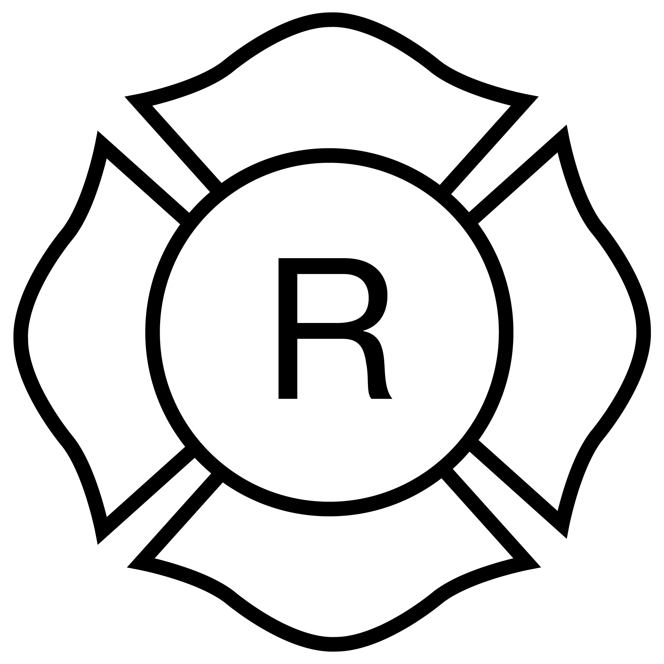
Light-frame “Roof” only

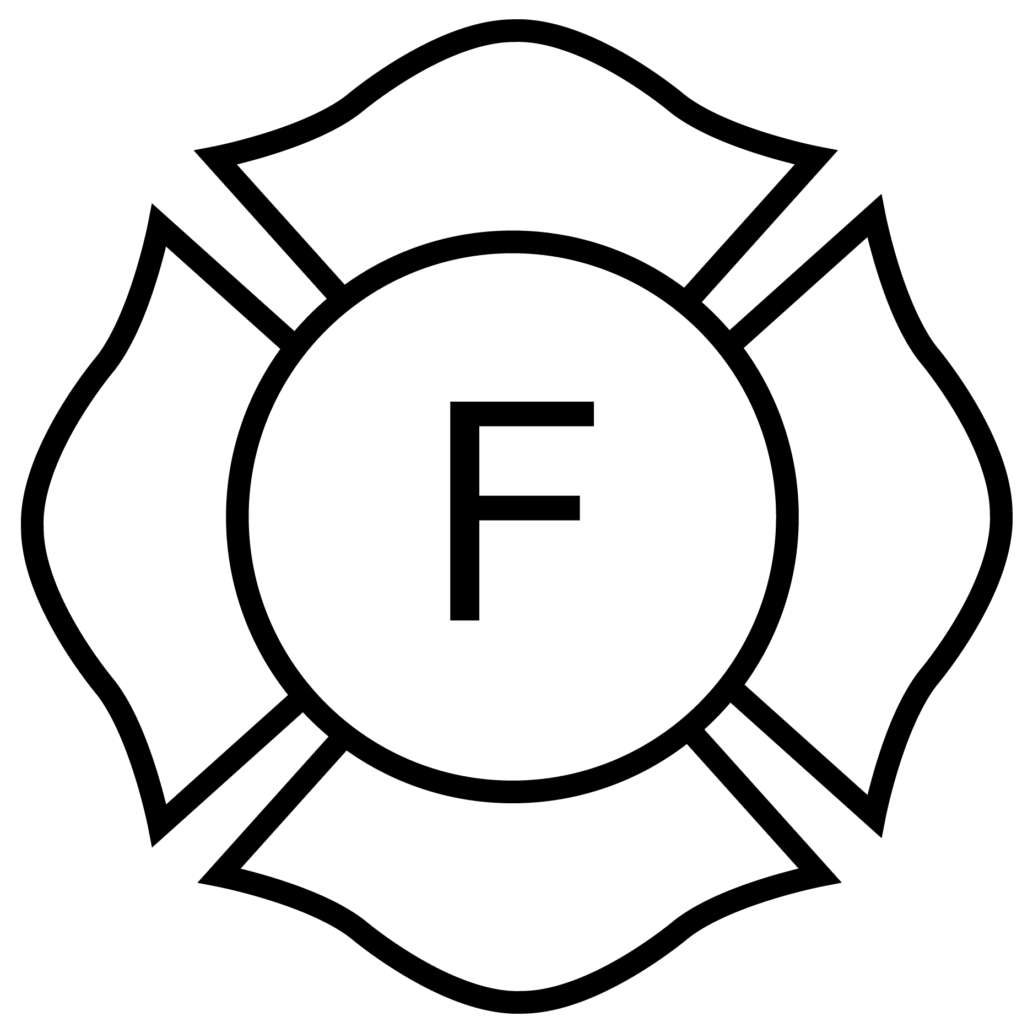
Light-frame “Floor” only

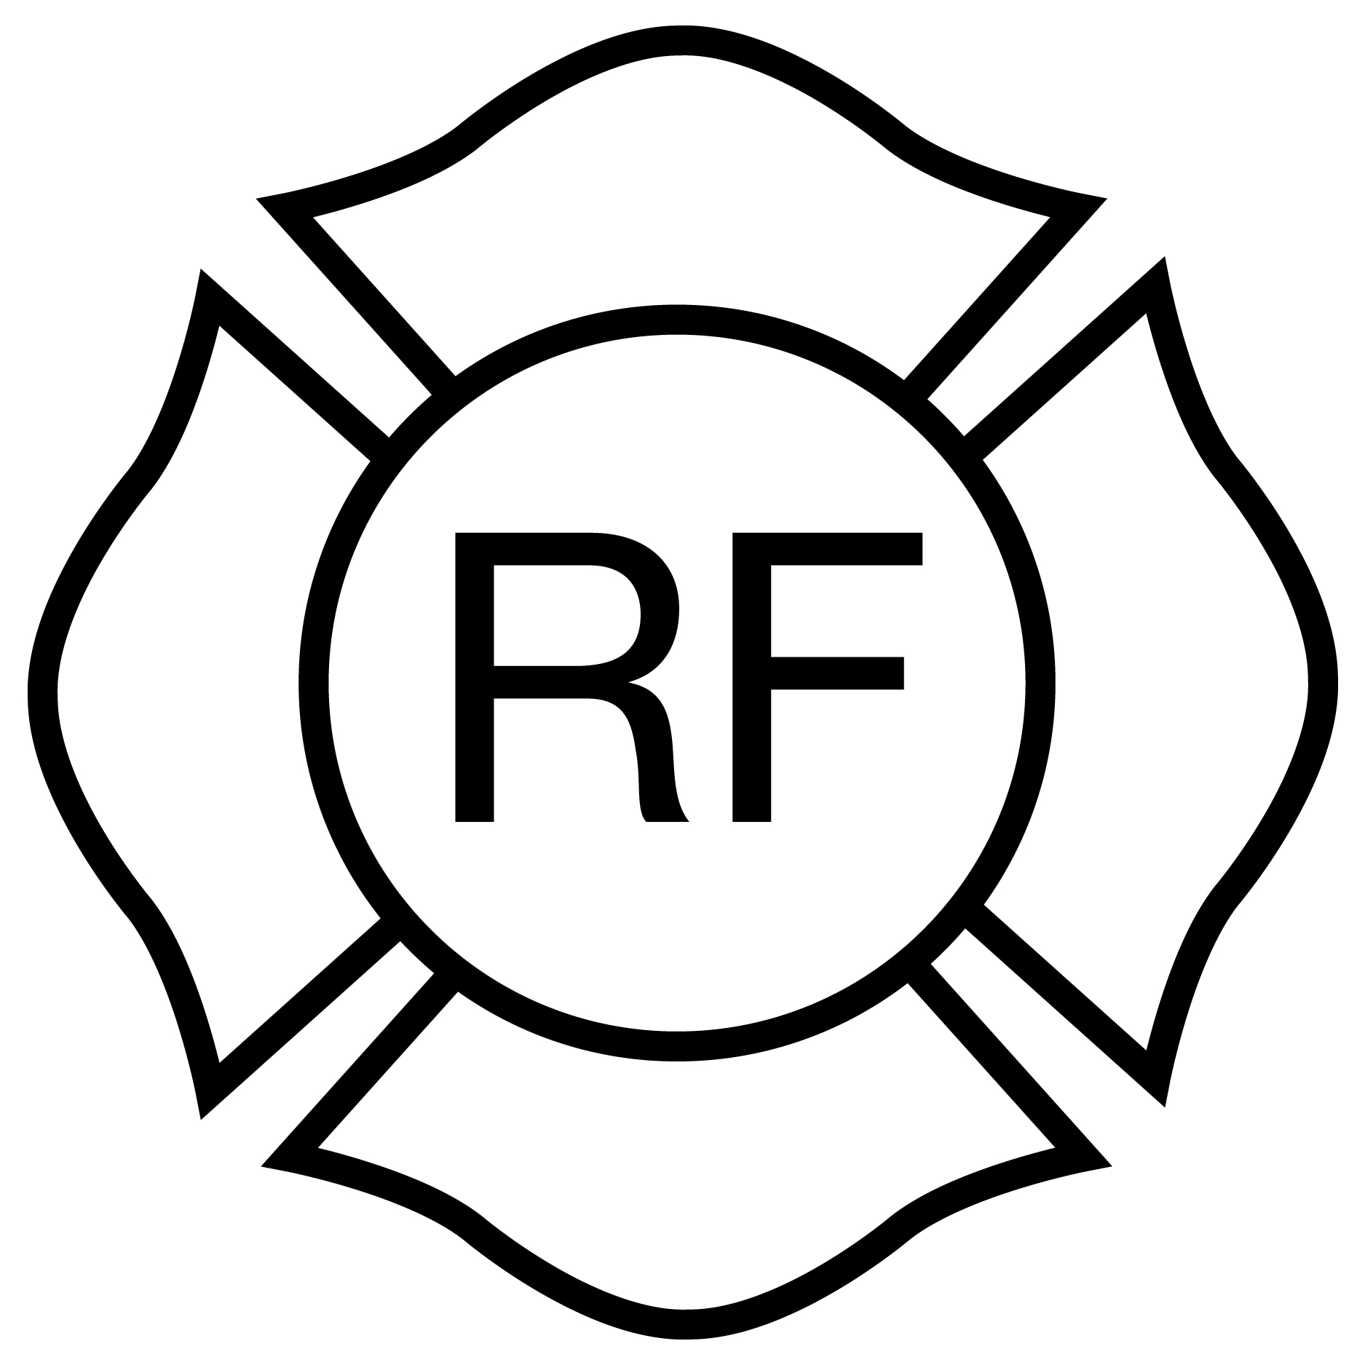
Light-frame “Floor & Roof”
Rulemaking Authority 633.104(1), 633.202, 633.206, 633.222(2) FS. Law Implemented 633.102, 633.104, 633.206, 633.222 FS. History–New 12-13-09.

69A-60.011 Informal, Non-Binding Interpretations of the Florida Fire Prevention Code.
(1) Definitions. For purposes of this rule section:
(a) “Code” means the Florida Fire Prevention Code as described under paragraph 69A-60.002(3)(a), F.A.C.
(b) “State Fire Marshal” or “Division” means the Chief Financial Officer of the State of Florida acting as State Fire Marshal, or the Division of State Fire Marshal, as the context requires.
(c) “Contractor” means the entity with which the State Fire Marshal enters into a contract to provide administrative services to facilitate the provision of informal, non-binding interpretations of the Code as described in Section 633.212, F.S.
(d) “Fire Code Interpretations Committee,” or “FCIC” means the committee established to provide informal, non-binding interpretations of the Code.
(e) “Surcharge Funds” means funds from permit fees associated with the enforcement of the Florida Building Code, as described in Section 553.721, F.S.
(2) Membership of the FCIC.
(a) The FCIC shall consist of seven members and seven alternate members. Each member and his or her alternate shall represent one of the following seven emergency management regions in the State:
1. Emergency Management Region 1 Counties: Escambia, Santa Rosa, Okaloosa, Walton, Holmes, Jackson, Washington, Bay, Gulf, and Calhoun;
2. Emergency Management Region 2 Counties: Gadsden, Liberty, Leon, Franklin, Wakulla, Taylor, Jefferson, Madison, Lafayette, Hamilton, Suwannee, Columbia, and Dixie;
3. Emergency Management Region 3 Counties: Nassau, Duval, Clay, St. Johns, Flagler, Putnam, Bradford, Union, Baker, Levy, Alachua, and Gilchrist;
4. Emergency Management Region 4 Counties: Citrus, Hernando, Pasco, Pinellas, Hillsborough, Polk, and Manatee;
5. Emergency Management Region 5 Counties: Marion, Sumter, Lake, Orange, Seminole, Osceola, Brevard, and Volusia;
6. Emergency Management Region 6 Counties: Hardee, Sarasota, Desoto, Charlotte, Glades, Highland, Okeechobee, Hendry, Lee, and Collier; and,
7. Emergency Management Region 7 Counties: Monroe, Miami-Dade, Broward, Palm Beach, Martin, St. Lucie, and Indian River.
(b) Each person serving on the FCIC must have on file with the Division Form DFS-K3-1673 (rev. 01/06), “Member Application for Fire Code Interpretations Committee,” adopted and incorporated herein, which may be obtained by writing to the Division of State Fire Marshal, 200 East Gaines Street, Tallahassee, Florida 32399-0340, or by visiting the State Fire Marshal’s website located at http://www.MyFloridaCFO.com/divisions/SFM.
The first seven applications received from individuals who meet the qualifications set forth in Section 633.212(2), F.S., and the geographic requirements set forth in paragraph (a), and who are approved by the Division, shall be appointed as members. The next seven applications received from individuals who meet the qualifications set forth in Section 633.212(2), F.S., and the geographic requirements set forth in paragraph (a), and who are approved by the Division, shall be appointed as alternate members. Applications to serve on the FCIC may be submitted at any time and will be kept on file to fill vacancies as they occur. When a vacancy occurs, the existing alternate will be appointed to serve in the vacant seat. An alternate will be chosen for the seat in the same manner as the original member was chosen.
(c) The name of each person to serve on the FCIC must be on file with the Division at least thirty (30) days before that person may voice an opinion or cast a vote as a member of the FCIC on a petition for an informal, non-binding interpretation.
(3) Procedures.
(a) To obtain an informal, non-binding interpretation of the Code, the petitioner shall submit to the Contractor a fully completed petition using Form DFS-K3-2050, “Petition for an Informal, Non-Binding Interpretation of the Florida Fire Prevention Code http://www.flrules.org/Gateway/reference.asp?No=Ref-08918,” Rev. 9/17, adopted and incorporated by reference herein. This form may be obtained by visiting the Division’s website located at http://www.MyFloridaCFO.com/division/SFM. The petitioner must include a fee of $110.00 or elect to use Surcharge Funds to subsidize the fee.
(b) Petitioners may elect to use Surcharge Funds to subsidize the fee on Form DFS-K3-2050. Petitioners shall only be entitled to four (4) subsidized petitions per calendar year. Local authorities having jurisdiction shall only be entitled to four (4) subsidized petitions for the entire organization per calendar year, regardless of who in the organization submits the petition. Subsidized petitions shall only be granted until the Surcharge Funds are exhausted. If all of the Surcharge Funds have been exhausted, the Contractor shall notify the petitioner and give petitioner an opportunity to pay the $110.00 fee or withdraw the petition.
(c) The Contractor, through its designated representative or representatives, shall review each petition. If the petition does not qualify for consideration by the FCIC, the Contractor shall notify the petitioner in writing of the reason why it does not qualify for consideration, arrange for a refund of the fee (if paid), and shall take no further action. If the petition is proper and the fee of $110.00 has been received or the petitioner’s election to use Surcharge Funds has been granted, the Contractor shall assign the petition to the FCIC and provide a copy of the petition to the local fire official if the petition requests review of an interpretation of the Code made by the local fire official. The Contractor shall notify the local fire official that he or she may submit a written response to the petition to the FCIC within three (3) business days following the local fire official’s receipt of the petition.
(d) If the FCIC deems it appropriate or necessary, it may initiate a review process which solicits comments for development of a response. The FCIC shall not consider any comment unless the comment includes the name, employer (if any), and contact information of the submitter. Anonymous comments shall not be presented to or considered by the FCIC.
(e) A meeting to consider the petition shall be held if requested by two or more FCIC members. The meeting may be conducted in person or as otherwise authorized by law.
(f) Each FCIC member participating in an informal, non-binding interpretation shall submit his or her individual response to the Contractor within eight (8) business days after the Contractor’s receipt of the petition. The Contractor shall prepare a response that is the result of a vote of at least a majority of the members of the FCIC and each member of the FCIC who reviewed the petition must be identified in the response. The Contractor shall distribute the response to the FCIC for a final vote within nine (9) business days after the Contractor’s receipt of the petition.
(g) Following the final vote, the Contractor shall forward the majority FCIC response without comment or amendment by the Contractor to the petitioner via electronic transmission or regular mail within 10 business days after the Contractor’s receipt of the petition, unless that time period has been waived in compliance with Section 633.212(3), F.S. The FCIC response must include the notice required by Section 633.212(8), F.S., concerning the petitioner’s right to request a formal interpretation from the State Fire Marshal pursuant to Section 633.104(6), F.S.
(h) The Contractor shall send an electronic copy of all documentation received or produced in conjunction with any informal, non-binding interpretation to the Division at the email address specified in the contract between the Division and Contractor.
(i) The Contractor shall publish on its Internet website each petition that is assigned to the FCIC by the Contractor, any response to the petition submitted by the local fire official, and the majority FCIC response to the petition.
(j) Each majority FCIC response is nonbinding and constitutes the opinion of the FCIC, and not the opinion of the Department, the State Fire Marshal, or the Contractor.
(k) No person serving on the FCIC is permitted to participate in the consideration of any matter involving such person’s own jurisdiction, if he or she is the firesafety inspector for that jurisdiction, and the firesafety inspector’s duties by statute, rule, ordinance, or code require or permit him or her to inspect any building or structure which is the subject of the petition provided to the FCIC, or if that person has provided input on the matter for the building or structure that is the subject of the petition.
(l) Each person serving on the FCIC shall serve at the pleasure of the State Fire Marshal, and may be removed without cause.
Rulemaking Authority 553.721, 633.104, 633.212 FS. Law Implemented 553.721, 633.212 FS. History–New 4-26-07, Amended 5-29-13, 1-18-18.

69A-60.012 Purpose, Criteria and Procedures for Designation as an Approved Nationally Recognized Testing Laboratory in Florida for Firesafety Purposes.
(1) The purpose of this rule is to determine whether a laboratory is nationally recognized in accordance with the following provision:
(a) Section 633.306, F.S., pertaining to fire suppression equipment;
(b) Section 633.308, F.S., pertaining to fire extinguishers;
(c) Section 633.314, F.S., pertaining to certain types of fire extinguishers;
(d) Section 633.334, F.S., pertaining to fire protection systems; and,
(e) Section 633.348, F.S., pertaining to alarm systems.
(2) Criteria for Determination of Designation.
(a) Documentation that the applicant is designated as a Nationally Recognized Testing Laboratory by the U.S. Department of Labor, and the purpose or purposes for which it was recognized; or, in the alternative;
(b) Documentation that the applicant is eligible for recognition as a Nationally Recognized Testing Laboratory by the U.S. Department of Labor, and the purpose or purposes for which Florida designation is sought in accordance with subsection (1), above.
(3) Application Procedure.
(a) An applicant that is currently recognized by the United States Department of Labor as a Nationally Recognized Testing Laboratory can make application for Florida designation to the Division of State Fire Marshal on Form DFS-K3-1791 (effective 9/12/07), “Application for Recognition as Nationally Recognized Testing Laboratory in Florida,” which is hereby adopted and incorporated herein, and which may be obtained by writing to the Division of State Fire Marshal, 200 East Gaines Street, Tallahassee, Florida 32399-0342, or by visiting the Division of State Fire Marshal’s website located at http://www.fldfs.com/SFM/index.htm.
(b) An applicant that is not currently recognized by the United States Department of Labor as a Nationally Recognized Testing Laboratory can make application for Florida designation to the Division of State Fire Marshal on Form DFS-K3-1792 (effective 9/12/07), “Application for Nationally Recognized Testing Laboratory in Florida,” which is hereby adopted and incorporated herein, and which may be obtained by writing to the Division of State Fire Marshal, 200 East Gaines Street, Tallahassee, Florida 32399-0342, or by visiting the Division of State Fire Marshal’s website located at http://www.fldfs.com/SFM/index.htm, and shall include all of the information and material requested thereon.
(c) The Division of State Fire Marshal shall review the application for completeness and request additional information that was either not provided or is necessary to make a determination.
(d) When the application is deemed complete, the Division of State Fire Marshal shall either approve or deny the application.
(e) If the application is approved, the Division of State Fire Marshal shall issue a certificate to the applicant evidencing its designation as a Nationally Recognized Testing Laboratory qualified in Florida, and the purposes to which the designation is limited. The designation may be for any of the purposes set forth in subsection (1), above, as approved by the Division of State Fire Marshal, but only for those purposes.
(f) If the application is denied, the applicant shall be notified in writing, together with the reasons for denial and rights under Chapter 120, F.S.
(g) An application that is approved in part but denied for one or more requested purposes shall be treated procedurally as a denied application.
(4) Material Changes. Any testing laboratory designated in Florida as “nationally recognized” for one or more of the purposes in the statutes listed in subsection (1), above:
(a) Will be subject to ongoing verification that it continues to meet the Florida designation criteria; and,
(b) Shall notify the Division of State Fire Marshal within 30 days of the occurrence of any of the following:
1. A change in the company name or the company address;
2. A change in any major test equipment;
3. The establishment of a new branch office or facility at which items are to be tested;
4. A change in principal officers, key supervisory personnel or key testing personnel in the company.
Rulemaking Authority 633.306, 633.308, 633.314, 633.334, 633.348 FS. Law Implemented 633.306, 633.308, 633.314, 633.334, 633.348 FS. History–New 8-20-07.

