LAB ASSIGNMENT REPORT
Campus Services Management System
C# · .NET 10 · ASP.NET Core Web API · .NET MAUI Blazor Hybrid · EF Core · PostgreSQL · Identity · JWT
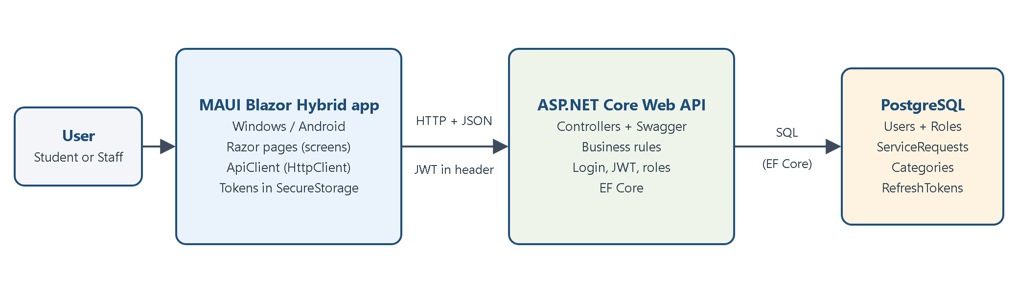
Student name | ______________________________
Registration / Roll No. | ______________________________
Course | ______________________________
Lab / Assignment | Campus Services Management System
Submitted to | ______________________________
Date of submission | ______________________________
GitHub repository | https://github.com/Usman2k25/assignment
Contents
1. Introduction
2. What the Assignment Asked For (and Where I Did It)
3. Tools and Technologies
4. Where I Started From (My Old lab3 Project)
5. How the System Is Designed (Clean Architecture)
6. Database Design (EF Core + PostgreSQL)
7. Business Rules: Request Status
8. The REST API
9. Security: Login, Tokens and Roles
10. The MAUI Blazor Hybrid App (With Screenshots)
11. OOP and SOLID in My Project
12. Testing
13. How to Run the Project in Visual Studio
14. How to Demonstrate the Project (Swagger + App)
15. Challenges and How I Handled Them
16. Limitations and Future Improvements
17. Conclusion
Appendix A: Viva Questions and Answers
Appendix B: Important Files and What They Do
Appendix C: Command Cheat Sheet
Appendix D: Full List of Automated Tests

1. Introduction
In this lab I built a Campus Services Management System. Students use it to report problems on campus, for example 'the Wi-Fi is not working in the library' or 'a chair is broken in the computer lab'. Staff members use it to manage these requests: they give a request to a staff member (assign it) and change its status until the problem is solved.
The system has two programs that work together:
- The Web API (ASP.NET Core). This is the server. It has all the rules, all the security, and it is the only program that talks to the PostgreSQL database.
- The app (.NET MAUI Blazor Hybrid). This is what the user sees. It runs on Windows and Android. It gets all its data from the API over HTTP.
The app never connects to the database directly. It always asks the API. This is safer, because the API checks every single request (who are you, and are you allowed to do this?).
Figure 1: The big picture: the app talks to the API, and only the API talks to the database

1.1 Objectives
My goals for this lab were:
- Build a REST API with Clean Architecture (Domain, Application, Infrastructure, API).
- Save the data in PostgreSQL using Entity Framework Core Code-First and migrations.
- Protect the system with ASP.NET Core Identity, JWT tokens, refresh tokens and two roles: Student and Staff.
- Check permissions on the server, not only by hiding buttons in the app.
- Build a .NET MAUI Blazor Hybrid app that talks to the API with a typed HttpClient.
- Test the system with automated tests and explain how to run and demonstrate it.

1.2 The two roles
Action | Student | Staff
Register a new account | Yes | No (the staff account is created for them)
Log in | Yes | Yes
Create a service request | Yes | No
See requests | Only their own | All requests
Open request details | Only their own | Any request
Assign a request to a staff member | No | Yes
Change the status | No | Yes (only allowed changes)
Edit a request (API only) | Own request, while Pending | No
Table 1: What each role can do

2. What the Assignment Asked For (and Where I Did It)
The assignment gave a list of things the system must have. The table below shows every requirement, what I did, and where to find it in the code. All paths start from the solution folder.
Requirement | What I did | Where in the code
Clean Architecture with separate projects | Five projects + one test project, with references only pointing inwards | CampusServicesManagementSystem.sln
Two roles: Student and Staff | Identity roles, created when the API starts | Domain/​Roles.cs, Infrastructure/​Seed/​DbSeeder.cs
Student: register, log in, create, view own, details, track status | Register / Login / Create / My Requests / Details pages + API | MAUI/​Components/​Pages/​*.razor
Staff: log in, view, assign, update status | Staff Dashboard + Manage Requests page + staff-only endpoints | ManageRequests.razor, RequestsController.cs
Categories: IT Support, Facilities, Administration | A Category table filled by the migration (HasData) | Infrastructure/​Data/​Configurations/​CategoryConfiguration.cs
Statuses with valid transitions only | One rule table + methods on the entity | Domain/​Enums/​StatusRules.cs, Domain/​Entities/​ServiceRequest.cs
EF Core Code-First, DbContext, DbSet, Fluent API, migrations | AppDbContext + 3 configuration classes + InitialCreate migration | Infrastructure/​Data/​, Infrastructure/​Migrations/​
AsNoTracking, change tracking, no N+1 | Read queries use AsNoTracking + Include; updates use tracked entities | Infrastructure/​Repositories/​ServiceRequestRepository.cs
PostgreSQL, no hard-coded passwords | Npgsql provider; connection string from user secrets | Infrastructure/​DependencyInjection.cs, API/​appsettings.json
REST API: POST, GET list, GET one, PUT | /​api/​requests endpoints | API/​Controllers/​RequestsController.cs
DTOs, validation, correct HTTP codes | DTO classes with attributes; 200/201/204/400/401/403/404/500 | Application/​DTOs/​, API/​Middleware/​ExceptionHandlingMiddleware.cs
Middleware + central error handling | One middleware converts exceptions to JSON errors | API/​Middleware/​ExceptionHandlingMiddleware.cs
Swagger with JWT | Swagger UI with the Authorize button | API/​Extensions/​SwaggerExtensions.cs
Identity + password hashing | UserManager stores only a password hash; lockout after 5 wrong tries | Infrastructure/​Auth/​AuthService.cs
JWT: issuer, audience, key, expiry, claims, roles, validation | Token creation + token checking | Infrastructure/​Auth/​TokenService.cs, API/​Extensions/​AuthenticationExtensions.cs
Refresh tokens: rotation and revocation | RefreshTokens table, /refresh and /logout endpoints | Infrastructure/​Auth/​AuthService.cs
Server-side authorization | [Authorize(Roles = ...)] + ownership checks | RequestsController.cs, Application/​Services/​ServiceRequestService.cs
Secure token storage in the app | MAUI SecureStorage (not browser localStorage) | MAUI/​Services/​SessionStore.cs
Secrets not in GitHub | dotnet user-secrets / environment variables | API/​CampusServices.API.csproj (UserSecretsId)
MAUI Blazor Hybrid app with 8 pages | Login, Register, Student Dashboard, Create, My Requests, Details, Staff Dashboard, Manage | MAUI/​Components/​Pages/​
Typed HttpClient, separate from pages | ApiClient registered with AddHttpClient<ApiClient>() | MAUI/​Services/​ApiClient.cs, MAUI/​MauiProgram.cs
Tests for the 7 required cases | 46 automated tests (all passing) | CampusServices.Tests/​
Documentation | README, architecture document, and this report | README.md, docs/​
Table 2: Assignment requirements and where each one is done

3. Tools and Technologies
Technology | Version | What I used it for
C# and .NET SDK | .NET 10 (SDK 10.0.401) | The language and platform for all projects
ASP.NET Core Web API | 10 | The server (REST API)
.NET MAUI Blazor Hybrid | 10 | The app: Razor pages inside a native Windows / Android window
Entity Framework Core | 10.0.14 | Talking to the database with C# classes (no hand-written SQL)
Npgsql EF Core provider | 10.0.3 | Lets EF Core work with PostgreSQL
PostgreSQL | local or Supabase | The database
ASP.NET Core Identity | 10.0.14 | Users, roles, password hashing, lockout
JWT Bearer authentication | 10.0.14 | Checking the access token on every request
System.IdentityModel.Tokens.Jwt | 8.23.0 | Creating (signing) the access token
Swashbuckle (Swagger) | 10.3.1 | A web page to test the API
xUnit + WebApplicationFactory | 2.9.3 / 10.0.14 | Automated tests that start the real API in memory
EF Core InMemory | 10.0.14 | A fake database for the tests
dotnet-ef tool | 10.0.14 | Creating and running migrations
Visual Studio 2026, Git, GitHub | - | Writing, running, debugging and saving the code
Table 3: Technologies used

3.1 NuGet packages in each project
Project | NuGet packages
CampusServices.Domain | Microsoft.Extensions.Identity.Stores 10.0.14 (only for the IdentityUser base class)
CampusServices.Application | none (only references Domain)
CampusServices.Infrastructure | Npgsql.EntityFrameworkCore.PostgreSQL 10.0.3, Microsoft.AspNetCore.Identity.EntityFrameworkCore 10.0.14, System.IdentityModel.Tokens.Jwt 8.23.0
CampusServices.API | Microsoft.AspNetCore.Authentication.JwtBearer 10.0.14, Swashbuckle.AspNetCore 10.3.1, Microsoft.EntityFrameworkCore.Design 10.0.14
CampusServices.MAUI | MAUI packages from the template, Microsoft.AspNetCore.Components.Authorization 10.0.14, Microsoft.Extensions.Http 10.0.14
CampusServices.Tests | xunit 2.9.3, Microsoft.AspNetCore.Mvc.Testing 10.0.14, Microsoft.EntityFrameworkCore.InMemory 10.0.14
Table 4: NuGet packages by project

4. Where I Started From (My Old lab3 Project)
I did not start from an empty folder. I started from my earlier repository lab3 (https://github.com/Usman2k25/lab3). First I downloaded (cloned) it, checked that it was up to date, and looked at every project before changing anything.
lab3 was a small Product management app. It had nothing to do with campus services, so the assignment asked me to replace it completely (not to add a second app next to it).
Old folder | What it was | What I did
BlazorApp1, BlazorApp2 | Empty Blazor web templates (Counter, Weather demo pages) | Removed
ProductManagementApp | Blazor web app with the Product CRUD screen | Removed
Business | ProductService + the Supabase SDK package | Removed
DataAccessLayer | Raw Npgsql SQL commands and a JSON file repository for products | Removed
Shared | ProductModel class | Removed
966-lab3.slnx | Old solution file | Replaced by CampusServicesManagementSystem.sln
.gitignore | Git ignore rules | Kept and improved (also ignores secret files)
Table 5: What happened to the old lab3 files
I removed the old files with git rm, so they disappear from the project but stay in the Git history. Then I created the new solution with the official .NET templates. Now there is one clean project: no Product code, no demo pages, and no old Supabase SQL code.
Improvement: the old project kept the database connection details inside the code. The new project never stores a password, key or connection string in the code. They are kept in user secrets on the developer's computer (see section 9.6).

5. How the System Is Designed (Clean Architecture)
Clean Architecture means: split the code into layers, like the layers of an onion. The inside has the important business rules. The outside has the technical details (database, web, screens). The most important rule is: outer layers may use inner layers, but inner layers never use outer layers.
Why is this good? The business rules (for example "a Resolved request cannot change any more") do not depend on PostgreSQL or on ASP.NET. If I changed the database, the rules would stay the same.
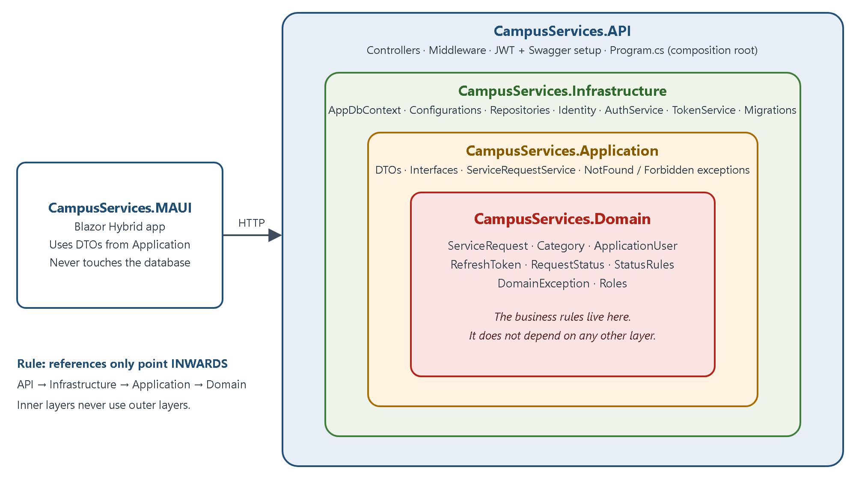
Figure 2: The layers of my solution. References only point inwards
Project | What is inside | It references
CampusServices.Domain | Entities (ServiceRequest, Category, ApplicationUser, RefreshToken), RequestStatus, StatusRules, DomainException, Roles | nothing of ours
CampusServices.Application | DTOs, interfaces (IServiceRequestService, IServiceRequestRepository ...), ServiceRequestService, NotFound/Forbidden exceptions | Domain
CampusServices.Infrastructure | AppDbContext, entity configurations, migrations, repositories, AuthService, TokenService, DbSeeder | Application (+ Domain)
CampusServices.API | Controllers, middleware, JWT and Swagger setup, Program.cs | Application, Infrastructure
CampusServices.MAUI | Razor pages, layout, ApiClient, SessionStore, AppAuthStateProvider, AuthService | Application + Domain (only for DTOs, roles and status rules)
CampusServices.Tests | xUnit tests | all of the above
Table 6: The projects in the solution
You can check the rule yourself: open each .csproj file and look at the <ProjectReference> lines. CampusServices.Domain.csproj has no project reference at all, so the Domain cannot use EF Core or ASP.NET even by mistake.

5.1 Folder structure
CampusServicesManagementSystem.sln
├── CampusServices.Domain
│ ├── Entities/ ApplicationUser, ServiceRequest, Category, RefreshToken
│ ├── Enums/ RequestStatus, StatusRules
│ ├── Exceptions/ DomainException
│ └── Roles.cs
├── CampusServices.Application
│ ├── DTOs/ AuthDtos, RequestDtos, LookupDtos
│ ├── Interfaces/ IServiceRequestService, IAuthService, I...Repository
│ ├── Services/ ServiceRequestService
│ └── Exceptions/ NotFoundException, ForbiddenException
├── CampusServices.Infrastructure
│ ├── Data/ AppDbContext + Configurations/
│ ├── Migrations/ InitialCreate
│ ├── Repositories/ ServiceRequest, Category, User repositories
│ ├── Auth/ AuthService, TokenService, JwtSettings
│ ├── Seed/ DbSeeder
│ └── DependencyInjection.cs
├── CampusServices.API
│ ├── Controllers/ Auth, Requests, Categories, Staff
│ ├── Middleware/ ExceptionHandlingMiddleware
│ ├── Extensions/ AuthenticationExtensions, SwaggerExtensions
│ └── Program.cs
├── CampusServices.MAUI
│ ├── Services/ ApiClient, AuthService, SessionStore, AppAuthStateProvider, ApiSettings
│ ├── Components/ Pages/, Layout/, Shared/, Routes.razor
│ └── wwwroot/ index.html, app.css
├── CampusServices.Tests ApiFactory + 4 test classes
└── docs/ ARCHITECTURE.md, this report, screenshots, diagrams

5.2 How one request travels through the layers
This is what happens when a student presses Submit request:
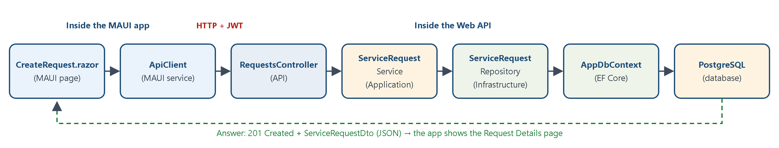
Figure 3: The path of "create a request" through the code
- The student fills the form in CreateRequest.razor. The form already checks the CreateRequestDto rules (for example: title is required).
- ApiClient.CreateRequestAsync sends POST /api/requests with the JWT in the header Authorization: Bearer ....
- ASP.NET Core authentication reads the token and checks the signature, issuer, audience and expiry.
- Authorization: RequestsController.Create has [Authorize(Roles = Roles.Student)], so a staff token gets 403.
- Validation: [ApiController] checks the DTO attributes. Bad data gets 400 automatically.
- The controller reads the student's id from the token (never from the request body) and calls ServiceRequestService.CreateAsync.
- The service checks that the category exists, builds a ServiceRequest object and asks the repository to save it.
- ServiceRequestRepository uses EF Core, which writes an INSERT into PostgreSQL.
- The service reads the new request back (with the category and student names) and turns it into a ServiceRequestDto.
- The controller answers 201 Created. The app then opens the Request Details page.

6. Database Design (EF Core + PostgreSQL)
I used EF Core Code-First. This means I wrote the C# classes first, and EF Core created the tables from them with a migration.
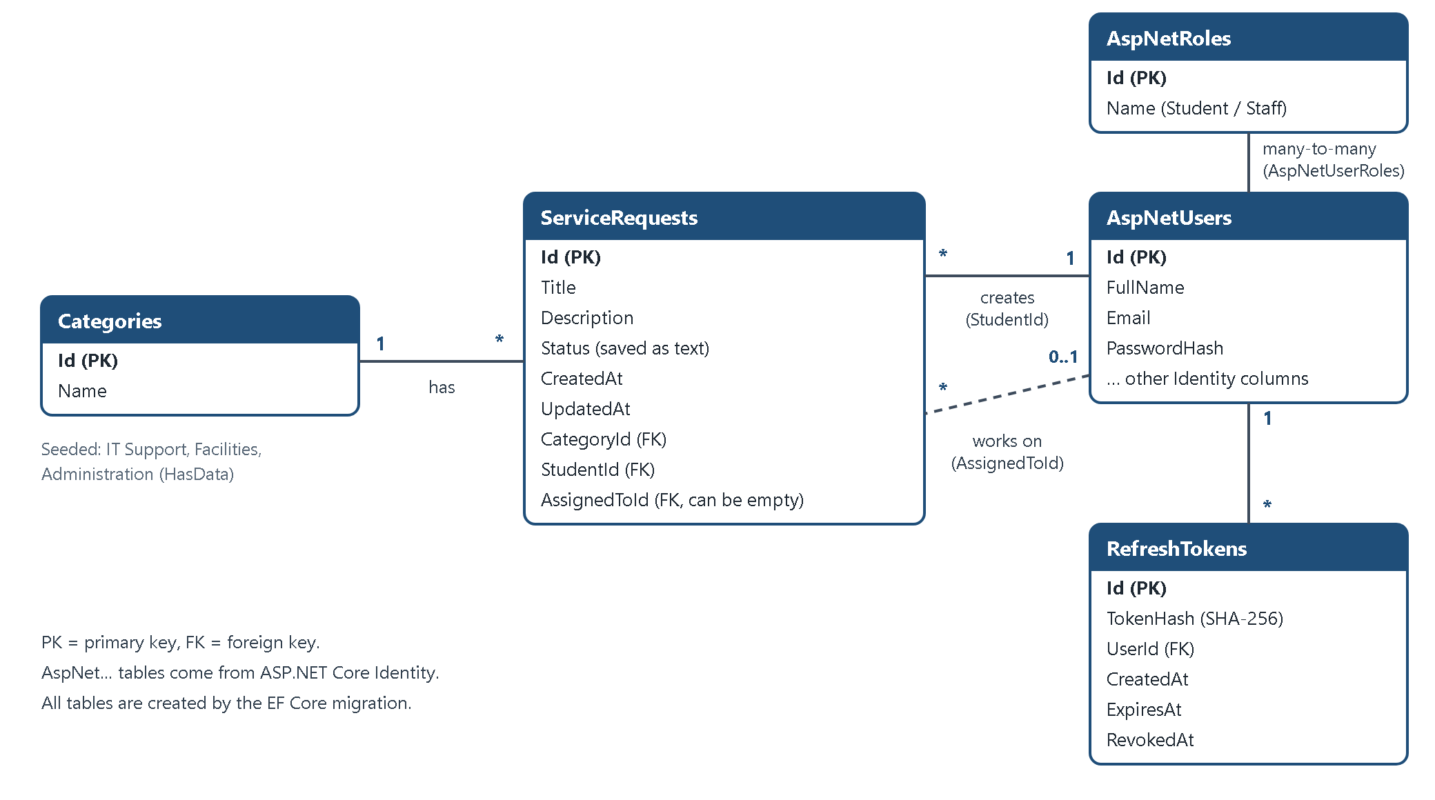
Figure 4: The tables and their relationships
Table | C# class | What it stores
ServiceRequests | ServiceRequest | Every request: title, description, status, dates, category, the student, and the staff member (if assigned)
Categories | Category | The 3 categories: IT Support, Facilities, Administration
AspNetUsers | ApplicationUser | Students and staff. ApplicationUser adds FullName to the normal Identity user
AspNetRoles / AspNetUserRoles | (Identity) | The roles Student and Staff, and which user has which role
RefreshTokens | RefreshToken | The HASH of each refresh token, when it expires and when it was revoked
Table 7: Main tables

6.1 Relationships in simple words
- One category has many requests. Each request has exactly one category (CategoryId).
- One student creates many requests. Each request has exactly one student (StudentId).
- One staff member can work on many requests. A request has zero or one staff member (AssignedToId can be empty).
- One user has many refresh tokens (UserId).
- Delete rules: you cannot delete a category or a student that still has requests (Restrict). If a staff user is deleted, their requests just become unassigned (SetNull).

6.2 The DbContext
The AppDbContext class is the bridge between C# and the database. Each DbSet is one table. It inherits from IdentityDbContext, which adds the Identity tables for us.
File: CampusServices.Infrastructure/Data/AppDbContext.cs
public class AppDbContext : IdentityDbContext<ApplicationUser>
{
public AppDbContext(DbContextOptions<AppDbContext> options) : base(options)
{
}

// Each DbSet is one table.
public DbSet<ServiceRequest> ServiceRequests => Set<ServiceRequest>();
public DbSet<Category> Categories => Set<Category>();
public DbSet<RefreshToken> RefreshTokens => Set<RefreshToken>();

protected override void OnModelCreating(ModelBuilder builder)
{
base.OnModelCreating(builder);

// Loads every class that implements IEntityTypeConfiguration (see the Configurations folder).
builder.ApplyConfigurationsFromAssembly(typeof(AppDbContext).Assembly);
}
}

6.3 Fluent API configuration
The Fluent API describes the details of each table in C#: maximum lengths, the relationships, and the delete rules. The status is saved as text (for example "InProgress"), so the table is easy to read.
File: CampusServices.Infrastructure/Data/Configurations/ServiceRequestConfiguration.cs
public void Configure(EntityTypeBuilder<ServiceRequest> builder)
{
builder.Property(r => r.Title).IsRequired().HasMaxLength(100);
builder.Property(r => r.Description).IsRequired().HasMaxLength(1000);

// Save the status as text ("InProgress") instead of a number, so the table is easy to read.
builder.Property(r => r.Status).HasConversion<string>().HasMaxLength(20);

// Category 1 --- * ServiceRequest
builder.HasOne(r => r.Category)
.WithMany(c => c.ServiceRequests)
.HasForeignKey(r => r.CategoryId)
.OnDelete(DeleteBehavior.Restrict);

// Student 1 --- * ServiceRequest (the creator)
builder.HasOne(r => r.Student)
.WithMany(u => u.CreatedRequests)
.HasForeignKey(r => r.StudentId)
.OnDelete(DeleteBehavior.Restrict);

// Staff 1 --- * ServiceRequest (the person working on it, optional)
builder.HasOne(r => r.AssignedTo)
.WithMany(u => u.AssignedRequests)
.HasForeignKey(r => r.AssignedToId)
.OnDelete(DeleteBehavior.SetNull);
}
The three categories are added with HasData, so the migration inserts them automatically:
File: CampusServices.Infrastructure/Data/Configurations/CategoryConfiguration.cs
public void Configure(EntityTypeBuilder<Category> builder)
{
builder.Property(c => c.Name).IsRequired().HasMaxLength(50);

// The three fixed categories. HasData puts them into the migration,
// so they are inserted into the database when you run "database update".
builder.HasData(
new Category { Id = 1, Name = "IT Support" },
new Category { Id = 2, Name = "Facilities" },
new Category { Id = 3, Name = "Administration" });
}

6.4 Migrations
A migration is a C# file that says how to change the database. I created the first one with:
dotnet ef migrations add InitialCreate --project CampusServices.Infrastructure --startup-project CampusServices.API --output-dir Migrations
To create the tables in your own PostgreSQL database you run:
dotnet tool restore
dotnet ef database update --project CampusServices.Infrastructure --startup-project CampusServices.API
This is part of the real SQL that the migration runs (I got it with dotnet ef migrations script). You can see the lengths, the status stored as text, and the three foreign keys with their delete rules:
CREATE TABLE "ServiceRequests" (
"Id" integer GENERATED BY DEFAULT AS IDENTITY,
"Title" character varying(100) NOT NULL,
"Description" character varying(1000) NOT NULL,
"Status" character varying(20) NOT NULL,
"CreatedAt" timestamp with time zone NOT NULL,
"UpdatedAt" timestamp with time zone,
"CategoryId" integer NOT NULL,
"StudentId" text NOT NULL,
"AssignedToId" text,
CONSTRAINT "PK_ServiceRequests" PRIMARY KEY ("Id"),
CONSTRAINT "FK_ServiceRequests_AspNetUsers_AssignedToId" FOREIGN KEY ("AssignedToId") REFERENCES "AspNetUsers" ("Id") ON DELETE SET NULL,
CONSTRAINT "FK_ServiceRequests_AspNetUsers_StudentId" FOREIGN KEY ("StudentId") REFERENCES "AspNetUsers" ("Id") ON DELETE RESTRICT,
CONSTRAINT "FK_ServiceRequests_Categories_CategoryId" FOREIGN KEY ("CategoryId") REFERENCES "Categories" ("Id") ON DELETE RESTRICT
);

6.5 AsNoTracking (one simple example)
Normally EF Core remembers (tracks) every object it loads, so it can notice changes later. For screens that only show data (lists and details) we change nothing, so tracking is wasted work. AsNoTracking() turns it off. It is faster and uses less memory.
File: CampusServices.Infrastructure/Repositories/ServiceRequestRepository.cs
private IQueryable<ServiceRequest> ReadOnlyQuery()
{
return _db.ServiceRequests
.AsNoTracking()
.Include(r => r.Category)
.Include(r => r.Student)
.Include(r => r.AssignedTo);
}

6.6 Change tracking (one simple update example)
When a student edits a request, I load it with tracking. I change the object in C# and call SaveChangesAsync(). EF Core compares the object with the original values and writes an UPDATE only for the columns that changed. I never write UPDATE SQL myself.
File: CampusServices.Infrastructure/Repositories/ServiceRequestRepository.cs
public async Task<ServiceRequest?> GetByIdForUpdateAsync(int id)
{
return await _db.ServiceRequests.FirstOrDefaultAsync(r => r.Id == id);
}
File: CampusServices.Application/Services/ServiceRequestService.cs
public async Task<ServiceRequestDto> UpdateAsync(int id, string studentId, UpdateRequestDto dto)
{
// Tracked query: EF Core remembers the original values of this object.
var request = await _requests.GetByIdForUpdateAsync(id);
if (request == null)
{
throw new NotFoundException("Request " + id + " was not found.");
}

if (request.StudentId != studentId)
{
throw new ForbiddenException("You can only edit your own requests.");
}

await CheckCategoryExistsAsync(dto.CategoryId);

request.Edit(dto.Title.Trim(), dto.Description.Trim(), dto.CategoryId);

// CHANGE TRACKING: EF Core compares the object with its original values
// and creates an UPDATE statement for the changed columns only.
await _requests.SaveChangesAsync();

return await GetDtoAsync(id);
}

6.7 The N+1 problem and how I avoided it
The N+1 problem happens when you load a list (1 query) and then run one more query for every item in the list (N queries). With 1000 requests that is 1001 queries, which is very slow.
Bad example (this code is NOT in my project, it is only to explain the problem):
var requests = await _db.ServiceRequests.ToListAsync(); // 1 query

foreach (var request in requests)
{
var category = await _db.Categories // +1 query for EVERY request
.FirstAsync(c => c.Id == request.CategoryId);
Console.WriteLine(request.Title + " - " + category.Name);
}
// 20 requests = 21 queries. 1000 requests = 1001 queries.
My solution: load the related data in the same query with Include (SQL JOIN). This is exactly what ReadOnlyQuery() in section 6.5 does. Whatever the number of requests, it is one query:
var requests = await _db.ServiceRequests
.Include(r => r.Category) // JOIN Categories
.Include(r => r.Student) // JOIN AspNetUsers
.Include(r => r.AssignedTo) // LEFT JOIN AspNetUsers
.ToListAsync(); // 1 query in total
Also good to know: another way to avoid N+1 is a projection with .Select(...), which loads only the columns you need. I also did not use any raw SQL in the project: every query is LINQ-to-Entities.

7. Business Rules: Request Status
A request moves through clear steps. Only some changes are allowed. For example, a Pending request cannot jump straight to Resolved, and nothing can change after Resolved or Rejected.
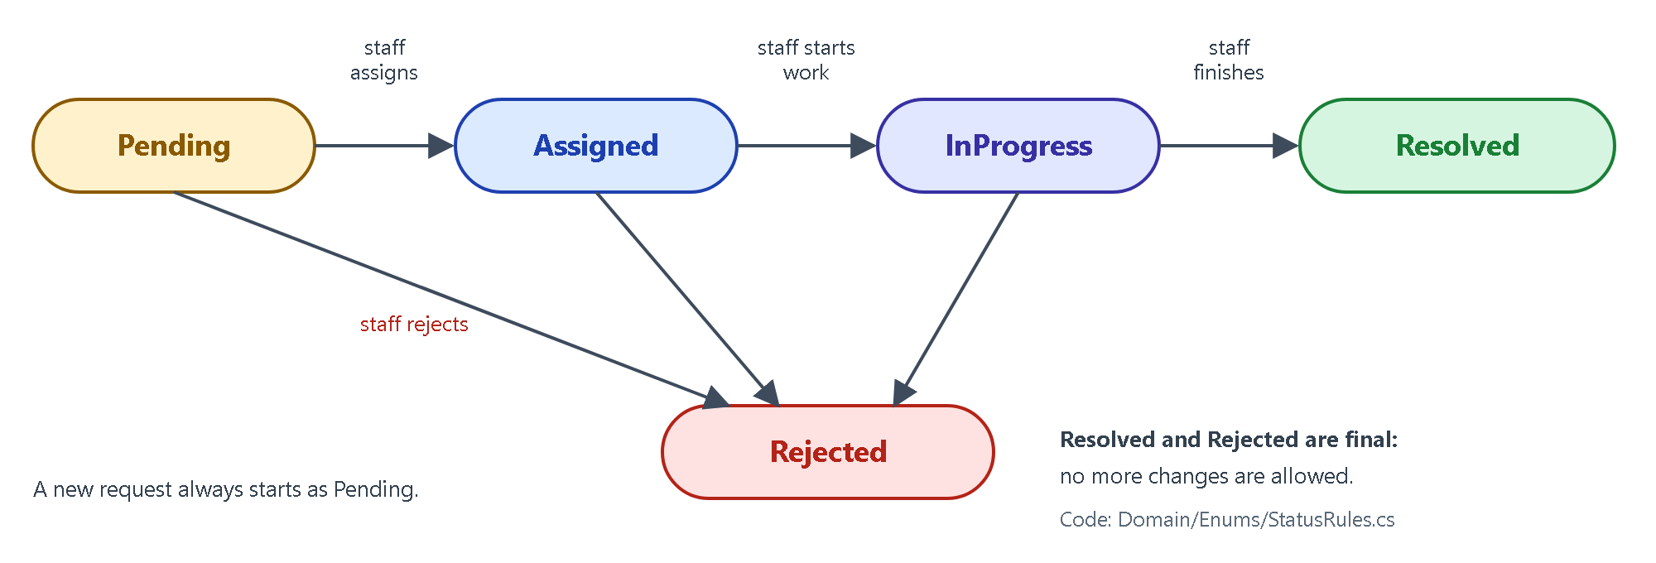
Figure 5: Allowed status changes
The rules are written once, in the Domain layer. Both the API (to block invalid changes) and the app (to show only valid choices in the drop-down) use this same table:
File: CampusServices.Domain/Enums/StatusRules.cs
public static List<RequestStatus> GetNextStatuses(RequestStatus current)
{
switch (current)
{
case RequestStatus.Pending:
return new List<RequestStatus> { RequestStatus.Assigned, RequestStatus.Rejected };

case RequestStatus.Assigned:
return new List<RequestStatus> { RequestStatus.InProgress, RequestStatus.Rejected };

case RequestStatus.InProgress:
return new List<RequestStatus> { RequestStatus.Resolved, RequestStatus.Rejected };

default:
// Resolved and Rejected are final.
return new List<RequestStatus>();
}
}
The ServiceRequest entity checks the rule before it changes itself. If the change is not allowed, it throws a DomainException, and the API turns that into 400 Bad Request:
File: CampusServices.Domain/Entities/ServiceRequest.cs
public void ChangeStatus(RequestStatus newStatus)
{
var allowed = StatusRules.GetNextStatuses(Status);

if (!allowed.Contains(newStatus))
{
throw new DomainException("A request cannot change from " + Status + " to " + newStatus + ".");
}

// "Assigned" needs a staff member, so it must be done with Assign().
if (newStatus == RequestStatus.Assigned)
{
throw new DomainException("To set the status to Assigned, assign the request to a staff member.");
}

Status = newStatus;
UpdatedAt = DateTime.UtcNow;
}
Assigning is also a rule on the entity. A request can be assigned only while it is Pending or Assigned (to re-assign it):
File: CampusServices.Domain/Entities/ServiceRequest.cs
public void Assign(string staffId)
{
if (Status != RequestStatus.Pending && Status != RequestStatus.Assigned)
{
throw new DomainException("A request that is " + Status + " cannot be assigned.");
}

AssignedToId = staffId;
Status = RequestStatus.Assigned;
UpdatedAt = DateTime.UtcNow;
}

8. The REST API

8.1 Endpoints
Method + URL | Who can use it | Success | Errors
POST /api/auth/register | anyone | 200 | 400
POST /api/auth/login | anyone | 200 | 400, 401
POST /api/auth/refresh | anyone with a refresh token | 200 | 401
POST /api/auth/logout | anyone with a refresh token | 204 | -
GET /api/categories | any logged-in user | 200 | 401
GET /api/staff | Staff | 200 | 401, 403
POST /api/requests | Student | 201 | 400, 401, 403
GET /api/requests | logged in (student: own, staff: all) | 200 | 401
GET /api/requests/{id} | the owner or staff | 200 | 401, 403, 404
PUT /api/requests/{id} | Student, own request, while Pending | 200 | 400, 401, 403, 404
PUT /api/requests/{id}/assign | Staff | 200 | 400, 401, 403, 404
PUT /api/requests/{id}/status | Staff | 200 | 400, 401, 403, 404
Table 8: All API endpoints

8.2 HTTP status codes I used
Code | Meaning in simple words | Example in my API
200 OK | It worked, here is the data | GET /api/requests
201 Created | A new thing was made | POST /api/requests (also returns a Location header)
204 No Content | It worked, nothing to send back | POST /api/auth/logout
400 Bad Request | The data is wrong or breaks a rule | Empty title, unknown category, Pending → Resolved
401 Unauthorized | You are not logged in (no token, wrong or expired token) | GET /api/requests without a token
403 Forbidden | You are logged in but not allowed | A student calls the staff-only /status endpoint
404 Not Found | That item does not exist | GET /api/requests/99999
500 Internal Server Error | Something unexpected broke on the server | Database down (details are hidden from the user)
Table 9: Status codes

8.3 DTOs and validation
A DTO (Data Transfer Object) is a small class that only carries data between the app and the API. I never send the EF Core entities directly. This stops private data (like password hashes) from leaking and keeps the API simple.
The validation rules are attributes on the DTO. Because the controller has [ApiController], ASP.NET Core checks them automatically and answers 400 with a list of errors. The MAUI app uses the same DTO in its forms, so the user sees the same messages before anything is sent.
File: CampusServices.Application/DTOs/RequestDtos.cs
public class CreateRequestDto
{
[Required]
[StringLength(100, MinimumLength = 3)]
public string Title { get; set; } = string.Empty;

[Required]
[StringLength(1000, MinimumLength = 10)]
public string Description { get; set; } = string.Empty;

[Range(1, int.MaxValue, ErrorMessage = "Please select a category.")]
public int CategoryId { get; set; }
}

8.4 One place for error handling (middleware)
A middleware is code that runs for every request. My ExceptionHandlingMiddleware catches errors from anywhere below it and turns them into the correct status code. That is why my controllers have no try/catch blocks. For a 500 error, the real error is written to the log, and the user only gets a general message.
File: CampusServices.API/Middleware/ExceptionHandlingMiddleware.cs
private async Task WriteErrorAsync(HttpContext context, Exception ex)
{
int statusCode;
string title;
string detail;

if (ex is NotFoundException)
{
statusCode = StatusCodes.Status404NotFound;
title = "Not Found";
detail = ex.Message;
}
else if (ex is ForbiddenException)
{
statusCode = StatusCodes.Status403Forbidden;
title = "Forbidden";
detail = ex.Message;
}
else if (ex is DomainException)
{
statusCode = StatusCodes.Status400BadRequest;
title = "Bad Request";
detail = ex.Message;
}
else
{
_logger.LogError(ex, "Unhandled error while processing {Path}", context.Request.Path);
statusCode = StatusCodes.Status500InternalServerError;
title = "Internal Server Error";
detail = "Something went wrong on the server. Please try again later.";
}

var problem = new ProblemDetails
{
Status = statusCode,
Title = title,
Detail = detail
};

context.Response.StatusCode = statusCode;
await context.Response.WriteAsJsonAsync(problem);
}

8.5 Program.cs: connecting everything (Dependency Injection)
Program.cs is the composition root: the one place where all layers are connected. It stays short because the details are in small extension methods (AddInfrastructure, AddJwtAuthentication, AddSwaggerWithJwt). The order of the middleware matters: first error handling, then authentication (who are you?), then authorization (are you allowed?).
File: CampusServices.API/Program.cs (using lines left out)
// Program.cs is the "composition root": it connects all the layers together.
var builder = WebApplication.CreateBuilder(args);

// ----- Register services (Dependency Injection) -----
builder.Services.AddControllers();
builder.Services.AddInfrastructure(builder.Configuration); // database, Identity, repositories, AuthService
builder.Services.AddScoped<IServiceRequestService, ServiceRequestService>(); // Application use cases
builder.Services.AddJwtAuthentication(builder.Configuration);
builder.Services.AddSwaggerWithJwt();

var app = builder.Build();

// ----- Middleware pipeline (the order matters) -----
app.UseMiddleware<ExceptionHandlingMiddleware>(); // turns exceptions into proper JSON errors

if (app.Environment.IsDevelopment())
{
app.UseSwagger();
app.UseSwaggerUI();
}
else
{
// In development the MAUI app talks to plain http://localhost, so we only redirect in production.
app.UseHttpsRedirection();
}

app.UseAuthentication(); // 1. Who are you? (reads the JWT)
app.UseAuthorization(); // 2. Are you allowed? (checks [Authorize] roles)
app.MapControllers();

// ----- Create the roles (and the optional staff account) -----
try
{
await DbSeeder.SeedAsync(app.Services);
}
catch (Exception ex)
{
app.Logger.LogError(ex, "Could not seed the database. Did you run 'dotnet ef database update'? (see README.md)");
}

app.Run();

// Makes the Program class visible to the test project (WebApplicationFactory<Program>).
public partial class Program
{
}
This is how Infrastructure registers its classes. Each interface from the Application layer is connected to the class that implements it:
File: CampusServices.Infrastructure/DependencyInjection.cs
public static IServiceCollection AddInfrastructure(this IServiceCollection services, IConfiguration configuration)
{
var connectionString = configuration.GetConnectionString("DefaultConnection");
if (string.IsNullOrWhiteSpace(connectionString))
{
throw new InvalidOperationException(
"ConnectionStrings:DefaultConnection is missing. Set it with user-secrets (see README.md).");
}

// Database: EF Core with PostgreSQL.
services.AddDbContext<AppDbContext>(options => options.UseNpgsql(connectionString));

// ASP.NET Core Identity: users, roles and password hashing.
// (AddIdentityCore is used because we log in with JWT, not with cookies.)
services.AddIdentityCore<ApplicationUser>()
.AddRoles<IdentityRole>()
.AddEntityFrameworkStores<AppDbContext>();

// JWT settings + token creation + login/register logic.
services.Configure<JwtSettings>(configuration.GetSection("Jwt"));
services.AddScoped<TokenService>();
services.AddScoped<IAuthService, AuthService>();

// Repositories: each interface (from Application) is connected to its EF Core class.
services.AddScoped<IServiceRequestRepository, ServiceRequestRepository>();
services.AddScoped<ICategoryRepository, CategoryRepository>();
services.AddScoped<IUserRepository, UserRepository>();

return services;
}

8.6 Swagger
Swagger is a web page that lists every endpoint and lets you try them. When the API runs, open http://localhost:5080/swagger. The green Authorize button lets you paste a JWT to test protected endpoints.
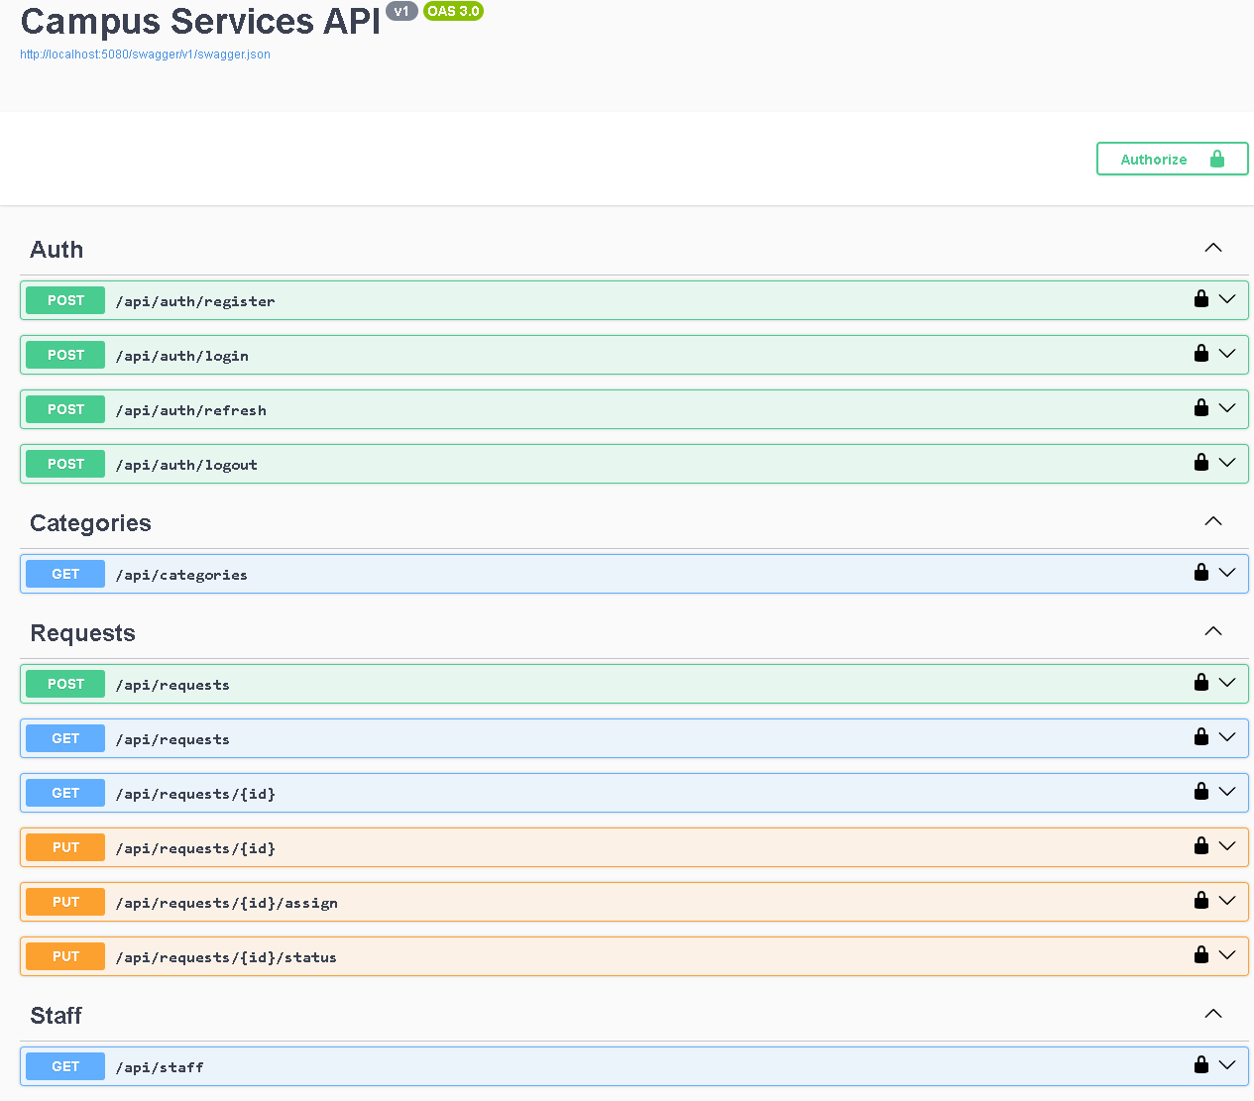
Figure 6: Swagger page of my API with all 12 endpoints

9. Security: Login, Tokens and Roles

9.1 Passwords with ASP.NET Core Identity
When a user registers, UserManager.CreateAsync(user, password) hashes the password (PBKDF2 with a random salt). Only the hash is saved in AspNetUsers.PasswordHash. The plain password is never stored.
- Password rules (Identity defaults): at least 6 characters, with an uppercase letter, a lowercase letter, a number and a symbol.
- After 5 wrong passwords the account is locked for a few minutes (I tested this).

9.2 Two roles, created safely
The roles Student and Staff are created when the API starts (DbSeeder). The register form has no role field, and the code always gives the Student role. So nobody can make themselves staff. The staff account is created from the user secrets (SeedStaff:Email and SeedStaff:Password).
File: CampusServices.Infrastructure/Auth/AuthService.cs
public async Task<AuthResponseDto> RegisterAsync(RegisterDto dto)
{
var user = new ApplicationUser();
user.UserName = dto.Email.Trim();
user.Email = dto.Email.Trim();
user.FullName = dto.FullName.Trim();

// Identity hashes the password for us. We never store the plain password.
var result = await _userManager.CreateAsync(user, dto.Password);
if (!result.Succeeded)
{
var messages = new List<string>();
foreach (var error in result.Errors)
{
messages.Add(error.Description);
}
throw new DomainException(string.Join(" ", messages));
}

// Anyone who registers is a Student. There is no way to ask for the Staff role here.
await _userManager.AddToRoleAsync(user, Roles.Student);

return await CreateResponseAsync(user, Roles.Student);
}

9.3 The JWT access token
After login the API gives the app an access token. Think of it as a signed ID card with an expiry time. It contains claims: the user id, name, email and role. The API signs it with the secret key Jwt:Key, so nobody can change it without the API noticing. It is valid for 30 minutes.
File: CampusServices.Infrastructure/Auth/TokenService.cs
public string CreateAccessToken(ApplicationUser user, string role, DateTime expiresAt)
{
var claims = new List<Claim>
{
new Claim(ClaimTypes.NameIdentifier, user.Id),
new Claim(ClaimTypes.Name, user.FullName),
new Claim(ClaimTypes.Email, user.Email ?? string.Empty),
new Claim(ClaimTypes.Role, role)
};

var key = new SymmetricSecurityKey(Encoding.UTF8.GetBytes(_settings.Key));
var credentials = new SigningCredentials(key, SecurityAlgorithms.HmacSha256);

var token = new JwtSecurityToken(
issuer: _settings.Issuer,
audience: _settings.Audience,
claims: claims,
expires: expiresAt,
signingCredentials: credentials);

return new JwtSecurityTokenHandler().WriteToken(token);
}
On every request the API checks the token: the signature, the issuer, the audience and the expiry time. A changed (tampered) token gets 401.
File: CampusServices.API/Extensions/AuthenticationExtensions.cs
public static IServiceCollection AddJwtAuthentication(this IServiceCollection services, IConfiguration configuration)
{
var jwt = configuration.GetSection("Jwt").Get<JwtSettings>();

// Fail early with a clear message instead of a confusing error later.
if (jwt == null || string.IsNullOrWhiteSpace(jwt.Key) || jwt.Key.Length < 32)
{
throw new InvalidOperationException(
"Jwt:Key is missing or shorter than 32 characters. Set it with user-secrets (see README.md).");
}

var signingKey = new SymmetricSecurityKey(Encoding.UTF8.GetBytes(jwt.Key));

services.AddAuthentication(JwtBearerDefaults.AuthenticationScheme)
.AddJwtBearer(options =>
{
options.TokenValidationParameters = new TokenValidationParameters
{
ValidateIssuer = true,
ValidIssuer = jwt.Issuer,
ValidateAudience = true,
ValidAudience = jwt.Audience,
ValidateIssuerSigningKey = true,
IssuerSigningKey = signingKey,
ValidateLifetime = true, // reject expired tokens
ClockSkew = TimeSpan.Zero // no extra grace time after expiry
};
});

services.AddAuthorization();

return services;
}

9.4 Refresh tokens: rotation and revocation
A short access token is safer: if someone steals it, it stops working soon. But typing the password every 30 minutes would be annoying. So login also gives a refresh token: a long random text that is valid for 7 days. When the access token is almost expired, the app sends the refresh token to POST /api/auth/refresh and gets a new pair of tokens.
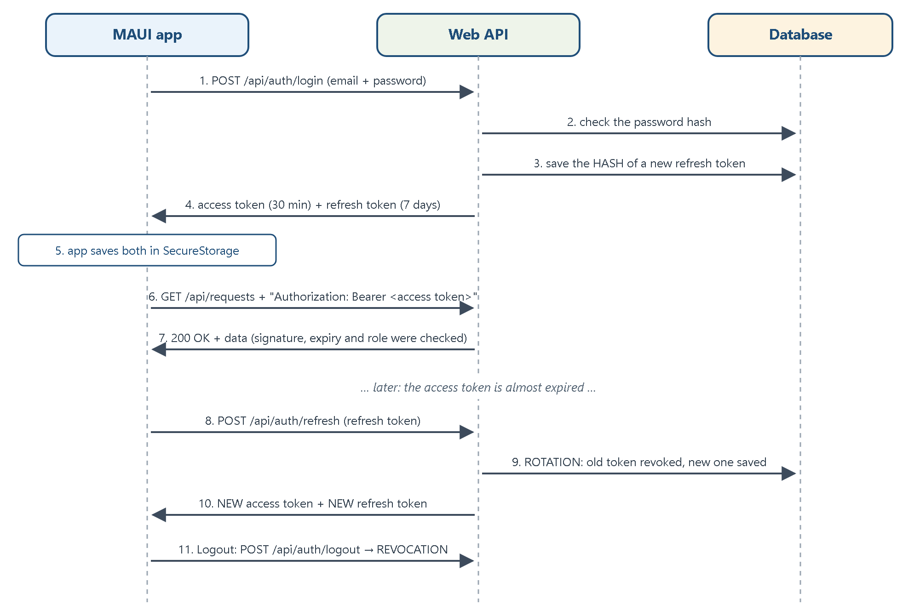
Figure 7: Login, using the access token, refreshing and logging out
Idea | How my project does it
Stored safely | Only a SHA-256 hash of the refresh token is saved in the RefreshTokens table. A database leak does not give usable tokens.
Rotation | Every refresh uses up the old refresh token (RevokedAt is set) and gives a new one. Using the old one again gives 401.
Revocation | Logout (POST /​api/​auth/​logout) sets RevokedAt, so the token can never be used again. Tokens also stop working after 7 days.
In the app | ApiClient refreshes automatically when less than 1 minute is left. If the refresh token is rejected, the app logs the user out and shows the login page.
Table 10: Refresh token design
File: CampusServices.Infrastructure/Auth/AuthService.cs
public async Task<AuthResponseDto?> RefreshAsync(string refreshToken)
{
var saved = await FindRefreshTokenAsync(refreshToken);
if (saved == null || !saved.IsActive)
{
return null;
}

var user = await _userManager.FindByIdAsync(saved.UserId);
if (user == null)
{
return null;
}

// ROTATION: the old refresh token is used up. CreateResponseAsync below
// saves this change together with the brand-new token.
saved.RevokedAt = DateTime.UtcNow;

var role = await GetRoleAsync(user);
return await CreateResponseAsync(user, role);
}

9.5 Authorization is checked on the SERVER
Hiding a button in the app is not security. Anyone can call the API directly with Swagger, Postman or curl. So the API checks everything itself, in three layers:
- Role check. Staff-only endpoints have [Authorize(Roles = Roles.Staff)]. Wrong role → 403. No token or a bad token → 401.
- Ownership check. The service compares the request's StudentId with the user id inside the token. A student who opens another student's request gets 403. The user id always comes from the token, so it cannot be faked.
- Business rules. The Domain refuses invalid status changes and refuses to assign a request to someone who is not staff → 400.
File: CampusServices.API/Controllers/RequestsController.cs (Swagger attributes left out)
[ApiController]
[Route("api/requests")]
[Authorize]
public class RequestsController : ControllerBase
...

private string CurrentUserId
{
get { return User.FindFirstValue(ClaimTypes.NameIdentifier) ?? string.Empty; }
}

[HttpPut("{id:int}/assign")]
[Authorize(Roles = Roles.Staff)]
public async Task<ActionResult<ServiceRequestDto>> Assign(int id, AssignRequestDto dto)
{
var updated = await _service.AssignAsync(id, dto);
return Ok(updated);
}
File: CampusServices.Application/Services/ServiceRequestService.cs
public async Task<ServiceRequestDto> GetByIdAsync(int id, string userId, bool isStaff)
{
var request = await _requests.GetByIdAsync(id);
if (request == null)
{
throw new NotFoundException("Request " + id + " was not found.");
}

// Staff can see everything. A student can only see their own request.
if (!isStaff && request.StudentId != userId)
{
throw new ForbiddenException("You can only view your own requests.");
}

return ToDto(request);
}

9.6 Keeping secrets out of GitHub
Secret | Where it is kept | In GitHub?
Database password (connection string) | dotnet user-secrets (or an environment variable) | No
JWT signing key (Jwt:Key) | dotnet user-secrets (or an environment variable) | No
Staff account password (SeedStaff:Password) | dotnet user-secrets | No
The user's tokens in the app | MAUI SecureStorage (encrypted by Windows / Android) | n/a
Table 11: Where secrets are kept
User secrets are saved in a folder on your own computer, outside the project, so they can never be committed. appsettings.json has no password and no key. .gitignore also blocks files like secrets.json and .env. In the app, the tokens are saved with SecureStorage, not with browser localStorage:
File: CampusServices.MAUI/Services/SessionStore.cs
public async Task SaveAsync(AuthResponseDto session)
{
_session = session;
_loaded = true;

try
{
await SecureStorage.Default.SetAsync(StorageKey, JsonSerializer.Serialize(session));
}
catch (Exception)
{
// Same as above: keep the session in memory only.
}

Changed?.Invoke();
}

10. The MAUI Blazor Hybrid App (With Screenshots)
The app is a .NET MAUI Blazor Hybrid app. The screens are normal Razor components, but they run inside a real Windows (or Android) app window, not in a web browser. All screenshots below were taken from the real Windows app while it was talking to the real API (with test data).
Page | Route | Who | What it does
Login | / or /login | everyone | Log in, then go to the right dashboard
Register | /register | everyone | Create a student account
Student Dashboard | /student | Student | Welcome + number of requests per status
Create Request | /student/create | Student | Form: category, title, description
My Requests | /student/requests | Student | Table of the student's own requests
Request Details | /requests/{id} | Student (own) / Staff | All details + progress bar
Staff Dashboard | /staff | Staff | Number of ALL requests per status
Manage Requests | /staff/requests | Staff | Filter, assign to staff, change status
Table 12: Pages of the app

10.1 Student screens
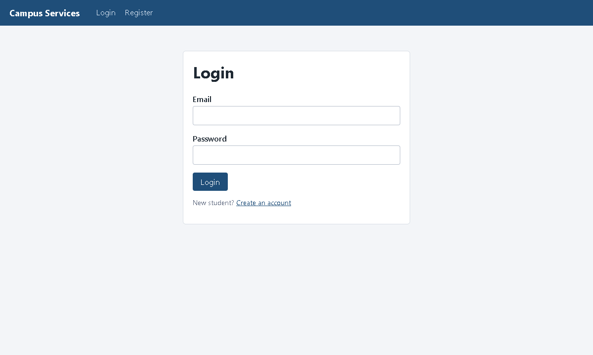
Figure 8: Login page
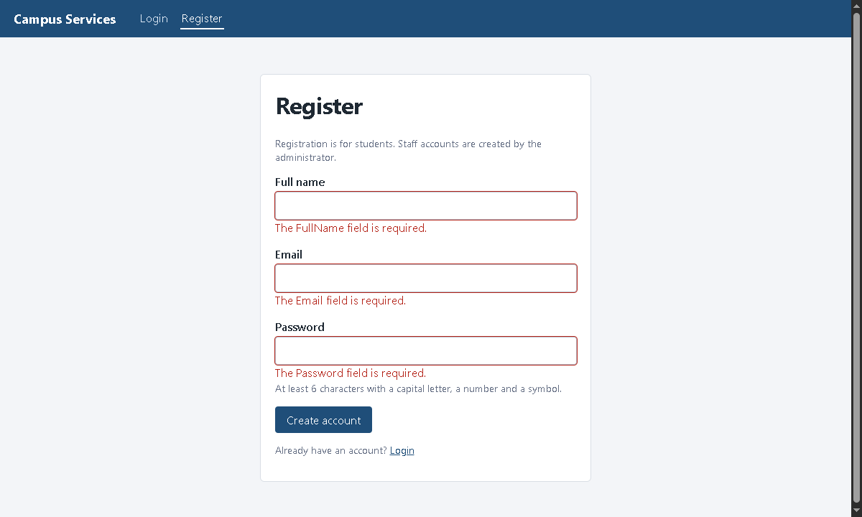
Figure 9: Register page: the form shows validation messages when fields are empty
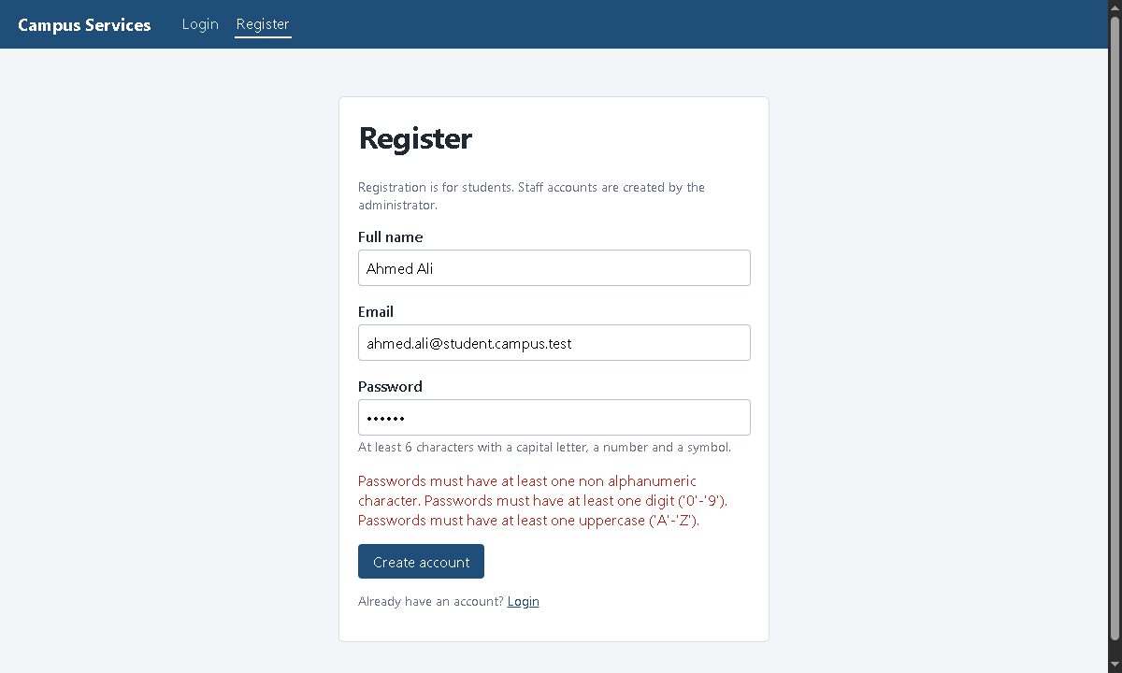
Figure 10: Register page: the API refuses a weak password and the app shows the reason
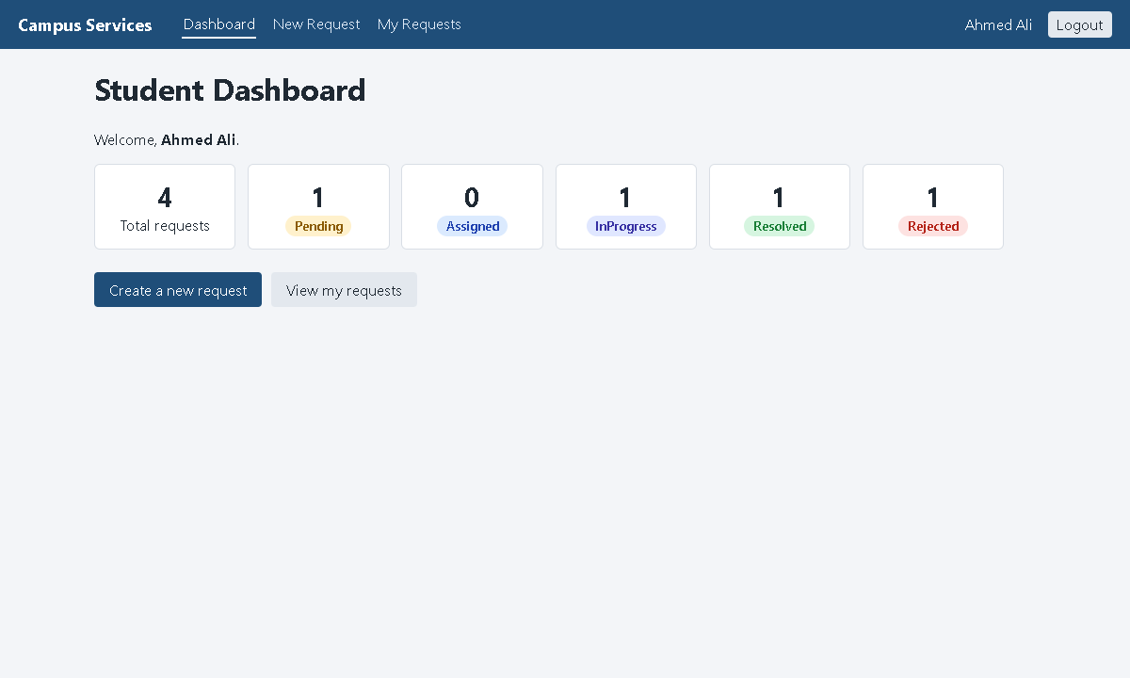
Figure 11: Student Dashboard: counts of the student's requests by status
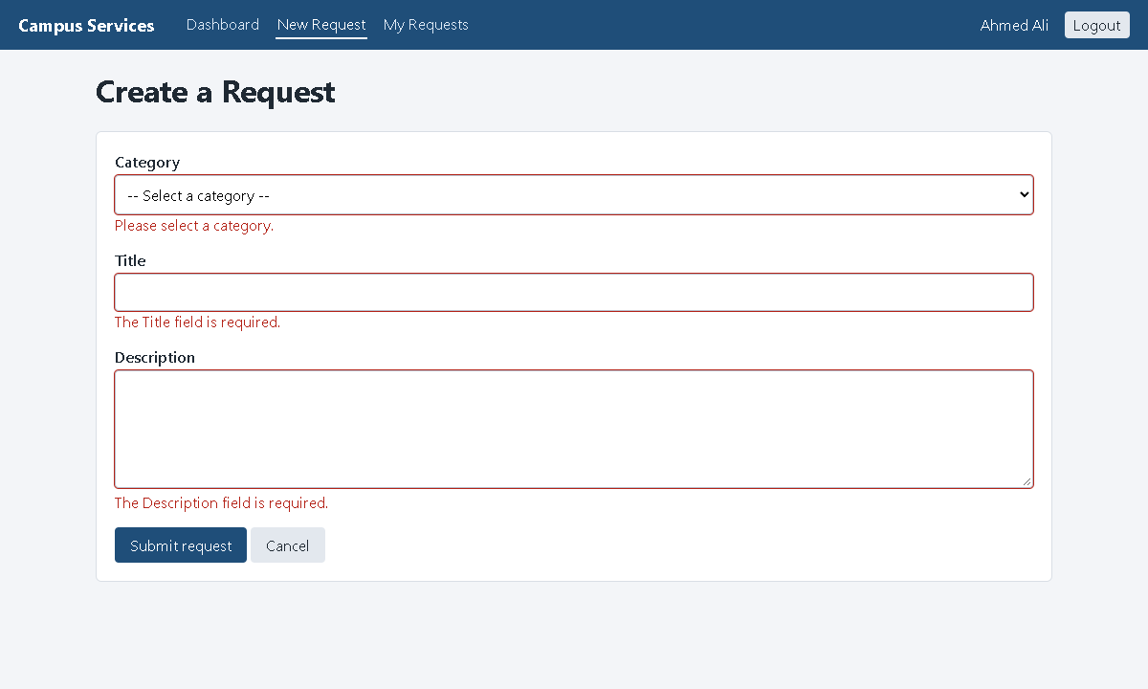
Figure 12: Create Request: validation messages
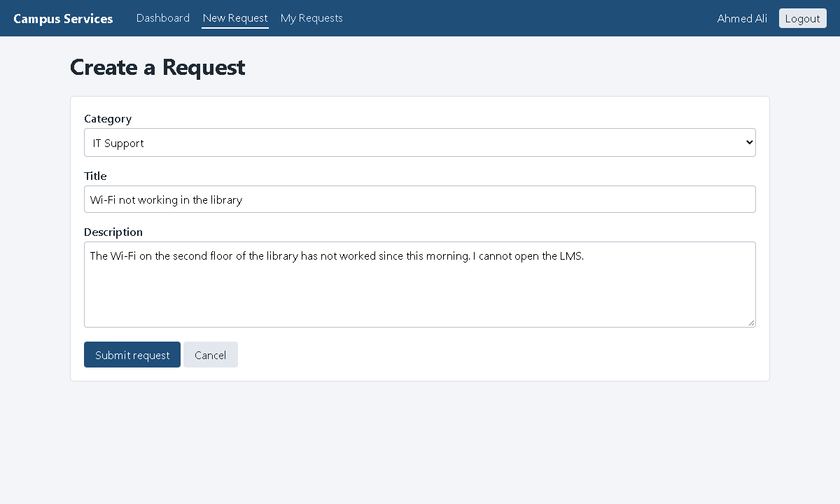
Figure 13: Create Request: a correctly filled form
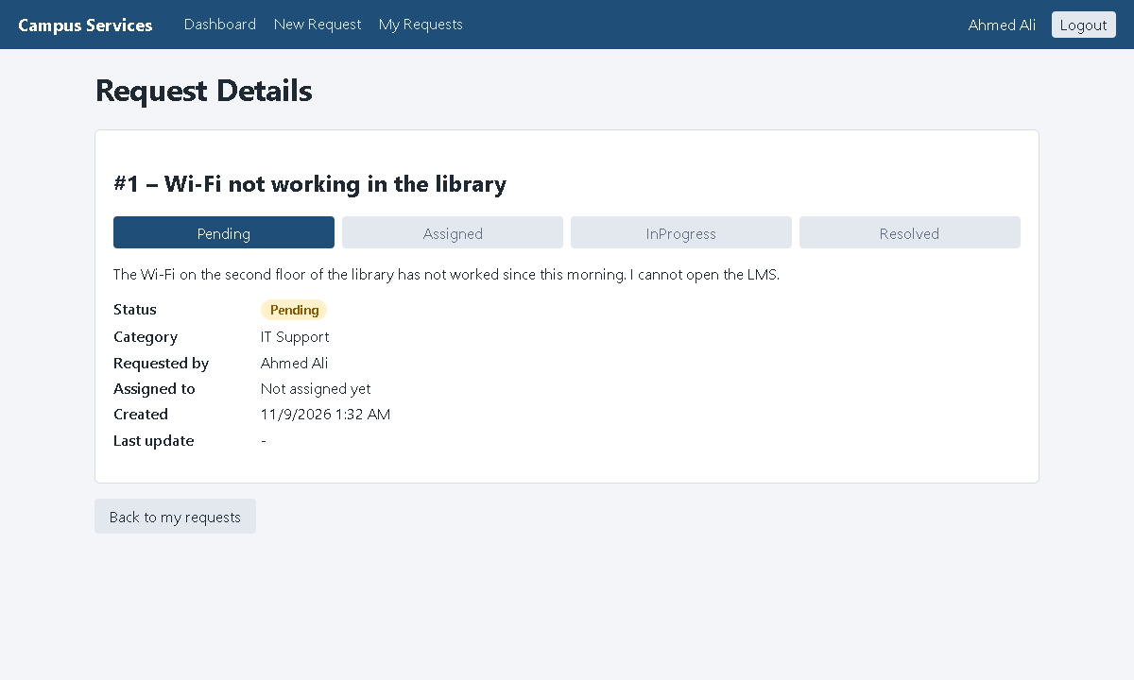
Figure 14: Request Details right after creating it (status Pending)
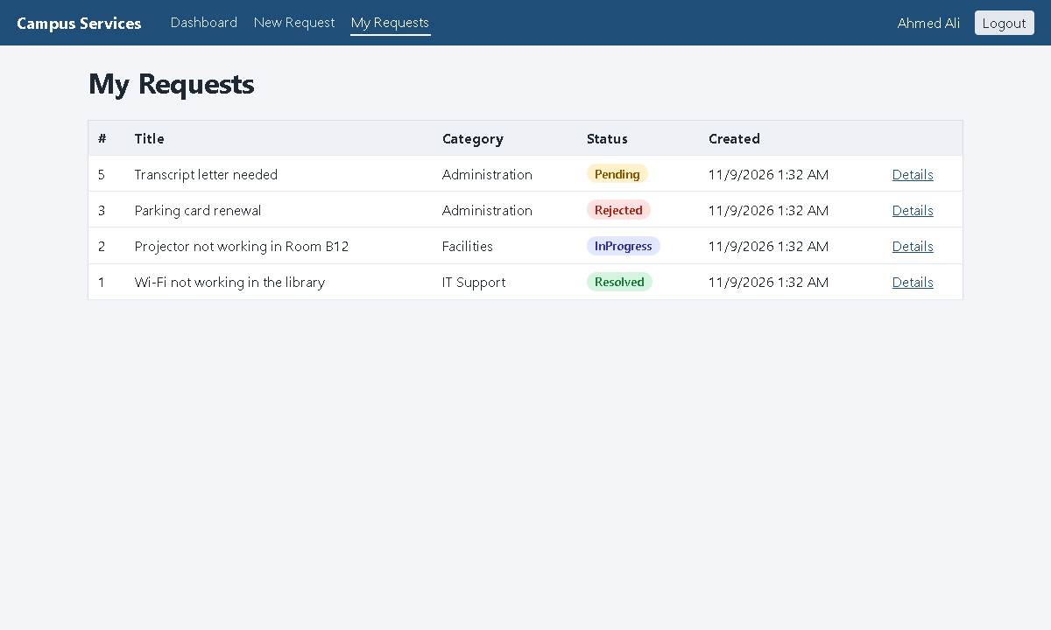
Figure 15: My Requests: only Ahmed's own requests are listed (Bilal's request is not shown)
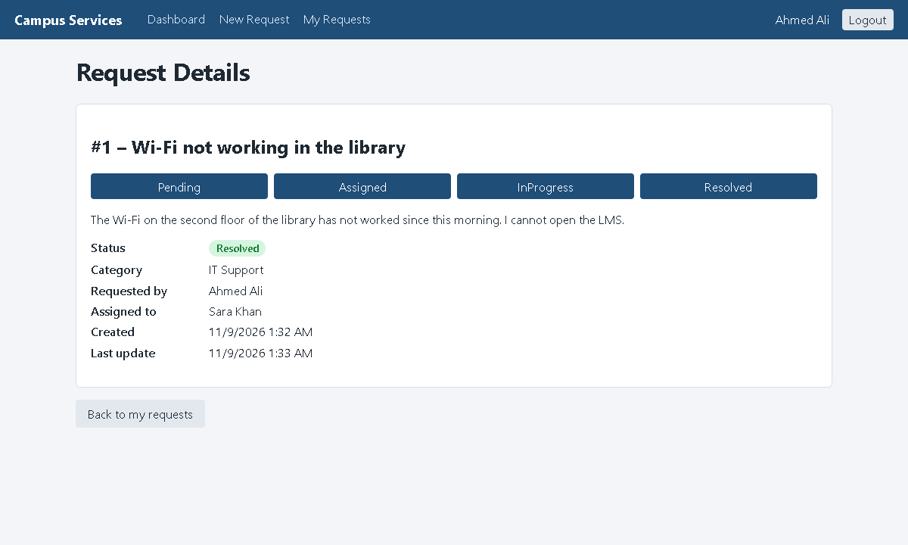
Figure 16: Request Details after staff resolved it: the progress bar is complete
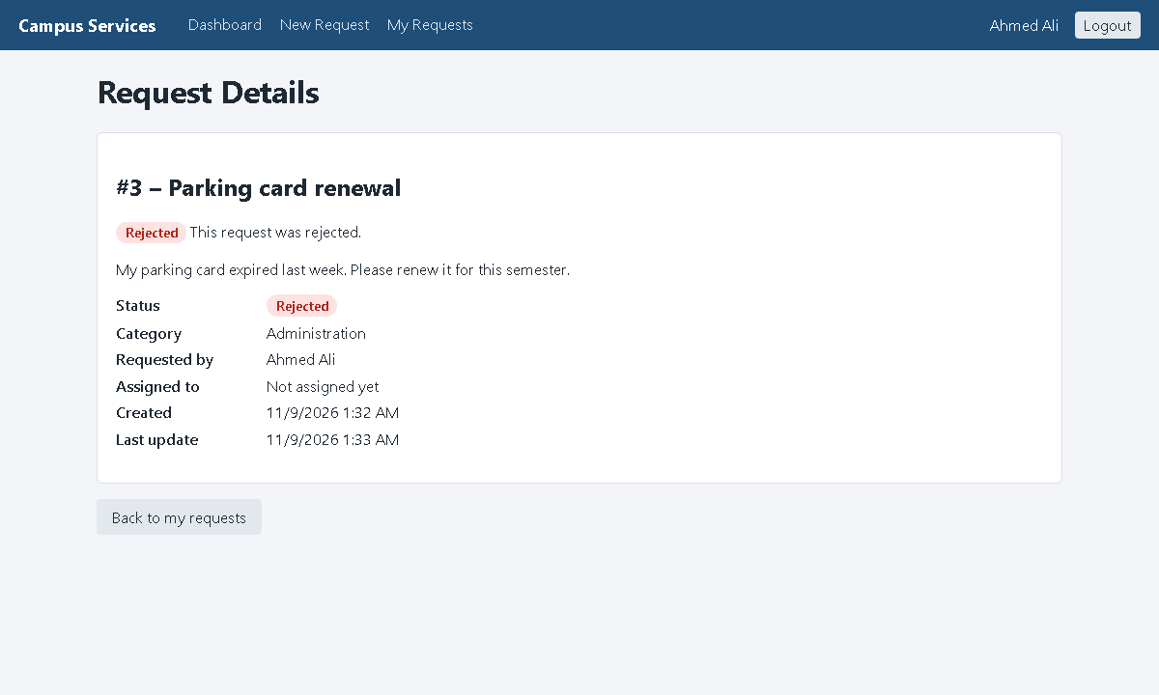
Figure 17: Request Details of a rejected request
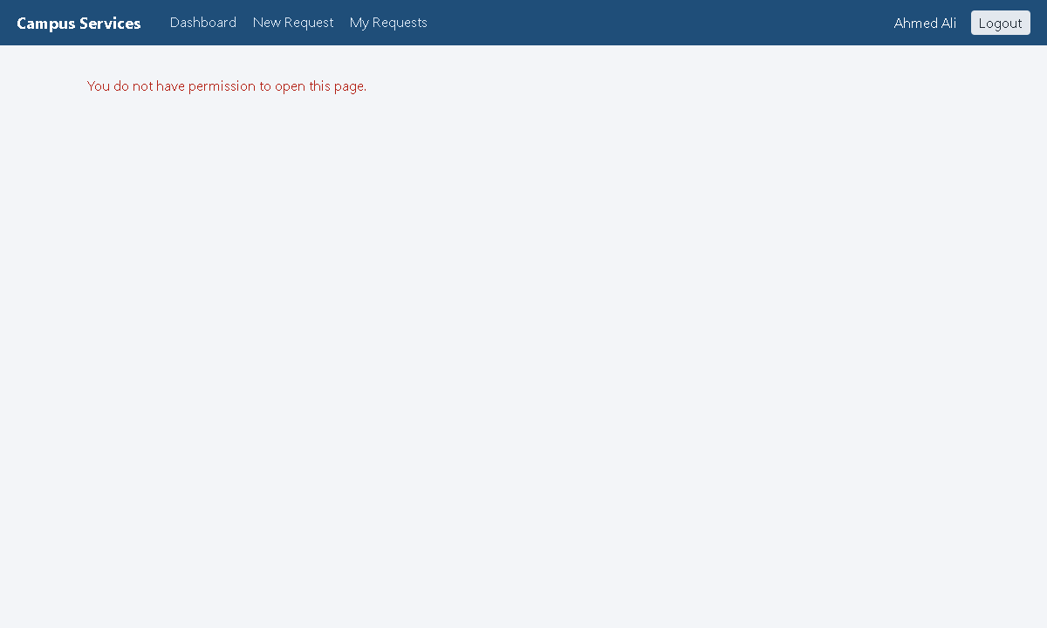
Figure 18: A student who opens a staff page sees "You do not have permission"
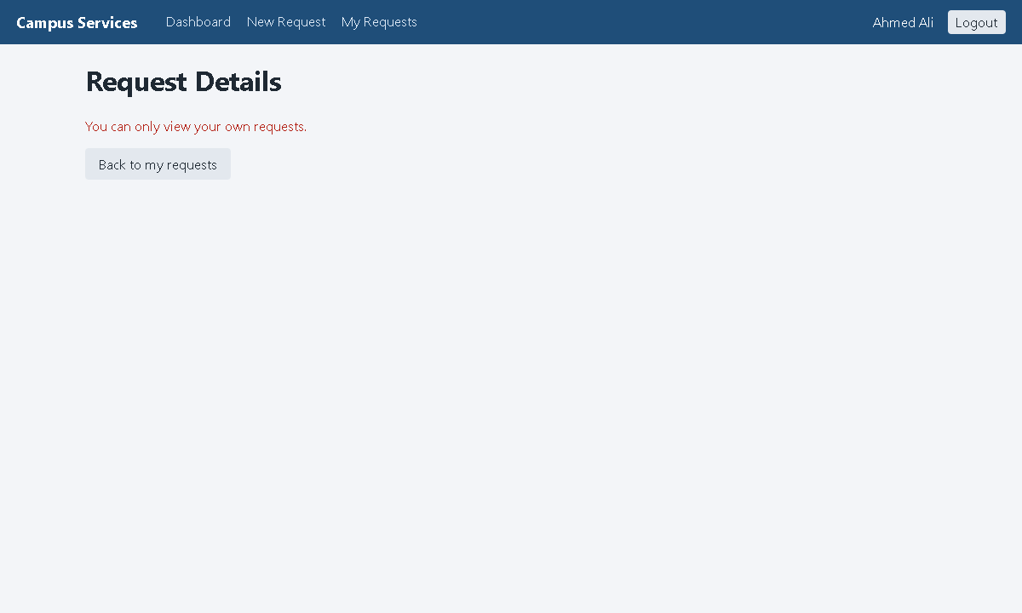
Figure 19: A student who opens another student's request: the API answers 403 and the app shows its message

10.2 Staff screens
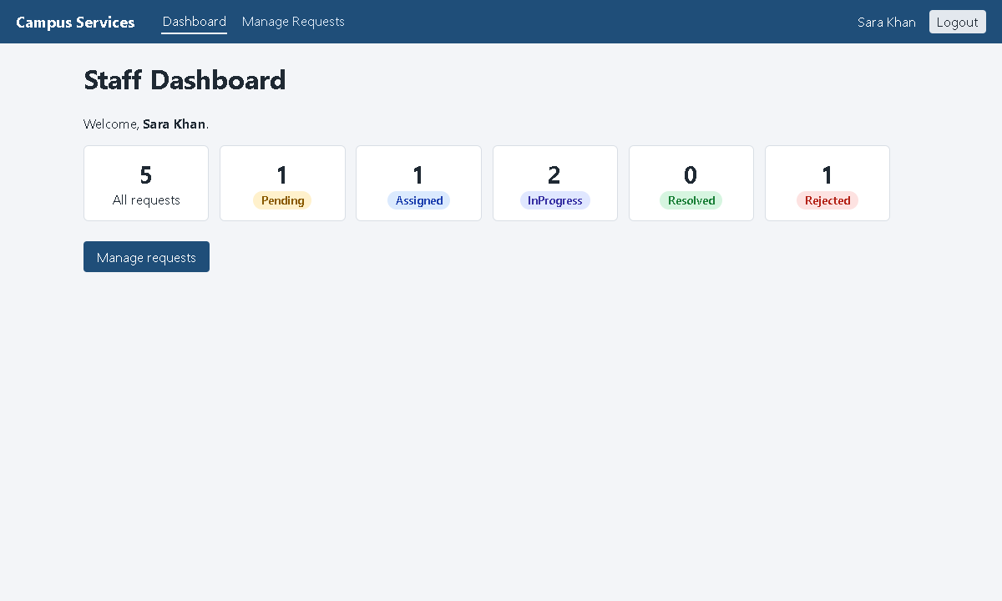
Figure 20: Staff Dashboard: counts of ALL requests by status
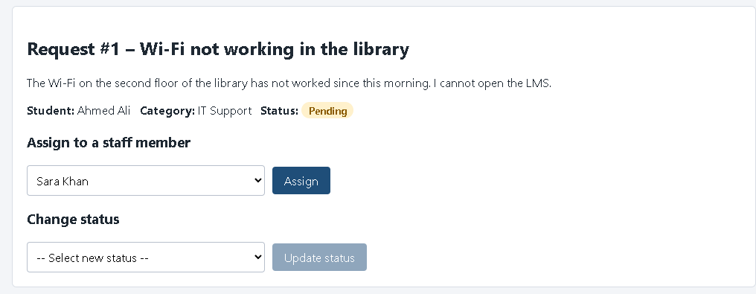
Figure 21: Manage panel: choosing a staff member before pressing Assign
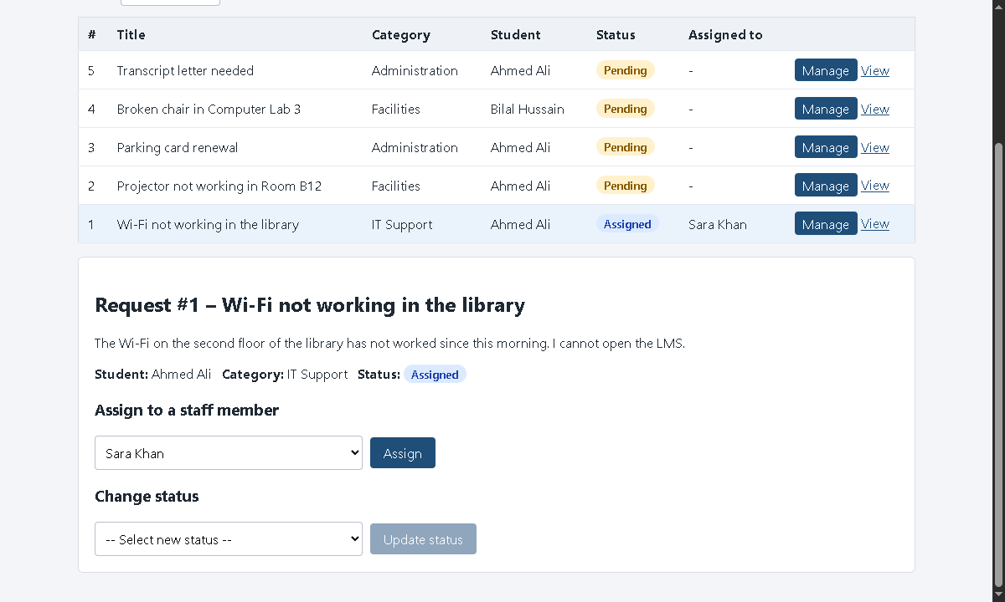
Figure 22: After Assign: the status became Assigned and only valid next statuses are offered
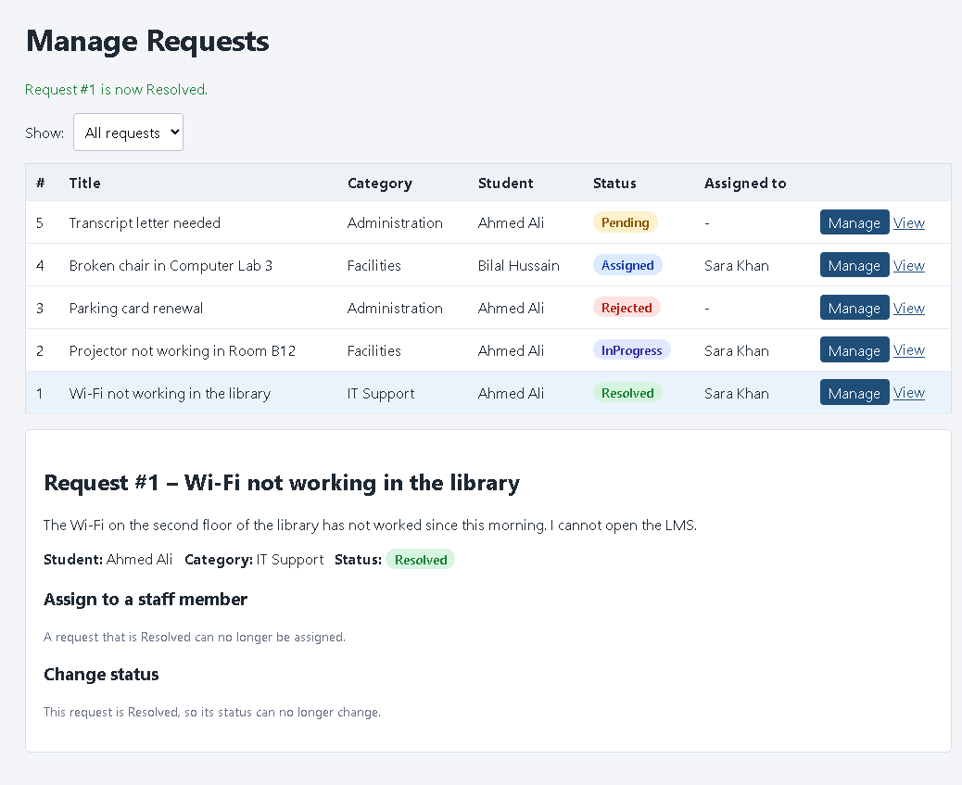
Figure 23: Manage Requests: all five statuses; a Resolved request can no longer be changed

10.3 How the app talks to the API
The pages never use HttpClient themselves. They call ApiClient, which is a typed HttpClient. It is registered in MauiProgram.cs together with the login-state classes:
File: CampusServices.MAUI/MauiProgram.cs
// ----- Login state for Blazor (<AuthorizeView>, [Authorize]) -----
builder.Services.AddAuthorizationCore();
builder.Services.AddCascadingAuthenticationState();
builder.Services.AddSingleton<SessionStore>();
builder.Services.AddSingleton<AppAuthStateProvider>();
builder.Services.AddSingleton<AuthenticationStateProvider>(sp => sp.GetRequiredService<AppAuthStateProvider>());

// ----- Talking to the API -----
// Typed HttpClient: ApiClient receives an HttpClient that already knows the API address.
builder.Services.AddHttpClient<ApiClient>(client =>
{
client.BaseAddress = new Uri(ApiSettings.BaseUrl);
client.Timeout = TimeSpan.FromSeconds(30);
});
builder.Services.AddSingleton<AuthService>();
Before each call, ApiClient adds the access token. If the token is almost expired, it first gets a new one with the refresh token:
File: CampusServices.MAUI/Services/ApiClient.cs
private async Task<string?> GetValidAccessTokenAsync()
{
var session = await _sessionStore.GetAsync();
if (session == null)
{
return null;
}

if (session.ExpiresAt > DateTime.UtcNow.AddMinutes(1))
{
return session.AccessToken;
}

var newSession = await RefreshAsync(session.RefreshToken);
if (newSession == null)
{
// The refresh token is also expired or was revoked: the user must log in again.
_sessionStore.Clear();
throw new ApiException("Your session has expired. Please log in again.", 401);
}

return newSession.AccessToken;
}
The API address is in Services/ApiSettings.cs: http://localhost:5080/ on Windows and http://10.0.2.2:5080/ on the Android emulator (10.0.2.2 is how the emulator reaches your PC).

10.4 Login state and the role-based menu
AppAuthStateProvider tells Blazor who is logged in and their role. Then the menu can show different links for each role with <AuthorizeView>, and pages can be protected with [Authorize]:
File: CampusServices.MAUI/Components/Layout/NavMenu.razor
<AuthorizeView Roles="@Roles.Student" Context="studentContext">
<NavLink href="student" Match="NavLinkMatch.All">Dashboard</NavLink>
<NavLink href="student/create">New Request</NavLink>
<NavLink href="student/requests">My Requests</NavLink>
</AuthorizeView>

<AuthorizeView Roles="@Roles.Staff" Context="staffContext">
<NavLink href="staff" Match="NavLinkMatch.All">Dashboard</NavLink>
<NavLink href="staff/requests">Manage Requests</NavLink>
</AuthorizeView>
File: CampusServices.MAUI/Components/Pages/StudentDashboard.razor
@page "/student"
@attribute [Authorize(Roles = Roles.Student)]
@inject ApiClient Api
Remember: hiding links in the app is only for a nicer user experience. The real protection is on the server (section 9.5).

11. OOP and SOLID in My Project
Principle | Simple meaning | Example in my code
Encapsulation | An object protects its own data and rules | ServiceRequest.ChangeStatus(), Assign() and Edit() check the rules before changing the object
Abstraction | Use something without knowing how it works inside | Controllers only know the interface IServiceRequestService
Polymorphism | Different classes can be used through the same interface | ICategoryRepository can be the real EF Core repository, or a broken test version in ErrorHandlingTests
Inheritance | A class gets features from a parent class | ApplicationUser : IdentityUser, AppDbContext : IdentityDbContext
S – Single Responsibility | Each class has one job | TokenService only makes tokens; the middleware only handles errors; repositories only run queries
O – Open/Closed | Add new behaviour without changing old code | A new exception type only needs one more mapping in the middleware; controllers do not change
L – Liskov Substitution | A replacement class must work in the same place | Any ICategoryRepository works with ServiceRequestService (proved by the 500 test)
I – Interface Segregation | Small interfaces instead of one huge one | ICategoryRepository and IUserRepository have only 2 methods each
D – Dependency Inversion | Depend on interfaces, not on concrete classes | ServiceRequestService depends on IServiceRequestRepository, not on EF Core
Table 13: OOP and SOLID examples

11.1 Dependency Injection in simple words
Dependency Injection means a class does not create the objects it needs. It asks for them in its constructor, and ASP.NET Core gives them. This makes classes easy to test and easy to change.
File: CampusServices.Application/Services/ServiceRequestService.cs
// Dependency Injection: ASP.NET Core gives us the three repositories.
public ServiceRequestService(
IServiceRequestRepository requests,
ICategoryRepository categories,
IUserRepository users)
{
_requests = requests;
_categories = categories;
_users = users;
}
In the API all of these are registered as Scoped: one object per HTTP request, so everything in one request shares the same AppDbContext. In the MAUI app, the session classes are Singletons because there is only one user in the app at a time.

12. Testing
I wrote 46 automated tests with xUnit. They are in the CampusServices.Tests project. All 46 pass.
- API tests start the real API in memory with WebApplicationFactory<Program> and call it with HttpClient. Only the database is swapped for an in-memory database. So the controllers, the JWT checks, the roles and the middleware are the real code.
- Domain tests check the status rules directly, without any API or database.

12.1 The 7 required test cases
Required case | My tests | Expected
Valid request creation | Create_WithValidData_Returns201AndPendingRequest | 201
Invalid request validation | Create_WithInvalidData_Returns400, Create_WithUnknownCategory_Returns400 | 400
Unauthenticated API access | GetRequests_WithoutToken_Returns401, CreateRequest_WithoutToken_Returns401 | 401
Student tries a staff-only operation | Student_CannotAssignRequest_Returns403, Student_CannotChangeStatus_Returns403, Student_CannotListStaffMembers_Returns403 | 403
Student opens another student's request | Student_CannotViewAnotherStudentsRequest_Returns403, Student_CannotEditAnotherStudentsRequest_Returns403, StudentList_ContainsOnlyTheirOwnRequests | 403
Request that does not exist | GetRequest_ThatDoesNotExist_Returns404, Staff_ChangingStatusOfMissingRequest_Returns404 | 404
Invalid status transition | Staff_InvalidStatusTransition_Returns400 + the rule tests in ServiceRequestDomainTests | 400
Extra: unexpected error | UnexpectedError_Returns500_AndDoesNotLeakDetails | 500
Extra: login and tokens | register, wrong password, weak password, lockout, cannot register as staff, refresh rotation, logout revocation | 200 / 400 / 401
Table 14: Required test cases and my tests

12.2 Example tests
An API test: a student tries to assign a request (a staff-only action). The API must answer 403.
File: CampusServices.Tests/ServiceRequestApiTests.cs
[Fact]
public async Task Student_CannotAssignRequest_Returns403()
{
var student = await _factory.CreateStudentAsync();
var staff = await _factory.CreateStaffAsync();
var created = await CreateRequestAsync(student);

var response = await student.Client.PutAsJsonAsync(
"/api/requests/" + created.Id + "/assign",
new AssignRequestDto { StaffId = staff.Id });

Assert.Equal(HttpStatusCode.Forbidden, response.StatusCode);
}
A domain test: invalid status changes must throw DomainException and must not change the status. [Theory] runs the same test for every [InlineData] line.
File: CampusServices.Tests/ServiceRequestDomainTests.cs
[Theory]
[InlineData(RequestStatus.Pending, RequestStatus.InProgress)]
[InlineData(RequestStatus.Pending, RequestStatus.Resolved)]
[InlineData(RequestStatus.Assigned, RequestStatus.Resolved)]
[InlineData(RequestStatus.InProgress, RequestStatus.Pending)]
[InlineData(RequestStatus.Resolved, RequestStatus.InProgress)]
[InlineData(RequestStatus.Resolved, RequestStatus.Rejected)]
[InlineData(RequestStatus.Rejected, RequestStatus.Assigned)]
public void ChangeStatus_InvalidTransition_ThrowsDomainException(RequestStatus from, RequestStatus to)
{
var request = new ServiceRequest { Status = from };

Assert.Throws<DomainException>(() => request.ChangeStatus(to));
Assert.Equal(from, request.Status); // the status did not change
}

12.3 Test results
Command: dotnet test CampusServices.Tests (in Visual Studio: Test → Run All Tests). Real output:
Test Run Successful.
Total tests: 46
Passed: 46
Total time: 7.5139 Seconds
The full list of the 46 test names is in Appendix D.

12.4 Proof that the tests really catch mistakes
A test that can never fail is useless. So I did a small experiment: I removed two security checks on purpose (the staff-only role on "assign", and the "own requests only" check). Then I ran the tests again. Exactly the two matching tests failed (Student_CannotAssignRequest_Returns403 and Student_CannotViewAnotherStudentsRequest_Returns403). After I put the checks back, all tests passed again.

12.5 Manual end-to-end testing
I also tested the real Windows app against the running API:
- Register (empty form, weak password, valid password), log in, log out.
- Create requests, see them in My Requests and in the details page.
- Staff: assign, InProgress, Resolved and Rejected. Only valid status choices are offered.
- A student cannot open staff pages, and cannot open another student's request (403 from the API).
- The login is remembered after closing and opening the app again (SecureStorage).
- With very short access tokens, the app refreshed the token by itself many times (each time a new refresh token).
- When the refresh token was no longer valid, the app went back to the login page.
- Calling the API directly (no app) with a student token on staff endpoints gave 403; a changed token gave 401.

13. How to Run the Project in Visual Studio

13.1 What you need
- Windows 10 or 11 with Visual Studio 2026 (version 18).
- Visual Studio workloads: ASP.NET and web development and .NET Multi-platform App UI development (install them with the Visual Studio Installer → Modify).
- The .NET 10 SDK (comes with Visual Studio 2026). Check in a terminal with dotnet --list-sdks.
- A PostgreSQL database: install PostgreSQL on your computer, or use your Supabase project.
- Optional: an Android emulator (Tools → Android → Android Device Manager).

13.2 Step 1 – Get the code
git clone https://github.com/Usman2k25/assignment.git
Or on GitHub press Code → Download ZIP and unzip it.

13.3 Step 2 – Open the solution
Double-click CampusServicesManagementSystem.sln. Visual Studio opens all six projects and restores the NuGet packages automatically (wait until it finishes). Then use Build → Build Solution to check that everything builds.

13.4 Step 3 – Set the user secrets
In Solution Explorer, right-click CampusServices.API → Manage User Secrets. Paste this and change the values to your own:
{
"ConnectionStrings": {
"DefaultConnection": "Host=localhost;Port=5432;Database=CampusServices;Username=postgres;Password=YOUR_DB_PASSWORD"
},
"Jwt": {
"Key": "PUT-A-RANDOM-TEXT-OF-AT-LEAST-32-CHARACTERS-HERE"
},
"SeedStaff": {
"Email": "staff@campus.local",
"Password": "CHOOSE-A-STRONG-PASSWORD-1!",
"FullName": "Staff Member"
}
}
- Supabase: use the Session pooler (or direct) connection string on port 5432, and add SSL Mode=Require;Trust Server Certificate=true. Do not use the 6543 "transaction pooler" for migrations.
- To make a random JWT key in PowerShell: $b = New-Object byte[] 48; [Security.Cryptography.RandomNumberGenerator]::Create().GetBytes($b); [Convert]::ToBase64String($b)
- The staff password must follow the Identity rules (uppercase, lowercase, number, symbol, 6+ characters).

13.5 Step 4 – Create the database
Open View → Terminal in Visual Studio (it opens in the solution folder) and run:
dotnet tool restore
dotnet ef database update --project CampusServices.Infrastructure --startup-project CampusServices.API
This creates all tables and the three categories. You can check them in pgAdmin or in the Supabase Table Editor.

13.6 Step 5 – Run the API
- Right-click CampusServices.API → Set as Startup Project.
- In the toolbar, choose the http profile.
- Press F5. The browser opens Swagger at http://localhost:5080/swagger.
- When the API starts it creates the roles and the staff account from your user secrets.

13.7 Step 6 – Run the app
- Keep the API running.
- Right-click CampusServices.MAUI → Set as Startup Project.
- In the toolbar choose Windows Machine (easiest) or an Android emulator.
- Press F5. Register a student, or log in with the staff account.

13.8 Step 7 – Run both at the same time
Right-click the Solution → Configure Startup Projects… → Multiple startup projects → set CampusServices.API = Start and CampusServices.MAUI = Start → OK. Now F5 starts both. Wait a few seconds for the API before you press Login.

13.9 Step 8 – Run the tests
Test → Run All Tests (Test Explorer), or in the terminal: dotnet test CampusServices.Tests. The tests do not need PostgreSQL.

13.10 If something goes wrong
Problem | Fix
"Jwt:Key is missing or shorter than 32 characters" | Set the Jwt:Key user secret (Step 3).
"ConnectionStrings:DefaultConnection is missing" | Set the connection string user secret.
dotnet ef is not found | Run dotnet tool restore in the solution folder.
Log says "Could not seed the database" | The database is not reachable or not migrated. Check the connection string and run Step 4.
App says "Cannot reach the server" | Start the API first. For a real phone, put your PC's IP address in ApiSettings.cs.
Staff cannot log in | Set SeedStaff:Email and SeedStaff:Password, then restart the API.
MAUI project does not build | Install the .NET Multi-platform App UI workload.
Table 15: Troubleshooting

14. How to Demonstrate the Project (Swagger + App)
This is the order I would show the project to the instructor. All screenshots are real.

14.1 A successful API request
- In Swagger, use POST /api/auth/register (or login) and copy the accessToken from the answer.
- Click Authorize, paste the token, press Authorize, then Close.
- Open POST /api/requests → Try it out → write the body → Execute. The answer is 201 Created.
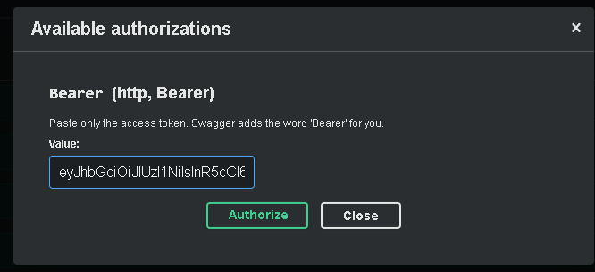
Figure 24: Swagger Authorize dialog: paste only the token
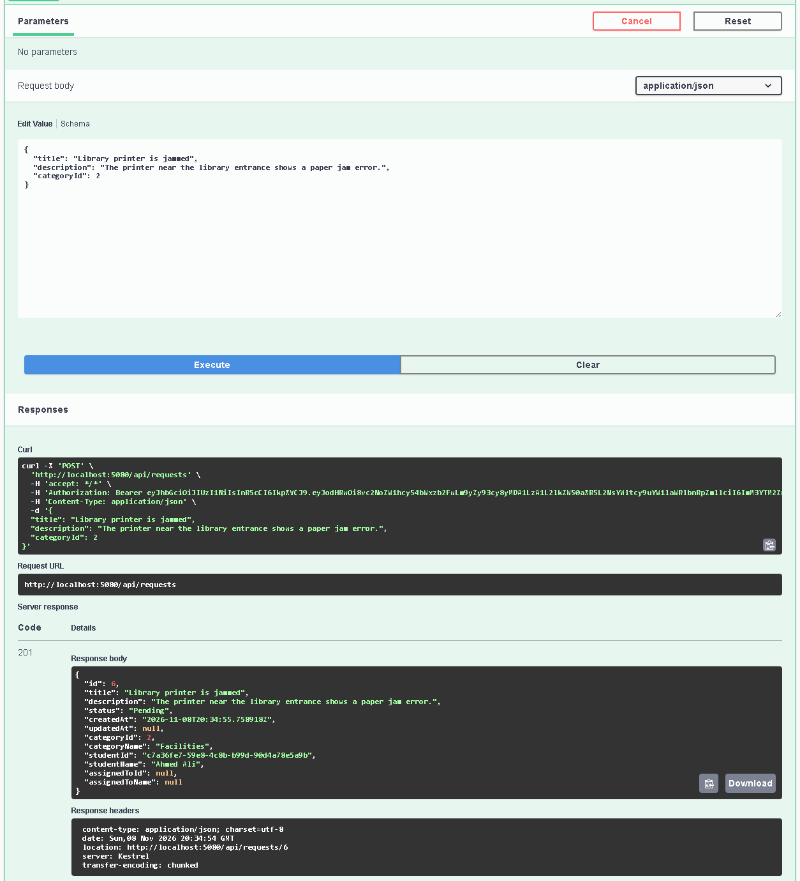
Figure 25: Creating a request in Swagger: 201 Created with the new request and a Location header

14.2 A validation failure
Send an empty title, a very short description and category 0. The API answers 400 and lists every problem:
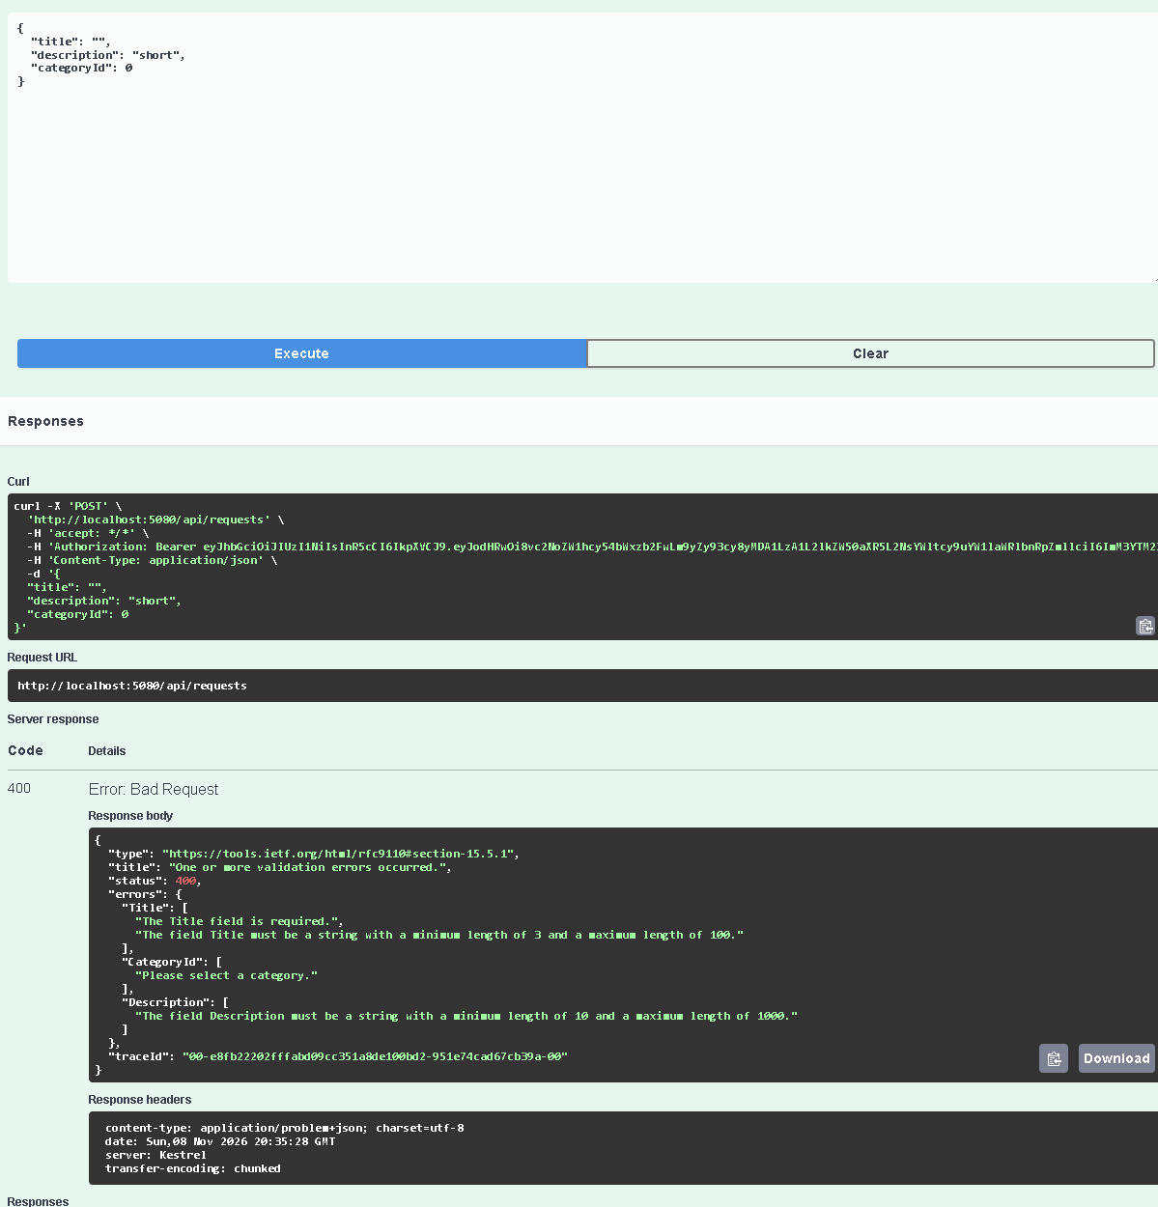
Figure 26: Validation failure: 400 with the list of errors

14.3 Authorization denial
No token → 401. Click Authorize → Logout, then call GET /api/requests:
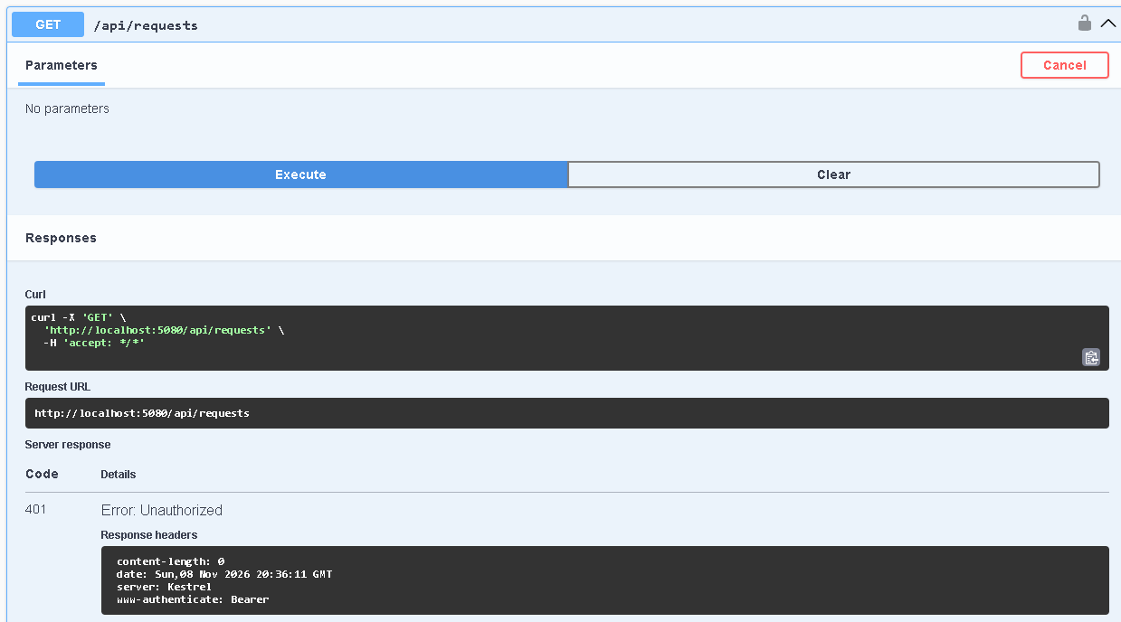
Figure 27: No token: 401 Unauthorized
Student token on a staff-only endpoint → 403. With the student's token, call PUT /api/requests/{id}/status:
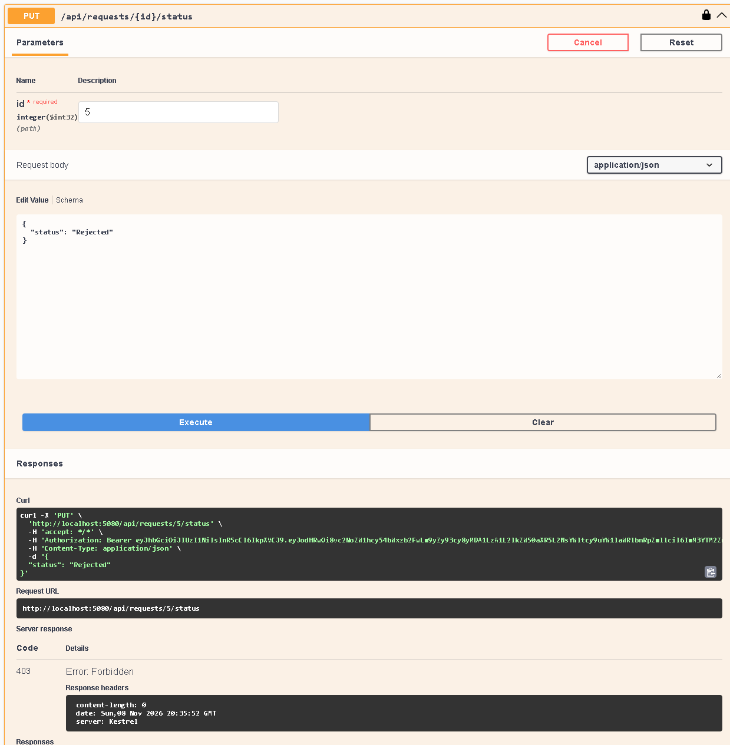
Figure 28: A student is not allowed to change the status: 403 Forbidden

14.4 An invalid status change
With the staff token, try to move a Pending request straight to Resolved. The token is fine, but the business rule says no: 400.
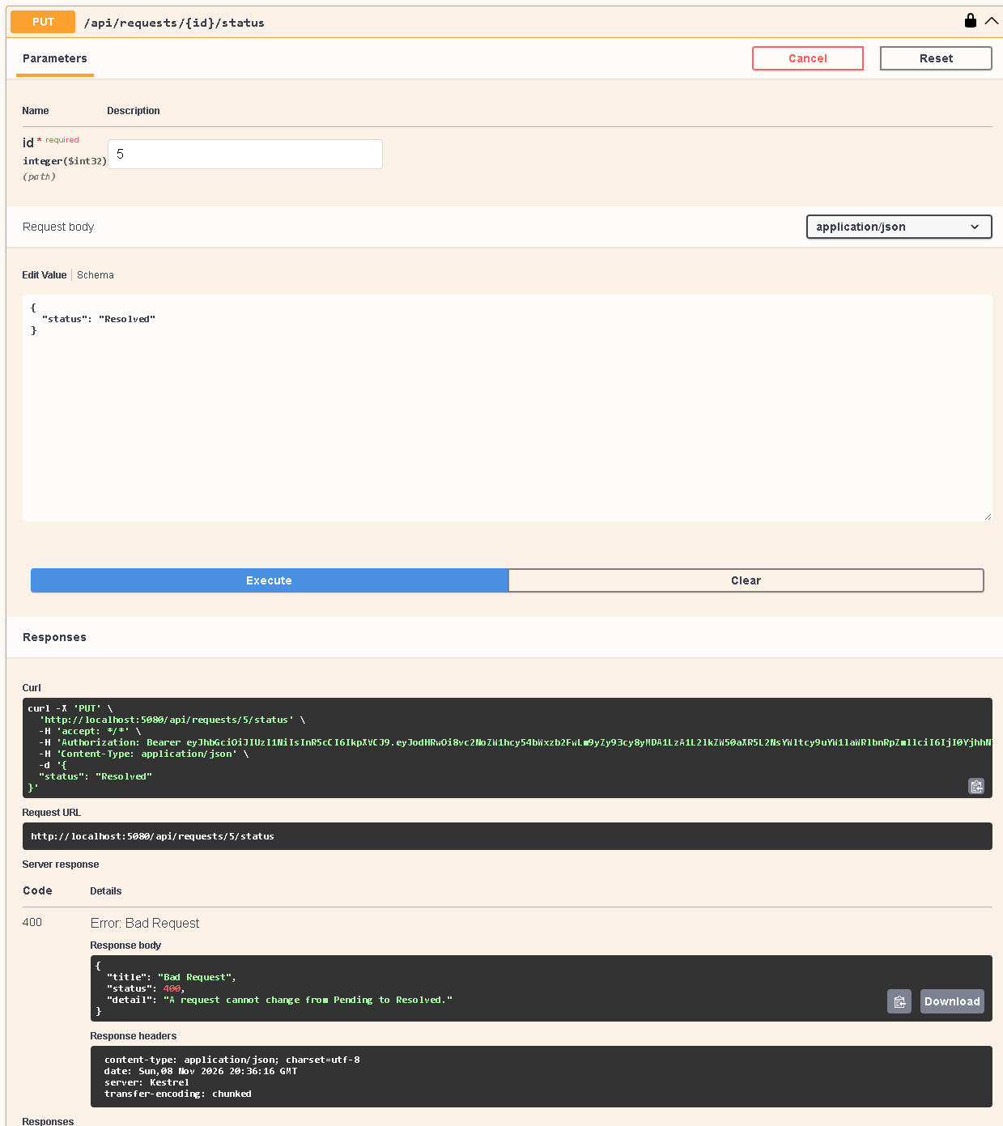
Figure 29: Invalid transition: 400 "A request cannot change from Pending to Resolved."

14.5 The database migration
- Show the migration files in CampusServices.Infrastructure/Migrations (the InitialCreate class with its Up() and Down() methods).
- Run dotnet ef database update --project CampusServices.Infrastructure --startup-project CampusServices.API.
- Open pgAdmin or the Supabase Table Editor and show the tables: AspNetUsers, AspNetRoles, Categories (with 3 rows), ServiceRequests, RefreshTokens.
- After using the app, show the new rows in ServiceRequests (the Status column contains text like "InProgress").

14.6 Student workflow in the app
- Register: first press the button with empty fields (validation messages), then try a weak password (API error), then use a strong password.
- On the Student Dashboard press Create a new request. Submit empty first (validation), then fill it in and submit.
- The app opens Request Details (status Pending).
- Open My Requests: only this student's requests are listed.
- Show that the menu only has student pages.

14.7 Staff workflow in the app
- Log out, log in as staff. The Staff Dashboard counts all requests.
- Open Manage Requests, press Manage on a request.
- Choose a staff member and press Assign → status Assigned.
- Change the status to InProgress, then Resolved. Only allowed statuses are in the drop-down. After Resolved nothing can change.
- Log in as the student again: the request shows Resolved with the full progress bar.
- Finally show in Swagger that a student token gets 403 on staff endpoints (the real protection is on the server).

15. Challenges and How I Handled Them
Challenge | How I handled it
A student could make themselves staff if the register form had a role field. | The register DTO has no role field. The code always gives the Student role. A test sends "role": "Staff" and checks that it is ignored.
The status rules were needed in two places (API checks and the app drop-down). | I wrote the rules once in Domain/​Enums/​StatusRules.cs and used them in both places.
In the MAUI app, the word Application matched my namespace CampusServices.Application. | In App.xaml.cs I wrote the full name Microsoft.Maui.Controls.Application.
SecureStorage might not work on every device. | SessionStore catches the error and keeps the session in memory, so the app still works.
dotnet ef starts the API, and the API stops if Jwt:Key is missing. | Set the user secrets before running migrations (documented in the README and in this report).
Supabase's transaction pooler (port 6543) is not good for migrations. | Use the session pooler or direct connection on port 5432.
The tests needed a database, but no PostgreSQL server is available while testing. | WebApplicationFactory with an in-memory database. I had to remove EF Core's PostgreSQL setup in the test factory first.
The Android emulator cannot use "localhost". | The app uses 10.0.2.2 on Android. Plain http is allowed only for development.
Two refreshes at the same moment could conflict, because each refresh token works only once. | The pages load data one call after another, so this does not happen in normal use (listed as a limitation).
Table 16: Challenges

16. Limitations and Future Improvements
- Refresh token reuse detection: if a used refresh token comes back, the API only answers 401. A stricter design would also log out all sessions of that user.
- Cleanup: old refresh tokens stay in the table. A background job could delete them.
- HTTPS: in development the app uses http://localhost (and Android cleartext traffic). A real deployment must use HTTPS only.
- No email confirmation or "forgot password" (not required by the assignment).
- Only one staff account is created automatically. There is no admin screen to add more staff.
- No edit screen in the app. Editing a Pending request is possible through the API (PUT /api/requests/{id}).
- Platforms: the app targets Windows and Android. iOS and Mac need a Mac to build.
- Not tested by me yet: running inside Visual Studio, running the migration on a real PostgreSQL/Supabase database, and running on an Android emulator (the Android version builds successfully).

17. Conclusion
I turned my old Product lab into a complete Campus Services Management System. It uses Clean Architecture with five projects, a REST API with Swagger, EF Core Code-First with PostgreSQL and migrations, ASP.NET Core Identity with JWT access tokens and refresh tokens, and a .NET MAUI Blazor Hybrid app for students and staff.
The most important thing I learned is that security must be on the server. The app hides buttons to be friendly, but the API checks the token, the role, the owner of the request and the business rules on every call. The 46 automated tests prove that these checks work, and that the tests would catch a mistake.
I also learned how the layers work together: the Domain keeps the rules, the Application describes what the system does, the Infrastructure does the technical work, and the API connects everything with Dependency Injection.

Appendix A: Viva Questions and Answers
Q1. What is Clean Architecture and why did you use it?
It splits the code into layers. The inner layers (Domain, Application) hold the rules and do not depend on the database or the web. The outer layers (Infrastructure, API) hold the technical parts. It keeps the rules safe and makes the code easier to change and test.
Q2. Why does the MAUI app not use the database directly?
Because then every user would need the database password and the app could skip the rules. The API checks every request and is the only program that can reach the database.
Q3. What is a DTO and why not return the entity?
A DTO is a small class that only carries data. Entities can contain private data (like password hashes through navigation properties) and loops. DTOs show only what the client needs.
Q4. What is Dependency Injection?
A class asks for what it needs in its constructor, and ASP.NET Core gives it. Example: ServiceRequestService receives IServiceRequestRepository. The registrations are in Program.cs and AddInfrastructure().
Q5. What is the difference between Scoped, Singleton and Transient?
Scoped = one object per HTTP request (my repositories and services). Singleton = one object for the whole app (SessionStore in MAUI). Transient = a new object every time (the typed ApiClient).
Q6. What is EF Core Code-First and what is a migration?
Code-First: I write C# classes and EF Core creates the tables. A migration is a file that describes the changes to the database. "database update" runs it.
Q7. What does AsNoTracking do?
It tells EF Core not to remember the loaded objects. I use it for read-only screens because it is faster and uses less memory.
Q8. What is change tracking?
EF Core remembers the original values of a loaded object. When I change it and call SaveChangesAsync, EF Core writes an UPDATE for the changed columns only.
Q9. What is the N+1 problem? How did you avoid it?
Loading a list (1 query) and then one extra query for each item (N queries). I used Include, so the request, category, student and staff come in one query.
Q10. How are passwords stored?
ASP.NET Core Identity stores only a salted hash (PBKDF2) in AspNetUsers.PasswordHash, never the real password. After 5 wrong tries the account is locked for a while.
Q11. What is a JWT and what is inside your token?
A signed token, like an ID card with an expiry time. Mine has the user id, name, email and role, the issuer and audience, and expires after 30 minutes. It is signed with Jwt:Key.
Q12. Access token vs refresh token?
The access token is sent with every request and lives 30 minutes. The refresh token lives 7 days and is only used to get a new access token.
Q13. What are rotation and revocation?
Rotation: each refresh uses up the old refresh token and gives a new one. Revocation: logout marks the refresh token as revoked so it can never be used again.
Q14. How do you stop a student from calling a staff endpoint?
The endpoint has [Authorize(Roles = Roles.Staff)]. The role comes from the signed token, so a student gets 403 even with Swagger or Postman.
Q15. How do you stop a student from seeing another student's request?
In ServiceRequestService I compare the request's StudentId with the user id from the token. If they are different, I throw ForbiddenException, which becomes 403.
Q16. Why is hiding a button not enough?
Anyone can call the API without the app. The server must check every request itself.
Q17. Where are the secrets?
In dotnet user-secrets on the developer computer (or environment variables on a server). Never in appsettings.json or GitHub. The app keeps tokens in SecureStorage.
Q18. What happens with an invalid status change?
ServiceRequest.ChangeStatus checks StatusRules and throws DomainException. The middleware turns it into 400 Bad Request with a clear message.
Q19. What does your middleware do?
ExceptionHandlingMiddleware catches exceptions and returns JSON: NotFound → 404, Forbidden → 403, DomainException → 400, anything else → 500 without internal details.
Q20. How did you test without PostgreSQL?
With WebApplicationFactory, which starts the real API in memory, and the EF Core InMemory database instead of PostgreSQL.
Q21. Why 10.0.2.2 on Android?
Inside the Android emulator, "localhost" means the phone itself. 10.0.2.2 is the special address of the computer that runs the emulator.
Q22. What is SecureStorage?
A MAUI feature that saves small secrets encrypted by the operating system (Windows Data Protection, Android Keystore). I use it for the tokens instead of browser localStorage.

Appendix B: Important Files and What They Do
File | What it does
Domain/​Entities/​ServiceRequest.cs | The request entity and its rules: Edit, Assign, ChangeStatus
Domain/​Enums/​StatusRules.cs | The allowed status changes (used by the API and the app)
Domain/​Entities/​ApplicationUser.cs | The user (IdentityUser + FullName)
Domain/​Entities/​RefreshToken.cs | A stored refresh token (only its hash)
Application/​DTOs/​*.cs | Data sent between app and API, with validation attributes
Application/​Services/​ServiceRequestService.cs | The use cases: create, list, details, edit, assign, change status
Application/​Interfaces/​*.cs | Interfaces that Infrastructure implements
Infrastructure/​Data/​AppDbContext.cs | The EF Core DbContext (tables)
Infrastructure/​Data/​Configurations/​*.cs | Fluent API configuration and seed categories
Infrastructure/​Migrations/​*.cs | The InitialCreate migration
Infrastructure/​Repositories/​*.cs | EF Core queries (AsNoTracking, Include, tracked update)
Infrastructure/​Auth/​AuthService.cs | Register, login, refresh, logout
Infrastructure/​Auth/​TokenService.cs | Creates the JWT and refresh tokens, hashes refresh tokens
Infrastructure/​Seed/​DbSeeder.cs | Creates the roles and the staff account at start-up
Infrastructure/​DependencyInjection.cs | Registers the DbContext, Identity, repositories and AuthService
API/​Program.cs | Composition root: services and middleware order
API/​Controllers/​RequestsController.cs | The service request endpoints with role checks
API/​Controllers/​AuthController.cs | Register, login, refresh, logout endpoints
API/​Middleware/​ExceptionHandlingMiddleware.cs | Turns exceptions into 400/403/404/500 JSON answers
API/​Extensions/​AuthenticationExtensions.cs | JWT checking rules
API/​Extensions/​SwaggerExtensions.cs | Swagger with the Authorize button
MAUI/​MauiProgram.cs | App start-up and service registration (typed HttpClient)
MAUI/​Services/​ApiClient.cs | All HTTP calls to the API + automatic token refresh
MAUI/​Services/​SessionStore.cs | Saves the tokens in SecureStorage
MAUI/​Services/​AppAuthStateProvider.cs | Tells Blazor who is logged in and their role
MAUI/​Components/​Pages/​*.razor | The 8 pages of the app
MAUI/​Components/​Layout/​NavMenu.razor | The menu with different links for each role
Tests/​ApiFactory.cs | Starts the API in memory for the tests
README.md, docs/​ARCHITECTURE.md | How to run the project and the architecture explanation
Table 17: Important files (paths start with CampusServices.)

Appendix C: Command Cheat Sheet
# check the SDK and workloads
dotnet --list-sdks
dotnet workload list

# build everything
dotnet build CampusServicesManagementSystem.sln

# user secrets (run in the solution folder)
dotnet user-secrets set "ConnectionStrings:DefaultConnection" "Host=...;Password=..." --project CampusServices.API
dotnet user-secrets set "Jwt:Key" "<at least 32 random characters>" --project CampusServices.API
dotnet user-secrets list --project CampusServices.API

# database
dotnet tool restore
dotnet ef database update --project CampusServices.Infrastructure --startup-project CampusServices.API
dotnet ef migrations add NameOfChange --project CampusServices.Infrastructure --startup-project CampusServices.API --output-dir Migrations
dotnet ef migrations list --project CampusServices.Infrastructure --startup-project CampusServices.API --no-connect
dotnet ef migrations script --project CampusServices.Infrastructure --startup-project CampusServices.API -o schema.sql

# run
dotnet run --project CampusServices.API --launch-profile http # then open http://localhost:5080/swagger

# tests
dotnet test CampusServices.Tests

Appendix D: Full List of Automated Tests
All 46 tests passed (output of dotnet test with the "normal" logger). The class name is shown before the test name.
# | Test (class.method)
1 | ServiceRequestDomainTests.​ChangeStatus_InvalidTransition_ThrowsDomainException(from: Resolved, to: Rejected)
2 | ServiceRequestDomainTests.​ChangeStatus_InvalidTransition_ThrowsDomainException(from: InProgress, to: Pending)
3 | ServiceRequestDomainTests.​ChangeStatus_InvalidTransition_ThrowsDomainException(from: Resolved, to: InProgress)
4 | ServiceRequestDomainTests.​ChangeStatus_InvalidTransition_ThrowsDomainException(from: Pending, to: InProgress)
5 | ServiceRequestDomainTests.​ChangeStatus_InvalidTransition_ThrowsDomainException(from: Pending, to: Resolved)
6 | ServiceRequestDomainTests.​ChangeStatus_InvalidTransition_ThrowsDomainException(from: Assigned, to: Resolved)
7 | ServiceRequestDomainTests.​ChangeStatus_InvalidTransition_ThrowsDomainException(from: Rejected, to: Assigned)
8 | ServiceRequestDomainTests.​ChangeStatus_AllowedTransition_ChangesTheStatus(from: Pending, to: Rejected)
9 | ServiceRequestDomainTests.​ChangeStatus_AllowedTransition_ChangesTheStatus(from: Assigned, to: Rejected)
10 | ServiceRequestDomainTests.​ChangeStatus_AllowedTransition_ChangesTheStatus(from: InProgress, to: Resolved)
11 | ServiceRequestDomainTests.​ChangeStatus_AllowedTransition_ChangesTheStatus(from: InProgress, to: Rejected)
12 | ServiceRequestDomainTests.​ChangeStatus_AllowedTransition_ChangesTheStatus(from: Assigned, to: InProgress)
13 | ServiceRequestDomainTests.​StatusRules_FinalStatuses_HaveNoNextStatus
14 | ServiceRequestDomainTests.​Assign_ResolvedRequest_ThrowsDomainException
15 | ServiceRequestDomainTests.​Edit_PendingRequest_ChangesTheText
16 | ServiceRequestDomainTests.​ChangeStatus_ToAssigned_MustUseAssign
17 | ServiceRequestDomainTests.​Edit_RequestThatIsNotPending_ThrowsDomainException
18 | ServiceRequestDomainTests.​Assign_PendingRequest_BecomesAssigned
19 | AuthApiTests.​Register_CannotAskForStaffRole
20 | ErrorHandlingTests.​UnexpectedError_Returns500_AndDoesNotLeakDetails
21 | AuthApiTests.​Register_WithSameEmailTwice_Returns400
22 | AuthApiTests.​Refresh_GivesNewTokens_AndTheOldRefreshTokenStopsWorking
23 | AuthApiTests.​Register_WithWeakPassword_Returns400
24 | ServiceRequestApiTests.​StudentList_ContainsOnlyTheirOwnRequests
25 | AuthApiTests.​Register_ThenLogin_ReturnsTokensForStudentRole
26 | AuthApiTests.​Refresh_WithRandomText_Returns401
27 | ServiceRequestApiTests.​Staff_ChangingStatusOfMissingRequest_Returns404
28 | ServiceRequestApiTests.​Create_WithValidData_Returns201AndPendingRequest
29 | ServiceRequestApiTests.​Staff_InvalidStatusTransition_Returns400
30 | ServiceRequestApiTests.​Student_CannotListStaffMembers_Returns403
31 | AuthApiTests.​Login_AfterFiveWrongPasswords_LocksTheAccount
32 | ServiceRequestApiTests.​Student_CannotEditAnotherStudentsRequest_Returns403
33 | AuthApiTests.​Login_WithWrongPassword_Returns401
34 | ServiceRequestApiTests.​Student_CannotChangeStatus_Returns403
35 | AuthApiTests.​Logout_RevokesTheRefreshToken
36 | ServiceRequestApiTests.​GetRequest_ThatDoesNotExist_Returns404
37 | ServiceRequestApiTests.​Student_CannotAssignRequest_Returns403
38 | ServiceRequestApiTests.​Create_WithUnknownCategory_Returns400
39 | ServiceRequestApiTests.​Student_CanEditOwnPendingRequest
40 | ServiceRequestApiTests.​Staff_CanAssignAndMoveRequestToResolved
41 | ServiceRequestApiTests.​CreateRequest_WithoutToken_Returns401
42 | ServiceRequestApiTests.​GetRequests_WithoutToken_Returns401
43 | ServiceRequestApiTests.​Student_CannotViewAnotherStudentsRequest_Returns403
44 | ServiceRequestApiTests.​Staff_StatusValueThatDoesNotExist_Returns400
45 | ServiceRequestApiTests.​Staff_CannotAssignToSomeoneWhoIsNotStaff_Returns400
46 | ServiceRequestApiTests.​Create_WithInvalidData_Returns400
Table 18: Automated tests

