**M.USMAN ARSHAD**

**L19-2356**

**M**

**Play this game at**

<https://minesweeper.online/>

**Core Functionalities of system:**

The user should be able to choose any mine of his choice to open

The user can enter number of bombs by his choice

If the user selects the mine with the bomb, a game over message should be displayed and the user should be asked to play again or quit

If the user wins, they should be given a choice to save their score in a file (highscores.txt) along with their unique name

The score file should be present all scores starting from highest to lowest in sorted order

If the user wishes to save his game midway, they should be given an option to press ‘S’ along with their unique name and they state should be saved in a file

If the user wishes to load an already saved game, they should be given an option to press ‘R’ and restore the game from the previous state

In a single game, the user can save and restore as many time as they want

A new mine structure appears when a new game is played

**Assumptions and constraints :**

Assumptions are that I can only create 20*20 and 10*10 grid and there are no constraintants are that the number given to blocks after checking a bomb is by checking 3*3 grids in the game.

**High level diagram/block diagram of project:**

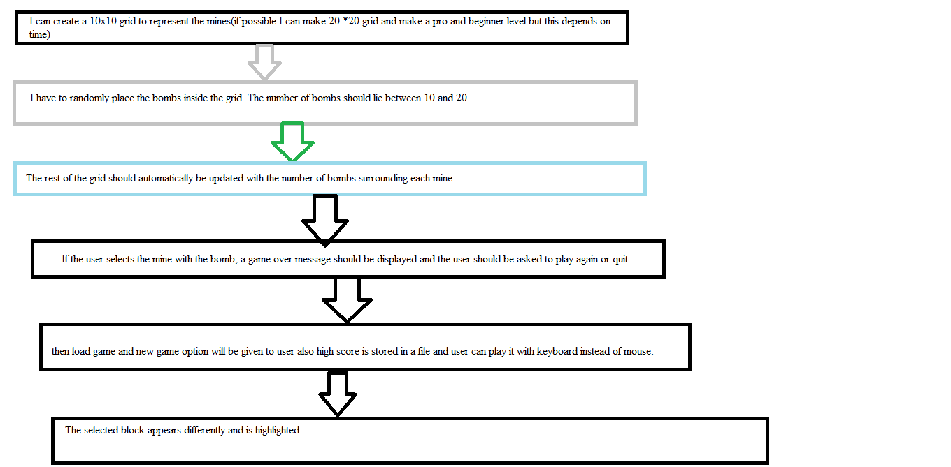

**Application:**

**Application** of project is to entertain and play it on x box and mobiles and further help in building high games and user can play it with key board (e.g. arrow head and o to open cell to load and n to start new game and r to restore game if user wants to leave).

**Estimated time:**

**Estimated time** to complete project is almost 210 hours for me I think enough.