DevOps Internship – Task 2
Docker Multi-Stage Build for a Multi-Dependency Application
Name: Usman Ghani
Task: 02
Technology: Docker
Application Port: 3000
Date: September 2026
1. Introduction
The objective of this task is to containerize an application using Docker and implement a multi-stage Docker build. The Dockerfile separates the build environment from the production environment to reduce the final image size, minimize unnecessary dependencies, and improve security.

2. Objectives
- Create a Dockerfile for the application.
- Use a multi-stage Docker build.
- Install and manage application dependencies.
- Keep the production image lightweight.
- Avoid exposing sensitive information directly in the Dockerfile.
- Configure the application to run on port 3000.
- Build and run the Docker container.
- Verify that the application works successfully.

3. Technologies Used
Technology | Purpose
Docker | Containerization
Dockerfile | Define image-building instructions
Node.js | Application runtime
npm | Dependency management
PowerShell | Running Docker commands
VS Code | Writing/editing project files

4. Project Structure
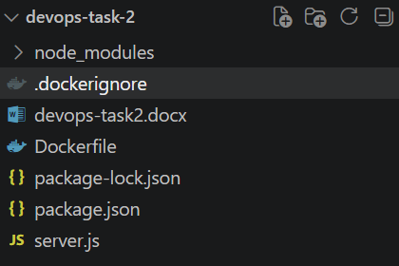

5. Dockerfile
The complete Dockerfile used for this task is shown below.
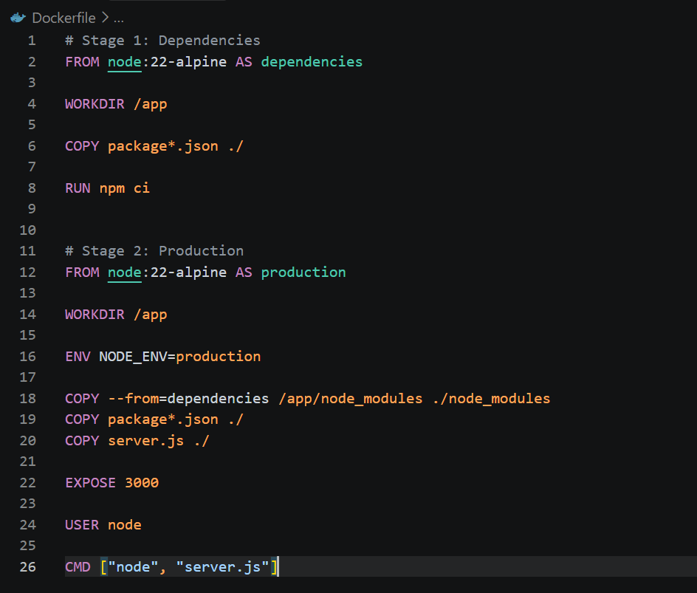

6. Explanation of Multi-Stage Build
Stage 1 – Dependencies
- Uses the node:22-alpine base image.
- Copies package.json and package-lock.json.
- Installs all dependencies using npm ci.
Stage 2 – Production
- Starts from a clean node:22-alpine image.
- Sets NODE_ENV=production as an environment variable.
- Copies only the installed node_modules and application files from the dependencies stage.
- Exposes port 3000.
- Switches to the built-in non-root 'node' user for better security.
- Starts the application with node server.js.
Build Flow:
Source Code
↓
Builder Stage
↓
Install Dependencies
↓
Build Application
↓
Production Stage
↓
Smaller Docker Image
↓
Running Container

7. Docker Build Process
The following command was used to build the Docker image:
docker build -t devops-task-2:1.0 .

8. Verify Docker Image
The following command was used to confirm the image was created successfully:
docker images devops-task-2
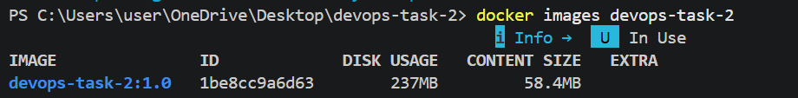

9. Run the Container
The container was started using:
docker run -d -p 3000:3000 --name devops-task-2-container devops-task-2:1.0
The running container was verified using:
docker ps
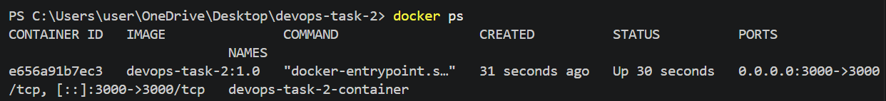

10. Application Testing
The application was accessed in a browser at:
http://localhost:3000/health
The endpoint returned a healthy status, confirming that the containerized application is running correctly.
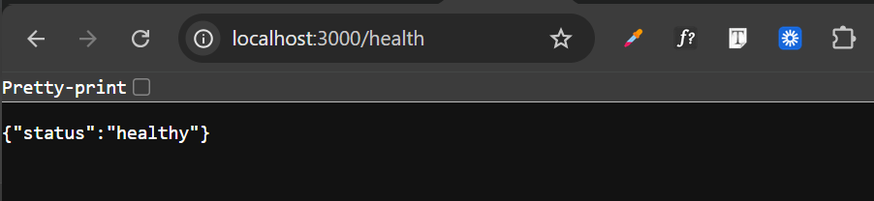

11. Environment Variables
Sensitive values were not hard-coded into the Dockerfile. Instead, they were passed at runtime using environment variables, for example:
docker run -d `
-p 3000:3000 `
-e NODE_ENV=production `
--name devops-task-2-container `
devops-task-2:1.0

12. Docker Commands Used
Command | Purpose
docker --version | Check Docker installation
docker build | Build Docker image
docker images | List Docker images
docker run | Create/run container
docker ps | View running containers
docker logs | View container logs
docker stop | Stop container
docker rm | Remove container

13. Testing & Results
Test | Expected Result | Actual Result
Docker build | Image created | Passed
Container start | Container runs | Passed
Port 3000 | Application accessible | Passed
Browser test | Application loads | Passed
Docker process | Container visible in docker ps | Passed

14. Challenges Faced
During the implementation, Docker build initially failed because Docker Desktop was manually paused. The Docker Desktop environment was unpaused before continuing with the image-building and container execution process.

15. Conclusion
The application was successfully containerized using Docker and a multi-stage Dockerfile. The approach separates the build environment from the production environment and helps reduce unnecessary dependencies in the final image. The Docker container was configured to expose port 3000, and the application was verified through the browser.

