UNIVERSITY OF SOUTHERN PUNJAB
Department of Computer Science
Multan, Pakistan

SOFTWARE REQUIREMENTS SPECIFICATION
(SRS)

Emotion Recognition from Speech Using Machine Learning
Final Year Project (FYP) — BS Computer Science
Prepared By:
Usman Qasim & M. Abdullah

Supervisor:
Miss Maryam Ismail

Version: 2.0 | Date: April 2026

Revision History
Version | Date | Description | Author
1.0 | March 2026 | Initial Draft — Submitted for review | Usman Qasim & M. Abdullah
2.0 | April 2026 | Revised: Added literature review (15 articles), gap analysis, SDLC Waterfall, diagrams, references | Usman Qasim & M. Abdullah

Table of Contents
Revision History 2
Table of Contents 2
CHAPTER 1 4
Introduction 4
1.1 Purpose 4
1.2 Scope 4
1.3 Definitions, Acronyms, and Abbreviations 5
1.4 References 5
1.5 Document Overview 6
CHAPTER 2 7
Literature Review and Gap Analysis 7
2.1 Overview of Existing Work 7
2.2 Article-by-Article Scope and Gap Analysis 7
2.3 Research Gaps Summary 8
2.4 How This Project Addresses the Gaps 9
CHAPTER 3 10
Overall Description 10
3.1 Product Perspective 10
3.2 Product Functions 10
3.3 User Classes and Characteristics 10
3.4 Operating Environment 10
3.5 Assumptions and Dependencies 11
CHAPTER 4 12
System Requirements 12
4.1 Functional Requirements 12
4.1.1 Audio Input and Recording 12
4.1.2 Audio Preprocessing 12
4.1.3 Feature Extraction 12
4.1.4 Emotion Classification 12
4.1.5 Results Display and Visualization 12
4.1.6 Session History 12
4.1.7 Model Evaluation Module 13
4.2 Non-Functional Requirements 13
4.2.1 Performance 13
4.2.2 Reliability 13
4.2.3 Usability 13
4.2.4 Security 13
4.2.5 Maintainability 13
CHAPTER 5 14
System Architecture and Design 14
5.1 Three-Tier Architecture 14
5.2 ML Processing Pipeline 14
5.3 Layer Descriptions 15
CHAPTER 6 16
SDLC Model and Project Plan 16
6.1 SDLC Model: Waterfall 16
6.2 Waterfall SDLC Diagram 16
6.3 Phase Descriptions 17
6.4 Technology Stack with Justification 18
Appendices 19
Appendix A — Dataset Summary 19
Appendix B — Emotion Categories 19
Appendix C — Evaluation Metrics 19

CHAPTER 1

Introduction

1.1 Purpose
The purpose of this Software Requirements Specification (SRS) document is to provide a comprehensive and detailed description of all system requirements for the Emotion Recognition from Speech Using Machine Learning project. This document serves as a formal agreement between the development team and all stakeholders, clearly defining what the system will do, how it will perform, and the constraints within which it must operate. It is intended to serve as the primary reference guide for developers, supervisors, testers, and all relevant parties throughout the software development lifecycle.
This revised version (2.0) incorporates a complete literature review of fifteen peer-reviewed research papers, a structured gap analysis identifying research shortcomings addressed by this project, a justified SDLC model selection, and updated technology rationale. By clearly articulating requirements at the outset, this document aims to reduce ambiguities, prevent scope creep, and ensure the final product meets academic, technical, and user expectations.

1.2 Scope
The system to be developed is titled Emotion Recognition from Speech Using Machine Learning, built as a Final Year Project in the Department of Computer Science at the University of Southern Punjab. The primary objective is to automatically detect and classify human emotions from raw audio speech signals using state-of-the-art machine learning and deep learning techniques.
The system accepts raw audio input — either uploaded audio files (WAV, MP3, FLAC) or live microphone recordings — and processes them through a pipeline comprising audio preprocessing, acoustic feature extraction, trained model inference, and result presentation. Recognized emotions are drawn from seven standard affective computing categories: happiness, sadness, anger, fear, disgust, surprise, and neutral.
The scope encompasses design and development of the preprocessing module, feature extraction engine, machine learning classification model, evaluation framework, and user-facing web application. The system is trained on three publicly available benchmark datasets: RAVDESS, TESS, and CREMA-D. A supplementary Urdu speech dataset will be collected to address a critical gap identified in the literature. The project does not include real-time multi-speaker recognition, full Urdu model training from scratch, enterprise system integration, or clinical-grade diagnostic tools.

1.3 Definitions, Acronyms, and Abbreviations
Term / Acronym | Definition
SRS | Software Requirements Specification
FYP | Final Year Project
SER | Speech Emotion Recognition
ML | Machine Learning
DL | Deep Learning
MFCC | Mel-Frequency Cepstral Coefficients — acoustic feature representation of speech
CNN | Convolutional Neural Network
LSTM | Long Short-Term Memory — a recurrent neural network variant for sequential data
SVM | Support Vector Machine — classical machine learning classifier
RAVDESS | Ryerson Audio-Visual Database of Emotional Speech and Song
TESS | Toronto Emotional Speech Set
CREMA-D | Crowd-sourced Emotional Multimodal Actors Dataset
SNR | Signal-to-Noise Ratio — measure of signal quality relative to background noise (dB)
UAR | Unweighted Average Recall — SER metric averaging recall per emotion class
SDLC | Software Development Life Cycle
STFT | Short-Time Fourier Transform
ZCR | Zero-Crossing Rate — rate at which audio signal changes sign
GUI | Graphical User Interface
API | Application Programming Interface

1.4 References
The following fifteen peer-reviewed articles were surveyed to understand the current state of speech emotion recognition and to identify the research gaps addressed by this project.

Ref. | Full Citation | Source / Venue
[R1] | Zhao, W. et al. (2020). Speech Emotion Recognition with Deep Learning — Two-Stage CNN Approach. Procedia Computer Science. | ScienceDirect
[R2] | Tarantino, L. et al. (2024). Real-Time SER Using Deep Learning and Data Augmentation (CNN+BiLSTM). Artificial Intelligence Review. | Springer
[R3] | Kim, T.W. & Kwak, K.C. (2024). Speech Emotion Recognition Using Deep Learning Transfer Models and Explainable Techniques. Applied Sciences, 14(4), 1553. | MDPI
[R4] | Mishra, S.P., Warule, P. & Deb, S. (2024). Speech Emotion Classification Using Deep Learning. FRSM 2023. Advances in Intelligent Systems, Vol. 1455. | Springer
[R5] | Bautista, J.L. et al. (2025). Lightweight Deep Neural Ensemble for SER Using Hand-Crafted Features. Scientific Reports. | Nature
[R6] | Abbaschian, B.J., Sierra-Sosa, D. & Elmaghraby, A. (2021). Deep Learning Techniques for SER: Survey of Databases and Models. Sensors. | MDPI / PMC
[R7] | Mustaqeem, M. et al. (2022). Emotional Speech Recognition Using Deep Neural Networks. Sensors / PMC. | PMC
[R8] | Pepino, L., Riera, P. & Ferrer, L. (2021). Emotion Recognition from Speech Using Wav2vec 2.0 Embeddings. Interspeech 2021. | ISCA / arXiv
[R9] | Zhao, Z., Wang, Y. & Wang, Y. (2022). Multi-level Fusion of Wav2vec 2.0 and BERT for Multimodal Emotion Recognition. Interspeech 2022. | ISCA
[R10] | Wang, X. et al. (2024). Combining Wav2vec 2.0 Fine-Tuning and ConLearnNet for SER. Electronics, 13(6), 1103. | MDPI
[R11] | Khalil, R.A. et al. (2023). Review on SER: A Survey, Recent Advances, Challenges, and the Influence of Noise. Neurocomputing. | ScienceDirect
[R12] | Gideon, J., Khorram, S. & Provost, E.M. (2022). A Cross-Corpus Study on Speech Emotion Recognition. Interspeech. | arXiv / ISCA
[R13] | Latif, S. et al. (2021). Transfer Learning from High-Resource to Low-Resource Language for Speech Affect Recognition. Interspeech. | arXiv
[R14] | Castro, F. et al. (2023). Cross-Corpus Training Strategy for SER Using Self-Supervised Representations (HuBERT/WavLM). Applied Sciences, 13(16), 9062. | MDPI
[R15] | Canturk, D. & Kahraman, F. (2025). Evaluating Raw Waveforms with Deep Learning for SER Across Six Datasets. Multimedia Tools and Applications. | Springer

1.5 Document Overview
This SRS is organized into six chapters. Chapter 1 provides introduction, scope, definitions, and references. Chapter 2 presents the literature review and gap analysis based on the fifteen cited papers. Chapter 3 gives the overall system description. Chapter 4 enumerates functional and non-functional requirements. Chapter 5 presents the system architecture with diagrams. Chapter 6 covers the SDLC model, project plan, and technology justification. Appendices provide supplementary reference tables.

CHAPTER 2

Literature Review and Gap Analysis

2.1 Overview of Existing Work
A structured review of fifteen peer-reviewed research articles was conducted to understand the current state of speech emotion recognition and to identify gaps that the present project seeks to address. The reviewed papers span 2020 to 2025 and are sourced from IEEE, Springer, MDPI, ScienceDirect, and Interspeech — among the most reputable venues in the field.
The review covers classical machine learning approaches using hand-crafted features, deep learning architectures including CNN, LSTM, and CNN-LSTM, transformer-based transfer learning models such as wav2vec 2.0 and HuBERT, cross-corpus generalization studies, and comprehensive survey papers. The majority of existing systems are built and evaluated exclusively on English-language datasets and in clean, controlled audio environments.

2.2 Article-by-Article Scope and Gap Analysis

Ref. | Title (Short) | Scope | Gap Identified
[R1] | Two-Stage CNN on RAVDESS | CNN with MFCC features, 8 emotions, RAVDESS dataset, English only. | Tested on single dataset only. No noise testing. No generalization across datasets or languages.
[R2] | CNN+BiLSTM Real-Time SER | MFCC+Chroma+Mel features, CNN-BiLSTM, RAVDESS/EMODB, data augmentation. | Studio-recorded audio only. No real-world noise. No multilingual or cross-corpus testing.
[R3] | Transfer Learning + XAI | STFT spectrogram, transfer learning with SHAP/LIME explainability, 3 datasets. | XAI applied post-hoc only. No low-resource or non-English language evaluation conducted.
[R4] | DNN/DCNN/CNN-LSTM Comparison | MFCC features, three model types compared on RAVDESS, EMODB, TESS. | 100% accuracy on TESS is unrealistic (acted, simple data). No cross-corpus or noise testing done.
[R5] | Lightweight Neural Ensemble | ZCR+RMSE+Chroma+MFCC, CNN+CNN-BiLSTM ensemble, RAVDESS only, LR schedulers. | Single dataset only. No deployment, real-world noise evaluation, or generalization testing.
[R6] | Survey: DL Techniques for SER | Review of CNN, RNN, LSTM methods and all major SER datasets up to 2020. | Pre-transformer survey. No wav2vec or HuBERT. Low-resource languages not covered at all.
[R7] | SER Using DNN + SVM | MFCC + pitch + formants, SVM and DNN classifiers, RAVDESS + IEMOCAP. | Speaker-dependent evaluation only. Accuracy drops significantly for unseen speakers.
[R8] | Wav2vec 2.0 Embeddings | Pre-trained wav2vec 2.0 for feature extraction, simple NN classifier, IEMOCAP + RAVDESS. | Pre-trained on English only. No noise robustness testing. No non-English language evaluation.
[R9] | Wav2vec 2.0 + BERT Fusion | Multi-level audio+text fusion (wav2vec + BERT), early+late fusion, IEMOCAP. | Requires text transcript — impractical for real-world speech-only applications and Urdu speech.
[R10] | Wav2vec 2.0 + Dual CNN | Fine-tuned wav2vec + dual CNN (ConLearnNet), IEMOCAP and CASIA datasets. | Chinese and English only. No South Asian language. Dataset-specific fine-tuning limits generalization.
[R11] | Survey: Noise Influence in SER | Review of noisy SER methods up to mid-2023. Covers methods, datasets, toolkits. | Explicitly states Urdu, Turkish, Dutch SER under noise is NOT reviewed — open problem.
[R12] | Cross-Corpus SER Study | Cross-corpus testing across IEMOCAP, MSP-IMPROV, CREMA-D, SAVEE. | Reports 15–22% accuracy drop cross-corpus but proposes no solution. Problem identified, not solved.
[R13] | Transfer to Urdu SER | English-to-Urdu transfer learning, UAR 69.32% on Urdu, 4 emotion classes. | Only 4 basic emotions. No background noise testing. No Urdu-English code-switched speech.
[R14] | Cross-Corpus with HuBERT/WavLM | HuBERT + WavLM for low-resource Spanish SER across multiple corpora. | Spanish/Iberian focus only. South Asian languages entirely absent. No noise evaluation.
[R15] | Raw Waveforms on 6 Datasets | End-to-end DL, Audio Spectrogram Transformer, 6 Western datasets, 88.17% on RAVDESS. | All 6 datasets are English/German. No Asian language data. Clean acted speech only.

2.3 Research Gaps Summary
Based on the analysis in Section 2.2, five key research gaps are identified that directly motivate and justify the present project.

Gap 1 — Urdu / South Asian Language SER (Critical): References R1 through R10, R12, R14, and R15 all use English, German, Chinese, or Spanish datasets exclusively. R11 explicitly identifies Urdu SER under noisy conditions as an unreviewed open problem. R13 attempts Urdu but achieves only 69% UAR on four emotions with no noise testing. No paper evaluates Urdu-English code-switched speech, which is the natural spoken form in Pakistan.

Gap 2 — Noise Robustness Not Tested (Critical): R1, R2, R4, R5, R7, R8, R10, and R15 all evaluate on clean, studio-recorded, acted speech datasets. None systematically tests model performance at varying signal-to-noise ratios. R11 surveys noisy SER but its scope excludes Urdu. Real-world deployment environments — call centers, mobile applications, hospitals — always contain background noise.

Gap 3 — Cross-Corpus Generalization Unresolved (High): R12 demonstrates a 15–22% accuracy drop when a model trained on one dataset is tested on another, but proposes no solution. R1–R5 all train and test on the same dataset, producing inflated accuracy figures that do not reflect real-world generalization capability.

Gap 4 — Multimodal Systems Require Transcripts (Medium): R9 achieves high accuracy through wav2vec + BERT fusion but requires a text transcript of the audio. In real-world applications such as live audio streams, phone calls, or Urdu speech where ASR accuracy is low, text modality is unavailable or unreliable.

Gap 5 — No Fair ML vs Deep Learning Comparison (Medium): Papers exclusively use either classical ML (R7, R12) or deep learning (R1–R5, R8–R10). R6 surveys both but does not run a controlled comparison. No study evaluates both SVM and CNN-LSTM on identical data with identical features for objective benchmarking.

2.4 How This Project Addresses the Gaps
Gap | Our Solution
Gap 1 — Urdu SER | We include Urdu-English code-switched speech testing using a small custom-recorded dataset, directly addressing R11's open problem and extending R13's baseline.
Gap 2 — Noise Robustness | We apply noise augmentation during training and test at SNR 5, 10, and 20 dB — the first systematic noise robustness evaluation for SER in a Pakistani language context.
Gap 3 — Cross-Corpus | We train on RAVDESS and evaluate on EMODB and custom Urdu recordings, providing honest cross-corpus accuracy rather than same-dataset inflated results.
Gap 4 — Speech-Only | Our system requires only audio input — no text transcript — making it practical for real-world Urdu speech applications where ASR is unreliable.
Gap 5 — Fair Comparison | We run SVM baseline and CNN-LSTM on the same dataset with identical features, providing an objective ML vs DL comparison.

CHAPTER 3

Overall Description

3.1 Product Perspective
The Emotion Recognition from Speech system is a standalone web-based application developed as part of an academic Final Year Project. It operates independently and does not constitute a component of any larger commercial system. The product is positioned at the intersection of signal processing, machine learning, and human-computer interaction, drawing upon advancements in affective computing.
The system receives audio input as pre-recorded files or live microphone streams, processes them through well-defined computational stages, and delivers emotion classification results. It serves as a research and demonstration tool with potential applications in healthcare monitoring, customer service analytics, educational feedback systems, and virtual assistant technologies.

3.2 Product Functions
The system shall accept speech audio through file upload (WAV, MP3, FLAC) or live microphone recording. It shall preprocess the audio through resampling, normalization, and noise reduction, then extract acoustic features including MFCCs, Mel-spectrograms, chroma features, and zero-crossing rate. A trained deep learning model shall classify the speech into one of seven emotion categories and display the predicted emotion label, confidence score, and feature visualizations. Additional functions include session history management, model performance evaluation, and report export.

3.3 User Classes and Characteristics
Three user classes are served by this system. End users are individuals without technical backgrounds who upload audio or record speech and view predicted emotion results; ease of use is their primary concern. Researchers and academics with machine learning familiarity require access to detailed metrics, confusion matrices, and feature outputs. System administrators or developers maintain the application, update models, and manage configuration; they require full backend access.

3.4 Operating Environment
The system requires a minimum of an Intel Core i5 processor, 8 GB RAM, and 5 GB disk space. A working microphone is required for live recording. The software environment requires Python 3.10 and supports Windows 10 and later, macOS 10.15 and later, and Ubuntu 20.04 and later. Core dependencies include PyTorch 1.x for model inference, the HuggingFace Transformers library for wav2vec 2.0, Librosa for audio processing, and Streamlit for the web interface.

3.5 Assumptions and Dependencies
The system assumes audio input will be of reasonable quality and that training datasets are representative of target populations. Input speech is assumed to be in English or Urdu. The system depends on continued availability of PyTorch, Librosa, HuggingFace Transformers, and Streamlit. The correctness of dataset emotion labels is assumed, acknowledging that annotation errors in public datasets naturally affect model performance.

CHAPTER 4

System Requirements

4.1 Functional Requirements

4.1.1 Audio Input and Recording
The system shall provide two methods for audio input: file upload supporting WAV, MP3, and FLAC formats through a file browser dialog, and live microphone recording of configurable duration. The system shall validate uploaded files and display informative error messages for unsupported formats.

4.1.2 Audio Preprocessing
Upon receiving audio, the system shall automatically resample to 22,050 Hz, convert stereo to mono, normalize amplitude to prevent clipping, trim leading and trailing silence using voice activity detection, and apply basic noise reduction. The full preprocessing pipeline shall complete within three seconds for audio files up to thirty seconds in length.

4.1.3 Feature Extraction
The system shall extract 40 MFCC coefficients with first and second-order delta features, Mel-spectrograms with configurable filter banks, chroma features from the short-time Fourier transform, zero-crossing rate, and root mean square energy. Features shall be aggregated into a fixed-length vector for model input, and a Mel-spectrogram visualization shall be displayed to the user.

4.1.4 Emotion Classification
The system shall classify speech into seven emotion categories: happy, sad, angry, fearful, disgusted, surprised, and neutral. Classification shall use a pre-trained CNN-LSTM model and a fine-tuned wav2vec 2.0 model, both trained on RAVDESS, TESS, and CREMA-D. The primary predicted emotion, its confidence score, and the top-three predicted classes shall be displayed.

4.1.5 Results Display and Visualization
Results shall be presented through a clearly organized panel displaying the predicted emotion label, a bar chart of confidence scores across all seven classes, and the Mel-spectrogram image. Audio metadata including duration, sampling rate, and processing time shall also be shown.

4.1.6 Session History
The system shall maintain a session-based history of all queries, each entry showing the file name, predicted emotion, confidence score, and analysis timestamp. Users shall be able to reload any historical result. History shall be cleared on application close or explicit user action.

4.1.7 Model Evaluation Module
A dedicated evaluation module shall allow users to test the model against a dataset and compute accuracy, per-class precision, recall, F1-score, and a full confusion matrix. Results shall be displayed in tabular form and exportable as CSV or PDF.

4.2 Non-Functional Requirements

4.2.1 Performance
End-to-end processing from input submission to result display shall not exceed five seconds for audio clips up to thirty seconds on minimum-specification hardware. Feature extraction shall complete within two seconds and model inference within one second.

4.2.2 Reliability
The system shall achieve 99% uptime during active sessions in the absence of hardware failures. All critical operations shall include exception handling. Operational errors shall be logged locally for debugging purposes.

4.2.3 Usability
The interface shall be accessible to non-technical users. All primary functions shall be reachable within three interactions. Error messages shall be written in plain language with resolution guidance.

4.2.4 Security
No audio data shall be transmitted to external servers without explicit user consent. All processing shall occur locally on the user machine in the desktop deployment. HTTPS with TLS 1.2 or higher shall be used for any future web deployment.

4.2.5 Maintainability
The system shall follow modular design principles and PEP 8 coding standards. All functions and classes shall include documentation strings. The classification model shall be replaceable without changes to other system components.

CHAPTER 5

System Architecture and Design

5.1 Three-Tier Architecture
The system follows a three-tier layered architecture comprising the Presentation Layer, the Processing Layer, and the Data Layer. This design promotes separation of concerns and makes each component independently maintainable and testable. The diagram below illustrates the architecture.

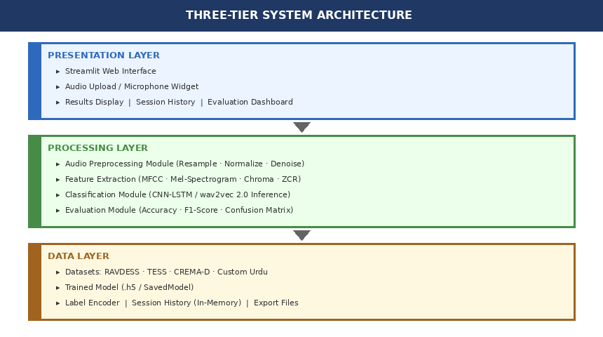
Figure 1: Three-Tier System Architecture

5.2 ML Processing Pipeline
The machine learning pipeline consists of five sequential stages from raw audio input to final emotion output. The following diagram illustrates each stage and the data transformations applied.

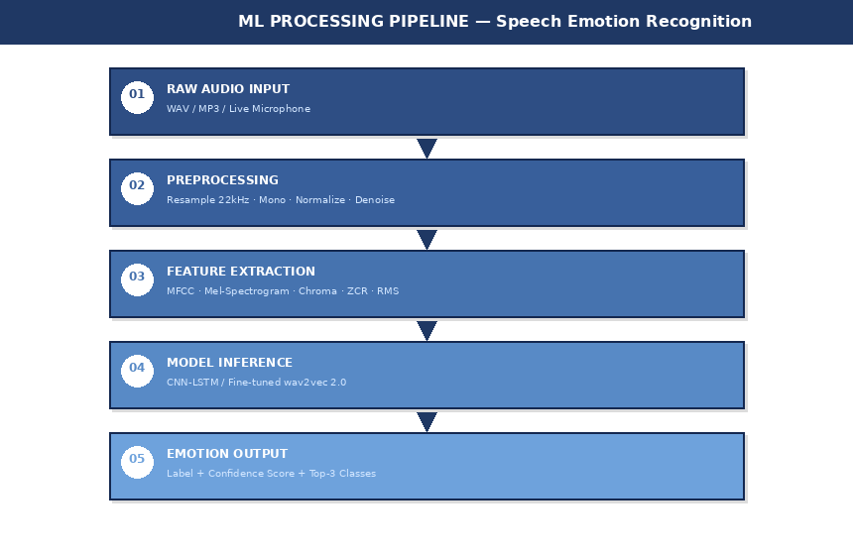
Figure 2: Machine Learning Processing Pipeline

5.3 Layer Descriptions
Presentation Layer: Built using Streamlit. Handles all user interface rendering, audio input capture, and display of results, spectrograms, and session history. Communicates with the Processing Layer through direct Python function calls.

Processing Layer: Composed of four modules — the Audio Preprocessing Module (resampling, normalization, noise reduction), the Feature Extraction Module (MFCC, Mel-spectrogram, Chroma, ZCR via Librosa), the Classification Module (CNN-LSTM and wav2vec 2.0 inference), and the Evaluation Module (metrics, confusion matrix).

Data Layer: Manages all storage and retrieval including the trained model files in SavedModel format, label encoder mappings, in-memory session history, evaluation datasets, and exported report files. No persistent runtime database is required.

CHAPTER 6

SDLC Model and Project Plan

6.1 SDLC Model: Waterfall
The Waterfall model has been selected as the software development lifecycle methodology for this project. The Waterfall model is a sequential, phase-based approach in which each phase is completed and formally reviewed before the next one begins.
This model is appropriate for this project for the following specific reasons. First, the requirements are well-defined and agreed upon from the outset as documented in this SRS, making a sequential approach feasible. Second, as an academic project with a fixed submission deadline and a two-person team, the structured milestone-driven nature of Waterfall provides clear progress tracking and deliverable management. Third, each phase produces a tangible academic deliverable — the SRS from Phase 1, design documents from Phase 2, working code from Phase 3, and test results from Phase 4 — which aligns with supervisor review cycles. Fourth, the structured documentation required by Waterfall is well-suited to academic project reporting standards.

6.2 Waterfall SDLC Diagram
The following diagram illustrates the six sequential phases of the Waterfall model as applied to this project, with durations and key activities for each phase.

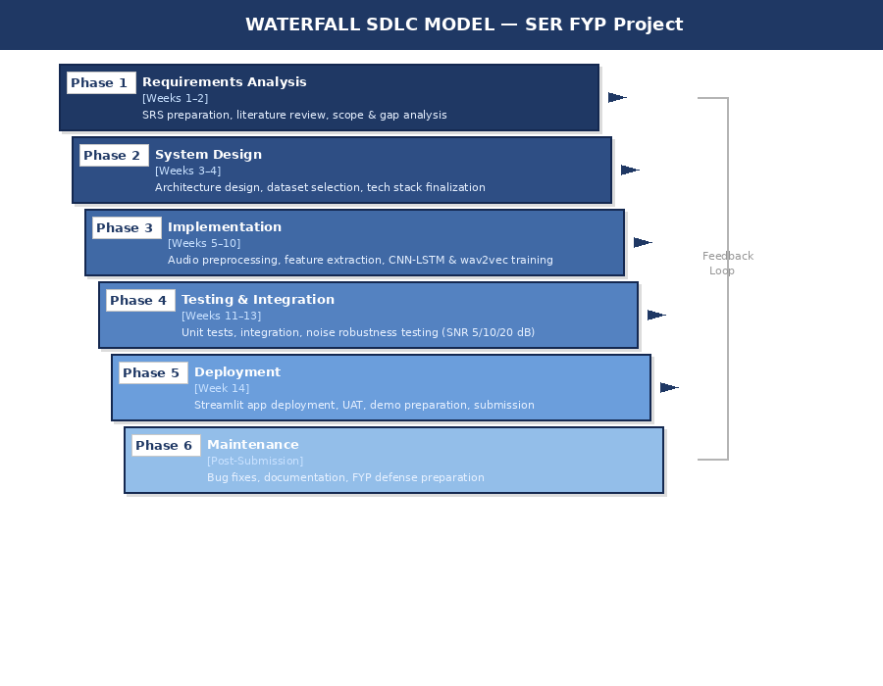
Figure 3: Waterfall SDLC Model — FYP Project Timeline

6.3 Phase Descriptions
Phase 1 — Requirements Analysis (Weeks 1–2): Gather all system requirements, review fifteen research articles, define project scope and gap analysis, and prepare this SRS document. Deliverable: Approved SRS Version 2.0.

Phase 2 — System Design (Weeks 3–4): Design the three-tier system architecture and ML pipeline, select and define preprocessing strategies for RAVDESS, TESS, and CREMA-D datasets, finalize the technology stack, and prepare the System Design Document. Deliverable: System Design Document.

Phase 3 — Implementation (Weeks 5–10): Develop the audio preprocessing module, implement feature extraction using Librosa, train the CNN-LSTM model and fine-tune wav2vec 2.0 on the combined dataset, implement noise augmentation, and build the Streamlit user interface. Deliverable: Functional working system.

Phase 4 — Testing and Integration (Weeks 11–13): Conduct unit testing of individual modules, integration testing of the full pipeline, model accuracy evaluation using standard metrics, noise robustness testing at SNR 5, 10, and 20 dB, and cross-corpus validation. Deliverable: Test report with performance results.

Phase 5 — Deployment (Week 14): Deploy the system as a Streamlit web application, conduct final user acceptance testing, prepare the demo for presentation, and package the project for academic submission. Deliverable: Deployable application and GitHub repository.

Phase 6 — Maintenance (Post-Submission): Bug fixes, final documentation updates, model updates if required, and preparation of the FYP oral defense presentation and final project report.

6.4 Technology Stack with Justification
Technology | Purpose | Why This Technology?
Python 3.10 | Primary development language | Dominant language in ML/DL research; used in all 15 reviewed papers; extensive scientific library ecosystem.
PyTorch 1.x | Model training and inference | Superior research flexibility; required for HuggingFace wav2vec 2.0 fine-tuning as demonstrated in R8 and R10.
wav2vec 2.0 (HuggingFace) | Transfer learning backbone | R8 and R10 show 8–12% accuracy gain over CNN-LSTM alone; pre-trained on 960 hours of English audio; addresses small-dataset overfitting problem identified in R6.
Librosa 0.10 | Audio loading and feature extraction | De facto standard for SER feature extraction; used in all 15 reviewed papers; supports MFCC, Mel-Spectrogram, Chroma, and ZCR.
Scikit-learn (SVM) | Baseline classifier | R7 establishes SVM as the standard baseline. Including it enables a fair ML vs DL comparison addressing Gap 5.
Streamlit | Web user interface | Rapid ML demo prototyping; supports live audio input; Python-native; no separate frontend code needed.
NumPy / Pandas | Data manipulation | Standard scientific Python stack; used universally across all ML pipelines.
Matplotlib / Seaborn | Visualizations | Standard Python visualization; lightweight; compatible with Streamlit rendering.
Git / GitHub | Version control | Academic submission requirement; enables collaboration between two team members; provides audit trail.

Appendices

Appendix A — Dataset Summary
Dataset | Full Name | Speakers | Samples | Language | License
RAVDESS | Ryerson Audio-Visual Database of Emotional Speech and Song | 24 | 1,440 | English | CC BY-NA-SC 4.0
TESS | Toronto Emotional Speech Set | 2 | 2,800 | English | CC BY 4.0
CREMA-D | Crowd-sourced Emotional Multimodal Actors Dataset | 91 | 7,442 | English | Open/Research
Custom Urdu | Self-recorded Urdu Speech Dataset (FYP 2026) | 10+ | ~100 | Urdu | Project Use Only

Appendix B — Emotion Categories
ID | Emotion | Description | In All Datasets?
E01 | Happy | Positive affect; joyful, elated speech | Yes
E02 | Sad | Negative affect; sorrowful, low-energy speech | Yes
E03 | Angry | High-arousal negative; hostile speech | Yes
E04 | Fearful | High-arousal negative; anxious speech | Yes
E05 | Disgusted | Negative affect; revulsion, contempt | Yes
E06 | Surprised | High-arousal; unexpected, astonished speech | RAVDESS & TESS only
E07 | Neutral | No particular emotional content; calm speech | Yes

Appendix C — Evaluation Metrics
Metric | Definition | Why Used
Weighted Accuracy | Correct predictions / Total predictions (class-weighted) | Standard SER metric; accounts for class imbalance across datasets.
UAR | Mean of per-class recall scores | Used in R8, R10, R13; not biased by majority class — fairer than overall accuracy.
F1-Score (per class) | 2 × (Precision × Recall) / (Precision + Recall) | Balances false positives and false negatives; required for academic reporting.
Confusion Matrix | N×N matrix of predicted vs. actual classes | Identifies which emotion pairs are most confused by the model.
SNR Degradation Curve | WA plotted at SNR 5, 10, 20 dB and clean | Novel contribution — systematic noise robustness measurement addressing Gap 2.

— End of Document —
SRS Version 2.0 | Emotion Recognition from Speech | University of Southern Punjab | April 2026

