Frontend CV

Summary
- Designed the PyQt6 desktop UI for the cyber threat prevention system.
- Added an animated landing page, login workflow, dashboard, monitoring and quarantine views.
- Kept the interface modern, responsive, and easy to use.

Skills
- PyQt6 widgets and layout management
- Frontend-only:
  - PyQt6 (QtCore, QtGui, QtWidgets) — UI framework (timers, widgets, layouts, stacked pages, styling, events)

- QStackedWidget for page navigation
- Custom styling and animated startup UX
- User-friendly forms, tables, and alert handling

Experience
- Built `LandingPage` with animated logo pulse and concise onboarding steps.
- Created secure login and main dashboard pages with live metrics.
- Integrated navigation sidebar and dynamic page switching.
- Preserved existing app behavior while adding startup branding.

Key impact
- Improved first impressions with a polished entry screen.
- Guided users seamlessly from launch to login to dashboard.
- Simplified user adoption with clear usage steps on startup.
Animated landing page

python
class LandingPage(QWidget):
def __init__(self, on_complete) -> None:
super().__init__()
self.on_complete = on_complete
self.step_index = 0
self._build_ui()
self._pulse_timer = QTimer(self)
self._pulse_timer.timeout.connect(self._animate)
self._pulse_timer.start(300)
self._finish_timer = QTimer(self)
self._finish_timer.setSingleShot(True)
self._finish_timer.timeout.connect(self.finish)
self._finish_timer.start(6500)

Transition to login page

python
self.landing_page = LandingPage(self.show_login_page)
self.login_page = LoginPage(self.auth_service, self.handle_login_success)
self.dashboard_shell = DashboardShell(self)
self.stack.addWidget(self.landing_page)
self.stack.addWidget(self.login_page)
self.stack.addWidget(self.dashboard_shell)
self.stack.setCurrentWidget(self.landing_page)

Login form layout

python
self.username = QLineEdit()
self.username.setPlaceholderText("Username")
self.password = QLineEdit()
self.password.setPlaceholderText("Password")
self.password.setEchoMode(QLineEdit.EchoMode.Password)
self.new_password = QLineEdit()
self.new_password.setPlaceholderText("New password for sign up")
self.new_password.setEchoMode(QLineEdit.EchoMode.Password)
```

screenshots:
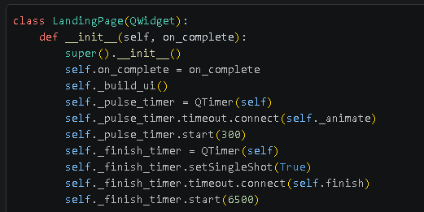
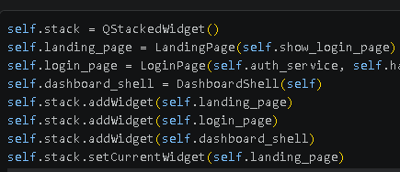
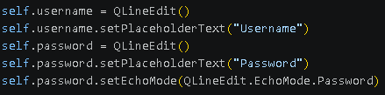

Frontend Interface:

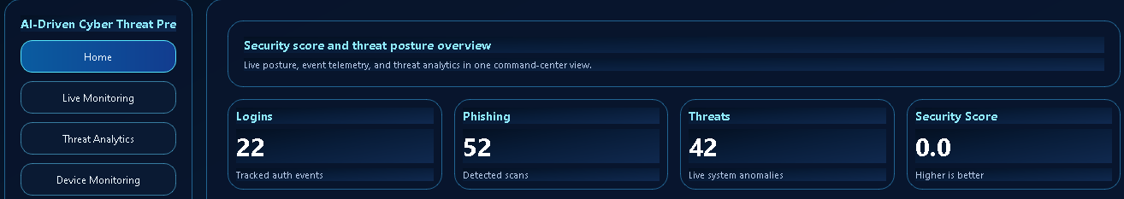

Extension:
