Incident Reporting System
Project Report
A database-driven platform to report, track and resolve incidents

NAME | Usman Aslam & Abdullah Amjad
ID | (41566 & 41195)
COURSE | Database Systems
Submitted to | Ma'am Tayyaba Shehzad
Technology | MySQL · Python (Flask) · HTML / CSS / JavaScript

Table of Contents
1. Abstract 3
2. Introduction 3
3. Problem Statement 3
4. Objectives 3
5. System Requirements 4
5.1 Software Requirements 4
5.2 Hardware Requirements 4
6. Functional Requirements 4
7. System Architecture 4
8. Database Design 5
8.1 Entity-Relationship Diagram 6
8.2 Database Tables 6
8.3 Relationships 8
8.4 Normalization 9
8.5 Constraints and Referential Integrity 9
9. Data Flow Diagram 9
10. Incident Lifecycle 10
11. Implementation 11
11.1 Technology Stack 11
11.2 Key SQL Queries 11
12. Results (Screenshots) 11
13. Conclusion 14

1. Abstract
The Incident Reporting System is a database-powered platform designed to manage and organize incidents within an organization. It provides a structured approach for reporting incidents, tracking their status, and resolving issues in an efficient and organized way. The system is built on a relational MySQL database and allows users to report incidents, administrators to review and manage them, and support staff to update their status and record resolutions.
By storing every incident, verification, resolution and notification in a set of related database tables, the system helps an organization handle incidents quickly, maintain proper records, and improve overall response time, transparency and accountability.

2. Introduction
In many organizations, different types of incidents can occur, such as technical problems, security issues, or workplace accidents. Managing these incidents manually is difficult because information may be lost, records may not be organized, and resolving problems can take a long time.
Often incidents are reported through phone calls, emails, or paper forms, which makes it harder to track their status and progress. This creates confusion and delays in solving the issues. The Incident Reporting System solves this problem by providing a digital platform where users can easily report incidents, administrators can review these reports and assign them to the responsible staff, and the reporter is kept informed at every step.

3. Problem Statement
In many organizations, incidents are reported and managed manually through paper records, emails, or verbal communication. This method causes delays, missing information, and difficulty in tracking the status of incidents. Because there is no proper system to record and monitor incidents, it becomes hard for administrators to manage them efficiently and to ensure that problems are resolved on time.
The Incident Reporting System solves this problem by providing a centralized database where incidents can be reported, stored, tracked, and resolved in an organized way, improving efficiency, transparency and record management.

4. Objectives
- Provide a secure platform for users and administrators to log in.
- Allow users to report incidents with full details (category, severity, location).
- Enable tracking of each incident's status from report to resolution.
- Let administrators manage incidents by verifying, assigning and resolving them.
- Keep users informed through automatic notifications on every status change.
- Store all records securely in a well-designed relational database.

5. System Requirements

5.1 Software Requirements
- Database: MySQL 8.0 (relational database engine).
- Backend: Python with the Flask web framework (using raw SQL).
- Frontend: HTML, CSS and JavaScript.
- Tools: Visual Studio Code and a MySQL client.

5.2 Hardware Requirements
- Processor: any modern dual-core processor or better.
- Memory: minimum 4 GB RAM.
- Storage: around 2 GB free disk space for the database engine and data.

6. Functional Requirements
- User Authentication — secure login and registration for users and administrators.
- Incident Reporting — users can report incidents by submitting details through the system.
- Incident Tracking — users can track the current status of their reported incidents.
- Incident Management — administrators can review, verify, assign and manage incidents.
- Status Updates — staff can update incident progress and record resolution details.
- Notifications — the system notifies users automatically when their incident changes.
- Database Management — secure storage of incident records and user information.

7. System Architecture
The system follows a classic three-tier architecture. The presentation layer (the web pages in the browser) sends requests to the application layer (the Flask server), which runs SQL queries against the data layer (the MySQL database) and returns the results to the user.
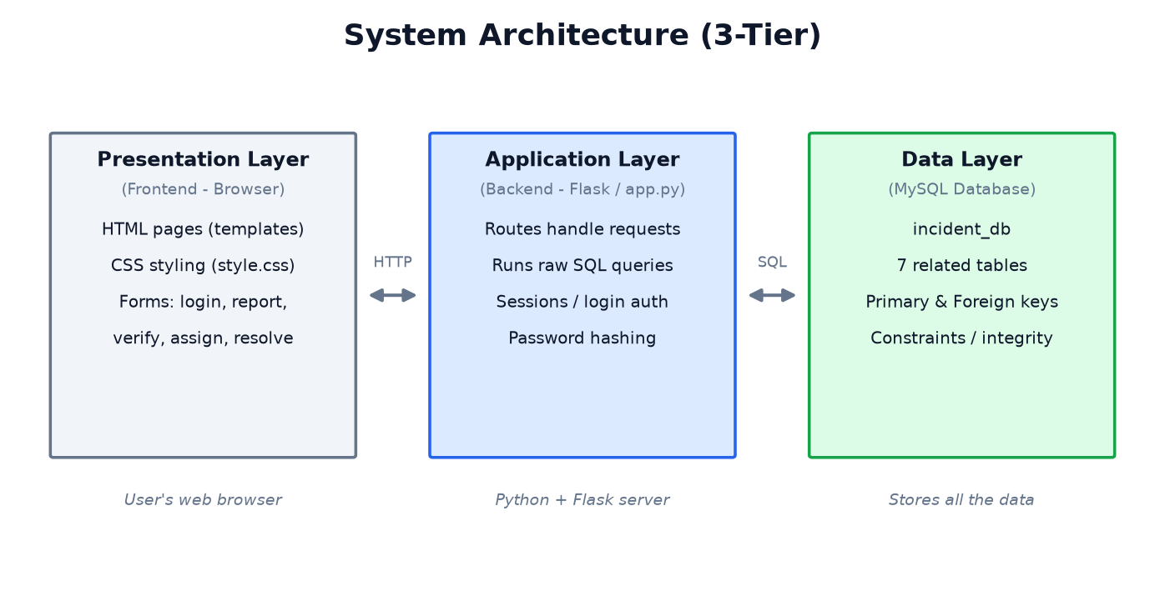
Figure 1: Three-tier system architecture.

8. Database Design
The database is the core of this project. It is named incident_db and contains seven related tables. The design uses primary keys to identify rows uniquely and foreign keys to link the tables together, enforcing referential integrity.

8.1 Entity-Relationship Diagram
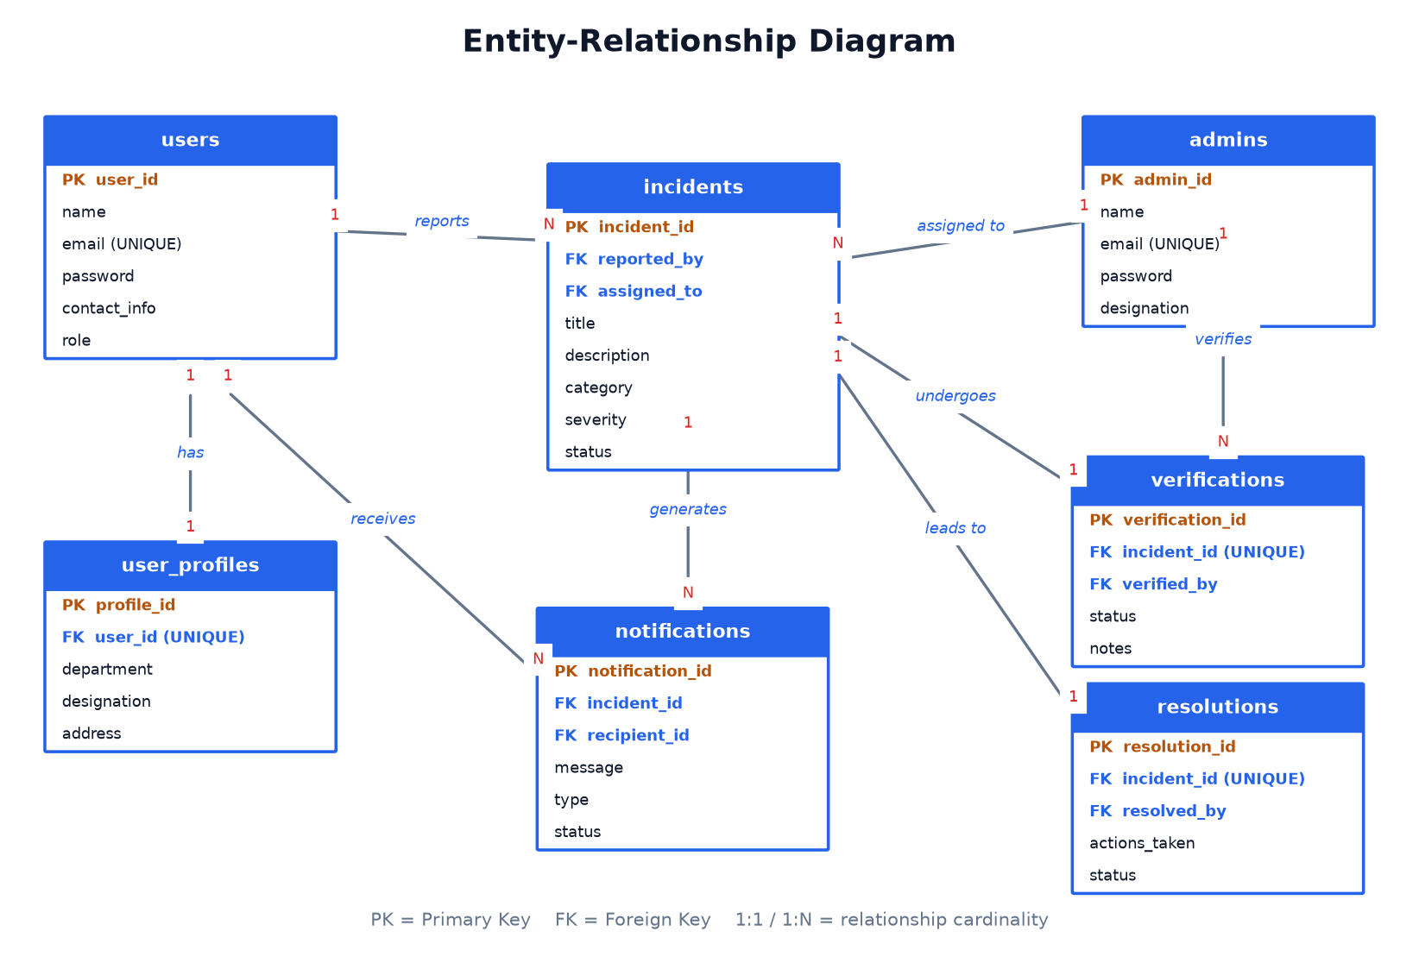
Figure 2: Entity-Relationship (ER) diagram of the database.

8.2 Database Tables
The following tables describe each entity, its columns, and the keys and constraints used.
Table 1 — users (people who report incidents)
Column | Type | Key / Constraint | Description
user_id | INT | PRIMARY KEY | Unique id of the user (auto-increment).
name | VARCHAR(100) | NOT NULL | Full name of the user.
email | VARCHAR(120) | UNIQUE, NOT NULL | Login email; no two users share one.
password | VARCHAR(255) | NOT NULL | Password stored in hashed form.
contact_info | VARCHAR(50) | — | Phone or contact number.
role | VARCHAR(20) | DEFAULT 'Reporter' | Role of the user.
created_at | TIMESTAMP | DEFAULT now | When the account was created.

Table 2 — user_profiles (extra details, 1:1 with users)
Column | Type | Key / Constraint | Description
profile_id | INT | PRIMARY KEY | Unique id of the profile.
user_id | INT | FK → users, UNIQUE | Links to one user (UNIQUE makes it 1:1).
department | VARCHAR(80) | — | Department of the user.
designation | VARCHAR(80) | — | Job title of the user.
address | VARCHAR(200) | — | Address of the user.

Table 3 — admins (administrators / support staff)
Column | Type | Key / Constraint | Description
admin_id | INT | PRIMARY KEY | Unique id of the administrator.
name | VARCHAR(100) | NOT NULL | Name of the administrator.
email | VARCHAR(120) | UNIQUE, NOT NULL | Login email of the administrator.
password | VARCHAR(255) | NOT NULL | Hashed password.
designation | VARCHAR(50) | DEFAULT 'Administrator' | Admin or Support Staff.

Table 4 — incidents (the central table)
Column | Type | Key / Constraint | Description
incident_id | INT | PRIMARY KEY | Unique id of the incident.
reported_by | INT | FK → users | The user who reported the incident.
title | VARCHAR(150) | NOT NULL | Short title.
description | TEXT | NOT NULL | Full description of the incident.
category | ENUM | NOT NULL | Technical / Security / Workplace / Other.
severity | ENUM | NOT NULL | Low / Medium / High / Critical.
location | VARCHAR(120) | — | Where the incident happened.
status | ENUM | DEFAULT 'Pending' | Current stage in the lifecycle.
assigned_to | INT | FK → admins, NULL | Admin handling it (NULL until assigned).
reported_at | TIMESTAMP | DEFAULT now | When it was reported.
assigned_at | TIMESTAMP | NULL | When it was assigned.

Table 5 — verifications (1:1 with incidents)
Column | Type | Key / Constraint | Description
verification_id | INT | PRIMARY KEY | Unique id of the verification.
incident_id | INT | FK → incidents, UNIQUE | The incident verified (UNIQUE = 1:1).
verified_by | INT | FK → admins | Admin who verified it.
status | ENUM | NOT NULL | Verified / Rejected.
notes | TEXT | — | Optional notes.
verified_at | TIMESTAMP | DEFAULT now | When it was verified.

Table 6 — resolutions (1:1 with incidents)
Column | Type | Key / Constraint | Description
resolution_id | INT | PRIMARY KEY | Unique id of the resolution.
incident_id | INT | FK → incidents, UNIQUE | The incident resolved (UNIQUE = 1:1).
resolved_by | INT | FK → admins | Responsible admin.
actions_taken | TEXT | NOT NULL | What was done to resolve it.
status | ENUM | DEFAULT 'Resolved' | Resolved / Closed / Reopened.
completion_date | TIMESTAMP | DEFAULT now | When it was resolved.

Table 7 — notifications (1:N with incidents and users)
Column | Type | Key / Constraint | Description
notification_id | INT | PRIMARY KEY | Unique id of the notification.
incident_id | INT | FK → incidents | The incident it is about.
recipient_id | INT | FK → users | The user who receives it.
message | VARCHAR(255) | NOT NULL | The notification text.
type | ENUM | DEFAULT 'System' | System / Email / SMS.
status | ENUM | DEFAULT 'Unread' | Unread / Read.
created_at | TIMESTAMP | DEFAULT now | When it was created.

8.3 Relationships
The tables are connected through the following relationships:
- users — user_profiles (1:1): each user has at most one profile (UNIQUE foreign key).
- users — incidents (1:N): one user can report many incidents.
- admins — incidents (1:N): one admin can be assigned many incidents.
- incidents — verifications (1:1): each incident has one verification.
- incidents — resolutions (1:1): each incident has one resolution.
- incidents — notifications (1:N): one incident can generate many notifications.
- users — notifications (1:N): one user can receive many notifications.

8.4 Normalization
The database is designed in Third Normal Form (3NF):
- First Normal Form (1NF): every column holds a single, atomic value — no repeating groups.
- Second Normal Form (2NF): each table has a single-column primary key, so every non-key column depends on the whole key.
- Third Normal Form (3NF): non-key columns depend only on the primary key. For example, an admin's name is not copied into the incidents table; only the admin's id is stored and the name is looked up with a JOIN.

8.5 Constraints and Referential Integrity
- PRIMARY KEY: uniquely identifies each row.
- FOREIGN KEY: links a row to a row in another table and enforces referential integrity.
- UNIQUE: prevents duplicate values (e.g. email) and enforces 1:1 relationships.
- NOT NULL / DEFAULT: ensure required columns always have a valid value.
- ENUM: restricts a column to a fixed list of valid values (e.g. severity).
- ON DELETE CASCADE / SET NULL: keep the data consistent when a parent row is deleted.

9. Data Flow Diagram
The data flow diagram shows how information moves through the system: a user reports an incident (stored in the incidents table); an admin verifies it (verifications table), then assigns and resolves it (resolutions table); and notifications are generated for the user.
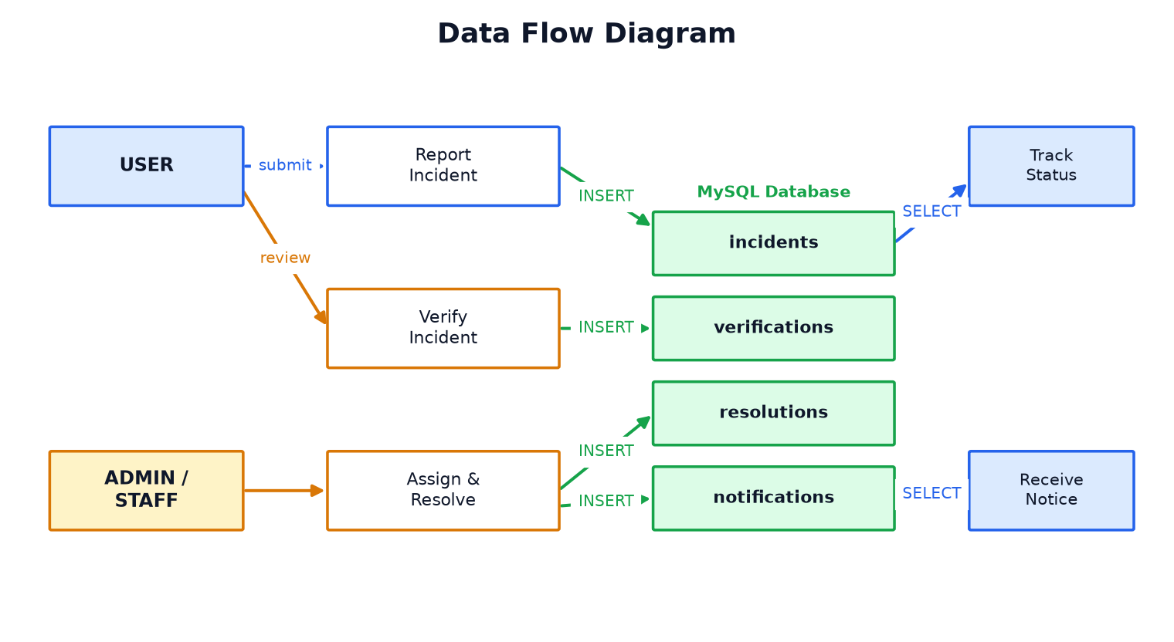
Figure 3: Data flow diagram.

10. Incident Lifecycle
Every incident moves through a clear set of statuses. A newly reported incident is Pending. After an admin reviews it, it becomes Verified (or Rejected). It is then Assigned to a staff member and finally marked Resolved. Each change updates the status column and notifies the reporter.
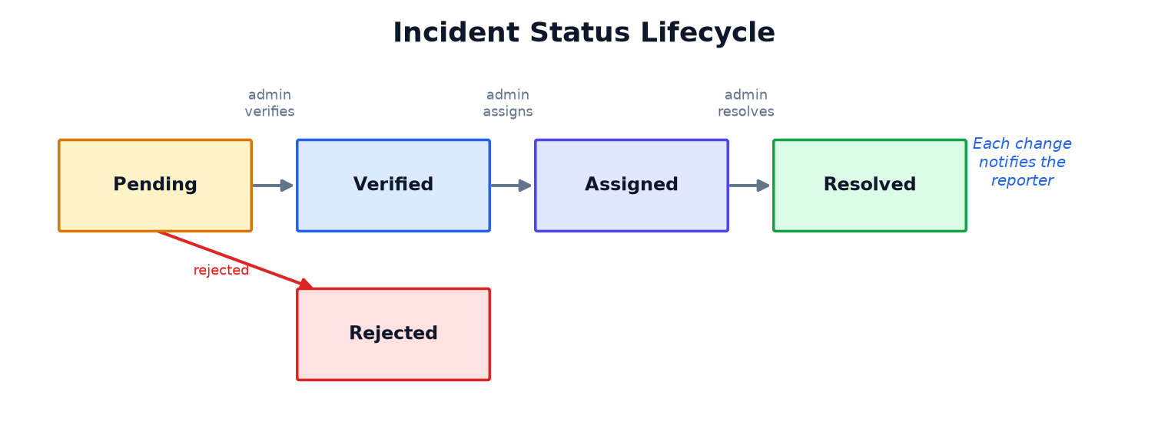
Figure 4: Incident status lifecycle.

11. Implementation

11.1 Technology Stack
The application is built with Python and the Flask web framework. Flask was chosen over an ORM-based framework so that every database operation is written as raw SQL that is fully visible in the code. The database is MySQL, and the user interface uses HTML, CSS and JavaScript.

11.2 Key SQL Queries
Reporting a new incident (INSERT):
INSERT INTO incidents (reported_by, title, description, category, severity, location) VALUES (%s, %s, %s, %s, %s, %s);
Showing a user only their own incidents (SELECT with WHERE):
SELECT incident_id, title, status FROM incidents WHERE reported_by = %s ORDER BY reported_at DESC;
Joining an incident with its reporter and assigned admin (JOIN):
SELECT i.*, u.name AS reporter_name, a.name AS admin_name FROM incidents i JOIN users u ON i.reported_by = u.user_id LEFT JOIN admins a ON i.assigned_to = a.admin_id WHERE i.incident_id = %s;
Counting incidents by status (GROUP BY):
SELECT status, COUNT(*) AS c FROM incidents GROUP BY status;

12. Results (Screenshots)
The following screenshots show the working system.
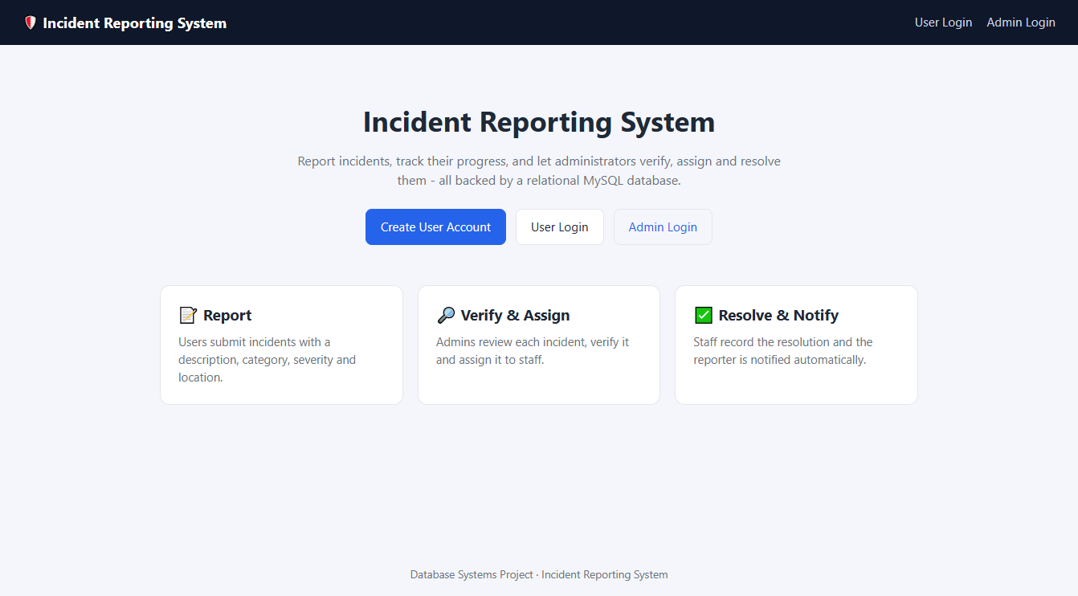
Figure 5: Home page.
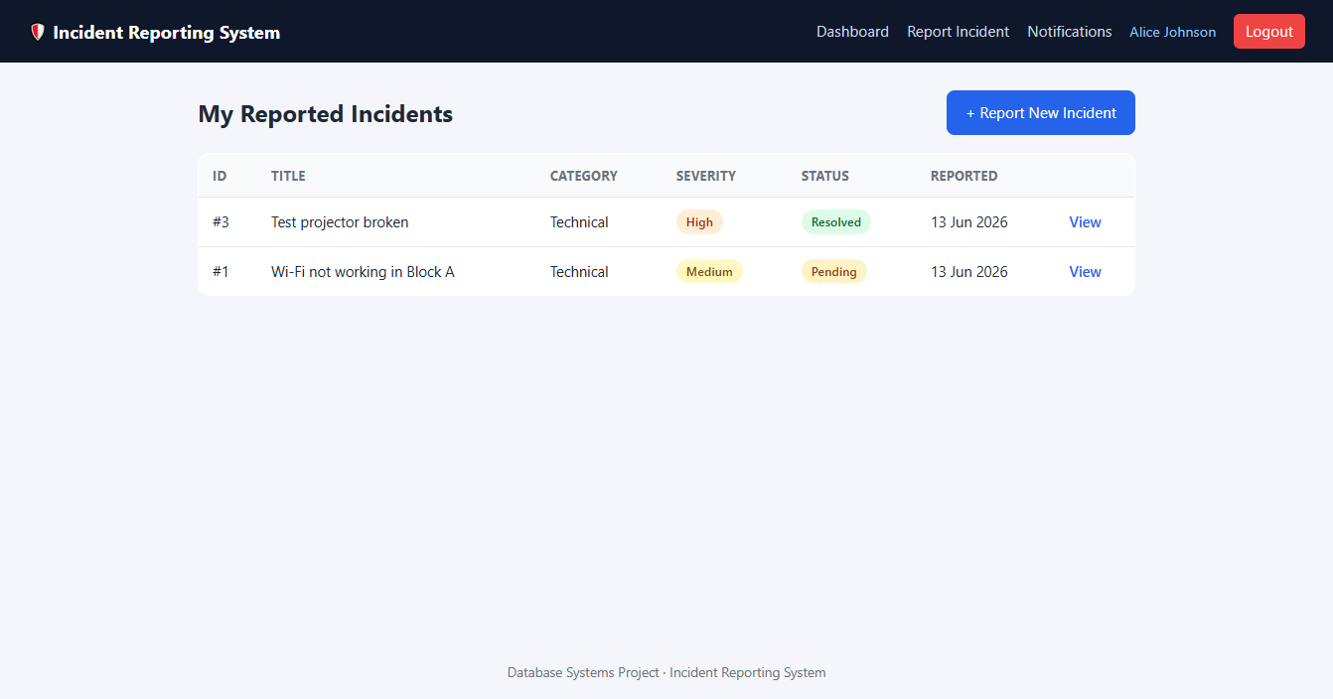
Figure 6: User dashboard listing the user's reported incidents.
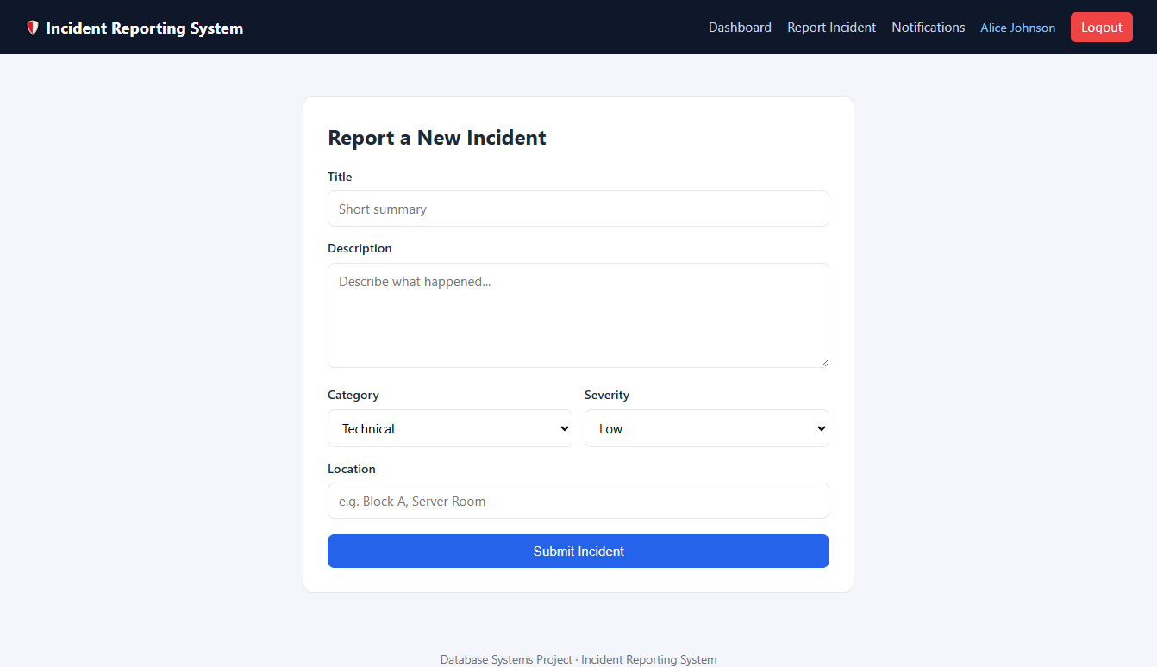
Figure 7: Reporting a new incident.
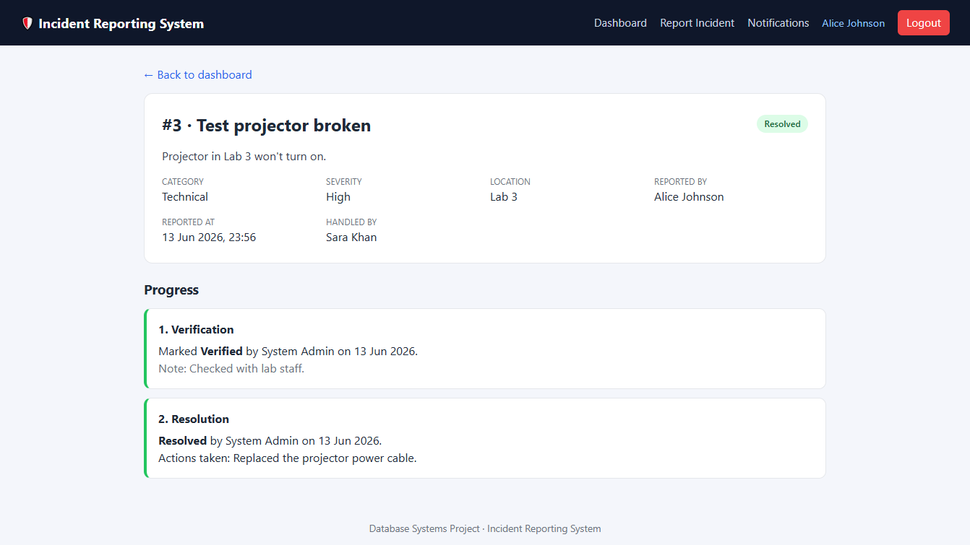
Figure 8: Incident tracking with verification and resolution.
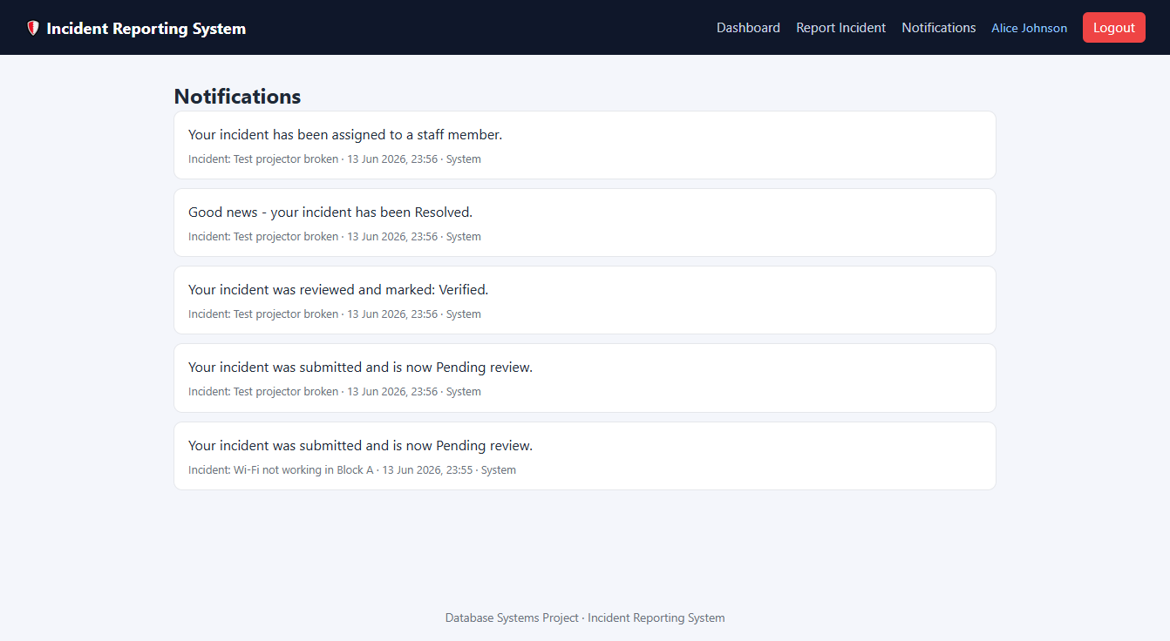
Figure 9: User notifications.
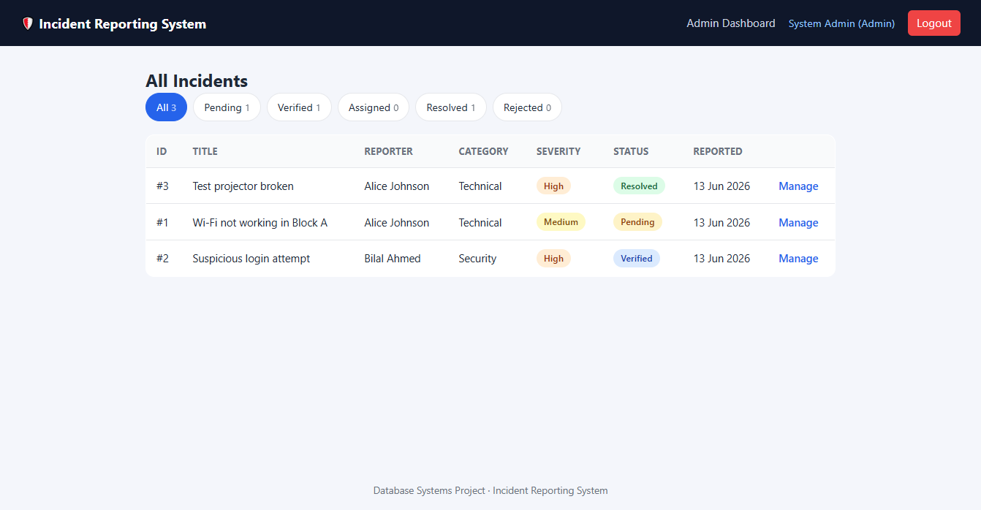
Figure 10: Admin dashboard with status filters and counts.
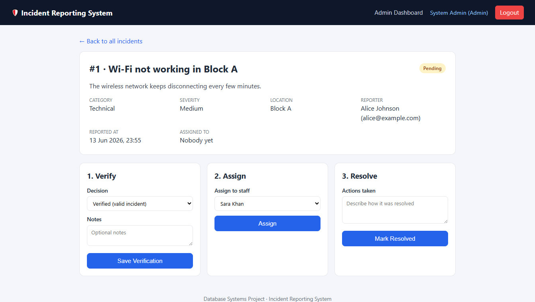
Figure 11: Admin managing an incident (verify, assign, resolve).

13. Conclusion
The Incident Reporting System provides an organized and efficient way to record and handle incidents within an organization. By using a relational MySQL database of seven well-designed tables, the system ensures that incident information is stored securely and can be accessed easily when required. Primary and foreign keys enforce data integrity, the design is normalized to Third Normal Form, and constraints keep the data valid. Overall, the system improves response time, transparency and the management of incidents, making it a useful tool for any organization that wants to manage incidents in a structured and reliable way.

