Project Activity 5
Basic Secure Coding Implementation in Existing Semester Project
Semester project: CafeMS – Cafe Management System
Development environment: HTML, CSS, JavaScript and a web browser
Course: Secure Software Design
Field | Details
Roll number | 22L-7991
Group members | ____________________________________
Submitted to | ____________________________________
Date | 11 November 2026
Source code | github.com/Usman7576/CafeMS, branch security-hardening, commit d435d22

Contents

(If the list above is empty, right-click it in Word and choose Update Field.)

1. Objective and approach
The objective of this activity is to improve the security of our existing semester project, CafeMS, by implementing basic secure coding practices in its frontend. We examined the existing pages, identified weaknesses, implemented security improvements in the real project source code, and tested every improvement.
All changes were made in the existing CafeMS project, not in a separate application. The main changes are:
File | Purpose
public/js/validate.js (new) | Shared validation for forms, file checks and the password strength display
public/js/password_strength_helper.js (new) | Instructor's file, included unchanged (SHA-256 539b97de…3191)
home.js, reservation.js, login.js, menu.js, users.js, account.js, setup.js, inventory.js, reports.js | Each form calls Validate.attach(...) and sends only checked, trimmed values
public/js/common.js | Safer element builder CMS.h, browser-storage clean-up, Session.wipe() on sign-out
public/js/store.js, app.js | Store.forget() and Session.wipe() when signing out or when the session ends
public/css/style.css | Styles for field messages, file status and the strength meter
public/*.html | Load validate.js; account.html and setup.html also load the helper file
tests/activity5.test.js (new) | 9 automated checks that keep these protections in place
scripts/activity5-evidence.js (new) | Runs 28 test cases in Chrome and saves the screenshots used in this report

Summary of weaknesses and improvements
Task | Weakness found | Improvement
1. Input validation | Most forms had no browser checks; the public form gave one general message; spaces were not trimmed; maxlength could be bypassed | Required, length, format and range checks on 10 forms, trimming, and a message under each field
2. XSS | Earlier versions used innerHTML (53 places); the element builder accepted javascript: links and string handlers | Text shown only with textContent; javascript: links blocked; string handlers ignored; Trusted Types in the CSP
3. File selection | The photo field only had an accept attribute; any type and size could be chosen | Extension, type, 2 MB size and file-signature checks with clear messages; refused files are cleared
4. Sensitive data | Earlier version kept the database in localStorage; sign-out left page data and forms behind | Only 4 display fields stored; storage cleaned on every page; sign-out wipes state; no secrets in frontend
5. Password strength | No strength feedback | Instructor's checkPasswordStrength() called as the user types, result shown below the field

2. Task 1: Secure input validation

2.1 Weaknesses found
- Public reservation form (index.html): only checked that four fields were not empty and showed one general message. A mobile number like 12345, a past date or 25 guests were sent to the server.
- Staff reservation form (reservation.html): showed one message at a time and did not check the mobile number format or opening hours.
- Menu item, add staff, sign-in, stock, refund and security-question forms: no browser checks at all.
- Leading and trailing spaces were not removed consistently, and doubled spaces in names were kept.
- maxlength limits only typing; a value set in DevTools bypassed it, and scripts did not check lengths again.

2.2 Improvements implemented
A shared function Validate.attach(form, rules) in public/js/validate.js now runs on 10 existing forms. For every field it:
- Removes leading and trailing spaces (and doubled spaces in names) and writes the cleaned value back into the field. Passwords are not changed, because a space can be part of a password.
- Prevents submission of empty mandatory fields and shows, for example, "Your name is required."
- Applies minimum and maximum character limits, both as minlength/maxlength attributes and again in the script.
- Validates formats: names, mobile number 03XXXXXXXXX, username, real dates not in the past, opening hours 10:00–23:00, number ranges, matching password confirmation.
- Displays a message under each invalid field, a summary at the top, marks the field with aria-invalid and moves focus to the first problem. Messages clear as soon as the field is fixed.

Form | Page | Rules
Online reservation | index.html | Name 2–60, name format; mobile 03XXXXXXXXX; date not past, ≤ 60 days ahead; time 10:00–23:00; guests 1–20; notes ≤ 160
Staff reservation | reservation.html | Same as above without the 60-day limit
Staff sign-in | login.html | Username required, 3–30, username format; password required, ≤ 128
Menu item | menu.html | Name 2–40; category 2–24; price whole number Rs 50–20,000; description ≤ 80; photo (Task 3)
Add staff member | users.html | Full name 2–60; username format; role from the list
Change password | account.html | Current required; new 12–128, all four character types, different from current
Security question | account.html | Question 10–100, no < or >; answer 3–100
Choose a password | setup.html | 12–128, all four character types; confirmation must match
Restock / write off | inventory.html | Quantity 0.1–1000; reason 3–60
Refund | reports.html | Reason 4–80

Example: the rules for the online reservation form (public/js/home.js)
const reserveRules = Validate.attach(el("reserveForm"), {
rName: { label: "Your name", required: true, min: 2, max: 60, format: "personName", collapseSpaces: true },
rPhone: { label: "Mobile number", required: true, max: 13, format: "mobile" },
rDate: { label: "Date", required: true, format: "date", notBefore: today, notAfter: ... },
rTime: { label: "Time", required: true, format: "time", timeFrom: "10:00", timeTo: "23:00" },
rParty: { label: "Guests", required: true, number: { min: 1, max: 20 } },
rNotes: { label: "Notes", max: 160, collapseSpaces: true }
}, { summary: el("reserveErr") });

const checked = reserveRules.check(); // trims, validates, shows messages
if (!checked.ok) return; // nothing is sent

2.3 Evidence
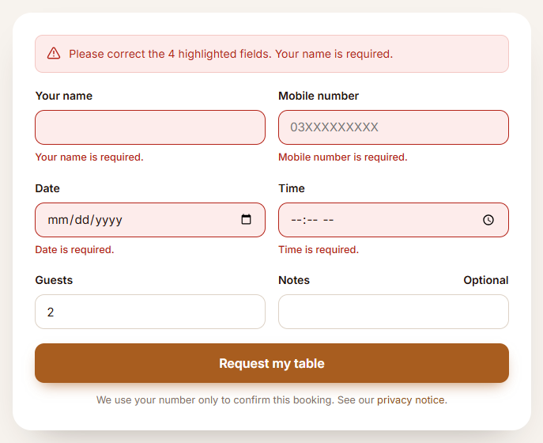
Figure 1: Online reservation: required fields left empty. Each shows a message and nothing is sent.
TC-01 result: Pass
Actual: 4 messages shown: rName: Your name is required. | rPhone: Mobile number is required. | rDate: Date is required. | rTime: Time is required. Requests sent to the server: 0
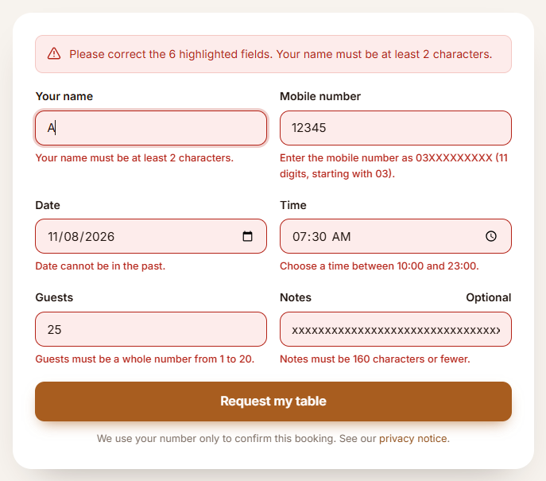
Figure 2: Online reservation: too-short name, wrong mobile format, past date, closed hours, 25 guests, 170-character notes.
TC-02 result: Pass
Actual: 6 messages shown: rName: Your name must be at least 2 characters. | rPhone: Enter the mobile number as 03XXXXXXXXX (11 digits, starting with 03). | rDate: Date cannot be in the past. | rTime: Choose a time between 10:00 and 23:00. | rParty: Guests must be a whole number from 1 to 20. | rNotes: Notes must be 160 characters or fewer. Requests sent: 0
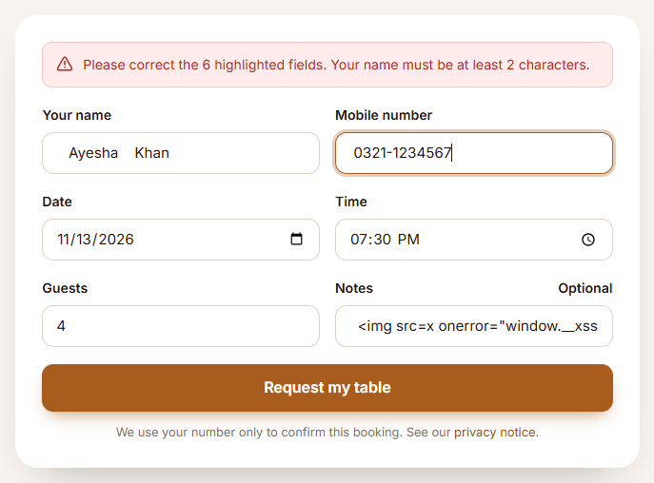
Figure 3: Online reservation: values typed with extra spaces before submitting.
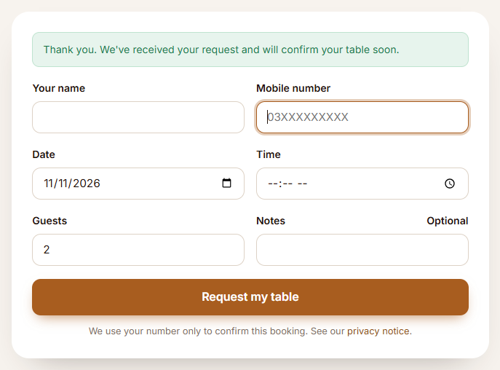
Figure 4: The trimmed values were accepted and the booking was confirmed.
TC-03 result: Pass
Actual: Confirmation: "Thank you. We've received your request and will confirm your table soon.". Sent to the server: name "Ayesha Khan", mobile "03211234567", notes start "<img src=x o"
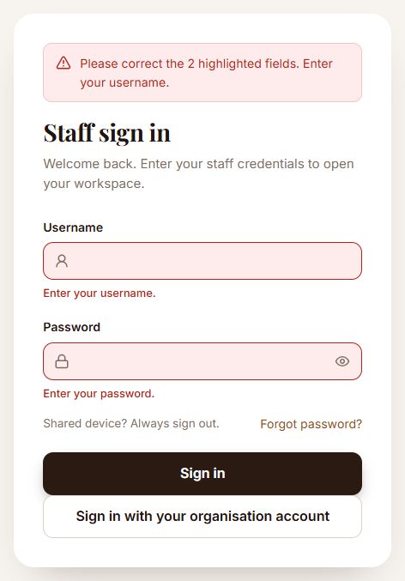
Figure 5: Staff sign-in form: both fields empty.
TC-04 result: Pass
Actual: 2 messages shown: username: Enter your username. | password: Enter your password.
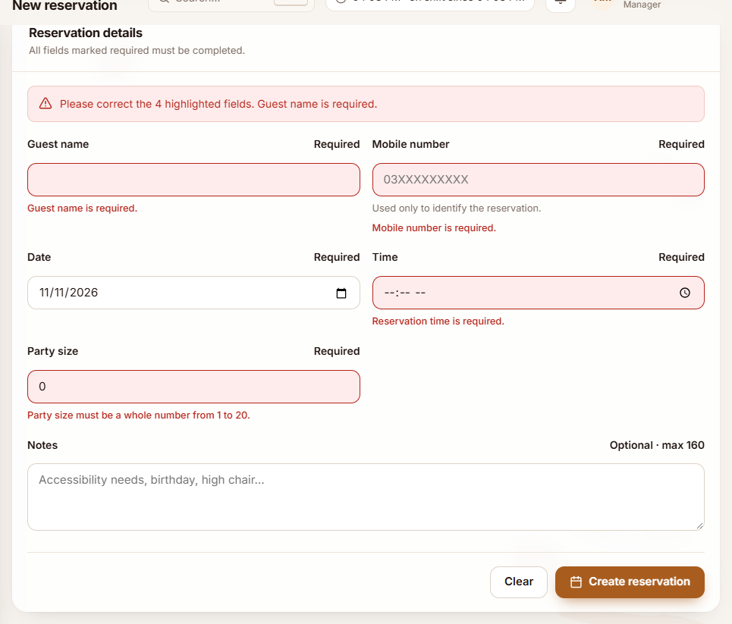
Figure 6: Staff reservation form (second form): empty name, mobile and time, party size 0.
TC-05 result: Pass
Actual: 4 messages shown: guestName: Guest name is required. | guestPhone: Mobile number is required. | reservationTime: Reservation time is required. | partySize: Party size must be a whole number from 1 to 20.
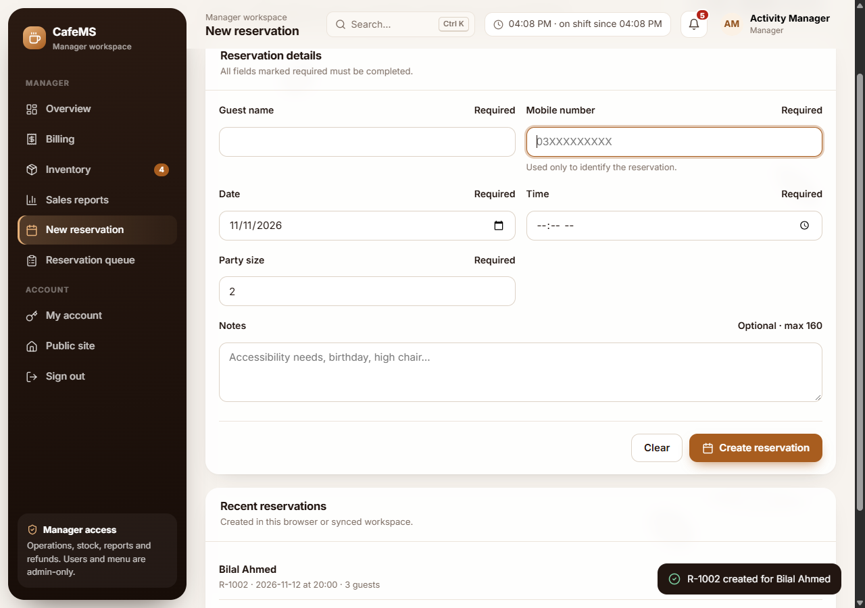
Figure 7: Staff reservation form: after correcting the values the messages clear and the reservation is created.
TC-06 result: Pass
Actual: 0 messages left; toast: "R-1002 created for Bilal Ahmed"
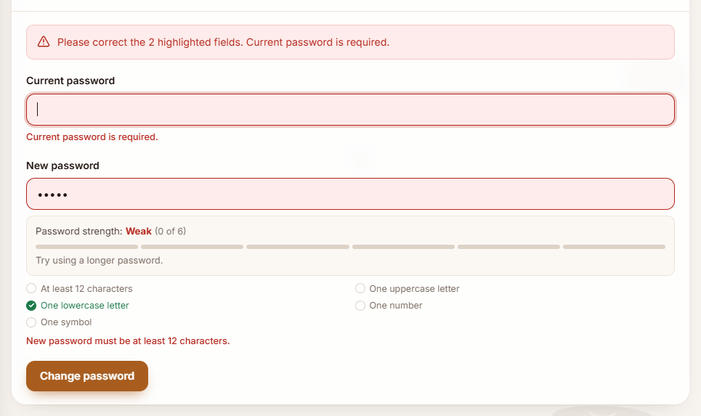
Figure 8: Change password form: current password empty and new password too short.
TC-14 result: Pass
Actual: 2 messages: currentPassword: Current password is required. | newPassword: New password must be at least 12 characters.

3. Task 2: Cross-Site Scripting (XSS) prevention

3.1 Components that display user-provided information
- Reservation notes and guest name: typed by any member of the public on the home page; staff later open them in the Reservation queue (reservations.js, View dialog). This is the main risk, because anyone on the internet can write text that staff will open.
- Menu item name and description: typed by the Admin on menu.html and shown to every visitor on the public menu (home.js).
- Kitchen notes on orders, customer names and audit details are displayed the same way.

3.2 Examination of unsafe DOM manipulation
Earlier versions of our project built screens with innerHTML, which turns text into real HTML. A note such as <img src=x onerror=alert(1)> would have become an image element and run its script:
Version (commit) | innerHTML uses
8a072ed – first prototype | 7
ab6c012 – v2.0 | 50
57d8978 – Activity 3 | 53
Current code (d435d22) | 0

We searched every file in public/js again for innerHTML, outerHTML, insertAdjacentHTML and document.write: none are used now. We also examined our element builder CMS.h and found two remaining gaps: an href or src value of javascript:alert(1) was set as it was, and an onclick given as a string was passed to addEventListener.

3.3 Safer rendering implemented
- All user text is inserted with textContent or text nodes through CMS.h, so the browser treats it as data, never as HTML.
- CMS.h now accepts only safe addresses in href, src, action and formaction (relative, http(s), mailto, tel, blob, image data). javascript: and similar become about:blank#blocked, including when hidden with tabs.
- Event handlers must be functions; a string such as "alert(1)" is ignored.
- The Content-Security-Policy has require-trusted-types-for 'script', so the browser itself refuses any innerHTML assignment of a plain string, and script-src 'self' blocks inline scripts.
- A test fails if innerHTML, outerHTML, insertAdjacentHTML or document.write is ever added.
// public/js/common.js – every element is built like this; text is never parsed as HTML
if (attrs.text !== undefined) el.textContent = attrs.text;
else if (k.indexOf("on") === 0) { if (typeof v === "function") el.addEventListener(k.slice(2), v); }
else if (URL_ATTRS.indexOf(k.toLowerCase()) !== -1) el.setAttribute(k, safeUrl(v));

3.4 Test inputs simulating malicious content
Where | Input
Reservation notes | <img src=x onerror="window.__xss=1;alert('XSS')"> <script>window.__xss=2;alert('XSS')</script>
Menu item name | <script>alert(1)</script>
Menu item description | <svg onload=alert(document.cookie)> <b>bold?</b>
Browser console | element.innerHTML = '<img src=x onerror=alert(1)>'; CMS.h('a', { href: 'javascript:alert(1)' }); CMS.h('button', { onclick: 'alert(1)' })

3.5 Evidence: the browser does not execute the content
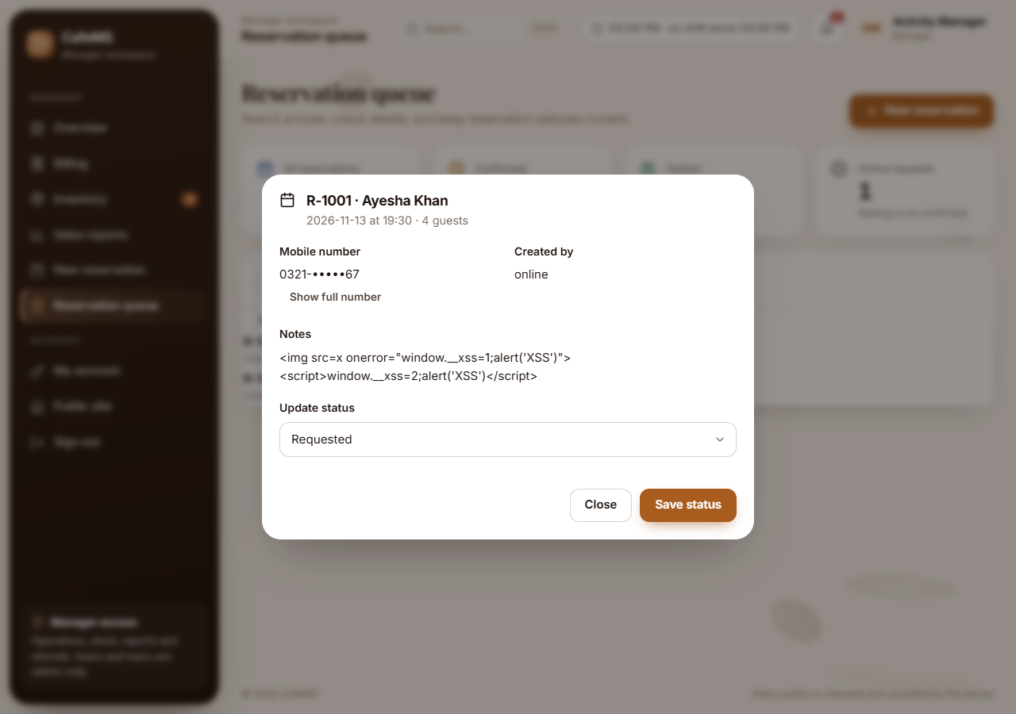
Figure 9: Reservation queue: the malicious notes are shown as plain text; no alert, no image, no script.
TC-07 result: Pass
Actual: Shown as text: "<img src=x onerror="window.__xss=1;alert('XSS')"> <script>window.__xss=2;alert('XSS')</script>" (child elements inside the paragraph: 0). window.__xss: not set; injected <img>: 0; injected <script>: 0; alerts opened: 0
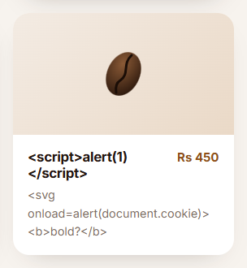
Figure 10: Public menu: a menu item whose name is <script>alert(1)</script> is displayed literally.
TC-19 result: Pass
Actual: Title shown: "<script>alert(1)</script>"; description shown: "<svg onload=alert(document.cookie)> <b>bold?</b>"; <script>: 0, <svg>: 0, <b>: 0; alerts opened: 0
Unsafe APIs refused (console test, TC-08)
TC-08 result: Pass
Actual: innerHTML: TypeError: Failed to set the 'innerHTML' property on 'Element': This document requires 'TrustedHTML' assignment; href became "about:blank#blocked" (with a hidden tab: "about:blank#blocked"); onclick attribute: not set; alerts opened: 0

4. Task 3: Secure file selection and validation
Component: the Photo field of the menu item form (menu.html), used by the Admin to add a picture of a dish.

4.1 Weakness found
The field only had accept="image/png,image/jpeg,image/webp" and a label saying "up to 2 MB". The accept attribute only filters the file dialog (choosing "All files" bypasses it), and no script checked the size or type, so any file of any size was sent to the server.

4.2 Improvements implemented
Check | Rule | Message shown
Extension | Only .png, .jpg, .jpeg, .webp; a hidden second extension such as photo.php.png is refused | "setup.exe" is not an allowed file type. Choose a PNG, JPEG or WebP file.
Browser file type | image/png, image/jpeg or image/webp | … does not look like a PNG, JPEG or WebP image.
Size | More than 0 bytes and at most 2 MB (same as the server) | "large-photo.png" is 3.00 MB. The largest file allowed is 2.00 MB.
File signature | First bytes must be a real PNG, JPEG or WebP header | "not-really.png" is named .png but its contents are not a PNG image.
File name | 120 characters or fewer | The file name is too long…

A refused file is removed from the picker so it cannot be uploaded by mistake; an accepted file shows "Ready to upload" with its name and size. The file is checked again just before upload.
Important: client-side checks are only an initial screen and cannot prove a file is safe. The server therefore decodes and rebuilds every image with sharp, limits its size and pixel count, and serves it with nosniff.
// public/js/menu.js
const PHOTO = {
types: { ".png": "png", ".jpg": "jpeg", ".jpeg": "jpeg", ".webp": "webp" },
mimes: ["image/png", "image/jpeg", "image/webp"],
maxBytes: 2 * 1024 * 1024,
label: "PNG, JPEG or WebP"
};
photoCheck = Validate.attachFile(document.getElementById("fPhoto"), PHOTO);

4.3 Evidence: permitted and unsupported files
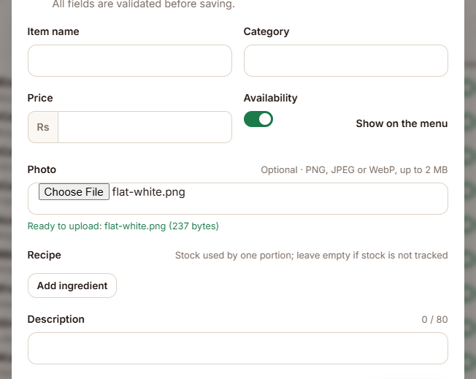
Figure 11: Permitted file: flat-white.png is accepted ("Ready to upload").
TC-20 result: Pass
Actual: Status: "Ready to upload: flat-white.png (237 bytes)"; files kept: 1
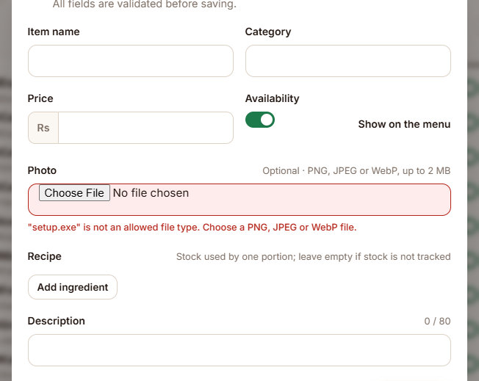
Figure 12: Unsupported file: setup.exe is refused.
TC-21 result: Pass
Actual: Message: ""setup.exe" is not an allowed file type. Choose a PNG, JPEG or WebP file."; files kept in the picker: 0
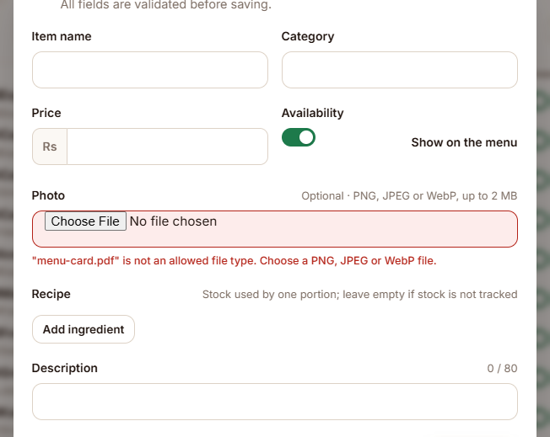
Figure 13: Unsupported file: menu-card.pdf is refused.
TC-22 result: Pass
Actual: Message: ""menu-card.pdf" is not an allowed file type. Choose a PNG, JPEG or WebP file."; files kept in the picker: 0
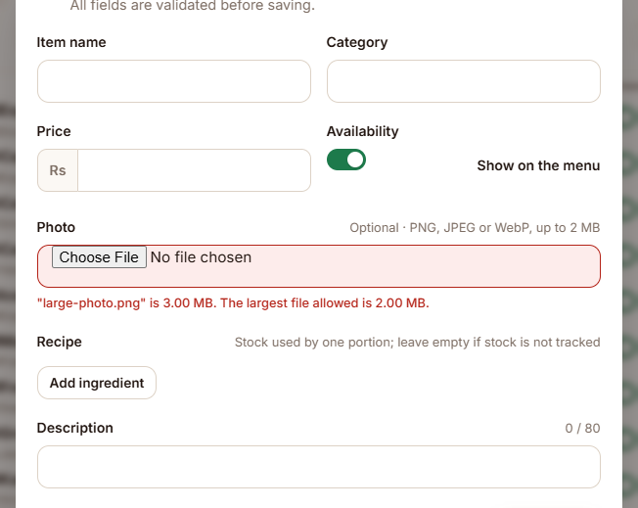
Figure 14: File over the limit: a 3 MB image is rejected by the interface.
TC-23 result: Pass
Actual: Message: ""large-photo.png" is 3.00 MB. The largest file allowed is 2.00 MB."; files kept in the picker: 0
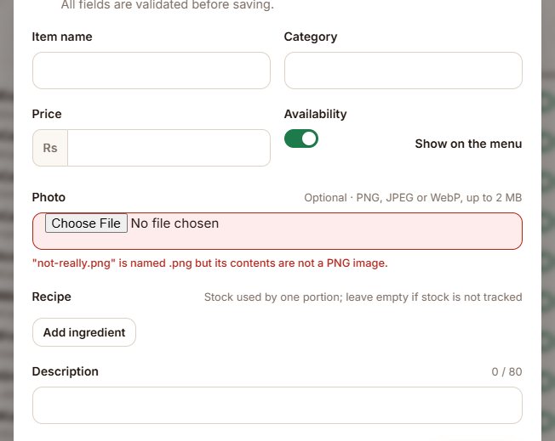
Figure 15: A PHP script renamed to .png is refused because its contents are not an image.
TC-24 result: Pass
Actual: Message: ""not-really.png" is named .png but its contents are not a PNG image."; files kept in the picker: 0
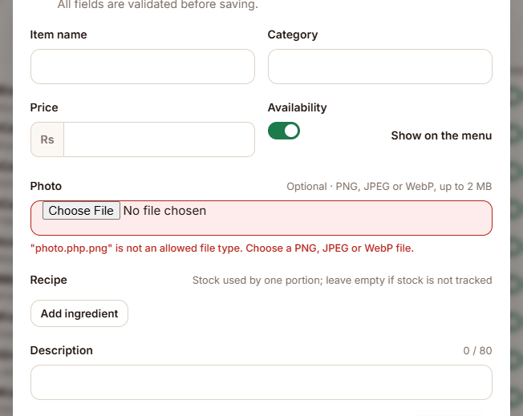
Figure 16: photo.php.png (hidden second extension) is refused.
TC-25 result: Pass
Actual: Message: ""photo.php.png" is not an allowed file type. Choose a PNG, JPEG or WebP file."; files kept in the picker: 0
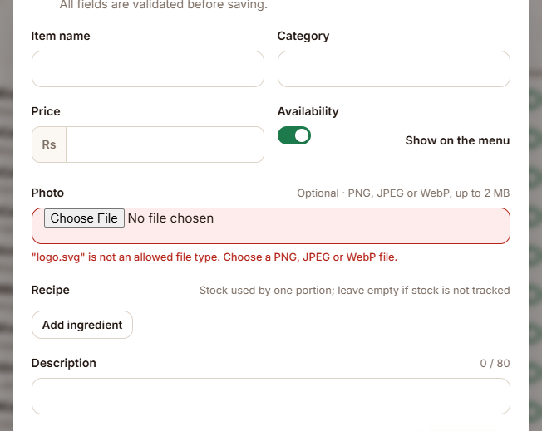
Figure 17: An SVG containing an onload script is refused.
TC-26 result: Pass
Actual: Message: ""logo.svg" is not an allowed file type. Choose a PNG, JPEG or WebP file."; files kept in the picker: 0
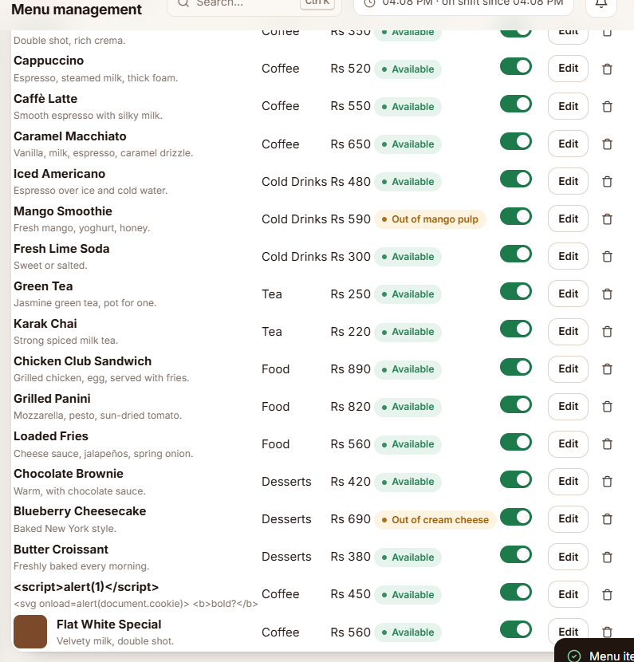
Figure 18: The permitted photo was uploaded and its thumbnail appears in the menu list.
TC-27 result: Pass
Actual: Saved; thumbnail shown in the list

5. Task 4: Sensitive information handling

5.1 What we examined
We reviewed every use of localStorage, sessionStorage, IndexedDB and document.cookie in public/js, and what remains in the browser after signing out.

5.2 Weaknesses found
- The Activity 3 version kept the whole database in localStorage (cms_db_v4): staff usernames, roles, orders and the audit log, which stayed on the device after the browser closed. It was removed in a later phase, and the app still deletes old copies.
- Session.set wrote any object given to it into sessionStorage, so a later change could have stored a token by mistake.
- Leftover keys from older versions, or added from the console, were never cleaned up.
- Sign-out removed only the display copy; in-memory data, the refresh timer, the CSRF token in memory, open dialogs and filled forms stayed until the page changed. The Back button could show a cached page.

5.3 Improvements implemented
- Passwords are never stored in localStorage or sessionStorage. They exist only in the password field until sent, and the sign-in form clears the field. The session is an HttpOnly, Secure, SameSite=Strict cookie that scripts cannot read.
- Only four display fields are stored: user, name, role and loginAt. Anything else passed to Session.set is dropped.
- Unnecessary information is removed: on every page load only cms_session and cms_flash may remain in sessionStorage, and localStorage is cleared (the app keeps nothing there).
- No secret credentials or private keys in frontend JavaScript: server keys and database passwords live only in server environment variables. A test scans every file in public/. The browser's own signing key is created non-extractable, so no script can read it.
- Logout clears the temporary interface state: Session.wipe() removes the session copy and flash message, clears the in-memory CSRF token, cleans storage, resets every form, clears password and code fields, closes dialogs and notifications, and Store.forget() stops the refresh timer and drops all in-memory data. The server also sends Clear-Site-Data: "cache", and a page restored by the Back button sends the user to sign in.
// public/js/common.js
const SESSION_FIELDS = ["user", "name", "role", "loginAt"];
const STORAGE_KEYS = ["cms_session", "cms_flash"]; // everything else is removed on every page
wipe: function () {
Session.clear(); Api.csrfToken = null; sweepStorage();
document.querySelectorAll("form").forEach(function (f) { f.reset(); });
... // clear password fields, close dialogs, Store.forget()
}

5.4 Evidence
Browser storage while signed in (TC-15)
TC-15 result: Pass
Actual: sessionStorage: {"cms_session":"{\"user\":\"activity.manager\",\"name\":\"Activity Manager\",\"role\":\"Manager\",\"loginAt\":\"2026-11-11T11:08:26.676Z\"}"}; localStorage: {}; document.cookie: ""; sensitive words found: none
Planted sensitive items are removed (TC-16)
TC-16 result: Pass
Actual: localStorage items: 0; authToken: removed; sessionStorage keys: cms_session
No secrets in frontend JavaScript (TC-17)
TC-17 result: Pass
Actual: None found in 7 scripts
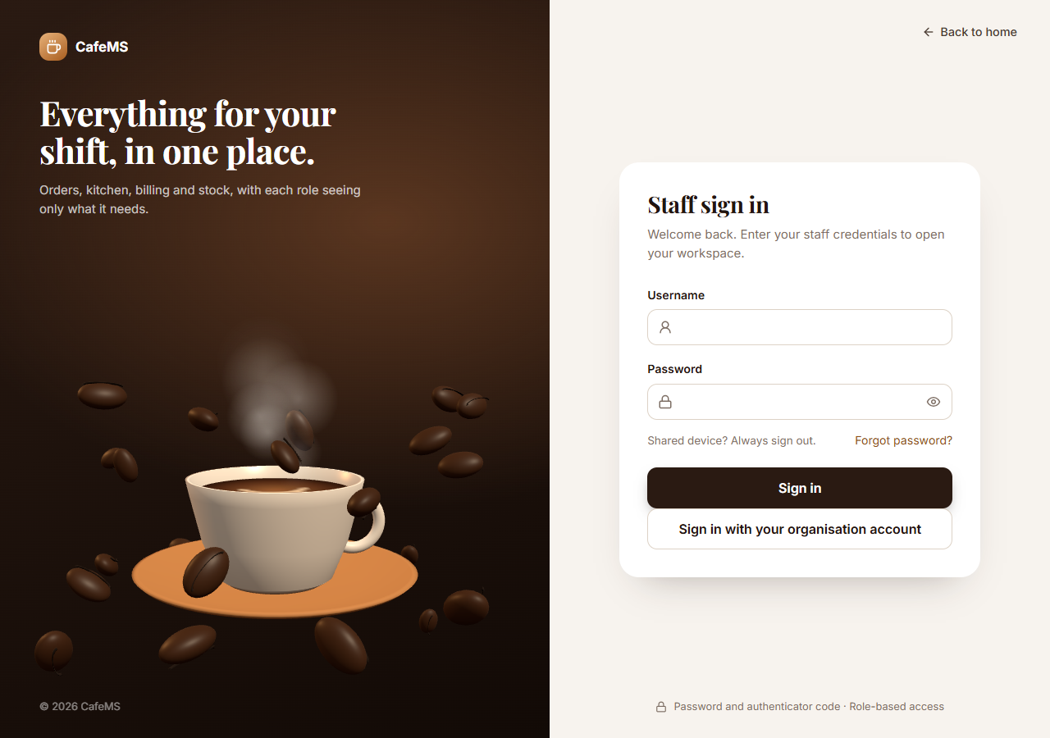
Figure 19: After signing out, opening a staff page again lands on the sign-in page.
TC-18 result: Pass
Actual: sessionStorage keys after sign-out: none; localStorage items: 0; /auth/me now returns 401; opening overview.html ended on /login.html; message: "You have been signed out."

6. Task 5: Password strength checker

6.1 Integration steps
- Downloaded password_strength_helper.js from the instructor and copied it unchanged into public/js/. A test checks its SHA-256 hash so it cannot be modified by accident.
- Selected two existing forms: Change password (account.html) and Choose a password (setup.html, used for invitations and password resets).
- Included the file in both HTML pages before the page scripts.
- Called checkPasswordStrength(password) whenever the password is typed, pasted, cut or changed.
- Displayed the returned level, score (out of 6), a six-part bar and the message directly below the password field. The box hides when the field is empty.
<!-- account.html and setup.html -->
<script src="js/password_strength_helper.js"></script>

// public/js/validate.js
const result = window.checkPasswordStrength(inputEl.value);
level.textContent = result.level;
score.textContent = " (" + result.score + " of " + result.maximumScore + ")";
message.textContent = result.message;

This is feedback only; the server still requires at least 12 characters with all four character types and refuses common passwords.

6.2 Test results
Password | Level | Score | Message
abc | Weak | 0 of 6 | Try using a longer password.
password1 | Weak | 2 of 6 | Try using a longer password.
Coffee2024 | Moderate | 3 of 6 | A longer password or more variety may improve it.
Brew-House-58-Lantern! | Strong | 6 of 6 | Good password pattern. Avoid reusing passwords.
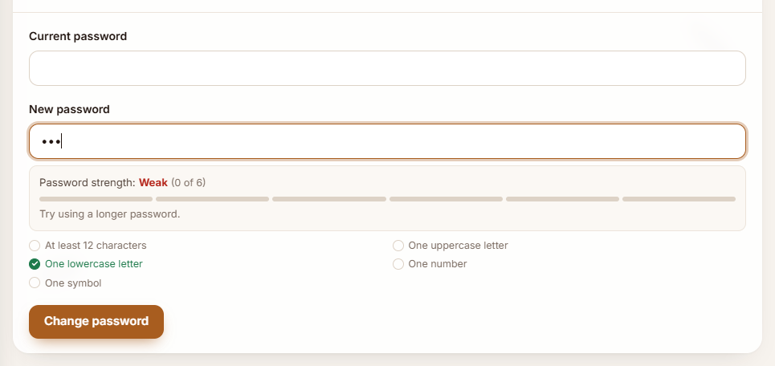
Figure 20: Weak: "abc".
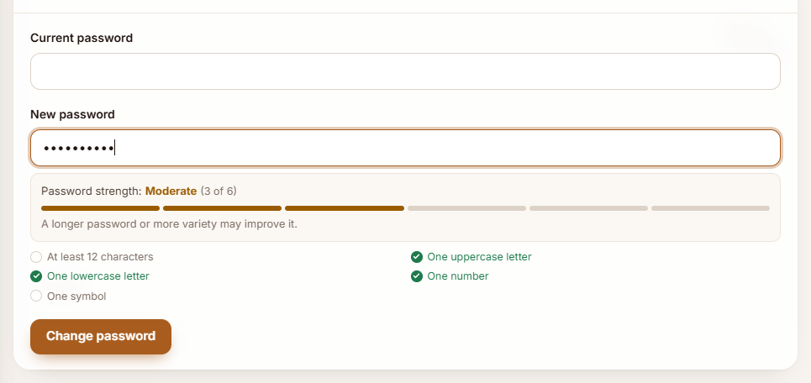
Figure 21: Moderate: "Coffee2024".
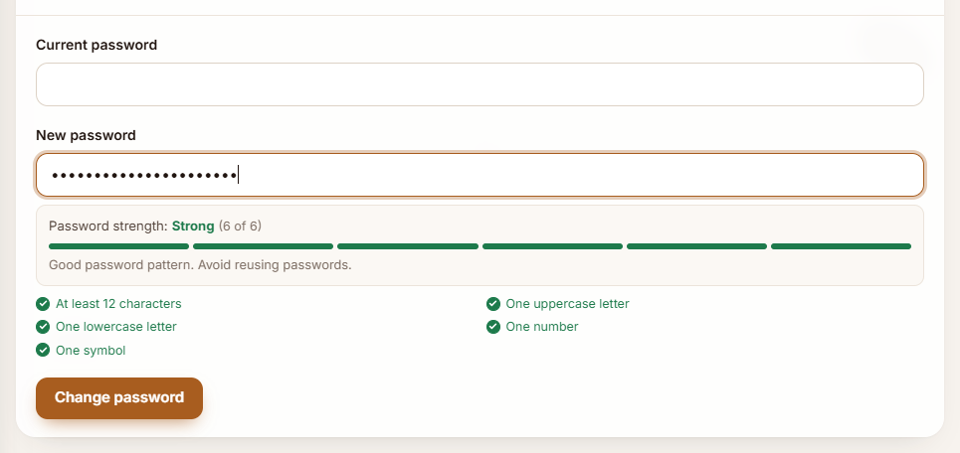
Figure 22: Strong: "Brew-House-58-Lantern!".
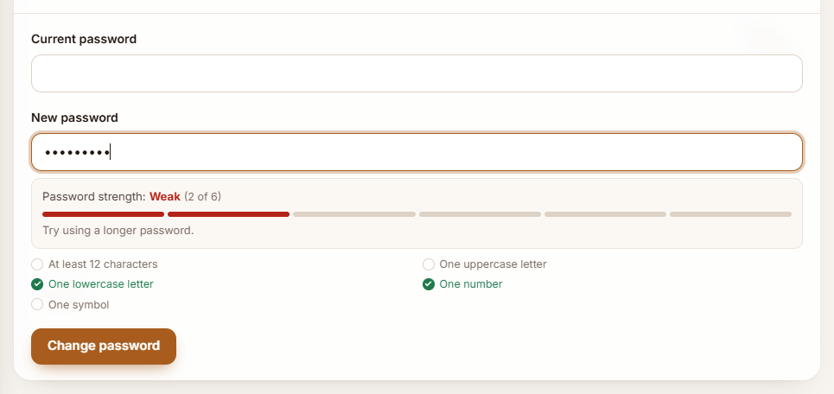
Figure 23: Weak: "password1".
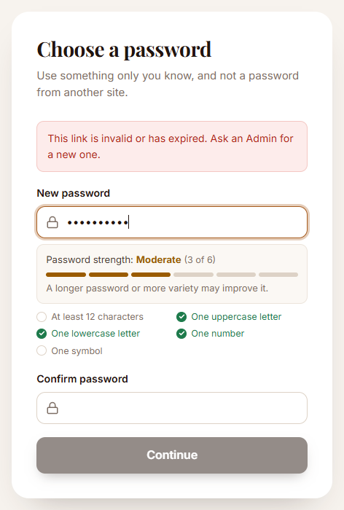
Figure 24: The same checker on the invitation / reset page (setup.html).

7. Testing and demonstration
All test cases were run in Google Chrome against CafeMS. 28 of 28 passed. They include normal input and invalid or unexpected input. The actual results were read from the page during the run (messages shown, storage contents, whether a script ran). Screenshots for each case are in the sections above.
ID | Task | Feature | Input / action | Expected result | Actual result | Result
TC-01 | T1 | Public reservation form (index.html) – mandatory fields | Name, mobile number, date and time left empty; Request my table pressed | Form is not sent; a message appears under each empty required field | 4 messages shown: rName: Your name is required. | rPhone: Mobile number is required. | rDate: Date is required. | rTime: Time is required. Requests sent to the server: 0 | Pass
TC-02 | T1 | Public reservation form – lengths, formats and ranges | Name "A", mobile "12345", a date 3 days ago, time 07:30, 25 guests, notes of 170 characters (maxlength bypassed in DevTools) | Each field shows its own message: name too short, mobile format, past date, opening hours, guest range, notes too long | 6 messages shown: rName: Your name must be at least 2 characters. | rPhone: Enter the mobile number as 03XXXXXXXXX (11 digits, starting with 03). | rDate: Date cannot be in the past. | rTime: Choose a time between 10:00 and 23:00. | rParty: Guests must be a whole number from 1 to 20. | rNotes: Notes must be 160 characters or fewer. Requests sent: 0 | Pass
TC-03 | T1 | Public reservation form – leading and trailing spaces removed | Name " Ayesha Khan ", mobile " 0321-1234567 ", valid date, time and guests | Spaces are trimmed (and doubled spaces collapsed) before sending; booking is accepted | Confirmation: "Thank you. We've received your request and will confirm your table soon.". Sent to the server: name "Ayesha Khan", mobile "03211234567", notes start "<img src=x o" | Pass
TC-04 | T1 | Staff sign-in form (login.html) – mandatory fields | Username and password left empty; Sign in pressed | Nothing is sent; "Enter your username." and "Enter your password." appear | 2 messages shown: username: Enter your username. | password: Enter your password. | Pass
TC-05 | T1 | Staff reservation form (reservation.html) – required fields and party size | Guest name, mobile and time empty, party size 0 | Four messages, one under each field; the reservation is not created | 4 messages shown: guestName: Guest name is required. | guestPhone: Mobile number is required. | reservationTime: Reservation time is required. | partySize: Party size must be a whole number from 1 to 20. | Pass
TC-06 | T1 | Staff reservation form – messages clear when fixed | Valid name, mobile "0300 7654321", date, time and party size 3 | All messages disappear and the reservation is created | 0 messages left; toast: "R-1002 created for Bilal Ahmed" | Pass
TC-07 | T2 | Reservation queue (reservations.html) – stored notes shown to staff | Guest notes submitted on the public form: <img src=x onerror="window.__xss=1;alert('XSS')"> <script>window.__xss=2;alert('XSS')</script> | The notes appear as plain text; no image or script element is created, no alert opens, window.__xss stays unset | Shown as text: "<img src=x onerror="window.__xss=1;alert('XSS')"> <script>window.__xss=2;alert('XSS')</script>" (child elements inside the paragraph: 0). window.__xss: not set; injected <img>: 0; injected <script>: 0; alerts opened: 0 | Pass
TC-08 | T2 | Unsafe DOM APIs are refused by the browser (Trusted Types) and by CMS.h | From the page: element.innerHTML = '<img src=x onerror=alert(1)>'; CMS.h('a', { href: 'javascript:alert(1)' }); CMS.h('button', { onclick: 'alert(1)' }) | innerHTML with a plain string throws; javascript: links are replaced; a string handler is ignored | innerHTML: TypeError: Failed to set the 'innerHTML' property on 'Element': This document requires 'TrustedHTML' assignment; href became "about:blank#blocked" (with a hidden tab: "about:blank#blocked"); onclick attribute: not set; alerts opened: 0 | Pass
TC-09 | T5 | Password strength checker (account.html, Change password) | "abc" typed into New password | Weak, shown below the field as the user types | Shown: Weak (0 of 6) – "Try using a longer password.". checkPasswordStrength() returned Weak, score 0 | Pass
TC-10 | T5 | Password strength checker (account.html, Change password) | "password1" typed into New password | Weak, shown below the field as the user types | Shown: Weak (2 of 6) – "Try using a longer password.". checkPasswordStrength() returned Weak, score 2 | Pass
TC-11 | T5 | Password strength checker (account.html, Change password) | "Coffee2024" typed into New password | Moderate, shown below the field as the user types | Shown: Moderate (3 of 6) – "A longer password or more variety may improve it.". checkPasswordStrength() returned Moderate, score 3 | Pass
TC-12 | T5 | Password strength checker (account.html, Change password) | "Brew-House-58-Lantern!" typed into New password | Strong, shown below the field as the user types | Shown: Strong (6 of 6) – "Good password pattern. Avoid reusing passwords.". checkPasswordStrength() returned Strong, score 6 | Pass
TC-13 | T5 | Password strength checker – cleared field | New password emptied | The strength box is hidden again | Hidden | Pass
TC-14 | T1 | Change password form (account.html) – required and minimum length | Current password empty, new password "short" | Two messages; the request is not sent | 2 messages: currentPassword: Current password is required. | newPassword: New password must be at least 12 characters. | Pass
TC-15 | T4 | Browser storage while signed in | Developer tools → Application: sessionStorage, localStorage and document.cookie read after signing in and using the app | No password, token, code or customer number; localStorage empty; the session cookie is invisible to scripts (HttpOnly) | sessionStorage: {"cms_session":"{\"user\":\"activity.manager\",\"name\":\"Activity Manager\",\"role\":\"Manager\",\"loginAt\":\"2026-11-11T11:08:26.676Z\"}"}; localStorage: {}; document.cookie: ""; sensitive words found: none | Pass
TC-16 | T4 | Unneeded items in browser storage are removed | localStorage.password and sessionStorage.authToken planted from the console, then the next page opened | Both are removed on page load; only cms_session (name, username, role, sign-in time) remains | localStorage items: 0; authToken: removed; sessionStorage keys: cms_session | Pass
TC-17 | T4 | No secret keys or credentials in frontend JavaScript | 7 scripts loaded by the Manager overview page scanned for private keys, API keys, server secrets and database passwords | None found | None found in 7 scripts | Pass
TC-18 | T4 | Sign out clears the temporary state | Sign out pressed and confirmed, then the overview page opened again | cms_session removed, nothing in localStorage, the server session ends (401), and the protected page sends the user back to sign in | sessionStorage keys after sign-out: none; localStorage items: 0; /auth/me now returns 401; opening overview.html ended on /login.html; message: "You have been signed out." | Pass
TC-19 | T2 | Public menu (index.html) – item name and description entered by staff | Item name <script>alert(1)</script>; description <svg onload=alert(document.cookie)> <b>bold?</b> | Both are displayed literally as text on the public menu; nothing executes | Title shown: "<script>alert(1)</script>"; description shown: "<svg onload=alert(document.cookie)> <b>bold?</b>"; <script>: 0, <svg>: 0, <b>: 0; alerts opened: 0 | Pass
TC-20 | T3 | Menu item photo (menu.html) | flat-white.png (64×64 PNG, 237 bytes) | Accepted: "Ready to upload" with the name and size | Status: "Ready to upload: flat-white.png (237 bytes)"; files kept: 1 | Pass
TC-21 | T3 | Menu item photo (menu.html) | setup.exe (a program) | Refused: not an allowed file type; the selection is cleared | Message: ""setup.exe" is not an allowed file type. Choose a PNG, JPEG or WebP file."; files kept in the picker: 0 | Pass
TC-22 | T3 | Menu item photo (menu.html) | menu-card.pdf (a document) | Refused: not an allowed file type | Message: ""menu-card.pdf" is not an allowed file type. Choose a PNG, JPEG or WebP file."; files kept in the picker: 0 | Pass
TC-23 | T3 | Menu item photo (menu.html) | large-photo.png (3 MB) | Refused: larger than the 2 MB limit | Message: ""large-photo.png" is 3.00 MB. The largest file allowed is 2.00 MB."; files kept in the picker: 0 | Pass
TC-24 | T3 | Menu item photo (menu.html) | not-really.png (a PHP script renamed to .png) | Refused: contents are not a PNG image | Message: ""not-really.png" is named .png but its contents are not a PNG image."; files kept in the picker: 0 | Pass
TC-25 | T3 | Menu item photo (menu.html) | photo.php.png (hidden second extension) | Refused: not an allowed file type | Message: ""photo.php.png" is not an allowed file type. Choose a PNG, JPEG or WebP file."; files kept in the picker: 0 | Pass
TC-26 | T3 | Menu item photo (menu.html) | logo.svg (an SVG with an onload script) | Refused: SVG is not allowed | Message: ""logo.svg" is not an allowed file type. Choose a PNG, JPEG or WebP file."; files kept in the picker: 0 | Pass
TC-27 | T3 | Menu item photo – permitted file is uploaded | flat-white.png selected and the item saved | Item is saved and its photo thumbnail appears in the menu list | Saved; thumbnail shown in the list | Pass
TC-28 | T5 | Password strength checker on the invitation / reset page (setup.html) | "Coffee2024" typed into New password | Moderate shown below the field | Shown: Moderate | Pass

8. Important security considerations
These are frontend controls. They give users quick feedback and add a layer of protection, but anyone can switch them off in their own browser, so they cannot replace server-side security. In CafeMS the server enforces each one independently:
Frontend control | Server-side enforcement
Input validation | Strict zod schemas refuse unknown fields, wrong types, lengths and formats (server/lib/schemas.js)
Hidden buttons and pages | Every request is authorised from the role in the signed session, never from what the page shows
File selection checks | 2 MB body limit, type check, and the image decoded and rebuilt by sharp; served with nosniff
Password strength feedback | 12–128 characters, four character types, common passwords refused, Argon2id hashes
Browser storage | Never trusted; the session lives in an HttpOnly cookie checked by the server on every request

9. Final completion checklist
Task | Item | Done
Task 1 | Selected at least two existing forms (10 forms) | ✓
Task 1 | Implemented mandatory field validation | ✓
Task 1 | Implemented minimum and maximum character limits | ✓
Task 1 | Removed leading and trailing spaces; validated formats | ✓
Task 1 | Added appropriate validation messages | ✓
Task 2 | Identified components displaying user-provided information | ✓
Task 2 | Identified unsafe rendering techniques (innerHTML in earlier versions; CMS.h gaps) | ✓
Task 2 | Implemented safer rendering | ✓
Task 2 | Tested with malicious input; no JavaScript executed | ✓
Task 3 | Implemented file extension restrictions | ✓
Task 3 | Implemented file size restrictions (2 MB) | ✓
Task 3 | Tested permitted and unsupported files | ✓
Task 4 | Checked browser storage for sensitive information | ✓
Task 4 | Ensured passwords are not stored in browser storage | ✓
Task 4 | Removed unnecessary sensitive information | ✓
Task 4 | Verified logout clears temporary frontend state | ✓
Task 5 | Downloaded and included the provided JavaScript file (unchanged) | ✓
Task 5 | Successfully called checkPasswordStrength() | ✓
Task 5 | Displayed password strength feedback | ✓
Task 5 | Tested Weak, Moderate and Strong examples | ✓
Testing | Completed at least three security test cases (28 cases) | ✓
Testing | Captured screenshots of implemented improvements | ✓
Testing | Updated the existing semester project source code | ✓
Testing | Prepared a brief explanation of weaknesses and solutions | ✓

10. Submission contents
- Updated source code: the complete CafeMS project (zip made with git archive, without secret files or node_modules).
- Implementation evidence: this document, and docs/activity-5/screenshots/ (24 screenshots).
- Testing evidence: section 7 of this document and docs/activity-5/test-results.json.
- Brief explanation: sections 2–6 of this document and docs/activity-5/ACTIVITY-5-REPORT.md.
To repeat the tests: node scripts/activity5-evidence.js (all 28 cases in Chrome) and node --test tests/activity5.test.js (9 automated checks).

