**Campus Connect Navigation and Event Planner**



**Session:** 2023-2027

**Submitted by:**

Usman Ali Ashraf

2023-CS-106

**Submitted To:**

Mr. Ali Raza

**Department of Computer Science**

**University of Engineering and Technology, Lahore**

Contents

**Campus Connect Navigation & Event Planner System** 3

**1.** **Introduction** 3

**2. Project Objectives** 3

**3. System Features** 3

**3.1 Campus Navigator** 3

**3.2 Event Manager** 4

**3.3 Task Scheduler** 4

**3.4 Event Search Tree** 5

**4. Data Structures and Their Uses** 6

**4.1 Graph** 6

**4.2 Doubly Linked List** 6

**4.3 Queue** 6

**4.4 Binary Search Tree (BST)** 6

**5. Technical Details** 7

**6. Installation & Usage** 7

**7. Future Enhancements** 7

**8. Conclusion** 7

**Campus Connect Navigation & Event Planner System**

**1. Introduction**  
The **Campus Connect Navigation & Event Planner System** is a comprehensive, GUI-based application designed specifically for UET students. It integrates multiple data structures and algorithms into a single platform, allowing users to navigate the campus, manage events, schedule tasks, and search events efficiently.

The application focuses on practicality and user-friendliness while demonstrating real-world implementations of **Graph Algorithms, Linked Lists, Stacks, Queues, and Binary Search Trees (BSTs)**. All modules are integrated into a clean graphical interface built using **Streamlit**, enabling easy accessibility from any device.

**2. Project Objectives**

The main objectives of this project are:

1. To help students easily navigate campus buildings and pathways.
2. To provide an efficient event management and scheduling platform.
3. To allow quick and organized task handling.
4. To offer a fast and categorized event search mechanism.
5. To showcase real-life applications of Data Structures and Algorithms in a practical system.

**3. System Features**

**3.1 Campus Navigator**

* Models the campus as a **graph** with nodes representing buildings and edges representing pathways.
* **BFS (Breadth-First Search)** to find all reachable locations from a given point.
* **DFS (Depth-First Search)** to explore connectivity and relationships between campus areas.
* **Dijkstra’s Algorithm** to find the shortest path between two buildings based on actual distances.
* Interactive map functionality for visualizing routes and distances.

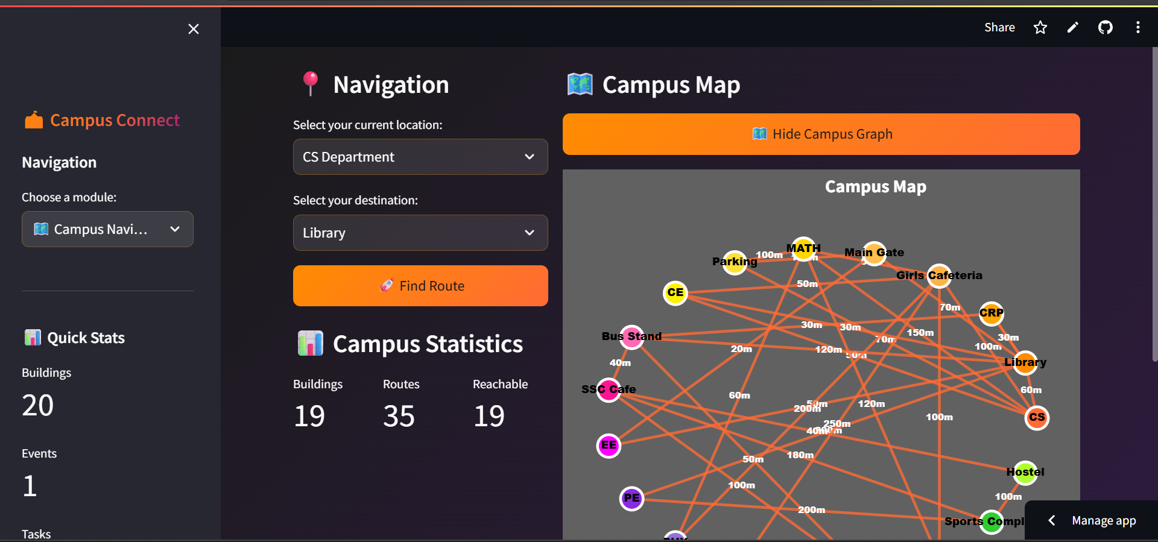Figure 1: Campus Navigator and Campus Graph

**3.2 Event Manager**

* Stores events in a **doubly linked list** for efficient addition and removal.
* Includes a **stack-based undo/redo** feature, allowing reversal of recent actions.
* Supports adding, editing, deleting, and searching for events.
* Allows categorization (e.g., Academic, Sports, Cultural) and setting priorities (High, Medium, Low).
* Automatically saves all event data to JSON files for persistence.

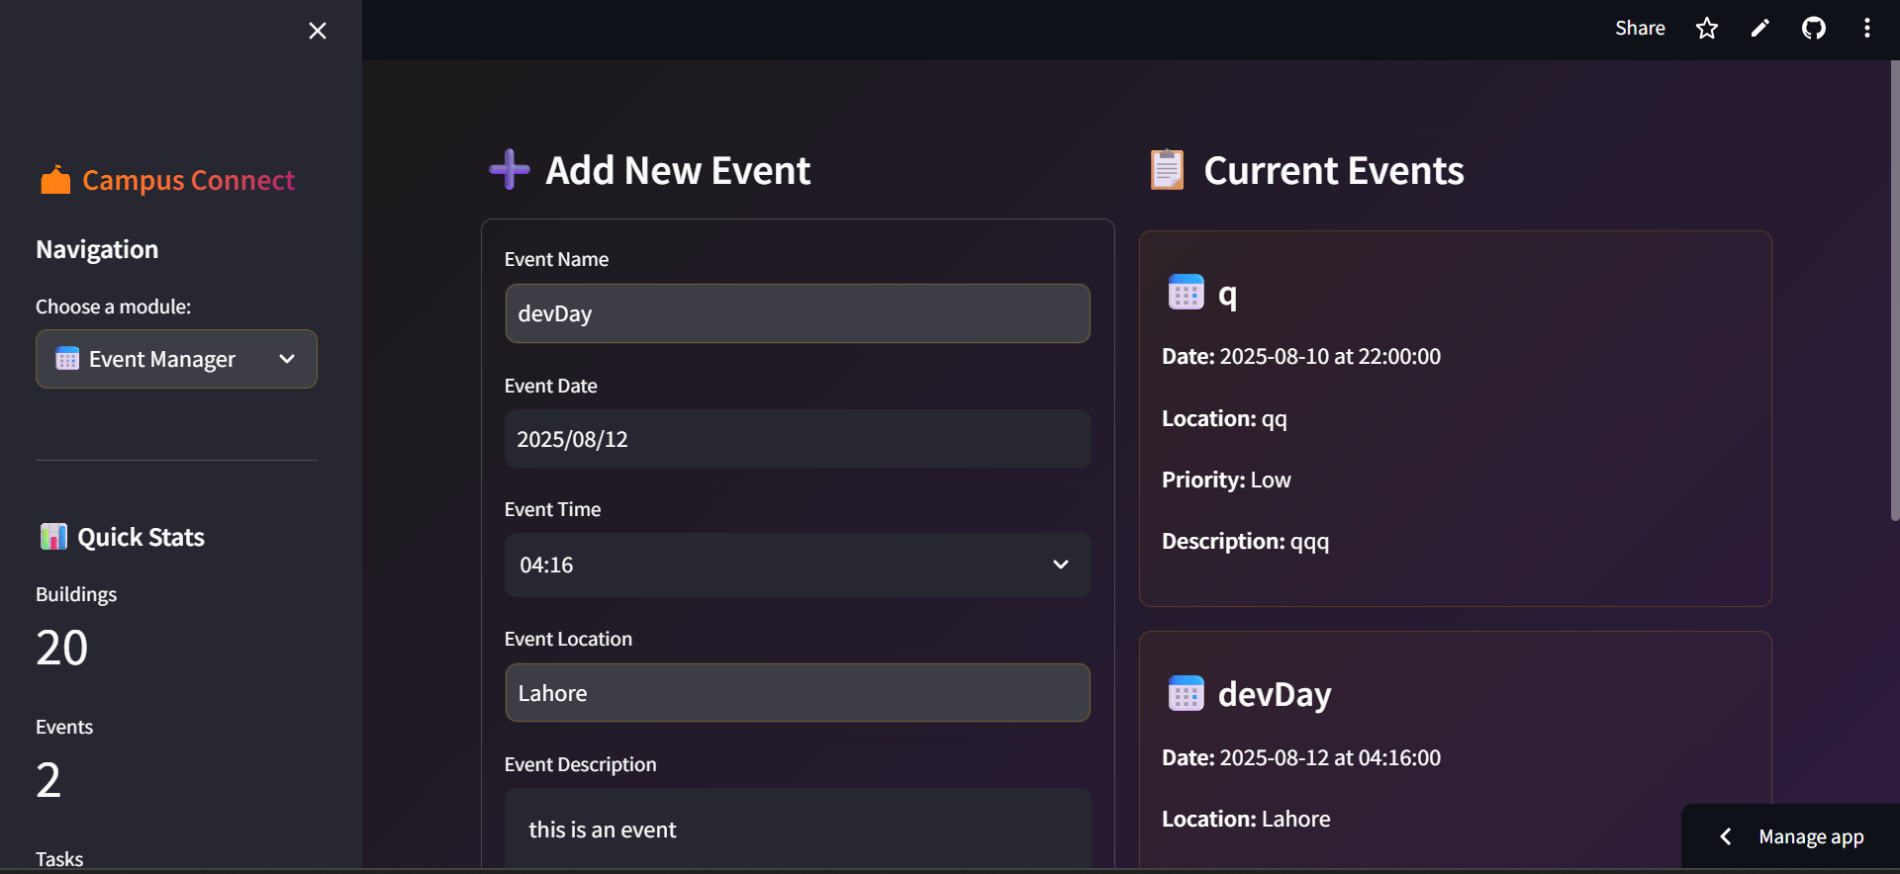Figure 2: Event Manager

**3.3 Task Scheduler**

* Uses a **queue** to manage tasks in **FIFO (First-In-First-Out)** order.
* Assigns priority levels to tasks while maintaining the order of addition.
* Tracks pending and completed tasks.
* Displays statistics and deadlines.

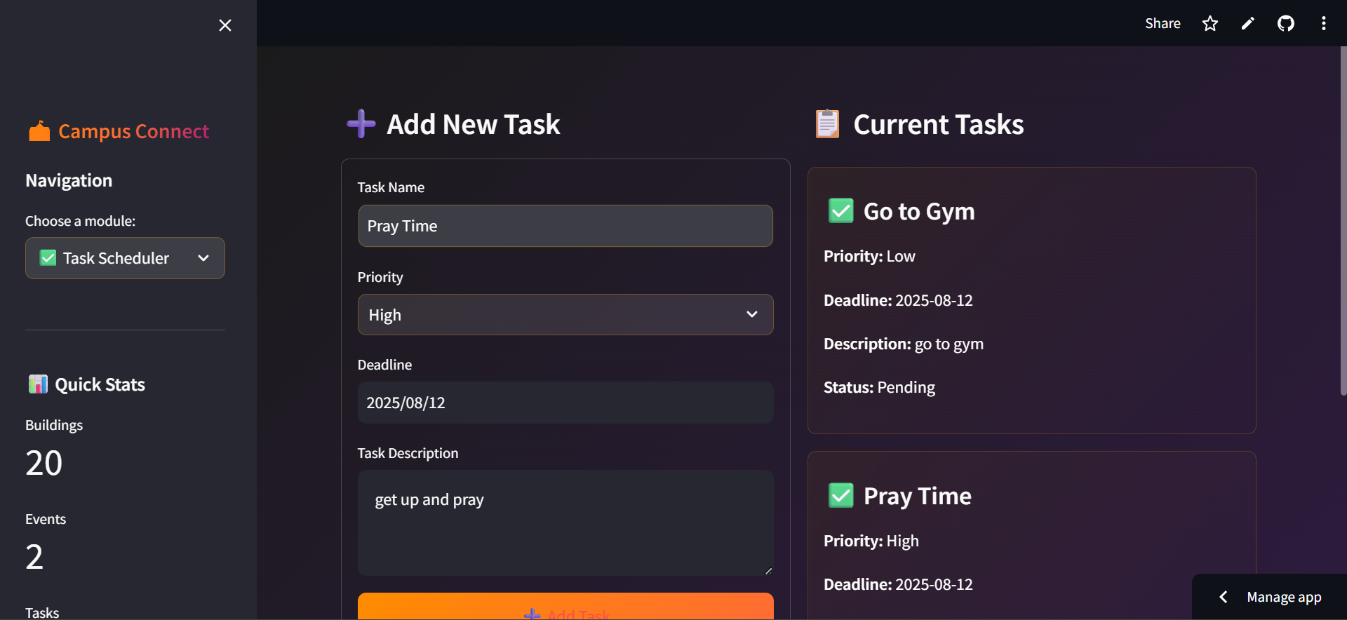Figure 3: Task Scheduler

**3.4 Event Search Tree**

* Uses a **binary search tree** for storing and retrieving events efficiently.
* Supports searching by event title, date, category, location, or priority.
* Provides sorted output using **inorder traversal**.
* Displays upcoming events based on the current date.

Figure 4: Event Search Tree

**4. Data Structures and Their Uses**

**4.1 Graph**

* **Used In:** Campus Navigator.
* **Purpose:** Represent campus buildings (nodes) and walkways (edges).
* **Algorithms Implemented:**
  + **BFS:** To find reachable locations.
  + **DFS:** To explore campus connectivity.
  + **Dijkstra’s:** To calculate shortest distances between two buildings.
* **Reason:** Graphs are ideal for representing interconnected structures like campus layouts.

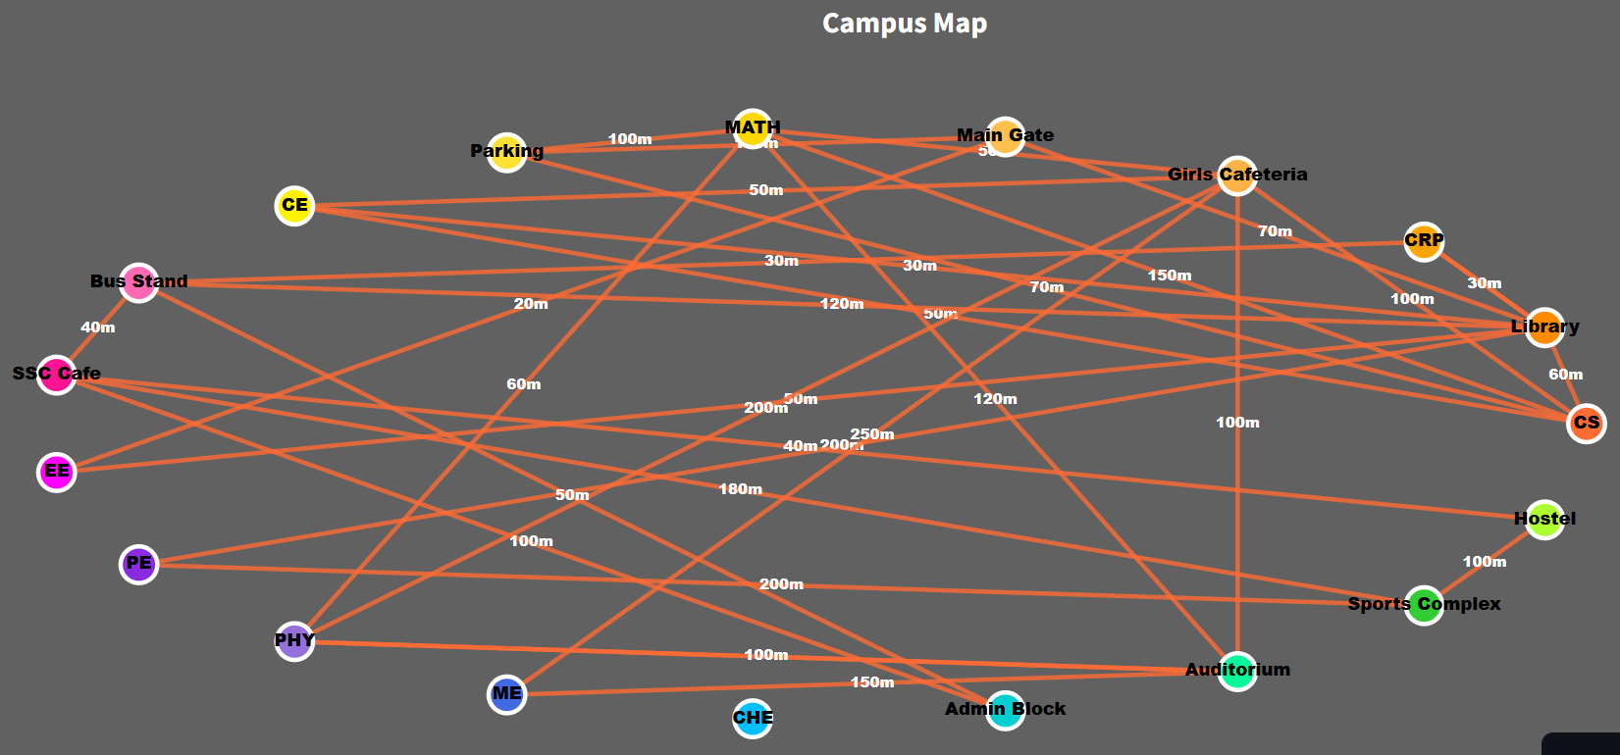Figure 5: Campus Graph with nodes and Edges

**4.2 Doubly Linked List**

* **Used In:** Event Manager.
* **Purpose:** Store and manage events in sequence.
* **Benefit:** Allows quick addition/removal from both ends and easy traversal in both directions.
* **Reason:** Event management often requires moving forward/backward through a list.

**4.3 Queue**

* **Used In:** Task Scheduler.
* **Purpose:** Handle tasks in **FIFO** order to ensure fairness.
* **Reason:** Tasks are processed in the order they were added.

**4.4 Binary Search Tree (BST)**

* **Used In:** Event Search Tree.
* **Purpose:** Store events for quick search and sorting.
* **Reason:** BST allows **O(log n)** average-case search and retrieval.

**5. Technical Details**

* **Language:** Python 3.7+
* **GUI Framework:** Streamlit
* **Data Storage:** JSON files
* **Modules:**
  + navigator.py – Graph-based campus navigation
  + events_manager.py – Event handling with linked lists & stacks
  + task_scheduler.py – Task management with queues
  + event_search_tree.py – Event search using BST
* **Time Complexities:**
  + BFS/DFS: **O(V + E)**
  + Dijkstra’s: **O((V + E) log V)**
  + Linked List insert/delete: **O(1)** at ends
  + Stack/Queue operations: **O(1)**
  + BST search/insert/delete: **O(log n)** averages

**6. Installation & Usage**

1. Install Python 3.7 or higher.
2. Clone the repository.
3. Navigate to GUI/ and install dependencies:
4. pip install -r requirements.txt
5. Run the application:
6. python run_app.py
7. Access the GUI via your default web browser.

**7. Future Enhancements**

* Mobile application support.
* Real-time notifications for upcoming events.
* Calendar view integration.
* User authentication and profiles.
* Cloud-based data backup and sync.

**8. Conclusion**

The **Campus Connect Navigation & Event Planner System** is a practical application that not only solves common campus-related challenges but also demonstrates the real-world usage of fundamental **Data Structures and Algorithms**. Its modular design ensures that features can be expanded or optimized in the future while keeping the system user-friendly and efficient.