Differential Equations Project

Semester Project Report

Course: MT-1006 Differential Equations

Section: CS(B)

Made By: 22i-1177 Usman Haroon

**Table of Contents:**

* Deliverable 1: Objective and Introduction
* Deliverable 2: Analytical Solution
* Deliverable 3: MATLAB CODE
* Deliverable 4: MATLAB SOLUTION and Results
* Deliverable 5: Flowchart
* Deliverable 6: Conclusion

**Deliverable 1: Objective and Introduction**

A partial differential equation known as the Kadomtsev-Petviashvili (KP) equation can be used to describe specific wave types in two dimensions. It is well-known for explaining the behaviour of ion-acoustic waves in plasmas and was first proposed in the context of plasma physics. The KP equation is expanded upon by the modified Kadomtsev-Petviashvili (mKP) equation. In this project, we have used Second- Order ODE of modified Kadomtsev-Petviashvili (mKP) equation as a System of First-Order Differential Equation and plucked in the value provided in MATLAB Program which would simulate behavior of equation on user-transcribed value.

Firstly, mKP equation was provided to us and to solve this equation we defined some new variables such as (l) and (m) which define direction of cosine along z and z axis respectively also (U) defines speed of wave. Secondly, we used these variables in solution. Lastly, a MATLAB program was designed to ask user for above mentioned and simulate us the behavior of mKP equation.

**Deliverable 2: Analytical Solution**

The problem was solved firstly by defining new variables in the solution. Which were used to defined speed and angles etc. Which were substituted in equation to achieve solution of mKP equation. Following that integration and derivation was performed on equation to achieve result.

Hand Solution is attached below.

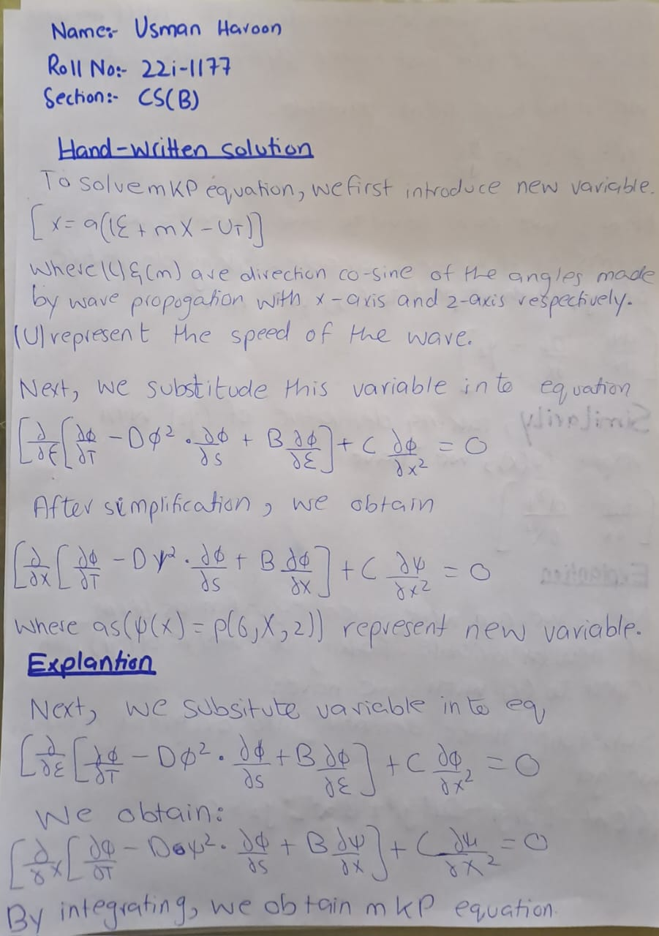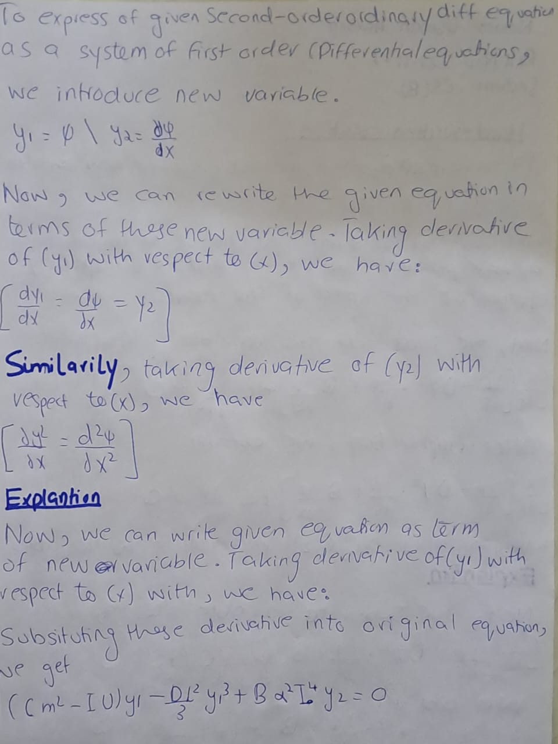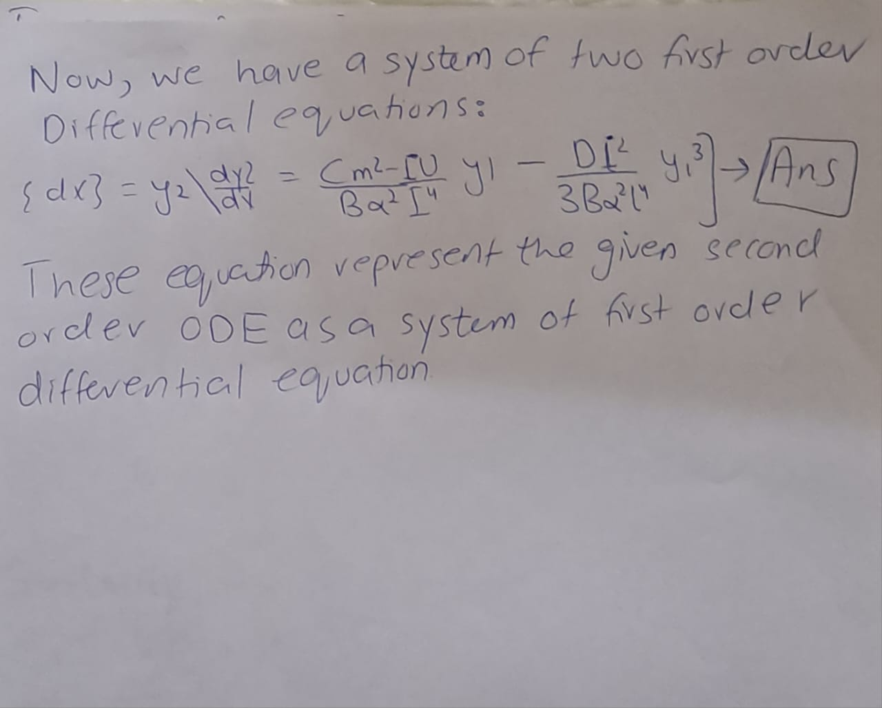

At end, Final Equation was obtained of mKP First Order Differential System. Which was successfully able to determine Behaviour of mKP equation on user provided values of cosine and speed on wave.

**Assumption:** In the solution, Conversation law of mass, energy and momentum were utilized, and this equation was studied on a finite domain.

**Deliverable 3: MATLAB CODE**

Quantitative Analysis of part(i) snapshots

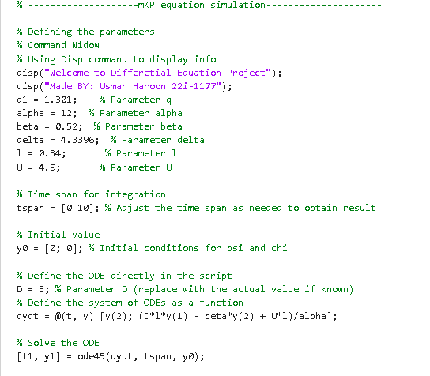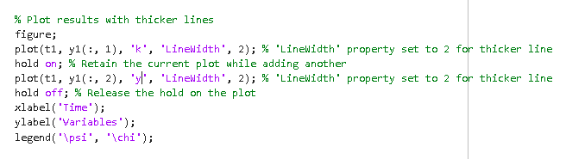

Quantitative Analysis of part(ii) snapshots

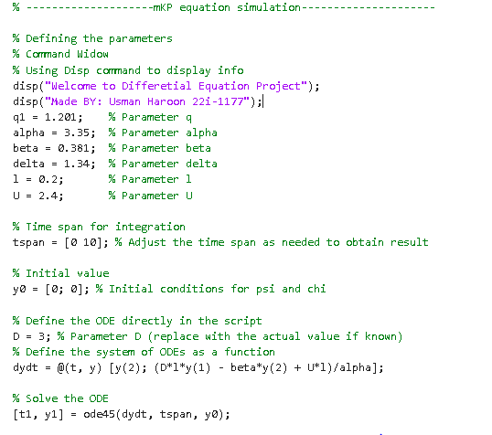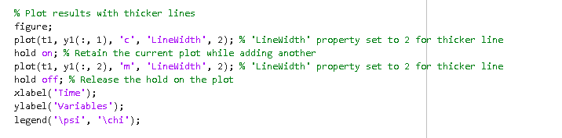

**Deliverable 4: MATLAB Solution and Result**

The following below are the snapshot of animation of mKP equation in MATLAB. The following are snapshots of mKP equation taken in Radom interval.

Part(i) Solution

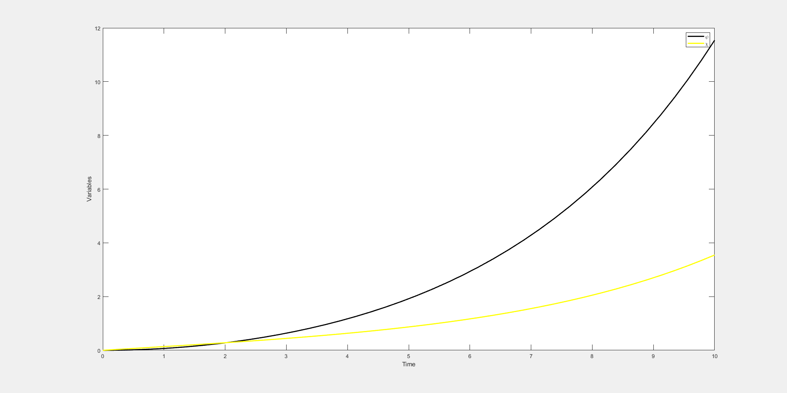

Part(ii) Solution

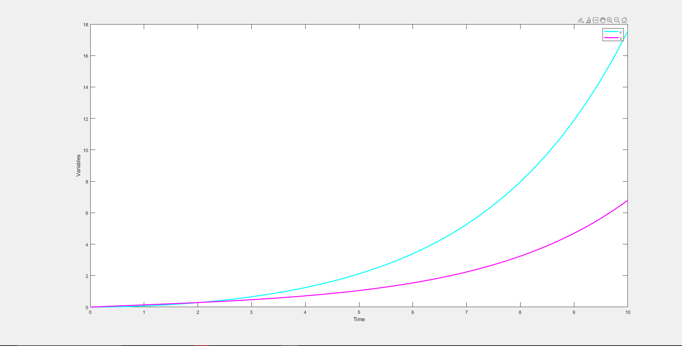

**Deliverable 5: Flowchart**

A flowchart for the solution methodology can be seen below, which extensively explains the approach and process for tackling the problem and finding its result:

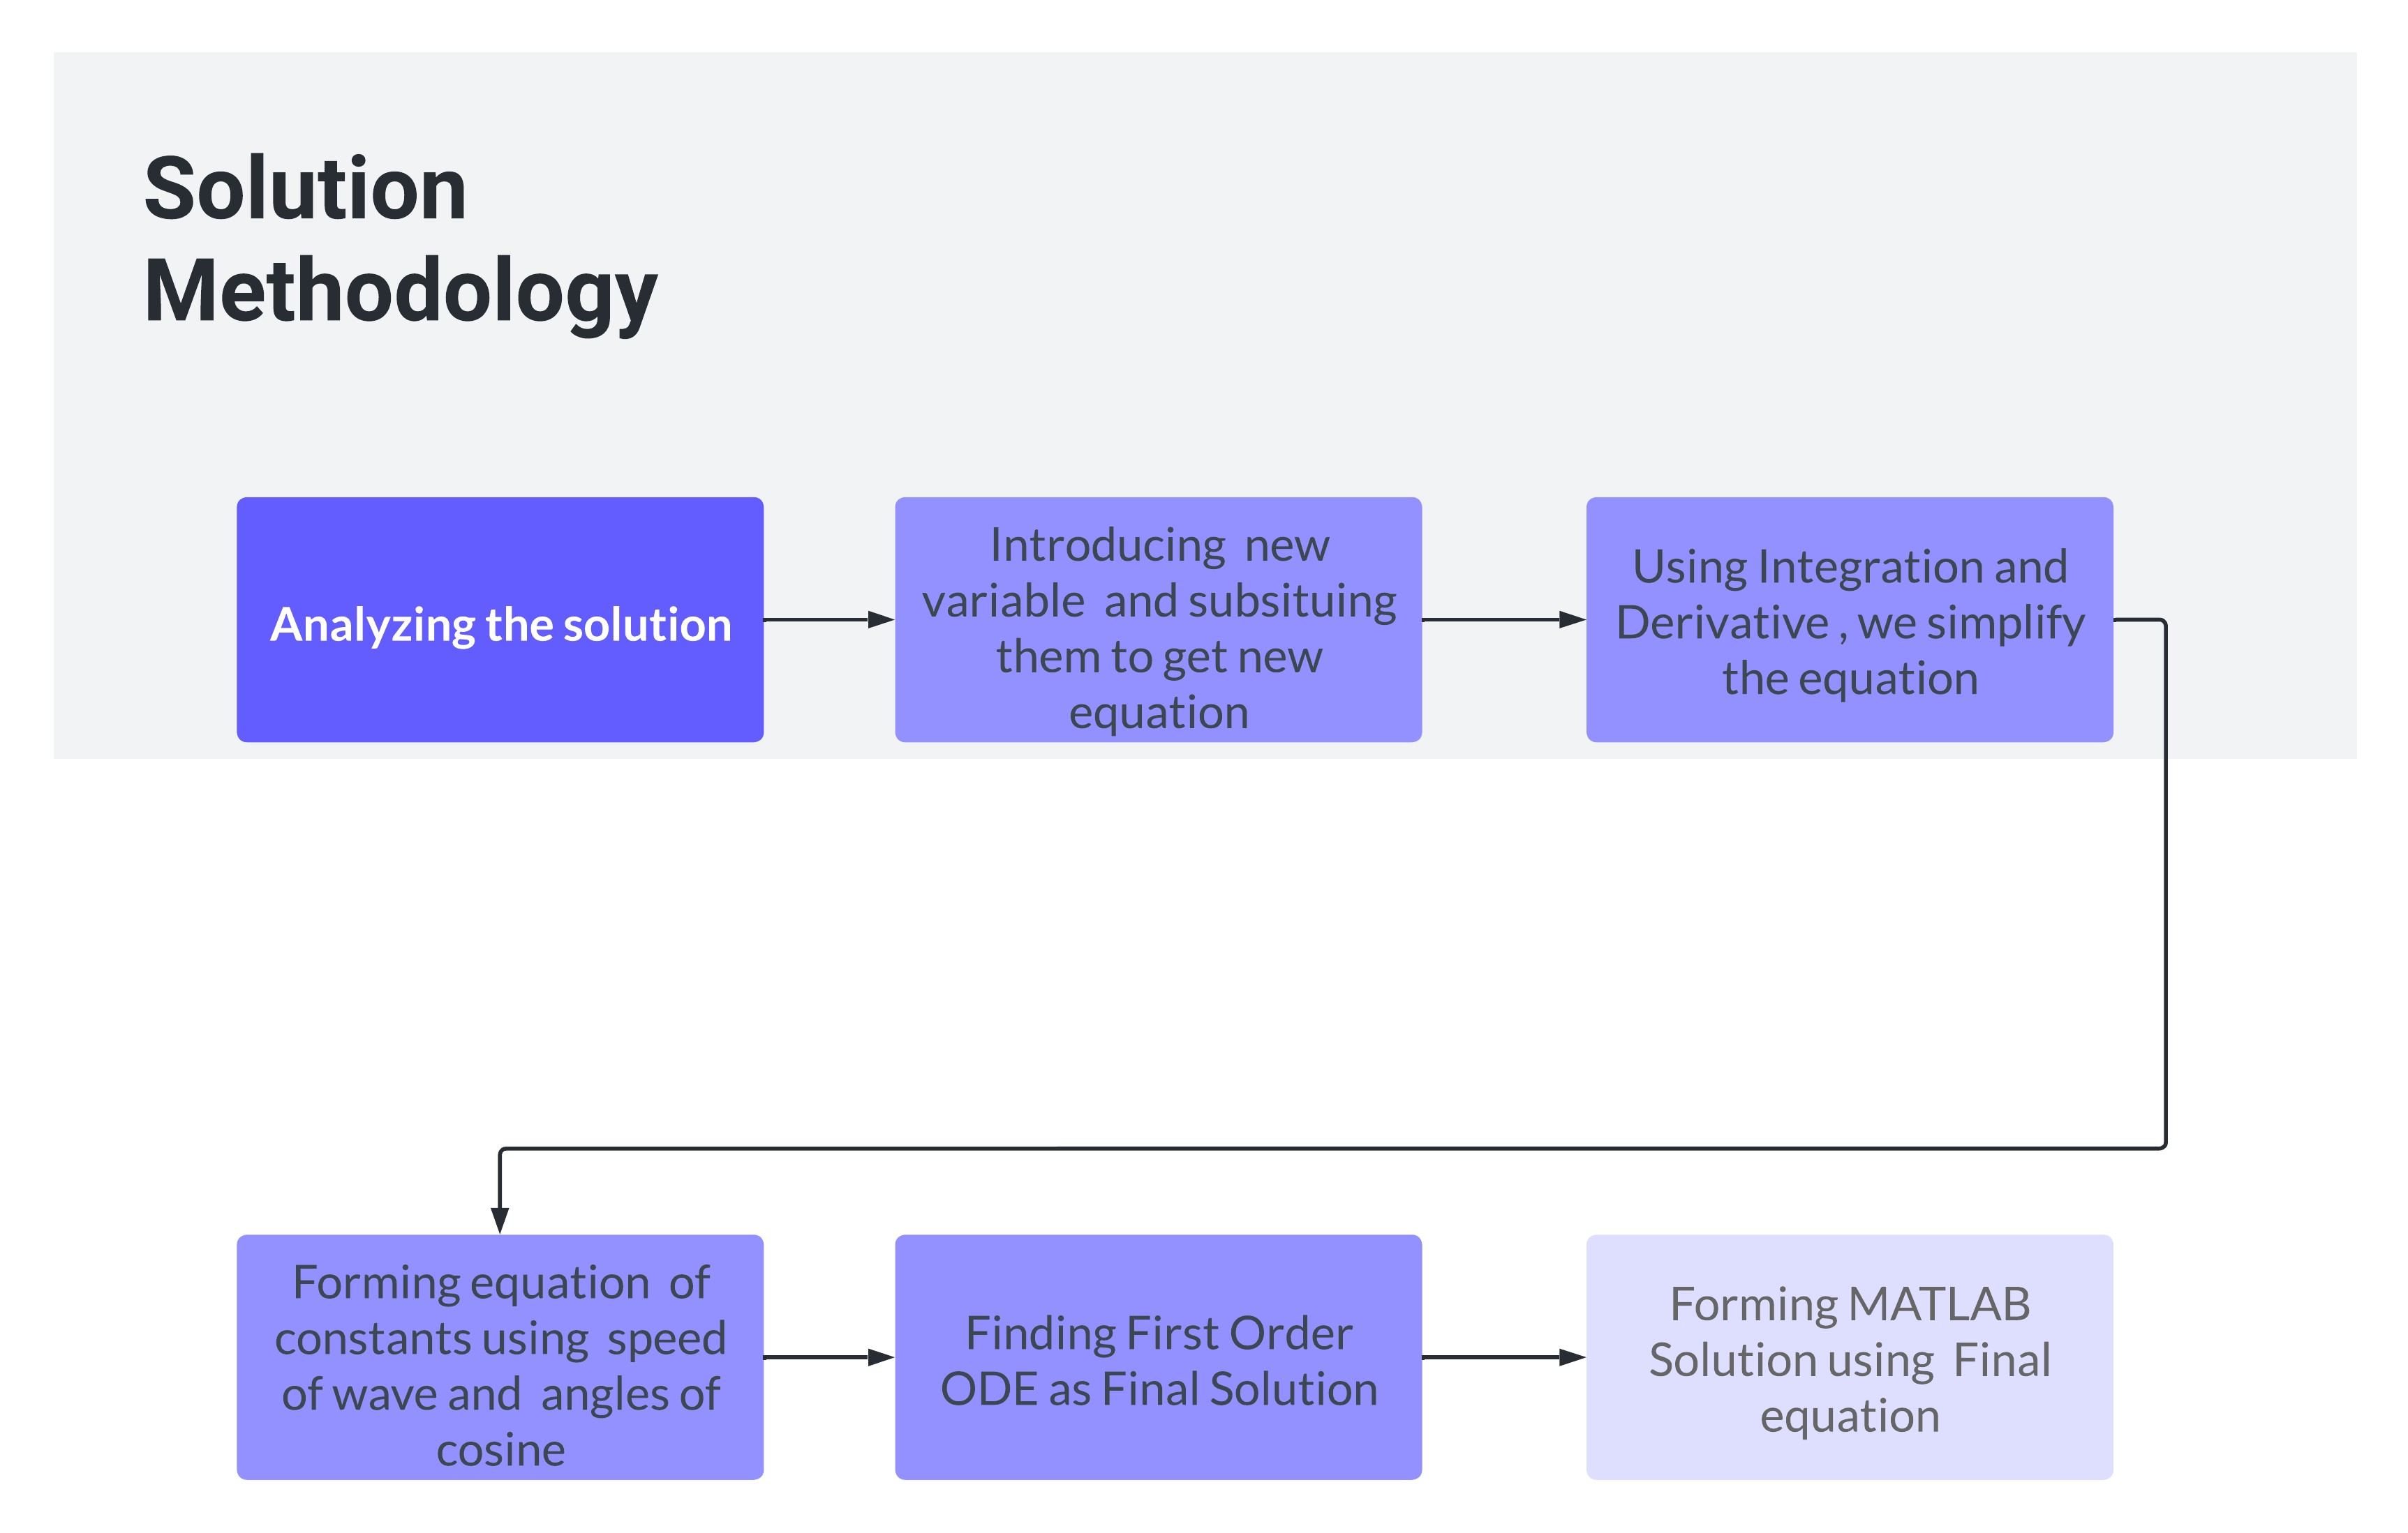

**Deliverable 6: Conclusion**

The Project requirement was to simulate the behaviour of mKP equation for the user provided inputs. Using the provided input, a First Order ODE was formulated using multiple laws and techniques. By using this ODE, a MATLAB program was created which would take input from user.

Finally Handwritten solution and MATLAB program were compared for verification. The results were also accurate for all other values. Overall, the project showed the importance of ODE in common problems around us and how they are used in real life applications of fluid Dynamics, Plasma Physics and Geo physics etc. As They can be used to solve major problems.