Design and Analysis of Algorithms

Project Report

Performance Analysis of Binary Heap, Fibonacci Heap, and Hollow Heap in Dijkstra’s Algorithm

1. Theoretical Overview of Heaps

1.1 Binary Heap
A Binary Heap is a complete binary tree stored in an array. It follows the heap property:
- Every parent node has a value less than or equal to its children (min-heap)
Array index relations:
- Parent(i) = (i - 1) / 2
- Left child(i) = 2i + 1
- Right child(i) = 2i + 2

Complexity:
- Insert: O(log n)
- Extract Minimum: O(log n)
- Decrease Key: O(log n)
- Find Minimum: O(1)
Binary heaps are simple and cache-friendly due to contiguous memory layout, making them efficient in practice.

1.2 Fibonacci Heap
A Fibonacci Heap is a collection of heap-ordered trees stored in a root list.
Key ideas:
- Multiple trees are maintained in a root list
- Trees are merged lazily
- Decrease-key uses cascading cuts

Amortized Complexity:
- Insert: O(1)
- Find Minimum: O(1)
- Extract Minimum: O(log n)
- Decrease Key: O(1)
Although theoretically efficient, pointer-heavy operations and structural complexity increase real-world overhead.

1.3 Hollow Heap
A Hollow Heap is a simplified alternative to Fibonacci heaps.
Key ideas:
- Instead of updating nodes, a new node is inserted during decrease-key
- Old node is marked as hollow and ignored later
- Cleanup happens during extract-min

Amortized Complexity:
- Insert: O(1)
- Extract Minimum: O(log n)
- Decrease Key: O(1)
Hollow heaps reduce structural complexity while maintaining good theoretical bounds.

2. Implementation Details

2.1 Programming Language
Implemented in C++, using only standard libraries to ensure portability and simplicity.

2.2 System Design
The system uses a template-based Dijkstra implementation, allowing different heap structures to be plugged in without modifying algorithm logic.
Common heap interface:
- insert(key, nodeId)
- extractMin()
- decreaseKey(nodeId, newKey)
- size()
- empty()
- contains(nodeId)

2.3 Data Structures Used
- Binary Heap: Vector + hash map (position tracking)
- Fibonacci Heap: Pointer-based circular linked trees
- Hollow Heap: Node-based structure with lazy deletion

2.4 Engineering Trade-offs

Binary Heap
- Fast in practice due to array storage
- Low memory usage
- Simple implementation

Fibonacci Heap
- Excellent theoretical decrease-key performance
- High pointer overhead
- Cache inefficient in real systems

Hollow Heap
- Simplified structure compared to Fibonacci heap
- Uses lazy deletion instead of cascading cuts
- Still pointer-heavy compared to binary heap

2.5 Lazy Deletion Mechanism (Important)
The implementation uses a lazy strategy in Dijkstra:
- Outdated heap entries are not removed immediately
- Instead, they are ignored when extracted if distance is outdated
This improves efficiency and simplifies heap operations.

3. Experimental Setup and Test Data

3.1 Dataset Description
Real-world road networks in .road-d format:
Dataset | Nodes | Edges | Description
Hong Kong (Small) | 43,620 | 91,542 | Urban road network
Shanghai (Medium) | 390,171 | 855,982 | Metropolitan network
Chongqing (Large) | 1,185,464 | 2,428,866 | Regional road network

3.2 Graph Characteristics
- Average degree ≈ 7
- Sparse graph structure
- Represents real-world road networks

3.3 Methodology

Experiment A: Dijkstra Benchmarking
- Run from source node 0
- Measure total execution time
- Record heap statistics (height, trees, memory)

Experiment B: Operation Profiling
- 100,000 random heap operations
- Mix of insert, extract-min, decrease-key
- Measure average operation time

4. Results and Analysis

4.0 Raw Experimental Output

Experiment A — Static Routing
Heap Type | Nodes | Edges | Insert (μs) | Extract (μs) | Decrease-Key (μs) | Time (ms) | Height | Trees | Memory (MB)
Binary Heap | 43,620 | 91,542 | 0.066 | 0.143 | 0.054 | 14.1 | 7 | 1 | 1.9
Fibonacci Heap | 43,620 | 91,542 | 0.061 | 0.436 | 0.057 | 26.4 | 6 | 7 | 3.2
Hollow Heap | 43,620 | 91,542 | 0.092 | 0.301 | 0.182 | 22.2 | 6 | 7 | 2.5

Experiment B — Operation Profiling
Heap Type | Inserts | Extracts | Decrease-Key | Insert (μs) | Extract (μs) | Decrease-Key (μs)
Binary Heap | 33,491 | 33,394 | 33,115 | 0.086 | 0.121 | 0.067
Fibonacci Heap | 33,491 | 33,394 | 33,115 | 0.053 | 0.387 | 0.057
Hollow Heap | 33,491 | 33,394 | 33,115 | 0.087 | 0.371 | 0.086

4.1 Runtime Comparison
The runtime results across all datasets show a consistent pattern:
- Binary Heap is the fastest in all cases
- Hollow Heap is second best
- Fibonacci Heap is the slowest overall
Total Dijkstra Runtime:
Dataset | Binary | Fibonacci | Hollow
Hong Kong | 14.1 ms | 26.4 ms | 22.2 ms
Shanghai | 188.3 ms | 341.1 ms | 287.6 ms
Chongqing | 584.6 ms | 1067.5 ms | 1059.7 ms

Observation:
Runtime increases sharply with graph size, which is expected because Dijkstra scales with O(E log V).
Key Insight:
Even though Fibonacci Heap has better theoretical decrease-key complexity, it performs worse due to:
- pointer-heavy structure
- poor cache locality
- high constant overhead

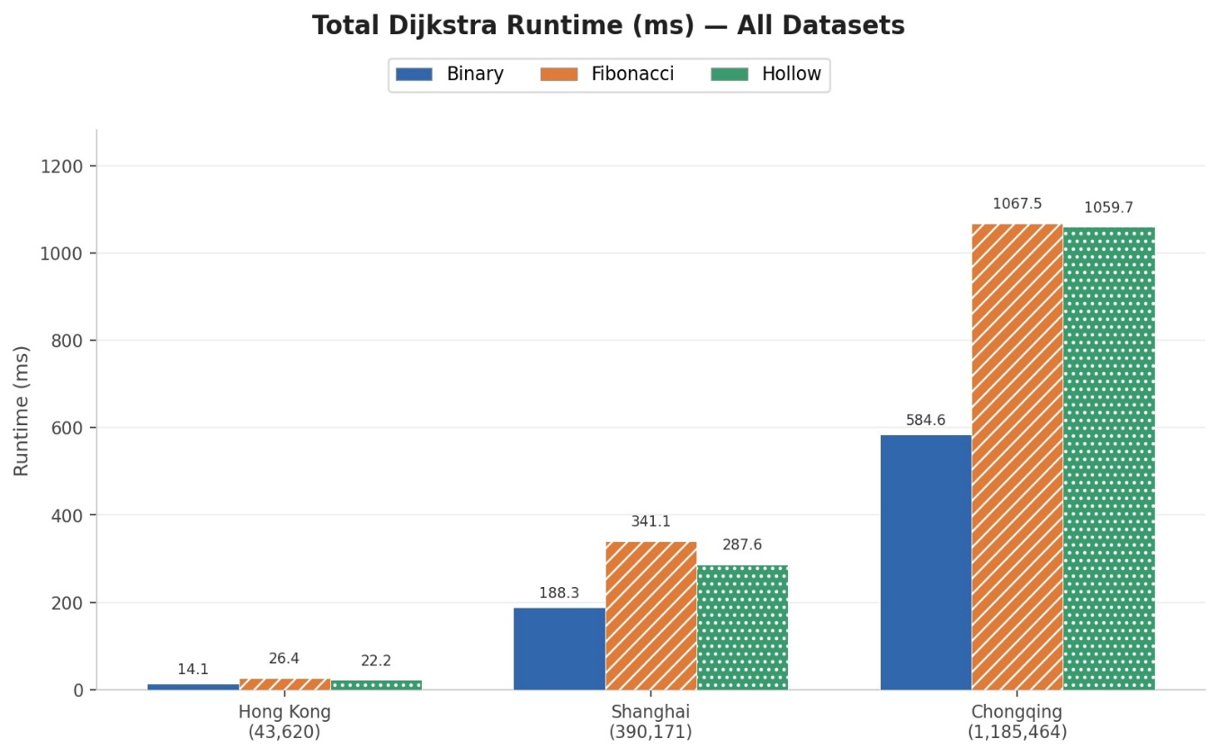
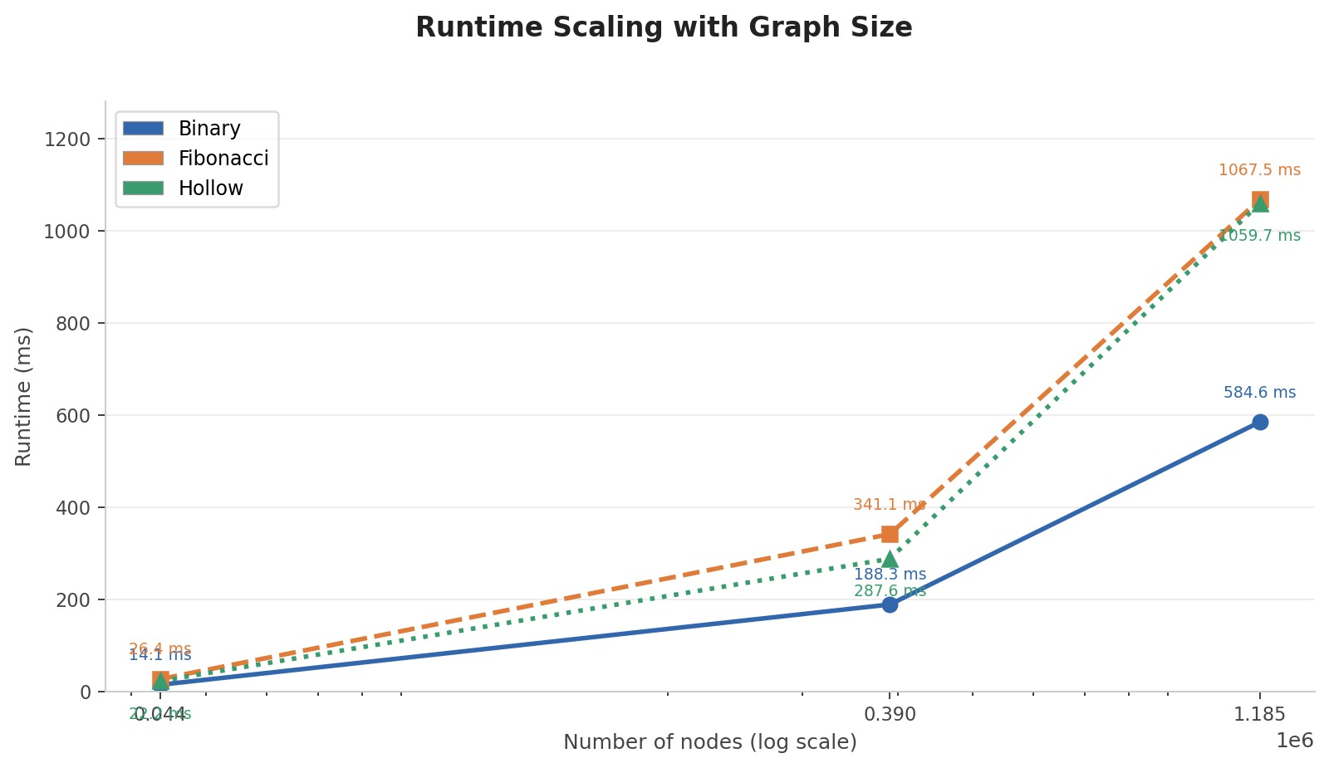

4.2 Operation Timing Analysis
Insert:
- Fibonacci Heap is slightly faster in small cases
- Difference becomes negligible in large graphs
Extract-Min:
- Binary Heap consistently performs best
- Fibonacci Heap is worst due to tree consolidation overhead
Decrease-Key:
- Fibonacci Heap performs well in theory
- Hollow Heap is worse in practice due to lazy structure overhead
Conclusion:
Extract-min dominates total runtime in Dijkstra’s algorithm, so Binary Heap wins overall.

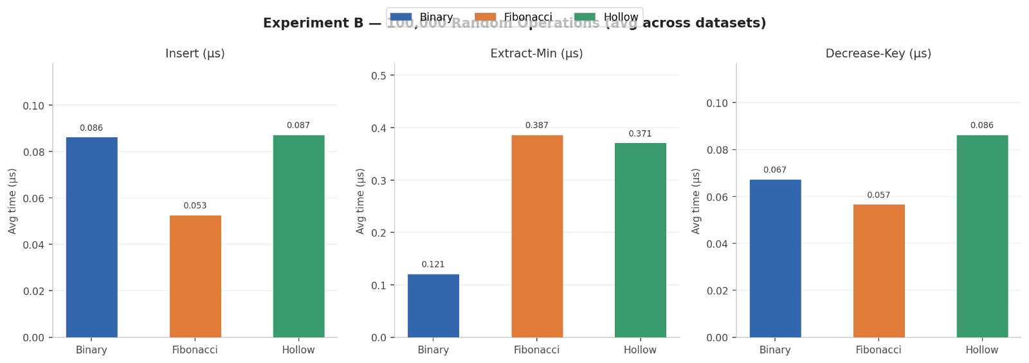

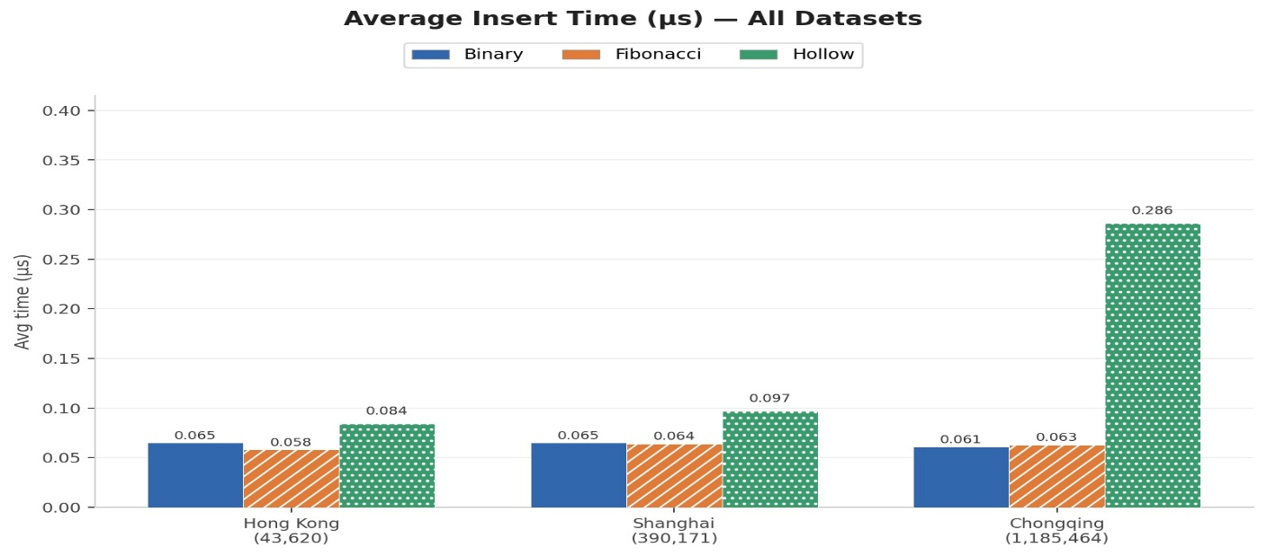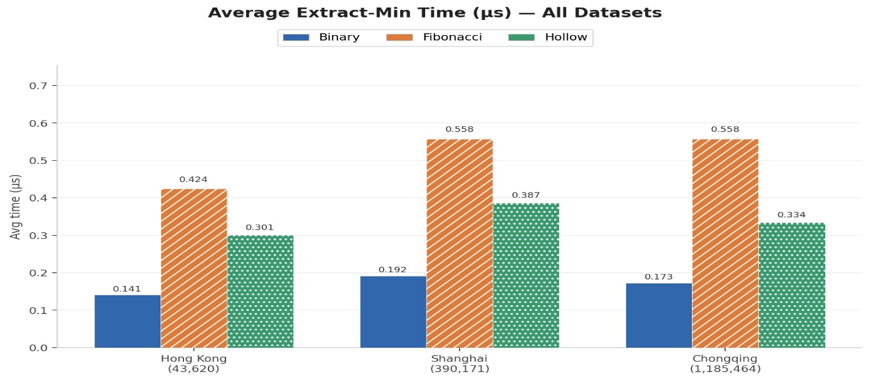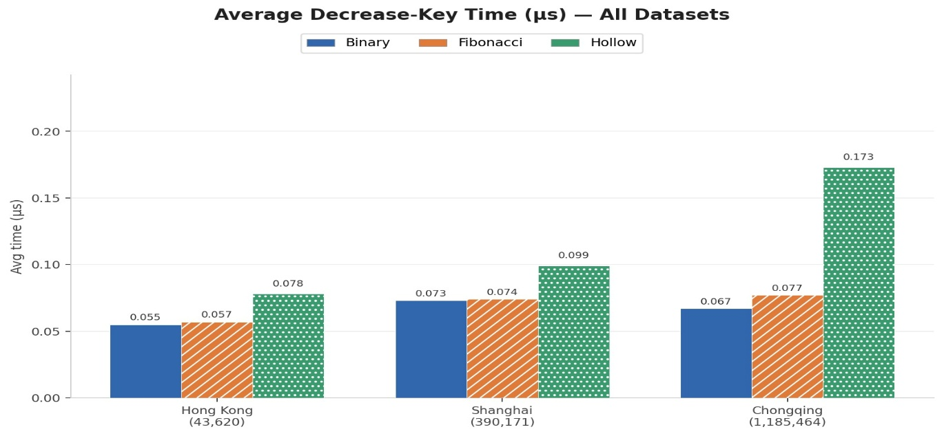

4.3 Heap Structure Statistics
Heap Height:
Dataset | Binary | Fibonacci | Hollow
Hong Kong | 7 | 6 | 6
Shanghai | 10 | 9 | 9
Chongqing | 9 | 8 | 8

Interpretation:
- Binary heap grows logarithmically as expected
- Fibonacci and Hollow heaps maintain multiple shallow trees

Number of Trees in Root List:
Dataset | Binary | Fibonacci | Hollow
Hong Kong | 1 | 7 | 7
Shanghai | 1 | 8 | 8
Chongqing | 1 | 11 | 10

- Binary heap is always single structured
- Fibonacci/Hollow heaps maintain multiple root trees, increasing overhead

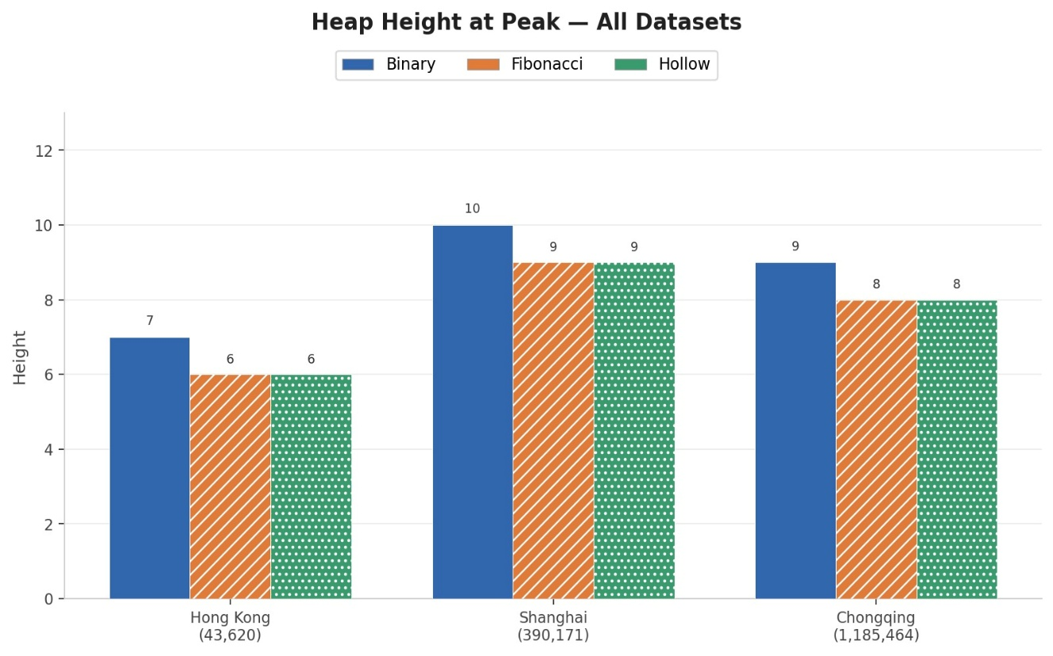
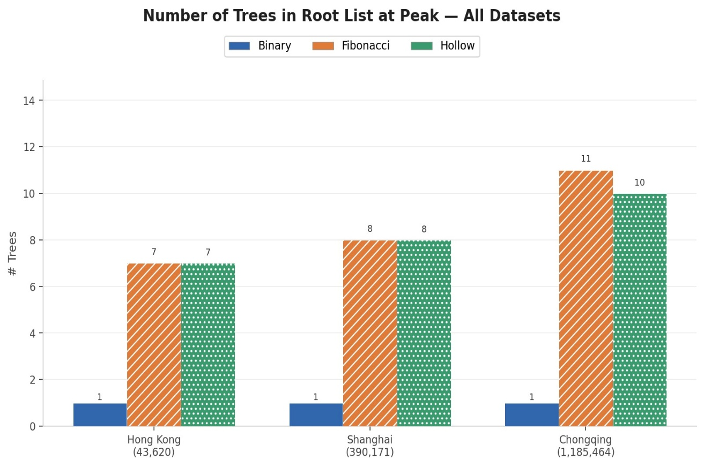

4.4 Memory Usage
Dataset | Binary | Fibonacci | Hollow
Hong Kong | 1.9 MB | 3.2 MB | 2.5 MB
Shanghai | 16.7 MB | 28.7 MB | 22.7 MB
Chongqing | 50.9 MB | 87.1 MB | 69.0 MB

Key Observation:
- Binary Heap uses significantly less memory
- Fibonacci Heap is the most memory-intensive
- Hollow Heap is in between but still pointer-heavy

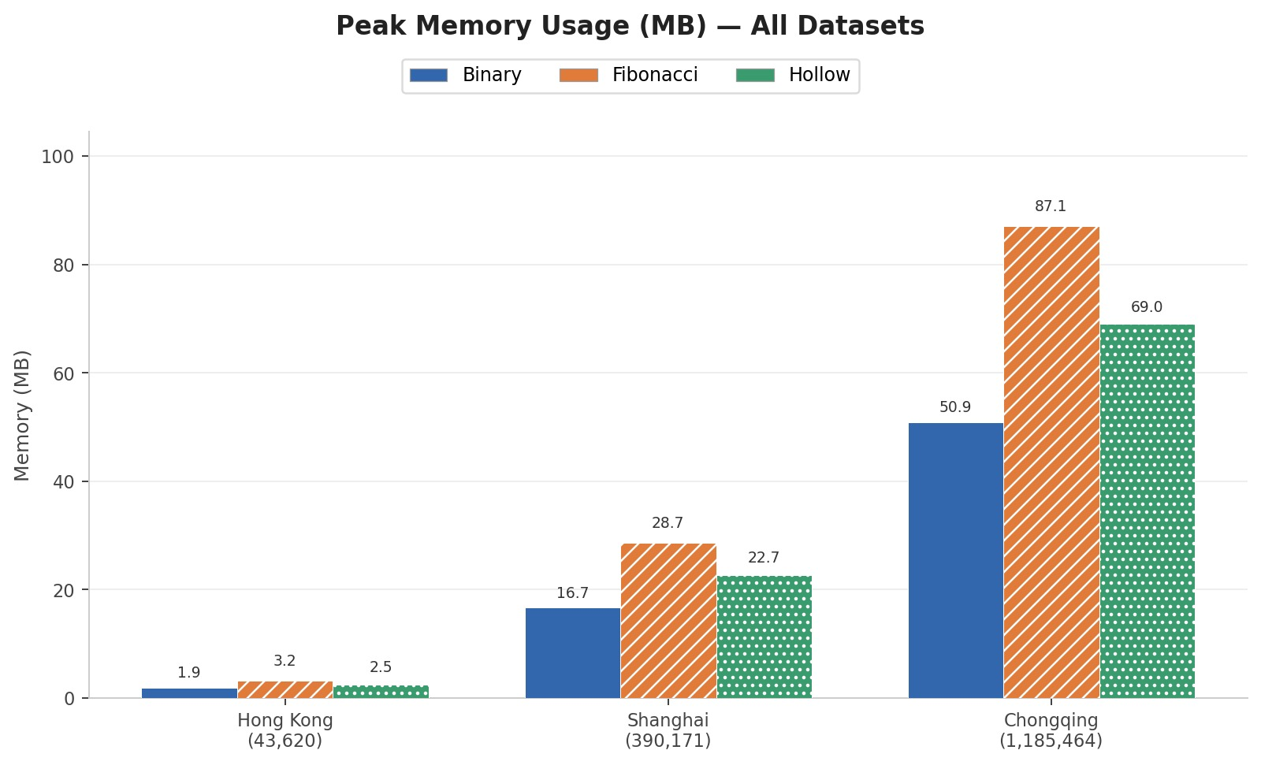

4.5 Scaling Behavior
From the runtime scaling graph:
- Binary Heap scales most smoothly
- Fibonacci Heap grows steeply with dataset size
- Hollow Heap is slightly better than Fibonacci but still expensive
Final Interpretation:
Real-world performance is dominated by:
- cache efficiency
- memory access pattern
- constant overhead (not just asymptotic complexity)

4.6 Trade-off Summary
Heap Type | Speed (Real) | Memory | Complexity
Binary Heap | Fastest | Low | Easy
Fibonacci Heap | Slow | High | Very Hard
Hollow Heap | Medium | Medium | Moderate

5. Conclusion and Recommendations
Although Fibonacci Heap and Hollow Heap provide better theoretical performance for decrease-key operations, they do not outperform Binary Heap in real-world road network graphs.
The main reason is that Dijkstra’s algorithm is dominated by extract-min operations, and Binary Heap handles these efficiently due to array-based storage and cache locality.

Final Recommendation
- Real-world routing systems → Binary Heap (best practical choice for this workload type)
- Theoretical study / algorithm research → Fibonacci Heap
- Balanced design and modern alternative → Hollow Heap

Final Insight
This experiment shows that theoretical complexity alone is not sufficient to predict real-world performance. Memory access patterns, cache efficiency, and constant factors significantly affect runtime in large-scale graph processing.

