DPEG
Acquisition & Disposition
End-to-End Process
How a property enters, moves through, and leaves the DPEG portfolio
Describes the system as built in Salesforce as of 6 August 2026

Contents
Contents 2
1. Purpose and scope 3
2. The lifecycle at a glance 4
3. Acquisition 5
3.1 Phase 1 — Lead Qualification 6
3.2 Phase 2 — Deal Screening 6
3.3 Phase 3 — Underwriting and Principal Approval 6
3.4 Phase 4 — LOI and Principal Approval 7
3.5 Phase 5 — Contract and Execution 7
3.6 Phase 6 — Transaction to Close 7
Two rules that apply across the whole acquisition flow 8
4. From acquisition to disposition 9
5. Disposition 10
5.1 Phase 7 — Sell Decision and BOV Outreach 11
5.2 Phase 8 — Listing, Buyer NDAs and Offers 11
5.3 Phase 9 — Closing and Completion 12
6. Approvals 13
What is not an approval process 14
7. Stage reference matrix 15

1. Purpose and scope
This document traces a single property from the moment a broker submission becomes a qualified lead, through acquisition and closing, into ownership, and back out again through disposition to a completed sale.
It covers three things:
- The end-to-end flow — what happens in each phase and what triggers the next one.
- The stages carried on every record — collected in the reference matrix in section 7.
- The approval processes — who signs off, on what, and what happens when they decline.
It describes what the system does today. It is not a proposal and contains no recommendations. Where a control is manual rather than enforced by the system, it says so.

2. The lifecycle at a glance
A property makes one pass through the platform. Acquisition builds a deal up to a signed contract; the Transaction record carries it to close; ownership hands the asset to Property Management; and disposition eventually takes it back to market.
Lead — a broker submission being qualified. Deal — screening, feasibility and underwriting. Contract — LOI, then PSA. Transaction — due diligence through to close. Property Asset — the owned, operated asset. Disposition — listing and offers. Sold — completed sale.
Two records carry the deal end to end. The Deal is the acquisition record — it holds the stage everyone watches and it is the record both approvals run on. The Transaction takes over once the deal is about to close and runs the closing checklist. Everything else — NDA, feasibility reviews, underwriting, LOI, contract review — is a supporting record created off the Deal at the point it becomes relevant, each carrying its own stages.

3. Acquisition
The acquisition side runs in six phases. The Deal's own stage is the spine; the supporting records are created automatically as it advances.
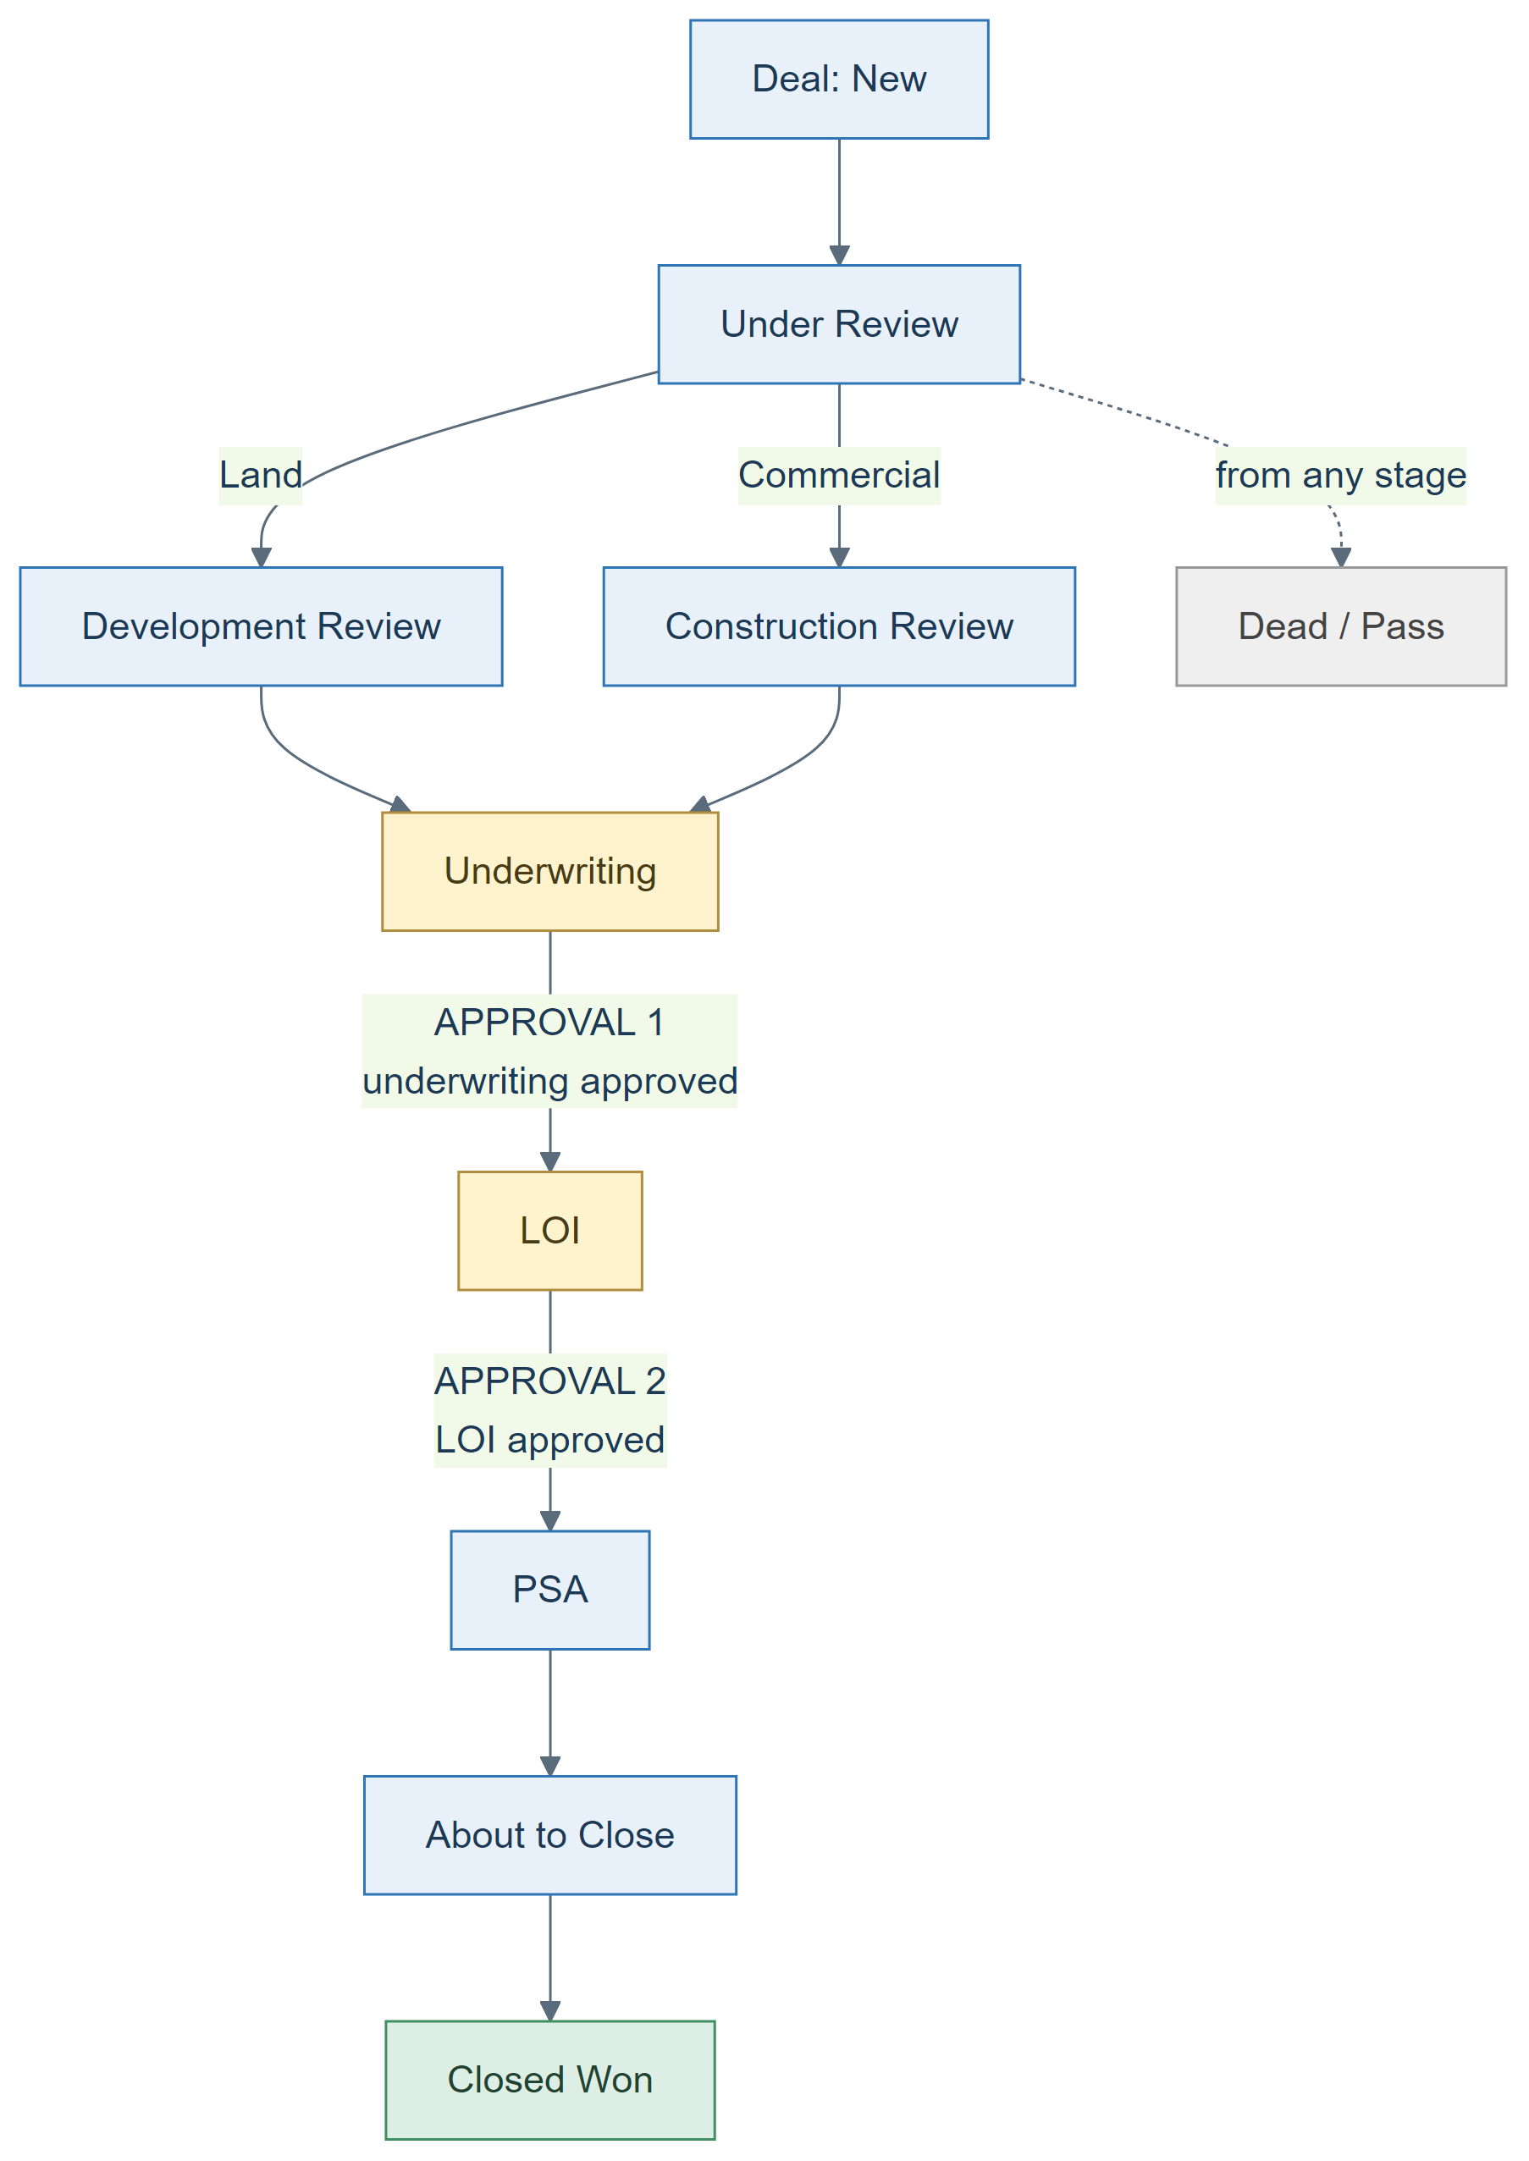
A signed NDA is required before the deal can pass Under Review. Both approvals sit on the Deal record itself.

3.1 Phase 1 — Lead Qualification
Stages: New → Under Review → Qualified → Converted (or Disqualified at any point.)
Broker submissions arrive by email or through the public broker portal and land as leads. The Acquisitions Analyst works the lead through three actions — mark it Under Review, mark it Qualified, then convert it. Disqualify is available throughout and ends the lead.
Converting is the hand-off into the deal pipeline. It creates the Deal, creates the Property record behind it, carries the deal type across so the Deal opens on the right path, and records who approved the lead.
To leave this phase: the lead must be qualified and converted. A disqualified lead stops here.

3.2 Phase 2 — Deal Screening
Stages: New → Under Review, then a branch determined by deal type.
The Deal opens at New. At the same moment an NDA record is created against it and linked as the deal's primary NDA, starting at Pending and moving Pending → Sent → Signed as the counterparty signs.
From Under Review the path branches on deal type, and this branch is the only structural difference between the two:
- Land deals go through Development Review — Requested → Feasibility analysis → Vendor proposals → Share Opinion → Completed.
- Commercial deals go through Construction Review — Requested → Site Visit → Condition Assessment → Cost Estimate → Share Opinion → Completed.
Entering the stage creates the matching review record automatically. Either review can also be requested outside its stage by flagging that input is needed, which creates the same record without moving the deal.
To leave this phase: the primary NDA must be signed. Without it the deal cannot reach Underwriting, LOI, PSA, About to Close or Closed Won.

3.3 Phase 3 — Underwriting and Principal Approval
Stages: Requested → In Progress → Approved → Completed on the Underwriting record.
Entering the Underwriting stage creates the Underwriting record and links it to the deal. The analyst builds the model on it — underwritten NOI, cap rate, target price, returns and notes — and the deal owner then submits the deal for principal sign-off.
Approval 1 — Underwriting Approval runs here. It is covered in full in section 6.
To leave this phase: underwriting must be approved. The system refuses to move a deal to LOI otherwise.

3.4 Phase 4 — LOI and Principal Approval
Stages: Draft → Prepare/Review → Sent → Counter → Completed on the LOI record.
Entering the LOI stage creates the LOI record. Each round of negotiation is logged as its own Counter Offer child, carrying the direction (ours or the seller's), a revision number, the counter price and cap rate, and the response. The most recent counter is reflected back onto the LOI, so the deal always shows the current position without anyone reading the history.
Approval 2 — LOI Approval runs here. It is covered in full in section 6.
To leave this phase: the deal must have a linked LOI and that LOI must be approved. Both conditions are checked before the deal can enter PSA.

3.5 Phase 5 — Contract and Execution
Negotiation status: Initial Draft → Revised → Ready for Execution → Executed on the Contract Review record.
Entering the PSA stage creates the Contract Review record. Every draft exchanged is logged as a PSA Version — direction, date, a summary and a link to the document — so the full negotiation history sits on the record.
The Contract Review's stage is derived, not set by hand. It follows the negotiation status: Initial Draft shows as PSA Drafting, Revised and Ready for Execution show as Review, and Executed shows as Contract Execution.
When the contract reaches Executed, three things happen automatically: the deal is marked Contract Signed, the contract execution date is stamped as Day 0, and the Transactions, Investor Relations and Due Diligence teams are notified.
To leave this phase: the deal's close date must be current — a close date in the past blocks the move to About to Close.

3.6 Phase 6 — Transaction to Close
Stages: Open Contract → Due Diligence → Closing Prep → Post-Closing → Closed Won on the Transaction record.
The Transaction record opens when the deal reaches About to Close — deliberately not at signature. The Transactions team picks a deal up when it is genuinely about to close, which may be weeks after the contract was executed.
Opening the Transaction arms the closing checklist of roughly 75 tasks. Every task is dated by offset from Day 0, and Day 0 is the contract execution date, not the date the deal reached About to Close. Dating the checklist from the stage change would silently shift every deadline.
Alongside the checklist the Transaction tracks five critical dates: Closing Date, Feasibility End, Insurance Binding, Loan Commitment and Earnest Money Due.
To leave this phase: the contract must be signed. A deal cannot be marked Closed Won without it.

Two rules that apply across the whole acquisition flow
- A deal cannot move backwards. To stop work on a deal it is moved to Dead/Pass, which is available from any stage. This is enforced, not a convention.
- The gates above are enforced by the system, not left to discipline. Each one blocks the stage change and explains why.

4. From acquisition to disposition
Closing does not end the record trail. The acquired property becomes an owned Property Asset, which is what Property Management operates against and what the disposition side later acts on. A Disposition is opened against that asset, not against the original deal.
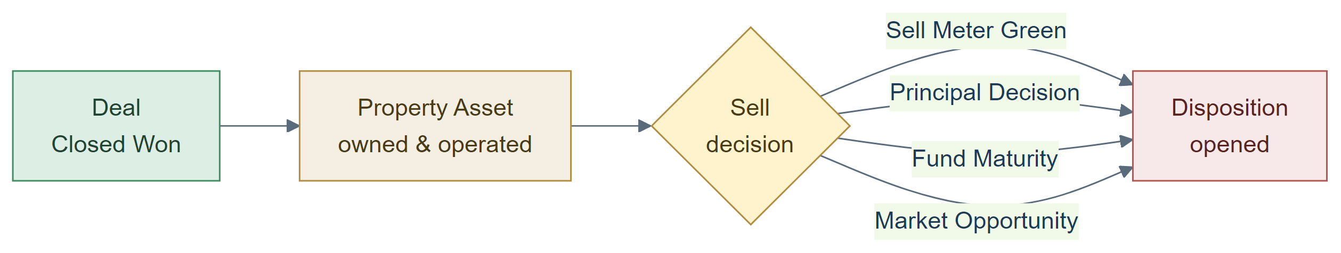
The sell decision is recorded against one of four triggers: Sell Meter Green, Principal Decision, Fund Maturity or Market Opportunity.

5. Disposition
Disposition runs in three phases across five stages.
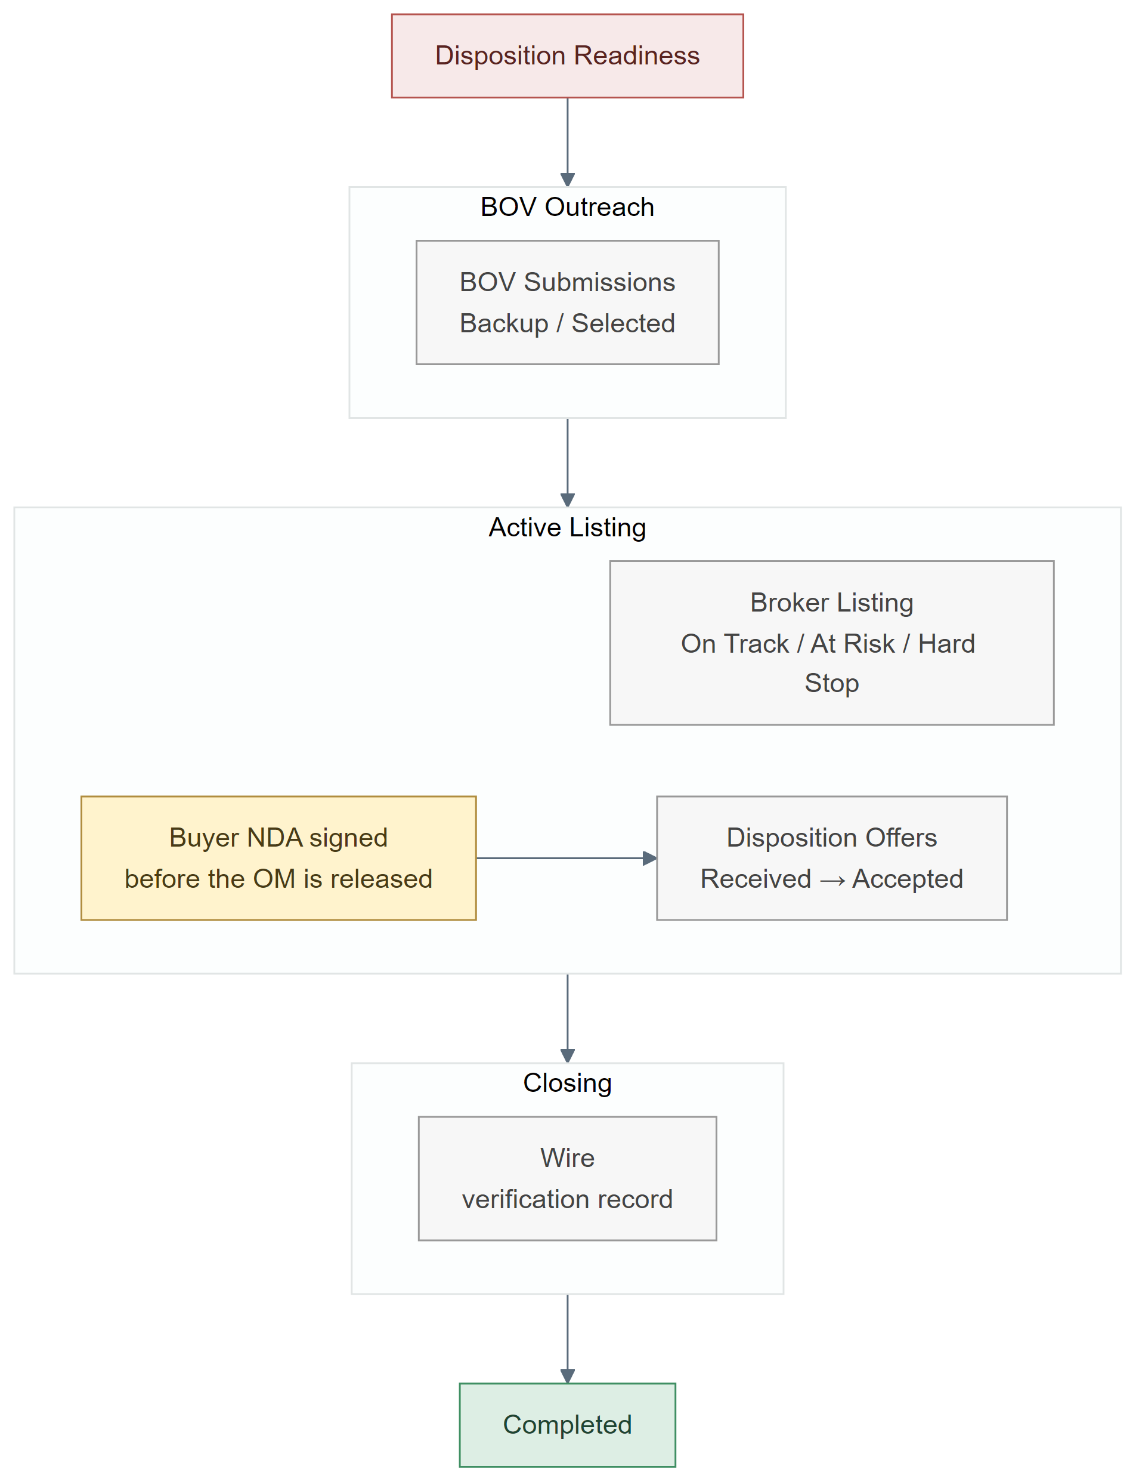
The five Disposition stages, with the records worked inside each one. The buyer NDA gates release of the offering memorandum, so it always precedes an offer.

5.1 Phase 7 — Sell Decision and BOV Outreach
Stages: Disposition Readiness → BOV Outreach.
The Disposition opens at Disposition Readiness carrying the sell-decision trigger. Before it advances, the asset metrics and the Argus signal are confirmed to support the decision to sell.
Moving to BOV Outreach starts the broker search. An OM package goes out to five or six brokers against a submission deadline, and the record tracks how many were approached and how many responded; the comparison matrix generates once three or more responses are in. This package goes to brokers so they can price the asset — it is a separate thing from the offering memorandum later released to prospective buyers under NDA in Phase 8.
Each broker's opinion of value comes back as a BOV Submission, carrying the firm and contact, the BOV amount and cap rate, estimated days to market, proposed commission, the firm's historical success rate and a score. Every submission is marked either Backup or Selected.
Checkpoint — broker selection. The chosen broker is recorded on the Disposition. This is a field on the record, not a routed approval.

5.2 Phase 8 — Listing, Buyer NDAs and Offers
Stage: Active Listing.
The listing is held on a Broker Listing record — list date, call-for-offers date, commission percentage, offers received and days on market — with a health status of On Track, At Risk or Hard Stop. Those three values track a six-week marketing clock running from the listing date: week four raises the listing to At Risk, and week six raises it to Hard Stop and escalates it.

The buyer NDA
A prospective buyer signs an NDA before the offering memorandum is released to them. Access to the OM and the deal room follows the signed NDA, not the other way round — an interested party is not sent the marketing package until it is in place.
What the system records is the NDA state for that buyer, carried on their Disposition Offer as Pending → Signed, or Waived where the parties agree none is required.
Two consequences follow from where that field sits, and both are worth knowing:
- The record appears only when an offer does. The NDA state lives on the Disposition Offer, and that record is created when an offer arrives. A party who signs an NDA, receives the OM and then never bids leaves no trace of having signed.
- Disposition NDAs are a status, not a document record. On the acquisition side an NDA is its own record with Sent and Signed dates, an expiry and a stored document. The NDA object can be linked to a Disposition, but nothing creates one, no related list surfaces it, and the org holds none today — so on the disposition side the NDA is tracked as a picklist value on the offer instead.
Neither is a system control: nothing blocks the OM from going out before the NDA state is set.

Offers
Each buyer's offer is a Disposition Offer running Received → Under Review → Countered by DPEG → Counter Received from Buyer → Accepted, with Rejected and Withdrawn by Buyer as the other endings. Alongside the status and the NDA state it carries the offer amount, both sides' counter prices and dates, the final agreed price, due diligence and closing periods, proposed earnest money and financing type.
Checkpoint — offer acceptance. Acceptance is recorded by setting the offer's status and stamping the accepted price on the Disposition. This is a field change, not a routed approval.

5.3 Phase 9 — Closing and Completion
Stages: Closing → Completed.
Closing tracks PSA execution, the title company and whether the closing statement has been uploaded. Marking the PSA executed spawns the closing tasks.
Funds move against a Wire record, which captures where the wire instructions came from, whether verbal verification was completed, the name and phone number of the person who verified them, the date and time of verification, and the confirmed amount. Together these six fields are the wire fraud prevention gate, and the stage guidance requires all of them to be complete before any wire is sent.
At Completed the Disposition records gross sale proceeds, selling costs, net sale proceeds and the closing date, with days on market carried through from the listing.
Checkpoint — wire verification. The verbal callback and verifier details are recorded on the Wire record. This is a field-based control, not a routed approval.

6. Approvals
There are two formal approval processes in the system. Both run on the Deal, and both are on the acquisition side.
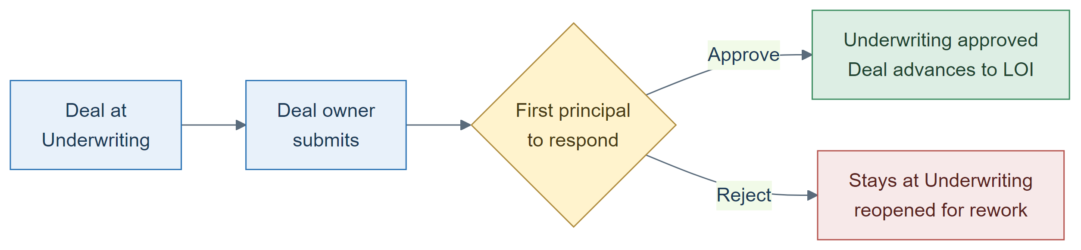
Approval 1 — Underwriting Approval.
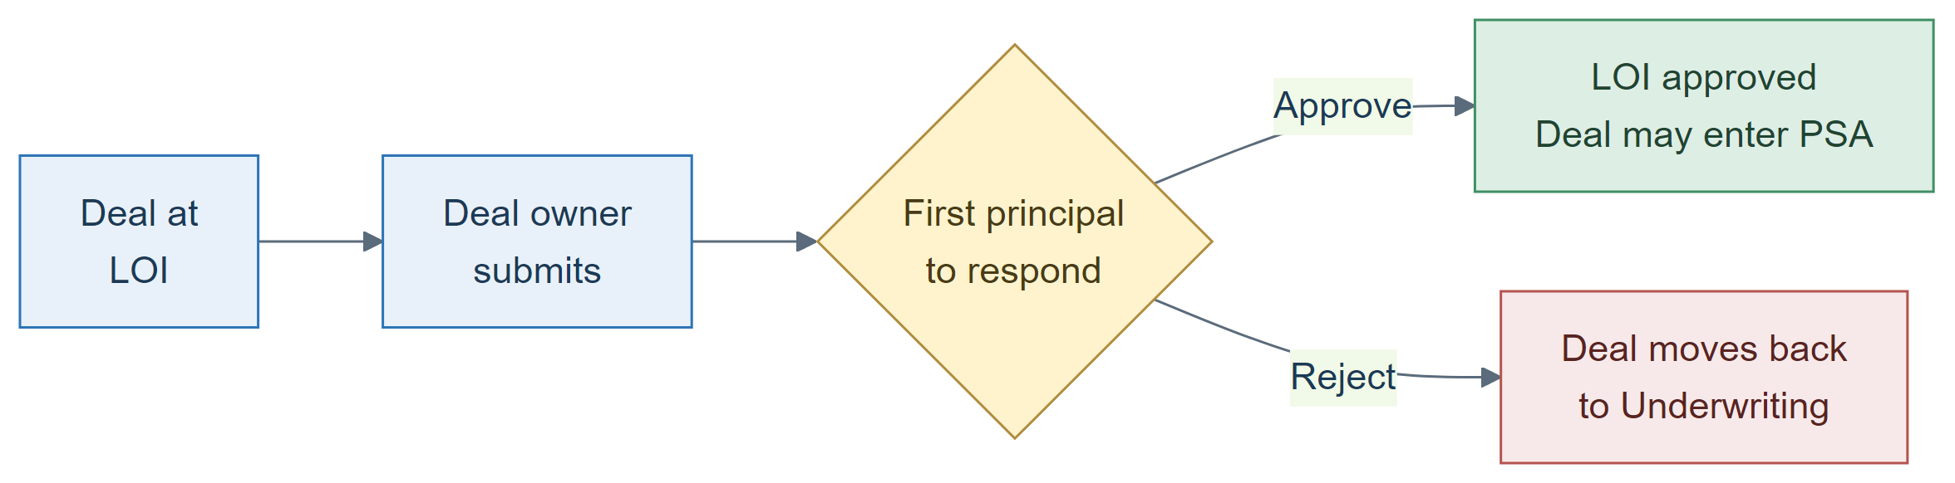
Approval 2 — LOI Approval.
 | Underwriting Approval | LOI Approval
Runs on | The Deal | The Deal
Entry condition | Deal is at the Underwriting stage | Deal is at the LOI stage
Who may submit | The deal owner | The deal owner
Approvers | Two principals | The same two principals
Steps | One | One
Decision rule | First response wins | First response wins
On approval | Underwriting marked approved, underwriting record set to Approved, deal advances to LOI | LOI marked approved
On rejection | Deal stays at Underwriting with underwriting-complete cleared, so the numbers can be reworked and resubmitted | Deal moves back to Underwriting
Recall | Allowed | Allowed
Delegation | Not allowed | Not allowed
Record locked after decision | No | No
Approval history visible | Yes | Yes

First response wins means exactly that: the first principal to act decides. The first approval approves the deal and the first rejection rejects it. The second principal is never waited for, and their outstanding request is withdrawn.
While an approval is in flight the deal is editable by administrators only. After the decision the record is released either way — neither process locks it.

What is not an approval process
These two are the only formal approval processes in the platform. The disposition side has none. Its sign-off points — broker selection, offer acceptance and wire verification — are recorded as fields on their records and reviewed by the people working the deal. They are not routed to an approver, they do not lock the record, and they leave no approval history.
The same is true of the two lead decisions: qualifying and disqualifying a lead are permission-controlled actions, not approvals.

7. Stage reference matrix
Every record in both flows, with its stages in order.
Record | Stages, in order | Worked by
Lead | New → Under Review → Qualified → Converted (Disqualified at any point) | Acquisitions Analyst
Deal — Land | New → Under Review → Development Review → Underwriting → LOI → PSA → About to Close → Closed Won (Dead/Pass at any point) | Acquisitions Analyst
Deal — Commercial | New → Under Review → Construction Review → Underwriting → LOI → PSA → About to Close → Closed Won (Dead/Pass at any point) | Acquisitions Analyst
NDA (acquisition) | Pending → Sent → Signed | Acquisitions Analyst
Development Review (Land) | Requested → Feasibility analysis → Vendor proposals → Share Opinion → Completed | Development team
Construction Review (Commercial) | Requested → Site Visit → Condition Assessment → Cost Estimate → Share Opinion → Completed | Construction team
Underwriting | Requested → In Progress → Approved → Completed | Acquisitions Analyst; Principals approve
LOI | Draft → Prepare/Review → Sent → Counter → Completed | Acquisitions Analyst; Principals approve
Counter Offer | No stage. Logged per round, direction ours or seller's | Acquisitions Analyst
Contract Review | PSA Drafting → Review → Contract Execution (derived from negotiation status: Initial Draft → Revised → Ready for Execution → Executed) | Legal with Acquisitions Analyst
PSA Version | No stage. Logged per draft, direction ours or seller's | Legal
Transaction | Open Contract → Due Diligence → Closing Prep → Post-Closing → Closed Won | Transactions Coordinator
Critical Date | No stage. One per deadline: Closing Date, Feasibility End, Insurance Binding, Loan Commitment, Earnest Money Due | Transactions Coordinator
Disposition | Disposition Readiness → BOV Outreach → Active Listing → Closing → Completed | Disposition team
BOV Submission | Backup / Selected | Disposition team
Broker Listing | On Track / At Risk / Hard Stop (listing health, not a sequence) | Listing broker with Disposition team
Buyer NDA (disposition) | Pending → Signed (or Waived) — a status on the buyer's Disposition Offer, not a document record | Disposition team
Disposition Offer | Received → Under Review → Countered by DPEG → Counter Received from Buyer → Accepted (or Rejected / Withdrawn by Buyer) | Disposition team
Wire | No stage. Verification record: instructions source, verbal verification, verifier, verified date and time, confirmed amount | Finance with Disposition team

A note on "Worked by". Salesforce defines four named roles — Acquisitions Analyst, DPEG Principal, Transactions Coordinator and Property Management Coordinator. Where a record is worked by a team that has no dedicated role, the team is named instead.
Prepared 6 August 2026. Reflects the configuration deployed at that date.

