**Question:** How many total messages are being sent every day?

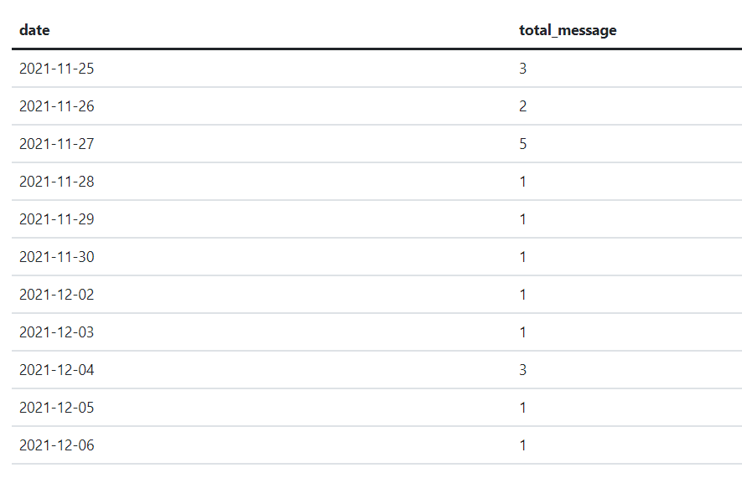

* SELECT TO_DATE("message"."createdAt",'YYYY-MM-DD') as Date, count(*) as Total_message FROM "public"."message" group by 1 order by 1;

**Question:** Are there any users that did not receive any message?

**Ans**: Yes, User Id **4** didn’t receive any message

* SELECT "user"."id" as User FROM "public"."user" where "user"."id" not in (SELECT "message"."receiverId" from "public"."message");

**Question:** How many active subscriptions do we have today?

**Ans:** The total Active subscription are **4.**

* SELECT count(*) as Total_active_subscription FROM "public"."subscription"   
  where "subscription"."status" = 'Active';

**Question:** Are there users sending messages without an active subscription? (Some extra context for you: in our apps Only premium users can send messages).

**Ans:** Users sending message without active subscription are User Id **4 and 6**

* Select Distinct "message"."senderId" from "public"."message" where "message"."senderId" not in (Select Distinct "user"."id" from "public"."user" inner join "public"."subscription" on "user"."id" = "subscription"."userid" and "subscription"."status" = 'Active')

**Question:** How much is the average subscription amount (sum amount subscriptions / count subscriptions) breakdown by year/month (format YYYY-MM)?

Ans: The Average **is 47.07** for the year **2021** and month **November**

* select to_char(TO_DATE("subscription"."createdAt",'YYYY-MM'),'YYYY-MM') as Date, avg(CAST("subscription"."amount" AS FLOAT(2))) as subscription_amount from "public"."subscription" group by 1;