**Power BI Dashboard Deployment Process:**

* **We need Credentials of the client for which we are deploying Dashboard.**
* **We “pbix” file for Dashboard to be deployed. Each Dashboard should have separate pbix files for admissions, Usage, and applicants etc.**

**To deploy a PowerBI dashboard for any particular tenant requires the tenant’s source DB credentials, and the Power BI service login credentials.**

1. **- Changing the data source in the report**
2. **The first step is to change the data source in the ‘.pbix’ file. We can do this in the ‘Edit Queries’ button. Which will open the Query Editor.**

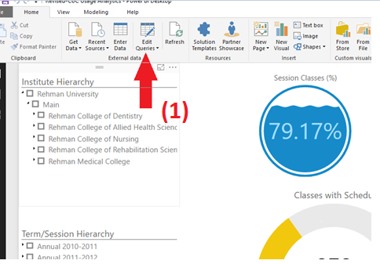

1. **In the Query Editor select the ‘Data Source Settings’ button. This will open another window which shows the data sources currently connected to the dashboard.**

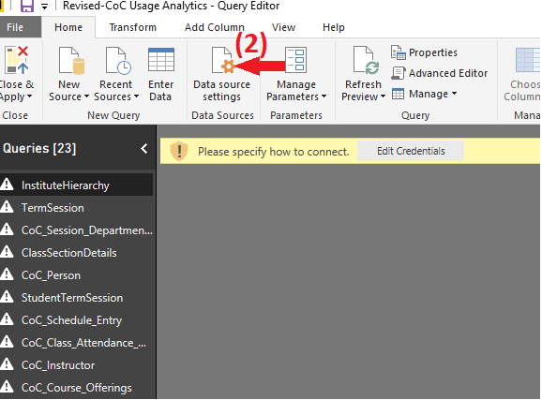

1. **Press the ‘Change Source’ button to change the DB server and the DB name. No other option needs to be changed.**

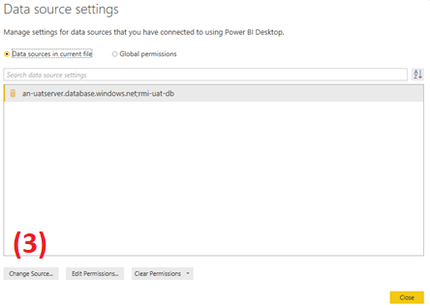

1. **Then press OK**

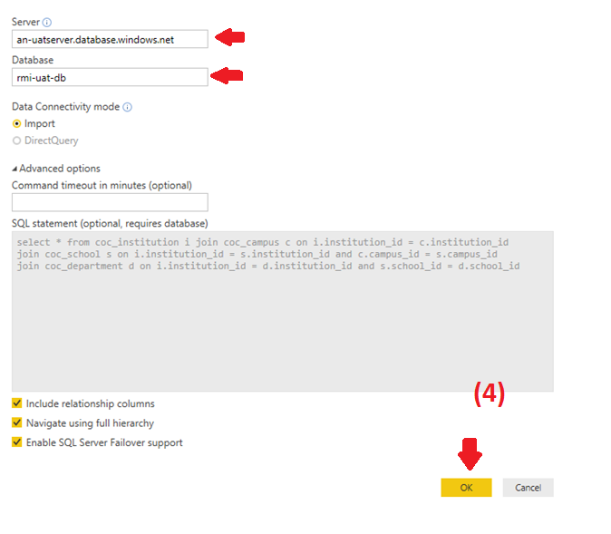

1. **Then again from the ‘Data Source Settings’ window select ‘Edit Permissions’ to change the DB credentials.**

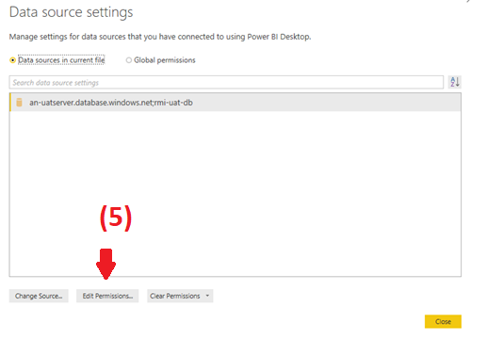

1. **Select ‘Edit’ then change the credentials to that of the tenant.**

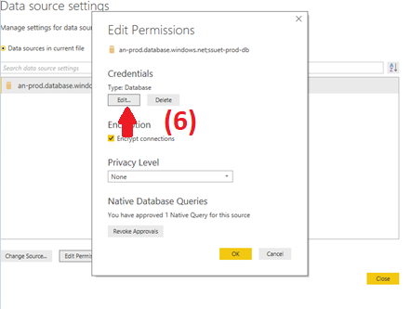

1. **Save the new settings, and close the ‘Data Source Settings’ window.**

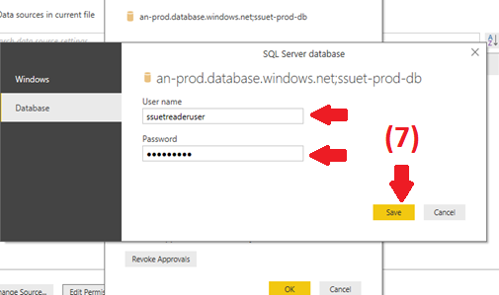

1. **Now in the Query Editor, select ‘Close and Apply’.**

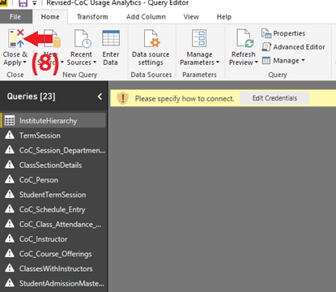

1. **Power BI may prompt for permissions to run native SQL queries, select ‘Run’ for any prompt raised.**

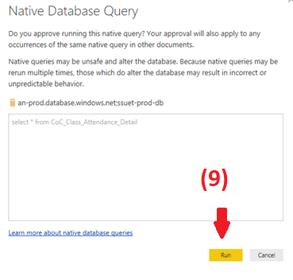

1. **Power Bi will apply the data source change.**

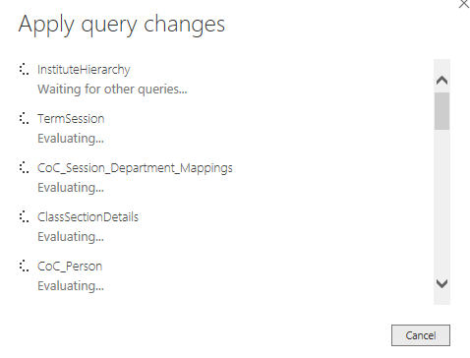

**2) After the change takes effect, move on to publish the report.**

1. To publish the report to the **Power BI** service directly from Power BI Desktop, on the **Home** ribbon, select **Publish.**

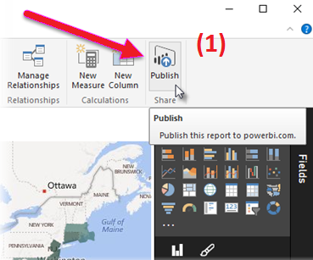

1. You may be prompted to sign in to Power BI.

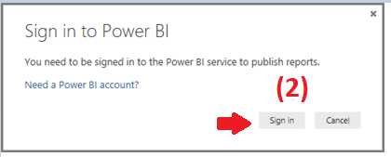

1. Enter the tenants Power BI account credentials in the following screen:

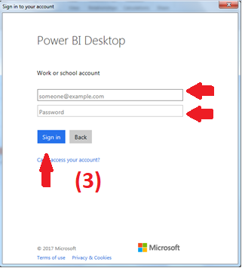

1. When you've signed in and the publish process is complete, you see a success dialog:

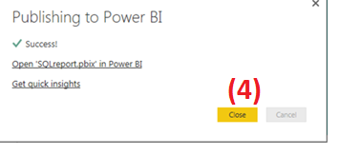

1. When you sign in to the online Power BI service (<http://powerbi.microsoft.com/>), you'll see Power BI Desktop file you just loaded in the **Reports**, and **Datasets** sections of the service.
2. **– Schedule Refresh at Power Bi service:**
3. Once logged in at Power BI Service navigate to the dataset subsection in the workspace section.

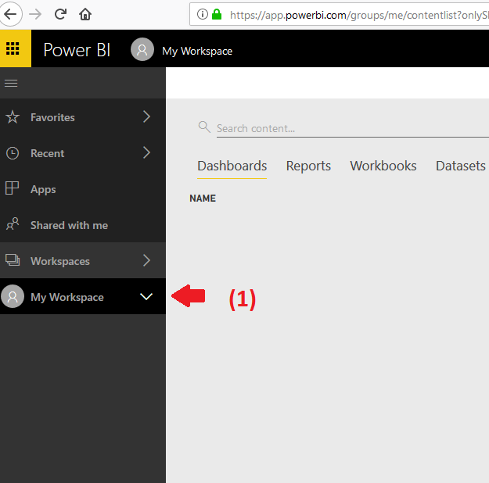

1. Select the dataset you want to Schedule Refresh for, by clicking on the ellipses icon.

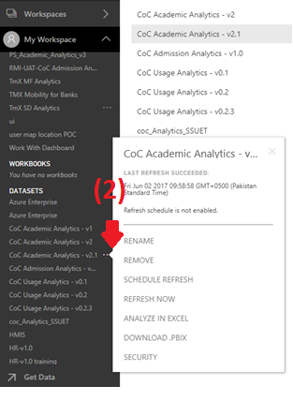

1. **Select Schedule Refresh.**

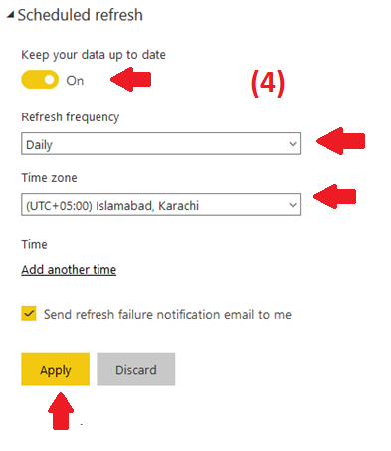

1. **Enable the ‘Keep your data up to date’ slider and set the frequency at which you want to refresh the dashboard and adjust the Time Zone.**
2. **Apply the change and you are done.**