# Cloud Operations

Techlogix Cloud Operation Team provides Infrastructure Support including Servers and Application Monitoring, Cost Management and Capacity Planning. Techlogix Cloud Operation offers an Industry Leading Cloud Service Level Agreement (SLA) with 100% uptime guarantee.

**Contents**

***Cloud Operations*** 1

Purpose 4

Client Machine Setup 4

Download OpenVPN client 4

Install OpenVPN client 4

Revision Chart

This chart contains a history of this document’s revisions. The entries below are provided solely for purposes of illustration. Entries should be deleted until the revision they refer to has actually been created.

The document itself should be stored in revision control, and a brief description of each version should be entered in the revision control system. That brief description can be repeated in this section.

It can be removed from the client version of the document, however the local copy of the client version should contain the revision chart and version column should exhibit the “Client Version” in it.

Revision Chart

| Version | Author(s) | Description of Change | Effective Date |
| --- | --- | --- | --- |
| 1 | Ammar Sajid | Initial draft created for distribution and review comments | November 30, 2017 |
|  |  |  |  |

# Purpose

The purpose of this document is to provide a complete guide for the installation of OpenVPN client and connecting it with the main server.

# Client Machine Setup

## Download OpenVPN client

Download OpenVPN client on the machine that needs to be connected to VPN from the link below.

Link: <http://swupdate.openvpn.org/community/releases/openvpn-install-2.3.18-I002-x86_64.exe>

## Install OpenVPN client

* Run the exe downloaded in the earlier step with the administrator privileges
* Keep the default component selection and move on

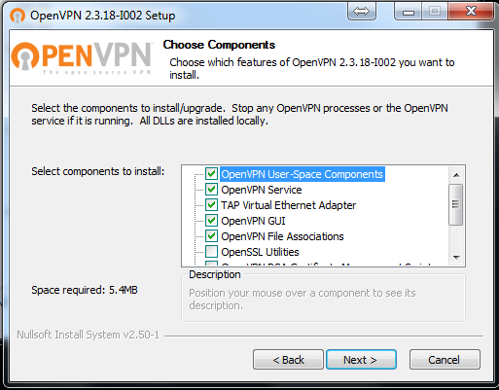

* It would probably prompt you to agree with the installation of TAP in addition to OpenVPN client. Select “Install”.

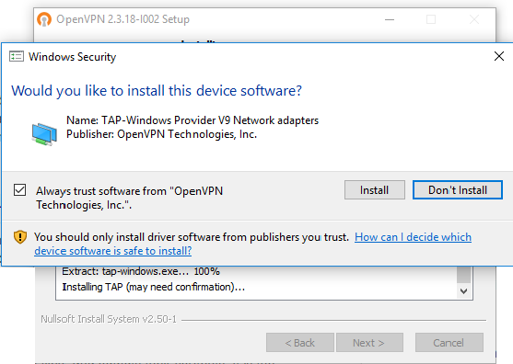

* Keep going until you get this

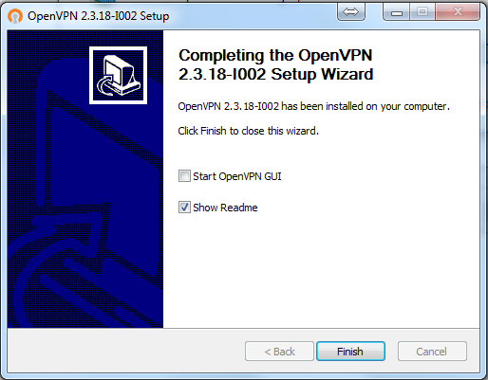

Don’t check “Start OpenVPN GUI” check box and click Finish.

* Make sure you have azure.zip file containing four files from CloudOps team
* Unzip the file azure.zip and copy “azure” folder in “C:\Program Files\OpenVPN\config” directory. It would probably require administrative privileges
* Extract the files may be on Desktop and then copy the whole folder due to permissions issue. If you try to extract the zip file inside or directly to the “C:\Program Files\OpenVPN\config” directory, then it might give you an error.

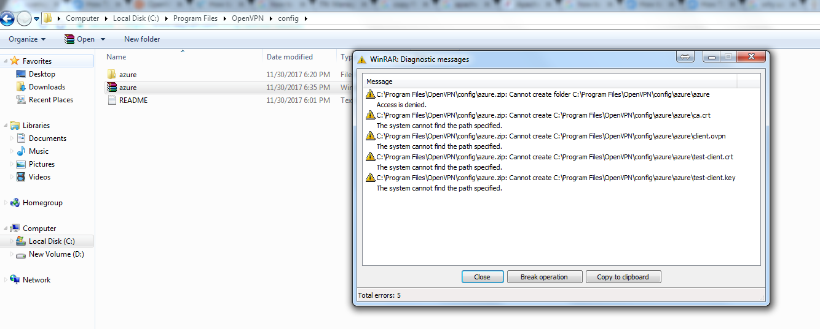

* Verify that you have four files in “C:\Program Files\OpenVPN\config\azure” directory.

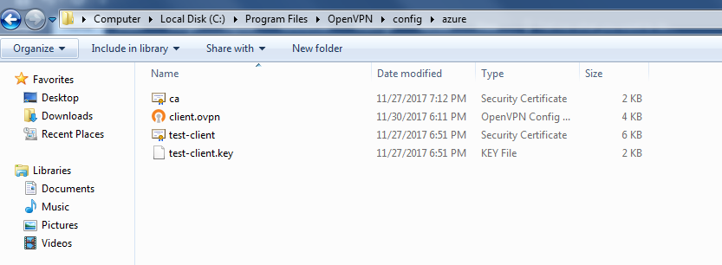

* Once you have these files in place then start OpenVPN from your desktop shortcut with administrative privileges.
* You will see an icon on the taskbar, right click on that icon and select connect.

