# Personal Information

Father Name Date Of Birth Nationality Gender Religion Domical

# Education

* Muhammad Hanif
* 10-03-1997
* Pakistani
* Male
* Islam
* Narowal

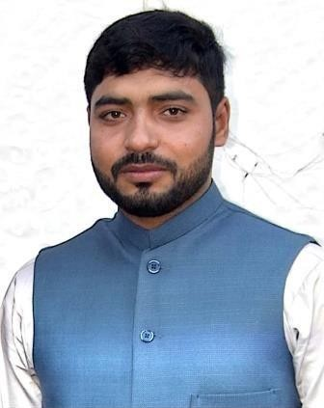

SADAM HUSSAIN

34501-5351479-7

Contact

**Address:**

Village: Bathanwala PO: Badhomalhi Tehsil Narowal District Narowal

**Phone:**

0347-2894405

**Email:**

[**Sadamhanif2@gmail.com**](mailto:Sadamhanif2@gmail.com)

Languages

* Punjabi
* Urdu
* English

Hobbies

* Reading
* Cricket
* Social worker
* Football
* Traveling

|  |  |  |  |  |  |
| --- | --- | --- | --- | --- | --- |
| **Education level** | **Specialization** | **Board/ University** | **Passing year** | **Marks** | **Divisions / Grade** |
| Metric | Science | BISE.  Gujranwala | 2014 | 525/1100 | D |
| DAE | Diploma of (Civil) | Abdul Wahab Tarkait  collage Narowal | 2017 | 2496/3500 | A |
| Bachelor | BS Civil technology | The University of Lahore | 2022 | CGPA 2.99 | B |

# Other Skills

Diploma in Office Management Diploma of SCAFFOLDING

# Computer Skills

MS Office management Window Installation Typing Master Compute Application Project

Internet

# Experience

Fresh

Reference

To be furnished on demand.