

**The University of Azad Jammu and Kashmir, Muzaffarabad**  
**Department of Software Engineering**  
**Technology**

**Programming Fundamentals**  
**Lab Instructor: Engr. ZEESHAN RASHID**  
**Semester: 2ⁿᵈ SET**  
**Session: 2024 – 28**

**Name:** Usman Arif  
**Roll No:** 2024 – SET – 17  
**Lab 1**

Table of Contents

Task 1: Student Record System 2

Objective: 2

Attributes: 2

Member Functions: 2

Code: 3

Task 2: Rectangle Area and Perimeter 4

Objective: 4

Attributes: 4

Member Functions (Outside Class): 4

Code: 5

Task 3: Simple Calculator 6

Objective: 6

Attributes: 6

Member Functions: 6

Code: 6

Conclusion: 7

# Task 1: Student Record System

# Objective:

To create a class Student with member functions inside the class to input and display student data.

### Attributes:

- string name – Stores the name of the student.

- int rollNumber – Stores the roll number of the student.

- float marks – Stores the marks of the student.

### Member Functions:

- getData() – Inputs student details from the user.

- displayData() – Displays the student’s information.

### Code:

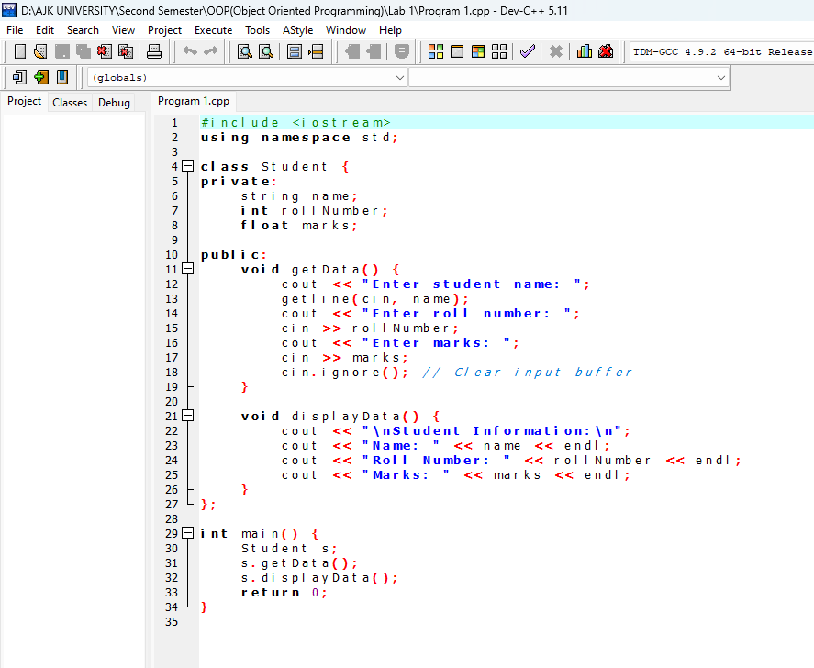

**Output:**  
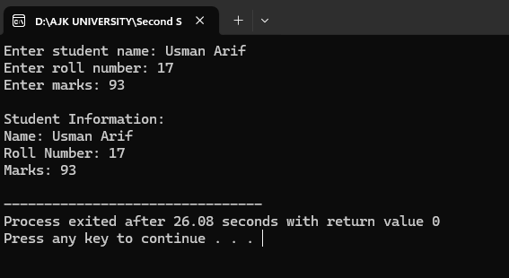

## Task 2: Rectangle Area and Perimeter

### Objective:

To create a class Rectangle with member functions outside the class to set dimensions, calculate area, and perimeter.

### Attributes:

- int length – Length of the rectangle.

- int width – Width of the rectangle.

### Member Functions (Outside Class):

- setDimensions() – Sets length and width.

- area() – Calculates the area of the rectangle.

- perimeter() – Calculates the perimeter.

### Code:

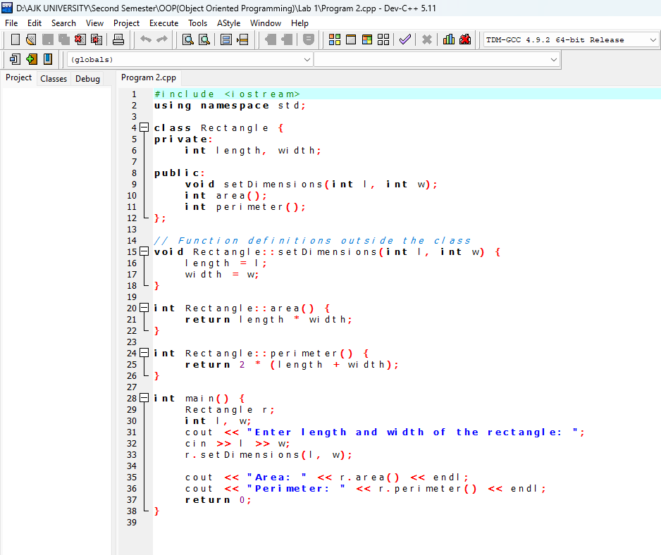

**Output:**

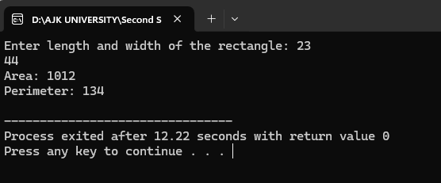

## Task 3: Simple Calculator

### Objective:

To create a Calculator class that can perform basic arithmetic operations using member functions outside the class.

### Attributes:

- float num1 – First number.

- float num2 – Second number.

### Member Functions:

- setNumbers() – Sets the two numbers.

- add() – Adds the numbers.

- subtract() – Subtracts the numbers.

- multiply() – Multiplies the numbers.

- divide() – Divides the numbers (with zero-check).

### Code:

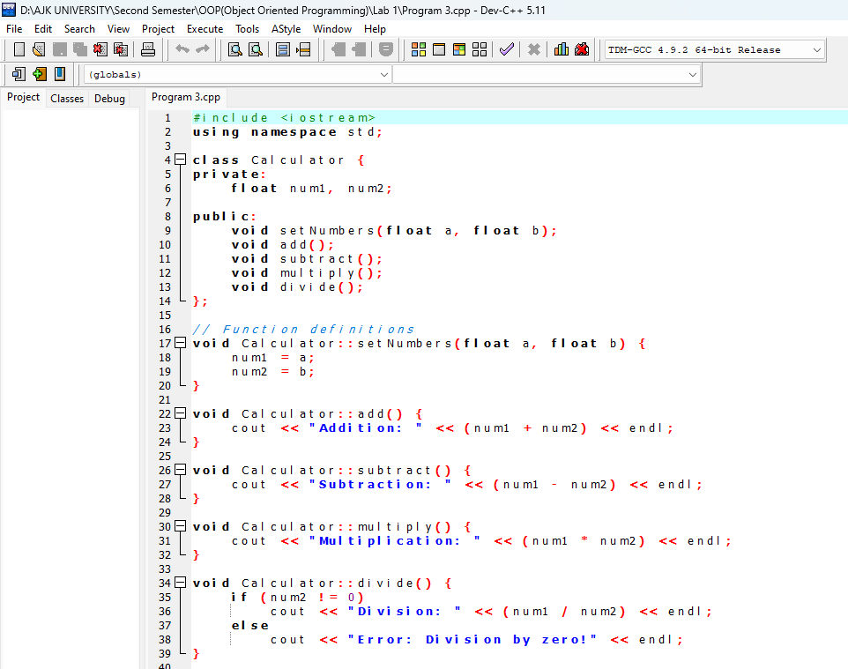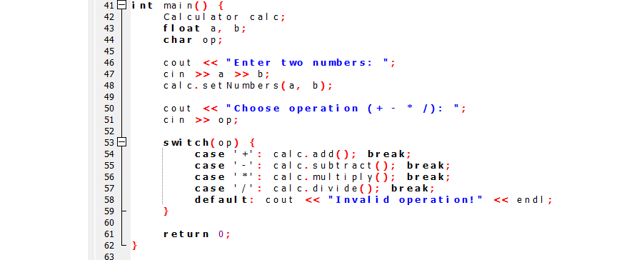

**Output:**

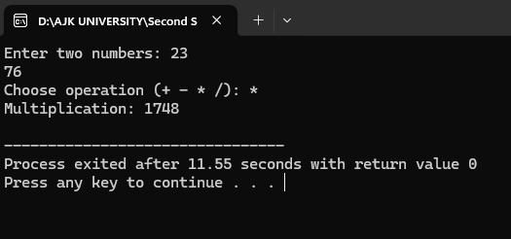

## Conclusion:

These three tasks help in understanding the fundamentals of object-oriented programming in C++, including:  
- Working with classes and objects.  
- Using member functions inside and outside the class.  
- Performing arithmetic and geometric calculations.  
- Applying encapsulation and data hiding.