Pet Sync - Pet E-Care, E-Commerce, and Community
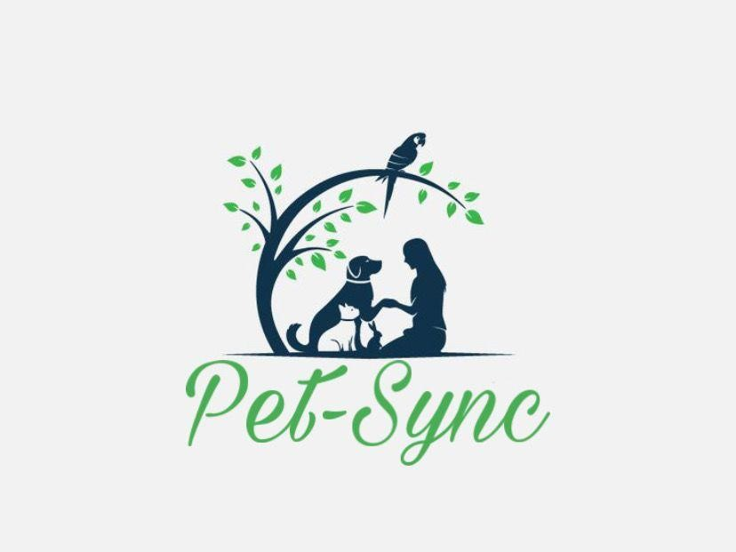

FYP Team Muhammad Sameed 20F-0116
Muhammad Usman Ashfaq 20F-0115 Minahil Ali 20F-1088

Supervised by Mr. Asif Ameer

Co-Supervised by Mam Faryal Saud

Department of Computer Science
National University of Computer and Emerging Science Chiniot, Pakistan
2023

Contents

- Introduction: 1
- Vision Document 1
  - Problem Statement: 1
  - Business Opportunity 2
  - Objectives: 3
  - Scope 3
  - Constraints: 4
  - Stakeholder and User Descriptions: 5
    - Market Demographics: 5
 Age Group: 5
 Gender: 5
 Location: 6
 Types of Pets Owned: 6
 Pet Ownership Experience 6
 Technology Adoption: 6
 Socioeconomic Status: 6
    - Stakeholder Summary: 6
 Investors: 6
 Development Team: 6
 Pet Owners and Caregivers: 7
 Veterinarians and Pet Care Professionals: 7
 Pet Care Product Vendors: 7
 Administrators and Moderators: 7
    - User Environment for Pet Sync (Web-Based System) 8
Device Diversity: 8
Operating Systems: 8
Connectivity Options: 8
Geographic Location 8
User Behavior: 8
User Preferences: 8
Internet Accessibility: 8
Accessibility Considerations: 8
    - Stakeholder Profiles: 9
 Stakeholder Profile 1: Investor 9
 Stakeholder Profile 2: Lead Developer 9
 Stakeholder Profile 3: Pet Owner and User 9
 Stakeholder Profile 4: Veterinarian and Pet Care Professional 9
 Stakeholder Profile 5: Pet Care Product Vendor 9
 Stakeholder Profile 6: Administrator/Moderator 9
- System Requirement Specification 3.1. System Features: 10
  - Functional Requirements 10
    - User Registration and Profile Management: 10
    - Pet Health Tracking: 10
    - Appointment Scheduling: 10
    - Social Networking 10
    - E-commerce Platform: 11
    - Telehealth Consultations 11
    - Pet Activity Tracking: 11
    - Nutrition and Diet Planning: 11
    - Emergency Services Locator: 11
  - Non-Functional Requirements 11
    - Performance 11
    - Security: 11
    - Usability: 12
    - Reliability: 12
    - Scalability and Availability: 12
    - Compliance and Legal: 12
    - Performance Monitoring: 12
    - Third-Party Integrations: 12
  - Analysis and Design Artifacts 13
      - Business Modeling: 13
        - Domain Model: 13
      - Use Case Model: 14
        - Use case Diagram: 14
        - High level Use cases: 15
2.2.1. Registration: 15
2.2.2. Register Veterinarian: 15
2.2.3. Register Pet Store: 15
2.2.4. Buying Pet: 16

Introduction:
Pet-Sync is an innovative web-based ecosystem for pet care that aims to transform pet ownership. This complete platform gives pet owners an all-in-one solution by seamlessly integrating pet care management, health tracking, social networking, e-commerce, and veterinary services. Users may effectively manage the health of pets by monitoring their medical history, diet, and daily activities. Additionally, they may interact with a thriving pet care community to exchange experiences and get guidance. Pet-Sync is a safe online marketplace where customers may buy pets, pet food, and accessories. Additionally, it guarantees rapid access to emergency services and veterinarian consultations using location-based information. Pet-Sync enables pet owners to provide their furry friends with the finest care possible while taking advantage of a seamless and intelligent pet care experience.

Vision Document

Problem Statement:
The problem of disconnected and inefficient pet care management affects pet owners, veterinarians, and pet enthusiasts alike. The impact of this problem is the lack of a holistic and streamlined approach to pet care, resulting in missed health updates, nutrition imbalances, and fragmented social interactions within the pet-loving community.

Pet owners often struggle to keep track of their pets' health records, feeding schedules, and training progress, leading to suboptimal pet well-being. Additionally, the absence of a unified platform for pet enthusiasts to connect and share experiences creates a fragmented community.

A successful solution would include the development of a comprehensive web-based pet e- care system that seamlessly integrates pet nutrition analysis and tracking, AI-driven insights, e-commerce capabilities, and social networking features. This solution aims to empower pet owners with intelligent recommendations, facilitate online pet purchases, and foster a supportive community where pet lovers can connect, share, and grow together. The ultimate goal is to enhance the quality of pet care, trusted pet-purchases, and create a vibrant and interconnected pet care ecosystem and community.

Business Opportunity

The business opportunity for Pet Sync lies in tapping into the growing pet care and management industry, which presents several promising opportunities:

Growing Pet Ownership:

There is a continuous increase in pet ownership worldwide, with many people considering their pets as integral members of their families. This trend creates a substantial market for products and services related to pet care.

Tech-Savvy Pet Owners:

Pet owners are becoming increasingly tech-savvy and are actively seeking digital solutions to manage their pets' health, activities, and overall well-being. They are looking for convenient and efficient ways to stay connected with their pets and streamline their care routines.
Fragmented Pet Care Market: The pet care industry is vast and fragmented, encompassing various segments such as pet healthcare, nutrition, grooming, social interaction, and e-commerce. There is an opportunity to create an all-in-one platform like Pet Sync that integrates these segments into a unified and user-friendly interface.

E-Commerce Potential:

The e-commerce aspect of Pet Sync can capitalize on the demand for pet-related products and services. Pet owners are continually purchasing pet food, accessories, medications, and other essentials. Providing a trustworthy and convenient e-commerce platform can lead to significant revenue opportunities.

Data-Driven Insights:

By collecting data on pet health and care activities, Pet Sync can generate valuable insights for pet owners and veterinarians. These insights can lead to additional revenue streams, such as offering personalized health recommendations, pet insurance partnerships, or research collaborations.

Community Building:

The social networking component of Pet Sync can foster a loyal and engaged community of pet owners. This presents opportunities for user-generated content, advertising partnerships, and sponsored content from pet-related businesses.

Veterinary Collaboration:

Collaborating with veterinarians and pet care professionals can open doors to referral partnerships and premium services within the platform, such as telehealth consultations, emergency services, and specialized care recommendations.

Global Reach:

With the potential to scale the platform globally, Pet Sync can tap into diverse markets and cultures where pet ownership is a cherished practice.

Objectives:

Unified Pet Care Platform:

Develop a user-friendly, all-in-one platform that seamlessly integrates pet care, health tracking, social networking, and e-commerce.

Efficient Health Management:
Simplify pet health management by providing tools for tracking vaccinations, medications, vet appointments, and nutrition.

Community Building:

Foster an engaged and supportive pet care community where users can share experiences, seek advice, and connect with other pet owners.

Trustworthy E-commerce:

Offer a secure and diverse e-commerce platform for purchasing pets, pet food, and accessories, ensuring user trust and satisfaction.

Enhanced Veterinary Services:

Improve access to veterinary consultations and emergency services through location-based information and appointment scheduling.

User Support and Assistance:

Provide responsive customer support, help center resources, and AI-driven chatbot assistance to ensure a smooth user experience.

Admin Oversight:

Enable administrators to manage content, user accounts, and AI features to maintain platform integrity and user satisfaction.

Scope:
The scope of the Pet Sync project outlines the boundaries and extent of what the project aims to achieve. Pet Sync will serve as a comprehensive platform that integrates various aspects of pet care, including health management, social networking, e-commerce, and veterinary services. Pet owners will be able to track and manage their pets' health, including vaccinations, medications, vet appointments, and nutrition plans through user-friendly interfaces. Pet Sync will provide a space for pet owners to create profiles for their pets, connect with other pet owners, share experiences, seek advice, and build a supportive pet care community. The platform will feature a secure and diverse e-commerce section where users can purchase pets, pet food, accessories, medications, and other pet-related products. Pet Sync will facilitate improved access to veterinary consultations and emergency services through location-based information and appointment scheduling. The platform will offer responsive customer support, a comprehensive help center, and AI-driven chatbot assistance to ensure a smooth user experience. Administrators will have the tools and capabilities needed to manage content, user accounts, and AI features to maintain platform integrity and user satisfaction.

Constraints:
Here are some potential constraints for the Pet Sync project:

Budgetary Constraints:

Pet Sync may have budget limitations that affect the project's resources, including funding for development, marketing, and ongoing maintenance. Managing costs effectively is crucial.

Time Constraints:

The project may have deadlines or timeframes that must be met, such as launching the platform before a certain date or aligning with specific industry events or seasons.

Resource Availability:

Availability of human resources (developers, designers, support staff), hardware, software, and other essential resources may be limited, impacting project timelines and capabilities.

Technology Compatibility:

Pet Sync's functionalities may need to be compatible with various devices, operating systems, and web browsers, which can present technical challenges.

Data Privacy and Security Regulations:

The platform must comply with data privacy and security regulations, which may vary by region. Ensuring compliance can be a constraint that affects the project's design and operation.

Legal and Regulatory Compliance:

Pet Sync may need to adhere to local, national, or international laws and regulations related to e- commerce, pet care, and data handling. Non-compliance can lead to legal issues.

Scalability:

As the user base grows, the platform must be scalable to handle increased traffic, data, and user interactions. Scalability constraints may require additional infrastructure and resources.

User Adoption and Engagement:

Ensuring that users adopt and engage with the platform can be a constraint. Strategies for user onboarding and engagement need to be developed to address this challenge.

Technological Limitations:

Technical constraints, such as limitations in the platform's hosting capabilities, software compatibility, or integration with external systems, can impact the project's functionality.

Infrastructure and Hosting:

The availability and reliability of hosting services, servers, and infrastructure can impact the platform's uptime and performance.

Vendor Relationships:

Relying on third-party vendors for services such as payment processing, shipping, or cloud hosting can introduce constraints related to vendor availability, service quality, and costs.

User Feedback and Iteration:

Gathering and incorporating user feedback into the platform's development can be a constraint, as it may require additional development cycles and resources.

Cultural and Regional Differences:

Pet Sync may need to accommodate cultural and regional differences in pet care practices, preferences, and regulations, which can affect content and features.

Environmental Considerations:

Sustainability and eco-friendly practices may be important to users. Incorporating environmentally responsible practices can be a constraint that affects product design and sourcing.

Stakeholder and User Descriptions:

Market Demographics:
The target audience for Pet Sync encompasses a diverse range of pet owners and caregivers who are passionate about their pets' well-being and are seeking a convenient and comprehensive solution to enhance their pet care experience. Below is a breakdown of the key market demographics:

Age Group:

Young Adults (Ages 25-34): This group represents a significant portion of our target audience. They are often first-time pet owners or young families with pets.
Middle-Aged Adults (Ages 35-54): Middle-aged adults are well-represented among pet owners. They may have multiple pets and are looking for efficient ways to manage their pets' needs.

Gender:

Female: Women make up a substantial portion of pet owners and caregivers. They are typically involved in various aspects of pet care, including health management and purchasing pet-related products.
Male: The percentage of male pet owners is also notable, with an increasing trend of active involvement in pet care.

Location:

Urban and Suburban Areas: Pet owners in urban and suburban settings form a significant part of the user base. They seek solutions that align with their fast-paced lifestyles and offer convenience.
Rural Areas: Rural pet owners are also important users, often having larger properties and more outdoor space for their pets.

Types of Pets Owned:

Dogs: Dog owners make up a substantial portion of the user base. They are looking for services related to dog health, training, and social interaction.
Cats: Cat owners are also well-represented and seek solutions for cat health, grooming, and enrichment. Exotic Pets: A smaller but significant portion of users may have exotic pets, such as reptiles, birds, or small mammals, and look for specialized care information.

Pet Ownership Experience:

First-Time Pet Owners: A portion of users are first-time pet owners seeking guidance and support in pet care.
Experienced Pet Owners: Many users have owned pets for several years and have a wealth of experience but are looking for tools to streamline pet care.

Technology Adoption:

Tech-Savvy Users: A significant segment of our target audience is comfortable with technology and actively seeks digital solutions for pet care.
Moderate Tech Users: Some users may not be tech-savvy but are open to adopting user-friendly digital tools that simplify pet care.

Socioeconomic Status:

Varied Socioeconomic Backgrounds: Pet owners from various socioeconomic backgrounds are part of the target audience, with differing spending capacities on pet-related products and services.

Stakeholder Summary:

Investors:
Role: Investors provide financial backing and support for the Pet Sync project.
Responsibilities: They contribute funds for development, marketing, and scaling the platform. Interests: Investors are primarily interested in the project's long-term profitability and return on investment.
Importance: Investors play a crucial role in securing the necessary resources to bring Pet Sync to fruition and ensuring its sustainability.

Development Team:
Role: The development team consists of software engineers, designers, and technical experts responsible for building and maintaining the Pet Sync platform.
Responsibilities: They are tasked with developing the platform's features, ensuring its technical functionality, and addressing any technical challenges.
Interests: The development team is interested in the successful implementation of their technical work and the platform's usability.
Importance: The expertise and dedication of the development team are essential for the platform's functionality and user experience.

Pet Owners and Caregivers:
Role: Pet owners and caregivers are the primary end-users of Pet Sync, utilizing the platform to manage their pets' health, connect with other pet owners, and access e-commerce services.
Responsibilities: They actively engage with the platform's features, contribute content, and rely on it for pet care needs.
Interests: Pet owners and caregivers seek convenience, efficiency, and reliable information for pet care and well-being.
Importance: The satisfaction and engagement of pet owners are critical for the platform's success, as they form the user base and drive its growth.

Veterinarians and Pet Care Professionals:
Role: Veterinarians and pet care professionals provide expertise and guidance related to pet health and care within the platform.
Responsibilities: They may offer telehealth consultations, contribute articles, and provide recommendations to pet owners.
Interests: Veterinarians and pet care professionals are interested in expanding their reach and providing valuable insights to pet owners.
Importance: Collaboration with veterinarians enhances the platform's credibility and ensures that users receive accurate and trusted pet care information.

Pet Care Product Vendors:
Role: Pet care product vendors include suppliers of pet food, accessories, medications, and other pet- related products available on the e-commerce platform.
Responsibilities: They manage product listings, transactions, and customer service related to their offerings.
Interests: Vendors are interested in showcasing their products to a wide audience and generating sales. Importance: Pet care product vendors contribute to the platform's revenue and the diversity of products available to users.

Administrators and Moderators:
Role: Administrators and moderators are responsible for overseeing content, user accounts, and the platform's integrity.
Responsibilities: They manage platform policies, address user issues, and maintain a safe and positive environment.
Interests: Their interests lie in ensuring the platform is well-moderated, secure, and aligned with its objectives.
Importance: Administrators and moderators play a vital role in creating a welcoming and trusted community within the platform.

User Environment for Pet Sync (Web-Based System)

The user environment for Pet Sync, as a web-based system, is diverse and dynamic, catering to a wide range of pet owners and caregivers who are seeking a comprehensive and user-friendly platform for managing their pets' health and well-being. This environment encompasses various aspects:

Device Diversity:

Desktop Computers: Some users, particularly when engaged in detailed pet care management tasks, will access Pet Sync through desktop computers for a larger screen and extended functionality.
Tablets: Tablet users may prefer the platform's versatility for tasks like reading articles, participating in the community, and shopping for pet-related products.

Operating Systems:

Pet Sync will be accessible through web browsers on desktop computers across multiple operating systems, including Windows, macOS, and Linux.
Web Browsers:

Users accessing Pet Sync via web browsers will have compatibility with popular browsers like Google Chrome, Mozilla Firefox, Safari, and Microsoft Edge to ensure a seamless online experience.

Connectivity Options:

Pet Sync users will rely on various connectivity options, including Wi-Fi, broadband connections, and mobile data, depending on their location and device capabilities.

Geographic Location:

Users will be located in various geographic regions, including urban, suburban, and rural areas. This diversity in location may influence their pet care needs and preferences.

User Behavior:

Pet owners will engage with Pet Sync at different times of the day, depending on their schedules and pet care routines. Some users may have regular interactions, while others may use the platform intermittently for specific needs.

User Preferences:

User preferences for interaction and engagement may vary. Some may prefer to use Pet Sync through web browsers on their desktop or tablet for in-depth tasks and exploration of features.

Internet Accessibility:

Users' internet accessibility may vary. While urban areas generally have reliable high-speed internet connections, rural areas may have varying levels of internet access, which could influence their usage patterns.

Accessibility Considerations:
Pet Sync will prioritize accessibility, ensuring that the web-based platform is usable by individuals with disabilities, including those who rely on screen readers or other assistive technologies. Accessibility features will be integrated into the web interface to provide an inclusive user experience.

Stakeholder Profiles:

Stakeholder Profile 1: Investor

Role: Investor
Responsibilities: Provide financial support, monitor project progress, and evaluate return on investment.
Interests: Financial returns, project success, long-term profitability.
Influence: High influence due to financial backing; decisions can impact project direction and resource allocation.

Stakeholder Profile 2: Lead Developer

Role: Lead Developer
Responsibilities: Oversee technical development, coordinate development team, ensure technical integrity.
Interests: Technical excellence, platform functionality, user experience.
Influence: High influence on technical aspects and feature implementation.

Stakeholder Profile 3: Pet Owner and User

Role: End User (Pet Owner)
Responsibilities: Utilize the platform for pet care, health tracking, social interaction, and e-commerce. Interests: Efficient pet care, access to valuable information, community engagement, product quality. Influence: High influence collectively as the user base; their satisfaction drives platform success.

Stakeholder Profile 4: Veterinarian and Pet Care Professional

Role: Veterinary Advisor
Responsibilities: Provide expert advice on pet health, participate in telehealth consultations, contribute content.
Interests: Enhancing pet care standards, reaching a broader audience, professional reputation.
Influence: High influence on the credibility and trustworthiness of health-related content and services.

Stakeholder Profile 5: Pet Care Product Vendor

Role: Product Vendor Partner
Responsibilities: List and manage products on the e-commerce platform, handle customer transactions and inquiries.
Interests: Expanding product reach, increasing sales, positive user feedback.
Influence: High influence on the diversity of products available and revenue generation.

Stakeholder Profile 6: Administrator/Moderator

Role: Administrator/Moderator
Responsibilities: Oversee platform policies, user accounts, and content, ensuring a safe and positive environment.

Interests: Platform integrity, user safety, adherence to guidelines.
Influence: High influence on maintaining platform quality and safety.

System Requirement Specification
        - System Features:

User Registration and Authentication
      - User Settings and Notifications

User Support and Help Center
      - Pet Profile Management

Behavior and Training Logs
      - Health Tracking and Reminders

Feeding Schedule and Nutrition Management
      - Pet-Friendly Recipes and Nutrition Analysis

Activity Tracking
      - Pet Memories and Milestones

AI Integration: Natural Language Chatbot
      - AI Integration: Personalized Recommendations

Social Platform and Networking
      - E-Commerce: Pet Purchase

Vet Consultations and appointments
      - Admin Control

Functional Requirements

User Registration and Profile Management:
Users must be able to create accounts with a unique username and password.
Users should have the option to register using social media accounts for convenience.
Users must provide basic profile information, including name, email address, and contact details. Users should be able to create and manage profiles for their pets, including adding photos and important pet information.

Pet Health Tracking:
Users should be able to record and update their pets' health records, including vaccinations, medications, and medical history.
The system should send reminders for upcoming vaccinations and medication doses.
Users should have access to a pet health calendar that displays past and upcoming health-related events. The platform should generate health reports and summaries based on the entered data.

Appointment Scheduling:
Users must be able to schedule vet appointments, grooming sessions, and other pet-related appointments.
The system should provide a calendar view with available time slots and allow users to select suitable appointment slots.
Users should receive email or push notifications to remind them of scheduled appointments.

Social Networking:
Users should be able to create and customize profiles for their pets within the social networking feature. The platform should allow users to search for and connect with other pet owners.

Users must be able to post photos, stories, and updates related to their pets on their profiles. Users should be able to join and participate in pet-related communities, forums, and groups.

E-commerce Platform:
Users should be able to browse and search for pet-related products in an organized manner. The system should display product details, including descriptions, prices, and user reviews. Users should be able to add products to a shopping cart and proceed with secure transactions. The platform should provide order tracking and status updates for purchased items.

Telehealth Consultations:
Users should be able to request telehealth consultations with veterinarians and pet care professionals. The system should facilitate video or chat-based consultations with professionals.
Users must be able to view the profiles and credentials of available professionals before scheduling consultations.

Pet Activity Tracking:
Users should be able to record and monitor their pets' activities and exercise routines. The system should allow users to set activity goals for their pets and track progress.
Users should receive recommendations for appropriate activities based on their pets' breed, age, and health.

Nutrition and Diet Planning:
Users should have access to a database of pet food products with detailed nutritional information. The platform should provide tools for creating customized diet plans for pets based on dietary requirements and preferences Users must receive alerts and recommendations for feeding schedules and portion sizes.

Emergency Services Locator:
Users should be able to access a map-based service that displays nearby veterinary clinics, emergency services, and pet care facilities.
The system should provide contact information and directions to these locations in case of emergencies.

Non-Functional Requirements

Performance:
Response Time: The platform should respond to user interactions within 2 seconds for most operations to ensure a responsive user experience.
Scalability: The system should be designed to handle a growing user base and increased data volume without significant degradation in performance.
Load Testing: Regular load testing should be conducted to ensure that the platform can handle peak user loads without crashing or slowing down.

Security:
Data Encryption: All user data, including personal information and health records, must be encrypted both in transit and at rest to ensure data security.
Access Control: Access to user data and features should be role-based and tightly controlled to prevent unauthorized access.
Authentication: Users should be required to use strong passwords and multi-factor authentication for added security.
Data Backup: Regular data backups should be performed to prevent data loss in case of system failures or data breaches.

Usability:
User-Friendly Design: The platform should have an intuitive and user-friendly interface to accommodate users of all tech-skill levels.
Accessibility: The platform should adhere to accessibility standards, ensuring that it is usable by individuals with disabilities.
Consistency: The user interface should maintain a consistent look and feel across different devices and screen sizes.
Mobile Responsiveness: The platform should be fully responsive on mobile devices to accommodate users on smartphones and tablets.

Reliability:
Uptime: The system should aim for 99.9% uptime, with minimal scheduled downtime for maintenance and updates.
Error Handling: Comprehensive error handling and reporting mechanisms should be in place to notify administrators and users of issues promptly.

Scalability and Availability:
Horizontal Scalability: The architecture should support horizontal scaling to accommodate increased traffic and users.
Redundancy: Redundant servers and failover mechanisms should be in place to ensure high availability and fault tolerance.

Compliance and Legal:
Data Privacy: The platform must comply with relevant data protection regulations, such as GDPR, HIPAA, or local data privacy laws.
Legal Requirements: The system should adhere to all relevant legal and regulatory requirements related to e-commerce, pet care, and health information.

Performance Monitoring:
Logging and Monitoring: The system should log user activities and errors for auditing and troubleshooting purposes. Real-time monitoring should track system performance and user activity.

Third-Party Integrations:
API Integration: The platform should provide well-documented APIs to enable third-party integrations, such as payment gateways and external data sources.

Analysis and Design Artifacts

Business Modeling

  - Domain Model

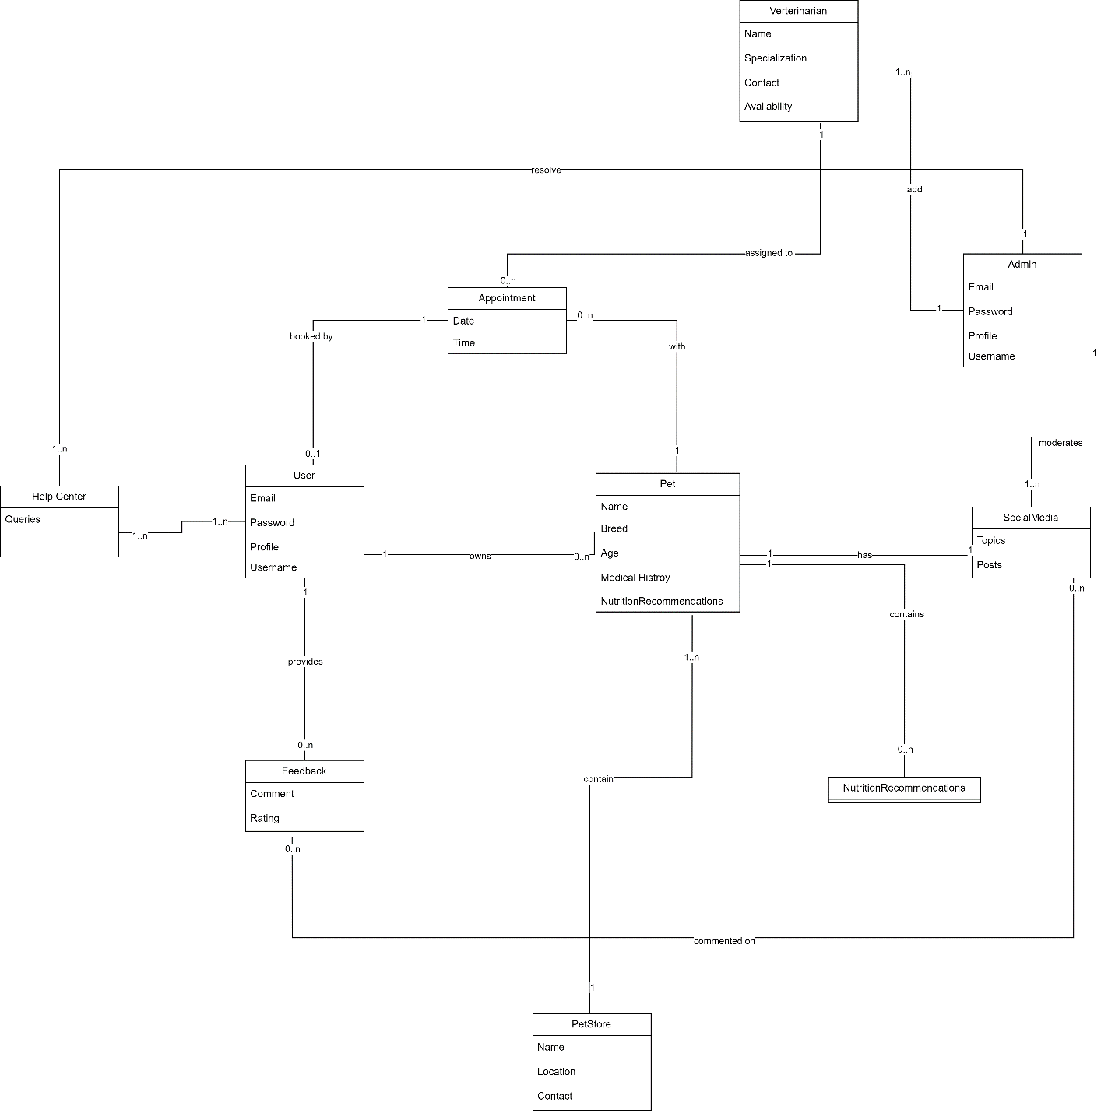

Figure 1Domain Model for Pet-Sync

- Use Case Models
  - Use Case Diagram
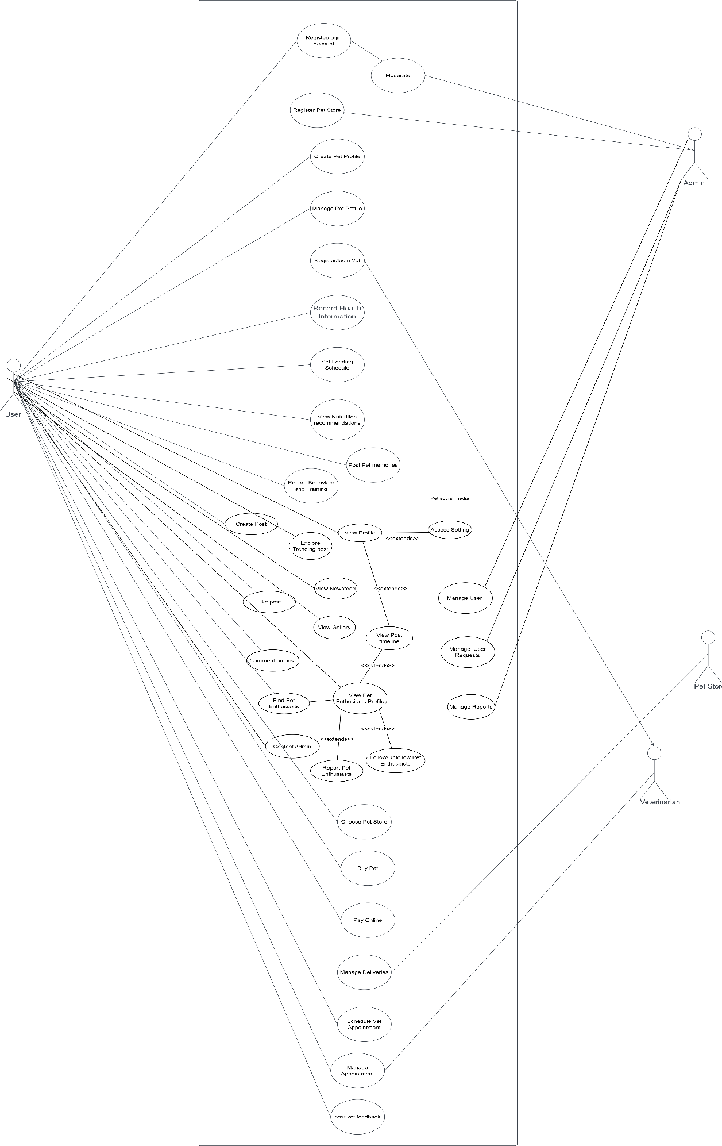

Figure 2 Use Case diagram for Pet-Sync

  - High level Use Cases

    - Registration

Use case ID | 01
User case Name | Registration
Actor | User (Pet Owner)
Type | Primary
Description | The user (pet owner) will create an account by providing their details and credentials. Registration enables users to access various features and services within the pet care system.

    - Register Veterinarian

Use case ID | 02
Use case Name | Register Veterinarian
Actor | Vet
Type | Primary
Description | Vets can create veterinarian account by entering their professional details and credentials. Vet Registration allows veterinarians to offer their services within the pet care system.

    - Register Pet Store

Use case ID | 03
Use case Name | Register Pet Store
Actor | Administrator
Type | Primary
Description | Administrators can create pet store accounts by entering their store details and credentials. Registration allows pet stores to list their services and pets within the pet care system.

    - Buying Pet

Use case ID | 04
Use case Name | Buying Pet
Actor | Pet Owner
Type | Primary
Description | Pet owners can browse and purchase pets from registered pet stores within the pet care system. The purchase process may involve selecting a pet, making a payment, and arranging for pet delivery or pickup.

    - Feedback

Use case ID | 05
Use case Name | Feedback
Actor | Pet Owner, Admin
Type | Primary
Description | Pet owners can provide feedback and reviews about their experiences with various services, pet stores, and veterinarians within the pet care system. This feedback can help improve services and assist other pet owners in making informed decisions. The admin would resolve patient quires.

    - Authentication

Use case ID | 06
Use case Name | Authentication
Actor | User (Pet Owner, Veterinarian, Administrator)
Type | Primary
Description | Users must authenticate themselves to access the pet care system. Authentication involves verifying the user's identity through their credentials (e.g., username and password) to ensure secure access to the system.

    - Create Pet Profile

Use case ID | 07
Use case Name | Create Pet Profile
Actor | Pet Owner
Type | Primary
Description | Pet owners can create and manage profiles for their pets within the pet care system. Creating a pet profile involves providing details such as the pet's name, breed, age, and other relevant information.

    - View Nutrition Recommendations

Use case ID | 08
Use case Name | View Nutrition Recommendations
Actor | Pet Owner
Type | Primary
Description | Pet owners can access nutrition recommendations and information for their pets within the pet care system. This feature provides insights into the dietary needs and recommendations for different pet breeds and types.

    - Connect with Pet Enthusiasts

Use case ID | 09
Use case Name | Connect with Pet Enthusiasts
Actor | Pet Owner
Type | Primary
Description | Pet owners can connect with other pet enthusiasts within the pet care system. This feature enables pet owners to build a network, share experiences, post, comment and like content related to pets and pet care.

    - Schedule Vet Appointment

Use case ID | 10
Use case Name | Schedule Vet Appointment
Actor | Vet, Pet owner
Description | Pet owner will choose the vet based on their preferences and schedule the appointment according to his/her prefer date.

    - Record Health Information

Use case ID | 11
Use case Name | Record Health Information
Actor | Pet Owner
Description | Pet owners can record and manage their pet's health information, including vaccinations, medications, and medical history.

    - Manage pet profile.

Use case ID | 12
Use case Name | Manage Pet Profile
Actor | Pet Owner
Description | Pet owners can manage profiles for their pets, including updating pet information, and keeping track of important details.

    - Set feeding Schedule.

Use case ID | 13
Use case Name | Set Feeding Schedule
Actor | Pet Owner
Description | Pet owners can set up and manage feeding schedules for their pets, specifying mealtimes and portion sizes

    - Post pet memories

Use case ID | 14
Use case Name | Post Pet Memories
Actor | Pet owner
Description | Pet owners can create and share memories of their pets, including photo and abouts privately.

    - Record Behaviors and Training

Use case ID | 15
Use case Name | Record Behaviors and Training
Actor | Pet Owner
Description | Pet owners can record and track their pet's behaviors and training progress, including notes and observations.

  - Expanded Use Cases

    - Schedule Vet Appointment

Use case ID | 01
Use case Name | Schedule Vet Appointment
Actor | Vet, Pet owner
Description | Pet owner will choose the vet based on their preferences and schedule appointment.
Trigger | Pet owner selects the appointment button
Pre-Condition | Pet owner must me logged in
Post-Condition | Pet owner will get the schedule appointment
Normal flow | 1. Click on the Vet to see all the Vets.  2. Select the Vet  3. Book an Appointment
Alternative flow | No alternative flow
Special Requirements | Availability of internet
Frequency of use | High
Assumption | The pet owner intends to view vet profile for appointment

    - Record Health Information

Use case ID | 02
Use case Name | Record Health Information
Actor | Pet Owner
Description | Pet owners can record and manage their pet's health information, including vaccinations, medications, and medical history.
Trigger | Pet owner selects the "Record Health Information" option.
Pre-Condition | Pet owner must be logged in.
Post-Condition | Health information is successfully recorded and stored in the pet's profile.
Normal flow | 1. Pet owner clicks on the "Record Health Information" option.  2. The system displays the pet's profile and health information section.  3. Pet owner selects the type of health information they want to record (e.g., vaccination, medication).  4. The system prompts the pet owner to enter details, such as the date, type, and description of the health event.  5. Pet owner provides the required information.  6. The system validates the information and stores it in the pet's profile.  7. The recorded health information is displayed in the pet's profile for reference.
Alternative flow | None
Special Requirements | Availability of an internet connection
Frequency of use | Moderate
Assumption | The pet owner has the necessary information about their pet's health event to record it accurately.

    - Manage Pet Profile

Use case ID | 03
Use case Name | Manage Pet Profile
Actor | Pet Owner
Description | Pet owners can manage profiles for their pets, including updating pet information, and keeping track of important details.
Trigger | Pet owners select the "Manage Pet Profile" option.
Pre-Condition | Pet owners must be logged in.
Post-Condition | Pet profile is successfully managed and updated.
Normal flow | 1. Pet owner clicks on the "Manage Pet Profile" option.  2. The system displays a list of the pet owner's registered pets.  3. Pet owner selects the pet they want to manage.  4. The system shows the selected pet's profile page.  5. Pet owners can update pet information, including name, breed, age, and any other relevant details.  6. The system saves the updated pet profile information.
Alternative flow | None
Special Requirements | Availability of an internet connection
Frequency of use | Moderate
Assumption | The pet owner has the necessary information and images to update the pet's profile.

    - Set Feeding Schedule

Use case ID | 04
Use case Name | Set Feeding Schedule
Actor | Pet Owner
Description | Pet owners can set up and manage feeding schedules for their pets, specifying mealtimes and portion sizes
Trigger | Pet owner selects the "Set Feeding Schedule" option
Pre-Condition | Pet owner must be logged in
Post-Condition | Feeding schedule is successfully set up and saved
Normal flow | 1. Pet owner clicks on the "Set Feeding Schedule" option.  2. The system displays a list of the pet owner's registered pets.  3. Pet owner selects the pet for which they want to set up a feeding schedule.  4. The system shows the selected pet's feeding schedule page.  5. Pet owner specifies the mealtimes (e.g., breakfast, lunch, dinner) for each day of the week.  6. For each meal, the pet owner enters portion sizes or selects from predefined options.  7. Pet owner saves the feeding schedule.  8. The system stores the feeding schedule in the pet's profile for future reference.
Alternative flow | None
Special Requirements | Availability of an internet connection
Frequency of use | Moderate
Assumption | The pet owner has a clear understanding of their pet's feeding requirements and schedule.

    - Post Pet Memories

Use case ID | 05
Use case Name | Post Pet Memories
Actor | Pet owner
Description | Pet owners can create and share memories of their pets, including photos and about privately.
Trigger | Pet owner selects the "Post Pet Memories" option.
Pre-Condition | Pet owner must be logged in.
Post-Condition | Pet memories are successfully posted and shared with the community.
Normal flow | 1-Pet owner clicks on the "Post Pet Memories" option.  2. The system displays a form for creating a new pet memory post.  3. Pet owners can upload photos.  4. Pet owners can add a title and description to the memory.  5. Pet owner confirms and submits the pet memory post.  6. The system processes the post and displays it in the pet owner's pet profile.
Alternative flow | None
Special Requirements | Availability of an internet connection
Frequency of use | Moderate to high
Assumption | Pet owners want to save there pet memories.

    - Record Behaviors and Training

Use case ID | 06
Use case Name | Record Behaviors and Training
Actor | Pet Owner
Description | Pet owners can record and track their pet's behaviors and training progress, including notes and observations.
Trigger | Pet owners select the "Record Behaviors and Training" option.
Pre-Condition | Pet owner must be logged in.
Post-Condition | Behaviors and training records are successfully recorded and stored.
Normal flow | 1. Pet owner clicks on the "Record Behaviors and Training" option.  2. The system displays a form for recording behaviors and training sessions.  3. Pet owners select the pet for which they want to record behaviors and training.  4. Pet owner enters the date and time of the training session or behavior observation.  5. Pet owner describes the behavior or training session, including any specific details or notes.  6. The system allows pet owners to categorize the record (e.g., behavior, training, milestone).  7. Pet owner confirms and saves the record.  8. The system stores the behavior and training records in the pet's profile for future reference.
Alternative flow | None
Special Requirements | Availability of an internet connection
Frequency of use | Moderate
Assumption | Pet owners want to keep track of their pet's behaviors and training progress for reference and training improvement.

    - View Nutrition Recommendations

Use case ID | 07
Use case Name | View Nutrition Recommendations
Actor | Pet Owner
Description | Pet owners can access nutrition recommendations and information for their pets within the pet care system. This feature provides insights into the dietary needs and recommendations for different pet breeds and types.
Trigger | Pet owner selects the "View Nutrition Recommendations" option.
Pre-Condition | Pet owner must be logged in.
Post-Condition | Pet owner successfully views nutrition recommendations for their pet.
Normal flow | 1. Pet owner selects the "View Nutrition Recommendations" option.  2. The system displays a nutrition recommendations page.  3. Pet owners can search for nutrition recommendations by specifying their pet's breed, age, and any other relevant details.  4. The system provides a list of nutrition recommendations and information tailored to the pet owner's pet.  5. Pet owner can read and access detailed nutrition recommendations, including diet plans and feeding guidelines.
Alternative flow | None
Special Requirements | 1. Availability of an internet connection  2. Access to up-to-date and accurate nutrition information
Frequency of use | Occasional (whenever a pet owner seeks nutrition advice for their pet)
Assumption | Pet owners accessing nutrition recommendations intend to provide their pets with the best possible diet and care, based on expert advice within the pet care system.

    - Connect with Pet Enthusiasts

Use case ID | 08
Use case Name | Connect with Pet Enthusiasts
Actor | Pet Owner
Description | Description: Pet owners can connect with other pet enthusiasts within the pet community system. This feature enables pet owners to build a network, share experiences, and engage in discussions related to pets and pet care.
Trigger | Pet owner selects the "Connect with Pet Enthusiasts" option.
Pre-Condition | Pet owner must be logged in.
Post-Condition | Pet owner successfully connects with other pet enthusiasts and can participate in community.
Normal flow | - Pet owner selects the "Connect with Pet Enthusiasts" option.  - The system displays a community or forum where pet owners can connect with each other.  - Pet owners can browse through discussions, topics, and profiles of other pet enthusiasts.  - Pet owners can initiate connections by following other pet enthusiasts.  - Pet owner can participate in discussions, share experiences, ask questions, and offer advice to other members of the community.  - Pet owner can report inappropriate content or behavior, which is then reviewed by the admin for moderation. The admin has the authority to take actions such as blocking or neglecting reported content or user requests.  - Admin can manage users, including actions like deleting users, blocking users, or unblocking users. There is also a contact admin support option for pet owners to reach out in case of any issues.  - The system includes core features such as a newsfeed, user profiles, search functionality for other user profiles, following/unfollowing users, creating posts, liking posts, commenting on posts, and a gallery for user posts.  - Pet owners can access settings to update their social media profiles and find other people within the community.  - Alternative flow: None  - Special Requirements:  - Availability of an internet connection.  - A user-friendly community or forum interface for discussions.  - Frequency of use: Varies (depends on the pet owner's interest in connecting with other pet enthusiasts).
Alternative flow | None
Special Requirements | 1. Availability of an internet connection  2. A user-friendly community or forum interface for discussions.
Frequency of use | Varies (depends on the pet owner's interest in connecting with other pet enthusiasts)
Assumption | Assumption: Pet owners connecting with pet enthusiasts intend to build a network, share knowledge, and engage in discussions related to pets and pet care within the pet community system.

    - Buying Pet

Use case ID | 09
Use case Name | Buying Pet
Actor | Pet Owner
Description | Pet owners can browse and purchase pets from registered pet stores within the pet care system. The purchase process may involve selecting a pet, making a payment, and arranging for pet delivery or pickup.
Trigger | Pet owner selects the "Buy Pet" option.
Pre-Condition | Pet owner must be logged in.
Post-Condition | Pet owner successfully purchases a pet from a registered pet store.
Normal flow | 1. Pet owner clicks on the "Buy Pet" option.  2. The system displays a list of available pets from registered pet stores.  3. Pet owners browses through the list of pets, filtering by criteria such as breed, age, and location.  4. Pet owner selects a pet they wish to purchase.  5. The system provides detailed information about the selected pet, including price, location, and store details.  6. Pet owner confirms their decision to buy the pet.  7. If applicable, the system facilitates the payment process, allowing pet owners to make the payment through secure methods such as credit card or online payment gateway.  8. The system notifies the pet store about the purchase.  9. Pet store arranges for pet delivery or pickup based on the pet owner's preference.  10. Pet owner receives the purchased pet.
Alternative flow | If the selected pet is no longer available, the system notifies the pet owner and provides alternatives.
Special Requirements | 1. Availability of an internet connection  2. Secure payment processing
Frequency of use | Occasional
Assumption | Pet owners interested in buying pets intend to make purchases through the pet care system from registered pet stores.

    - - Create Post
Use case ID
Use case Name | Create Post
Actor | Pet Owner
Description | User creates a new post to share content with others.
Trigger | User selects the "Create Post" button.
Pre-Condition | User must be logged in.
Post-Condition | New post is successfully published.
Normal flow | - User navigates to the "Create Post" section.  - User selects the type of content to share (text, image, video, etc.).  - User writes the content and attaches any relevant media.  - User adds hashtags or tags to categorize the post.  - User clicks the "Post" button to publish the content.
Alternative flow | No alternative flow
Special Requirements | none
Frequency of use | High
Assumption | User has permission to create posts.

2.3.11- Like Post
Use case ID
Use case Name | Like Post
Actor | Pet Owner
Description | User likes a post to show appreciation or support.
Trigger | User selects the "Like" button beneath a post.
Pre-Condition | User must be logged in and viewing a post.
Post-Condition | Like is successfully registered for the post.  Normal flow:.
Normal flow | - User scrolls through the newsfeed or explores a specific post.  - User finds a post they want to like.  - User clicks the "Like" button beneath the post.
Alternative flow | No alternative flow
Special Requirements | none
Frequency of use | High
Assumption | User has permission to create posts.

2.3.12- Comment Post

Use case ID
Use case Name | Comment on Post
Actor | Pet Owner
Description | User adds a comment to engage with a post or share their thoughts.
Trigger | User selects the "Comment" option beneath a post..
Pre-Condition | User must be logged in and viewing a post.
Post-Condition | Comment is successfully added to the post.
Normal flow | - User scrolls through the newsfeed or explores a specific post.  - User finds a post they want to comment on.  - User clicks the "Comment" option beneath the post.  - User types their comment in the provided text field.  - User clicks the "Post" button to submit the comment.
Alternative flow | No alternative flow
Special Requirements | none
Frequency of use | High
Assumption | User has permission to create posts.

2.3.13- Explore
Use case ID
Use case Name | Explore Trending Post
Actor | Pet Owner
Description | User explores posts that are currently trending or popular.
Trigger | User selects the "Explore Trending" option.
Pre-Condition | User must be logged in.
Post-Condition | User views trending posts.
Normal flow | - User navigates to the "Explore" section.  - User selects the "Trending" tab or option.  - User browses through the list of trending posts.
Alternative flow | No alternative flow
Special Requirements | none
Frequency of use | Medium
Assumption | The system accurately identifies and displays trending posts.

2.3.14- View Pet Enthusiast Profile
Use case ID
Use case Name | View Pet Enthusiast Profile
Actor | Pet Owner
Description | User views the profile of another user.
Trigger | User selects the profile of another user.
Pre-Condition | User must be logged in.
Post-Condition | User successfully views the profile of the selected user.
Normal flow | - User searches for or navigates to the profile of another user.  - User selects the profile of the desired user.  - User is directed to the profile page displaying information about the user.
Alternative flow | No alternative flow
Special Requirements | none
Frequency of use | Medium
Assumption | The user can view other users' profiles.

2.3.15- View Newsfeed

2.3.16- Report Pet Enthusiastic

2.3.17- Follow/Unfollow Pet Enthusiastic

2.3.18- Contact Admin

2.3.19- Manage Setting

2.3.20- Find Pet Enthusiastic

2.3.21- View gallery

2.3.22- Manage User

2.3.23- Manage User Requests

2.3.24- Manage Reports

  - System Sequence Diagram

    - Book Appointment

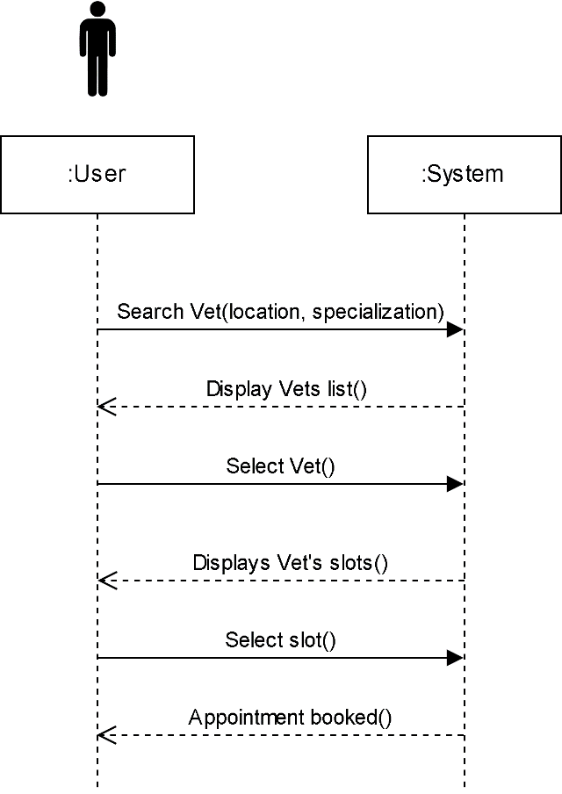

Figure 3 Book Appointment SSD

    - Buy Pet

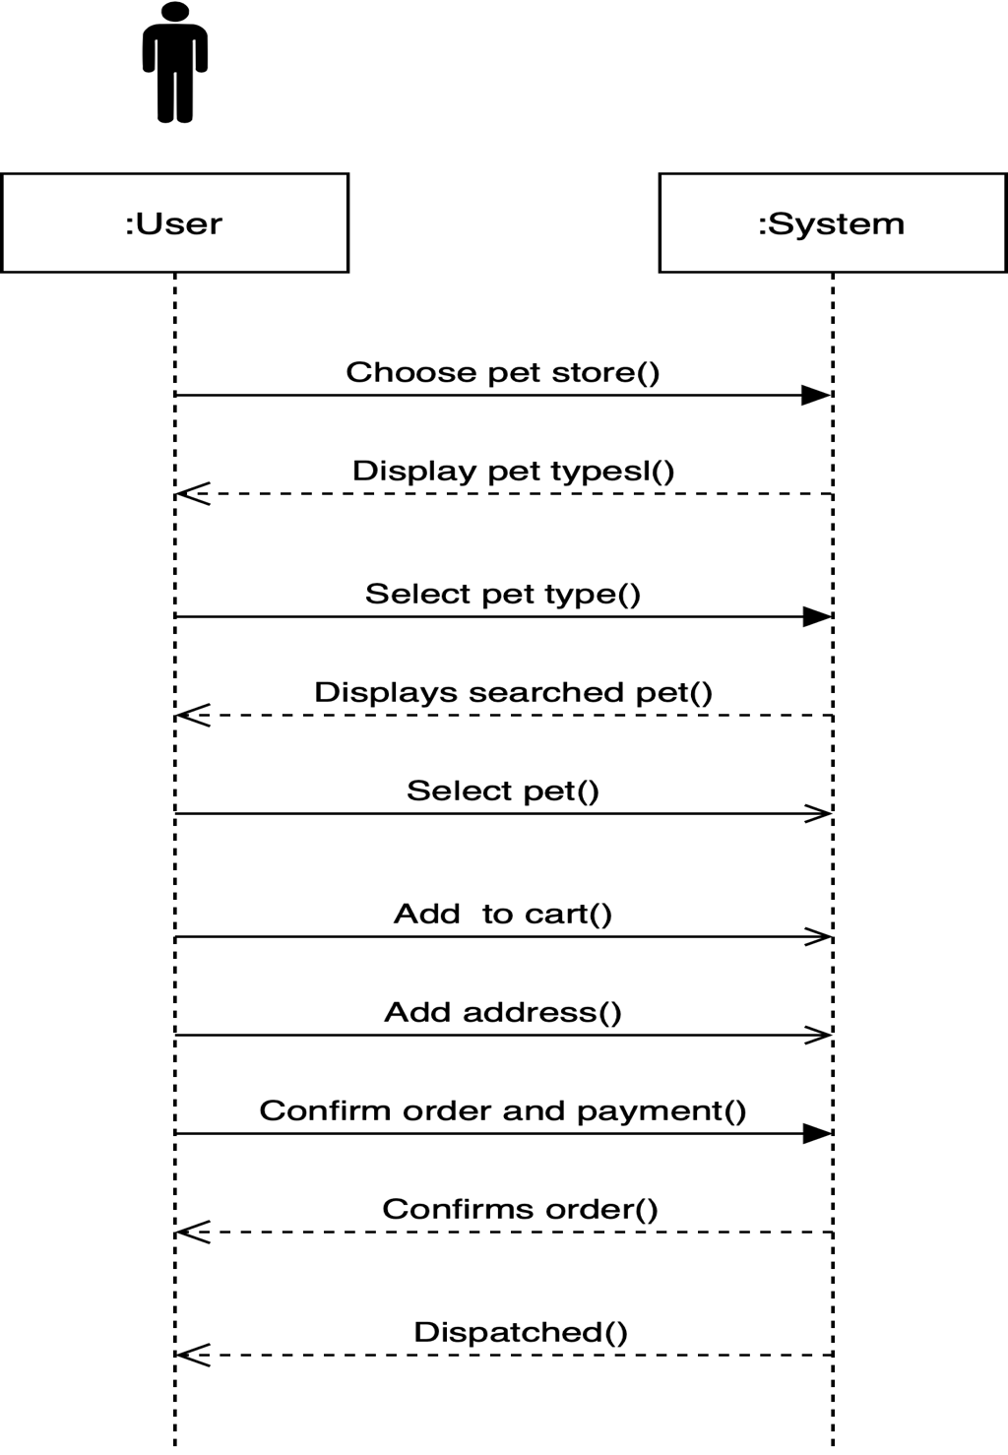

Figure 4 Buy Pet SSD

    - Manage Pet Profile

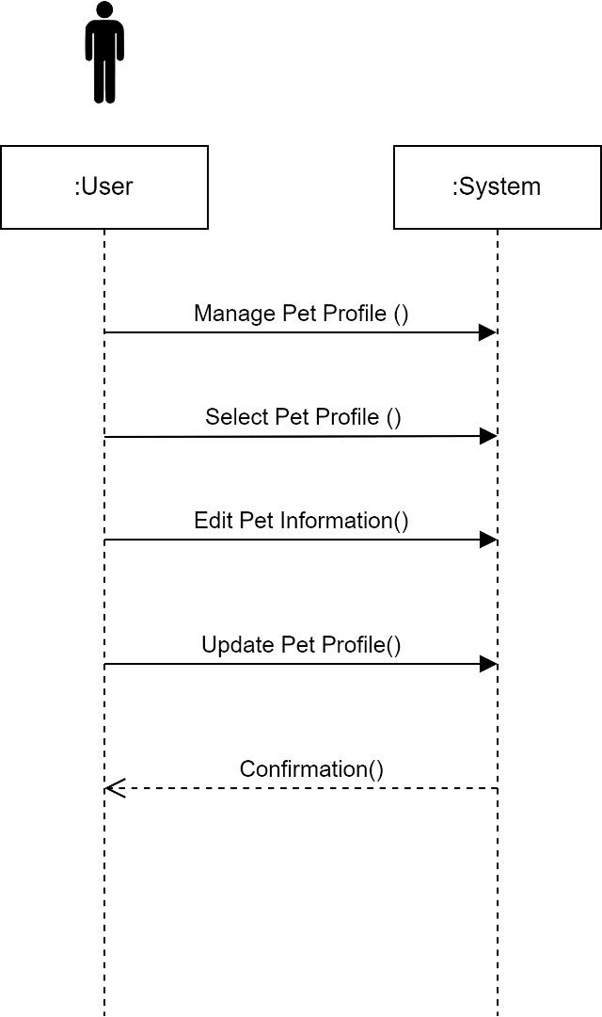

Figure 5 Manage Pet Profile SSD

    - Login

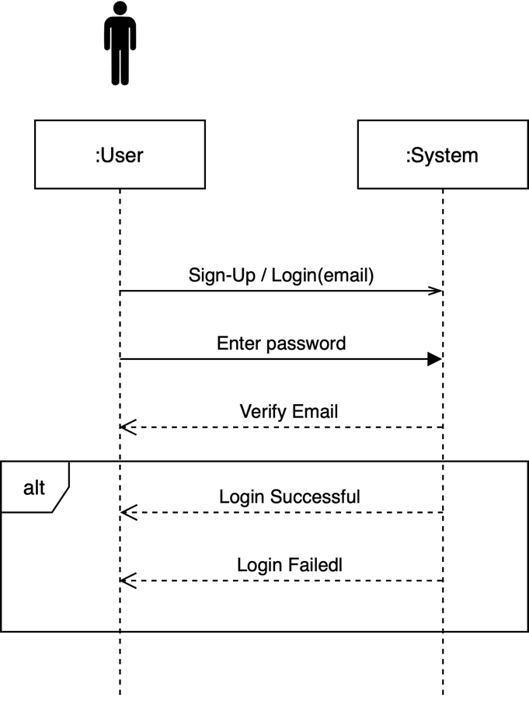

Figure 6 Login SSD
    - Payment Method
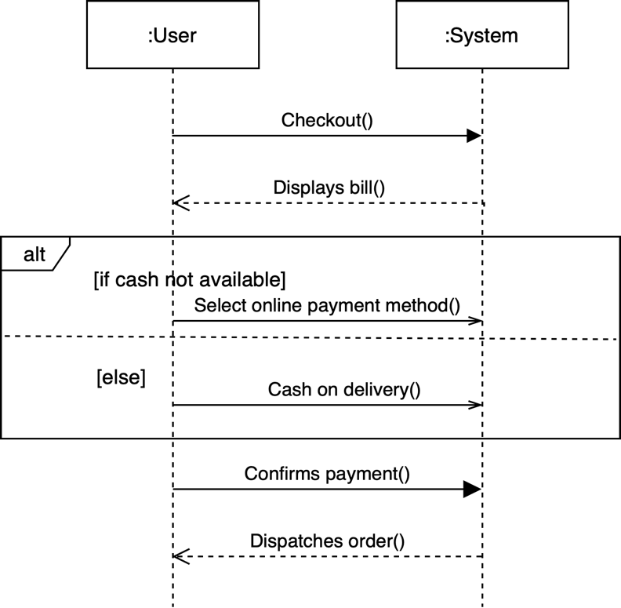

Figure 7 Payment Method SSD
    - Record health data
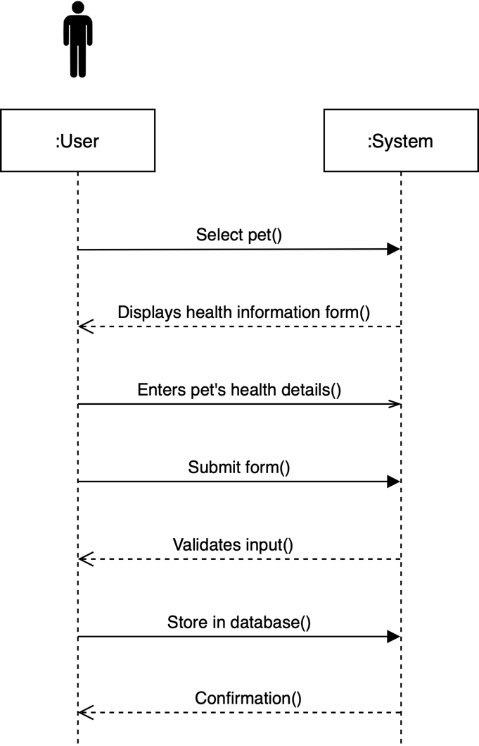

Figure 8 Record Health Data SSD
    - Register Pet Store
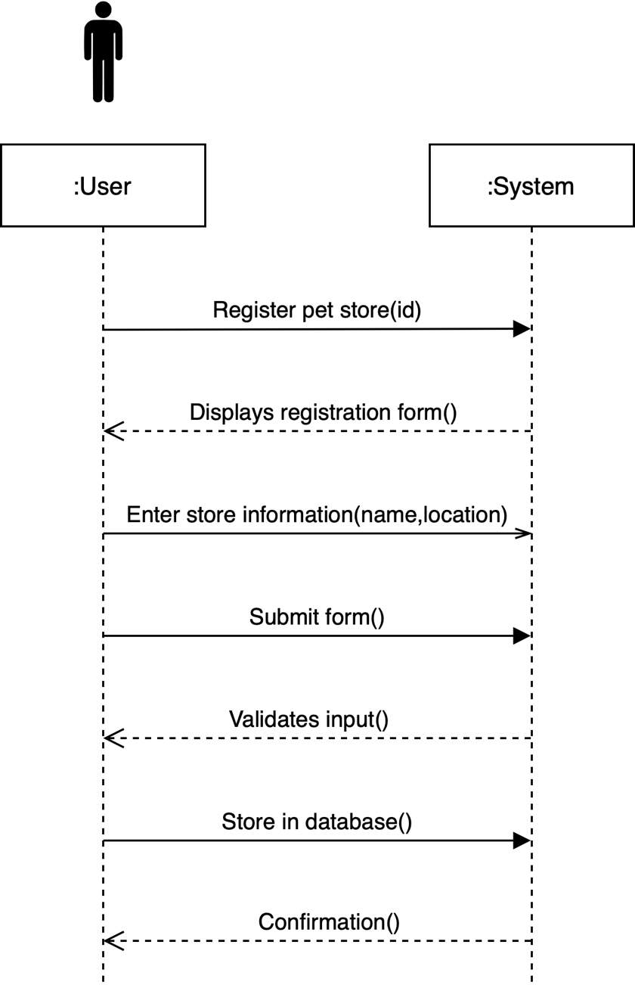

Figure 9 Register Pet Store SSD

    - Register User

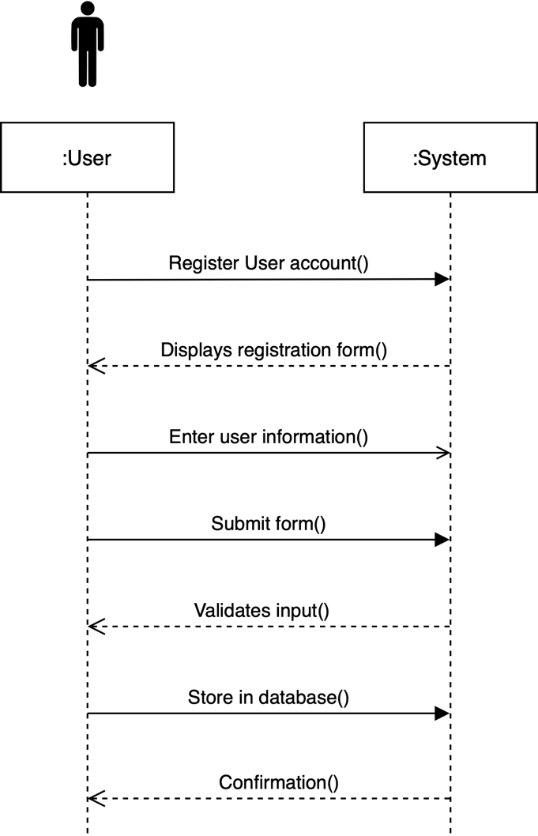

Figure 10 Register User SSD

    - Register Veterinarians

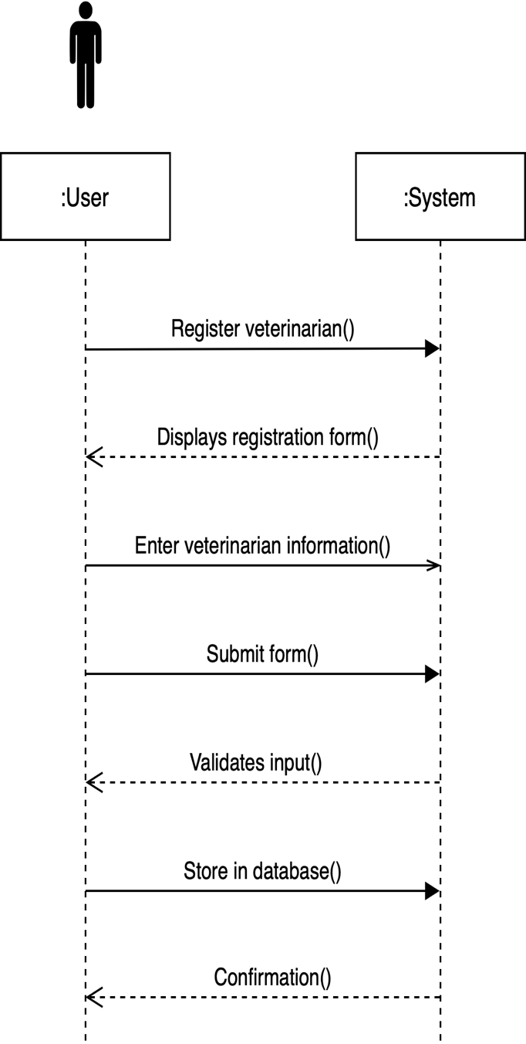

Figure 11Register Veterinarians SSD

    - Select behaviors and training.
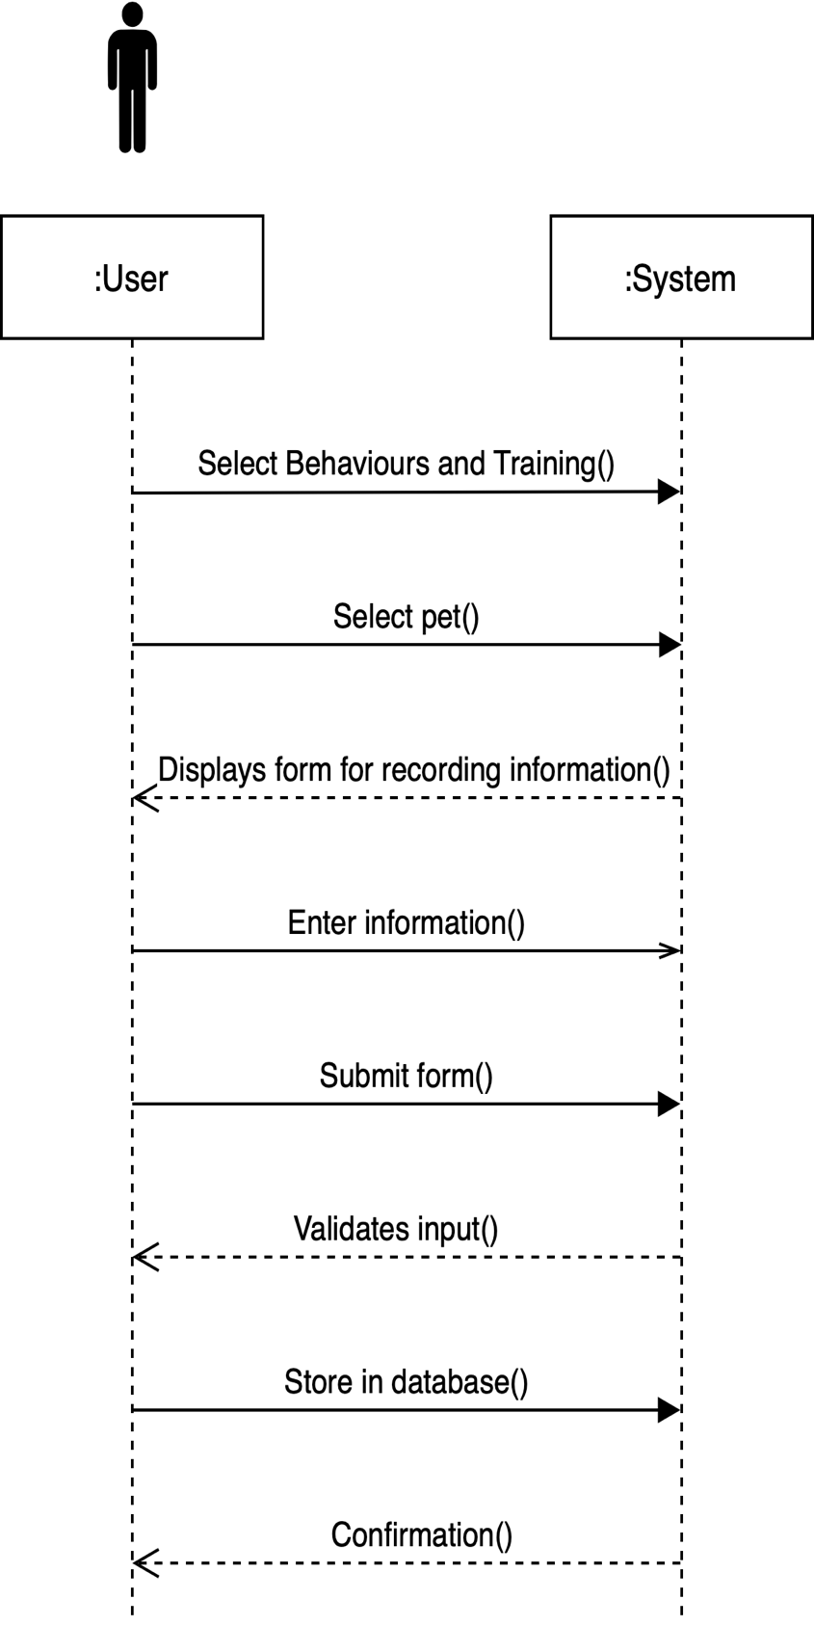

Figure 12 Select Behavior and Training SSD

    - Set Pet Feeding Schedule

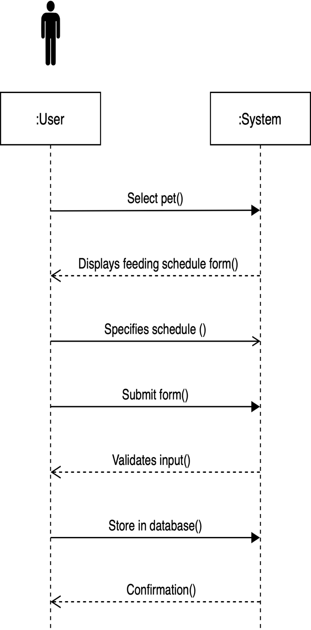

Figure 13 Set Pet Feeding Schedule SSD

    - Social Media

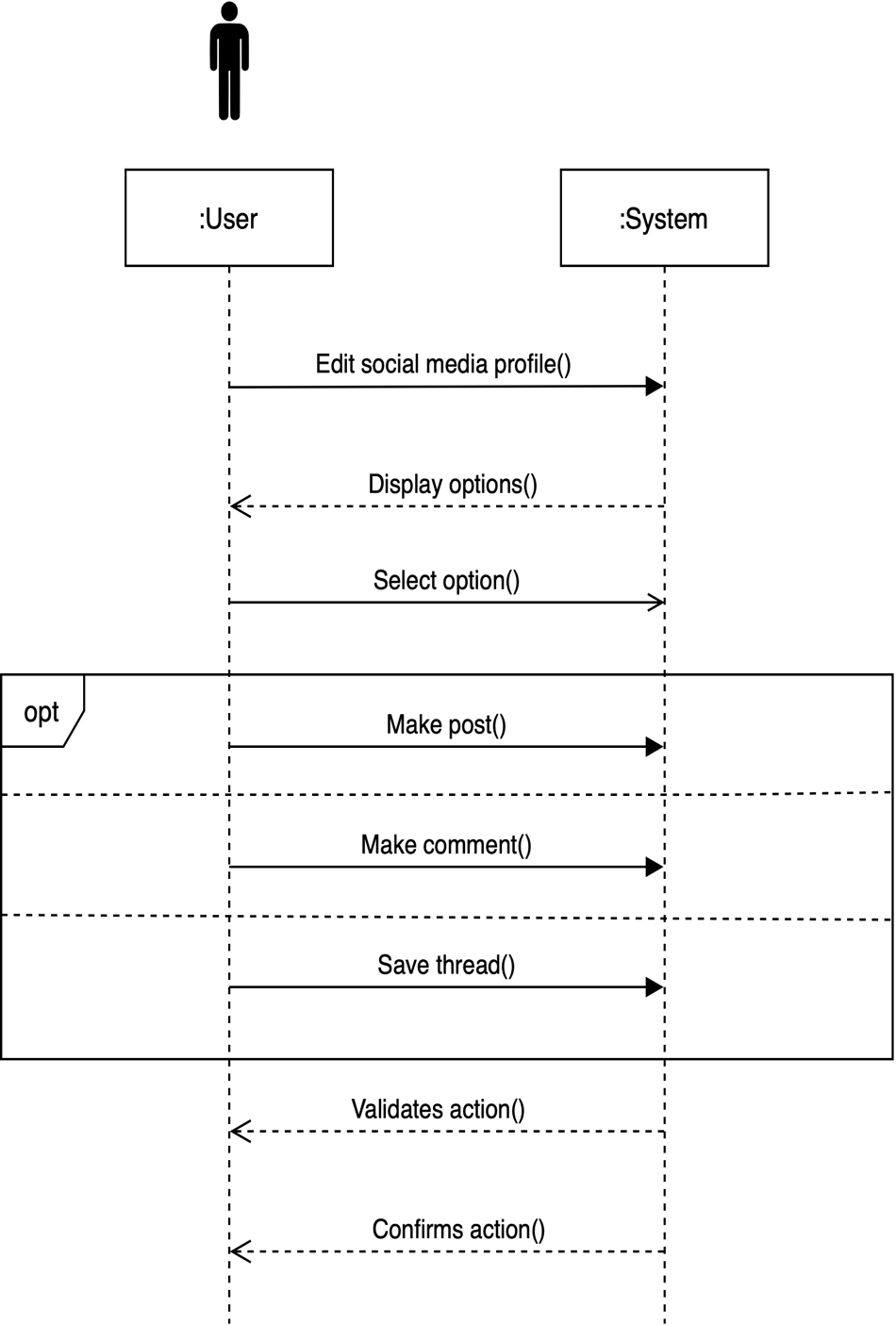

Figure 14 Social Media SSD

    - View nearby pet services.
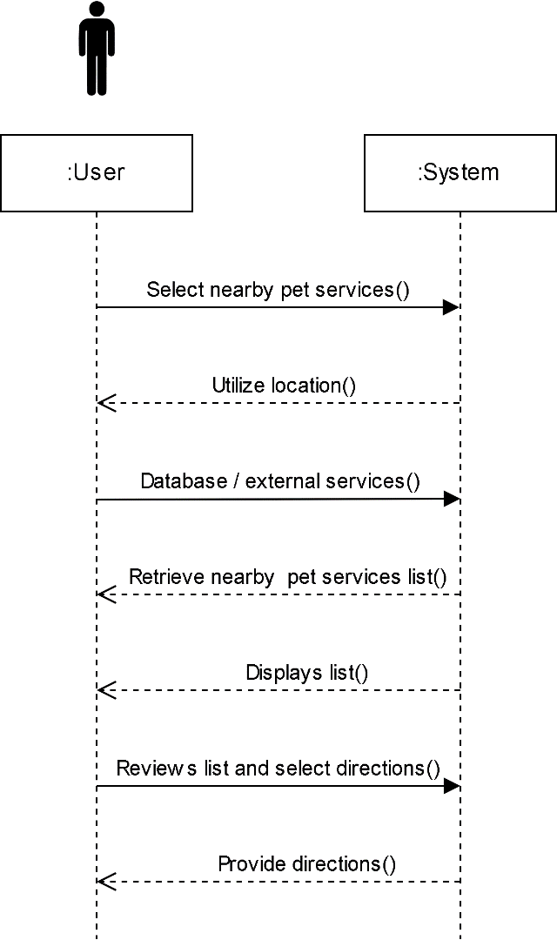

Figure 15 View Nearby Pet Services SSD

    - View nutrition recommendations

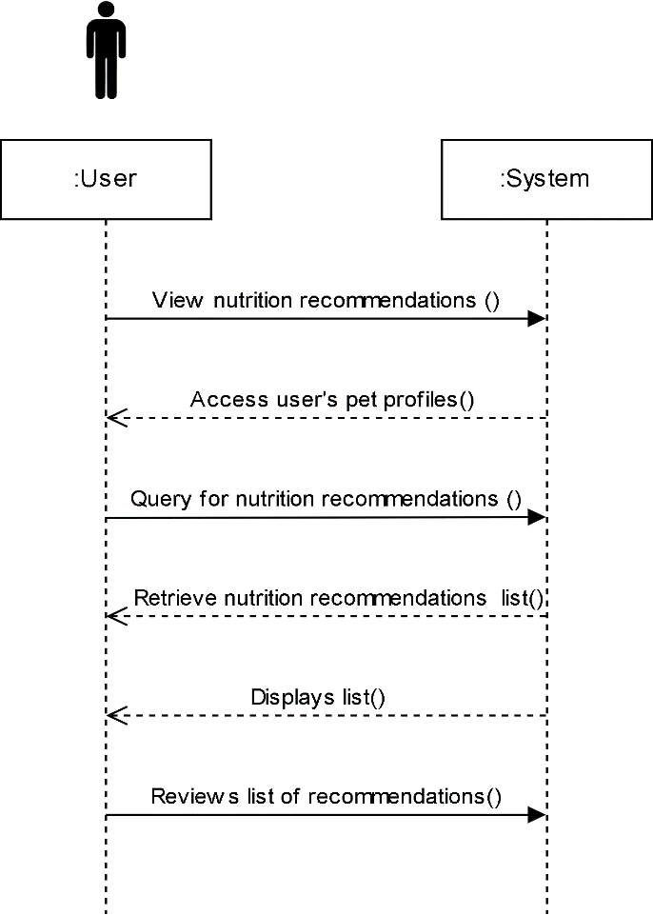

Figure 16 View Nutrition Recommendations SSD
- Activity Diagram

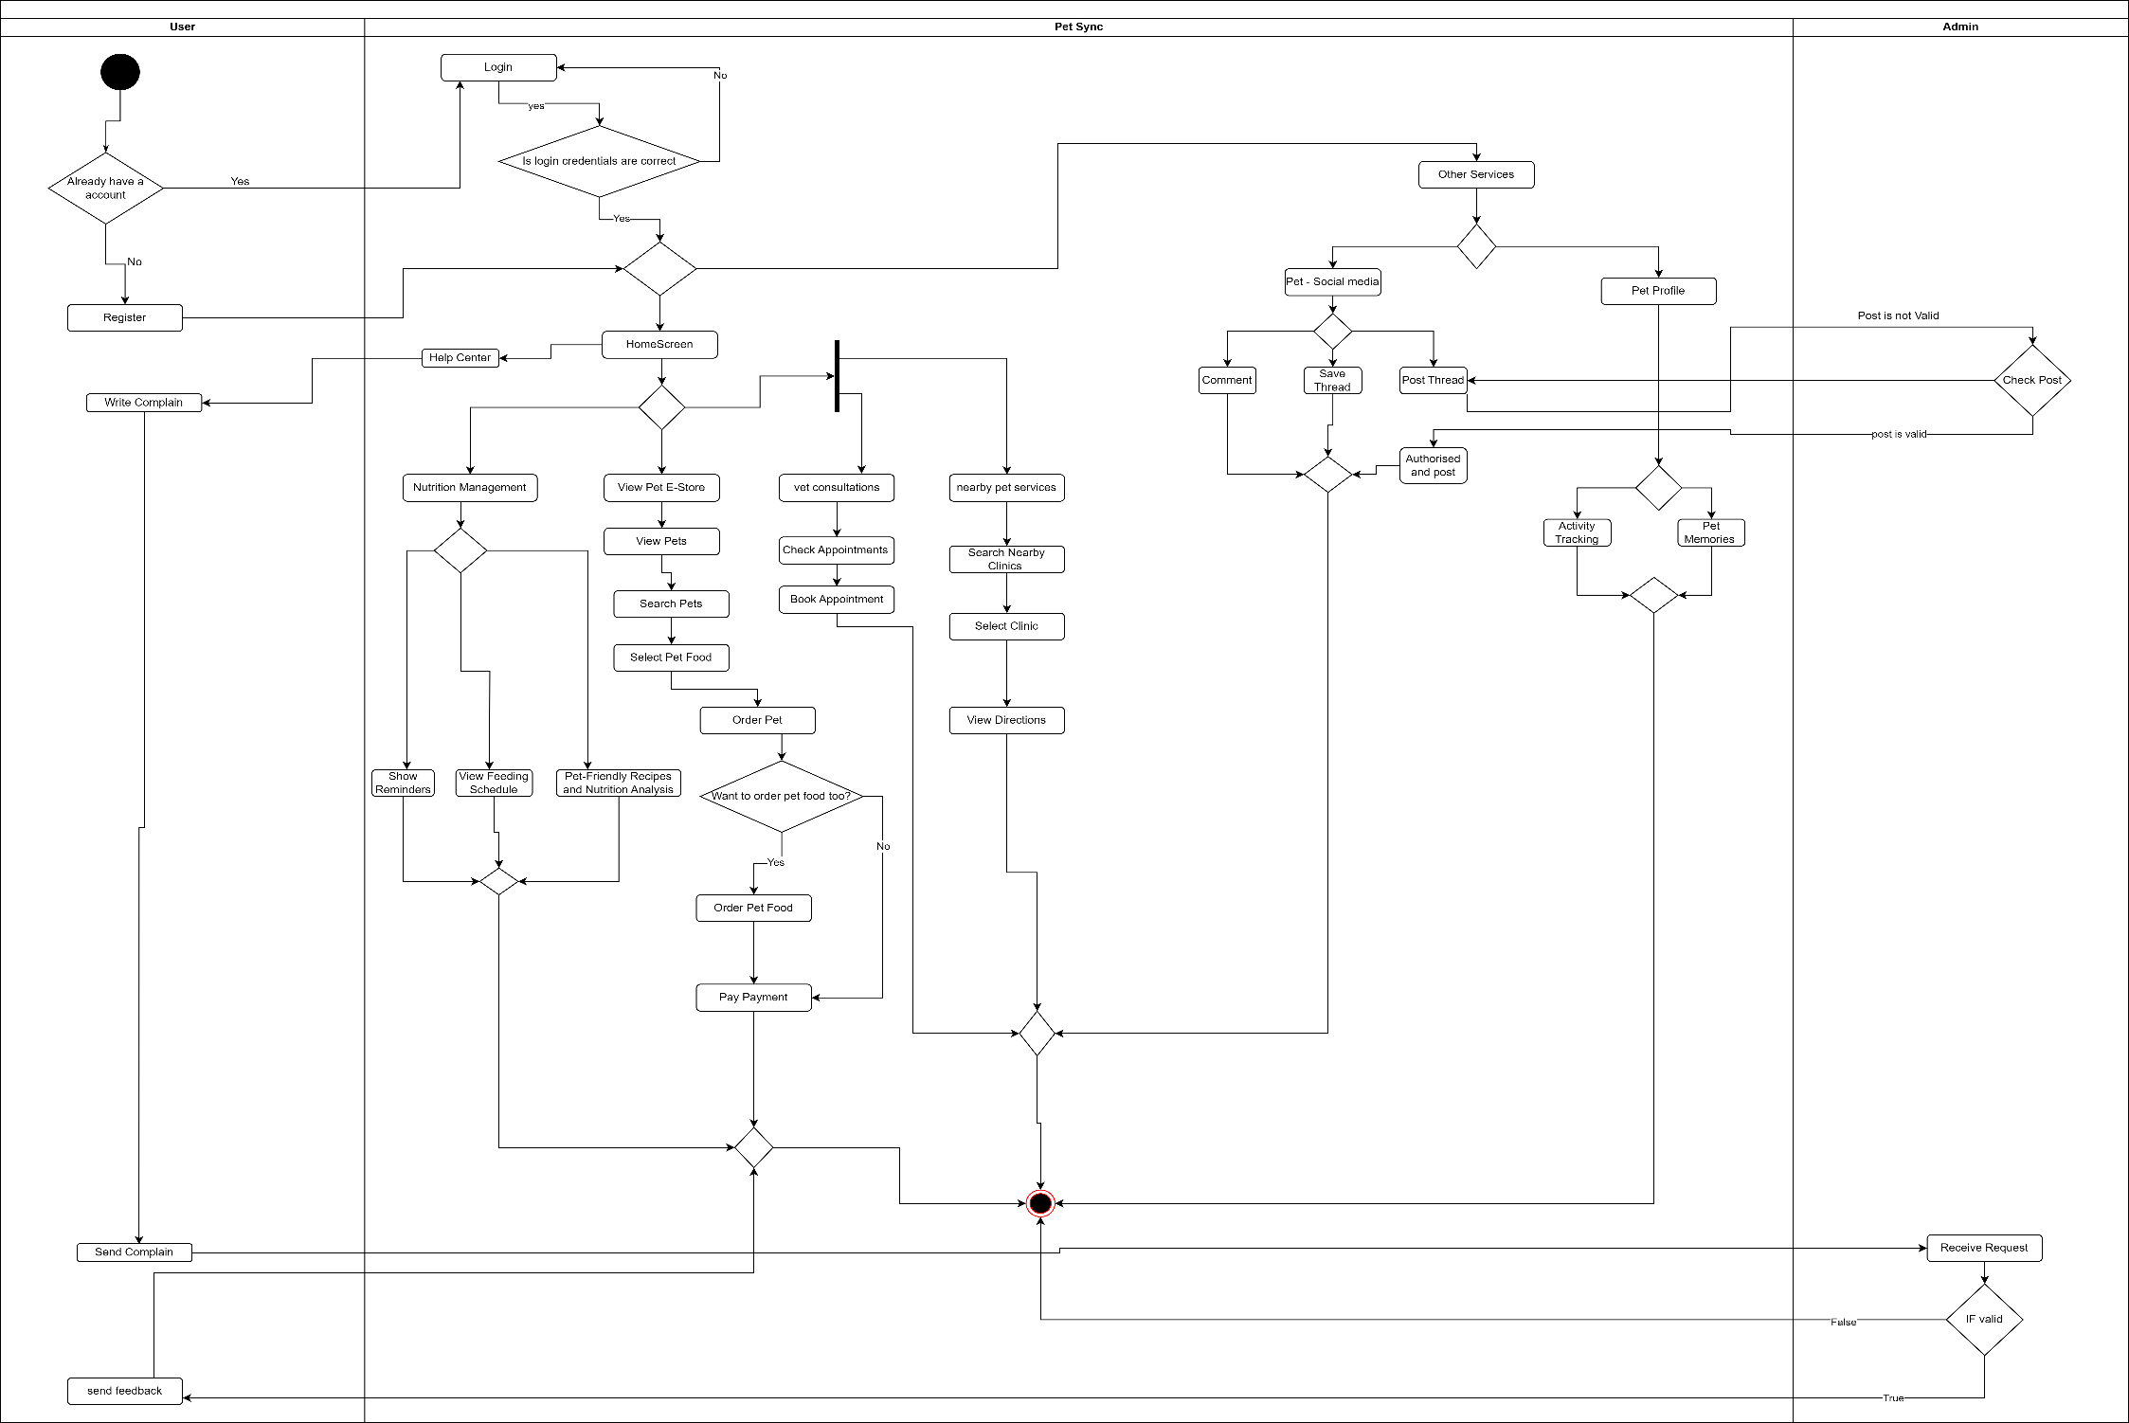

Figure 17 Activity Diagram Pet-Sync

- Data flow diagram

- Level 0
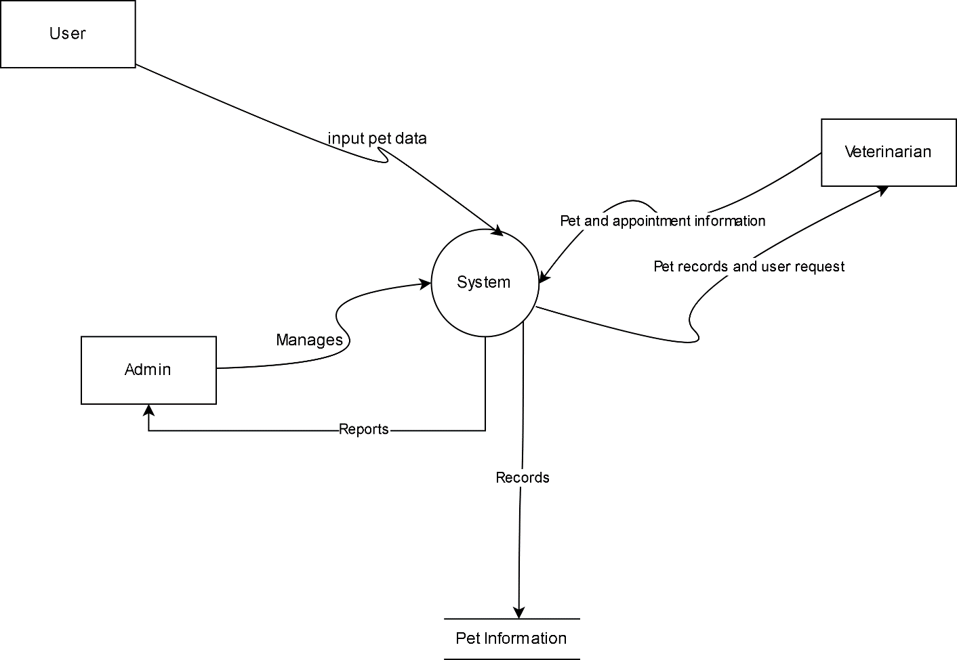

Figure 18 Data Flow Diagram Level 0

- Level 1
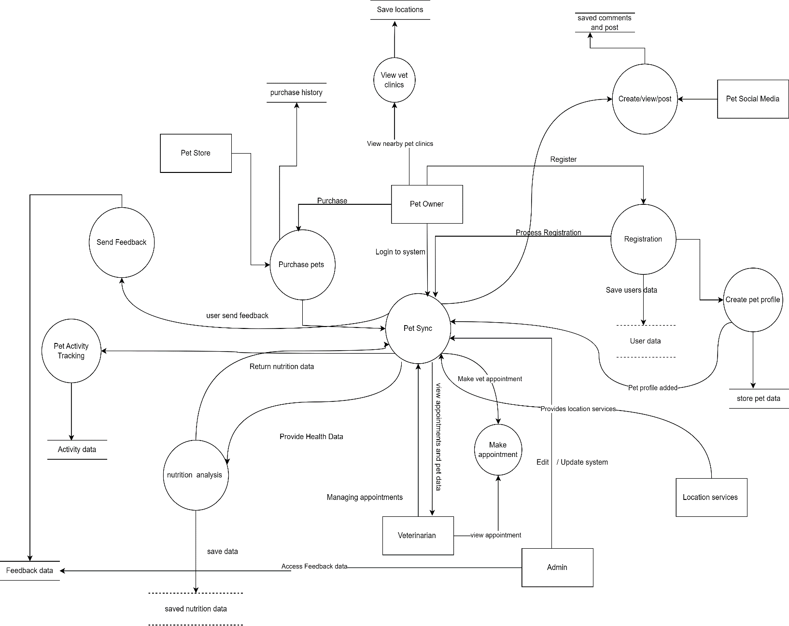

Figure 19 Data Flow Diagram Level 1

- Level 2
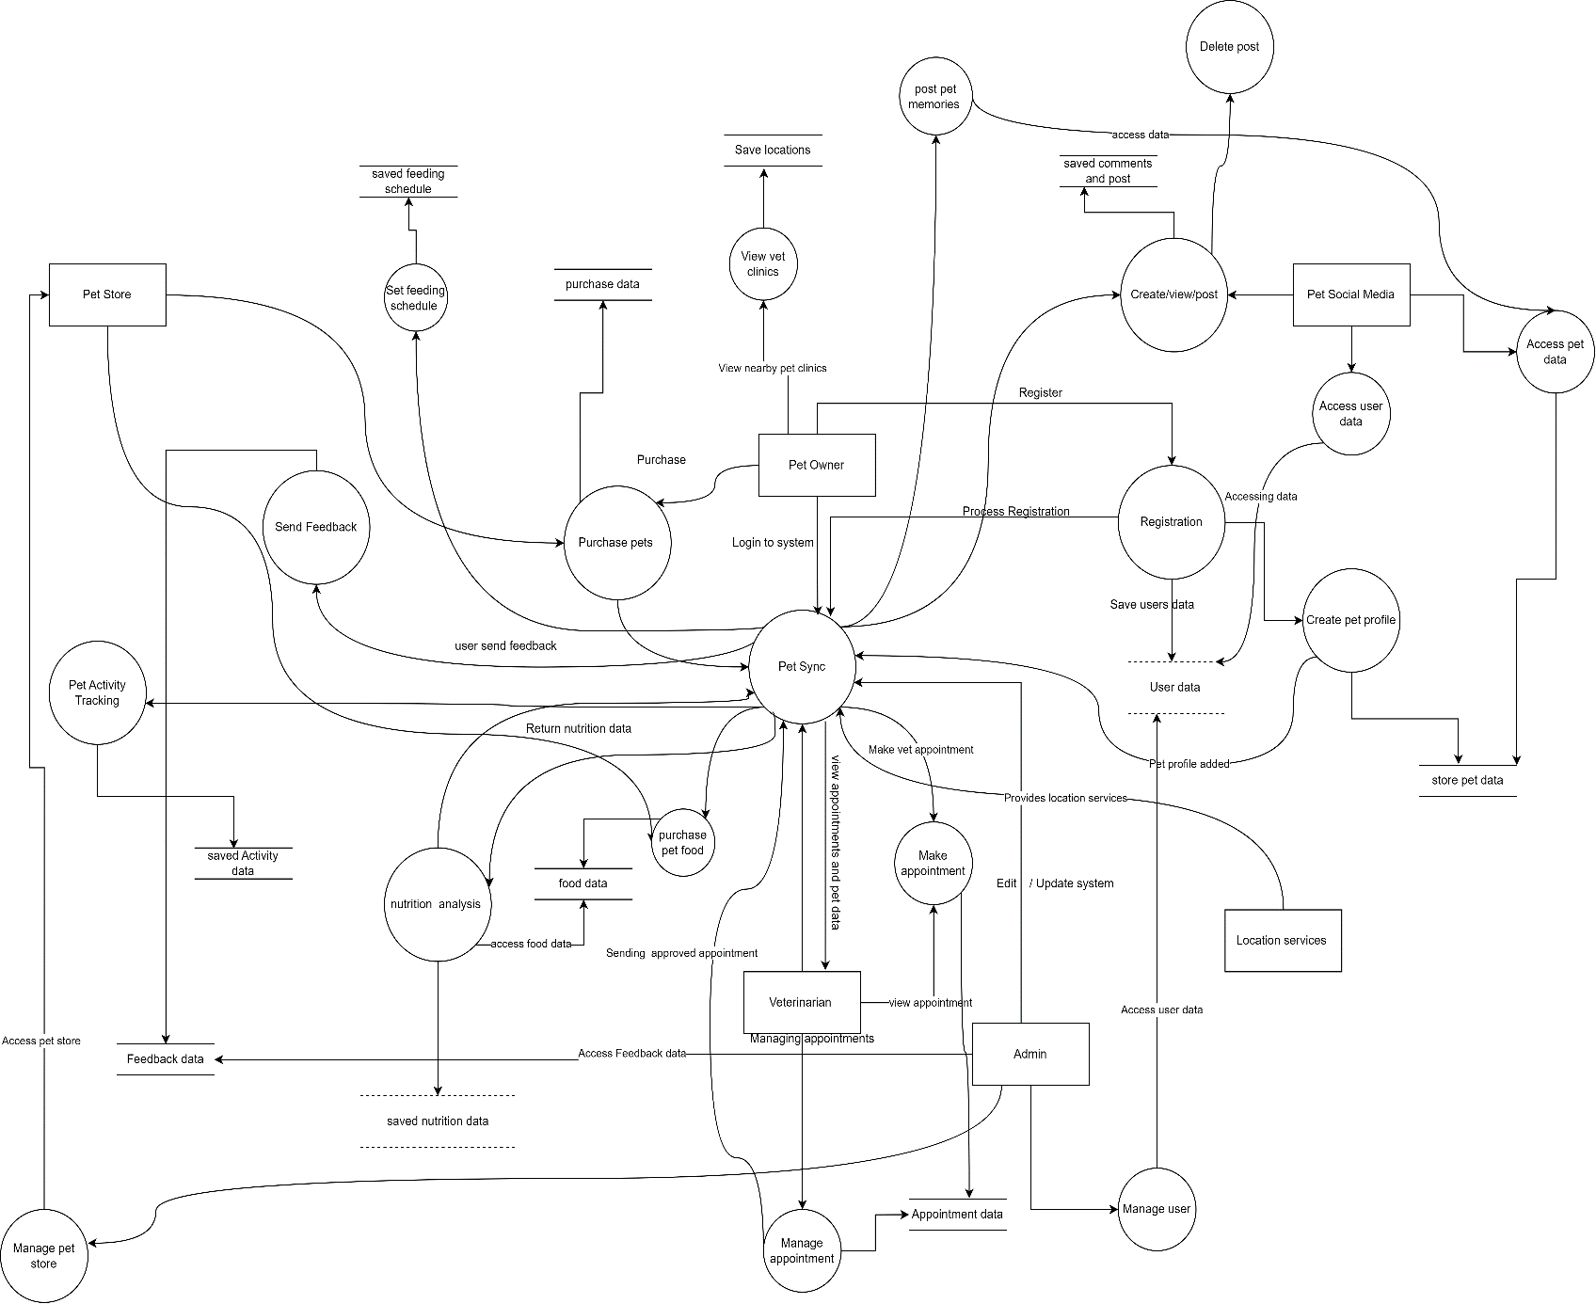

Figure 20 Data Flow Diagram Level 2

- Component diagram

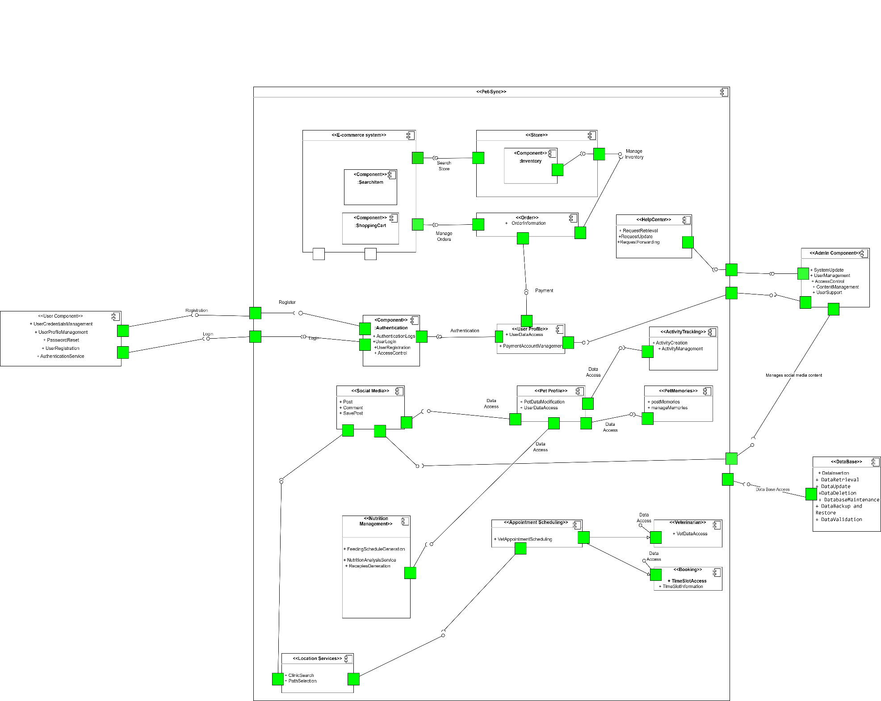

Figure 21 Component Diagram Pet-Sync

- Entity relationship diagram

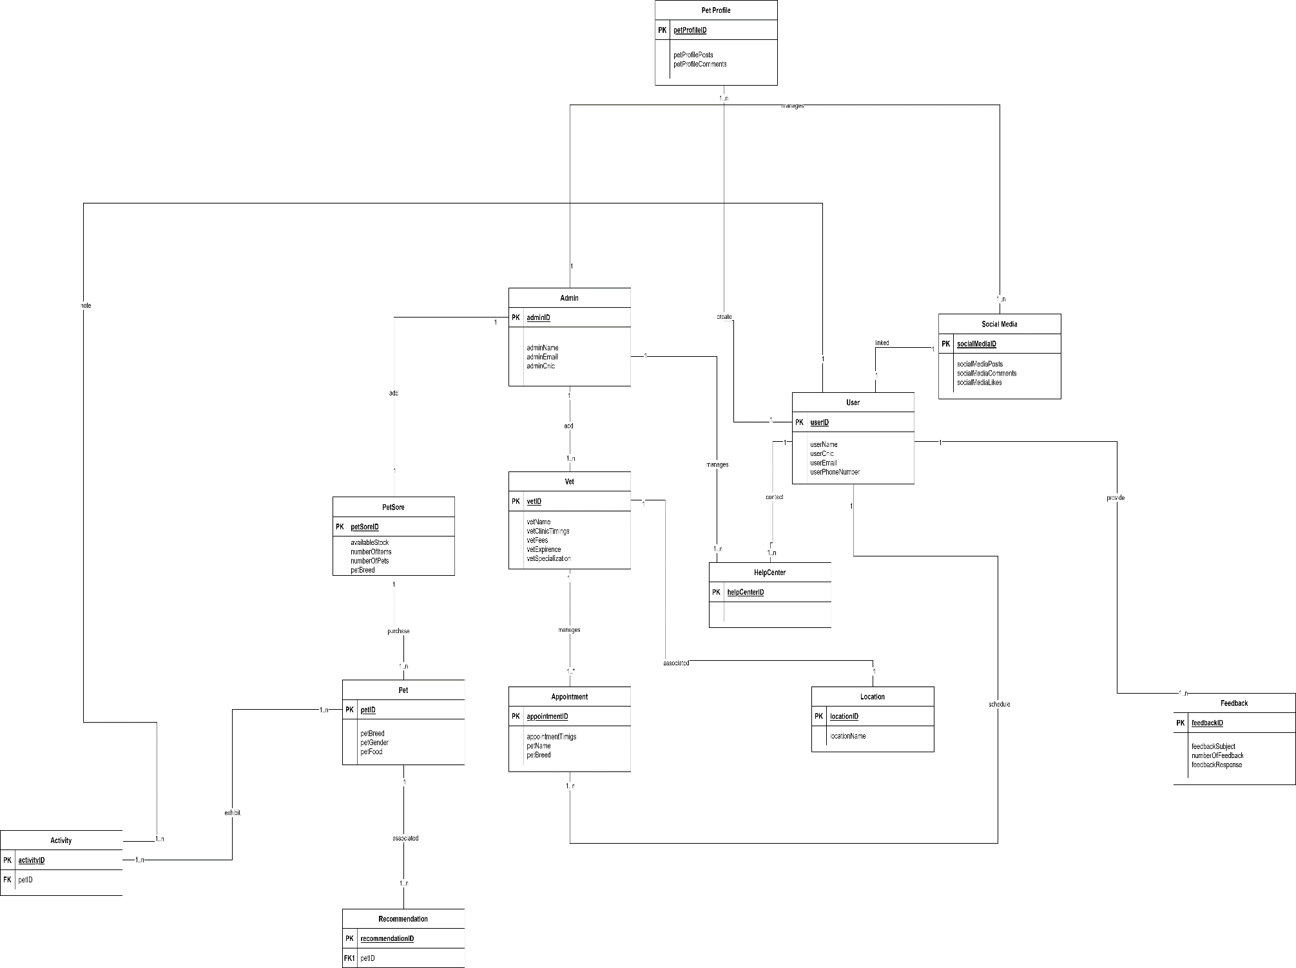

Figure 22 Entity Relationship Diagram Pet-Sync

