COS 202 Project Report
Smart Library Circulation & Automation System (SLCAS)

1. Description
The Smart Library Circulation & Automation System (SLCAS) is a desktop Java Swing application built for a university library. It manages the catalogue of borrowable items, user accounts, the borrow/return workflow, a reservation waitlist, overdue tracking, and simple management reports, all through an event-driven, tabbed GUI. The project follows the required package structure (model, controller, gui, utils), an abstract class hierarchy for library items, and hand-implemented search and sort algorithms rather than relying on Java's built-in Collections.sort.

2. Features
- Add new library items (Book, Magazine, Journal) through a dynamic form
- Borrow and return items, with automatic handling of the return workflow
- Reservation/waitlist queue that hands a returned item straight to the next user in line
- Search catalogue items by title, author, or type using linear, binary, or recursive search
- Sort the catalogue by title, author, or year using selection, insertion, merge, or quick sort (chosen from a dropdown)
- Undo the last admin add/delete action via a Stack
- Tabbed GUI dashboard: View Items, Borrow/Return, Admin, Search & Sort
- Save and load the full catalogue and user list to/from a text file, plus CSV import/export via a file-chooser dialog
- Reports: most borrowed items, users with overdue items (with recursively computed fines), and category distribution

3. Architecture & Class Hierarchy
The system is organised into four packages mirroring the required layered design: model (LibraryItem abstract class, Book/Magazine/Journal subclasses, the Borrowable interface, UserAccount, LibraryDatabase), controller (LibraryManager facade with the undo stack and MFU cache, BorrowController, SearchEngine, SortEngine, AdminAction), gui (MainWindow and the four tab panels, plus a shared table model and custom cell renderer), and utils (IDGenerator, FileHandler for save/load and CSV import/export).
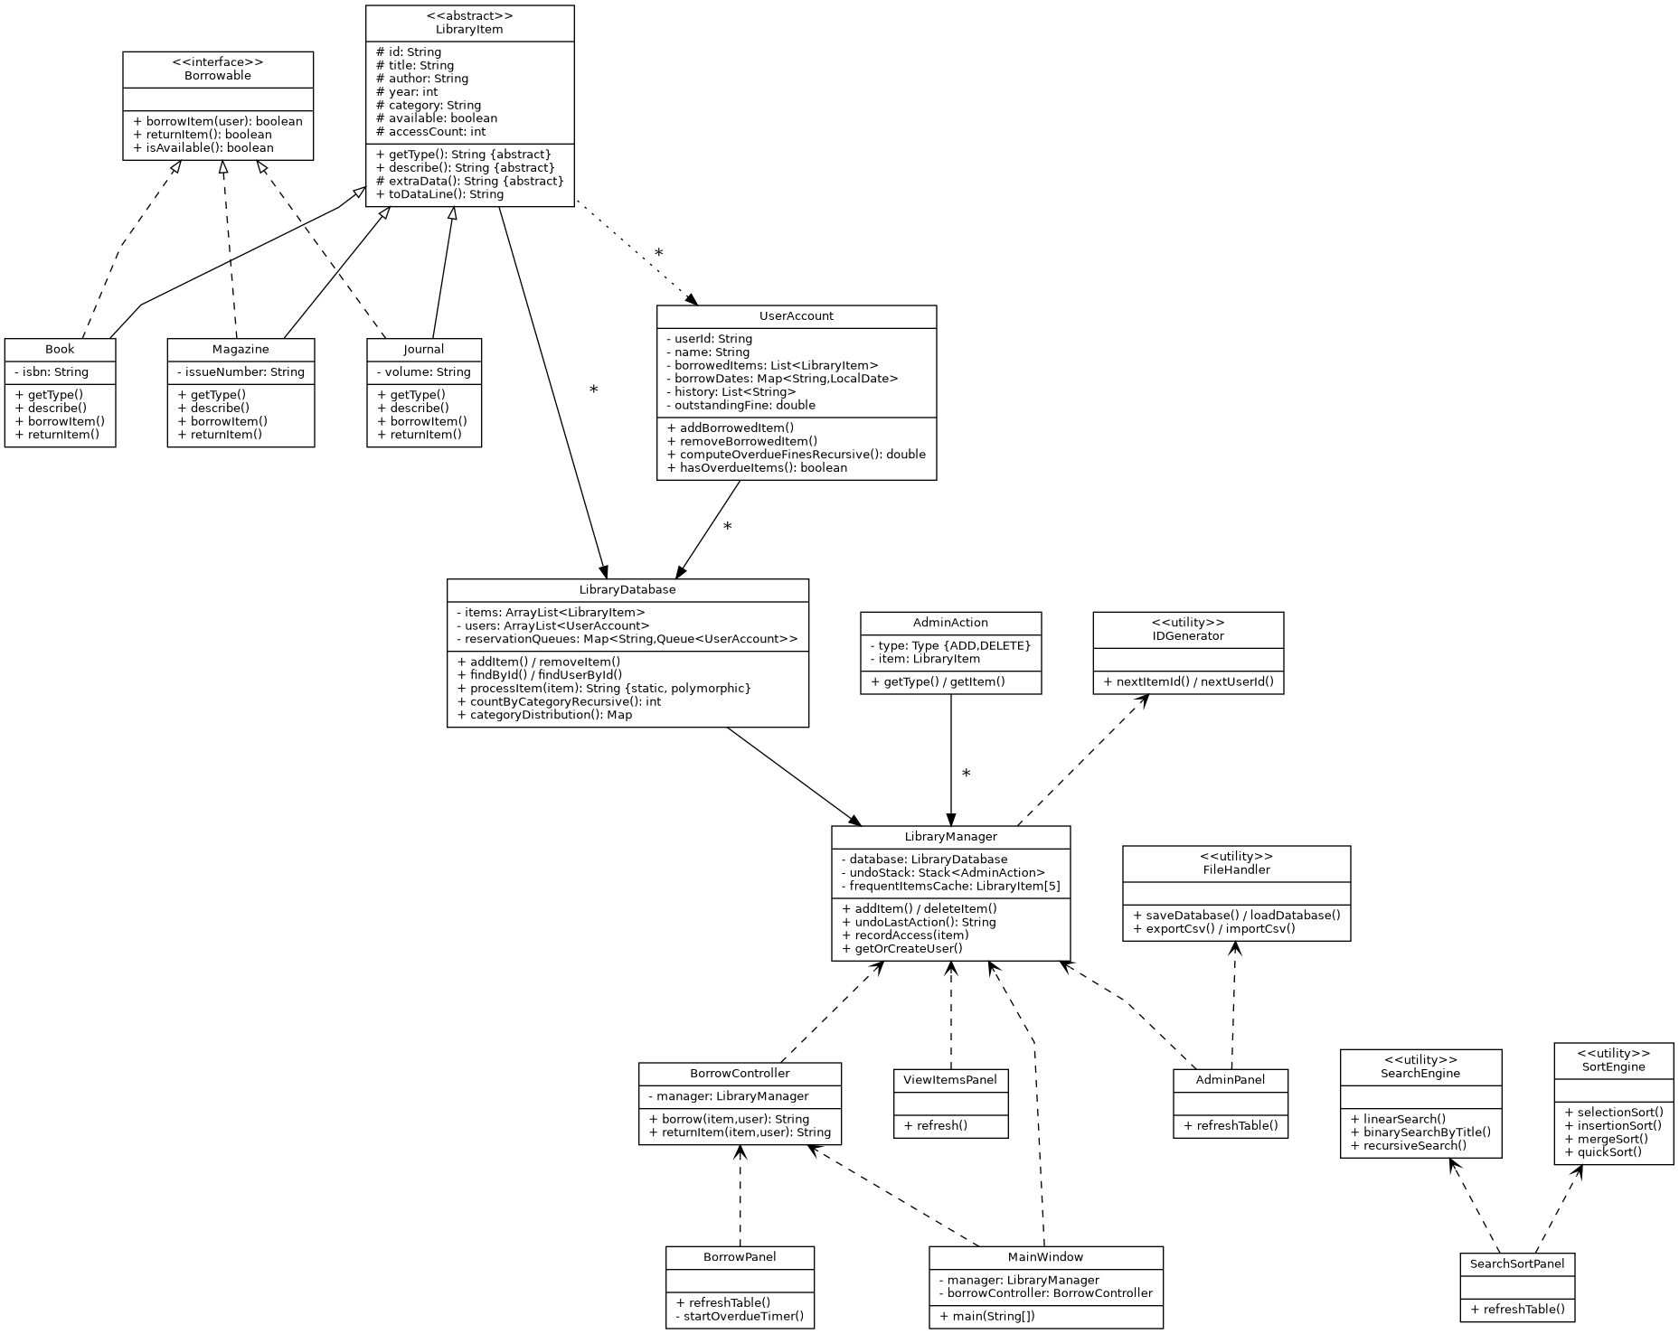
Figure 1: UML class diagram showing inheritance (Book/Magazine/Journal -> LibraryItem), interface realization (-> Borrowable), and composition/dependency relationships.

4. Data Structures Used
Structure | Where / Why it is used
ArrayList<LibraryItem> | Backs LibraryDatabase, the main catalogue store. The catalogue is read/iterated far more often than items are inserted mid-list, so ArrayList gives O(1) indexed access for the table view and sort algorithms.
Queue<UserAccount> | One reservation/waitlist queue per item id. When a borrowed item is returned, the next user in the FIFO queue automatically receives it - a natural fit for Queue semantics.
Stack<AdminAction> | Records every add/delete performed in the Admin panel so the most recent action can be popped and reversed with one Undo button - LIFO order is exactly what "undo" needs.
LibraryItem[5] array | A fixed-size cache of the most frequently accessed items. A plain array (not a List) was used to satisfy the fixed-size cache requirement and keep lookup/replacement bounded to the cache size.
HashMap | Used for the reservation-queue lookup table (item id -> Queue), the borrow-date lookup inside UserAccount, and the category-distribution report, where O(1) key access matters more than ordering.

5. Algorithms Chosen and Why
Category | Algorithms Implemented | Why Chosen
Searching | Linear search, Binary search, Recursive search | Linear search works on any list regardless of sort order, so it is the safe default. Binary search is offered when the catalogue is already sorted by title, giving O(log n) lookups for exact-title queries. Recursive search satisfies the recursion requirement while performing a full-catalogue scan.
Sorting | Selection sort, Insertion sort, Merge sort, Quick sort | All four were implemented and exposed through a GUI dropdown so behaviour can be compared directly. Selection/insertion sort are simple O(n^2) baselines; merge sort guarantees O(n log n) stable sorting; quick sort gives fast average-case performance for in-place sorting.
Recursion | Recursive category count, recursive overdue-fine total, recursive catalogue search, recursive merge/quick sort partitioning | Recursion is used both where it is the natural fit (merge/quick sort) and where the brief explicitly asks for a recursive alternative to an iterative task (category counts, overdue fines), to clearly demonstrate the technique.

6. Challenges Faced
- Choosing data structures that satisfy the brief literally (a fixed-size array cache) while still keeping the code idiomatic Java - solved by wrapping the array inside LibraryManager and exposing normal getter methods so the rest of the code never manipulates raw indices directly.
- Making binary search safe to expose in the GUI: binary search only gives correct results on data already sorted by the same field being searched. The Search & Sort panel tracks whether the catalogue was last sorted by title and blocks binary search with a clear dialog message otherwise, rather than silently returning wrong results.
- Keeping the reservation queue and the borrow/return workflow consistent: returning an item needed to atomically free the item and, if someone was waiting, immediately re-borrow it on their behalf, without ever leaving the item in an inconsistent "available but reserved" state.
- Recursion depth and correctness: the recursive category count and recursive overdue-fine calculation both needed clear base cases (index >= list size) to avoid infinite recursion, and were tested against the iterative equivalents to confirm they returned the same results.
- Building a dynamic Admin form: the extra field (ISBN / Issue Number / Volume) changes depending on the selected item type. A CardLayout panel keyed by type name was used so the correct field swaps in automatically when the type combo box changes.

7. GUI Screenshots
The four tabs of the running application (View Items, Borrow/Return, Admin, Search & Sort) are shown below.
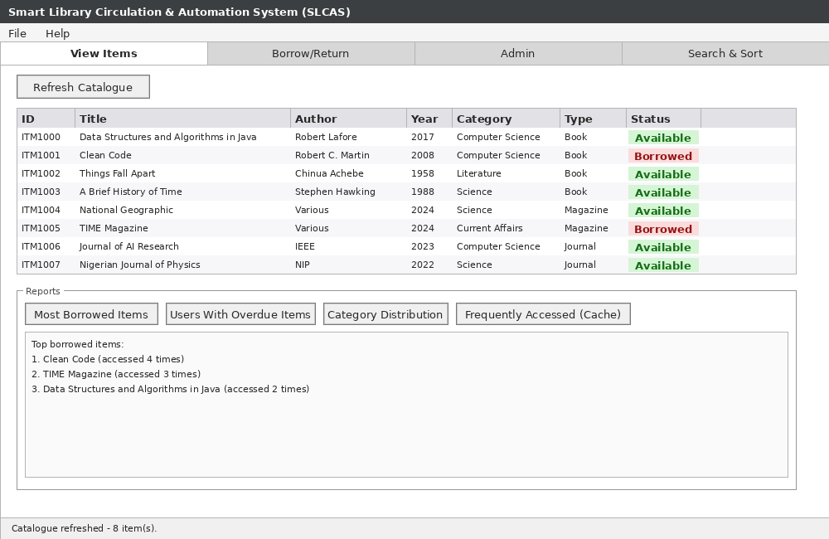
Figure 2: View Items tab - full catalogue table with availability colour-coding and report buttons.
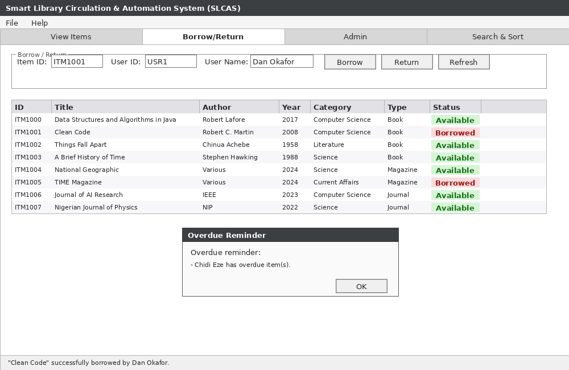
Figure 3: Borrow/Return tab - borrow/return form, catalogue table, and a Timer-triggered overdue reminder dialog.
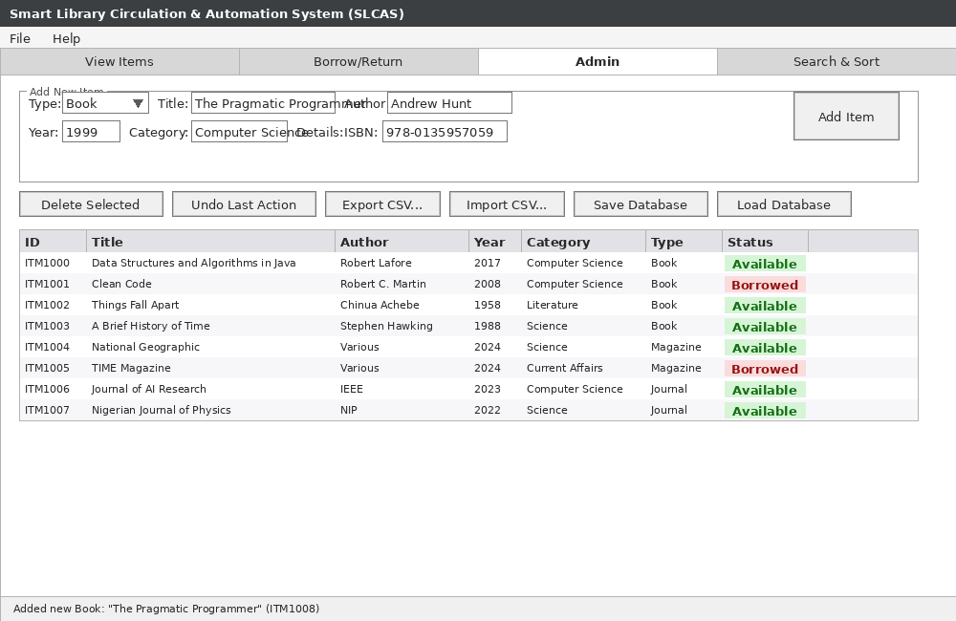
Figure 4: Admin tab - dynamic add-item form (CardLayout swaps ISBN/Issue/Volume field by type), undo, import/export, and save/load.
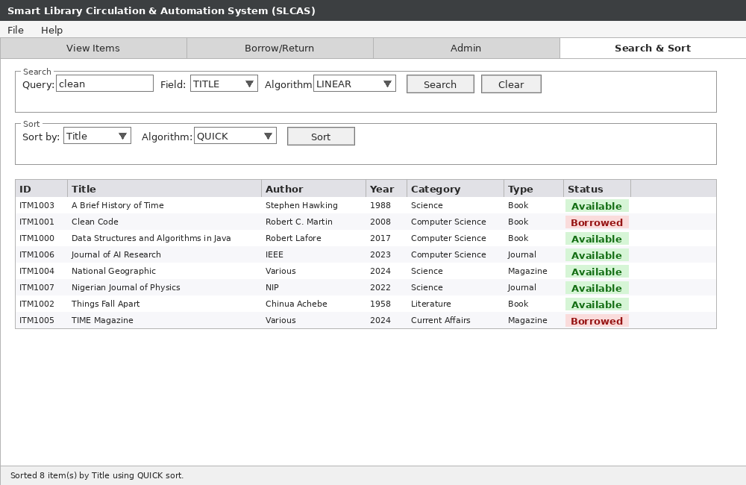
Figure 5: Search & Sort tab - algorithm-selectable search and sort controls with results table.

