Modeling and Estimating the LST using ML

Usman

2024-09-22

## R Markdown

myCol = terrain.colors(3)  
  
LST_24 <- rast("2024LST.tif")  
LST_03 <- rast("2003LST.tif")  
LST_84 <- rast("1984LST.tif")  
  
# Converting raster data to a dataframe   
# lines of code.  
rasterdf <- function(x, aggregate = 1) {  
 resampleFactor <- aggregate  
 inputRaster <- x  
 inCols <- ncol(inputRaster)  
 inRows <- nrow(inputRaster)  
 # Compute numbers of columns and rows in the resampled raster  
 resampledRaster <- rast(ncol=(inCols / resampleFactor),  
 nrow=(inRows / resampleFactor),  
 crs = crs(inputRaster))  
 # Match to the extent of the original raster  
 ext(resampledRaster) <- ext(inputRaster)  
 # Resample data on the new raster  
 y <- resample(inputRaster,resampledRaster,method='near')  
 # Extract cell coordinates into a dataframe  
 coords <- xyFromCell(y, seq_len(ncell(y)))  
 # Extract layer names  
 dat <- stack(values(y, dataframe = TRUE))  
 # Add names-'value' for data,'variable' for different  
 # layer names in a multilayerraster  
 names(dat) <- c('value', 'variable')  
 dat <- cbind(coords, dat)  
 dat  
}  
  
# The following code converts the LST raster to a dataframe after  
# aggregating the cell values by a factor of three.  
  
lst_df_24 <- rasterdf(LST_24, aggregate = 3)  
summary(lst_df_24)

## x y value variable   
## Min. :434204 Min. :1310203 Min. :26.97 Band_1:107712   
## 1st Qu.:441036 1st Qu.:1318093 1st Qu.:34.97   
## Median :447914 Median :1325983 Median :35.62   
## Mean :447914 Mean :1325983 Mean :35.63   
## 3rd Qu.:454791 3rd Qu.:1333873 3rd Qu.:36.37   
## Max. :461624 Max. :1341763 Max. :41.00   
## NA's :37089

head(lst_df_24)

## x y value variable  
## 1 434203.7 1341763 NA Band_1  
## 2 434293.6 1341763 NA Band_1  
## 3 434383.5 1341763 NA Band_1  
## 4 434473.4 1341763 NA Band_1  
## 5 434563.3 1341763 NA Band_1  
## 6 434653.2 1341763 NA Band_1

# lst_1 <- ifel(lst_df_24 == 0, NA, lst)  
# lst_1_c <- lst_1 * 0.02 - 273.15  
  
A <- ggplot(data = lst_df_24) +  
 geom_raster(aes(x = x,  
 y = y,  
 fill = value)) +  
 scale_fill_gradient(name = "Degrees C",  
 low = "blue",  
 high = "red") +  
 coord_sf(expand = FALSE) +  
 labs(title = "LST-2024",  
 x = "longitude",  
 y = "latitude") +  
 theme(legend.position = "bottom")  
  
lst_df_84 <- rasterdf(LST_84, aggregate = 3)  
summary(lst_df_84)

## x y value variable   
## Min. :434204 Min. :1310203 Min. :21.06 Band_1:107712   
## 1st Qu.:441036 1st Qu.:1318093 1st Qu.:28.33   
## Median :447914 Median :1325983 Median :28.82   
## Mean :447914 Mean :1325983 Mean :28.59   
## 3rd Qu.:454791 3rd Qu.:1333873 3rd Qu.:29.14   
## Max. :461624 Max. :1341763 Max. :31.82   
## NA's :37089

lst_df_84%>%filter(value!="NA")%>%head()

## x y value variable  
## 1 449577.0 1341763 28.69418 Band_1  
## 2 449487.1 1341673 28.33435 Band_1  
## 3 449577.0 1341673 28.40637 Band_1  
## 4 449666.9 1341673 28.79483 Band_1  
## 5 449756.8 1341673 28.50717 Band_1  
## 6 449846.7 1341673 28.50717 Band_1

B <- ggplot(data = lst_df_84) +  
 geom_raster(aes(x = x,  
 y = y,  
 fill = value)) +  
 scale_fill_gradient(name = "Degrees C",  
 low = "blue",  
 high = "red") +  
 coord_sf(expand = FALSE) +  
 labs(title = "LST-1984",  
 x = "longitude",  
 y = "latitude") +  
 theme(legend.position = "bottom")  
  
lst_df_03 <- rasterdf(LST_03, aggregate = 3)  
summary(lst_df_03)

## x y value variable   
## Min. :434204 Min. :1310203 Min. :22.08 Band_1:107712   
## 1st Qu.:441036 1st Qu.:1318093 1st Qu.:33.70   
## Median :447914 Median :1325983 Median :34.48   
## Mean :447914 Mean :1325983 Mean :34.24   
## 3rd Qu.:454791 3rd Qu.:1333873 3rd Qu.:34.96   
## Max. :461624 Max. :1341763 Max. :38.24   
## NA's :37089

lst_df_84%>%filter(value!="NA")%>%head()

## x y value variable  
## 1 449577.0 1341763 28.69418 Band_1  
## 2 449487.1 1341673 28.33435 Band_1  
## 3 449577.0 1341673 28.40637 Band_1  
## 4 449666.9 1341673 28.79483 Band_1  
## 5 449756.8 1341673 28.50717 Band_1  
## 6 449846.7 1341673 28.50717 Band_1

C <- ggplot(data = lst_df_03) +  
 geom_raster(aes(x = x,  
 y = y,  
 fill = value)) +  
 scale_fill_gradient(name = "Degrees C",  
 low = "blue",  
 high = "red") +  
 coord_sf(expand = FALSE) +  
 labs(title = "LST 2003",  
 x = "longitude",  
 y = "latitude") +  
 theme(legend.position = "bottom")  
  
ggarrange(A,B,C,nrow = 1,labels = c(  
 "2024","1984","2003"  
))

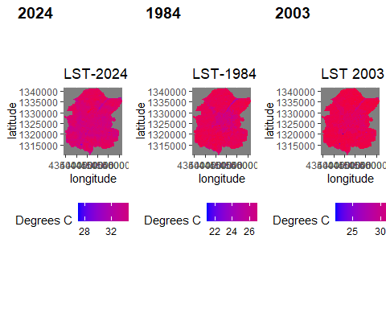

# Matrix table for Markov Chain  
# source("TransProb.R")  
# source("MatDataBase.R")  
# source("GatherTransMat.R")  
  
# mat_84324<- GatherTransMat("LST1984"=lst_df_84$value,"LST2003"=lst_df_03$value,"LST2024"=lst_df_24$value)  
# DriveZone<- c("LST1984","LST2003","LST2024")  
# Mat_state<- as.matrix(mat_84324)%>%na.omit()  
# MCZone<- new("markovchain",transitionMatrix=mat_84324,state=c("SDR","AE","CW"))  
#   
#   
# lst_df_84_new<- lst_df_84%>%mutate(LST= "LST1984")%>%select("value",LST)  
# lst_df_03_new<- lst_df_03%>%mutate(LST= "LST2003")%>%select("value",LST)  
# lst_df_24_new<- lst_df_24%>%mutate(LST= "LST2024")%>%select("value",LST)  
#   
# lst_matrix<- rbind(lst_df_84_new,lst_df_03_new,lst_df_24_new)%>%na.omit()  
# Dzone<- c("LST84","LST03","LST24")

## Preliminary Analysis: Modelling phase

LULC_24 <- rast("2024_LULC.tif")  
NDVI_24 <- rast("2024_NDVI.tif")  
NDBI_24 <- rast("2024_NDBI.tif")  
LULC_2044 <- rast("2084_LULC.tif")  
LULC_2064 <- rast("2084_LULC.tif")  
LULC_2084 <- rast("2084_LULC.tif")  
  
library(dplyr)  
lst_df_24_NAomit<- lst_df_24%>%filter(value!="NA")  
lst_lon_lat<- lst_df_24%>%filter(value!="NA")%>%dplyr::select(x,y)  
lulc_24_merg<-terra::extract(LULC_24,lst_lon_lat)%>%dplyr::select(Value_1)  
NDVI_24_merg<-terra::extract(NDVI_24,lst_lon_lat)%>%dplyr::select(Band_1)  
NDBI_24_merg<- terra::extract(NDBI_24,lst_lon_lat)%>%dplyr::select("2024_NDBI")  
current_lst_24<- cbind(lst_df_24_NAomit,lulc_24_merg,NDVI_24_merg,NDBI_24_merg)  
# names(current_lst_24)<- c("lon","lat","LST","variable","LULC","NDVI","NDBI")  
  
current_lst_24_naomit<- current_lst_24%>% na.omit(Value_1)  
current_lst_24_naomit$Value_1<-as.numeric(current_lst_24_naomit$Value_1)  
  
  
current_lst_24_logistM_1<- lm(value~Value_1+Band_1+current_lst_24_naomit$"2024_NDBI",data=current_lst_24_naomit)  
current_lst_24_logistM_2<- lm(value~Band_1,data=current_lst_24_naomit)  
current_lst_24_logistM_3<- lm(value~current_lst_24_naomit$Value_1,data=current_lst_24_naomit)  
summary(current_lst_24_logistM_1)

##   
## Call:  
## lm(formula = value ~ Value_1 + Band_1 + current_lst_24_naomit$"2024_NDBI",   
## data = current_lst_24_naomit)  
##   
## Residuals:  
## Min 1Q Median 3Q Max   
## -8.5351 -0.4489 0.0530 0.5122 5.1244   
##   
## Coefficients:  
## Estimate Std. Error t value Pr(>|t|)   
## (Intercept) 34.370064 0.011954 2875.284 < 2e-16 ***  
## Value_1 0.345194 0.003411 101.210 < 2e-16 ***  
## Band_1 -0.687839 0.115699 -5.945 2.78e-09 ***  
## current_lst_24_naomit$"2024_NDBI" 8.784863 0.126801 69.280 < 2e-16 ***  
## ---  
## Signif. codes: 0 '***' 0.001 '**' 0.01 '*' 0.05 '.' 0.1 ' ' 1  
##   
## Residual standard error: 0.7886 on 70568 degrees of freedom  
## Multiple R-squared: 0.3781, Adjusted R-squared: 0.3781   
## F-statistic: 1.43e+04 on 3 and 70568 DF, p-value: < 2.2e-16

summary(current_lst_24_logistM_2)

##   
## Call:  
## lm(formula = value ~ Band_1, data = current_lst_24_naomit)  
##   
## Residuals:  
## Min 1Q Median 3Q Max   
## -8.3252 -0.5958 0.0399 0.6902 5.6545   
##   
## Coefficients:  
## Estimate Std. Error t value Pr(>|t|)   
## (Intercept) 35.18834 0.01013 3472.98 <2e-16 ***  
## Band_1 4.40384 0.09363 47.04 <2e-16 ***  
## ---  
## Signif. codes: 0 '***' 0.001 '**' 0.01 '*' 0.05 '.' 0.1 ' ' 1  
##   
## Residual standard error: 0.9847 on 70570 degrees of freedom  
## Multiple R-squared: 0.0304, Adjusted R-squared: 0.03038   
## F-statistic: 2212 on 1 and 70570 DF, p-value: < 2.2e-16

summary(current_lst_24_logistM_3)

##   
## Call:  
## lm(formula = value ~ current_lst_24_naomit$Value_1, data = current_lst_24_naomit)  
##   
## Residuals:  
## Min 1Q Median 3Q Max   
## -8.0754 -0.4442 0.0717 0.5418 5.1545   
##   
## Coefficients:  
## Estimate Std. Error t value Pr(>|t|)   
## (Intercept) 34.643045 0.006450 5371.2 <2e-16 ***  
## current_lst_24_naomit$Value_1 0.401118 0.002285 175.5 <2e-16 ***  
## ---  
## Signif. codes: 0 '***' 0.001 '**' 0.01 '*' 0.05 '.' 0.1 ' ' 1  
##   
## Residual standard error: 0.8343 on 70570 degrees of freedom  
## Multiple R-squared: 0.3039, Adjusted R-squared: 0.3039   
## F-statistic: 3.081e+04 on 1 and 70570 DF, p-value: < 2.2e-16

# sss1<- predict(LULC_24,current_lst_24_logistM,type="response")  
#   
# lulc_64_merg<-terra::extract(LULC_2044,lst_lon_lat)  
# lulc_084_merg<-terra::extract(LULC_2064,lst_lon_lat)  
# lulc_44_merg<-terra::extract(LULC_2084,lst_lon_lat)  
# Pred_2044_using24<- predict(current_lst_24_logistM,lulc_44_merg,type="response")  
# Pred_2064_using24<- predict(current_lst_24_logistM,lulc_64_merg,type="response")  
# Pred_2084_using24<- predict(current_lst_24_logistM,lulc_084_merg,type="response")  
# plot(sss1)  
# plot(LST_24)  
# head(current_lst_24_naomit)  
  
tm_A<- tmap::tm_shape(LST_84)+  
tmap::tm_raster(title="LST2044",  
breaks = c(22,26,30,34,38,42,45),  
# labels = C(22-26,26-30,30-34,34-38,38-42,42-45),  
palette = c("lightblue","navyblue","green","yellow","orange","red"),  
legend.hist = T) +  
tmap::tm_layout(legend.outside = TRUE)+  
tmap::tm_scale_bar(position=c("right", "bottom"))  
  
tm_A

## Warning: Values have found that are less than the lowest break

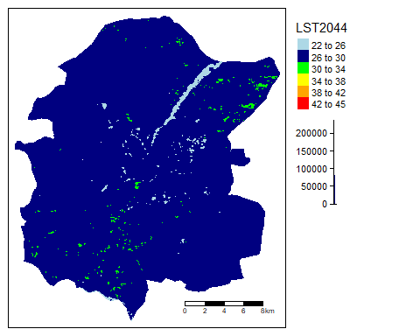

tm_B<- tmap::tm_shape(LST_03)+  
tmap::tm_raster(title="LST2064",  
style = "fixed",  
breaks = c(22,26,30,36,40,47),  
# labels = C(22-26,26-30,30-34,34-38,38-42,42-45),  
palette = c("lightblue","navyblue","yellow","orange","red"),  
legend.hist = T) +  
tmap::tm_layout(legend.outside = TRUE)+  
tmap::tm_scale_bar(position=c("right", "bottom"))  
  
tm_B

## Warning: Values have found that are less than the lowest break

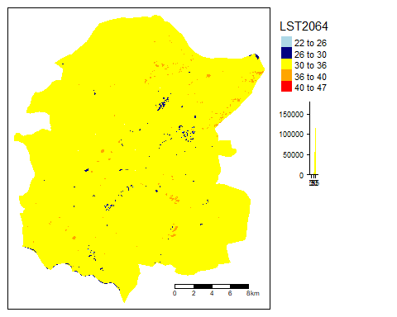

tm_C<- tmap::tm_shape(LST_24)+  
tmap::tm_raster(title="LST2084",  
style = "fixed",  
breaks = c(25,30,35,40,45),  
# labels = C(22-26,26-30,30-34,34-38),  
palette = c("lightblue","yellow","orange","red"),  
legend.hist = T) +  
tmap::tm_layout(legend.outside = TRUE)+  
tmap::tm_scale_bar(position=c("right", "bottom"))  
  
tm_C

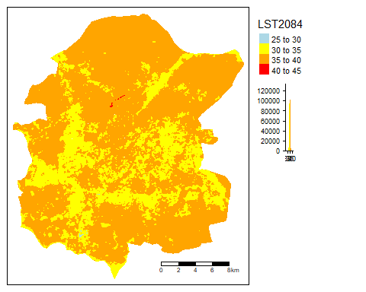

# install.packages(c('neuralnet','keras','tensorflow'),dependencies = T)  
  
cr<-rcorr(as.matrix(current_lst_24_naomit[,5:7]))  
cr$r

## Value_1 Band_1 2024_NDBI  
## Value_1 1.0000000 0.5802790 0.3374899  
## Band_1 0.5802790 1.0000000 -0.2684692  
## 2024_NDBI 0.3374899 -0.2684692 1.0000000

# model = neuralnet(  
# value~Band_1+current_lst_24_naomit$"2024_NDBI",data=current_lst_24_naomit,  
# hidden=c(4,2),  
# linear.output = FALSE  
# )  
#   
# sss<- predict(NDVI_24,model,type="response")  
# plot(sss)

# library(tiff)  
# library(leaflet)  
# library(tmap)  
# library(tmaptools)