Task-07

Class diagram:

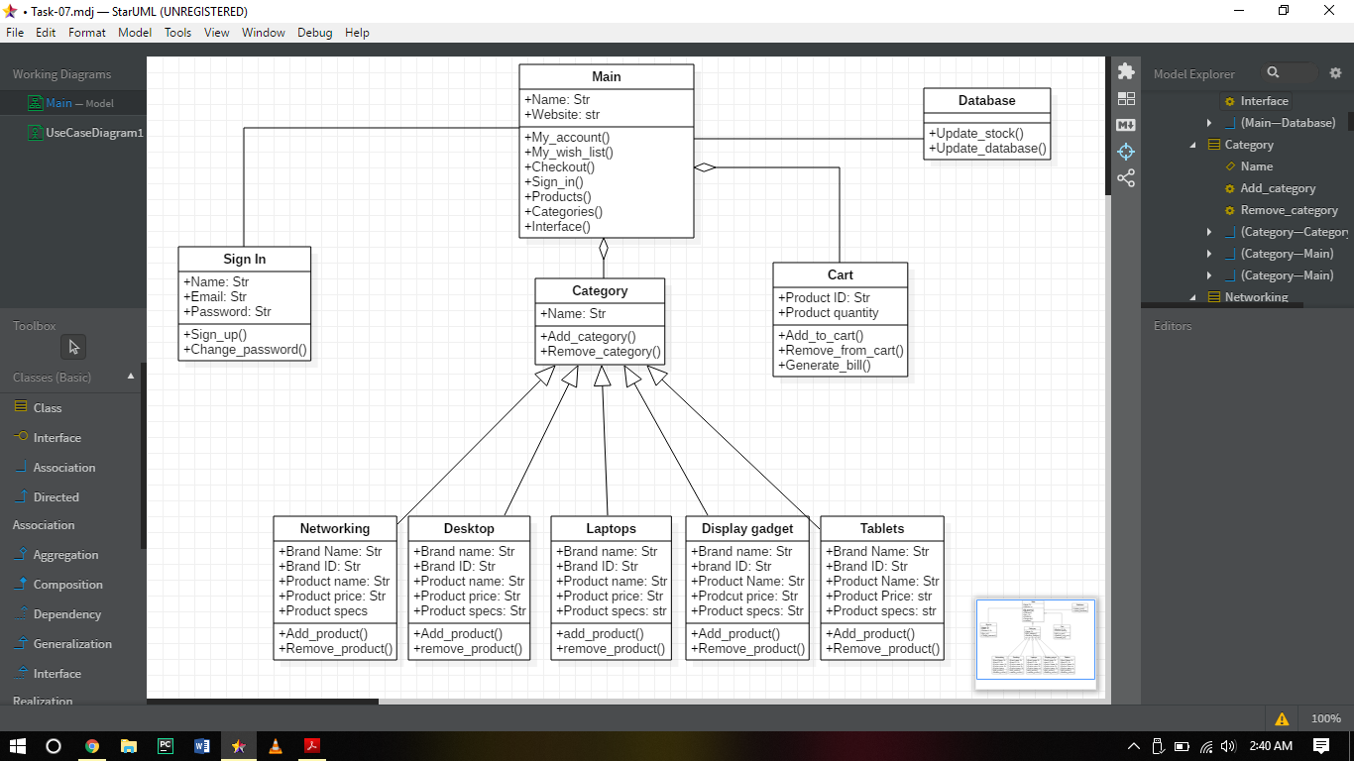

Code:

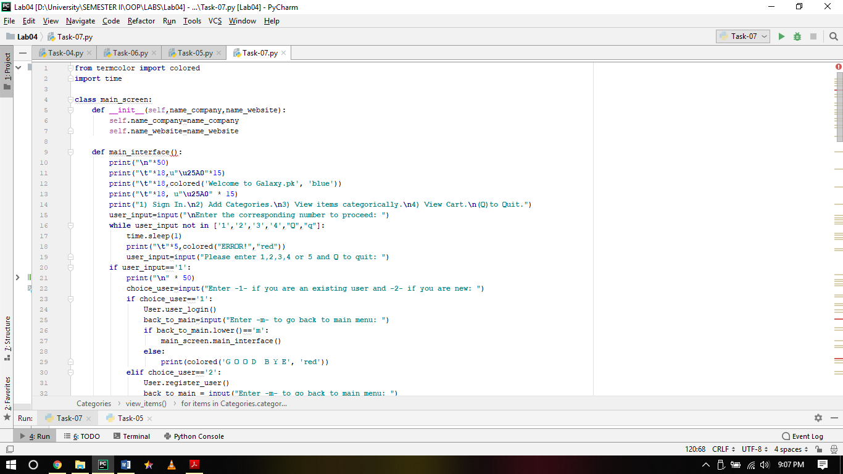

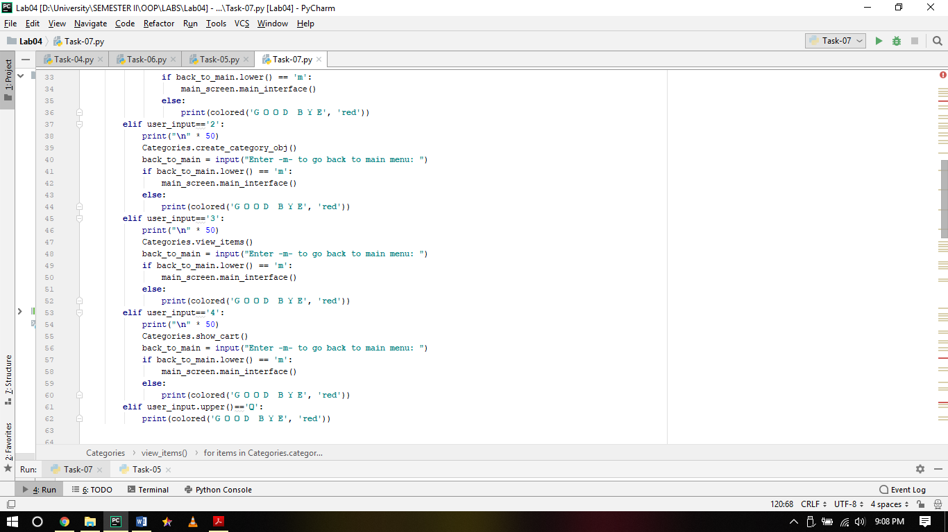

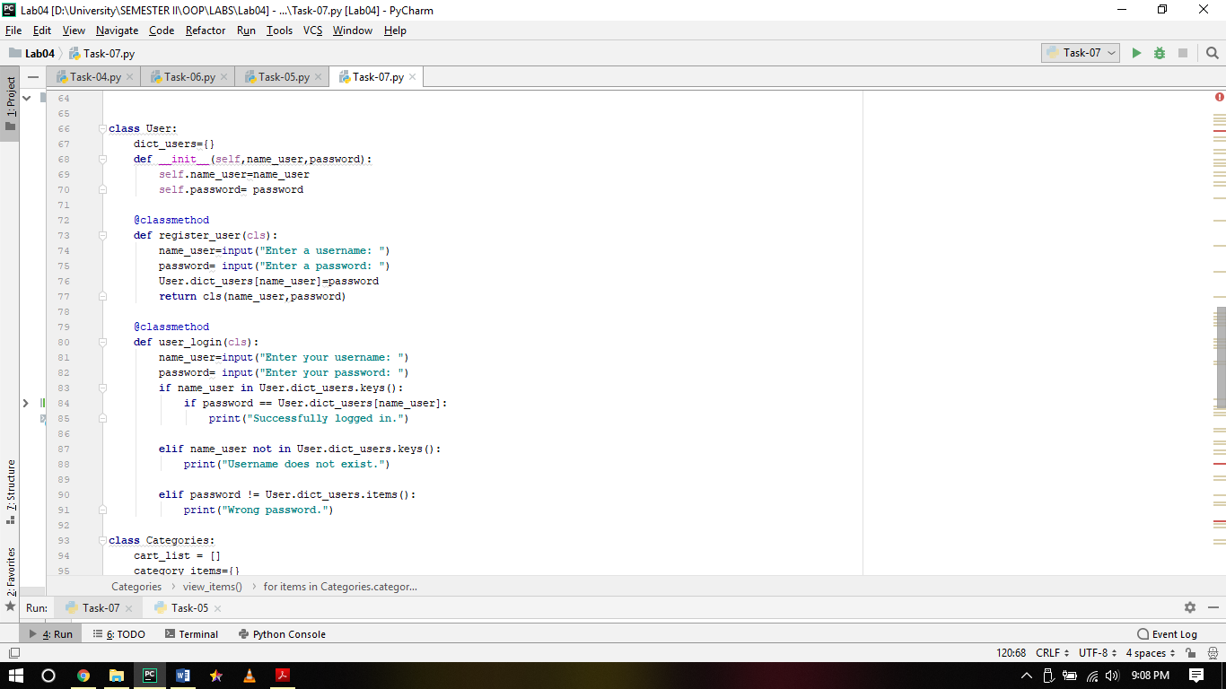

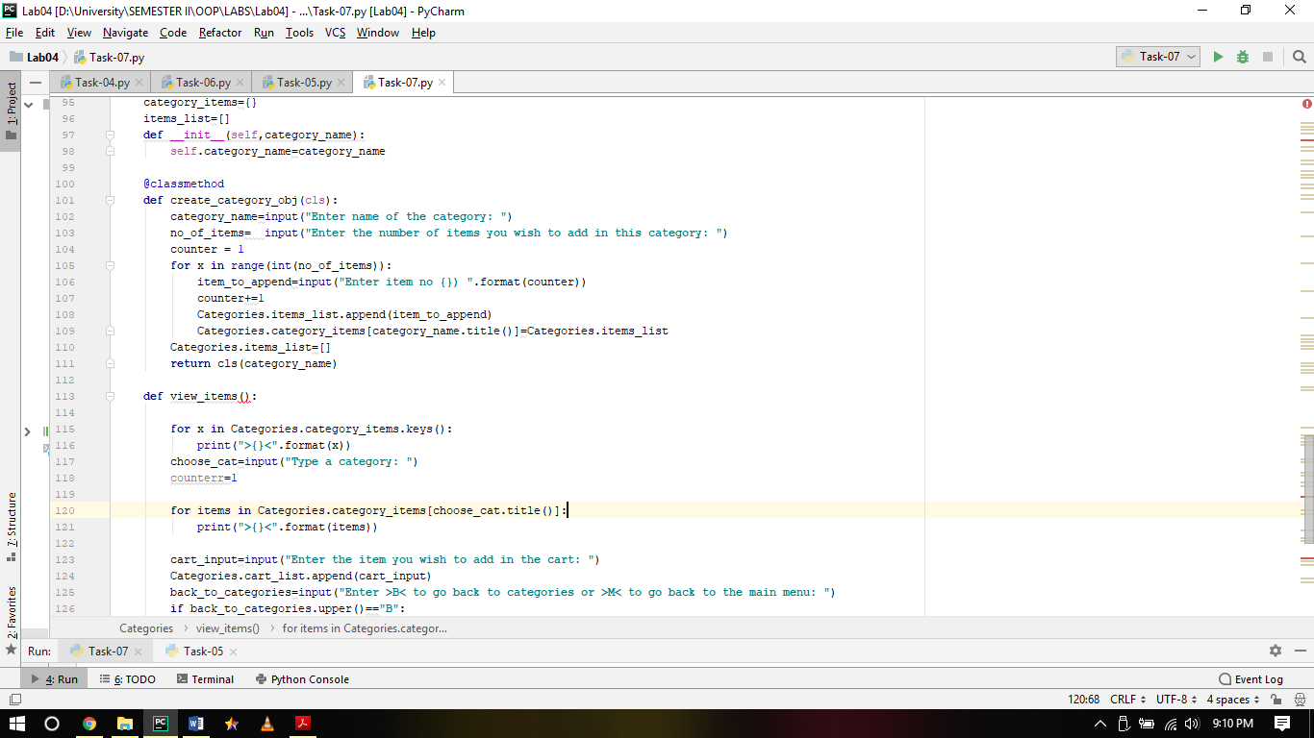

Output:

“**MAIN INTERFACE”**

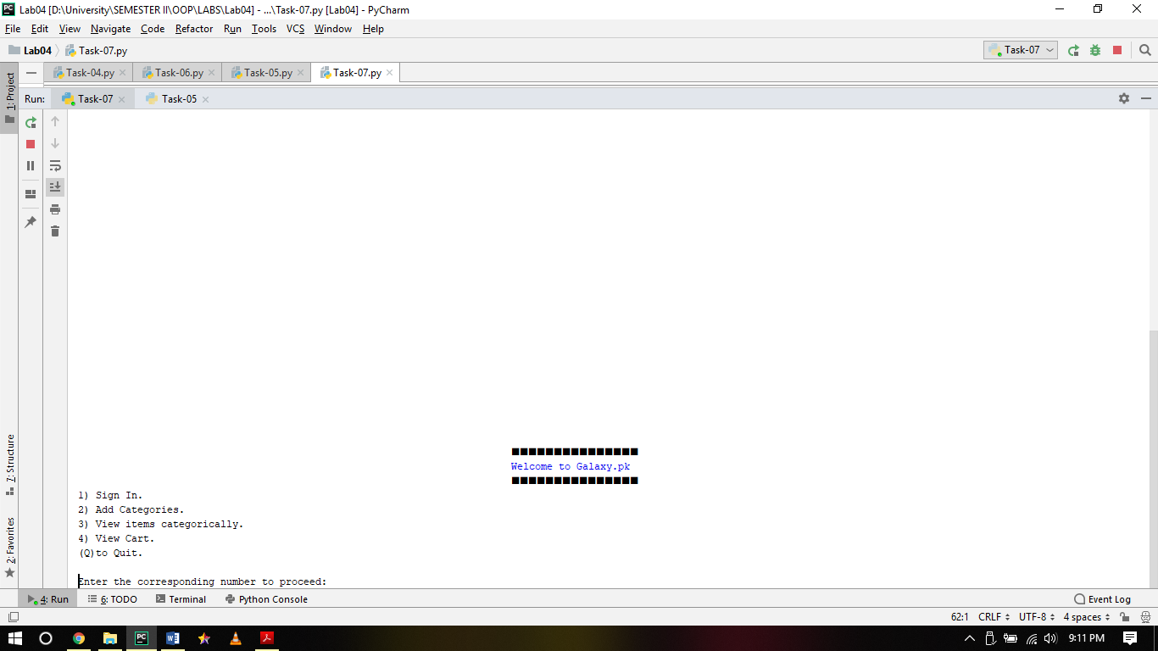

“**USER LOGIN/SIGNUP”**

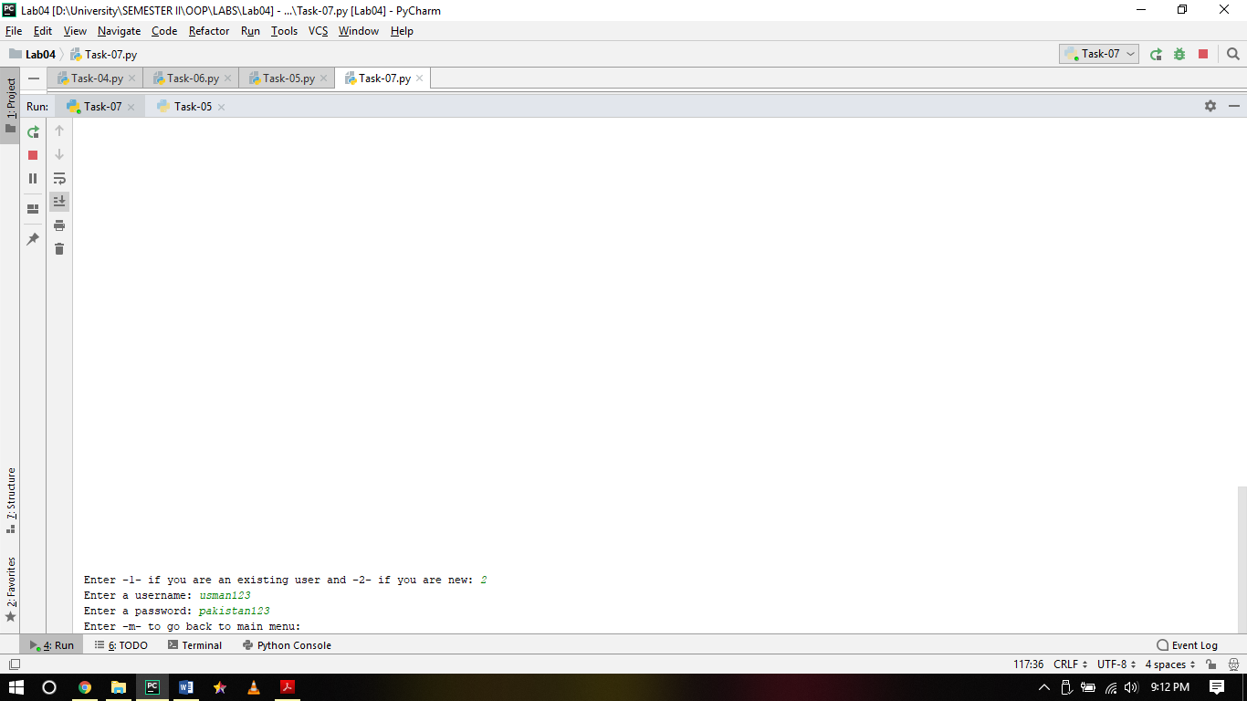

“**ADDING CATEGORIES AND ITEMS IN CATEGORIES”**

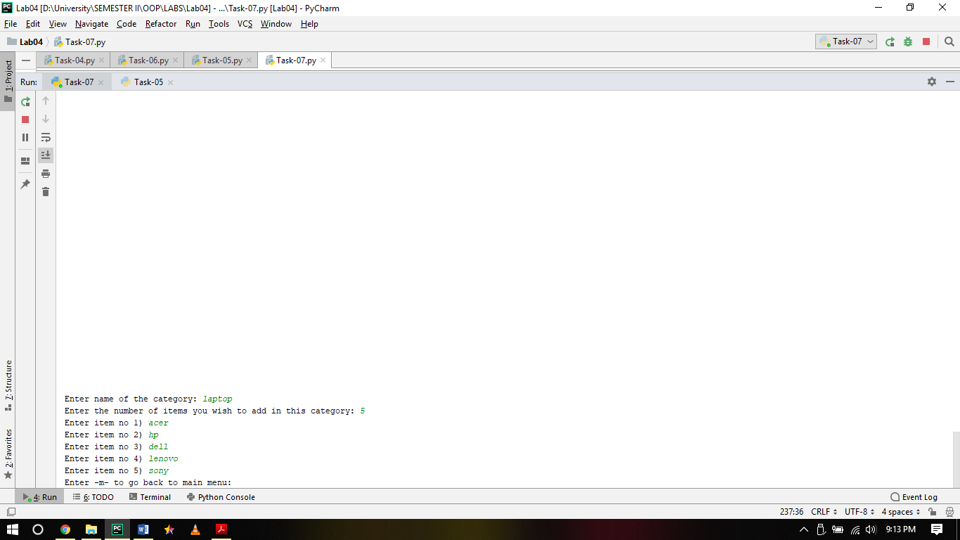

“**VIEWING CATEGORIES ADDED”**

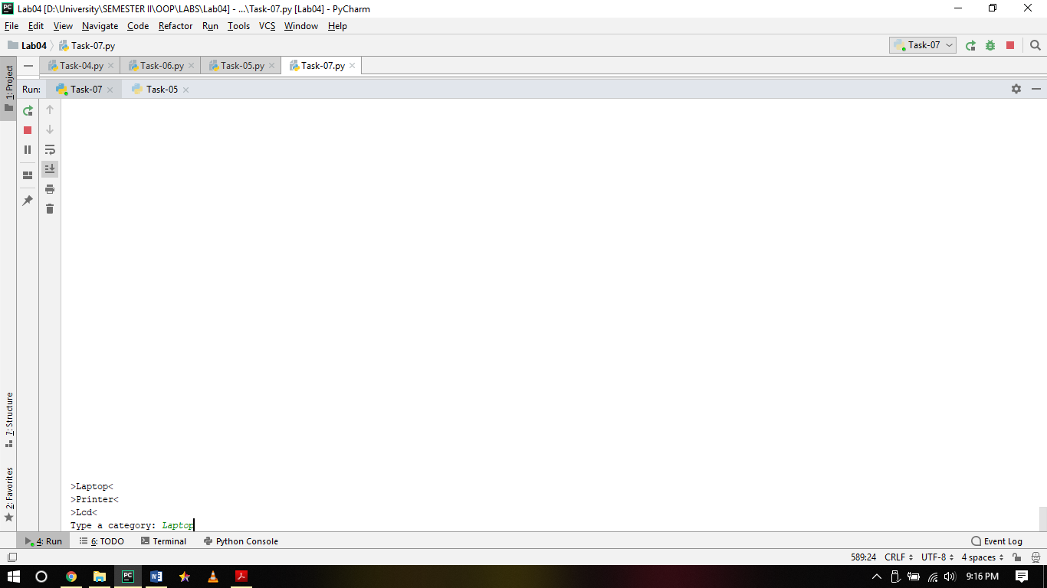

“**VIEWING INPUTTED CATEGORY ITEM AND ADDING TO CART”**

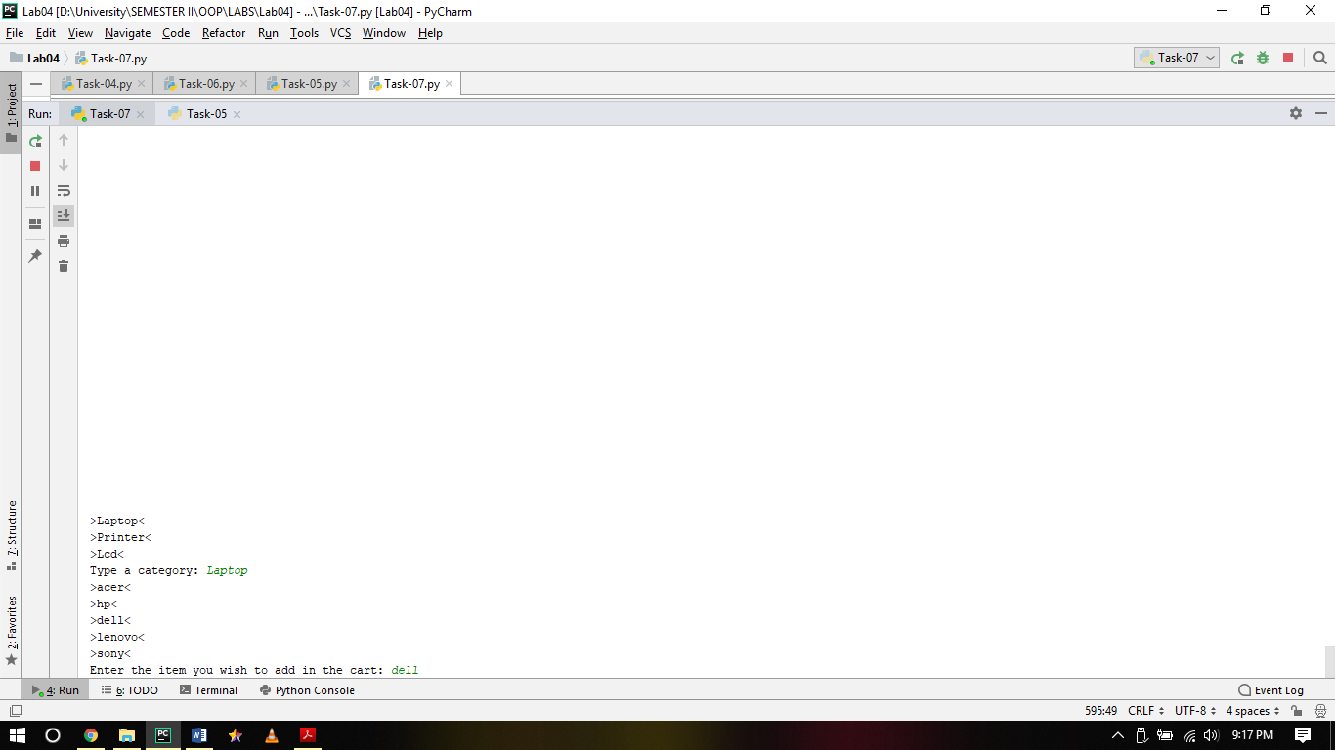

“**MULTIPLE ITEMS CAN BE ADDED”**

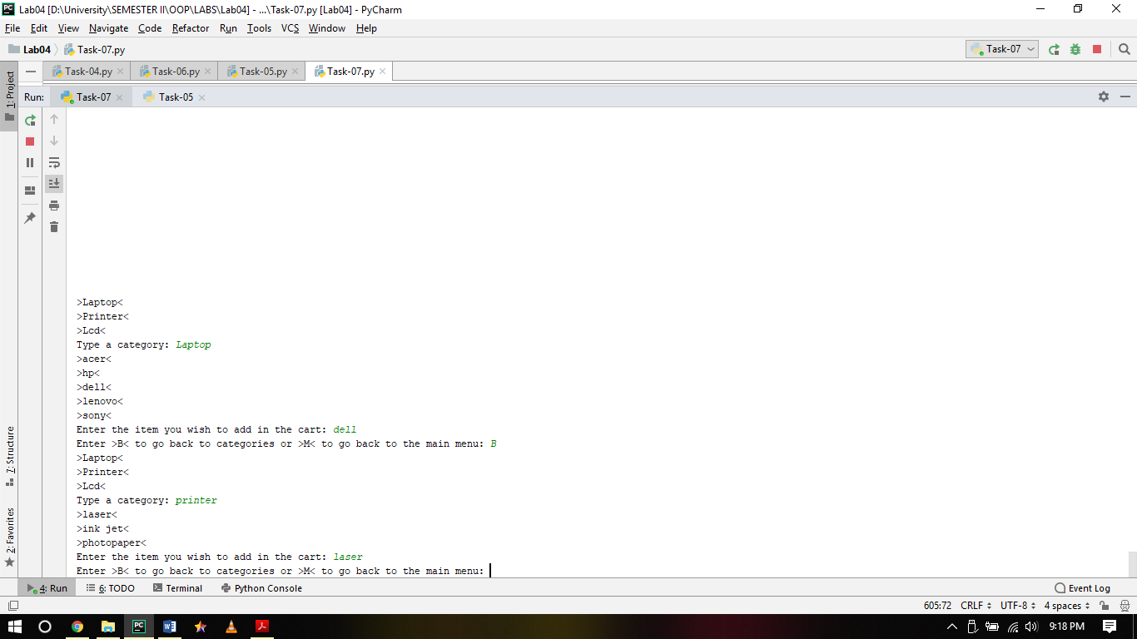

**“LASER PRINTER AND DELL LAPTOP ADDED TO CART”**

