

**Online Toys Finding Application**

**Design Document**

**Version 1.0**



**Group Id: F230262DF5 (Bc200406111)**

**Supervisor Name : Akmal Khan**

**Revision History**

|  |  |  |  |
| --- | --- | --- | --- |
| **Date (dd/mm/yyyy)** | **Version** | **Description** | **Author** |
| **20/12/2023** | 1.0 | “Online Toys Finding Application” is a web-based application that offers purchase the toys service to the application visitors. It offers to purchase the different or single toy. Main categories include Electronic toys, mechanical toys, stuffed toys. Toys will be delivered to address provide by user during the prescription delivery hours. Payment will be made by cash. | **Bc200406111** |
|  |  |  |  |
|  |  |  |  |
|  |  |  |  |

**Table of Contents**

1. Introduction of Design Document
2. Entity Relationship Diagram (ERD)
3. Sequence Diagrams
4. Architecture Design Diagram
5. Class Diagram
6. Database Design
7. Interface Design
8. Test Cases

|  |
| --- |
| 1. **Introduction of Design Document** |

The purpose of this document is to present a system design of **online toys finding Application.** This document is present both graphically in screenshots and in the text. This document produces the details about the design document with the help of several design drawing include is:

* Entity Relationship Diagram (ERD)
* Sequence Diagrams
* Architecture Design Diagram
* Class Diagram
* Database Design
* Interface Design

Finally it list down the suggested Test Cases for the unit and integrated testing of the system.

Design document is to provide the documentation add in software development giving the detail how Application should be built. This Application design document contains textual and graphical details of the Application design which includes Entity relationship diagrams, sequence diagrams, architecture design diagram, class diagram, database design, interface and test cases. The design activity provides a roadmap to progressively make over the requirements into the final product through a number of stages by describing the structure of the system to be implemented.

|  |
| --- |
| 1. **Entity Relationship Diagram (ERD)** |

ER diagrams are the most often used for the relational databases in software engineering. An ER diagram is a type of flowchart describer & how the entities relate with each other in a system Entities are represented as rectangles while the attributes are represented in ellipses and attributes are the properties of entities. The diamonds are used to show the relationships between entities. The ER diagram for the project is shown in the below.

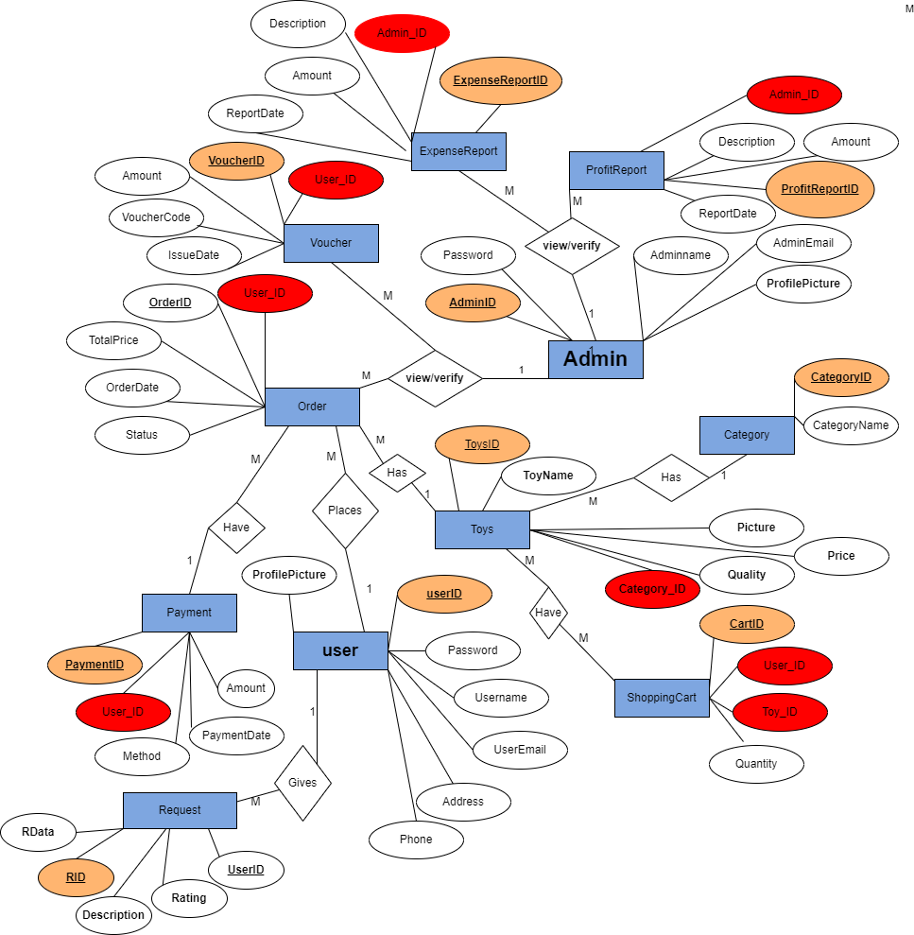

**Fig number 01:**

|  |
| --- |
| 1. **Sequence Diagrams** |

A Sequence Diagrams is an interaction diagrams that show how the objects operate with one another and it what order.

A sequence diagrams is used for the project show in below.

**Register for user:**

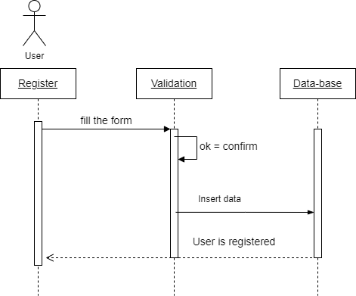

**Fig number 02: Register for user:**

**Verification login form:**

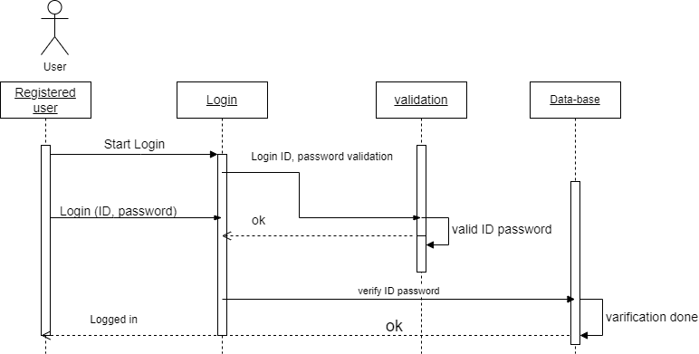

Fig number 03: Verification login form:

**For search toys**

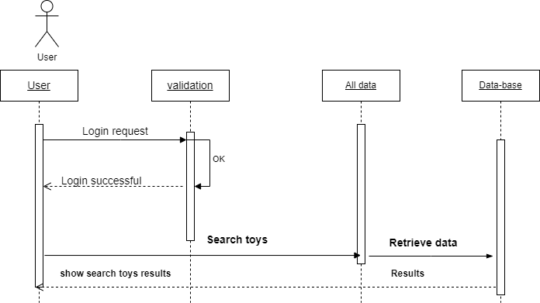

Fig number 04: For search toys:

**For add to cart**

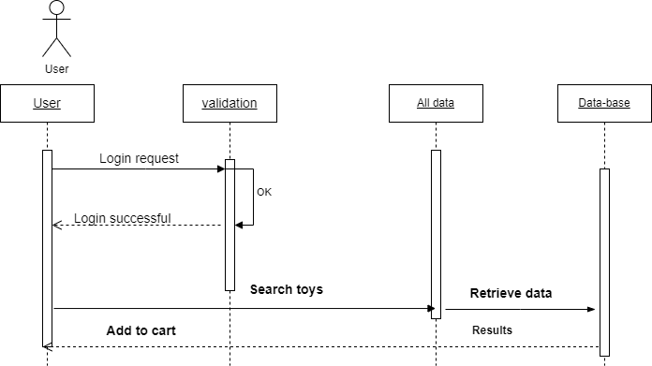

Fig number 05: **For add to cart**

**For Preview page**

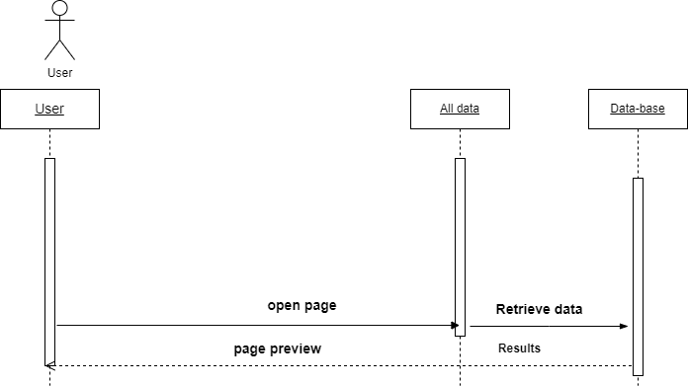

Fig number 06: **For Preview page**

**For user feedback:**

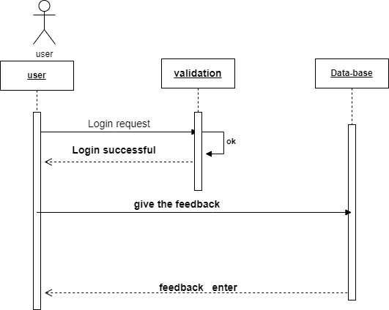

Fig number 07: **For user feedback:**

**For total price**

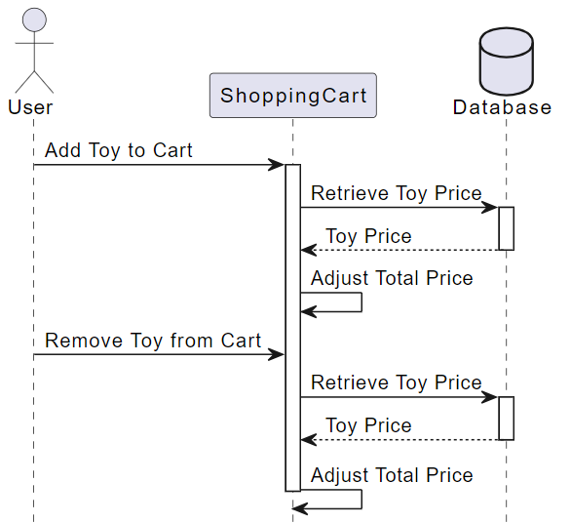

Fig number 08 **for** total price

**For category update**

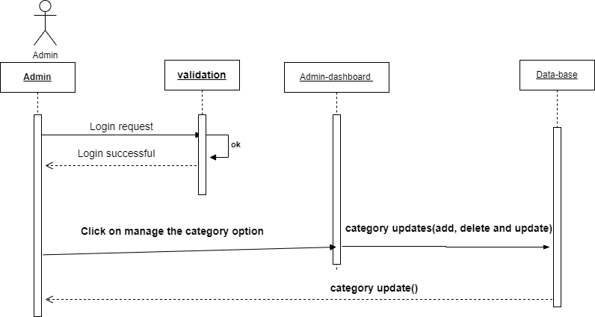

Fig number 09: For category update

**For record saved:**

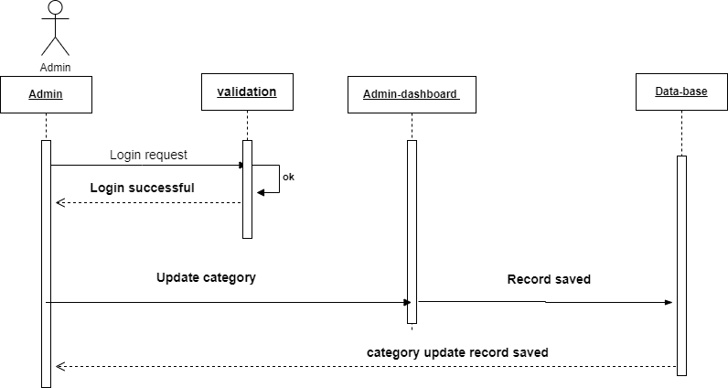

Fig number 09: **For record saved**

**expensive report generates**

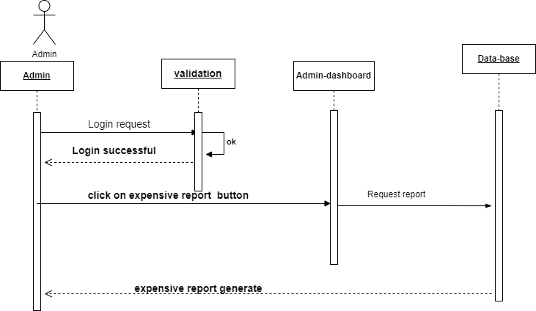

**Fig 10:**

**Profit report generate**

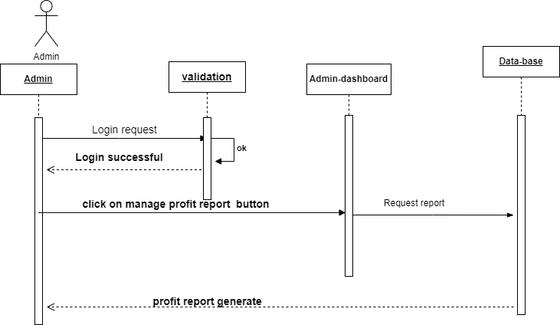

**Fig 11:**

**show the stock.**

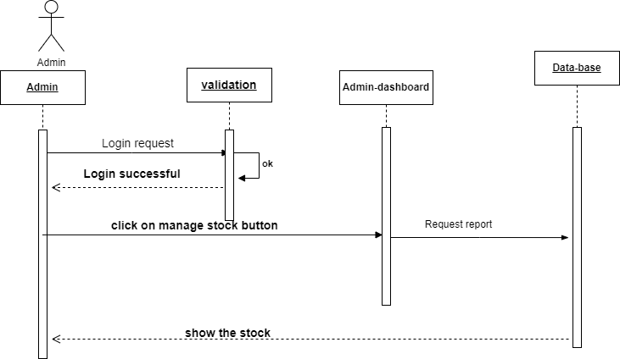

**Fig 12:**

**For order:**

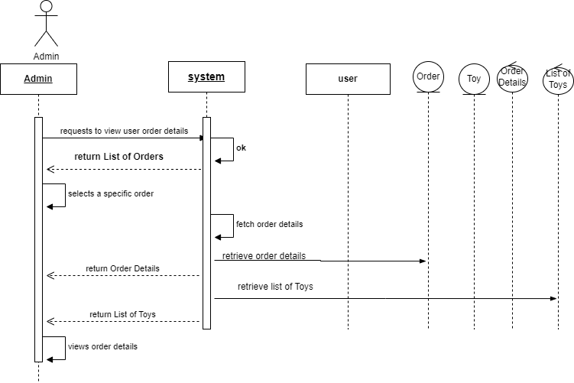

**Fig 13:**

**Generate voucher:**

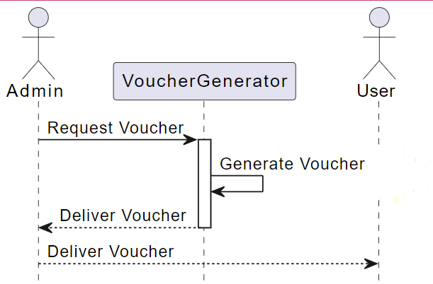

**Fig 14:**

**For dues or paid**

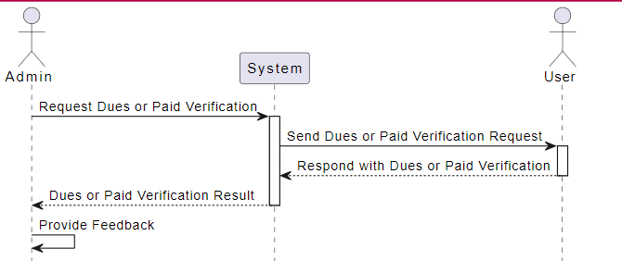

Fig 15:

**Shipping charge**

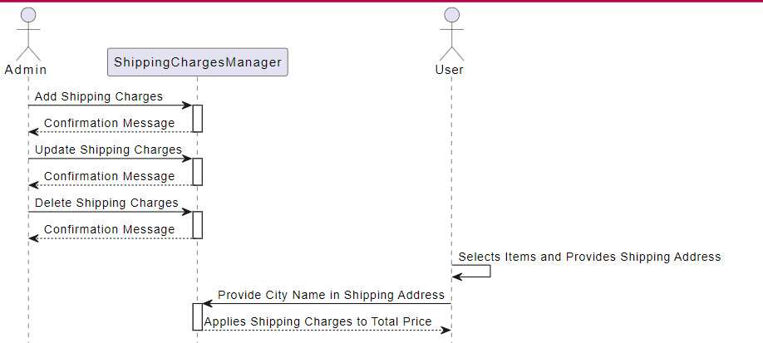

Fig 16:

**user request for a particular toy and feedback**

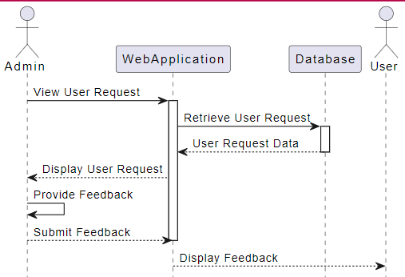

Fig 17:

|  |
| --- |
| 1. **Architecture Design Diagram** |

An architecture diagram is a crucial step for software and application developers. The basic software and application structure is separate by layer is describe by the architecture diagram. It depicts how a topically software system might the interact with its user, external system, data sources and services.

An architecture diagram for the project is show below.

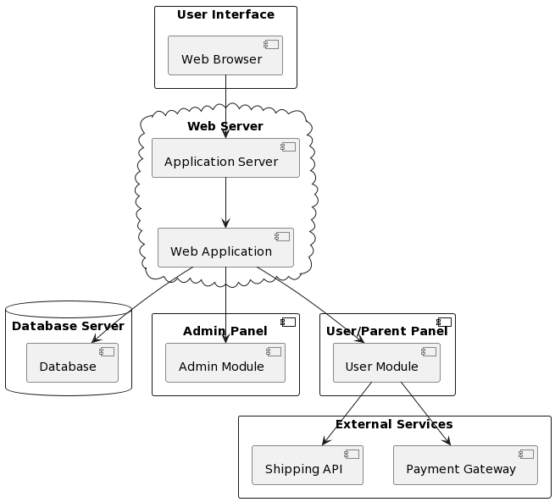

Fig number 18:

|  |
| --- |
| 1. **Class Diagram** |

A class diagram in the UML notation is a type of static structure diagram that describes the structure of a system by showing the system's classes. The class diagram is considered as the main building block of object oriented modeling and used as general conceptual modeling. The following class diagram for the system is given in the figure.

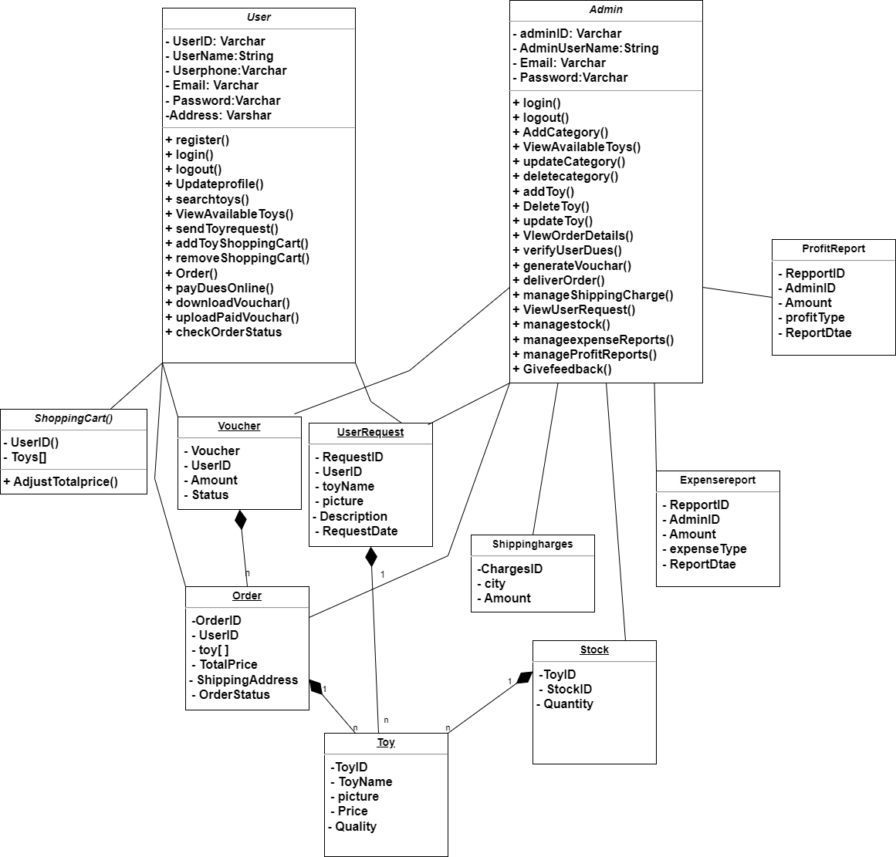

Fig number 19

|  |
| --- |
| 1. **Database Design** |

Fig number 20

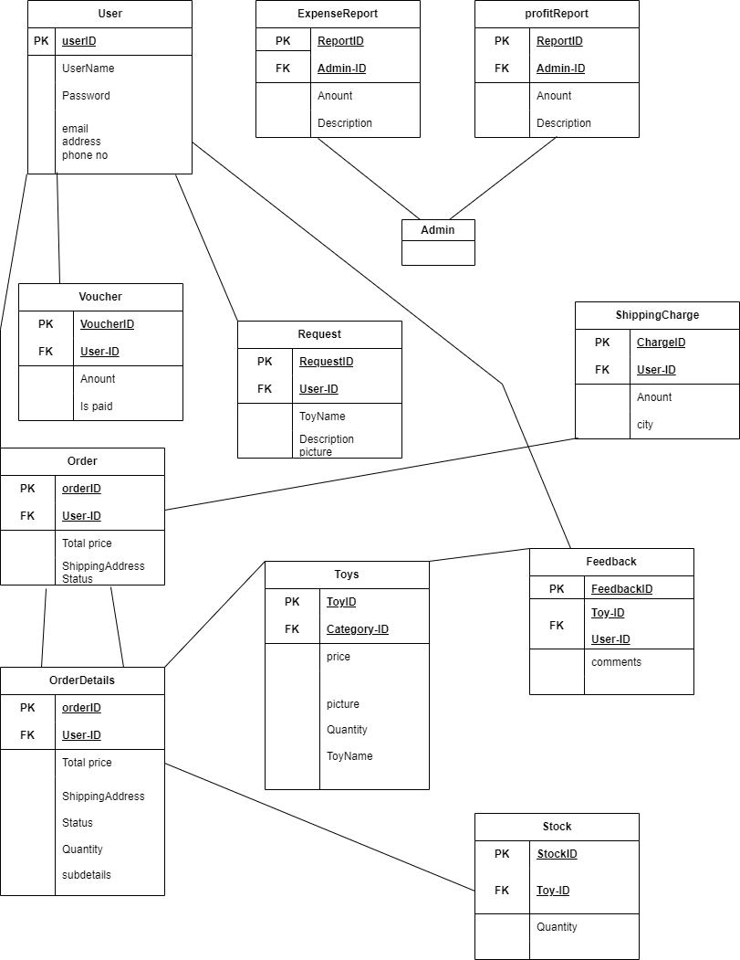

|  |
| --- |
| 1. **Interface Design** |

Interface design are used for making user and admin show how to use the application or system software.

Given below GUI SCREESHOTS

1. **For login**

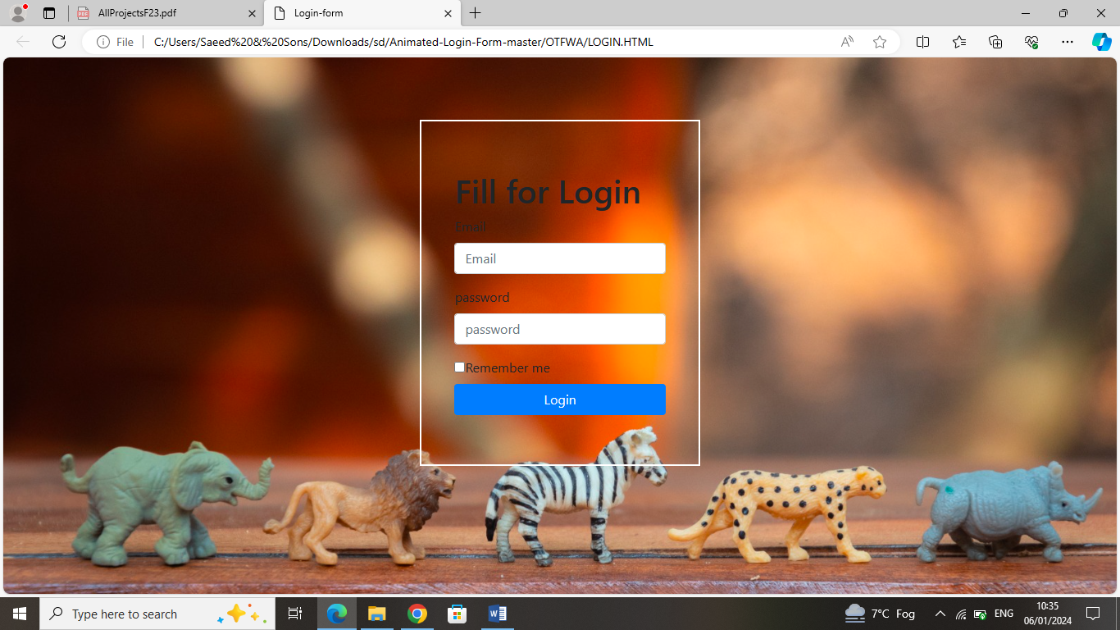

1. **For home:**

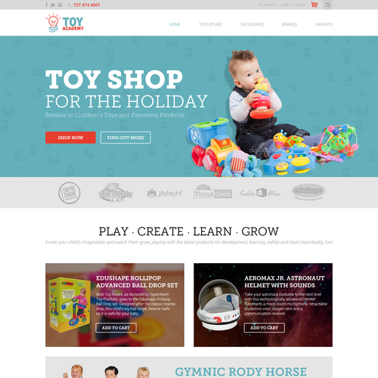

1. **Registration.**

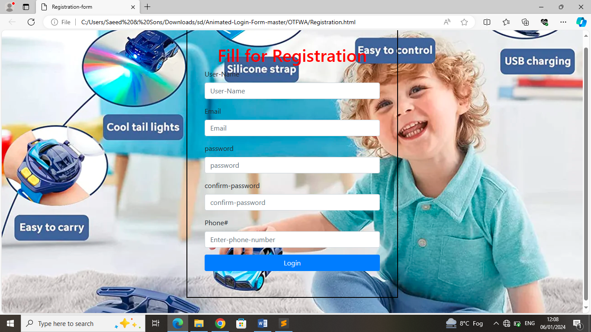

1. **User search toy.**

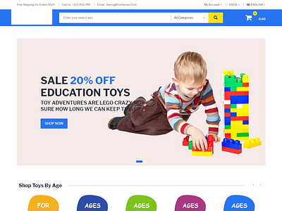

|  |
| --- |
| 1. **Test Cases** |

**Test case for user.**

**Registration:**

|  |  |
| --- | --- |
| **Test case no** | TC-01 |
| **Test case Name** | Register. |
| **System** | Online Toys Finding web-Application. |
| **Precondition** | Application is running. |
| **Action** | 1. Navigate to the registration page. 2. Enter valid user details (username, password, email, etc.). 3. Click on the "Register" button. |
| **Expected Results** | 1. User is successfully registered. 2. Redirected to the login page with a success message. |
| **Post Conditions** | User can login |
| **Result** | Pass |
| **Texted by** | Bc200406111 |

**Login:**

|  |  |
| --- | --- |
| **Test case no** | TC-02 |
| **Test case Name** | Login. |
| **System** | Online Toys Finding web-Application. |
| **Precondition** | User Must be registered. |
| **Action** | 1. Navigate to the login page. 2. Enter valid email and password 3. Click on the "login" button. |
| **Expected Results** | 1. The system should authenticate the user successfully. 2. The user should be redirected to the home page. |
| **Post Conditions** | The user is logged into the Application. |
| **Result** | Pass |
| **Texted by** | Bc200406111 |

**Search:**

|  |  |
| --- | --- |
| **Test case no** | TC-03 |
| **Test case Name** | Search |
| **System** | Online Toys Finding web-Application. |
| **Precondition** | User is logged into the Application OR Click to search bar. |
| **Action** | 1. Click to the search bar. 2. Enter the toy name 3. Click on the "search" button. |
| **Expected Results** | 1. The Application should display a list of toys related to the search. 2. The list should contain relevant information such as toy name, picture, price, etc |
| **Post Conditions** | User see the search results on the screen. |
| **Result** | Pass |
| **Texted by** | Bc200406111 |

**Add to cart:**

|  |  |
| --- | --- |
| **Test case no** | TC-04 |
| **Test case Name** | Add to cart. |
| **System** | Online Toys Finding web-Application. |
| **Precondition** | User is login into the Application. |
| **Action** | 1. Navigate to the toy details page. 2. Click on the "Add to Cart" button |
| **Expected Results** | 1. The selected toy is added to the shopping cart. 2. The total price in the cart is updated. |
| **Post Conditions** | The toy is in the user's shopping cart. |
| **Result** | Pass |
| **Texted by** | Bc200406111 |

**View cart:**

|  |  |
| --- | --- |
| **Test case no** | TC-05 |
| **Test case Name** | View cart. |
| **System** | Online Toys Finding web-Application. |
| **Precondition** | User is login into the Application. |
| **Action** | User can view cart. |
| **Expected Results** | User can see the toys in cart. |
| **Post Conditions** | User can click out or remove toy from cart. |
| **Result** | Pass |
| **Texted by** | Bc200406111 |

**Feedback:**

|  |  |
| --- | --- |
| **Test case no** | TC-06 |
| **Test case Name** | Feedback. |
| **System** | Online Toys Finding web-Application. |
| **Precondition** | User is login into the Application. |
| **Action** | 1. Login in application 2. Click on feedback. 3. Fill the feedback form. 4. Click on submit. |
| **Expected Results** | Application will be display successful after the submit feedback |
| **Post Conditions** | Show sumited. |
| **Result** | Pass |
| **Texted by** | Bc200406111 |

**Update profile:**

|  |  |
| --- | --- |
| **Test case no** | TC-07 |
| **Test case Name** | Update profile. |
| **System** | Online Toys Finding web-Application. |
| **Precondition** | User must be login into the Application. |
| **Action** | 1. Click on profile option. 2. Choose the "Update Profile" option. 3. Modify one or more profile fields (e.g., FirstName, LastName, Email, Address). 4. Click the "Save" or "Update" button. |
| **Expected Results** | The system should update the user's profile information |
| **Post Conditions** | The user's profile is successfully updated in the system. |
| **Result** | Pass |
| **Texted by** | Bc200406111 |

**Verify Total Price Adjustment on Add or del Toys:**

|  |  |
| --- | --- |
| **Test case no** | TC-08 |
| **Test case Name** | Verify Total Price Adjustment on Adding Toys |
| **System** | Online Toys Finding web-Application. |
| **Precondition** | User has items in the shopping cart with a total price. |
| **Action** | 1. Add a new toy to the shopping cart. 2. Check the total price in the shopping cart. |
| **Expected Results** | The total price should reflect the addition of the new toy. |
| **Post Conditions** | The new toy is added and delete to the shopping cart, and the total price is updated accordingly. |
| **Result** | Pass |
| **Texted by** | Bc200406111 |

**Shipping Address Confirmation:**

|  |  |
| --- | --- |
| **Test case no** | TC-09 |
| **Test case Name** | Shipping Address Confirmation |
| **System** | Online Toys Finding web-Application. |
| **Precondition** | User has selected toys and proceeded to the checkout page |
| **Action** | 1. User enters the complete shipping address (street, city, state, postal code, etc.) 2. User clicks on the "Confirm Order" button. |
| **Expected Results** | The system should display a confirmation message |
| **Post Conditions** | The system stores the shipping address associated with the order. |
| **Result** | Pass |
| **Texted by** | Bc200406111 |

**Online Pay and dues Voucher Upload:**

|  |  |
| --- | --- |
| **Test case no** | TC-10 |
| **Test case Name** | Online Payment and Voucher Upload |
| **System** | Online Toys Finding web-Application. |
| **Precondition** | User is logged in and has items in the shopping cart |
| **Action** | 1. User navigates to the shopping cart. 2. User reviews the items and total amount. 3. User selects the "Pay Online" option. 4. User completes the online payment process. 5. User downloads the payment voucher. 6. User uploads the downloaded voucher. |
| **Expected Results** | The online payment process completes successfully. |
| **Post Conditions** | 1. User's total dues are marked as paid. 2. The order status is updated to "Paid." 3. The system records the voucher information. 4. Payment transaction details are stored securely. |
| **Result** | Pass |
| **Texted by** | Bc200406111 |

**Verify User Order Status Retrieval:**

|  |  |
| --- | --- |
| **Test case no** | TC-11 |
| **Test case Name** | Verify User Order Status Retrieval |
| **System** | Online Toys Finding web-Application. |
| **Precondition** | User is login into the application. |
| **Action** | 1. Order Status" section in the user interface. 2. Enter the Order ID of the previously placed order. 3. Click on the "Check Status" button. |
| **Expected Results** | Status can be one of the following: "Processing," "Shipped," "Delivered," or "Cancelled," depending on the current status of the order. |
| **Post Conditions** | The user is informed about the current status of the order. |
| **Result** | Pass |
| **Texted by** | Bc200406111 |

**Logout:**

|  |  |
| --- | --- |
| **Test case no** | TC-12 |
| **Test case Name** | Logout |
| **System** | Online Toys Finding web-Application. |
| **Precondition** | User is login into the application. |
| **Action** | Click on logout. |
| **Expected Results** | Logout successful. |
| **Post Conditions** | Logout successful. |
| **Result** | Pass |
| **Texted by** | Bc200406111 |

**Test case for admin:**

**Login:**

|  |  |
| --- | --- |
| **Test case no** | TC-01 |
| **Test case Name** | Login. |
| **System** | Online Toys Finding web-Application. |
| **Precondition** | The admin user exists in the system, and the application is running. |
| **Action** | 1. Open the application login page. 2. Enter valid admin credentials (username and password). 3. Click on the "Login" button. |
| **Expected Results** | 1. The admin should be successfully login into the application. 2. The admin dashboard or main interface should be displayed. |
| **Post Conditions** | 1. The admin has access to the admin panel features. 2. The login session is established, and the admin can perform various tasks. |
| **Result** | Pass |
| **Texted by** | Bc200406111 |

**Admin Manage Categories:**

|  |  |
| --- | --- |
| **Test case no** | TC-02 |
| **Test case Name** | Admin_ManageCategories |
| **System** | Online Toys Finding web-Application. |
| **Precondition** | Admin is login into the application. |
| **Action** | 1. Admin adds a new category named "Action Figures." 2. Admin updates the existing category "Dolls" to "Fashion Dolls." 3. Admin deletes the category. |
| **Expected Results** | 1. New category "Action Figures" is added successfully. 2. Existing category "Dolls" is updated to "Fashion Dolls" successfully. 3. Category is deleted successfully. |
| **Post Conditions** | The system reflects the changes made by the admin in the categories. |
| **Result** | Pass |
| **Texted by** | Bc200406111 |

**Add, update and delete toys information:**

|  |  |
| --- | --- |
| **Test case no** | TC-03 |
| **Test case Name** | Add, update and delete toys information |
| **System** | Online Toys Finding web-Application. |
| **Precondition** | Admin is login into the application. |
| **Action** | 1. Click on the "Add update and delete Toy information". 2. Fill in the required information for a new toy (Toy Name, Picture, Price, Quality, etc.). 3. Click on the "Save" button. |
| **Expected Results** | The new toy is add update and delete to the application. |
| **Post Conditions** | New information show. |
| **Result** | Pass |
| **Texted by** | Bc200406111 |

**Admin View User Order Details:**

|  |  |
| --- | --- |
| **Test case no** | TC-04 |
| **Test case Name** | Admin View User Order Details |
| **System** | Online Toys Finding web-Application. |
| **Precondition** | Admin is login into the system and there is an existing user order with selected toys, total price, and shipping address. |
| **Action** | 1. View User Orders 2. Admin selects a specific user order for viewing details. |
| **Expected Results** | Details include the names of selected toys, their quantities, the total price of the order, and the shipping address. |
| **Post Conditions** | Admin has successfully viewed the order details for the selected user. |
| **Result** | Pass |
| **Texted by** | Bc200406111 |

**Admin Generates Voucher for User:**

|  |  |
| --- | --- |
| **Test case no** | TC-05 |
| **Test case Name** | Admin Generates Voucher for User |
| **System** | Online Toys Finding web-Application. |
| **Precondition** | Admin login in the application |
| **Action** | 1. Admin selects a user for whom the voucher needs to be generated. 2. Admin enters the voucher amount. 3. Admin clicks on the "Generate Voucher" button. |
| **Expected Results** | 1. A unique voucher code is generated for the selected user. 2. The voucher amount is set as specified by the Admin. |
| **Post Conditions** | The generated voucher is associated with the selected user in the application. |
| **Result** | Pass |
| **Texted by** | Bc200406111 |

**Verify and Deliver Order:**

|  |  |
| --- | --- |
| **Test case no** | TC-06 |
| **Test case Name** | Verify and Deliver Order |
| **System** | Online Toys Finding web-Application. |
| **Precondition** | Admin is login into the application. |
| **Action** | 1. order verification section. 2. Admin selects an order with online dues or a paid voucher. 3. Admin verifies the user's online dues or paid voucher. 4. Admin confirms the verification and proceeds to deliver the order. |
| **Expected Results** | 1. The system should display the order details along with the user's payment status. 2. If online dues are verified, the payment status should be marked as paid. 3. The system should allow the Admin to proceed with the order delivery. |
| **Post Conditions** | 1. The user's payment status for the selected order is updated (paid or redeemed). 2. The Admin is ready to deliver the order. |
| **Result** | Pass |
| **Texted by** | Bc200406111 |

**Admin can add, delete, update and calculate total price of shipping charge:**

|  |  |
| --- | --- |
| **Test case no** | TC-07 |
| **Test case Name** | Admin can add, delete, update and calculate total price of the shipping charge. |
| **System** | Online Toys Finding web-Application. |
| **Precondition** | Admin is login into the application. |
| **Action** | Admin add, delete, updates and calculate the shipping charge for the city |
| **Expected Results** | The system should confirm successful update, delete, add and calculate shipping charges. |
| **Post Conditions** | Non. |
| **Result** | Pass |
| **Texted by** | Bc200406111 |

**Admin View User Request And Provide Feedback:**

|  |  |
| --- | --- |
| **Test case no** | TC-08 |
| **Test case Name** | Admin view user request and provide feedback. |
| **System** | Online Toys Finding web-Application. |
| **Precondition** | Admin is login into the application. |
| **Action** | 1. Admin navigates to the "User Requests" section. 2. Admin selects a specific user request for a toy. 3. Admin provides feedback for the user request. |
| **Expected Results** | 1. The system displays the details of the selected user request, including toy name, description, and user information. 2. Admin can input feedback for the user request. 3. After providing feedback, the system updates the request status or logs the feedback. |
| **Post Conditions** | The status of the user request may be updated to reflect the feedback provided by the admin. |
| **Result** | Pass |
| **Texted by** | Bc200406111 |

**Manage stock:**

|  |  |
| --- | --- |
| **Test case no** | TC-09 |
| **Test case Name** | Manage stock. |
| **System** | Online Toys Finding web-Application. |
| **Precondition** | Admin is login into the application. |
| **Action** | 1. Go "Manage Stock" section in the admin panel. 2. View the current stock levels for various toys. 3. Update the quantity of a specific toy in the stock. |
| **Expected Results** | 1. The system should display the current stock levels accurately. 2. The admin should be able to successfully update the stock quantity for the selected toy. |
| **Post Conditions** | The stock quantity for the selected toy is updated in the system. |
| **Result** | Pass |
| **Texted by** | Bc200406111 |

**Manage expense reports:**

|  |  |
| --- | --- |
| **Test case no** | TC-10 |
| **Test case Name** | Manage expense reports. |
| **System** | Online Toys Finding web-Application. |
| **Precondition** | Admin is login into the application. |
| **Action** | 1. On Admin panel. 2. Select the option to manage expense reports. 3. Add a new expense report with details (e.g., amount, description). 4. Save the changes. |
| **Expected Results** | 1. The new expense report is successfully added to the system. 2. The system provides a confirmation message indicating successful addition. 3. The added expense report is now visible in the list of expense reports. |
| **Post Conditions** | The expense report is successfully added and stored in the system. |
| **Result** | Pass |
| **Texted by** | Bc200406111 |

**Manage profit reports:**

|  |  |
| --- | --- |
| **Test case no** | TC-11 |
| **Test case Name** | Manage profit reports. |
| **System** | Online Toys Finding web-Application. |
| **Precondition** | Admin is login into the application. |
| **Action** | 1. On Admin panel. 2. Select the option to manage profit reports. 3. View and modify the profit data as necessary. |
| **Expected Results** | 1. The system should display a list of profit reports. 2. Admin can edit and update the profit data. 3. Any changes made should be reflected in the system. |
| **Post Conditions** | The expense report is successfully added and stored in the system. |
| **Result** | Pass |
| **Texted by** | Bc200406111 |

**Admin logout:**

|  |  |
| --- | --- |
| **Test case no** | TC-12 |
| **Test case Name** | Logout |
| **System** | Online Toys Finding web-Application. |
| **Precondition** | Admin is login into the application. |
| **Action** | Click on logout. |
| **Expected Results** | Logout successful. |
| **Post Conditions** | Logout successful. |
| **Result** | Pass |
| **Texted by** | Bc200406111 |