**PROJECT REPORT…**

**GROUP MEMBERS**

**NAME:** HASEEB JAN

MUHAMMAD FARHAN

OSAMA ALAM

MUHAMMAD RAHEEM

**BATCH CODE:** 2103F1

**FACULTY:** MISS TOOBA KHAWAR

**COORDINATOR:** MISS SIDRA SALEEM

**ACKNOWLEDGEMENT**

Firstly, I would like to thank to the everlasting and almighty ALLAH who give us the strength to think, work, and to show our abilities at what we are assigned to do. Secondly, we are very much obliged to our beloved Faculty (MS TOOBA KHAWAR) who helped us throughout in this project with her constant administration and support. Her kind cooperation and encouragement helped us to do our best. Her valuable guidance as well as necessary information which she give enhances our skills with the invaluable advices , Inspiration and suggestion has helped us to patch this project and make it full success. Her support and instructions has served as the major contributor towards the completion of project

We are highly indebted and merciful to Aptech for giving us this challenging project as a part of our studies and giving us a chance to prove ourselves.

Lastly, we would like to express our gratitude to each other without the cooperation and unity completion of project was impossible..



1. INTRODUCTION:

PROBLEM STATEMENT:

Auctions Table is an organization selling valuable items and goods through auctions. They have a vast experience of organizing auctions for past 25 years. Now with the client base expanding, they want to provide e-services for auctions. Hence they want a website to be created with proper auction features

REQUIREMENTS AND SPECIFICATION:

The Website is to be created based on the following requirements.

1. The home page must be designed with beautiful color combination with all the required links defined properly. Also all the section of the webpage must be in used to avoid the blank space.
2. Home page should display all available items available for auction as a slide show.
3. Menu should provide links to various auctions. Categorization of items should be done viz. Furniture, Paintings etc.
4. On moving to any particular category, it should list various items available for auction.
5. Clicking on any item should display the details of item along with the base price of the item.
6. Menu should also provide link to completed auctions displaying the final price of product/item.
7. About us, Contact Us, Disclaimer must be included.
8. (Creating an account facility can also be added.
9. Dummy procedure for placing bid to be added.
10. Sitemap must be added.
11. Navigation of the project must be made smooth.

**2. DISCRIPTION:**

The website is divided into 4 different pages:

* Home
* Our Categories
* About Us
* Contact Us

Each page contains the navigation bar that has hyperlinks to different pages. At the bottom of every page there is footer that contains basic details.

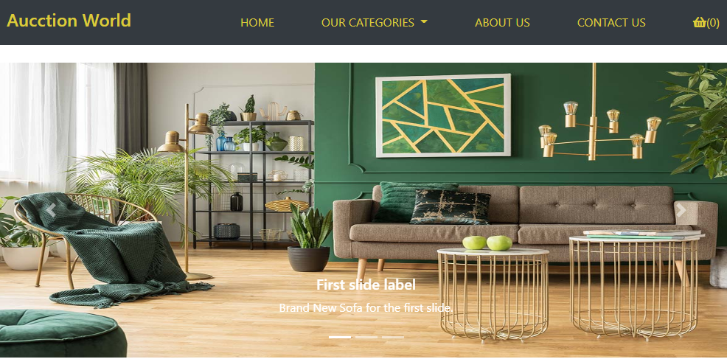

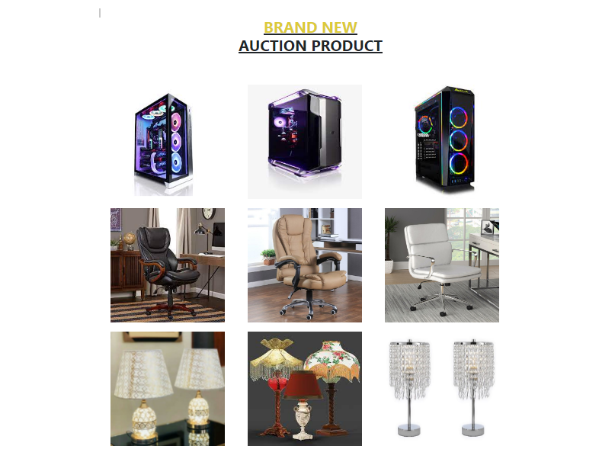

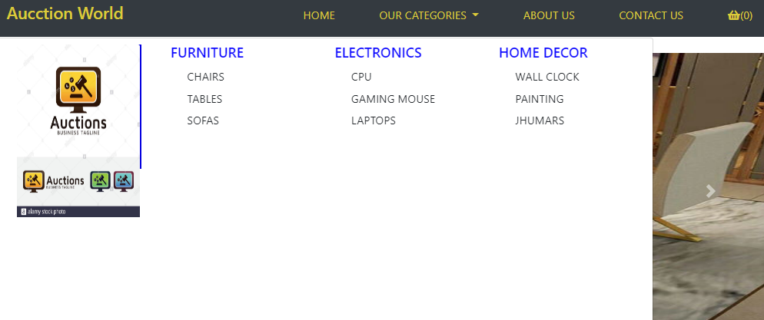

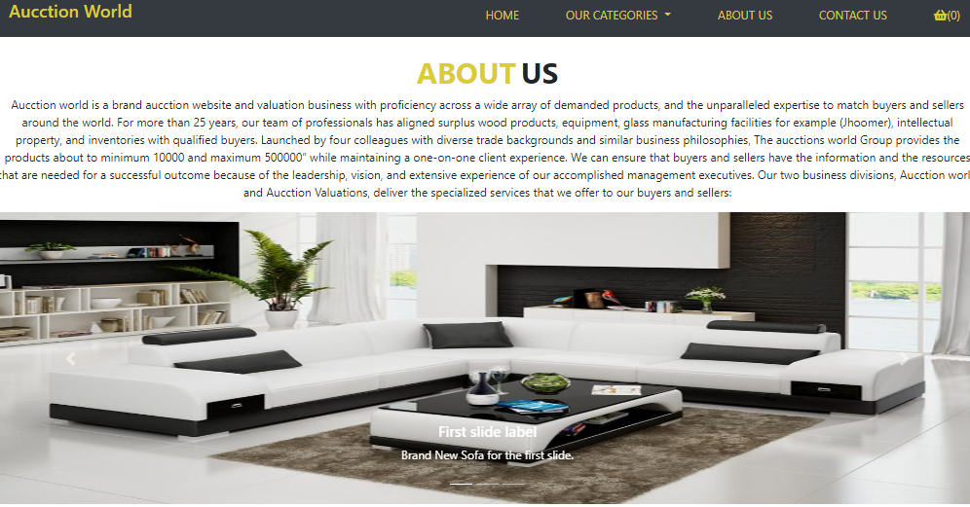

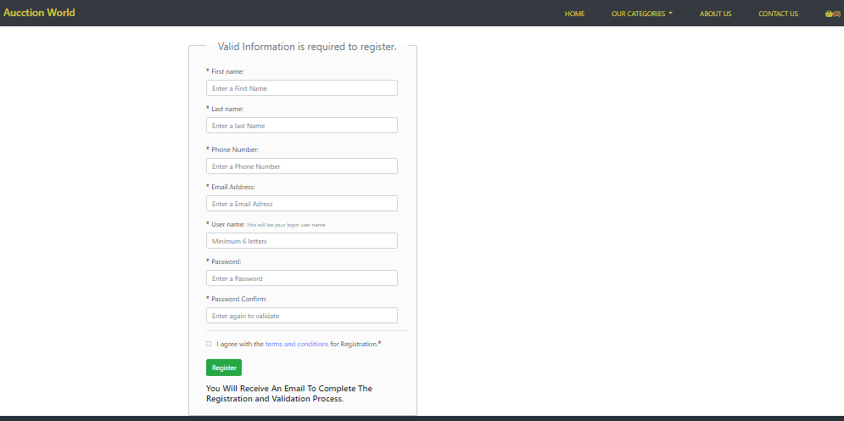

SUBMISSION CHECKLIST

|  |  |  |  |
| --- | --- | --- | --- |
| **No.** | **Requirement** | **Status** | **Comment/Reason** |
| 1 | ALL PAGES ARE AS PER REQUIREMENTS GIVEN | YES |  |
| 2 | LINKS TO ALL PAGES | YES |  |
| 3 | LAYOUT AND COLOR SCHEME | YES |  |
| 4 | BROWSER COMPATIBLE | YES | CHROME |
| 5 | RESPNSIVENESS | YES |  |
| 6 | LOGO | YES |  |
| 7 | PROJECT REPORTS(ALL THREE | YES |  |
| 8 | FEEBACK FORM | YES |  |
| 9 | PROJECT ZIP FILE | YES | WINRAR |
| 10 |  |  |  |

PAGE WISE TASK DISTRIBUTION

|  |  |  |
| --- | --- | --- |
| S.NO | PAGE | TEAM MATE NAME |
| 1 | HOME | HASEEB, FARHAN, OXAMA ALAM, RAHIM |
| 2 | OUR CATEGORIES | HASEEB, MUHAMMADFARHAN |
| 3 | ABOUT US | HASEEB, FARHAN, OXAMA ALAM, RAHIM |
| 4 | CONTACT US SECTION | HASEEB, FARHAN, OXAMA ALAM, RAHIM |