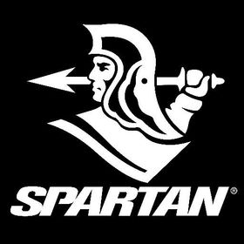

SPARTAN

# ***DESCRIPTION:***

Spartan was formed in 1893 as a club for [middle-class](https://en.wikipedia.org/wiki/Middle-class) black and creole cricketers who were denied entry into all-white cricket clubs such as [Wanderers](https://en.wikipedia.org/wiki/Wanderers_Cricket_Club) and [Pickwick](https://en.wikipedia.org/wiki/Pickwick_Cricket_Club). The inaugural president of the club was Sir [William Conrad Reeves](https://en.wikipedia.org/wiki/William_Conrad_Reeves), Chief Justice of Barbados and other members consisted mostly of "lawyers, medical practitioners, elite schoolmasters, higher level civil servants and the few non-whites to have penetrated the managerial levels of the business, commercial and plantation worlds." The club played its matches at the Belleville ground in [Saint Michael](https://en.wikipedia.org/wiki/Saint_Michael,_Barbados) and the first captain of the club was [George Learmond](https://en.wikipedia.org/wiki/George_Learmond_(cricketer)).

Cricket in Barbados at the time was strictly divided by color and class. Spartan was seen as a middle-class club and in its early year’s efforts to admit working-class cricketers met with some resistance. In 1899, the club was divided about the admission of [Fitz Hinds](https://en.wikipedia.org/wiki/Fitz_Hinds)—a talented cricketer who had previously worked as a grounds man at Pickwick Cricket Club. After his admission, many of his team-mates refused to play with him.

*ITEMS AVAILABLE ON A2Z SPORTS:*

* **CRICKET BAT.**

Our **Cricket brand** is recognized as one of the world’s most exciting and innovative brands. A brand that boasts two of the world’s most explosive batsman, Chris Gayle and Dave Warner.

*PICTURE OF ITEMS:*

