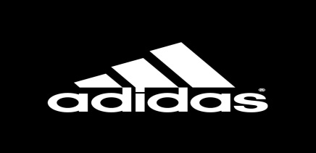

**Addidas**

# ***DESCRIPTION:***

**Adidas**[**AG**](https://en.wikipedia.org/wiki/Aktiengesellschaft) (German:  stylized as **adidas** since 1949) is a German corporation, founded and headquartered in [Herzogenaurach](https://en.wikipedia.org/wiki/Herzogenaurach), [Germany](https://en.wikipedia.org/wiki/Germany), that designs and manufactures shoes, clothing and accessories. It is the largest [sportswear](https://en.wikipedia.org/wiki/Sportswear_(activewear)) manufacturer in Europe, and the second largest in the world, after [Nike](https://en.wikipedia.org/wiki/Nike,_Inc.). It is the [holding company](https://en.wikipedia.org/wiki/Holding_company) for the Adidas Group, which consists of the [Reebok](https://en.wikipedia.org/wiki/Reebok) sportswear company, 8.33% of the German football club [Bayern München](https://en.wikipedia.org/wiki/FC_Bayern_Munich), and [Runtastic](https://en.wikipedia.org/wiki/Runtastic), an Austrian fitness technology company. Adidas' revenue for 2018 was listed at €21.915 billion.

*ITEMS AVAILABLE ON A2Z SPORTS:*

* **BASEBALL.**

Their products are famous for high-quality, good service and guarantee. It makes their reputation, meaning if you go anywhere else, their name is always considered as a phenomenon to make people impressive.

* **FOOTBALL.**

It is the holding company for the **Adidas** Group, which consists of the Reebok sportswear company, 8.33% of the German **football** club Bayern München, and Runtastic, an Austrian fitness technology company.

*PIICTURE OF ITEMS:*

