# **Python Tutorial for Beginners with VS Code**

* Installation Python: <https://www.python.org/downloads/>
* Installation Visual Studio Code: <https://code.visualstudio.com/download>
* Helping for VS Code: <https://code.visualstudio.com/docs/>
* Installation extension for VS Code:
  + Python
  + Jupyter Notebook
  + Code Runner
  + Flake8
  + Themes
* Terminal
  + Ctrl + Shift + p -> Python: Select Interpreter
  + Ctrl + Shift + ` -> New terminal
  + Ctrl + ` -> Open terminal
  + python -V -> version python in terminal
  + python -> run python in terminal / quit()
  + cd, dir -> change/view directory in terminal
    - cd / -> root directory
    - cd /xxx/xxx -> path begins from root directory.
    - cd xxx/xxx -> path begins from actual directory.
    - cd ../ -> go one level down
    - cd ../../ -> go two levels down
    - cd ../../xxx -> go two levels down to directory xxx
  + mkdir, rmdir -> new directory / remove directory.
  + cls -> clear window
* Working directory and New file:
  + Week_1/hello.py
    - print(“Hello!”)
  + Run Python file
* Virtual Environment:
  + python -m venv .my_env -> new virtual environment: .my_env
  + change interpreter in VS Code
  + .my_env\Scripts\activate.bat -> activate virtual environment
* Installation modules for python with **pip**
  + python.exe -m pip install --upgrade pip -> update pip
  + pip install pandas -> install pandas package
  + pip install package==version -> install package with particular version
  + pip list -> list installed packages in your env
  + pip list -o -> list packages with possible update
  + pip install -U pandas -> update pandas package
  + pip uninstall pandas -> uninstall pandas packages
  + pip freeze > requirements.txt -> list of install packages to file
  + pip install -r requirements.txt -> install packages from file list
* Working in VSCode with python file
  + ctrl+space -> help in position
  + F12 -> go to instance
  + ctrl+L -> select line
  + ctrl+K ctrl+C -> multi rows comment
  + ctrl+/ -> multi rows comment / delete comment
  + ctrl+K ctrl+U -> delete comments
  + shift+alt+A -> multi rows block comment
  + 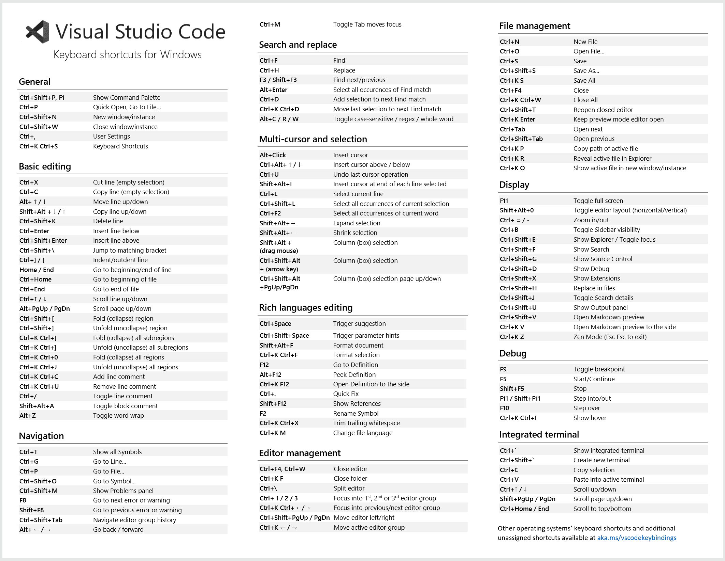ctrl+D -> selecting next combination + multi cursor