Appendix - B

SUKKUR IBA UNIVERSITY
Department of Computer Systems Engineering



Final Year Design Project Proposal Form

Submitted By:
Muhammad Usman (133-22-0016)
Asma Channa (133-22-0042)
Abdul Moiz (133-22-0032)
Kashish Thorani (133-22-0015)

Supervisor: Dr. Abdul Sattar Chan
Co-Supervisor: Engr. Umair Ayaz kamangar

Submission Date:

Project Title: | SafeDrive AI: Intelligent dashboard device for driver anomaly detection
Main Subject Area/s: | ☐Medical ☐ Agriculture ☐ Power Sector ☑ IOT ☑Robotics ☑ Artificial Intelligence ☑ Machine Learning  ☐ Software Development ☐ Web Development  Others: Computer Vision, Road Safety
Nature of Project: | ☑Research, Development, and Engineering (RD&E) leading to production capability  ☐Application oriented Research, Design & Development (R, D&D) having production potential  ☐Basic R&D
Mapped SDG: | ☐ No Poverty ☑ Industry, Innovation and Infrastructure  ☐ Zero Hunger ☑ Sustainable Cities and Communities  ☐ Good Health and Well-Being ☐ Climate action  ☐ Clean Water and Sanitation ☐ Partnerships  ☐ Affordable and Clean Energy ☑ Life in Land  ☐ Decent Work and Economic growth ☐ Reduced Inequalities  ☐ Gender Equality ☐ Peace, Justice and Strong Institutions  ☐ Life Below Water ☑ Responsible Consumption and Production
Students: | Name |  |  | CMS ID
 | Muhammad Usman |  |  | 133-22-0016
 | Asma Channa |  |  | 133-22-0042
 | Moiz Barlas |  |  | 133-22-0032
 | Kashish Thorani |  |  | 133-22-0015
Contact Information of Group Leader | Mobile No. 0325399186  Email Address: muhammadusman.becsef22@iba-suk.edu.pk
Supervisor: | Dr. Abdul Sattar Chan |  | Co-Supervisor (if any): |  | Engr. Umair Ayaz Kamangar
Industrial Advisor (if any): | Name:  Organisation/ Industry:  Designation:
Is this project a part of vertical integrated project? |  |  |  | Yes ☐ | No ☑
If yes, please give title of previous project:
Funding availability for the project: |  |  |  | Yes ☐ | No ☑
If yes, please give details from which funding agency:

Is this project targets to solve any industry/society related problem in particular? |  |  |  | Yes ☑ | No ☐
The project aims to solve the road safety related issue, where the drivers, passengers, and expensive material are gone under severe damage, due to anomaly of the driver. The project aims to solve this by developing a smart driver monitoring device.

Project Overview

SafeDrive AI: Intelligent Dashboard Device for Driver Anomaly Detection, is designed to significantly enhance road safety by mitigating accidents caused by driver drowsiness and distraction [1]. Driver fatigue impairs the ability to make safe decisions, and distractions, such as using a phone, eating, or engaging with passengers, redirect critical attention away from driving tasks, endangering both the driver and others on the road [1]. Traditional monitoring methods often fall short in real-time detection, especially given the dynamic nature of driving environments [6,9].
SafeDrive AI proposes a vision-based system that integrates deep learning techniques with computer vision to continuously monitor driver activity and facial expressions [1]. This approach offers a cost-effective, non-intrusive, and efficient alternative to physiological or vehicular-based methods [1].
The system will analyze visual indicators of fatigue, such as eye closure and yawning for driver’s drowsiness detection [11]. Head pose estimation and body posture tracking will provide crucial information for identifying driver distraction [5] Eye gaze direction will be determined by isolating the eye region, detecting the pupil, and assessing its relative position [1] Once risky behaviour is detected, the system immediately activates a multi-modal alert mechanism (buzzer, or voice alert) to refocus the driver’s attention. [3]. The system will also identify other common distractions like phone use, eating, or drinking [3].
The project will utilize the YOLOv8 algorithm for object detection to classify diverse driver behaviours [9]. While YOLOv8 is effective for standard behavior detection, further optimization may be needed to handle varying lighting and camera angles for robust real-world deployment.
Convolutional Neural Networks (CNNs) will be integrated for analysing facial expressions and creating robust detection models [12].
Deployment on Raspberry Pi is key aspect of SafeDrive AI is its deployment on a Raspberry Pi 4 using a simple camera module [3] The Raspberry Pi is an attractive platform due to its cost-effectiveness, portability, and suitability for embedded applications [3]. This aligns with the principles of Edge AI, enabling local data processing for real-time monitoring, where lightweight YOLO models are particularly well-suited for resource-constrained edge devices [14].

Project Motivation

Road safety is a global concern, with traffic accidents causing significant fatalities and injuries. In Pakistan, thousands of lives are lost yearly due to driver inattention, fatigue, and distractions [17]. Current monitoring methods are often ineffective or intrusive [6, 9]. There is a need for a cost-effective, non-intrusive solution that works in real-world conditions [1, 4]. Advances in computer vision and deep learning, such as YOLOv8 and CNNs, enable continuous monitoring and real-time alerts to prevent accidents [5, 12]. Raspberry Pi and Edge AI allow deployment on low-cost hardware, making the solution accessible [10, 14]. SafeDrive AI aims to improve driver safety and optimize fleet management, public transport, and long-haul driving by providing data-driven insights to reduce costs and enhance wellness [6]. Ultimately, it seeks to save lives, reduce accident costs, and contribute to safer, smarter roads.

Problem Statement

Road accidents caused by driver fatigue and distractions have become a major global public health issue. Pakistan has one of the highest traffic fatality rates, with 10,379 accidents and 5,608 fatalities reported in 2021 alone [16]. A study on Lahore–Islamabad Motorway crashes found that 66.8% of accidents were caused by driver error [17]. Fatigue-related accidents have been rising, with a 34.8% increase in crashes from 2003 to 2009 [19]. Drowsiness and distraction continue to be leading causes of accidents worldwide [1, 3, 11]. Existing solutions are often intrusive, non-scalable, or ineffective under varied real-world conditions [9, 11]. Additionally, deploying deep learning models on resource-constrained devices like Raspberry Pi presents computational challenges while maintaining real-time performance [14].

Aims and Objectives

The aim of the SafeDrive AI project is to enhance road safety by developing a cost-effective, vision-based, and real-time driver anomaly detection system that proactively identifies drowsiness and distractions. By leveraging AI-powered computer vision and edge computing, the project seeks to create a non-intrusive, reliable, and scalable in-vehicle safety device that can prevent accidents and contribute to intelligent transportation systems [1, 12, 15].

The Specific Objectives are:
- Develop a Real-Time Driver Monitoring System
Design and implement a vision-based solution to detect drowsiness (eye closure, yawning) and distractions (phone use, eating, head pose changes, talking to passenger, looking behind), ensuring accurate and continuous monitoring without intrusive sensors [1, 3, 5, 12, 14].
- Uses Advanced Deep Learning Models for Detection
Utilize and optimize YOLOv8 and CNN architectures for robust behavioral classification, focusing on high accuracy and speed to meet real-time requirements [5, 6, 9].
- Deploy on Edge Hardware for Practicality
Implement the system on Raspberry Pi 4, enabling low-latency, on-device processing that ensures portability, energy efficiency, and real-time alerts without reliance on cloud infrastructure [9, 10, 14].
- Implement Effective Alert Mechanisms and Validation
Integrate real-time audible alerts to warn drivers of anomalies and validate system performance using standard metrics (precision, recall, mAP, FPS) to ensure reliability under real-world conditions [9, 11, 12].

Literature Review

Road safety is a significant global concern, with driver drowsiness and distraction being major contributors to accidents and fatalities [1]. These conditions impair a driver's ability to make safe decisions, endangering themselves and others [1].
Vision-based fatigue detection systems rely heavily on camera data to track driver’s facial attributes. Fernández (2017) explored the use of facial recognition technology to identify drowsiness through specific facial attributes such as eye closure and yawning. These systems are capable of issuing timely alerts to the driver, potentially preventing accidents by giving them a chance to rest before fatigue leads to a loss of control. In addition, gaze detection is another popular technique used to identify fatigue. Gaze zone classification, as discussed by Hermens et al. (2024), involves detecting whether a driver’s gaze is fixed on the road or diverted due to tiredness. This can be critical in detecting drowsy behaviour, especially in environments where manual interventions are minimal, such as on highways or remote areas [4][5].
Historically, various methods have been proposed to detect driver fatigue and distraction, primarily categorized into three groups:
- Methods based on vehicle behavior analysis: These approaches analyze vehicle parameters to infer driver state [2].
- Methods based on physiological variables: These involve capturing biological signals such as electroencephalography (EEG), electrooculography (EOG), electrocardiography (ECG), or body temperature [2]. However, these methods are often costly, intrusive, complex, and sensor-dependent, potentially being uncomfortable or harmful to drivers [1].
- Vision-based methods using behavioural indicators: These systems utilize cameras to monitor a driver's facial expressions and body movements [1]. This approach has gained significant attention due to being more cost-effective, non-intrusive, and efficient compared to physiological or vehicular-based methods [1].

Key behavioral indicators and techniques in vision-based systems include:
Eye Closure Detection: Eye Aspect Ratio (EAR) and Percentage of Eye Closure over Time (PERCLOS) are crucial metrics [11]. Drowsiness is typically identified when eyes remain closed for a specific duration, such as 2-3 seconds (e.g., 30 consecutive frames at 10 frames per second) [1,1].
The Mouth Aspect Ratio (MAR), calculated from mouth landmarks, is used to detect yawning when its value exceeds a predefined threshold for a certain number of successive frames [1].
Head Pose Estimation provides valuable information about driver distraction [1]. Techniques like the Perspective-n-Point (PnP) algorithm or analysing vertical displacement between nose tip and chin can detect head movements such as a "Head Bowed Down" posture [1]. Eye Gaze Tracking involves isolating the eye region, detecting the pupil, and assessing its relative position to determine the gaze direction [1]. A driver is classified as distracted if their gaze is directed away from the centre for more than two to three seconds [1].

Recent studies have shown that combining YOLO-based image classification with gaze zone detection can significantly improve the accuracy of distraction detection. For example, Hermens et al. (2024) explored the use of YOLOv8 for gaze zone classification to detect when a driver is distracted, either by a phone or looking elsewhere in the car [5]. These technologies focus on the driver’s head and eye movement to assess whether their attention is on the road or diverted to external stimuli. Furthermore, in a study by Zandamela et al. (2024), the authors discuss the use of lightweight YOLO models deployed on edge devices, making these distraction detection systems cost-effective and accessible. These low-power solutions ensure that driver monitoring systems can be installed in a wide variety of vehicles without incurring significant hardware costs, which is crucial for mass adoption across commercial and public transport sectors [14].

Recent research integrates deep learning techniques, such as Convolutional Neural Networks (CNNs) and YOLO (You Only Look Once) algorithms, with computer vision tools like OpenCV, Dlib, and MediaPipe [1] These models analyse facial landmarks and behavior patterns for robust detection [1] MediaPipe Face Mesh, for example, has shown higher accuracy (96%) in detecting drowsy states compared to Dlib's Shape Predictor (87%), especially in diverse backgrounds and with drivers wearing glasses [1]. YOLOv8 is particularly noted for its effectiveness in object detection and image classification for driver behaviours, achieving high precision, recall, F1-score, and mAP values on relevant datasets [5].
A study by Adhikari et al. (2025) emphasizes that vision-based systems can effectively detect fatigue by analysing behavioural indicators, such as yawning, blinking, and head nodding. These indicators are usually early signs of drowsiness and can serve as warning signals before an accident occurs. By employing AI-driven models, such as deep learning-based convolutional neural networks (CNNs), these systems can provide real-time analysis of the driver’s facial expressions and eye movement to detect drowsiness with high accuracy [1].

Upon detecting any specified anomalies like drowsiness, phone use, eating/drinking, or looking away from the road, the system will trigger an audible and/or visual alert to warn the driver [1]. This real-time intervention is designed to encourage immediate corrective action, thereby preventing potential accidents [3] In critical situations, the system could send alarming notifications, including the driver’s location, to registered family members via platforms like Telegram, enabling them to quickly locate the driver and take necessary actions [12].
There are challenges and gaps in Existing Systems [15]. Despite significant progress, several challenges remain. Traditional rule-based and supervised learning methods often struggle with the vast volume of unlabelled and complex data in real-world intelligent transportation systems [15] Manually labelling such large datasets is difficult and prone to bias [15] Current systems face limitations in handling varying lighting conditions, camera angles, and the presence of accessories like glasses or sunglasses [1].

Similarly, Yang et al. (2025) highlights the importance of multi-task learning models that combine fatigue detection, distraction monitoring, and even emotion recognition to evaluate a driver’s cognitive state. This system could use a combination of vision-based techniques and sensor data, ensuring comprehensive driver monitoring. In the context of long-distance driving or commercial fleets, such systems could drastically reduce human error by actively preventing both fatigue and distractions before they lead to accidents [13].
Moreover, many studies focus on only one aspect of detection (e.g., eye conditions or mouth activity), failing to provide a holistic monitoring system [9] There is a critical need for cost-effective, real-time, and scalable solutions that can operate efficiently on resource-constrained edge devices like Raspberry Pi, balancing accuracy with inference speed [6]. Furthermore, models trained on specific individuals or limited conditions often do not generalize well to other drivers or varied situations [5].

Despite the progress made, there are several challenges in implementing these systems. One of the primary concerns is the processing power required to run real-time detection systems effectively. Most existing systems require high-performance computing capabilities, which may not be feasible for all vehicles. However, advancements in edge computing and lightweight AI models, as seen in research by Zandamela et al. (2024), are making it possible to run such systems on low-cost edge devices without compromising their effectiveness. Additionally, privacy concerns, as well as data storage and processing limitations, are crucial factors that need to be addressed to ensure the ethical deployment of these systems [14].

Future Enhancements for SafeDrive AI: The current system lay a strong foundation, but several areas offer potential for further improvement.
Robust Head Pose Estimation: Developing more robust methodologies for head pose estimation is necessary for more efficient detection of drowsy postures [1].
Integration with Other Data Sources: Combining these behavioural indicators with physiological (e.g., heart rate) and vehicular features (e.g., steering patterns) and training-based approaches could lead to a more comprehensive and efficient drowsiness detection system [12].
Data Diversity: The system should be trained on more varied data to account for changes in driver appearance (e.g., different clothing, hairstyles, accessories) and diverse illumination conditions to maintain high accuracy [9,5] Using (near) infrared cameras could also help mitigate lighting issues [5].
Optimization for Edge Devices: Further optimizing the inference speed of the models to run efficiently on low-spec hardware, such as IoT devices or car monitoring dashboards, is crucial for widespread real-time application [9].
Expanded Behaviour Categories: Adding more categories of driver behavior, such as using a cell phone while driving, looking back, or eating and drinking, will expand the scope of detection and improve the system's overall utility in driving safety [9]
Temporal and Cross-Modal Modelling: Exploring temporal modelling using techniques like Transformer networks with multi-frame YOLOv8 features could enhance dynamic anomaly detection. Additionally, integrating data from multiple sensing modalities, such as vibration, infrared thermography, and ultrasonic detection, could create a more robust multi-modal anomaly detection system [13]
Adaptive Classification Strategies: Applying reinforcement learning could enable the system to dynamically adjust its classification strategies based on historical detection data and environmental feedback, improving generalization [13].
By combining robust detection capabilities with an accessible hardware platform and continuous improvement, SafeDrive AI offers a practical and scalable solution for improving road safety.

Methodology
The development of SafeDrive AI follows a structured approach, involving key phases that ensure effective detection of driver fatigue and distraction, two major causes of road accidents.

Input Acquisition

The system begins with input acquisition, where real-time vision-based data is captured from cameras. This data serves as the primary source of information for the AI system and provides the foundation for further processing.
- Processing with AI Model

The acquired data is passed into trained DL models such as CNNs, YOLO, or NLP frameworks by the edge-computing Device. These models analyse the input vision-based data to detect patterns, classify information, and recognize anomalies, ensuring meaningful insights are extracted from raw data.

Decision Logic & Risk Assessment

Once the DL model generates outputs, a decision-making logic layer evaluates the results. This phase determines whether the detected state is normal, warning, or critical, ensuring that the system’s responses are both accurate and context-aware. Based on the results (If the detected state id warning) the signal for Alert is sent to Alert device by edge-computing device.

Alert/Action Triggering

Based on the assessment, the edge-device send signals to trigger appropriate actions. These may include activating alarms, sending notifications, or performing automated responses. This step ensures timely intervention whenever abnormal or risky situations are detected.

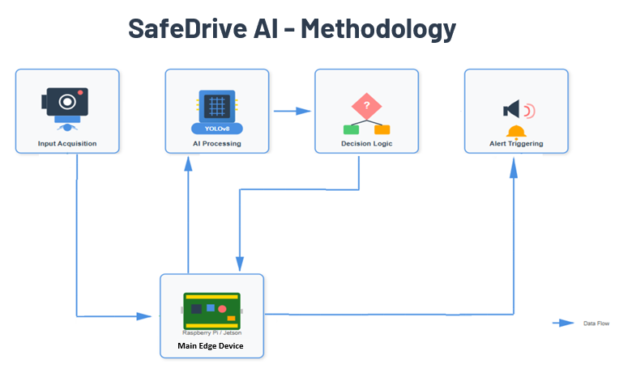

Project Plan/Gantt Chart

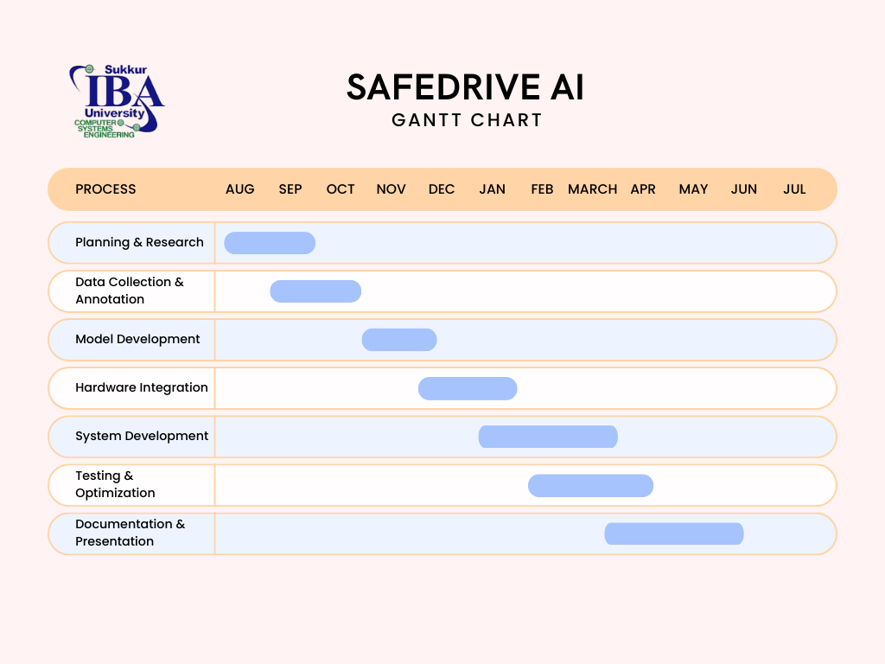

Budget Description

Sr. No | Items/Product | Details Of Product | Source Of Purchase | Quantity | Price
1 | Micro-controller/Micro-processer | Raspberry pi 4, with 8GB RAM | Electrobes.com | 1 | 42,500
2 | Pi Camera Module v2 | Official Raspberry Pi Camera Board V2 8MP 1080P High Resolution Camera Module | Electrobes.com | 1 | 8,000
3 | Power Supply and Casing | Batteries and Plastic work | Local Market | 1 | 6,500
4 | Speaker | Alarming System | Local market | 1 | 5,000
5 | Miscellaneous | Booting Devices, Modules, Wires, Printing etc | Local Market | 1 | 15,000
Total |  |  |  |  | 77,000

References

- Adhikari, M., Joshi, P., Shrestha, S., & Shaik, S. (2025). Vision-based driver drowsiness and distraction detection through behavioral indicators of fatigue. SoutheastCon. https://doi.org/10.1109/SoutheastCon56624.2025.10971515
- Chad, F. (2025). AI-driven query optimization for dashboard upgrades.
- Rozali, R. A. F., Fadilah, S. I., Shariff, A. R. M., Zaini, K. M., Karim, F., Wahab, M. H. A., Thangaveloo, R., & Shibghatullah, A. S. B. (2022). Driver drowsiness detection and monitoring system (DDDMS). Vol. 13(6).
- Fernández, A. (2017). Facial attributes recognition using computer vision to detect drowsiness and distraction in drivers. ELCVIA, 16(2), 25–28. https://doi.org/10.5565/rev/elcvia.1134
- Hermens, F., Anker, W., & Noten, C. (2024). Gaze zone classification for driving studies using YOLOv8 image classification. Sensors, 24(22), 7254. https://doi.org/10.3390/s24227254
- Faisal, M. M., Varshini, M., & Muvedha, K. (2025). YOLO-CNN powered real-time detection of visual distractions and drowsiness in drivers. IJSRCSEIT, 11(4), 94–101. https://doi.org/10.32628/CSEIT2511150
- Osaka, M., & Henry, D. (2025). AI-powered anomaly detection in financial and healthcare systems. IJAETI, 1(1).
- Prathyusha, C., & Yalawar, M. S. (2022). An approach for detecting drowsy drivers in vehicles using CNN techniques.
- Satya, M. R. A., Nurdiawan, O., Basysyar, F. M., & Hidayat, R. (2025). Utilization of YoloV8 for in-vehicle video-based driver monitoring system. JAI&EA, 4(3), 1721–1727.
- Saleh, A., Fitriandari, C., Ridwan, M., & Budikarso, A. (2022). Sidewalk violators detection innovation using Raspberry Pi. IJESI, 11(5), 56–65. https://doi.org/10.35629/6734-1105015665
- Takale, D. G. (2024). Driver drowsiness and distraction detection: An image processing-based comparative analysis for improved accuracy. JoCNV, 2(2), 6–9. https://doi.org/10.48001/JoCNV.2024.226-9
- Temkar, R., Jagli, D., Gupta, S., Shaikh, S., Mundas, A., & Patel, S. (2024). Deep learning solutions for real-time driver distraction and drowsiness using alerts. J. Electrical Systems, 20-10s, 4286–4925.
- Yang, L., Yang, M., Osman, G., Rahman, S. A., & Mustapha, M. F. (2025). Fuzzy-YOLO model for rail anomaly detection. IET Image Processing.
- Zandamela, F., Kunene, D., Skosana, V., & Stoltz, G. (2024). Lightweight YOLO for distracted driver detection on edge devices.
- Zhang, M., Chen, C., Wo, T., Xie, T., Bhuiyan, M. Z. A., & Lin, X. (2009). SafeDrive: Online driving anomaly detection from large-scale vehicle data. IEEE.
- Shahzad, Muhammad. "Fatal Road Accidents." The Express Tribune, 1 Feb. 2023, https://tribune.com.pk/story/2398660/fatal-road-accidents.
- Iqbal, Asad, et al. "Road Traffic Accident Analysis and Identification of Black Spot Locations on Highway." Civil Engineering Journal, vol. 6, no. 12, 2020, pp. 2448–2456, https://doi.org/10.28991/cej-2020-03091629.
- Khaista Muhammad, Shiraz Shaikh, Javeria Ashraf, Sikander Hayat “Characteristics, reasons and patterns of Road Traffic Injuries presenting in emergency department of a tertiary care public hospital in Karachi” https://pjms.org.pk/index.php/pjms/article/download/
- Zia, Asad. 2013. "Early to Bed...: Fatigue, a Leading Cause of Road Accidents." The Express Tribune, June 30. https://tribune.com.pk/story/570181/early-to-bed-fatigue-a-leading-cause-of-road-accidents.

Signature of Students:
1.

2.

Supervisor’s Comments

Name: Designation:

Signature:

FYDP Evaluator Remarks

Project Evaluator:

Name: Designation: _________________________

Signature:

Final Year Design Project Coordinator

